Image processing pipeline
REVISION NOTE: Yellow highlighting identifies proposed additions and corrected wording. The original document has not been overwritten.
This section describes the step-by-step image processing used to localise reflected Placido mires and calculate exploratory image-domain geometric descriptors. Processing is divided into two phases: Phase 1 performs image preprocessing and mire localisation, and Phase 2 calculates geometric descriptors from the accepted mire coordinates.
Phase 1 was carried out using two methods. Method 1 used the developed Placido pathway, in which Canny edge detection, circular masking, radial-gradient polarity separation, fragment merging, and opposite-boundary pairing generated physical-mire centrelines before geometric fitting. Method 2 used the classical SmartKC pathway adapted from the open-source SmartKC work (Gairola et al., 2021). SmartKC++ was not used in this comparison. The public SmartKC camera and sensor parameters are reference defaults and require device-specific calibration before any spatial output can be interpreted physically.
The localised coordinates from Phase 1 are analysed mire by mire in Phase 2. Eigen-ratio analysis evaluates the covariance geometry of each accepted mire. Cross-mire centre dispersion quantifies the spatial variation of mire centroids within one image. Explicit ellipse fitting is used to calculate normalised radial irregularity, while covariance eigenvectors provide the principal image-axis orientations.

Phase 1: Image preprocessing and mire localisation
The raw image is first decoded, oriented, and converted into an analysis-ready intensity representation. This phase suppresses irrelevant image structures where possible, identifies the Placido centre, restricts processing to a valid corneal image region, and converts the reflected pattern into ordered physical-mire coordinates. The two methods use different localisation principles, as described below.

Method 1: Developed Placido mire-detection method
This method detects Placido reflections by converting the raw image to grayscale, applying Canny edge detection, suppressing incompatible structures, recovering the Placido centre, and pairing the inner and outer boundaries of each bright band. The radial midpoint of each paired boundary forms one physical-mire centreline. The illustrated comparison uses the requested mire range 1–6; this reporting range does not define the physical meaning of a mire.

Step 01 – Acquire and select a frame.
This step involves selecting an image for analysis. The algorithm uses the frame rate in the MPEG-4 writer and blob-area threshold of 250 pixels. Each decoded frame is scored by the variance of a 3 x 3 Laplacian kernel, and the sharpest frame is selected before each ring analysis. The sharpness score is calculated before the edge detection so that the selection does not depend on a later ring count. The maximum Laplacian-variance rule is a focus priority: it favors high spatial frequency, but it can also favor eyelashes or sensor noise. This helps because a time-averaged frame can blur the narrow-reflected bands and alter the apparent number of rings. The output from this stage is a raw frame, not merely because it is sharp; it must be outside the transition margin and visually viewed.

Step 02 – Conversion to grey scale
The ring detection operates on the intensity gradients, while the selected frames are in RGB. A single scalar working image is required for the threshold and radial profiles to have a defined meaning. The script uses “im2gray” and send the results directly to the edge. It applies imfilter with a fspecial (‘disk’, 5), then assesses a vertical Prewitt operator, bwareopen = 40 and bwmorph (‘thicken’, 5). A disk filter is used to reduce the high-frequency noise but also broadens a thin mire and changes the peak location. This conversion produces a grayscale image.

Step 03 – Run Canny edge detection.
Canny is the first explicit boundary generator; it converts a continuous intensity field into a binary set of candidate pixels, but it does not know whether a boundary belongs to a Placido mire, a pupil, an eyelash, or the attachment. It first uses MATLAB’s default threshold selection, after which it runs with the normalised hysteresis pair [0.1, 0.3]. The lower value seeds weak edges connected to strong edges, while the upper value retains strong-gradient pixels.

Step 04 – Remove border-connected and tiny components.
This step involves improving edge detection by removing image borders, compression speckles, and isolated highlights before grouping. This reduces the number of false graph nodes and prevents frame edges from being mistaken for a ring. This is done using “imclearborder”, which removes components that touch the image boundary, followed by “bwareaopen” with blob threshold of 250 pixels and an area value of 40 after the disc smoothening and thickening. It uses a minimum blob size of 20.

Step 05 – Estimating the historical coarse centre.
This step involves retaining only the largest circle centered on the image's midpoint and then setting the pixels outside the circle to black. The next step is to estimate the coarse centre. An odd-square support, approximately one-tenth of the shorter image dimension, is used by “imboxflit”. Border locations outside the window are excluded, and the minimum local mean intensity is selected as the coarse centre.

Step 06 – Unwrap the image into polar coordinates.
This step converts the approximately concentric image structures into near-horizontal radius -versus-angle traces, making angular gaps and radial ordering explicit. Angles are sampled at every integer degree from 0 to 359 and radii from 0 to the largest border-safe coarse-centre radius. The Cartesian sample positions are x = cx + r cos (Ө) and y = cy + r sin (Ө).

Step 07 – Separate edge by radial gradient polarity
This step helps distinguish the opposite sides of each bright Placido band and reduce inappropriate merging between inward and outward intensity transitions. The Sobel gradients Gx and Gy are projected into the unit radial directions from the current batch centre. The clean edge pixels and non-negative (Gr) from one polarity mask and negative Gr for the other are determined by:
Gr = Gx cos (Ө) + Gy sin (Ө)

Step 08 – Grouping historical edge points into connected objects.
The steps convert individual edge pixels into provisional objects that can be assessed geometrically. The union of the two-polarity mask is labelled with “bwlabel” using the 8-connectivity. Each integer colour denotes a connected component.

Step 09 – Filter historical objects by enclosure geometry
For each connected component with at least 3 points, “convhull” produces a simplified “hull” and “inpolygon” assesses the coarse centre. Retained and rejected components are overlaid in separate colours. A long open arc can enclose the centre through its convex hull, while a valid incomplete ring may fail.

Step 10 – Recover the dedicated Placido hub.
This step defines the centre from which radial orientation, radius and angular support are calculated, and restricts the dedicated detector of the corneal Placido field. A synchronised runner searches a preview bounded to 480 pixels on its longest radius (8 and 12 pixels). The centre is mapped to native pixels. If no circle is returned, adaptive thresholding uses a sensitivity of 0.50 and retains regions greater than 500 pixels and circularity greater than 0.65. the detected hub boundary, centre cross and a distinct 380-pixel analysis over the greyscale image. Following hub localisation, a circular analysis region was centred on the estimated Placido centre. Its radius was automatically scaled according to the largest requested physical-mire index. For physical mires 2–10, a 700-pixel radius was used to ensure that both the inner and outer boundaries required to construct the outermost mire centreline remained within the search region. This region defined the detection search area and did not itself represent a detected mire or anatomical boundary.

Step 11 – Apply the dedicated Canny and radial orientation mask.
This step involved restricting the fixed canny evidence to the hub-centered working region and retaining separate inward/outward radial boundaries. Step 03 canny map is intersected with the 380-pixel region and cleaned at 20 pixels, and a “bwRobustSurgicalPrune” is first applied. Using a 70-degree angular criterion before polar separations and again independently on both polarity masks. This step retains edge boundaries, not center lines of bright bands.

Step 12 – Merge ring fragments using endpoint distance and tangent direction.
This step reconnects the short gaps caused by glare, weak contrast, or threshold interruption without joining geometrically incompatible structures. For each endpoint, all pixels in that component are ranked by Euclidean distance, and the vector from the 30th spatially nearest pixel or the last available pixel for a shorter component defines the normalized local direction. A gap of max 4 pixels is forced-merged. The rings-only categorical image, in which each merged edge curve has a single color.

Step 13 – Reject curves with insufficient angular subtense.
The step excludes short fragments that survive local geometry tests but do not span enough of the corneal field to be treated as ring traces. For each merged label, “getSubtenseRobust” constructs a simplified convex hull, converts the hull to centre-relative angles, accounts for circular wrap gaps, and defines subtense as 360° minus the largest gap. The curves with subtense at least 90° pass, while the degenerate curve returns zero.

Step 14 – Pair inner and outer boundaries and physical mire centrelines
This step assigns the reproducible inner-to-outer detected-curve indices and exposes exactly which indices enter the subsequent shape figures. Accepted boundary tracks are sorted by mean radius; radially adjacent tracks are paired only when they have opposite radial gradient polarity. For each pair, inner and outer radii are condensed independently into one-degree angular bins. Centrelines are numbered from the centre outwards; “firstRing: lastRing” now selects these physical mire centrelines.

Step 15 – Bin each selected mire on a fixed annular grid and spline fitting
This step condenses physical-mire centreline radii within annular sectors and provides a circular support representation for gap detection and spline fitting. fitAllPlacidoRings forwards each centreline to fitPeriodicSplineRobust with 180 angular bins. Within each occupied bin, representative angle and radius are calculated from medians, while the number of midpoint samples is retained as a spline weight. A Placido mire is classified as closed only when its maximum circular angular gap is strictly less than 45°. The minimum coverage setting of 90° supplies a low-coverage warning and is not the primary closure decision. The First Mire and Last Mire settings define an inclusive reporting window only; detection is performed independently of that window. For paired analysis, the software automatically retains only mire IDs classified as complete by both methods within the selected range.
These obtained variables in phase 1 of the image preprocessing and mire localisation will be utilised in phase 2 for further geometric fitting and analysis.

Method 2: Classical SmartKC mire-detection method
This method builds on Smart KC's proposed method in phase 1, which includes image preprocessing and mire localisation. The mire detection undergoes several steps before the complete rings are processed for phase 2. The code was adopted because it is open source: https://github.com/microsoft/SmartKC-A-Smartphone-based-Corneal-Topographer. The step-by-step process for this method is explained below, and the image outcomes for the steps are shown in Figure 15:

Step 01 – Read and orient the source image.
The step establishes the single traceable image and is decoded with “readImageWithExifOrientation”, which is applied before any coordinate is calculated. The maximum input dimention is set to 1152 pixels, if the source dimensions exceed this, bilinear resizing is applied and “inputResizeScale” records the mapping back to the source coordinates. The image source is the same as in the previous method

Step 02 – Detect the centre and create the centre crop.
This step involves locating the Placido hub and restricting the computation to a square field around it. This square is drawn once the centre is located and limited to a maximum of 720 pixels and a minimum of 480 pixels. The centre is transformed into crop coordinates. The analysis radius is 0.46x twice the nearest valid centre-to-boundary distance, ensuring radial sampling remains within the crop.

Step 03 – Flat field normalisation and percentile rescaling
This step essentially helps reduce the slow illumination fall-off while preserving the higher-frequency dark mire transactions. The crop is divided by a Gaussian-smoothed background, with the denominator floored at 0.05. Only the pixels inside the circular analysis determine the 1st and 99th percentile limits, after which a ratio is scaled to [0,1].

Step 04 – Dark mire response
This step enhances the dark annular bands at the special scale expected for the Placido mires. Here, two Gaussian images are calculated from “NormalizedGray” using sigma 0.8 and 7.0 pixels followed by “mat2gray”. This positive difference emphasises locations that are darker locally than their neighbourhood and suppresses the opposite polarity. It is based on a scale-selective response.

Step 05 – Threshold and clean the annular segmentation.
This step converts the continuous response into candidate dark -mire pixel inside the valid annulus. It begins outside the central exclusion radius and ends at “AnalysisRadiusPx”. A global threshold is the 0.66 response quantile, and it supplies a locally varying threshold with sensitivity 0.52. A pixel is retained when its response exceeds the larger of 0.72x the global threshold and the adaptive threshold. Components larger than 8 pixels are removed with 8-connectivity, then “bwmorph clean” removes isolated pixels.

Step 06 - Sample radial profiles and localise peaks.
This step transforms a 2D segmentation into radial observations on fixed meridians. Rays are sampled in 2° increments, and the response is bilinearly interpolated at one-pixel radial spacing. A five-sample Gaussian smooth is applied. At most 28 peaks are retained on a ray and sorted radially.

Step 07 - Classify select the complete mires.
An explicit quality gate is applied before moving to the next phase, which involves determining various parameters. For each selected mire, the analysis records the point count, observed angular coverage, and maximum circular angular gap. A mire is complete when it contains at least 30 points, coverage is at least 87.5%, and a maximum gap is no greater than 45°. Although a larger number of rings were detected using this method, we would use First Ring:1 and Last Ring: 6 to have a comparison for Phase 02.

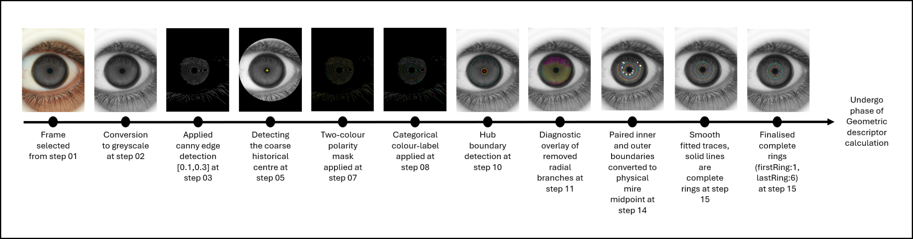
Figure 14: Output images of Method 1

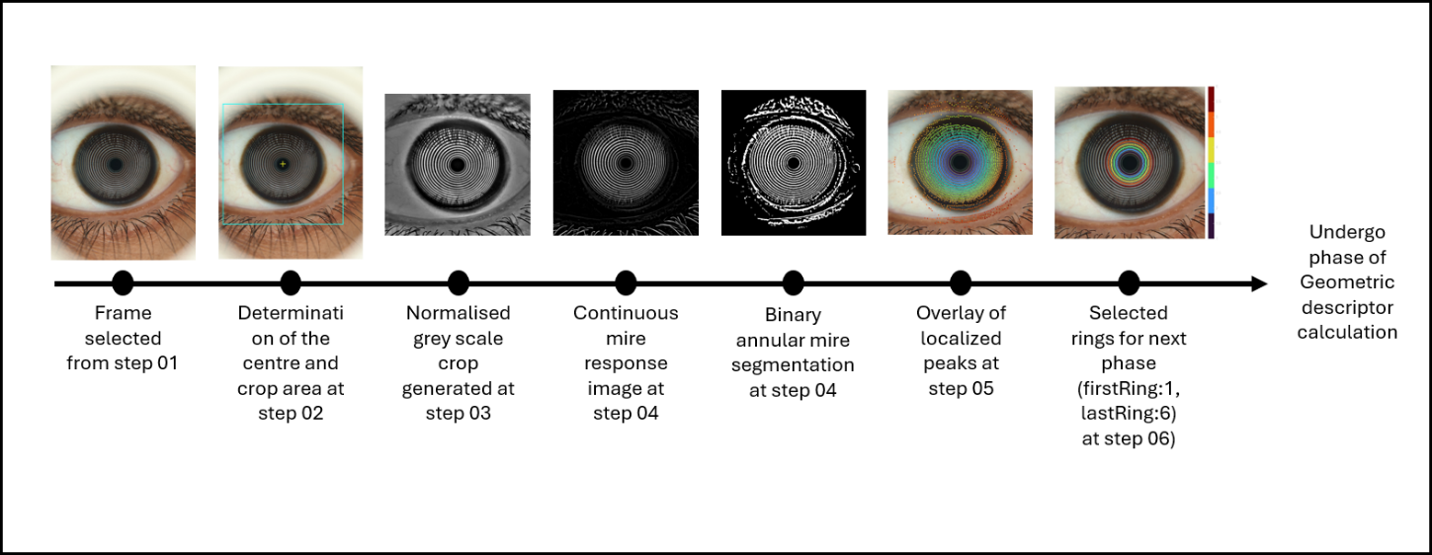
Figure 15: Output images of Method 2

Scientific comparison of Placido and classical SmartKC mire localisation
The two pathways localise different image features and therefore should not be expected to produce identical point distributions. In the developed Placido pathway, Canny edge detection identifies the two intensity transitions bounding a bright reflected Placido band. Opposite-polarity inner and outer boundaries are paired, and their radial midpoint defines the physical-mire centreline. This representation preserves deformation of the observed bright band while reducing the two detected boundaries to one physical mire.
The classical SmartKC pathway instead applies flat-field normalisation followed by a difference-of-Gaussians response that enhances dark reflected bands. Radial profiles are sampled from the estimated Placido centre, local response peaks are identified on each ray, and provisional mire indices are assigned in increasing radial order. SmartKC therefore localises a dark-band response directly rather than pairing the two boundaries of a bright band.
SmartKC numbering begins at the first accepted radial peak outside its central exclusion region. A missed inner peak, an additional artefact, or a locally weak band can shift the index assigned to subsequent observations. Consequently, the same numerical mire ID in the two methods does not by itself establish the same physical annulus. The intersection of complete mire IDs provides a reproducible selection rule, but physical correspondence remains unvalidated until mire identity is established through calibration or reviewed spatial matching.
Completeness has a specific quality-control meaning. In classical SmartKC, completeness is based on point count, angular coverage, and maximum circular angular gap. These criteria demonstrate circumferential support but do not independently prove correct radial identity, smoothness, or anatomical validity. A radially misassigned trace can therefore satisfy the completeness gate.
Following localisation, both pathways calculate covariance-based descriptors. A covariance ellipse preserves the centroid, principal orientation, and two principal spatial spreads, but suppresses higher-order local deviations. Raw mire traces can therefore produce similar covariance ellipses even when their local shapes or radial identities differ. Covariance-ellipse figures should be interpreted as compact geometric summaries rather than direct visualisations of detected mire contours.
The illustrated writeup used trial_proposal.jpg, which is identical to test_image_3.jpg. For that demonstration image, the two selected mire sets occupied similar radial regions and were nearly circular, so their covariance ellipses appeared similar. This observation is image-specific and does not demonstrate that the two localisation methods are generally interchangeable.

Phase 2: Geometric descriptor calculation
This phase calculates predefined descriptors from the complete mires detected in Phase 1. FIRST_MIRE and LAST_MIRE define a user-adjustable comparison window; the current demonstration default is 1–15. The final paired analysis automatically uses only numerical mire IDs that are classified as complete by both methods within that window. The descriptors comprise covariance eigen ratio, single-frame cross-mire centre dispersion, explicit-ellipse radial irregularity, and principal image-axis orientation. These are image-domain descriptors and are not calibrated corneal curvature, keratometry, or clinical astigmatism measurements.
The three comparison descriptors described below were implemented for this project and are not equations reported in the original SmartKC publication. SmartKC is cited for its acquisition, mire-localisation, Arc-Step and Zernike reconstruction framework (Gairola et al., 2021).

Step 01 – Compute the covariance eigen ratio for each selected mire.
For each of the selected mires, the tracking convention reconstructs X = R sin(Ө) and Y = R cos (Ө) from paired boundary midpoint radius. After mire-wise mean centring, eigenvalues are sorted. λmajor is determined as the largest eigenvalue and represents the variance of the points along the longest dimension of the fitted ellipse, while the λminor is the shortest dimension. Eigen ratio (ER) was calculated as the absolute eigenvalue magnitudes depend on the physical size of the mire, as shown in the equation below. An ER ≈ 1 indicated that the mire is nearly circular. The ER for the current example was calculated as 0.955 using both methods, indicating that the mires were circular (Figure 16)
$$ER=\sqrt{\frac{λ_{minor}}{λ_{major}}}$$

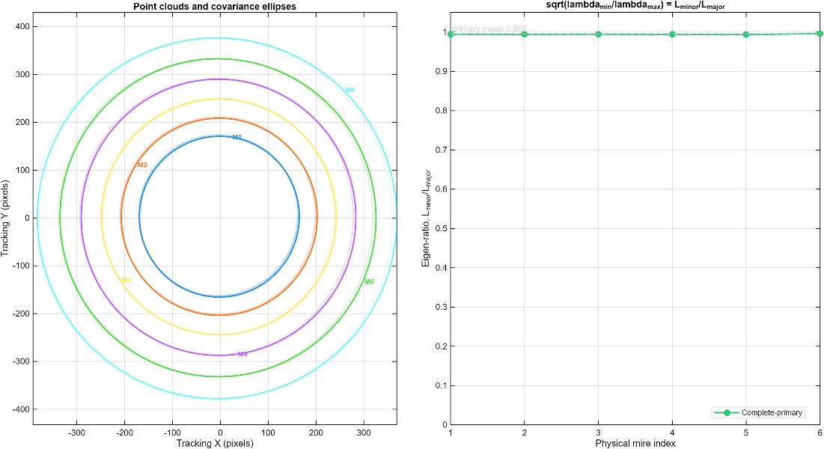
Figure 16: The constructed ellipse obtained from Step 01 using both the detection methods

Interpretive note: This panel is a covariance-based geometric summary. It is not a paired raw-centreline comparison and should not be used alone to infer agreement between the two mire-localisation methods.

Step 02 – Quantify single-frame cross-mire centre dispersion.
This step quantifies how closely the selected physical-mire centroids cluster within one image. For M common complete mires, each centroid is (Cx,i, Cy,i), and the reference centre is their arithmetic mean. The displacement of mire i is the Euclidean distance di = sqrt[(Cx,i − mean(Cx))² + (Cy,i − mean(Cy))²]. The reported cross-mire centre dispersion is Dc = sqrt[s(Cx)² + s(Cy)²] = sqrt[trace(S)], where s denotes the sample standard deviation and S is the two-dimensional sample covariance matrix. This descriptor is defined in the present study; it is not a temporal repeatability or frame-to-frame instability measurement.
$$\text{Centre dispersion}=\sqrt{\text{SD}{\left(C_{x}\right)}^{2}+\text{SD}{\left(C_{y}\right)}^{2}}$$
For the analysed demonstration image, Method 1 yielded a mean per-mire centroid displacement mean(di) of 1.714 pixels and Method 2 yielded 2.042 pixels. The corresponding single-frame cross-mire centre dispersions Dc were 2.241 pixels and 2.627 pixels, respectively. The lower Method 1 values indicate tighter centroid grouping for this single image. This image-specific result must be evaluated across a larger dataset before any conclusion about comparative performance is made.

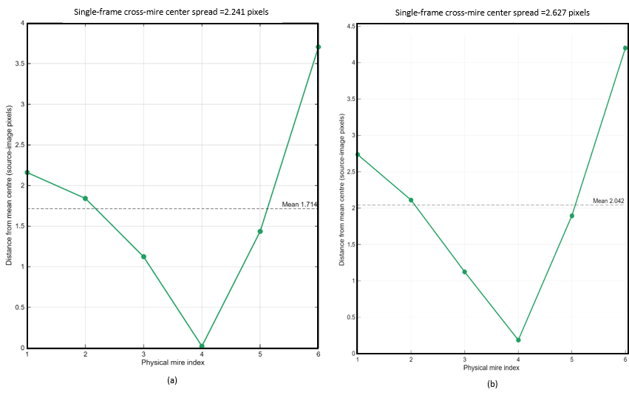
Figure 17: Single-frame cross-mire centre dispersion for mires 1–6 obtained using Method 1 (a) and Method 2 (b)

Step 03 – Compute explicit-ellipse radial irregularity.
Each mire is represented in polar coordinates about the shared working-coordinate origin, which corresponds to the estimated Placido centre. An unweighted least-squares conic ellipse Ax² + Bxy + Cy² + Dx + Ey + F = 0 is fitted using the fit_ellipse implementation (Gal, 2003), which estimates the ellipse semi-axes a and b and orientation φ. The current implementation then evaluates the detected radial samples against the centred ideal-ellipse radius rellipse(θ) = ab/sqrt[b² cos²(θ − φ) + a² sin²(θ − φ)]. It does not recentre the residual calculation on the fitted ellipse centroid.
Radial fit error is RMSE = sqrt{(1/N) Σ[ri − rellipse(θi)]²}. Ellipse irregularity is defined in this study as 100 × RMSE/mean(r). It is a dimensionless image-domain normalised fit residual and should not be interpreted as a validated clinical corneal-irregularity index. Gal (2003) is cited for the ellipse-fitting routine; the percentage normalisation is a project-defined descriptor.
$$\text{RMSE}=\sqrt{\frac{1}{n}\sum_{i=1}^{n}{{\left(R_{i}-r_{\text{ellipse}}\left(θ_{i}\right)\right)}^{2}}}$$
$$Irregularity (\%)=100 x \frac{RMSE}{\overline{R}}$$
For the analysed image, the project-defined mean ellipse-irregularity descriptor was 2.38% for Method 1 and 2.13% for Method 2 (Figure 18). Method 2 showed a higher value for the inner mires and progressively lower values across several outer mires. Both methods therefore exhibited distinct radial residual patterns even though their overall mean values were reasonably close. These percentages describe ellipse-fit residuals in this image and are not clinical indices.

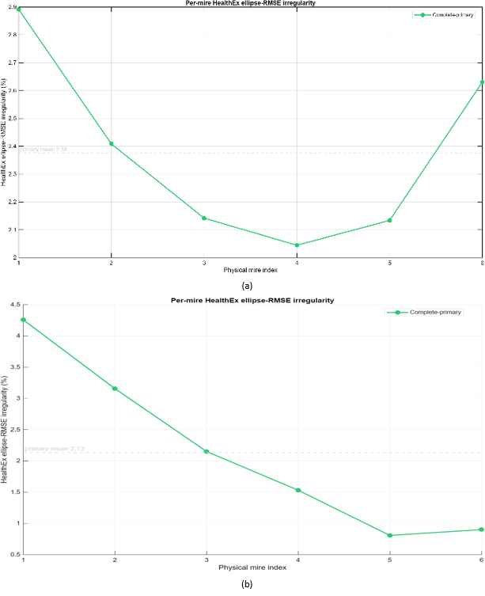

Figure 18: The irregularity for firstRing 1 to lastRing 6 obtained using Method 1 (a) and Method 2 (b)

Step 04 – Determine the image axes.
The principal orientation of each selected mire is obtained by eigendecomposition of its two-dimensional coordinate covariance matrix, following the standard principal-component analysis interpretation (Jolliffe & Cadima, 2016). The eigenvector vmax associated with the largest eigenvalue identifies the direction of greatest spatial spread and is defined here as the flat image axis. Its direction is αflat = atan2(vmax,y, vmax,x) mod 180°. The orthogonal direction is defined as the steep image axis, αsteep = (αflat + 90°) mod 180°.
Because an unoriented ellipse axis is unchanged by 180°, the mean direction across mires is calculated as axial directional data using the doubled-angle mean: mean(α) = 1/2 atan2[Σ sin(2αi), Σ cos(2αi)] mod 180° (Mardia & Jupp, 1999). These are principal image axes and must not be interpreted as calibrated keratometric meridians.
$${\overline{\left(α\right)}}_{flat}=\frac{1}{2}\left(atan2\right)\left(\sum_{j}{\sin\left(2α_{j}\right)},\sum_{j}{\cos\left(2α_{j}\right)}\right)$$

The same covariance principal-axis convention and doubled-angle axial mean were applied to the common complete mires in both methods. For the demonstration image trial_proposal.jpg (test_image_3.jpg), Method 1 produced a mean flat image axis of 3.62° and a steep image axis of 93.62°, while Method 2 produced 2.79° and 92.79°, respectively. This close agreement applies only to that source image and coordinate representation. It does not establish physical mire correspondence or general interchangeability, and orientations from nearly circular mires can be poorly determined.
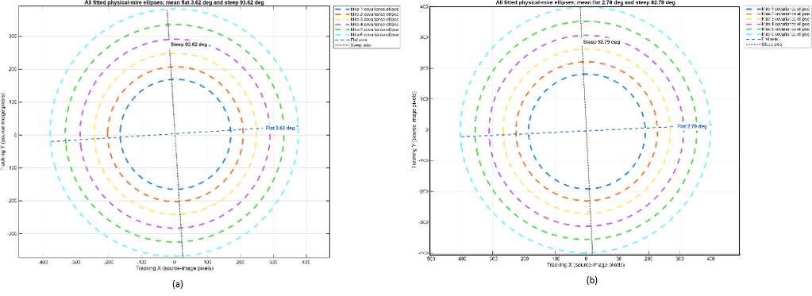
Figure 19: The axes determination for firstRing 1 to lastRing 6 obtained using Method 1 (a) and Method 2 (b)

References added for Phase 2 equations
Gairola, S., Bohra, M., Shaheer, N., Jayaprakash, N., Joshi, P., Balasubramaniam, A., Murali, K., Kwatra, N., & Jain, M. (2021). SmartKC: Smartphone-based Corneal Topographer for Keratoconus Detection. Proceedings of the ACM on Interactive, Mobile, Wearable and Ubiquitous Technologies, 5(4), Article 155, 1–27. https://doi.org/10.1145/3494982
Gal, O. (2003). fit_ellipse (Version 1.0.0.0) [MATLAB code]. MATLAB Central File Exchange. https://www.mathworks.com/matlabcentral/fileexchange/3215-fit_ellipse
Jolliffe, I. T., & Cadima, J. (2016). Principal component analysis: a review and recent developments. Philosophical Transactions of the Royal Society A, 374(2065), 20150202. https://doi.org/10.1098/rsta.2015.0202
Mardia, K. V., & Jupp, P. E. (1999). Directional Statistics. Wiley. https://doi.org/10.1002/9780470316979

