APPROACH NOTE
AI ENGINEERING, ENTERPRISE RAG
& AGENTIC SYSTEMS
A Practical, Tiered AI Engineering Programme for Healthcare Payer Technology Teams
PHASE 1  AI Engineering  Foundations | PHASE 2  Enterprise RAG  & Evaluation | PHASE 3  Agentic Systems  & Capstone

Prepared for | ZS Associates (HPP Team)
Target teams | Business Technology, Data Engineering & Analytics, and AI COE
Core curriculum | 24 hours | Instructor-led | Hands-on |
Delivery choices | Fully virtual (or) distributed in-person, (or) weekly in-person immersion
Prepared by InsightVerge

Draft for discussion

Contents

1. Programme Overview 3
Programme Objectives 3
2. Target Audience and Learning Tier Framework 3
Learning Tier Framework 4
3. Proposed Programme Architecture 4
4. Delivery Options 5
Recommended Delivery Considerations 5
5. Programme Design Principles 5
6. Phase 1: AI Engineering Foundations 6
Phase 1 Takeaways 6
7. Phase 2: Enterprise RAG & Evaluation 7
Phase 2 Takeaways 7
8. Phase 3: Agentic Systems & Healthcare AI Copilot 8
Capstone Components 8
Final Programme Outcomes 8
9. Practical Delivery Methodology 9
10. Expected Business Value for ZS Associates 10
11. Suggested Measures of Success 10
12. Client Inputs and Delivery Dependencies 11
13. Proposed Next Steps 11

1. Programme Overview
ZS Associates is considering a practical capability-building programme for healthcare payer technology teams across Business Technology (BT), Data Engineering & Analytics (DEA), and the AI Centre of Excellence (AI COE). The proposed programme combines a unified curriculum with tiered learning outcomes so that participants with different levels of AI experience can learn together without diluting technical depth.
The programme is structured around three connected phases: AI engineering foundations, enterprise Retrieval-Augmented Generation (RAG), and agentic systems. Healthcare payer scenarios involving claims, policies, benefits, structured data, unstructured documents, evaluation, governance and cost optimisation are used throughout.
Programme Promise
A single learning journey that enables beginners to participate confidently in AI solution discussions, practitioners to build enterprise AI prototypes, and experienced engineers or architects to make production-aware design decisions.

Programme Objectives
- Build a common understanding of LLMs, prompts, embeddings, RAG, tool calling, agents and responsible AI.
- Enable participants to develop healthcare-focused RAG applications, agents and structured-data workflows.
- Strengthen architecture judgement around retrieval, orchestration, evals, observability, scalability and cost.
- Develop an end-to-end Healthcare AI Copilot as the programme capstone.

2. Target Audience and Learning Tier Framework
Participant Group | Typical Roles | Programme Relevance
Business Technology (BT) | Data Engineers, AI Developers, Integration Engineers and Solution Engineers | Hands-on implementation, integration patterns, enterprise workflows and solution engineering.
Data Engineering & Analytics (DEA) | Analytics Consultants, AI Analysts, Business Translators and AI Solution Builders | Use-case translation, structured and unstructured data workflows, evaluation and solution prototyping.
AI COE | AI Champions, Solution Architects and Senior Engineers | Architecture decisions, retrieval optimisation, orchestration, observability, governance, scalability and cost awareness.

Learning Tier Framework
Tier | Primary Focus | Illustrative Capabilities | End Outcome
Tier 1: Foundation | Conceptual understanding | How LLMs work, prompt engineering, RAG concepts, agent concepts and responsible AI. | Can participate confidently in enterprise AI solution discussions.
Tier 2: Practitioner | Applied implementation | Build RAG systems and agents, use tool calling, develop NL-to-SQL workflows and apply evaluation frameworks. | Can independently develop enterprise AI prototypes.
Tier 3: Production-Aware Engineer | Architecture and production awareness | RAG architecture decisions, retrieval and token optimisation, agent orchestration, scalability, evaluation and observability. | Can contribute to the design of enterprise-ready AI solutions.

Separate recommendation for SIP teams: Because SIP participants are expected to focus more on problem framing, operating-model design, governance and workshop facilitation, a separate executive-awareness or solution-framing workshop is recommended rather than the full engineering curriculum.

3. Proposed Programme Architecture
Phase | Core Focus | Representative Build | Primary Outcome
Phase 1 | AI Engineering Foundations | Healthcare Policy Prompt Framework, Benefits Information Assistant and first Healthcare Operations Agent | Participants establish the technical foundations required to integrate LLMs and build a basic tool-enabled agent.
Phase 2 | Enterprise RAG & Evaluation | Healthcare Policy Knowledge Base, Semantic Search Engine and Claims & Benefits Assistant | Participants build grounded RAG applications and evaluate retrieval quality, reliability and governance.
Phase 3 | Agentic Systems & Capstone | Healthcare Support Agent, Claims Intelligence Agent and Healthcare AI Copilot | Participants combine tools, RAG, structured data, orchestration, evaluation and guardrails in an end-to-end solution.

4. Delivery Options
Option | Mode | Cadence | Duration | Contact Hours | Best Suited For
Option 1 | Virtual | 4 sessions per week; 2 hours per session | 3 weeks | 18 facilitated hours + 6 hours guided project work | Geographically distributed teams across locations and time zones requiring shorter, high-frequency sessions.
Option 2 | In-Person | 2 in-person sessions per week; 4 hours per session | 3 weeks | 18 facilitated hours + 6 hours guided project work | Teams that prefer in-person interaction but require a shorter three-week calendar.
Option 3 | In-Person | 1 in-person day per week; 8 hours per day | 3 weeks | 18 facilitated hours + 6 hours guided project work | Teams that prefer deeper weekly immersion with time between workshops for application and reflection.
Option 4 | In-Person | 3 consecutive days in-person;  8 hours per day | 3 days | 18 facilitated hours + 6 hours guided project work | Teams that prefer dedicated accelerated learning within the same week

Recommended Delivery Considerations
- Option 1 provides the greatest reinforcement and is the most suitable for a distributed cohort because the additional virtual sessions can be used for technical clinics and capstone reviews.
- Option 2 and Option 3 are compressed models and therefore depends on participants completing guided work between facilitated sessions.
- Option 4 provides the accelerated delivery of the 24-hour core curriculum and offers the strongest balance between immersion and application time.
- Final sequencing, session timings and cohort arrangements will be mutually agreed based on participant availability, locations and infrastructure readiness.

5. Programme Design Principles
- Unified but tiered: The same curriculum serves foundation, practitioner and production-aware participants, with layered explanations, exercises and architecture discussions.
- Hands-on first: Every phase includes guided builds using healthcare payer scenarios, prepared data, documents and APIs.
- Enterprise relevant: The learning journey goes beyond prompting to integration, retrieval, tool use, orchestration, evaluation, governance and operating considerations.
- Healthcare contextualized: Examples focus on claims, policy and benefits workflows, structured and unstructured information, auditability and healthcare data considerations.
- Cost and reliability aware: Token economics, context reduction, model selection, retrieval quality, latency, monitoring and failure handling are incorporated throughout.
- Outcome oriented: Each phase produces tangible artifacts and culminates in an end-to-end Healthcare AI Copilot.

6. Phase 1: AI Engineering Foundations
Phase 1 establishes the core development, LLM and integration capabilities required for the later RAG and agentic phases.
Module | Focus | Hands-On Application | Learning Output
1. Programme Orientation & Development Environment | Evolution of GenAI, enterprise AI landscape, AI solution lifecycle, healthcare payer opportunities and Azure AI ecosystem. | VS Code and Python setup, environment validation, first LLM interaction and API connectivity. | Set up an AI development environment, connect to an LLM endpoint and run a first AI application.
2. LLM Foundations for AI Engineers | Transformers, attention, tokenisation, context windows, embeddings, reasoning, model limitations and hallucinations. | Model comparison and prompt-effectiveness experiments. | Explain how LLMs generate responses, understand major limitations and compare model suitability.
3. Prompt Engineering & Cost-Aware Design | Prompt patterns, system prompts, structured outputs, few-shot prompting, prompt chaining, token economics, compression and context reduction. | Build a Healthcare Policy Assistant Prompt Framework. | Design stronger prompts, reduce unnecessary token use and generate structured outputs.
4. LLM Integration & Enterprise Workflows | API integration patterns, response validation, structured outputs, error handling, function calling, logging and traceability. | Build a Benefits Information Assistant. | Integrate LLMs into applications, validate outputs and handle failures more gracefully.
5. Building Your First Agent | Agent concepts, lifecycle, tool calling, memory and workflow invocation. | Build a Healthcare Operations Agent that can answer queries, use tools and generate recommendations. | Develop a first working tool-enabled agent.

Phase 1 Takeaways
- Validated development environment and connectivity to approved LLM endpoints.
- Understanding of LLM behaviour, limitations, model selection and enterprise implications.
- Reusable prompt patterns with structured-output and cost-aware design principles.
- A working LLM-integrated application and a first healthcare operations agent.

7. Phase 2: Enterprise RAG & Evaluation
Phase 2 develops the ability to transform enterprise healthcare documents into grounded, searchable and measurable AI knowledge systems.
Module | Focus | Hands-On Application | Learning Output
6. Enterprise RAG Foundations | RAG architecture, retrieval workflows, chunking strategies, metadata design and document preprocessing. | Build a Healthcare Policy Knowledge Base and ingestion pipeline. | Create a document-ingestion foundation for enterprise retrieval.
7. Embeddings & Vector Search | Embeddings, similarity search, vector databases, semantic retrieval, chunk-size trade-offs and metadata filtering. | Build a Healthcare Semantic Search Engine. | Implement vector-search workflows and improve retrieval precision.
8. End-to-End Enterprise RAG | Context assembly, prompt augmentation, citation generation, retrieval failures, context explosion, latency and hybrid retrieval concepts. | Build a Claims & Benefits Assistant with citations. | Develop a complete RAG solution and understand why it may fail at scale.
9. RAG Evaluation, Reliability & Governance | Groundedness, faithfulness, retrieval relevance, hallucination detection, healthcare data considerations, auditability and responsible AI controls. | Create and apply a test set, evaluation scorecard and improvement loop. | Measure RAG quality, benchmark responses and improve retrieval effectiveness.

Phase 2 Takeaways
- Document ingestion, chunking and metadata strategy for healthcare policy and claims content.
- Semantic-search capability using embeddings and vector retrieval.
- A complete enterprise RAG workflow with citations and grounded responses.
- Evaluation practices covering relevance, groundedness, faithfulness, hallucination and governance.

8. Phase 3: Agentic Systems & Healthcare AI Copilot
Phase 3 brings together reasoning, tools, structured data, RAG and governance through agentic workflows and an integrated capstone.
Module | Focus | Hands-On Application | Learning Output
10. Agentic AI & Tool Calling | Agent architectures, planning, tool selection, reasoning workflows, orchestration patterns, routing decisions and latency optimisation. | Build a Healthcare Support Agent. | Develop a tool-enabled reasoning agent and understand single-orchestrator patterns.
11. Structured Data Agents & Multi-Agent Workflows | NL-to-SQL, query planning, data interpretation, and planner, retrieval, analytics and reviewer agent patterns. | Build a Healthcare Claims Intelligence Agent combining structured and unstructured workflows. | Connect natural-language questions to data retrieval, analysis and recommendation workflows.
12. Capstone: Healthcare AI Copilot | Architecture review, production-readiness checklist, RAG, claims search, structured data, tool calling, orchestration, evaluation, guardrails and cost awareness. | Teams build and present an end-to-end Healthcare AI Copilot. | Deliver a working integrated solution and defend its architecture, controls and readiness.

Capstone Components
Knowledge & Models | Data & Tools | Orchestration & Controls | Quality & Readiness
LLM interaction | Claims knowledge search | Tool calling | Evaluation framework
Enterprise RAG | Structured data access | Agent orchestration and guardrails | Cost awareness and production-readiness checklist

Final Programme Outcomes
Competency Level | Participants Will Be Able To | Indicative Evidence
Foundation | Understand GenAI architecture, use prompt engineering and identify enterprise AI opportunities. | Prompt framework, model comparison and first LLM application.
Practitioner | Build RAG applications and agents, implement tool calling, develop NL-to-SQL workflows and evaluate AI systems. | RAG solution, semantic search, healthcare agent and evaluation scorecard.
Production Awareness | Understand scaling challenges, optimise token consumption, improve retrieval quality, design orchestration patterns and apply governance practices. | Architecture decisions, production-readiness review and defended capstone solution.

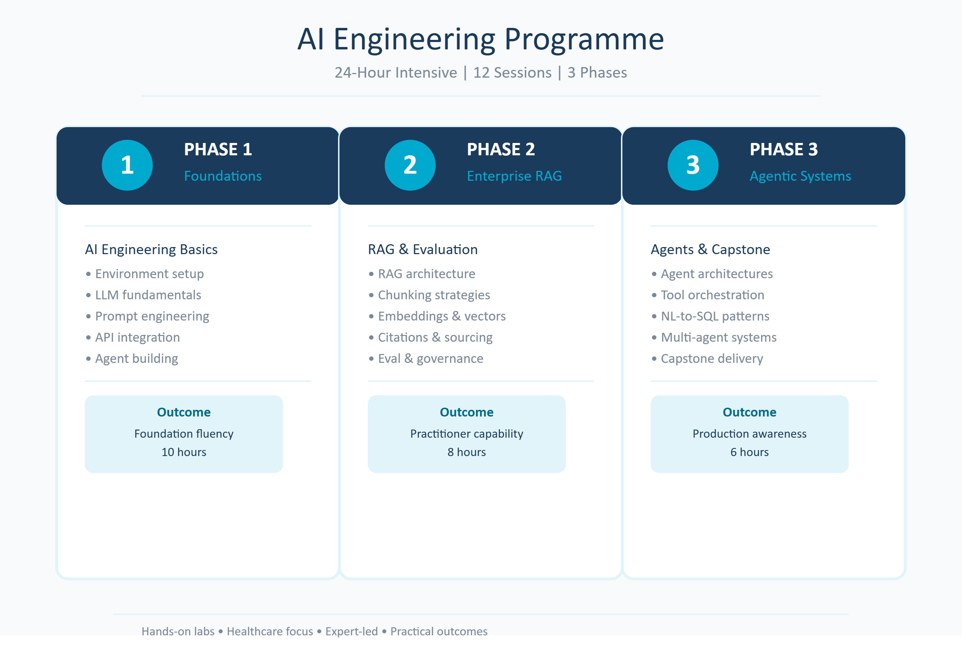

9. Practical Delivery Methodology
Stage | Delivery Method
Orient | Introduce the enterprise context, learning objectives and healthcare payer scenario for the module.
Explain | Build the technical mental model using architecture patterns, demonstrations and production-aware examples.
Demonstrate | Facilitators show the workflow or engineering pattern using prepared code, documents, data and approved tools.
Practise | Participants complete guided exercises and progressively modify the reference implementation.
Evaluate & Improve | Participants test outputs, identify failures, improve retrieval or prompts, add controls and review cost or reliability.
Build & Defend | Teams integrate the learning into a working artifact or capstone and explain the architecture, value, risks and next steps.

10. Expected Business Value for ZS Associates
Value Area | Expected Benefit
Common Engineering Language | A shared understanding of LLMs, RAG, agents, evaluation and production-aware AI engineering across BT, DEA and AI COE.
Prototype Capability | Greater ability to convert healthcare payer use cases into working RAG, agentic and structured-data prototypes.
Architecture Quality | More defensible decisions around retrieval, tools, orchestration, model selection, cost, latency, observability and failure handling.
Healthcare Relevance | Applied learning through policy, benefits, claims and healthcare data scenarios rather than generic demonstrations.
Reliability & Governance | Stronger evaluation, groundedness, auditability, responsible AI and human-accountability practices.
Reusable Capability | Reference patterns, code, artifacts and decision frameworks that can inform future internal AI solution development.

11. Suggested Measures of Success
- Environment readiness and successful completion of the first LLM application.
- Completion and quality of phase-level builds: prompt framework, LLM workflow, agent, RAG application and evaluation scorecard.
- Participant ability to explain key architecture decisions, trade-offs and enterprise risks.
- Improvement in RAG groundedness, retrieval relevance or hallucination rates during evaluation exercises.
- Successful integration and presentation of the Healthcare AI Copilot capstone.
- Participant confidence across foundation, practitioner and production-awareness competencies.

12. Client Inputs and Delivery Dependencies
Input | Requirement
Participants | Confirm cohort size, roles, prior experience, participant locations and any tier-specific needs.
Scheduling | Select the preferred delivery option and confirm session dates, time zones and attendance expectations.
Development Environment | Provide or approve laptops, Python, VS Code, package installation, source repository access and required network connectivity.
AI Services | Provide or approve access to LLM endpoints, embeddings, vector-search services, databases and any required Azure AI components.
Training Artifacts | Approve the use of synthetic or sanitised healthcare policy, claims and benefits documents and structured datasets.
Security & Support | Confirm data-handling rules, tool restrictions, user accounts, technical support contacts and an environment dry run before delivery.

Important delivery assumption: The practical scope depends on timely access to the approved development and AI environment. Where access is restricted or delayed, equivalent demonstrations, prepared outputs or shared environments may be used, and the hands-on scope may need to be adjusted.

13. Proposed Next Steps
- Confirm the preferred delivery option and target delivery window.
- Confirm the participant cohort, role mix, locations and prior AI experience.
- Validate the 24-hour core curriculum and identify any ZS-specific tools, architecture standards or payer use cases to be incorporated.
- Complete the technical-readiness checklist and conduct an environment dry run.
- Finalise the detailed facilitator plan, programme calendar, commercials and engagement documentation.

