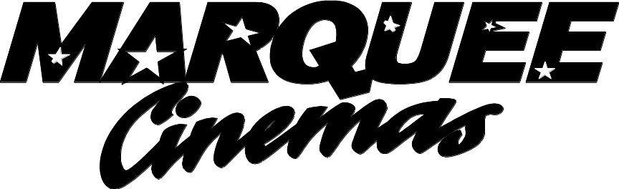

552 Ragland Road Beckley, WV 25801
304-255-4036 Fax 304-252-0526

Charitable Organizations Donation Request

Donations are intended for not-for-profit organizations for the betterment of the program. They are not intended for for-profit businesses and organizations including meetings, holiday parties, employee incentives or customer rewards.

Company Information
Organization:_________________________________________________________________501©(3)____No____

Address:______________________________________________________________________________________

Contact:___________________________________________________Title:_______________________________

Email Address:_________________________________________________________________________________

Phone:__________________________________________Fax:__________________________________________

Donate Request Information

When does the event take place?___________________________________________________________________

For what cause will the donation be used?___________________________________________________________

Who will benefit from the donation?________________________________________________________________

********Please Note: Application must be completed in full; if any information is omitted, your application cannot be processed. Allow a minimum of two weeks to receive a response. One donation per calendar year per organization

__________________________________________________________
Office Use Only

Date donation received:__________________________Date Completed:__________________________________

Serial Number:_________________________________________________________________________________

