

**Department of CSE**

Project Title

**Air Quality Measurement Device**

Submitted by: Team 5C

Akther uz zaman ( C183059 )

Mohammad Toufiqul Alam ( C191096 )

Nurul Karim Symon ( C183050 )

Submitted to:

**Md. Ashraful Alam**

***Abstract*—** The air quality sensor developed by our group senses various gasses but mainly carbon dioxide (CO2) in the environment in PPM (parts per million). The main aim of this project is to develop a device which can monitor PPM in air in real time.

The air monitoring device developed in this project is based on Arduino Uno. The sensor used for monitoring the air pollution is MQ-135 gas sensor. The Arduino board connects with the sensor using analog pins. The sensor data is also displayed on the serial monitor of Arduino software.

***INTRODUCTION—***The temperature of the earth has increased significantly over the past few decades. Scientists around the world have predicted that the average temperature of the Earth’s atmosphere will increase by 2° to 6° Celsius by the end of the 21st century unless appropriate measures are not taken. The Industrial Revolution has played the principal role in triggering this rise, followed by other human activities like burning of fossil fuels, deforestation, etc. Release of greenhouse gases like carbon dioxide, methane, nitrous oxide and fluorinated gases trap the heat in the atmosphere, leading to global warming. Gas Sensing and Monitoring refers to the process of continuously tracking the changes in concentration of different air component.

Growing urbanization and no. of Industrial towns make it a requirement to have a close concern of the environment. Hard to keep monitoring continuously certain sites such as industries, busy traffic signals, villages prone to soil erosion & high ammonia concentration etc.

Air quality monitoring is the process of assessment of pollutants present in atmosphere by their quantity and types as per air quality standards. Air quality monitoring helps us to take action based on pollutants present in atmosphere to improve air quality

***COMPONENT LIST—***

* *Arduino Uno*
* *MQ135 gas sensor*
* *Breadboard*
* *Jumper wires*
* *Potentiometer 10k*
* *Resistors 220 ohm*
* *16X2 Character LCD*

***COMPONENT DESCRIPTION—***

***Arduino Uno:***

The Arduino Uno is a microcontroller board based on the ATmega328. It has 20 digital input/output pins (of which 6 can be used as PWM outputs and 6 can be used as analog inputs), a 16 MHz resonator, a USB connection, a power jack, an in-circuit system programming (ICSP) header, and a reset button. It contains everything needed to support the microcontroller; simply connect it to a computer with a USB cable or power it with a AC-to-DC adapter or battery to get started.

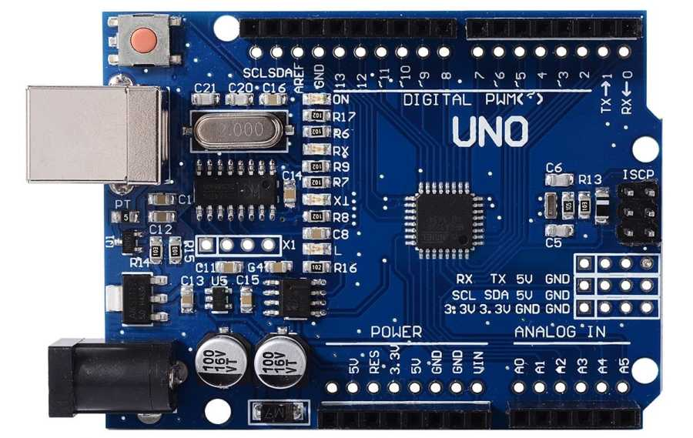

**MQ-135 Gas sensor:**

The **MQ-135 Gas sensor** can detect gases like Ammonia (**NH3**), sulfur (**S**), Benzene (**C6H6**), **CO2**, and other harmful gases and smoke. Similar to other MQ series gas sensor, this sensor also has a digital and analog output pin. When the levels of these gases go beyond a threshold limit in the air the digital pin goes high. This threshold value can be set by using the on-board potentiometer. The analog output pin, outputs an analog voltage which can be used to approximate the level of these gases in the atmosphere. The MQ135 air quality sensor module operates at 5V and consumes around 150mA. It requires some pre-heating before it could actually give accurate results.

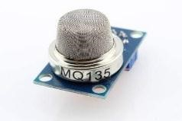

**Breadboard:**

A thin plastic board used to hold electronic components (transistors, resistors, chips, etc.) that are wired together. Used to develop prototypes of electronic circuits, breadboards can be reused for future jobs. They can be used to create one-of-a-kind systems but rarely become commercial products. The breadboard contains spring clip contacts typically arranged in matrices with certain blocks of clips already wired together. The components and jump wires (assorted wire lengths with pins at both ends) are plugged into the clips to create the circuit patterns. The boards also typically include metal strips along the side that are used for common power rails and signal buses.

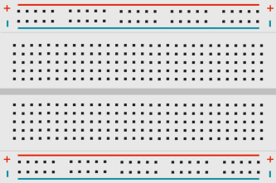

**Jumper wires :**

Jumper wires are simply wires that have connector pins at each end, allowing them to be used to connect two points to each other without soldering. Jumper wires are typically used with breadboards and other prototyping tools in order to make it easy to change a circuit as needed.

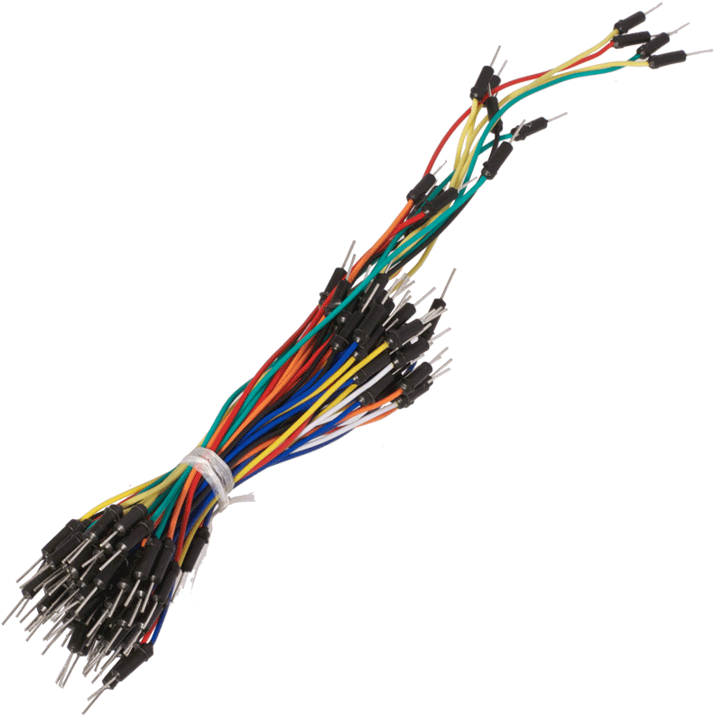

**Potentiometer 10k:**

Potentiometers are very useful in changing the electrical parameters of a system. It is a single turn 10k Potentiometer with a rotating knob. These potentiometers are also commonly called as a rotary potentiometer or just POT in short. These three-terminal devices can be used to vary the resistance between 0 to 10k ohms by simply rotating the knob. A potentiometer knob can also be used along with this POT for aesthetic purposes.

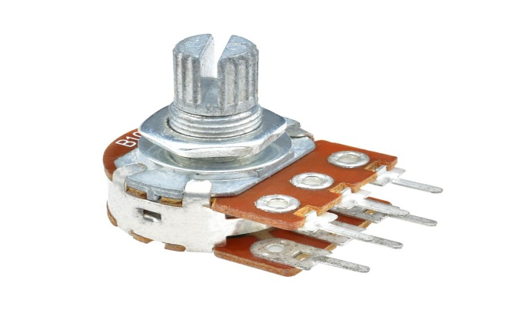

**Resistors 220 ohm:**

A resistor is a passive two-terminal electrical component that implements electrical resistance as a circuit element. Resistors act to reduce current flow, and, at the same time, act to lower voltage levels within circuits. In electronic circuits, resistors are used to limit current flow, to adjust signal levels, bias active elements, and terminate transmission lines among other uses.

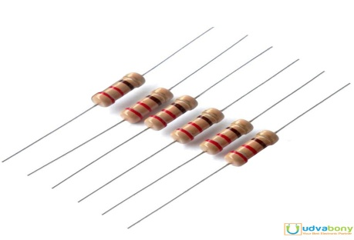

**16X2 Character LCD :**

The 16X2 LCD display is used to monitor the sensor values read by the Arduino board from MQ-135. It is interfaced with the Arduino Uno by connecting its data pins D4 to D7 with pins 5 down to 2 of the controller respectively. The RS and E pins of the LCD are connected to pins 12 and 11 of the controller respectively. The RW pin of the LCD module is connected to the ground.



***Component prices*—**

Arduino UNO- 700 tk

Breadboard- 120 tk

MQ135 sensor- 300 tk

16*2 LCD Display- 250 tk

Header male- 20 tk

1k pot- 30 tk

10k pot- 30 tk

220 ohm resistor- 10 tk

Jump wire- 50 tk

=1510 tk

***Software we used—***

**Arduino IDE**

To Program Arduino Uno we need IDE. Arduino IDE contains a text editor for writing code, a message area, a text console, a toolbar with buttons for common functions and a series of menus. It connects to the Arduino hardware to upload programs and communicate with them.

*Code—*

#include <LiquidCrystal.h>

LiquidCrystal lcd(12, 11, 5, 4, 3, 2);

int Gas = A0;

int th=250;

void setup()

{

pinMode(A0 , INPUT);

lcd.begin(16, 2);

}

void loop()

{

int ppm=analogRead(A0);

lcd.print("Gas: ");

lcd.print(ppm);

lcd.print(" ppm");

if (ppm > th)

{

lcd.setCursor(0,1);

lcd.print("Bad Air Quality");

}

else

{

lcd.setCursor(0,1);

lcd.print ("Good Air Quality");

}

delay (400);

lcd.clear();

}

***Circuit Diagram—***

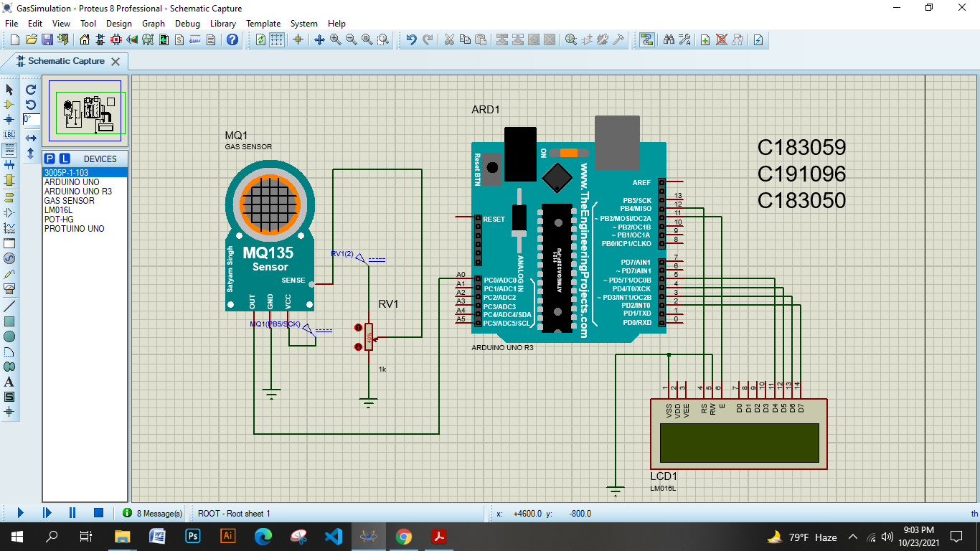

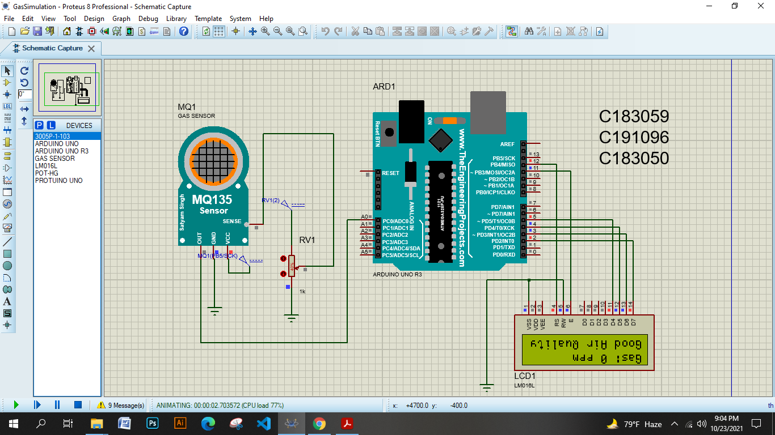

***Working Principle—***

* As the device is powered, the Arduino board loads the required libraries.
* The analogue voltage sensed at the pin A0 of the Arduino is converted to a digital value by using the in-built ADC channel of the Arduino.
* The Arduino board has 10-bit ADC channels, so the digitized value ranges from 0 to 1023. The digitized value can be assumed proportional to the concentration of gases in PPM.
* The VCC and Ground terminals of the MQ-135 sensor are connected to the common VCC and Ground. The Analogue Output pin of the sensor is connected to the A0 pin of the Arduino.
* The code is uploaded on the board using the USB drive and then run. The output is observed on the LCD directly in PPM unit.

***How we worked—***

The 16X2 LCD display is used to monitor the sensor values read by the Arduino board from MQ-135. It is interfaced with the Arduino Uno by connecting its data pins D4 to D7 with pins 5 down to 2 of the controller respectively. The RS and E pins of the LCD are connected to pins 12 and 11 of the controller respectively. The RW pin of the LCD module is connected to the ground. VDD pin is connected to 5v voltage source and V0 is connected to the middle pin of potentiometer. A pin is connected to the 5v through 220 ohm resistor and K to ground.

The other two pins of potentiometer connected to the common 5v source slot of breadboard and common ground. The potentiometer will control the contrast of the LCD.

The MQ-135 sensor’s Vcc pin connects to the common 5v source slot, GND pin connects to the common ground slot and A0 pin connects to the analog A0 pin of the Arduino.

Lastly, after coding in LAPTOP at Arduino IDE, we uploaded the code to the Arduino plugging it by a D type cable. It took 30-60 minutes to warm up the MQ-135 sensor and get the correct Gas measurement in PPM. We used different types of environment and experiments on ourselves to see the results of our device and It was successfully detecting CO2, Alcohol, Smoke, Naphthalene.