

*Department of Computer Science and Engineering*

**Lab report**

Name : Akther uz zaman

ID : **C183059**

Email : [c183059@ugrad.iiuc.ac.bd](mailto:c183059@ugrad.iiuc.ac.bd)

Semester : Spring-2021

Section : 6BM

Course Code : CSE-3532

Course Title : Tools and Technologies for Internet Programming

Course Teacher : Md. Mahmudur Rahman

Assistant Professor, CSE Department, IIUC

Submit Date : 29-12-2021

Student signature Teacher Signature



**OPU online**

A website for a online teaching coaching center

**Chapter-1**

Introduction

Now a days online teaching system is common in the current world. With the help of internet students can from remote places. Student’s who lives in villages can also lean from expert teachers with the help of online. In offline classes there are many disadvantages. Students lives in villages cannot attend offline classes in coaching. Female students cannot also attend classes timely. Again going to a place to learn is time killing process also. Also there is a cost for travel to coaching from home. Here my project will help them to learn from staying in home, to save their time, to save their money. There are also many benefits of online learning such as,

1. Flexibility Wider Range of Courses and Programs.
2. Immediately Applicable Coursework.
3. Affordability.
4. Time Management Skill Development.
5. Virtual Collaboration Opportunities.
6. Ability to Gain Technical Skills.

In this project I created a website for online learning. A online teaching platform where students can view courses, their costs and their online exam result. Students or their guardians can also post some comments, suggestions or ask questions.

* 1. **Objectives:**
* It is user friendly, no complexities. Just view online courses and their course fees.
* Admin can see visitors query and respond to them.
* Guardians can see their child’s exam results
* Visitors can learn more about coaching details.
  1. **Scope:**
* A new introduction of online teaching in our country.
* Will be recognized by guardians.
* Students can learn from home in this covid situation.
* As it is a new system, sponsors will also get involved in it and the coaching will get extra revenue.
  1. **Problems:**
* No online payment system.
* No offline services.
* No offline result card will be provided.

**Chapter-2**

Background

**2.1 Proposed System**

The system I proposed is an Online Website to increase popularity of a coaching center called “OPU Online”. Where students and guardians can get details about their courses and course fees and ask some questions and get response quickly.

**2.2 Why our system is better?**

* Students and visitors can get details about course fee, duration.
* Visitors can select courses sat affordable prices.
* Visitors can ask questions in our site.
* Students and their parents can see results.
* There will be a record of each Query.
* Students can directly contact with authorities.

**Chapter-3**

Methodology

**3.1 SDLC**

**Requirement**

**Analysis**

**Waterfall model**

**System**

**Design**

**Implementation**

**Testing**

**Deployment**

**Maintenance**

**3.2 Requirement Collection and Analysis:**

In XP, Requirement collection is done by gathering User stories.

**3.3 Feasibility Study:**

Feasibility is defined as the practical extent to which a project can be performed successfully. To evaluate feasibility, a feasibility study is performed, which determines whether the solution considered to accomplish the requirements is practical and workable in the software. Information such as resource availability, cost estimation for software development, benefits of the software to the organization after it is developed and cost to be incurred on its maintenance are considered during the feasibility study. There are some feasibility analysis categories. They are,

* Technical Feasibility
* Economic Feasibility
* Operational Feasibility
* Legal Feasibility
* Schedule Feasibility
* Risk Feasibility
* Social Feasibility
* Resource Feasibility, etc.

**Technical Feasibility:** The project that we’re developing can easily be done using any decent computer. After doing thorough research we decided to use visual studio as our main developing tool where we are using HTML language for building the application, CSS, Js for User Interface, PHPmysql for storing and accessing data. Technical skills that require is programming, designing interface, generating good and effective concepts. Existing technology is more than capable in building the app. Maintenance is quite easy cause we (**admins**) can easily access the codes whenever necessary, if users face any problem, we can also update it.

* User Interface:
  + Software: visual studio.
  + Front-End: HTML, CSS, Js.
  + Back-End: php, mysql.
* Hardware Requirements:
  + Any decent computer can handle the creation task. The decent means, the monitor should be at least 1920x1080 resolution, 8 Gigabytes of RAM, Faster variants of HDDs and CPU at least Intel Core i5 3rd Gen.
  + Internet connection is a must because of vast resource collection and background download process.
  + Keyboard with numpad is also provide efficiency to the work. If unavailable to a portable device, external should be used.
* Skill Required by Developers:
  + Programming.
  + Interface design.
  + Creative and useful concept generating.
  + Hardworking ability.
  + Database handling.
  + Availability during necessary meeting.
* Device Requirements (for users):
  + Any online device.
  + Internet connection is required to access all the features.

**Operational Feasibility:** PIECES: First thing that can be found when analyzing operational feasibility is to use framework to categorize problems and assist in requirements gathering, called PIECES. That means:

* + Performance: The system or the operations of our application offer adequate flow and response time. The application also has fast input design and real-time database connection makes it easy to insert and display information quite faster.
  + Information: Information gathering and organization is also easy for us to maintain and users can easily find various kinds of information in the application performing their desired operation.
  + Economy: The operation that is currently available does offer cost/efficiency to the developer team and cost can be saved, profit can be increased with additional ads running.
  + Control: The security level of the information managing can be hardened by changing rules of the firebase database to custom and thus other potential fraud or breach can also be erased.
  + Efficiency: Time wasting activities can be analyzed and all the activities are used and will be performed are useful to the users.
  + Services: The system we’ll build can be accurately made to 95% and we are sure about giving reliable and necessary services to the users.

**Resource Feasibility:** To complete the project all the necessary steps to collecting resources (human resource, artificial resource and financial resource) has been taken and moderated weekly by developer to monitor the resource amount.

**Social Feasibility:** The site doesn’t provide the feature that interaction between the users.

**Chapter-4**

Software Design and Implementation

**4.1 ERD (Entity Relationship Diagram):**

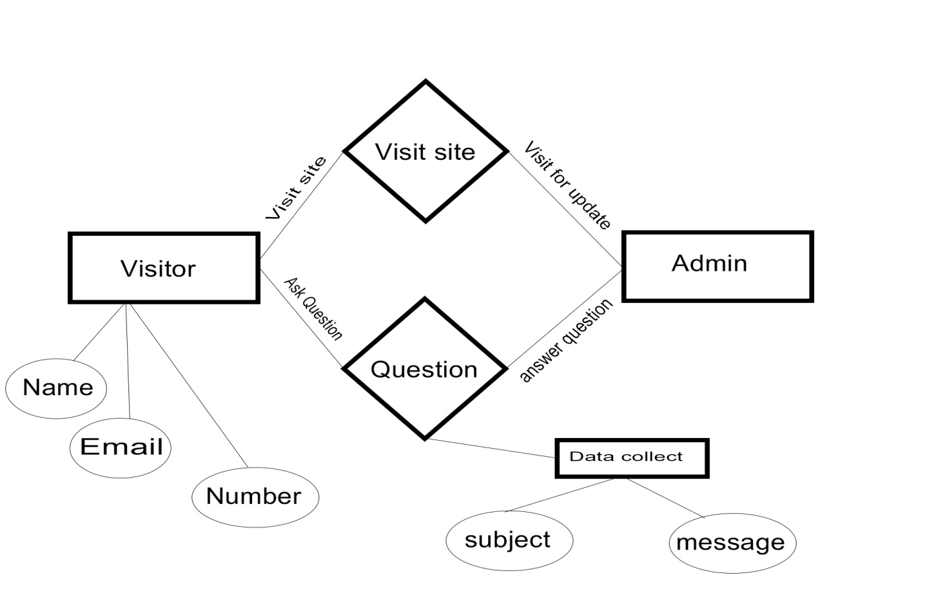

**4.2 DFD (Data Flow Diagram):**

Query Login

**Visitors** Get info **OPU online** Response **Admin**

**Websitesite**

Visitor info

**4.3 Technologies used:**

* Personal Computer (Intel core-i5 7400 3.00 GHz, 8GB RAM)

**4.4 Tools used:**

* visual studio
* Xampp
* Mysql

4.5 Interface Design:

* HTML
* CSS
* Javascript

**Chapter-5**

Conclusion

This is mainly a project for a coaching center where visitors can ask questions, view course details and choose courses at their affordable prices. This project will help students from far to learn from internet. In near future there will be class videos and notes. Students will be able to learn from home in this pandemic situation and be safe.

**5.1 The main motive of this project:**

* To spread throughout students in our country.
* To be recognized by every Guardians and students.
* To spread education by Internet.
* To save Students from COVID by providing education through internet

**5.2 Future plan:**

* Online payment system will be added.
* Many short lectures will be uploaded soon.
* Class notes also be added.
* Their will be a login system to get that lectures and notes.