SOFTWARE ENGINEERING LAB
List of Experiments

Prerequisites
- A course on “Programming for Problem Solving”

Co-requisite
  - A Course on “Software Engineering”

Do the following 8 exercises for any two projects given in the list to sample projects or any other projects:
- Development of problem statement.

- Preparation of Software Requirement Specification Document ,Design Documents and Testing Phase related documents.
- Preparation of Software Configuration Management and Risk Management related documents.
- Study and us age of any Design phase CASE tool.

- Performing the Design by using any Design phase CASE tools.

- Develop test cases for unit testing and integration testing.
- Develop test cases for various white box and black box testing Techniques.
Sample Projects:
- Passport automation System

- Book Bank
- Online Exam Registration
- Stock Maintenance System
- Online course reservation system

- E-ticketing

- Software Personnel Management System

- Credit Card Processing
- E-book management System.
- Recruitment system

TEXT BOOKS:

- Software Engineering, A practitioner’s Approach-RogerS.Pressman,6thedition, Mc GrawHill International Edition.
- SoftwareEngineering-Sommerville,7thedition, Pearson Education.
- The unified modeling language user guide Grady Booch, James Rambaugh, IvarJacobson,Pearson Education.
INDEX

TASK1: Passport Automation System

AIM: To create an automated system to perform the Passport Process

PROCEDURE: (I) PROBLEM STATEMENT
Passport Automation System is used in the effective dispatch of passport to all of the applicants. This system adopts a comprehensive approach to minimize the manual work and schedule resources, time in a cogent manner. The core of the system is to get the online registration form (with details such as name, address etc.,) filled by the applicant whose testament is verified for its genuineness by the Passport Automation System with respect to the already existing information in the database. This forms the first and foremost step in the processing of passport application. After the first round of verificationdone by the system, the information is in turn forwarded to the regional administrator's (Ministry of External Affairs) office. The applicationis then processed manually based on the report given by the system, and any forfeiting identified can make the applicant liable to penalty as per the law. The system also provides the applicant the list of available dates for appointment to 'document verification' in the administrator's office, from which they can select one. The system forwards the necessary details to the police for its separate verification whose report is then presented to the administrator. The administrator will be provided with an option to display the current status of application to the applicant, which they can view in their online interface. After all the necessary criteria have been met, the original information (data) is added to the database.

(II) SOFTWAREREQUIREMENTSPECIFICATION:

INTRODUCTION

Passport Automation System is an interface between the Applicant and the Authority responsible for the Issue of Passport. It aims at improving the efficiency in the Issue of Passport and reduces the complexities involved in it to the maximum possible extent.

PURPOSE
If the entire process of 'Issue of Passport' is done in a manual manner then it would takes several months for the passport to reach the applicant. Considering the fact that the number of applicants for passport is increasing every year, an Automated System becomes essential to meet the demand. So this system uses several programming and database techniques to elucidate the work involved in this process. Asthis is a matter of National Security, the system has been carefully verified and validated in order to satisfy it.

SCOPE
- The System provides an online interface to the user where they can fil in their personal details and submits then necessary documents (may be by scanning).
- The authority concerned with the issue of passport can use this system to reduce his workload and process the application in a speedy manner.
- Provide a communication platform between the applicant and the administrator.
- Transfer of data between the Passport Issuing Authority and the Local Police for verification of applicant's information.
- Users/Applicants will come to know their status of application and the date in which they must subject themselves form annual document verification.

DEFINITIONS,ACRONYMS AND THE ABBREVIATIONS

Administrator
Refers to the super user who is the Central Authority with the privilege to manage the entire system. It can be any higher official in the Regional Passport Office of Ministry of External Affairs.

Applicant
One who wishes to obtain the Passport.

PAS
Refers to this Passport Automation System.

HTML
Markup Language used for creating web pages.

J2EE
Java 2 Enterprise Edition is a programming platform java platform for developing and running distributed java applications.

HTTP
Hyper Text Transfer Protocol.

TCP/IP
Transmission Control Protocol/Internet Protocol is the communication protocol used to connect hosts on the Internet.

TECHNOLOGIES TO BE USED
    - HTML
    - JSP
    - JavaScript
    - Java

TOOLS TO BE USED
    - Eclipse IDÉ(Integrated Development Environment)
    - Rational Rose tool(for developing UML Patterns)

OVERVIEW

SRS includes two sections overall description and specific requirements Overall Description will describe major role of the system components and inter-connections.
Specific Requirements will describe roles &functions of the actors.

OVERALL DESCRIPTION

PRODUCT PERSPECTIVE

The PAS acts as an interface between the 'applicant' and the 'administrator'. This system tries to make the interface as simple as possible and at the same time not risking the security of data stored in. This minimizes the time duration in which the user receives the passport.

SOFTWARE INTERFACE

    - Front End Client –The applicant and Administrator online Interface is built using JSP and HTML. The Administrator’s local interface is built using Java.
    - Web Server – Apache Tomcat application server (Oracle Corporation).
    - Back End –Oracle11gdatabase.

HARDWARE INTERFACE

The server is directly connected to the client systems. The client systems have access to the database in the server.

SYSTEM FUNCTIONS
- Secure Registration of information by the Applicants.
- Schedule the applicants an appointment for manual verification of original documents.
- Panel for Passport Application Status Display by the Administrator.
- SMS and Mail updates to the applicants by the administrator.
- Administrator can generate reports from the information and is the only authorized personnel to add the eligible application information to the database.

USER CHARACTERISTICS

- Applicant
These are the person who desires to obtain the passport andsubmit the information to the database.

Administrator
He has the certain privileges to add the passport status and to approve the issue of passport. He may contain a group of persons under him to verify the documents and give suggestion whether or not to approve the dispatch of passport.

Police
He is the person who upon receiving intimation from the PAS, perform a personal verification of the applicant and see if he has any criminal case against him before or at present. He has been vetoed with the power to decline an application by suggesting it to the Administrator if he finds any discrepancy with the applicant. He communicates via this PAS.

CONSTRAINTS
- The applicants require a computer to submit their information.
- Although the security is given high importance, there is always a chance of intrusion in the web world which requires constant monitoring.
- The user has to be careful while submitting the information. Much care is required.

ASSUMPTIONS AND DEPENDENCIES
- The Applicant sand Administrator must have basic knowledge of computers and English Language.
- The applicants may be required to scan the documents and send.

(III) USE CASE DIAGRAM:
The Passport Automation system use cases are:
- Login
- Registration
- Verification
- Check status
- Enquiry
- Dispatch Passport

ACTORS INVOLVED:
- Applicant
- Passport Officer
- Police

USE-CASENAME: LOGIN
The applicant log into the system to obtain a passport

USE-CASENAME: REGISTRATION
The Applicant enters his name and details for applying a Passport. The applicant initially give his/ her details for registration.

USE-CASENAME: VERIFICATION
The system verifies the applicant mandatory information given by him/her.

USE-CASENAME: CHECKS TATUS
The Applicant tries to check the status in which category applied. The system displays the message to the applicant.

USE-CASENAME: ENQUIRY
The police receive intimation from the PAS, perform a personal verification of the applicant and see if he has any criminal case against him before or at present. He has been vetoed with the power to decline an application by suggesting it to the Administrator if he finds any discrepancy with the applicant. He communicates via this PAS.

USE-CASENAME: DISPATCHPASSPORT
The administrator check or process the application which are submitted by applicant .Process the application means the data which are given by the applicant is processed to create a passport for the applicant and finally dispatches the passport to the applicant

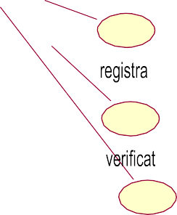



dispatchpassport
logi
applic
passport
check
enqu
poli

Fig.1.USECASEDIAGRAMFORPASSPORTAUTOMATIONSYSTEM

ACTIVITY DIAGRAM:
The activity diagram represents the series of activities that are occurring between the objects. Following is activity diagram which represents the Software personnel management system process.

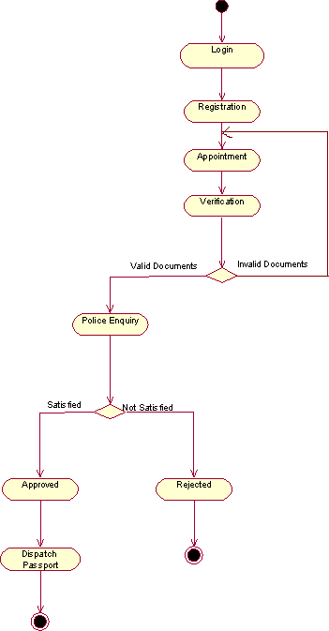

Fig.2.ACTIVITY DIAGRAM FOR PASSPORT AUTOMATION SYSTEM

CLASS DIAGRAM:
The class diagram is referred as object modeling in the static analysis diagram. The main task of object modeling is to graphically show what each object will do in the problem domain. The problem domain describes the structure and the relationships among objects.

The Passport Automation system class diagram consists of five classes
- Login class
- Appointment class
- Registration class
- Authority class
- Verification class

LOGIN CLASS:
It consists of two attributes and two operations. The attributes are user name, and password. The operations of this class are creating login ( ),sign in ( ).

APPOINMENT CLASS:
The attributes of this class are appointment id,applicant id,date, time, and description. The operation of this class are get appointment ( ), get appointment status (
), Modify (), cancel ().

REGISTRATION CLASS:
The attributes are applicant id, name, dob, gender, birthplace, fathername,addr1,addr2,district,state,country,pincode,mobile,emailid,qualification.The operation areadd( ), modify( ),view().

AUTHORITY CLASS:
The attributes of this class are officered, name, designation, and password. The operations are search ( ).

VERIFICATION CLASS:
The attributes of this class are verification id, appointment id,applicant id, officer id, status id, description. The operation are verify().
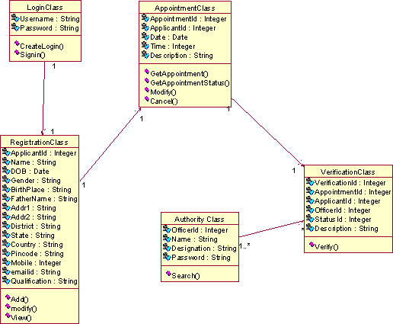

Fig.3.CLASS DIAGRAM FOR PASSPORT AUTOMATION SYSTEM

INTERACTION DIAGRAM:
  - A sequence diagram represents the sequence and interactions of a given USE-CASE or scenario. Sequence diagrams can capture most of the information about the system.
  - Most object to object interactions and operations are considered events and event s include signals , inputs, decisions, interrupts, transitions and actions to or from users or external devices.
  - An event also is considered to be any action by an object that sends information.
  - The event line represents a message sent from one object to another, in which the “form” object is requesting an operation be performed by the “to” object. The “to” object performs the operation using a method that the class contains.
  - It is also represented by the order in which things occur and how the objects in the system send message to one another.
  - The sequence diagram for each USE-CASE that exists when a user administrator, check status and new registration about passport automation system are given.

:applicant Database
Database
UI
AppointmentClass
RegistrationClass
LoginClass
UI
AppointmentClass
RegistrationClass
LoginClass

CreateLogin

EnterUsername/Pwd

Checkusername/Pwd

saveusername/pwd

Signin

getuse rname/pwd

Checkusername/Pwd

showRegistrationForm En erapplicantinformati on

checka
plicantinformation

saveapplica ntinformation

getdateandtime

savedateandtime



show applicantID,Date& time

Fig.4.SEQUENCE DIAGRAM FOR LOGIN AND VERIFICATION

Page15

12:Checkusername/Pwd 5:Checkusername/Pwd

1:CreateLogin 3:EnterUsername/Pwd
9:Signin 4:
UI |  | LoginCla ss
10:getusername/pwd  6:sarvn  7:  11: |  |  | eaumsee/
 |  | Databas e


14:Enterapplicantinformation

:applicant
2:
8:
13:showRegistrationForm
24:showsapplicantID,Date&time 23:

pwd

15:
16:checkapplicantinformation


17:saveapplicantinformation

19: getdateandtime
Registratio nClass

18:

20:savedateandtime

21:

22:
Appointme ntClass

Fig.5. COLLABORATION DIAGRAM FOR LOGIN AND VERIFICATION

  - The diagrams show the process done by the Passport Authority to the Passport Automation system. The applicant this to enter his details.
  - The details entered are verified by the Passport Authority and theapplicantisapprovedifthedetailsmatchthenthepassportisdispatc h, otherwise an appropriate error message is displayed.

STATE CHART DIAGRAM:

  - Every object undergoes through some state and on receivingsome event the state gets changed. This transition of the state can be represented by the state transition diagram.

Page16

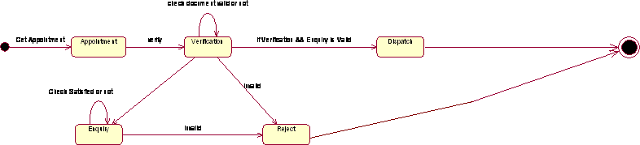

Fig.6.STATE CHART DIAGRAM FOR PASSPORT AUTOMATION SYSTEM

DEPLOYMENT DIAGRAM AND COMPONENT DIAGRAM

Deployment diagrams are used to visualize the topology of the physical components of a system where the software components are deployed.

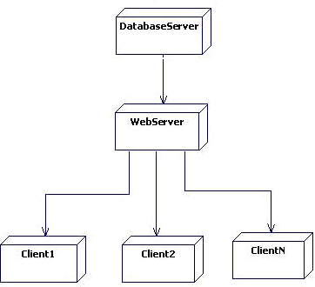

Fig.7.DEPLOYMENT DIAGRAM FOR PASSPORT AUTOMATION SYSTEM

COMPONENT DIAGRAM
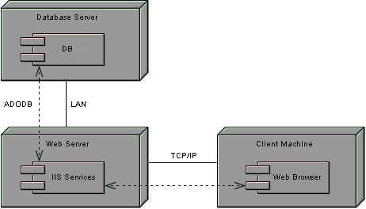
Component diagrams are used to visualize the organization and relationships among components in a system.
Fig.8.COMPONENT DIAGRAM FOR PASSPORT AUTOMATION SYSTEM

TASK2: BOOK BANK SYSTEM
AIM: To create a system to perform book bank operation

PROCEDURE :( I) PROBLEM STATEMENT:
A Book Bank lends books and magazines to member, who is registered in the system. Also it handles the purchase of new titles for the Book Bank. Popular titles are brought into multiple copies. Old books and magazines are removed when they are out or date or poor in condition. A member can reserve a book or magazine that is not currently available in the book bank, so that when it is returned or purchased by the book bank, that person is notified. The book bank can easily create, replace and delete information about the tiles, members, loans and reservations from the system.

(II) SOFTWARE REQUIREMENTS SPECIFICATION:

INTRODUCTION
Book Bank is the interface between the students and Librarian. It aims at improving the efficiency in the Issue of books or magazines and reduces the complexities involved in it to the maximum possible extent.

PURPOSE
If the entire process of 'Issue of Books or Magazines' is done in a manual manner then it would take several months for the books or magazines to reach the applicant. Considering the fact that the number of students for Book Bank is increasing every year, an Automated System becomes essential to meet the demand. So this system usesseveral programming and database techniques to elucidate the work involved in this process. The system has been carefully verified and validated in order to satisfy it.

SCOPE
The System provides an online interface to the user where they can fill in their personal details and submit the necessary documents (may be by scanning). The authority concerned with the issue of books can use this system to reduce his workload and process the application in a speedy manner.

DEFINITIONS, ACRONYMS AND THE ABBREVIATIONS

- Librarian –Refers to the super user who is the Central Authority who has been vested with the privilege to manage the entire system.
- Student-One who wishes to obtain the Books or Magazines.

- HTML –Markup Language used for creating web pages.

- J2EE-Java2EnterpriseEdition is a programming platform and it is the part of the java platform for developing and running distributed java applications.

- HTTP-Hyper Text Transfer Protocol

- TCP/IP - Transmission Control Protocol/Internet Protocol is the communication protocol used to connect hosts on the Internet.

TECHNOLOGIES TO BE USED
Visual Basic Oracle11g

TOOLS TO BE USED
Visual Basic Tools
Rational Rose tool (for developing UML Patterns)

OVERVIEW

SRS includes two sections overall description and specific requirements.

Overall description will describe major role of the system components and inter-connections.

Specific requirements will describe roles &functions of the actors.

OVERALL DESCRIPTION:

It will describe major role of the system components and inter-connections.

PRODUCT PERSPECTIVE

The SRS acts as an interface between the 'Students' and the' Librarian'. This system tries to make the interface as simple as possible and at the same time not risking the security

of data stored in. This minimizes the time duration in which the user receives the books or magazines.

SOFTWARE INTERFACE
Front End Client - The Student and Librarian online interface is built using Visual studio.
BackEnd-Oracle11gdatabase

HARDWARE INTERFACE
The server is directly connected to the client systems. The client systems have access to the database in the server.

SYSTEM FUNCTIONS
- Secure Registration of information by the Students.

- Librarian can generate reports from the information and is the only authorized personnel to add the eligible application information to the database.

USER CHARACTERISTICS
- Student - They are the people who desire to obtain the books and submit the information to the database.
- Librarian –He has the certain privileges to add the books and to approval of the reservation of books.

CONSTRAINTS
- The Students require a computer to submit their information.
- Although the security is given high importance, there is always a chance of intrusion in the web world which requires constant monitoring.
- The Students has to be careful while submitting the information. Much care is required.

ASSUMPTIONS AND DEPENDENCIES
- The Student and Librarian must have basic knowledge of computers and English Language.
- The Students may be required to scan the documents and send.

(III) USE-CASE DIAGRAM: The book bank use cases are:
- book_issue

- book_ return
- book_ order
- book_ entry
- search book_ details

ACTORS INVOLVED:
  - Student
  - Librarian
  - Vendor

USECASE NAME: SEARCH BOOK_DETAILS
The librarian initiates this use case when any member returns or request the book and checking if the book is available.
Precondition: The librarian should enter all Book details.
Normal Flow: Build message for librarian who search the book.

Post Condition: Send message to respective member who reserved the book.

USECASE NAME: BOOK_ISSUE

Initiated by librarian when any member wants to borrow the desired book. If the book is available, the book is issued.
Precondition: Member should be valid member of library.
Normal Flow: Selected book will be issued to the member.

Alternative Flow: If book is not available then reserved book use case should be initiate.

Post Condition: Update the catalogue.

USECASENAME: BOOK_ORDER

Initiated by librarian when the requested book is not available in the library at that moment. The book is reserved for the future and issued to the person when it is available.
Precondition: Initiated only when book is not available.
Normal Flow: It reserved the book if requested.
Post Condition: Mention the entry in catalogue for reservation.

USECASENAME: BOOK_RETURN
Invoked by the librarian when a member returns the book.
Precondition: Member should be valid member of library.
Normal Flow: Librarian enters bookid and system checks for return date of the book. Alternative Flow: System checks for return date and if it returned late fine message will be displayed.
Post Condition: Check the status of reservation.

USECASENAME: BOOK_ENTRY
The purchase book use-case when new books invoke it or magazines are added to the library.

Precondition: Not available or more copies are required. Normal Flow: Enter booki d, author information, publication information, purchased date, prize and number of copies. Post Condition: Update the information in catalogue.

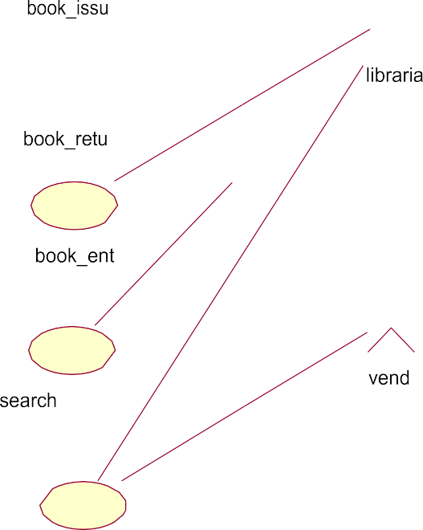

book_order

Fig.9. Use-Case Diagram For Book Bank System

ACTIVITYDIAGRAM:

Activity diagrams are graphical representations of workflows of step wise activities and actions with support for choice, iteration and concurrency. In the Unified Modeling Language, activity diagrams can be used to describe the business and operational step-by-step workflows of components in a system. An activity diagram shows the overall flow of control. An activity is shown as an rounded box containing the name of the operation.
This activity diagram describes the behavior of the system.




collectsquotationfr omvendors

no

ifsatisfiedwith norms?

yes placeorder

discount&modeofp aymentfinalised

takesdelivery

billamtpaid

Fig.11. Activity Diagram[OrderBook]



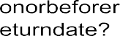


Fig.12.Activity Diagram[ReturnBook]

CLASS DIAGRAM:
The class diagram, also referred to as object modeling is the main static analysis diagram. The main task of object modeling is to graphically show what each object will do in the problem domain. The problem domain describes the structure and the relationships among objects.

The ATM system class diagram consists of four classes:
- Student
- Book
- Issue
- Return
- Vendor
- Details

STUDENT:

It consists of twelve attributes and three operations. The attributes are enrolling no, name, DOB, father name, address, dept name, batch and book limits. The operations of this class are addStInfo(), deleteStInfo(), modify StInfo().

BOOK:

It consists of ten attributes and four operations. This class is used to keep book information such as author, title, vendor, price ,etc

ISSUE:

It consists of eight attributes and two operations to maintain issue details such as, issue date, accno of issued book, name of the student who borrowed book.

RETURN:

It consists of eight attributes and two operations to maintain issue details such as, issue date, accno of issued book, name of the student who borrowed book

STUDENTS:

The attributes of this class are name, dept, year, bcode no The operation is display students ().

DETAIL:
The attributes of this class are book name, author, bcode no The operations are delete details ().

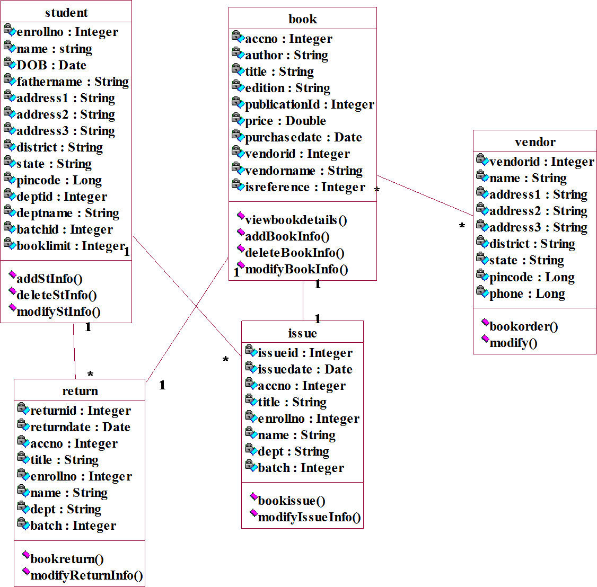

Fig.13.ClassDiagramForBook Bank System

SEQUENCE DIAGRAM:
A sequence diagram represents the sequence and interactions of a given USE-CASE or scenario. Sequence diagrams can capture most of the information about the system. Most object to object interactions and operations are considered events and events include signals, inputs, decisions, interrupts, transitions and actions to or from users or external devices.

An event also is considered to be any action by an object that sends information. The event line represents a message sent from one object to another, in which the “form” object is requesting an operation be performedbythe“to”object.The“to”objectperformstheoperationusingamethodthatthe class contains.

It is also represented by the order in which things occur and how the objects in the system send message to one another.

SE LAB
A.Y:2026-27


:librarian

:student
DB
search
:return
:issue
DB
search
: return
:issue

1:requestbook

2:checkavailablebook

3:checkavailablebook 4:notavilable
5:notavilable

6:notavailable

7:requestforanotherbook

8:checkavailability

9:checkavailabilty 10:available
11:avilable
12:avilable 13:providestudentdetails
14:enterissuedata

15:updateissuestatus 16:issuestatusupdated
17:updatedsuccessfully

18:issuebook

19:requesttoreturnbook

20:enterthebookdetails

21:updatereturnstatus 22:returnstatusupdated
23:updatedsuccessfully

24: bookreturned

Fig.14.SequenceDiagram For Book Issue &Return

DEPT OF CSE Page36
SE LAB- A.Y:2026-27

1:requestbook


7: request for another book13: provide student details19:requesttoreturnb ook

14:enterissuedata

:librarian 17:updatedsuccessfully

:issue

6:not available
12:avilable 15:updateissuestatu
18:issuebook
:student 24:bookreturned 16:issuestatusupdated

23:updatedsuccessfully 20:enterthebookdetails

5: notavilable
2: check available DB book8:checkavailabil
ity

21:updatereturnstatus
11:avilable 3:checkavailablebook

9:checkavailabilty

22:return statusupdated
4:notavilable 10:available

:return
search

Fig.15.CollaborationDiagram For BookIssue &Return

DEPT OF CSE Page37

STATE CHART DIAGRAM

It consists of state, events and activities. State diagrams are a familiar technique to describe the behavior of a system. They describe all of the possible states that a particular object can get into and how the object's state changes as a result of events that reach the object

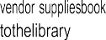
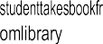
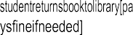

Fig.16.State Chart Diagram

DEPLOYMENT DIAGRAM AND COMPONENT DIAGRAM

Deployment diagrams are used to visualize the topology of the physical components of a system where the software components are deployed.

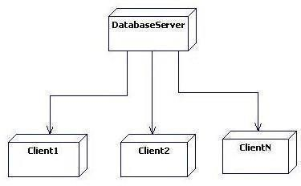
Fig.17. Deployment Diagram

TASK3: Exam Registration System

AIM: To create a system to perform the Exam Registration system

PROCEDURE :(I)PROBLEMSTATEMENT
Exam Registration system is used in the effective dispatch of registration form to all of the students. This system adopts a comprehensive approach to minimize the manual work and schedule resources, time in a cogent manner.
The core of the system is to get the online registration form (with details such as name, reg. no etc.,) filled by the student whose testament is verified for its genuineness by the Exam Registration System with respect to he already existing information in the database. This forms the first and foremost step in the processing of exam application. After the first round of verification done by the system, the information is in turn forwarded to the exam Controller. The application is then processed manually based on there port given by the system. The system also provides the student the list of exam dates. The controller will be provided with fees details to display the current status of application to the student, which they can view in their online interface. After all the necessary criteria has been met, the original information is added to the database and the hall ticket is sent to the student.

SOFTWARE REQUIREMENT SPECIFICATION:
INTRODUCTION

Exam Registration System is an interface between the Student and the Exam Controller responsible for the Issue of Hall Ticket. It aims at improving the efficiency in the Issue of Hall ticket and reduces the complexities involved in it to the maximum possible extent.

PURPOSE
If the entire process of 'Issue of Hall ticket' is done in a manual manner then it would takes several

days for the hall ticket to reach the student Considering the fact that the number of students for hall ticket is increasing every year, an Automated System becomes essential to meet the demand. So this system uses several programming and database techniques to elucidate the work involved in this process. As this is a matter of National Security, the system has been carefully verified and validated in order to satisfy it.

SCOPE
- The System provides an online interface to the user where they can fill in their personal details and submit the necessary documents (may be by scanning).
- The controller concerned with the issue of hall ticket can use this system to reduce his workload and process the application in a speedy manner.
- Provide a communication platform between the student and the controller.
Students will come to know their status of application and the date in which they must subject themselves form annual document verification.

DEFINITIONS,ACRONYMS AND THE ABBREVIATIONS
  - Exam Controller - Refers to the super user who is the Central Authority who has been vested with the privilege to manage the entire system.
  - Student-One who wishes to obtain the Hall Ticket.
  - ERS-Refers to this Examination Registration System.
  - HTML –Markup Language used for creating web pages.
  - J2EE – Java 2 Enterprise Edition is a programming platform java platform for developing and running distributed java applications.
  - HTTP-Hyper Tex t Transfer Protocol.
  - TCP/IP–Transmission Control Protocol/Internet Protocol is the communication protocol used to connect hosts on the Internet.

TECHNOLOGIESTOBEUSED
  - HTML
  - JSP
  - JavaScript
  - Java
  - ​

TOOLSTOBEUSED
  - Eclipse IDE(Integrated Development Environment)
  - Rational Rose tool(for developing UMLPatterns)

OVERVIEW

SRS includes two sections overall description and specific requirements –

Overall Description will describe major role of the system components and inter-connections.
Specific Requirements will describe roles & function soft he actors.

OVERALL DESCRIPTION

PRODUCT PERSPECTIVE
The ERS acts as an interface between the 'student' and the 'exam controller'. This system tries to make the interface as simple as possible and at the same time not risking the security of data stored in. This minimizes the time duration in which the user receives the hall ticket.

SOFTWARE INTERFACE
- Front End Client - The exporter online interface is built using JSP and HTML.
- Web Server–Apache Tomcat Server (Oracle Corporation)
- Back End -Oracle11gdatabase

HARDWARE INTERFACE
The server is directly connected to the client systems. The client systems have access to the database in the server.

SYSTEMFUNCTIONS
  - Secure Registration of information by the Students.
  - SMS and Mail updates to the students by the controller.
  - Controller can generate reports from the information and is the only authorized personnel to add the eligible application information to the database.

USER CHARACTERISTICS

Student- They are the people who desire to obtain the hall ticket and submit the information to the database.

  - Exam controller-He has the certain privileges to add the registration status and to approve the issue of hall ticket. He may contain a group of persons under him to verify the documents and give suggestion whether or not to approve the dispatch of hall ticket.

CONSTRAINTS
  - The applicants require a computer to submit their information.
  - Although the security is given high importance, there is always a chance of intrusion in the web world which requires constant monitoring.
  - The user has to be careful while submitting the information. Much care is required.

ASSUMPTIONS AND DEPENDENCIES
  - The Students and Exam Controller must have basic knowledge of computers and English Language.
  - The student may be required to scan the documents and send.

USECASEDIAGRAM:
The Exam Registration use cases in our system are:
  - Lo gin
  - View exam details
  - Register
  - Acknowledgement
  - Fee Processing

ACTORSINVOLVED:
- Student
- System DB

USE-CASENAME:LOGIN
The student enters his username and password to login and retrieve the information.

USE-CASENAME: VIEW EXAMDETAILS
The student view the details about the exam schedule which contains Date, time, etc...

USE-CASENAME: REGISTER
The student should notify the fee details that only the student can pay the correct amount.

USE-CASENAME: ACKNOWLEDGEMENT
The exam fees should be paid by the student to get the hall ticket from the exam controller.

USE-CASENAME: FEE PROCESSING
All the details should be viewed by both the student and the controller to verify whether all the entered details are correct.

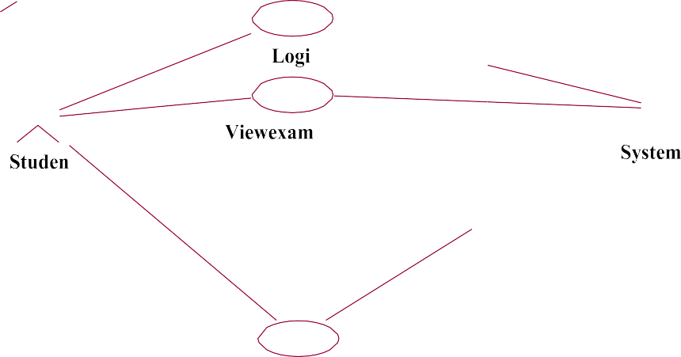
<<include>>
Register

Fig.18.UsecaseDiagramForExam Registration System

ACTIVITYDIAGRAM:

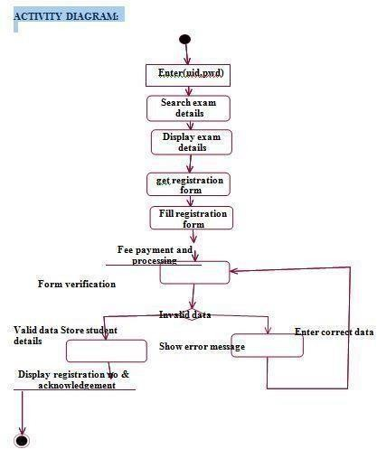
Fig.19.Activity Diagram For Exam Registration System

CLASS DIAGRAM:
The class diagram, also referred to as object modeling is the main static analysis diagram. The main task of object modeling is to graphically show what each object will do in the problem domain. The problem domain describes the structure and the relationships among objects.

The Exam Registration System class diagram consists of four two classes of registration system.
  - Student details
  - Exam details
  - Register r

- STUDENT_DETAILS
It consists of six attributes and six operations. The attributes id,password, name, age, sex, course. The operations of this class are login(), logout(), conformation(), register(), new fees details().

- EXAM_DETAILS
It consists of four attributes and six methods. The attributes are userid, password, exam fees, fees due. The methods are login(), logout(), fees details(), displayfees(), conformation(), exam controller().

REGISTER
This class is used to maintain the registered student information such as, subject registered, date of registration and etc,.

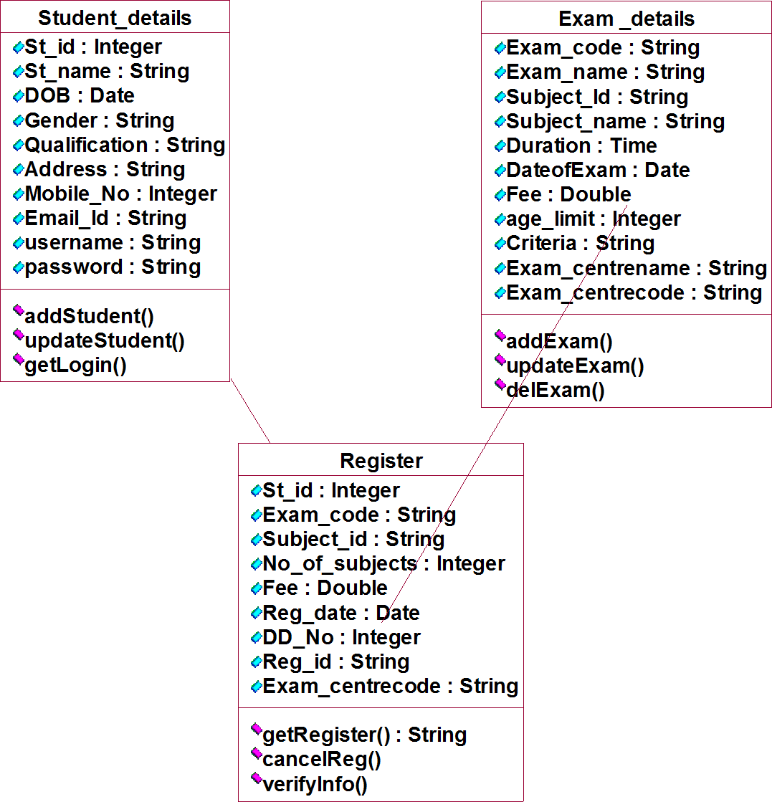

Fig.20.ClassDiagram For Exam Registration System

INTERACTION DIAGRAM:
A sequence diagram represents the sequence and interactions of a given USE-CASE or scenario. Sequence diagrams can capture most of the information about the system. Most object to object interactions and operation are considered events and events include signals, inputs, decisions, interrupts, transitions and actions to or from users or external devices.

An event also is considered to be any action by an object that sends in formation. The event line represents a message sent from one object to another, in which the “form” object is requesting an operation be performed by the “to” object. The “to” object performs the operation using a method that the class contains.

It is also represented by the order in which things occur and how the objects in the system send message to one another.

UI:Internet Explorer
:Register :Exam_details


:Student
:SystemDB
enter(uid,pwd)
Storeuid,pwd
Successfullystored
Viewexamdetails
Getexa
mdetails
Getregform
Fillregistrationform
register
Storestudentdetails
returnregid
Acknowledgement&iddisplayreg
:Exam_details
UI:
InternetE
:Register

Fig.21.SequenceDiagramForRegistrationSystem
DEPT OF CSE Page51

The sequence and collaboration diagram represents that the student enter the information to get the hall ticket and the exam controller issues the hall ticket after verifying the necessary items and this data are stored in the database.

Page49

:Exam_details
:SystemDB

:Student 1:enter(uid,pwd)4:Successfullystored 8:
6:Viewexamdetails
10:Getregform

16:Store studentdetails
12:Fillregistrationform 7:Getexamdetails3
:Storeuid,pwd

17: returnregid 2:Checkvalidation
5:

9:
11:

data
13:Checkgiven




15:Verifycriteria 19:Acknowledgement&displayreg id

18:
:Register

14:register

Fig.21.CollaborationDiagramForRegistrationSystem

UI:Internet Explorer

DEPLOYMENT DIAGRAM AND COMPONENT DIAGRAM

Deployment diagrams are used to visualize the topology of the physical components of a system where the software components are deployed.
Fig.22.Deployment

Diagram

COMPONENT DIAGRAM
Component diagrams are used to visualize the organization and relationships among components in a system.

Fig.23.Component Diagram

COLLABORATION DIAGRAM
Collaboration diagram and sequence diagrams are alternate representations of an interaction. A collaboration diagram is an interaction diagrams that shows the order of messages that implement an operation or a transaction. Collaboration diagram is an interaction diagram that shows the order of messages that implement an operation or a transaction. Collaboration diagram shows object s, their links and their messages. They can also contain simple class instances and class utility instances.
During, analysis indicates the semantics of the primary and secondary interactions. Design, shows the semantics of mechanisms in the logical design of system.

1: request for item 8:request for delivery
custome r
enter the details11:product delivery 2:

Shop ke eper

7:send for quation update delivery details9: 10:

Recording sales

Sendfor item order item3:

5:update product details

4:check for availability
dealer data base

6:product available
Fig.28.CollaborationDiagram

DEPLOYMENT DIAGRAM AND COMPONENTDIAGRAM

Fig.29. Deployment Diagram

Deployment diagrams are used to visualize the topology of the physical components of a system where the software components are deployed.

TASK4: Stock Maintenance

AIM: To create a system to perform the Stock maintenance

PROCEDURE :(I)PROBLEMSTATEMENT

The stock maintenance system must take care of sales information of the company and must analyze the potential of the trade. It maintains the number of items that are added or removed. The sales person initiates this Use case. The sales person is allowed to update information and view the database.

(II) SOFTWAREREQUIREMENTSPECIFICATION

INTRODUCTION
Stock maintenance is an interface between the customer and the salesperson. It aims at improving the efficiency in maintaining the stocks.

PURPOSE
The entire process of Stock maintenance is done in a manual manner considering the fact that the number of customers for purchase is increasing every year,a maintenance system is essential to meet the demand. So this system uses several programming and database techniques to elucidate the work involved in this process.

SCOPE
- The System provides an interface to the customer where they can fill in orders for the item needed.
- The sales person is concerned with the issue of items and can use this system.
- Provide a communication platform between the customer and the sales person.

DEFINITIONS,ACRONYMS ANDTHEABBREVIATIONS
- Market Data provider: One who analyze the product and distribute the news.
- Customer: One who takes order of product
- Salesperson: One who maintains the stock details

TECHNOLOGIESTOBEUSED
  - Visual Studio
  - VBScript

TOOLSTOBEUSED
- Eclipse IDE(Integrated Development Environment)
- Rational Rose tool(for developing UML Patterns)

OVERVIEW
SRS includes two sections overall description and specific requirements Overall Description will describe major role of the system components and inter-Connections
Specific Requirements will describe roles &functions of the actors.

OVERALLDESCRIPTION
The Stock maintenance acts as an interface between the 'customer' and the 'sales person'. This system tries to make the interface as simple as possible and at the same time not risking the work of data stored in

SYSTEMFUNCTIONS
Secure order of information by the customer
- Schedule the customer an appointment form annual delivery of the product.

USERCHARACTERISTICS

- Customer: The person who orders for the item.
- Validate customer: The items ordered by the customer are validated.
- Sales Detail: Maintains the stock details after delivering the items to the customer.

CONSTRAINTS
  - The customer should wait until the trade contractor and other to analyze the product.
  - After the distribution of the news about the product. The customer can take order and request of sales person to fill it.
  - Finally the sales person delivers the order.

(III) USECASE DIAGRAM
The functionality of a system can be described in a number of different use- cases, each of which represents a specific flow of events in a system. It is a graph of actors, a set of use-cases enclosed in a boundary, communication associations between the actors and the use-cases, and generalization among the use-cases.
The use cases used in this system are
- Product details: Used for placing an order.
- Purchased details: Used for tracking items that have been ordered.
- Sales details: Used forgive the sales particulars about a item.
- Stock details: Used forgive the stock detail in a shop.
5. Purchase the product : Used to provide bills for the customer.

- Supply the product: Used to give the order product to customer.

ACTORS

The actors used in this system are
- Customer: The person who orders for the item.
- Shop keeper: The items ordered by the customer are validated.
- Company: Maintains the stock details after delivering the items to the customer.

Draw your own use case

ACTIVITYDIAGRAM
Itshowsorganizationandtheirdependenceamongthesetofcomponents.These diagrams are particularly useful in connection with workflow and in describing behavior that has a lot of parallel processing. An activity is a state of doing something: either a real- world process, or the execution of a software routine.



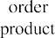
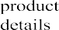
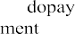
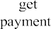
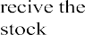
Fig.25.ActivityDiagram

CLASS DAIGRAM DESCRIPTION:
- A class diagram describes the type of objects in system and various kinds of relationships that exists among them.
- Class diagrams and collaboration diagrams are alternate representations of object models.
The Stock maintenance system class diagram consists of seven classes:

Purchase Details: One who takes orders for the product?
Sales Details: The customer makes an order for the required products.
Product Details: The items that are stored as stock.

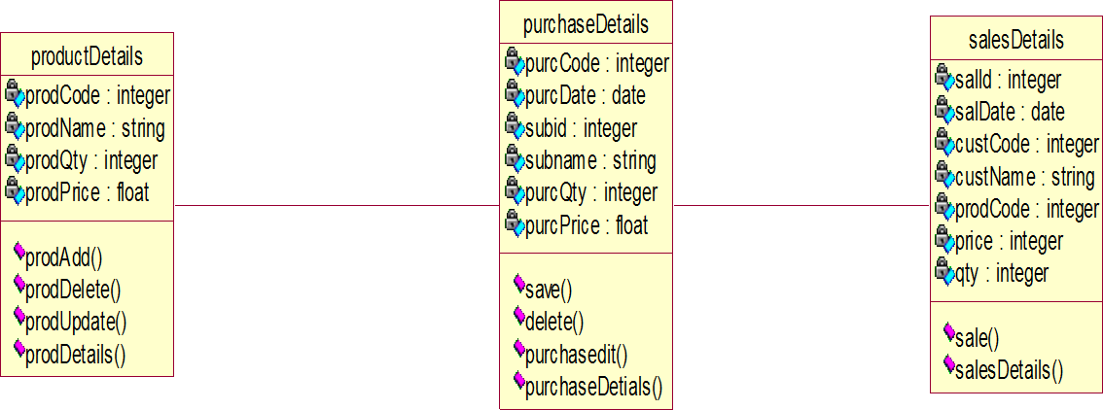

Fig.26.ClassDiagram

UML INTERACTION DIAGRAMS
It is the combination of sequence and collaboration diagram. It is used to depict the flow of events in the system over a timeline. The interaction diagram is a dynamic model which shows show the system behaves during dynamic execution.

SEQUENCE DIAGRAM

A sequence diagram represents the sequence and interactions of a givenUSE-CASEorscenario.Sequencediagramscancapturemostoftheinformationaboutthesystem.Mos tobjecttoobjectinteractionsandoperationsareconsideredeventsandeventsincludesignals, inputs, decisions, interrupts, transitions and actions to perform users to devices.

An event also is considered to be any action by an object that sends information. The event line represents a message from one object to another, in which the “from” object is requesting an operation be performed by the “to” object. The “to” object performs the operation using a method that the class contains. It is also represented by the order in which things occur and how the objects in the system send message to one another.

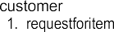
check forproduct availability
.6. product available

7.sendforquation
8.requestfordelivery
11.productdelivery
database
dealer
customer

Fig.27.Sequence Diagram

COLLABORATION DIAGRAM
Collaboration diagram and sequence diagrams are alternate representations of an interaction. A collaboration diagram is an interaction diagrams that shows the order of messages that implement an operation or a transaction. Collaboration diagram is an interaction diagram that shows the order of messages that implement an operation or a transaction. Collaboration diagram shows object s, their links and their messages. They can also contain simple class instances and class utility instances.
During, analysis indicates the semantics of the primary and secondary interactions. Design, shows the semantics of mechanisms in the logical design of system.

Draw collaboration diagram

DEPLOYMENT DIAGRAM

Fig.29. Deployment Diagram

Deployment diagrams are used to visualize the topology of the physical components of a system where the software components are deployed.

