

Ben-Gurion University of the Negev
Faculty of Engineering Science
School of Electrical and Computer Engineering
Concurrent and Distributed Programming
Final Project report
Parallel processing of large graphs from social networks using BSP

Or Erez 311250880
Jonathan Karin 309840866

GitHub : https://github.com/or-erez/BSP_Project/
Video: https://www.youtube.com/watch?v=c4SZOn-WA8A

Table of Contents
Introduction – Social graphs 3
Introduction – BSP 4
State Machine Diagrams 6
Communication between workers 7
Initial Algorithms 7
Main Algorithms 8
Shortest Path Between Two Vertices (Bellman Ford) 9
Minimum Spanning Tree 10
Testing 12
Conclusions 12

Introduction – Social graphs
Huge amount of interesting information can be gained by analyzing large-scale data that is derived from social networks, for example. Social networks are often modeled as graphs, usually known as social graph.
Social graphs of popular social networks (for example: graph that represents all Apple employees on LinkedIn) can contains large number of vertexes and edges.
Some examples for using known graph algorithms on social graphs:
Shortest Paths - a feature to predict most influencer in the network and followers of a person.
MST -co-citation networks of scientific publication.

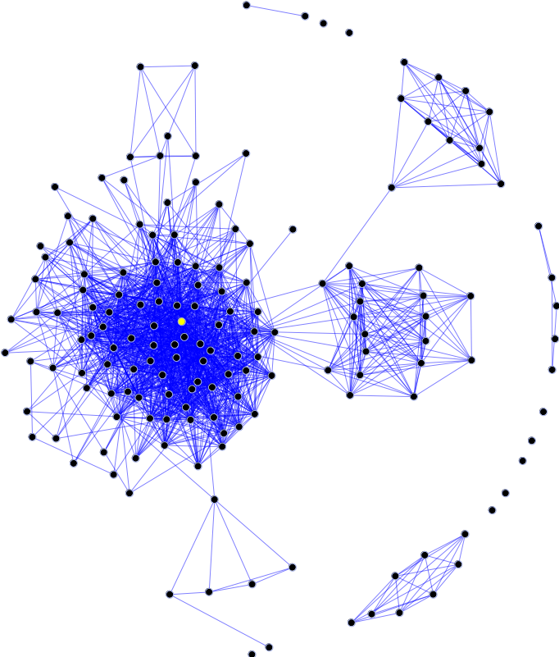

Introduction – BSP
The bulk synchronous parallel (BSP) model is a bridging model for designing parallel algorithms.
This model consists of:
  - components capable of processing and/or local memory transactions (i.e., processors),
  - a network that routes messages between pairs of such components, and
  - a hardware facility that allows for the synchronization of all or a subset of components.
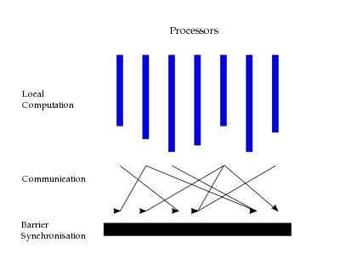

Planning the Architecture
In order to plan the solutions, we first decided on the hierarchy of the model – a GUI will be available to the user, to opt in all necessary input data. The GUI will then trigger a management program called “master”, that is a gen_statem module overseeing the algorithm. The master will then pre-process as necessary, and give orders to several mid-level management units called “sub-master”, also gen_statem based.
Each submaster shall be the managing unit of its respective node, and will handle a part of the graph (meaning each computer will have a copy of the file).
After reading the sub-graph associated with the submaster, it shall create a large amount of processes called “workers”, each representing a single vertex in the graph, and performing micro-operations revolving that vertex.

In order to implement a BSP based architecture, each iteration begins with the master handing down orders to the submasters, which in turn pass them to the workers, including the iteration numbers. The workers may communicate with each other (and see section “Communication between workers”), but a worker will only read messages from previous iterations, making each iteration separate and concise.
To achieve a high level of robustness and scalability, we decided to implement both the master and submaster frameworks as generic as possible, while leaving functions in key locations for algorithm specific behavior (before the algorithm begins, before each iteration, upon processing a response from an “underling” and after an iteration ends). This generic architecture may be a bit less optimal than dedicated code for each algorithm, but it allows for simplicity and readability, while also speeding up the development and debugging processes. In our opinion, the performance sacrifice is negligible in this case and acceptable given the benefits.
In hindsight, there was an additional benefit to the generic architecture, as it made coming up with optimizations and implementing them much simpler. For example, initially calculating the minimum spanning tree for a randomized 1000-node large graph with an average degree of 10 took well over 30 minutes. After a series of optimizations to both the worker flow and message creation, and to the submaster routing procedure, we managed to narrow the time down to a few seconds, and under 3 minutes for a graph 10000-node large with an average degree of 25.

With small adjustment, it can also be possible to take advantage of the built-in OTP possibility of updating the code online, in order to add more algorithms based on the same generic architecture.

State Machine Diagrams
Master State Machine

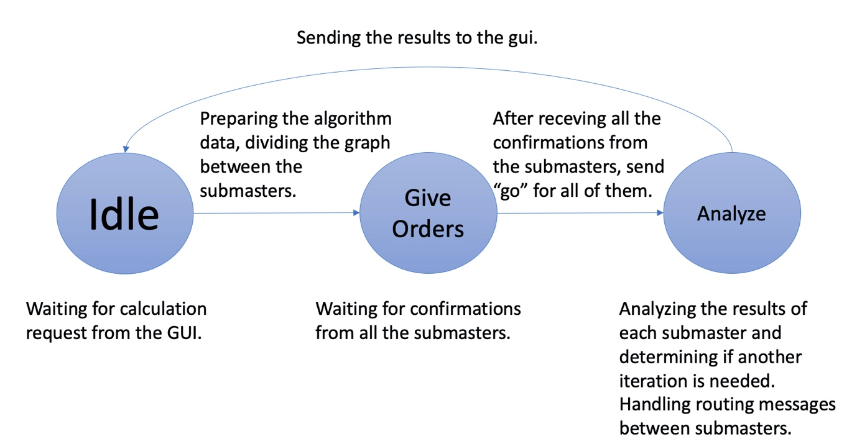Submaster State Machine
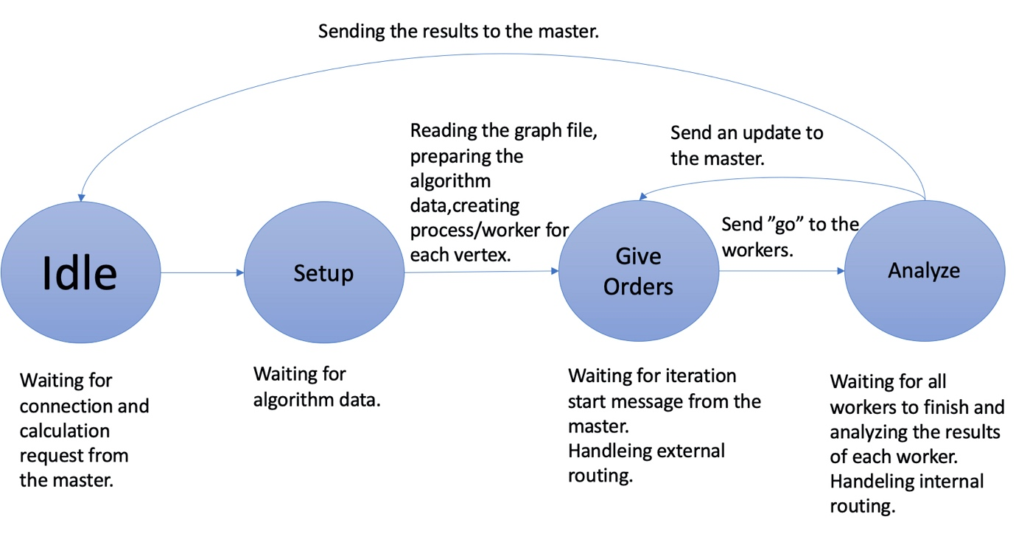

Communication between workers
In each time that worker A should send a message to worker B:
- Worker A search the PID of worker B in his node ETS.
- if they shared the same submaster, worker A will find the PID and send the message.
- Else, worker A will cast to the message to his submaster, the submaster will send it to the master, the master to worker’s B submaster, and then the message would be sent to worker B.
Each message between workers includes the iteration number, in order to avoid races.

Initial Algorithms
For architecture development and debug purposes, we initially implemented two simple algorithms –
- MaxDeg – given a graph G={V,E}, find the highest degree among all the vertices.
(This algorithm takes a single iteration, and involves no inter-worker communication)
- MaxBiDirectionalDeg – given a graph G={V,E}, find the highest bi-directional degree – the amount of neighbors that are both incoming/outgoing to the vertex.
(This algorithm takes 2 iterations, and involves O(|E|) inter-worker messages being sent)
Both algorithms are supported and operational as an extra feature to the program.

Main Algorithms

Breadth First Search
In order to calculate shortest paths from a specified node to every other node in the graph (unweighted), we used the well-known BSF algorithm.
Memory:
Workers – Delta: distance from root, Pi: previous vertex
Submasters – Change: in entire sub-graph, TotalDist: to calculate average
Master – Change: in entire graph, TotalDist: to calculate average
Step:
Worker goes over mailbox to look for {discover, NVID, Dist}. If not yet discovered, updates memory and sends discover messages to neighbors.

Runtime (5000 vertexes Mean rank is 40 (200,000 edges)):
We see behavioral difference between the different operation system. On both case 2 submasters gives the worse results.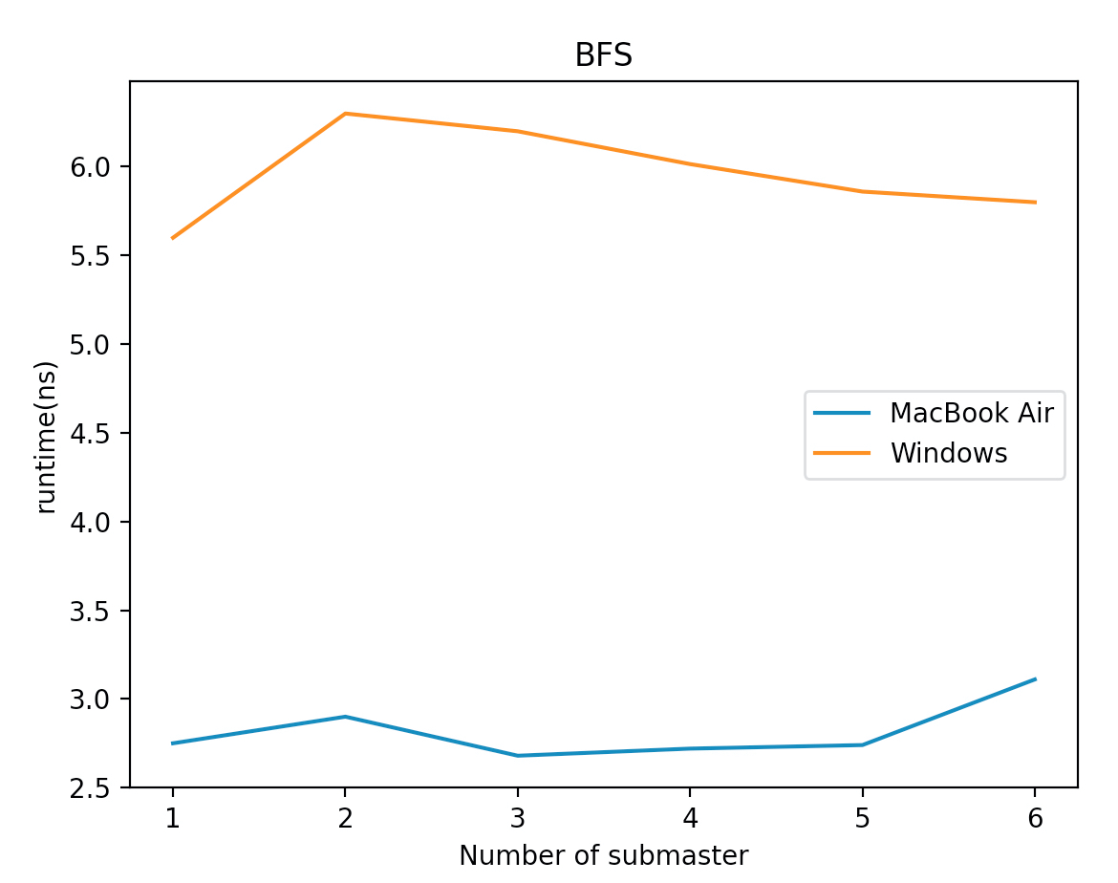

Shortest Path Between Two Vertices (Bellman Ford)
In order to calculate the lightest path between two nodes, with as little assumptions as possible, we chose to implement the Bellman-Ford algorithm. After the algorithm ends, we run a quick “reconstruct” set of iterations to recreate the path.
Memory:
Workers – Delta: distance (in weights) from root, Pi: previous vertex, Neighbors: list of NVIDs.
Submasters – Change: in entire sub-graph
Master – Change: in entire graph, Path, Weight
Step:
Worker goes over mailbox to look for {relax, NVID, Dist}. If an effective relax occurs, sends relax messages to all neighbors. Algorithm ends when no successful relaxes occur. In the “reconstruct phase”, each iteration the master requests the vertex prior to a specific V, which is the only responder.

Runtime (5000 vertexes Mean rank is 40 (200,000 edges)):
This computer has 4 cores (8 hyper threads), more submasters improves concurrency but add more sequential latency (routing)
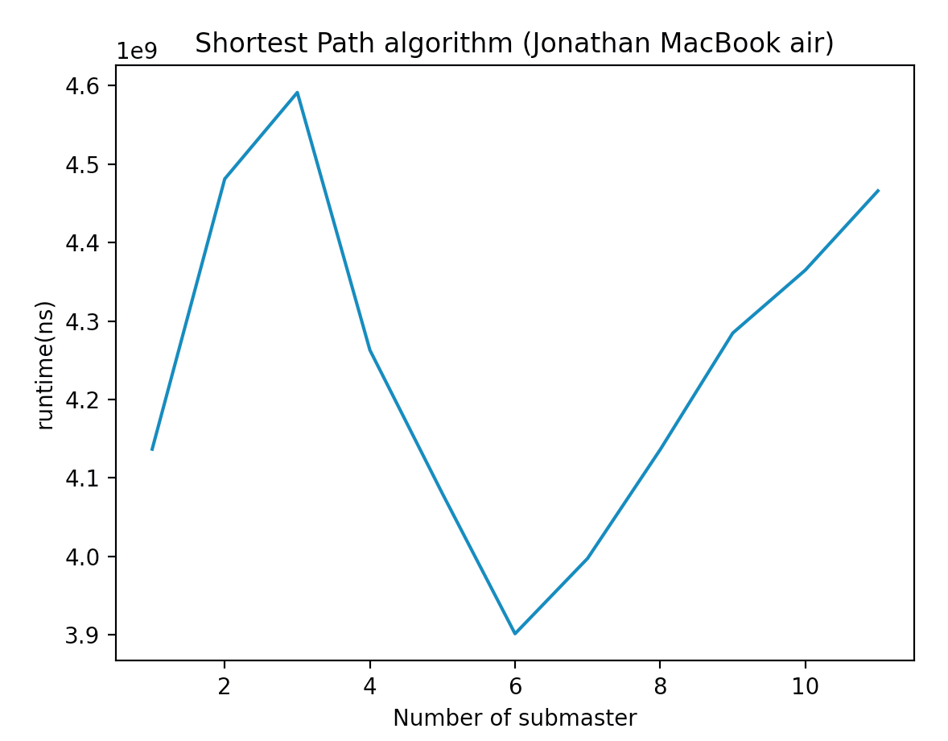

Minimum Spanning Tree
Many different algorithms exist to find MST. Finding efficient algorithms for distributed systems is an ongoing effort in the CS academic field, and complicated algorithms can be found in published papers. For simplicity, we chose to use Prim’s algorithm, that assumes non-negative undirected weights, and takes |V| iterations.
Memory:
Workers – Annexed: true/false Delta: best distance from root seen so far, Neighbors: list of potential NVIDs to annex.
Pi: vertex connecting to best distance.
Submasters – {W,{Source,Dest}}: the lightest edge seen so far, connecting some annexed vertex to a non-annexed vertex in the subgraph, and the vertices connected to it.
Master – {W,{Source,Dest}}: the lightest edge seen so far, connecting some annexed vertex to a non-annexed vertex in the entire graph, and the vertices connected to it. Weight: total weight of the MST
Step: Search step: The master declares a newly added vertex. That vertex sends {annex,_} messages to all neighbors. All other vertices remove that vertex from the neighbor list. Respond step: each non-annexed vertex reports the lightest edge connecting some annexed vertex to it.
Algorithm ends after 2|V| iterations.

Runtime:

Graph 1 - 1000 vertexes Mean rank is 40 (40,000 edges) , single computer :
Because it is a small graph, the best result is achieved by single submaster (no routing), then there is degradation (because of the routing) and improvement because of the concurrency.
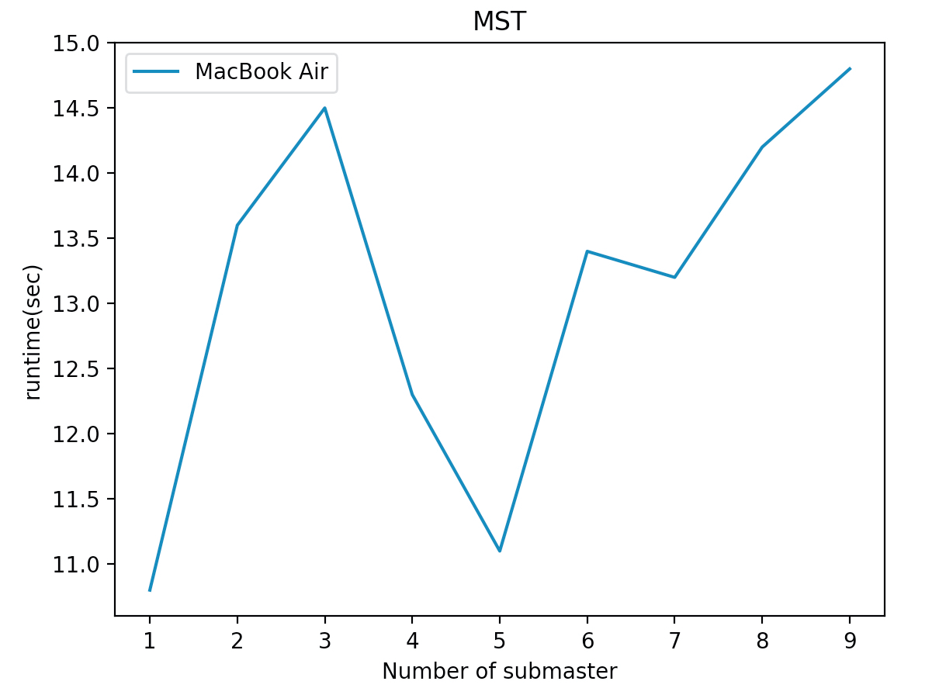
Graph 2 – 10,000 vertices, max rank of 50:
We can see great improvement by adding more computers.
PC-A | M | M | M | M+SM | M+SM | M+3XSM | M+3XSM
PC-B | SM | SM | SM | SM | X | X | 4XSM
PC-C | X | SM | SM | SM | X | X | 4XSM
PC-D | X | X | SM | SM | X | X | 4XSM
Results | 705 | 465 | 301 | 260 | 701 | 435 | 413

Testing
We created two python scripts that randomize both directed/undirected graphs with fix number of vertices and edges. The scripts are attached to the GitHub repository.

Conclusions
- The Number of messages is the main bottleneck for runtime improvement – minimize the number of messages on the MST algorithm reduced the runtime by 95%.
It may be possible to augment the submaster so that it can dynamically expect less responses (which may improve fixed iteration algorithms like Prim)
- Conflict between communication complexity/runtime and recoverability – simplest workers (in terms of flow and memory retention) improves runtime but hurts recoverability. The algorithms are all restarted automatically if any worker dies unexpectedly.
- The ETS is far more efficient than the DETS – by replacing all the usage of ETS with DETS we had significant degradation (800%). This is a great example for the efficiency of distributed calculation.
- Obviously, the runtime is very hardware dependent. In addition, it seems that for a specific set of hardware and algorithm, there is an optimal amount of submasters, after which the additional routing messages are not worth the speed up of each iteration.

