**סלניום: שיעור 2 - תרגילים**

**Exercise 1:**

1. Open this site <https://prd.canvusapps.com/signup>
2. Fill in valid email
3. Complete the form with illegal information
4. Press the ‘Sign Up’ button (you should get an error)
5. Print the text you get in the error message
6. Press the ‘already an existing user’ link
7. Press the ‘Forgoten Password’ link
8. Verify that you are in the ‘**Forgot Your Password’ page**
9. Fill in your email
10. Press the ‘Reset Password’ button

**Exercise 2:**

1. Open this site <https://www.w3schools.com/>
2. Find all links on page (elements of type a)
3. Print list of all link’s text
4. Search for links that contains ‘video’’ and print those links

**Exercise 3:**

1. Open <http://www.echoecho.com/htmlforms10.htm>
2. Click the second option in the radio buttons  
   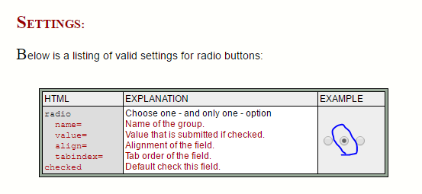
3. Click the first option in the radio buttons  
   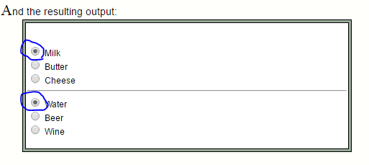

**Exercise 4:**

* Build a tool which will get your ISP information

1. Open <https://whatismyipaddress.com/>
2. Extract the IP address from the UI
3. Go to <https://apps.db.ripe.net/db-web-ui/query>
4. Type in the extracted IP address and perform search on the RIPE Database(Whois).
5. Print the whole block of the second result.

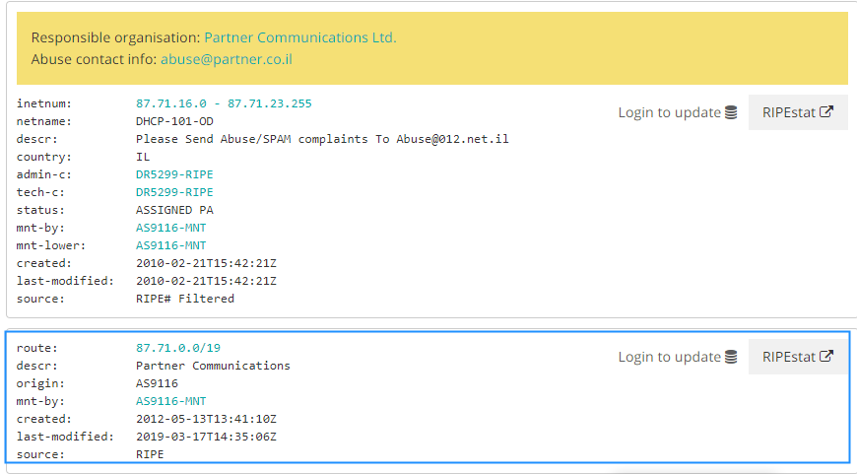

**Exercise 5:**

1. Open <https://www.amazon.com/>
2. Fill ‘tent’ in the search area and search for it
3. Print the list of the tents in the 10 first pages (to do it you should press the next button with a loop, in addition you should use Thread.sleep to wait for the results)

את שיעורי הבית שילחו באמייל אל [homework@automation.co.il](mailto:homework@automation.co.il)   
על מנת שנוכל לעבור עליהם, לתת לכם הערות ולשפר את יכולות הקוד שלכם.

בהצלחה,  
גל מטלון   
המכללה לאוטומציה  
  
