Niva focused repair completion
  - Implemented changes and independent local validation
The remaining description and freshness defects are repaired locally. Global ordering now considers the filtered catalog before pagination, and measured QA relevance improves on held-out examples and a fresh bounded listing sample. Two disposable local accounts complete the actual résumé, preferences, saving and redirect journey. Hosted staging and operational acceptance remain blocked. These changes are not deployed.
Focused status | Count
Fixed locally | 6
Partially fixed | 7
Deferred | 1
Counts cover 12 original audit/feature IDs plus prior new issue N01 and newly observed N02. “Fixed locally” is an implementation and local-validation result, not a hosted pass. F17 is explicitly deferred. The other 21 original IDs retain their earlier evidence without a new manual verdict.

Environment and version
Item | Evidence
Date and browser | 26 October 2026; fresh public GETs 17:56 UTC; local journey and checks through 18:16 UTC. Windows Chromium in the in-app browser; exact embedded version not exposed.
Local build | Node 24.19; Angular production build; actual Node/SQLite on loopback port 4310. Desktop 1440×1000; mobile 390×844 IAB plus Chromium device emulation.
Candidate source | Base 8550b51a7247039caa44424c3f1c5c4b90284458 plus uncommitted changes. Package remains 0.2.1. Proposed next feature release 0.3.0 is Unreleased.
Current production | Application 0.2.1 / Sites 41. Reviewed GitHub 55b21e270dab0ec25cd8d908ebdf600425d45cbb; Sites source ddc96b3a18b9e5861a0b48208b1dff6ea66c12e0. No preview URL available.
Authorization | Disposable local/staging data only. No production accounts or writes, employer submissions, external alerts, purchases or production deployment.

Release decision
Ready for code review and separately provisioned hosted staging validation. Not ready for unconditional production release: hosted two-account identity/D1 checks, real scheduled cleanup and restore, an accountable operator and an approved alert receiver remain unresolved. Broad-search relevance is improved but still imperfect.

Finding results for confirmed defects
Reported evidence below comes from the preceding independent verification. Current results were tested again; implementation claims alone do not establish a pass.
ID | Reported problem | Implemented and tested | Status and remaining limit
B03 | Arbitrary source h2 headings became paragraphs | Inert bounded HTML parsing retains heading/list structure. Public Canopy source sections are actual h3; nested ordered/unordered and hostile bilingual fixtures pass | Fixed locally. Old cached plain text needs successful upstream refresh; no deployment
F12 | Description semantics incomplete | Safe recursive source blocks with semantic headings. Desktop/mobile, light/dark structure tests and actual local IAB inspection | Fixed locally. Not deployed
N01 | Oldest successful check labelled last check | Separate oldest/newest success from latest attempt. Two successes on 25 and 26 Oct plus later failed attempt; expected dates all distinct | Fixed locally. Not deployed
F14 | Freshness summary misleading | Never-successful sources and truthful legacy fallback. Source-health regression and four browser cases show distinct labelled dates | Fixed locally. Not deployed
F08 | Ordering only loaded cards hides later matches | Server orders filtered catalog before pagination. 20 QA roles after 60 Sales roles appear first; two cursor pages unique; cursor invalidates on sort change | Fixed locally. Field latency and entire live catalog relevance untested; no deployment
N02 | Newly observed omitted unknown availability in apply log | Log unknown/unverified explicitly. Real local journey initially failed, repair applied, complete rerun passed | Fixed locally. Hosted log path untested; introduced-by version not established

Source structure and cache migration
parse5 parses a bounded, inert fragment. Only text, heading levels and list structure enter the model; source HTML is never rendered. Scripts, frames, forms and executable attributes cannot become active content. Ordered and nested lists, bilingual text and arbitrary heading names retain their order. Source headings are placed beneath the page description heading as h3–h6.
Previously cached plain text has already lost heading boundaries. The renderer preserves its existing paragraphs and bullets without inventing headings. A successful provider refresh is required to populate new structured blocks; no database migration or fabricated reconstruction is used.

Newly observed N02
Severity low. Reproduction: open an actual local application handoff for a listing whose source availability is absent, then inspect the stored click event. Expected: explicit unknown availability. Actual before repair: JSON omitted the key. The handler now records unknown and an unverified path when evidence is absent. The complete real-backend journey then passed. The version that introduced this omission is not established.

Journey and remaining finding results
ID | Prior gap and completed work | Independent result | Remaining gate
F01 | Only 6/20 useful roles in prior cohort. Evidence ranking and explicit QA alias retrieval | Held-out 48 and fresh 57 paired comparisons improve role relevance | Partially fixed. Fresh broad first 10 still only 5 useful; role family and inventory coverage remain limited
F11 | No empirical numeric-fit calibration. Replace composite headline with extracted-term coverage | 29/48 held-out cases scored with 0 pp error on simple term labels; 19 withheld | Partially fixed. No hiring/professional-fit probability calibration; dictionary completeness unproven
F15 | Live logged redirect untested. Unknown click availability explicitly logged | Actual local 303 to Canopy vacancy; one metadata-only event; no employer request | Partially fixed. Hosted redirect/session logging untested; local fixture does not establish vacancy open
F16 | Hosted persistence and independent owner isolation untested. Prepared two actual local accounts | Save/unsave/reload and separate Alice session; Bob export of Alice résumé 404 | Partially fixed. Separate hosted staging identity and D1 unavailable
F18 | Hosted first-time onboarding untested. Actual local sign-up/verification and setup gates | Two sign-ups 200 and verification 302; CV then preferences then workspace | Partially fixed. Hosted OAuth/identity and separate-origin checks remain untested
F19 | Hosted résumé upload path untested. Actual local PDF/DOCX parsing and review flow | Both valid formats parse; zero stored résumés before explicit confirmation | Partially fixed. Hosted flow untested; remote scanner unavailable; bytes stay on device
S02 | Operator cleanup alerts and restore unverified. Safe staging preparation; alert delivery off | Two actual local accelerated timer cycles; deletion/pointers; separate restore; injected failure detected | Partially fixed. No hosted scheduled delivery, D1 restore, approved receiver or accountable operator
F17 | Optional job hiding and tracking absent. Deferred per current user instruction | No new implementation or acceptance claim | Deferred. Resume only after core journey and operational gates

Actual journey evidence
Two synthetic local identities were created by the real sign-up route and verified through the local-only email outbox: both sign-ups returned 200 and both verification redirects 302 at 17:47:23 UTC. First sign-in entered setup. Subsequent complete regression runs reset only these authorized disposable account records; they did not recreate identities. No mocked account, résumé or state routes were used.
The PDF and DOCX fixtures parsed in the browser. No résumé record existed before the review checkbox and confirmation. Preferences survived refresh and a separate signed-in session. Save/unsave survived reload. Bob could not export Alice’s résumé (404) and had independent saved state. Apply returned 303 to the exact Canopy vacancy and added a metadata-only click event; the test did not follow that external redirect.
Exact tested destination vacancy
This checks redirect correctness, not current vacancy availability or employer acceptance. The local application-check fixture is explicitly labelled as a fixture. No new open-vacancy rate or successful application is claimed.

Measured job retrieval and ordering
The audit persona is a five-year mid/senior QA individual contributor: Python, TypeScript, Playwright, Selenium, SQL, APIs and GitHub Actions; Tel Aviv commute; onsite/hybrid/remote; Israel-only work authorization and no US citizenship. Degree, Java, management, gaming and AI-agent depth remain unconfirmed.
A frozen single-analyst diagnostic set contains 72 labelled records: 24 development and 48 held-out. Identical title/description pairs do not cross splits; recurring role families do. No held-out weight tuning was performed. This is document-level withholding, not unseen-family validation or independent adjudication.
Useful means grade 1 or 2 role relevance and no explicit eligibility blocker. Unknown eligibility remains unknown. Baseline uses the previous literal Engineer pool and source-ID order. Treatment first orders that identical pool globally; the third mode separately enables explicit QA aliases. Every before/after pair uses identical records and criteria.
Sample and mode | First 10 useful | First 20 useful
Held-out 48 baseline | 8/10 80% | 14/20 70%
Held-out same pool global order | 10/10 100% | 20/20 100%
Held-out explicit QA aliases plus global | 10/10 100% | 20/20 100%
Fresh 57 baseline | 0/10 0% | 0/20 0%
Fresh same pool global order | 5/10 50% | 5/20 25%
Fresh explicit QA aliases plus global | 6/7 returned 85.7% | 6/7 returned 85.7%
Held-out recall of useful records increased from 22/24 with literal retrieval to 24/24 with QA aliases. All eight explicit eligibility blockers were excluded in every mode; improved ranking is not a new eligibility pass. The fresh alias sample contains only seven results, so no complete P@10 or P@20 estimate exists for that mode.

Fresh inventory sample and tradeoffs
Read-only public requests at 17:56:10–17:56:11 UTC collected the first 50 Engineer results and all eight QA results, yielding 57 unique listings. The broad Engineer API reported 873 total; these results are a bounded purposive sample, not a full-catalog or random market estimate. All 57 titles, locations and available requirement facts were inspected. The prior audit’s 20-job cohort differs; its 6/20 useful rate is historical context, not a paired comparison.
The six useful fresh QA roles still include unresolved manual-testing, leadership, Java, gaming or AI-agent requirements. Global ranking rescans filtered metadata on each page; batch memory and top-page storage are bounded, but target-size field latency is unmeasured. Literal search and source order remain available. QA aliases deliberately reduce non-QA breadth.

Match evidence and feature scores
The headline now states extracted skill-term coverage instead of presenting the old composite as overall fit. Eligibility, source freshness and data confidence remain separate. Missing requirements remain unknown; no salary, citizenship, sponsorship or worldwide remote permission is invented. The old composite remains in the API for compatibility and is not used by the new catalog ranking.
Coverage test | Measured result | Interpretation
Held-out explicit term labels | 29/48 scored; 19 withheld; 0 percentage-point mean absolute error among scored cases | Exact accounting on simple Python/SQL/Java fixtures only
Development explicit term labels | 14/24 scored; 10 withheld; 0 percentage-point error among scored cases | Development sanity check, not held-out evidence
Professional fit or hiring calibration | Not tested | No ground-truth hiring outcomes, proficiency labels or independent employer adjudication
Legacy composite values and term coverage measure different constructs. Their numerical error cannot be compared as a calibration improvement. Limited extraction can omit meaningful requirements or withhold a score. F11 remains partially fixed until a broader independently labelled fit evaluation exists.

Focused 1 to 10 scorecard
Scores use the original 1–10 feature scale as evidence-backed review judgments. They are not test pass percentages. Hosted journey scores remain N/T; local scores are shown separately. Other feature scores are not reissued in this focused cycle.
ID | Previous verified | Local now | Support and limit
F01 | 6 | 7 | Paired held-out and fresh improvement; broad fresh first 10 remains 50% useful
F08 | 6 | 8 | All filtered candidates considered; cursor/ordering tests; field cost unmeasured
F11 | N/T | N/T | Term accounting tested; professional fit calibration untested
F12 | 7 | 9 | Source headings, lists, safe text and mobile semantics tested
F14 | 6 | 8 | Distinct success/attempt dates and missing evidence tested
F15 | 8 | 8 | Local exact handoff/logging; hosted N/T
F16 | N/T | 8 | Local persistence and independent account isolation; hosted N/T
F18 | N/T | 8 | Local actual identity and ordered setup; hosted OAuth N/T
F19 | N/T | 8 | Local PDF/DOCX review boundary; hosted/scanner N/T
F17 | N/T | N/T | Deferred optional feature

Description before and after evidence
B03/F12. Before is the genuine preceding verification capture of the prior implementation; after is the current running local build using the same public Canopy vacancy and dark theme. Crops show the opening sections, not the entire description. Historical originals are retained. Source timestamps are fixture timestamps, not new employer checks.
Before prior verification capture  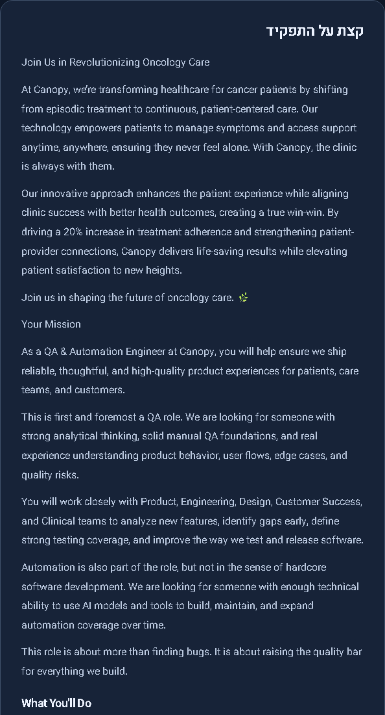 | After repaired local renderer  
Figure 1. “Join Us in Revolutionizing Oncology Care” and “Your Mission” now retain semantic heading roles. The independent local accessibility tree identifies both as level 3 headings. Nested and ordered list behavior is additionally checked with focused source fixtures. Screenshots alone are not the pass criterion.

Freshness and mobile evidence
N01/F14. The deterministic two-source fixture has success dates 25 Oct 10:00 and 26 Oct 11:00 UTC, plus a later failed attempt at 26 Oct 12:00. The three separately labelled values match those exact inputs. A failed attempt does not become a successful check.

Figure 2. Current local browser fixture, desktop dark. Successful newest and oldest dates are separate from the latest attempt and source failure. This is a controlled timestamp acceptance test, not a production monitoring observation.
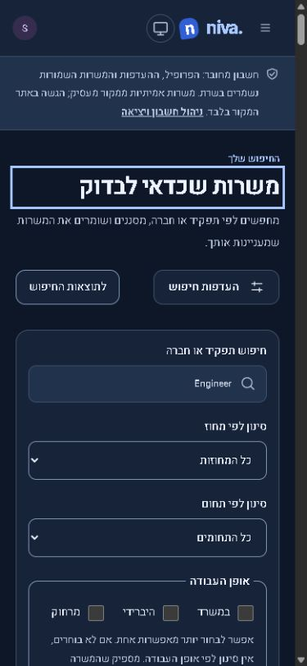 | Figure 3. Actual local Node/SQLite account session in the in-app browser at 390×844. Search remains readable; measured document scroll width 375 is below 390. The local accessibility tree showed Canopy QA, Unframe AI-first QA and Veeva QA first. This is pinned public data with a synthetic account, not a hosted staging session. Four deterministic light/dark desktop/mobile cases also passed structure, ordering, freshness and axe checks.

Resume review evidence and secure access
F18/F19. Both captures are from the actual local authentication and persistence backend, with synthetic résumé fixtures. The review checkbox is initially unchecked and the continuation button disabled. The test independently queried the backend and found zero stored résumés before confirmation.
  Figure 4. Actual local PDF parsing and review. Synthetic text only. |   Figure 5. Actual local DOCX parsing and review. Synthetic text only.

Access without sharing secrets
Start the isolated environment using docs/disposable-staging.md. The two accounts are alice.staging42@example.test and bob.staging42@example.test. Their random credentials are private in the ignored local access file; never put that file, the outbox, cookies or databases into a commit or report. For secure handoff use the local sign-in or Forgot password flow and read its one-time link from the device-only outbox. No email or alert is sent externally. Public hosted staging must use separate approved identity registrations, never this loopback outbox configuration.

Operational evidence and release gates
S02 remains partially prepared. The actual local drill invoked two independent real timers at an accelerated 1.1-second cadence. Each expired résumé probe became unreadable, was physically deleted and had its active pointer cleared. These are local scheduled invocations, not Cloudflare scheduler or 60-minute hosted-bound evidence.
Exercise | Observed result | Limit
Cleanup cycle 1 | 18:09:17 UTC; one expired probe removed; pointer cleared | Actual Node/SQLite timer
Cleanup cycle 2 | 18:09:18 UTC; one expired probe removed; pointer cleared | Accelerated cadence, not hosted cron
Separate SQLite restoration | Two account owners; cross-owner lookup 0; broken active pointers 0; expired probes restored 0 | Backup created after probe deletion; not older-backup erasure replay or D1 restore
Injected cleanup failure | Failure persisted; watchdog detected MAINTENANCE_FAILURE; cleanup recovery succeeded | Injected disabled transport returned 503; no notification delivered
Alert delivery guard | Plan shows disabled; run refuses without enable flag | Receiver and operator not configured

Operator and proposed receiver
The accountable operator remains unassigned. Responsibilities are independent five-minute health checks, cleanup-bound monitoring, alert acknowledgement, source/cleanup distinction, incident ownership, secret rotation, backup expiry and erasure-safe restores. The owner must obtain acceptance from an operator and backup; no accepted service-level commitment is implied.
Proposed receiver: an organization-owned authenticated HTTPS relay that forwards metadata-only watchdog events to a self-hosted ntfy server with private-topic access controls and deny-by-default access. An adapter must transform the existing JSON shape; a raw ntfy topic URL is not a drop-in destination. Approval, infrastructure, TLS, bearer authentication, private ACLs, retention, retry/deduplication and actual operator receipt are required. Nothing was installed, purchased or enabled.
Official ntfy publishing documentation
Official ntfy access control setup

Measurable acceptance before production release
- Provision a distinct non-production origin and D1 binding with the production host/database excluded; record exact candidate commit and direct/alternate-origin inventory.
- Use two independent hosted sign-ins. Repeat PDF/DOCX review, preference persistence across sessions, save/unsave isolation and exact 303 handoff logging with no candidate data sent to employers.
- Assign an operator and approve the HTTPS receiver. Keep alert delivery disabled until then. Observe two real hosted cleanup cycles, one controlled failure with acknowledged notification, recovery and a disposable hosted restore including earlier-backup erasure replay.
- Measure global-ordering latency at target catalog size and agree a latency budget. Expand independently reviewed relevance labels before asserting general matching accuracy. Authorize production deployment separately.

Checks evidence and scope closure
Check | Current result
Frontend and server | 59/59 frontend; 158/158 server; focused new server suite 5/5 after test-type correction
Main browser suite | 220/222 initially passed; two failures were missing trace files after concurrent staging output cleanup. Both exact affected cases passed recovery 2/2. All 222 unique cases now have passing evidence; no skipped or flaky cases.
Actual local journey | 1/1 passed on safe staging wrapper after fixture preparation. Real backend, no mocked account routes.
Build and types | Angular/Worker production build passed. Frontend test, server and end-to-end TypeScript checks passed. Two test-only typing errors were corrected before focused rechecks.
Worker and provenance | Actual Worker runtime 1/1; provenance 1/1; formatting passed.
Initial failures retained | A detail locator was corrected; restored headings required a level 1 selector; N02 was a real missing log value. Browser artifact collision fixed by separate staging outputDir. No application failure remains hidden as an infrastructure pass.
No forced source outage, paid provider call, production write, physical phone, screen reader, new full vacancy-open-status audit or real employer submission was performed. The browser file-chooser wrapper timed out during one manual attempt; repository Playwright file selection then exercised both actual parsers successfully. This tool limitation is not reported as a product upload failure.

Original findings outside focused repair scope
The following 21 IDs retain their preceding verification record. They were not manually reaudited here; full regression success does not upgrade their live verdicts.
IDs | Previously recorded scope
B01 B02 B04 | Work style, false collaboration gap and pay disclosure
S01 S03 | Explicit rights and conservative source extraction
F02 F03 F04 F05 F06 F07 | Eligibility, search, district/work-style/country/pay filters
F09 F10 F13 | Pagination, explanation evidence and data completeness
F20 F21 F22 F23 F24 F25 F26 | Mobile, usability, accessibility, performance, recovery, outages and AI

Reviewable implementation and receipts
Code: server/description-blocks.ts, source-health.ts, discovery.ts and career.ts; src/app/core/discovery-ranking.ts and job-assessment.ts; shared description/match components and jobs page. Preparation and checks: scripts/*disposable-staging.mts, local-staging.mts, staging-retention-drill.mts and evaluation scripts. Complete finding ledger and sanitized receipts are under docs/verification/repair42-*.json; labels/results under relevance42-*.json. Changelog is Unreleased.
Completion counts: 6 fixed locally, 7 partially fixed, 1 deferred. Hosted acceptance and operational blockers remain unresolved. The evidence supports code review and hosted staging preparation; it does not support an unconditional production release.

