Niva job finding verification
  - Independent retest of the original audit and repair claims
Overall verdict: verified with remaining issues. The live release contains the reviewed discovery repairs. Strict hybrid filtering now exposes the two intended roles, the false collaboration skill gap is removed, and four salary omissions are corrected. Description semantics remain incomplete and a freshness summary is misleading. The evidence does not establish that every issue is resolved or that all displayed vacancies are open and eligible.
Audit verdict | Count
Passed | 14
Partially passed | 14
Failed | 1
Not reproducible | 0
Blocked / not tested | 4
Counts cover 33 audit and feature rows: original B01–B04 and S01–S03, plus F01–F26 labels assigned by the fix report to the audit’s unnumbered scorecard. These labels are preserved for traceability. One new low-severity issue N01 is counted separately as Failed. F17 is an unimplemented optional recommendation, not a release regression.

Release decision
The checks support the specific repairs already deployed, with remaining issues. They do not support an unconditional production-readiness sign-off. S02 still needs accountable hosted retention, alerting, identity-isolation and restoration evidence. Live write paths remain untested under the user’s explicit instruction. No critical discovery or application blocker was demonstrated in the inspected public cohort; no successful application submission is claimed.

Tested version
Item | Recorded evidence
Environment | https://getnivajobs.com/app/jobs · production read-only; local isolated Node24 SQLite and D1-contract tests
Date and browser | 26 October 2026; public collection17:04–17:05 UTC; manual UI 17:07–17:17 UTC; Windows IAB Chromium engine; exact embedded browser build not exposed
Viewports | Desktop1440×1000; mobile 390×844 emulation; local Chromium desktop and mobile in both themes; no physical phone
Deployed release | 0.2.1 / Sites41; build-info built16:48:38 UTC; reviewed GitHub 55b21e270dab0ec25cd8d908ebdf600425d45cbb
Deployment provenance | Sites source ddc96b3a18b9e5861a0b48208b1dff6ea66c12e0; mapped-reviewed-source true; dirty false
Local checkout | 8550b51a7247039caa44424c3f1c5c4b90284458; src/server/package files equal reviewed 55b21e2; later local commit is documentation reconciliation

Method and authorization
I read all 28 audit pages and all 15 fix-report pages, including the supplied screenshots, scorecard, tested scenarios and bug register. The fix report describes an earlier local repair state; its statement that changes were uncommitted and unpublished is historical. Current deployment provenance and observed live behavior establish that the reviewed fixes are now deployed. Previous test claims were not accepted as new passes.
The original persona was retained: five years in QA, mid/senior individual contributor, Python, TypeScript, Playwright, Selenium, SQL, APIs and GitHub Actions; Tel Aviv commute, onsite/hybrid/remote; Israel-only authorization and no US citizenship; ILS25000–35000 gross monthly desired pay. Degree, Java, leadership, gaming and AI-agent depth remain unconfirmed. The exact seven skills were used in the independent isolated assessment. Existing browser regression fixtures use a smaller four-skill synthetic profile, so their scores are not substituted for persona calibration.
The user authorized isolated local data and requested live writes remain untested. No live profile, résumé, preference, saved-job, onboarding-account or application write was performed. The live Apply redirect is intentionally excluded because its GET handler inserts an apply-click event. Original employer pages were opened directly instead, and redirect behavior was tested locally. Ordinary feed/detail GET requests can update shared cache and provider quota metadata internally; they were not forced refresh or load tests.

Evidence register
E1 Fresh public GET data 17:04:31–17:05:08 UTC; 20 details, 14 official provider APIs, 20 original HTTP paths, seven scenarios and two-page traversal. public.json.
E2 Independent live IAB UI 17:07–17:17 UTC; desktop 1440×1000 and mobile 390×844. Counts, history, chips, map, sorting, empty recovery, keyboard and freshness inspected. Screenshots in verify41.
E3 Fourteen original source pages visibly inspected 17:08:44–17:09:54 UTC. browser-sources.json. Six blank application forms observed; no field filled or submit clicked.
E4 Exact audit persona assessed against 20 freshly fetched jobs in isolation. assessments.json and assess.ts; 28 assertions passed. Not a live profile update or empirical fit calibration.
E5 Fresh full local execution: frontend 59/59; server 153/153; Chromium 218/218 across desktop/mobile; Worker 1/1; provenance 1/1; build and three type checks passed. No failed, skipped or flaky browser tests.
E6 Original supplied 28-page audit and 15-page fix report read in full, including scores, screenshots and ledgers. Original images are explicitly labelled.
E7 Unperformed dependencies: hosted identity/retention/alerts, live profile/CV/save writes, live apply tracking redirect, real AI, field performance and physical-device/screen-reader validation.

What the sample can establish
All20 original unique results were re-read from fresh public Niva details; fourteen were independently compared with current official Greenhouse/Lever payloads and fourteen original pages were inspected visibly. The original twenty-record purposive cohort is kept separate from inventory changes and from the signed-in owner’s display. Neither a reachable URL nor an Apply control proves the vacancy accepts new applications. No vacancy-wide closure rate, hiring outcome, employer acceptance or market-wide relevance estimate is inferred.

Search scenarios and result quality
Scenario | Original | Fix report catalog | Fresh public | Interpretation
S1 QA automation | 4 | 4 | 4 | Exact category search
S2 QA all categories | 7 | 8 | 8 | One additional LQA posting
S3 QA Tel Aviv | 6 | 6 | 6 | Same district count
S4 remote QA IL including unknown | 1 | 2 | 2 | Country unknowns permitted
S4b strict known IL | 0 | 0 | 0 | No invented eligibility
S5 senior plus ILS30000/month | 0 | 0 | 0 | Honest restrictive result
S6 remote Engineer | 338 | 373 | 396 | Changing inventory; broad fallback is noisy
All seven fresh public requests returned 200. The original URLs were replayed with scope=all and limit 50. During later signed-in manual testing inventory moved to 397 and 49 cards were initially visible, then 99 after load more; all 99 links were unique. Confirmed owner eligibility can affect visible cards, so this is not treated as the same anonymous denominator. The public two-page traversal returned 100 unique IDs with no repeats.
Metric and definition | Original audit | Independent retest
Strong / partial / low role fit in fixed 20 | 1 /5 /14 | 1 /5 /14; unchanged independent judgment
Strong or partial role fit | 6/20 30% | 6/20 30%; not confirmed eligible
Focused QA role-family relevance | 6/7 85.7% | 6/7 in original QA subset; junior R05 remains low
Known work style | 14/20 70% | 17/20 85%; R03 R04 unknown and R10 conflict
Structured pay | 1/20 5% | 3/20 15%; plus R11/R12 pay present with unknown period
Literal amp/nbsp description tokens | 13/20 65% | 0/20; semantic heading loss still reproduced
Explicit candidate conflicts for S01 | Conditions not surfaced reliably | 4/4 original citizenship/local-rights cases blocked in isolated exact persona
Closed or broken visibly observed | 0/15 original pages | 0/14 current pages; subsets differ; not evidence all 20 open
Blank application forms visible | 6 original source forms | 6 current forms R01 R03 R04 R05 R11 R12; no submission
Distinct canonical vacancy paths | 20/20; semantic duplicates0/20 | 20/20; no conflicting same vacancy found; whole-market rate unmeasured
Numeric score presence | 0/20 withheld | 7/20 isolated persona; accuracy N/T; no live owner score exported
Publisher integration supplement: the live JSearch view showed 44 in-site cards, including 30 LinkedIn and 14 Indeed labels. It disclosed stale-source status and limited daily coverage. These44 cards are outside the original 20-result quality cohort and were not individually validated. No quota exhaustion or paid call was triggered.

Twenty result review ledger
Independent role fit concerns the original persona. Eligibility is separate: confirmation means unresolved information, not confirmed eligibility. Scores below are isolated exact-persona outputs only. B means a confirmed blocker; Q means confirmation required. Source page V means visibly matched title/content, H means HTTP path only. All20 HTTP paths returned 200; official APIs matched14 IDs/titles.
ID | Role | Role assessment and unresolved gap | Style | Eligibility / score | Page
R01 | Canopy  QA & Automation Engineer | Strong  Strong role fit; 2+ years and API testing. Manual QA and AI-assisted tooling still need confirmation. | hybrid | Q / 73 | V
R02 | Transmit Security  QA & Automation Lead | Partial  Partial: 5+ years automation and familiar frameworks; leadership and data-science test depth unresolved. | hybrid | Q / N/S | H
R03 | Unframe  QA Engineer | Partial  Partial: QA/API fit; manual emphasis and AI testing experience unresolved; collaboration gap removed. | unknown | Q / 43 | V
R04 | Unframe  AI-First QA Automation Engineer | Partial  Partial: Playwright and experience align; proven agent harness and orchestration expertise unresolved. | unknown | Q / 75 | V
R05 | WeDev  Junior QA Tester | Low  Low: junior manual tester below target seniority; JavaScript is required and remains distinct from Java. | onsite | Q / N/S | V
R06 | Playson  Manual QA Engineer (Game Client) | Partial  Partial: manual/API/browser QA; gaming experience and Europe employment inclusion unresolved. | remote | Q / N/S | H
R07 | Veeva  QA Automation Engineer - CDH | Partial  Partial: QA automation; Java, data-platform depth and qualification requirements unconfirmed. | onsite | Q / N/S | V
R08 | Datadog  Enterprise Sales Engineer - UK/Ireland | Low  Low: enterprise sales engineering outside QA; UK/Ireland regional remote. | remote | B / 25 | H
R09 | Datadog  Senior Sales Engineer - Key Accounts | Low  Low: sales engineering outside QA; 7+ years; US regional remote. Estimate not an ILS salary match. | remote | B / 18 | V
R10 | Datadog  Senior Product Security Engineer - AI Agents | Low  Low: specialized security and AI agents; US locations; source hybrid/remote conflict remains unknown. | unknown | B / N/S | H
R11 | JFrog  Senior Solution Engineer, Presales - Public Sector (US Remote) | Low  Low: public-sector presales/DevOps; explicit US citizenship conflicts with persona. | remote | B / 25 | V
R12 | JFrog  Regional Vice President, Strategic Solution Engineering (Central) | Low  Low: regional vice-president management; 10+ years and management depth beyond persona. | remote | B / N/S | V
R13 | Wiz  Solutions Engineer | Low  Low: cloud/security presales; Japan work rights and no sponsorship conflict with persona. | remote | B / N/S | V
R14 | Wiz  Security Engineer - Product | Low  Low: specialized security 7+ years; UK work rights and no sponsorship conflict with persona. | remote | B / N/S | V
R15 | Wiz  Principal Solutions Engineer | Low  Low: principal cloud solutions; Australia rights and no sponsorship conflict with persona. | remote | B / N/S | V
R16 | Fieldguide  Staff Software Engineer, App Platform | Low  Low: staff app-platform development, USA; not QA; USD pay remains not employer verified. | remote | Q / N/S | V
R17 | eMerchantPay  Senior AI Engineer | Low  Low: senior AI/ML engineering in Bulgaria; domain and country mismatch unresolved. | remote | Q / 30 | H
R18 | Canonical  Junior Linux Kernel Engineer - Ubuntu | Low  Low: junior kernel/C/Rust rather than QA; Anywhere board label does not prove IL hiring. | remote | Q / N/S | V
R19 | Canonical  Senior/Staff/Principal Engineer | Low  Low: senior systems engineering; deep coding/open-source and travel terms unresolved. | remote | Q / N/S | H
R20 | Canonical  Cloud Field Engineer | Low  Low: cloud consulting/infrastructure rather than QA; employment terms and board gate unresolved. | remote | Q / N/S | V
N/S means score withheld, not zero. Country association inferred from a location is weaker than an employer employment restriction. Remote Anywhere does not prove Israel employment. Four S01 conflicts are explicit authorization/citizenship conditions; other blocked outputs may rely on regional applicant-country restrictions and are not counted as the same four explicit cases.

Finding by finding verification
Expected and actual results are scoped to the tests performed. Partially passed includes successful isolated tests with a live acceptance criterion still untested. Recommendations are evaluated as requested functionality, not retroactively recast as confirmed bugs. Evidence IDs refer to the register.
Audit ID | Original issue | Claimed fix | Test performed | Expected result | Actual result | Verdict | Evidence
B01 | Explicit hybrid and onsite arrangements omitted | Recover explicit source styles and retain conflicts | Live strict hybrid search; list/map; fresh 20 records; local conflict controls | Canopy and Transmit retained; onsite recovered; true unknowns honest | Strict hybrid 2 results; styles hybrid/hybrid/onsite/onsite for R01/02/05/07; R10 unknown | Passed | E1 E2 E4 E5
B02 | Collaboration becomes Product Management skill gap | Separate required preferred and collaboration evidence | R03 live description versus match component; fresh required facts; positive and negation tests | No collaboration gap; genuine required skill retained | R03 mentions managers but has no Product Management requirement or gap; controls pass | Passed | E1 E2 E5
B03 | Entities and flattened description structure | Decode safely and render sections and lists | 20 fresh descriptions; Canopy employer h2 versus live tags; mobile; unsafe fixtures | No entity tokens; original section order and semantic headings retained | 0/20 amp/nbsp tokens; 27 Canopy list items; Your Mission and opening h2 rendered as paragraphs | Partially passed | E1 E2 E3 E5 Fig 2
B04 | Salary absent despite four monetary ranges | Keep currency period origin or unstructured label | Fresh R09 to R12 facts; R09 R11 R12 originals; unit filters in local tests | Four pay disclosures; no inferred JFrog period or currency conversion | Datadog 149000–198000 and 192000–240000 USD/year estimates; JFrog ranges present with unknown period | Passed | E1 E3 E5 Fig 3
S01 | Citizenship and local rights omitted suspected | Surface conditions and compare confirmed candidate criteria | Fresh R11 R13 to R15; employer pages; exact audit persona locally; unknown controls | Confirmed conflict blocked; absent candidate rights unresolved | US citizenship and JP GB AU rights retained; four persona conflicts blocked; unknown controls pass | Passed | E1 E3 E4 E5
S02 | Overdue maintenance needs operator verification suspected | Local cleanup safeguards; hosted operations remain prerequisite | Reviewed operational claim; reran isolated lifecycle tests only | Two hosted cleanup cycles alerts operator and restore evidence | No authorized hosted operational exercise; no retention breach established; exact dependency remains | Blocked / not tested | E5 E7
S03 | Optional skills years JavaScript and source facts suspected | Respect optional sections exact terms and provenance | Fresh R01 R02 R05; independent local assessment and server regressions | Bonus not mandatory; JavaScript distinct; known years retained | Canopy optional tools separate; WeDev JavaScript not Java; 2 and 5 year minima recovered | Passed | E1 E4 E5
F01 | Result relevance | QA alternate title actions | Live SDET action; 20 fresh source descriptions against persona | Better targeting without false eligibility | Action searches SDET; cohort still 1 strong 5 partial 14 low; no measured relevance uplift | Partially passed | E1 E2 E4
F02 | Eligibility | Confirmed facts separate from skills | Four explicit conflicts and unknown controls locally; live disclosure | Country restrictions respected for confirmed user | Policy controls pass; no live synthetic candidate write permitted | Partially passed | E1 E3 E4 E5
F03 | Search | Exact filtering and alternate titles | Seven public scenarios; live padded QA empty and SDET | Consistent query effects and clear scope | Padded QA 8; empty query recovery works; exclusion syntax and semantic search deferred | Partially passed | E1 E2 E5
F04 | District filter | Preserve office evidence | S3 public replay plus local multi-office tests | Tel Aviv results respect filter | 6 results; existing map and district regressions pass; no original defect alleged | Passed | E1 E5
F05 | Work style filter | B01 source recovery | Live strict hybrid mobile map; source style controls | Known styles preserved and conflicts unknown | 2 strict hybrid results; accessible map links same two jobs | Passed | E1 E2 E5
F06 | Country and missing data | Expose known and unknown values | S4 and S4b public replay; local country filters | Strict unknown exclusion and no worldwide inference | 2 inclusive remote QA versus 0 strict known country; clear limited-country disclosure | Passed | E1 E2 E5
F07 | Salary and seniority filters | Comparable units only | S5; four pay cases; local units and missing controls | Strict ILS/month does not match USD/year or unknown | S5 zero honestly; local comparable and cross-unit tests pass | Passed | E1 E4 E5
F08 | Sorting | Label loaded-result scope | Live source to relevance sort after loading more | Stable loaded list; no global ranking implication | 99 cards retained; URL sort=relevance; global calibrated catalog ranking absent | Partially passed | E2 E5
F09 | Pagination | Snapshot and stale cursor handling | Fresh public S6 two pages; live load more; synthetic cursor tests | No repeated IDs and useful expiry recovery | 100 unique public IDs; live 49 to 99 unique cards; local expiry recovery passes | Passed | E1 E2 E5
F10 | Match explanations | Required and preferred quotes and gaps | R03 live false-gap check; exact persona evidence; scoped fixtures | Gaps tied to qualifications; uncertainty explicit | B02 fixed; evidence dimensions and explicit blockers separate; no hiring-probability claim | Passed | E1 E2 E4 E5
F11 | Numeric match accuracy | Withhold insufficient evidence | Exact persona calculation and threshold controls | Empirical accuracy against independent truth labels | 7/20 numeric scores computed locally; arithmetic controls pass; no empirical calibration dataset | Blocked / not tested | E4 E5
F12 | Job descriptions | Safe semantic rendering | Live Canopy tags lists and mobile; local unsafe markup | Readable sections with original semantics | Entity and list repairs work; two source h2 labels remain paragraphs as B03 | Partially passed | E2 E3 E5
F13 | Data completeness | Recover source facts and unknowns | 20 fresh records; compare 14 official APIs | Available facts retained without invented data | 17/20 known styles; 3 structured pay plus 2 unstructured; source gaps still present | Partially passed | E1 E3 E4
F14 | Freshness disclosure | Separate source and check dates | Live summary versus 26 per-source checks; 20 details | Dates accurately labelled; stale sources disclosed | Card/source dates distinct and stale warning works; summary uses oldest check under last check label N01 | Partially passed | E1 E2 Fig 4
F15 | Application handoff | Trusted job-specific paths and gate labels | 20 original GETs; 14 visible pages; six empty forms; local redirect tests | Correct vacancy path; no false submission claim | 20 distinct trusted routes; live apply redirect deliberately uncalled as it logs an event; final Jobicy routes untested | Partially passed | E1 E3 E5
F16 | Saved jobs | Reversible persisted state | Reran local save reload unsave and isolation suites | State survives refresh and navigation | Local persistence checks pass; live writes explicitly untested by authorization | Partially passed | E5
F17 | Hide and track jobs optional | Company exclusion retained; per-job stages deferred | Inspect live controls and rerun exclusion tests | Per-job hide and self-reported stages if implemented | No per-job hiding or application-stage feature; recommendation deferred not a new regression | Failed | E2 E5
F18 | Onboarding and profile | Synthetic CV then preference gate and confirmed criteria | Local first-time workflow and criteria reload suites | Ordered setup; confirmed fields persist | Local workflows pass; hosted first OAuth account and profile writes untested | Partially passed | E5
F19 | Resume upload and parsing | PDF DOCX validation and review boundary | Local actual fixture file selection parsing and invalid input tests | Parse valid files and reject invalid inputs before confirmation | Local PDF/DOCX checks pass; live upload not performed; remote scanning unavailable | Partially passed | E5
F20 | Mobile layout | Move search above long source panel | Live 390 by 844 plus local themes and device tests | Search visible; no horizontal overflow | Search bottom y509; scroll width 375 below 390; list/map show same two results | Passed | E2 E5 Fig 1
F21 | Usability | Chips removal results link remedies | Live style-chip removal Back refresh results jump | State follows controls and history | 2 to 3 results after removal; Back and refresh restore 2; results link retains route and query | Passed | E2 E5
F22 | Accessibility spot checks | Labels keyboard and structure | Live keyboard skip Enter; mobile link; four local axe scans | Focus main without losing query; semantic document | Skip activation focuses main and preserves URL despite AX href; axe checks pass; B03 heading loss remains; screen reader N/T | Partially passed | E2 E5
F23 | Performance benchmark | Bounded metadata residency | Built current code; observed request times; no field benchmark | Repeatable field latency memory and loading metrics | Public scenario GETs about 0.7 to 1.0s; live refresh reached stale fallback; no controlled field benchmark | Blocked / not tested | E1 E2 E5
F24 | Empty and recovery states | Specific restrictions and retry | Live nonsense query then QA; real stale source; local cursor faults | Clear empty state and recovery without fabricated listings | 0 to 8 on query recovery; stale-source warning with retained cards; isolated recovery tests pass | Passed | E2 E5
F25 | Errors and outages | Fail truthfully and recover | Local provider network storage abort failure suites; actual stale feed | Explicit failure no substitute fake jobs; retry works | Isolated failures pass and live stale copy disclosed; no forced production outage or quota exhaustion | Partially passed | E2 E5
F26 | AI assistant | Remain unavailable without provider and consent | Local missing provider and mocked recovery tests | Only configured authorized real model grounded output | Real model quality not tested; provider consent and cost authorization required | Blocked / not tested | E5 E7

Before and after discovery evidence
Figure 1 relates to B01 and F20. The before capture below is the supplied original audit page 4, not a newly reproduced failure. The after card crop is a fresh isolated browser regression execution using public vacancy fixtures, with their historical source timestamps preserved. Independent live strict-hybrid and map checks also returned the same two jobs. The live mobile screenshot excludes the account header.
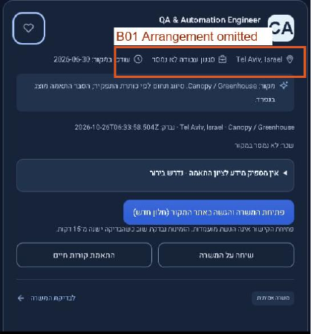
Original audit screenshot page 4 — Canopy work arrangement labelled unknown. B01.

After — current local UI regression, two hybrid source vacancies. Synthetic profile; not a live account mutation.

Description verification evidence
Figure 2 for B03. The before screenshot is the original audit’s annotated description from page 14. The after crop contains only public live job text. Entities are decoded and lists are restored. The employer source marks both the opening title and Your Mission as h2; the current Niva DOM renders these as p. What You’ll Do, What You’ll Bring, Bonus Points and Benefits are h3, with 27 list items. This is an incomplete repair, not a new regression.
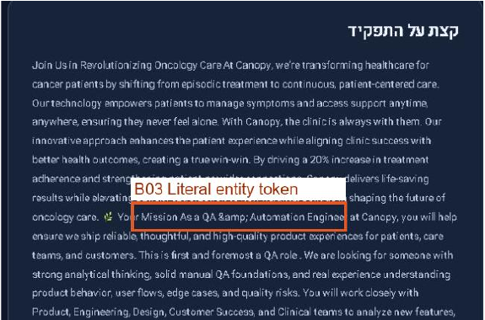
Original audit screenshot page 14 — encoded amp token and flattened description.

After — current live Canopy description. Your Mission remains paragraph text; personal account areas excluded.

Pay and mobile verification evidence
Figure 3 for B04 and F20. The salary capture is a fresh local isolated regression using the public R09 fixture. Employer-estimated annual USD pay is disclosed rather than converted to the persona’s ILS/month target. The mobile capture is current live390×844, cropped below the account header; search bottom was y509 and no horizontal overflow was observed.
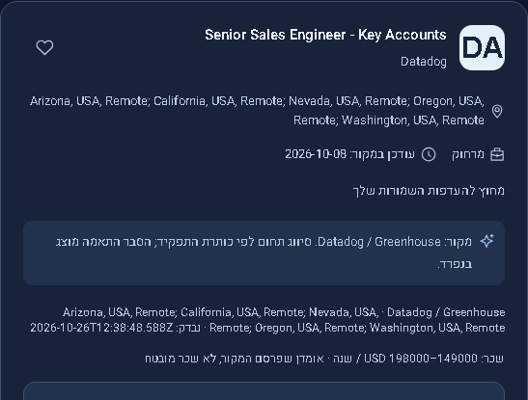
After — isolated R09 salary summary with employer estimate.
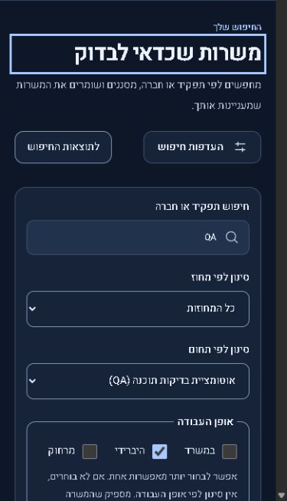
After — live mobile search first. Header removed to redact account identity. F20.

New issue and regression checks

N01 Oldest check labelled as last check
Severity Low P2. Previously undocumented; the version that introduced it is not established. Steps: open jobs with scope=all, expand source coverage, expand source check dates, compare the summary with per-source dates. Expected: a last-check label identifies the latest successful observation, or the UI explicitly labels the oldest source date and shows the range. Actual: summary shows 25 October 18:27:09 UTC while many sources show 26 October 16:57 UTC. Code corroboration: server/discovery.ts returns the ascending minimum checked_at as fetchedAt; jobs.html labels it last source check. This is misleading presentation, not evidence a newer listing is stale or that retention failed.
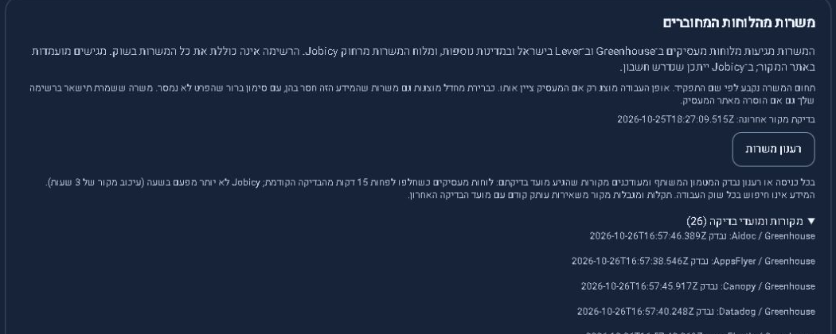
Figure 4 — current live summary and newer per-source timestamps. N01. Public source data only.

Related behavior tested
Style-chip removal changed 2 to 3 results; Back and refresh restored the original 2. The results jump kept the route and query. Padded QA returned 8, a nonsense query returned 0, and QA recovery returned 8. SDET sets an explicit alternate title and automation category. Loaded-result sorting retained 99 cards and changed the URL sort parameter. Public pagination had 100 unique IDs. The live source-failure warning appeared naturally while older listings remained visible.
A suspected global skip-link defect was not confirmed: its accessibility URL looked like /#main, but Enter focused the current main and preserved the jobs route and query. It is not registered as a failure. Full local suite fault cases covered aborted requests, stale cursors, unavailable providers, storage failures and recovery. No production outage or rate-limit failure was injected. No new high-severity regression was established; B03 remains incomplete and N01 is newly documented.

Updated feature scores
Scores are analyst judgments using the audit’s1–10 convention, not test-pass percentages. Live scores use current public behavior supported by isolated controls. N/T is used where live account writes, calibration or field behavior were not tested; a successful local test is not silently promoted to a live score. Original N/T values remain distinct from zero.
ID | Feature | Original /10 | Verified live /10
F01 | Result relevance | 6 | 6
F02 | Eligibility | 5 | 7
F03 | Search | 8 | 8
F04 | District filter | 8 | 8
F05 | Work style filter | 5 | 8
F06 | Country and missing data | 7 | 8
F07 | Salary and seniority filters | 6 | 7
F08 | Sorting | 6 | 6
F09 | Pagination | 8 | 8
F10 | Match explanations | 4 | 8
F11 | Numeric match accuracy | N/T | N/T
F12 | Job descriptions | 5 | 7
F13 | Data completeness | 4 | 7
F14 | Freshness disclosure | 7 | 6
F15 | Application handoff | 8 | 8
F16 | Saved jobs | 8 | N/T
F17 | Hide and track jobs optional | N/T | N/T
F18 | Onboarding and profile | N/T | N/T
F19 | Resume upload and parsing | N/T | N/T
F20 | Mobile layout | 8 | 8
F21 | Usability | 6 | 8
F22 | Accessibility spot checks | 7 | 7
F23 | Performance benchmark | N/T | N/T
F24 | Empty and recovery states | 8 | 8
F25 | Errors and outages | N/T | N/T
F26 | AI assistant | N/T | N/T
Local-only coverage remains strong for F16 saved jobs, F18 setup, F19 PDF/DOCX parsing and F25 faults, but those live paths are N/T. F11 arithmetic is exercised while empirical score accuracy remains N/T. F17 is absent optional functionality. Real AI and field performance remain N/T.

Weighted original rubric
Dimension | Weight | Original | Retest
Relevance | 25% | 6 | 6
Eligibility | 15% | 5 | 7
Data quality | 20% | 4 | 7
Application handoff | 15% | 8 | 8
Search | 10% | 8 | 8
Usability | 10% | 6 | 8
Responsive accessibility | 5% | 7 | 7
Weighted total | 100% | 6.0 | 7.1
7.1 is provisional within the bounded public journey, not a complete production-readiness score. Handoff 8 reflects job-specific originals and local redirect controls, with the live tracking redirect untested. The fix report’s7.3 local provisional score is not directly comparable: this retest reduces data quality for remaining source gaps/heading loss and separately flags freshness disclosure. No relevance uplift was demonstrated.

Supporting records and code references
Evidence is retained under .test-data/verify41: public.json, browser-sources.json, assessments.json, verification.json, frontend-tests.json, server-tests.json, browser-tests.json and execution logs. These are local audit artifacts; they are not production telemetry or application patches. The new verification source and report were authored independently from earlier conclusions.
Live Niva jobs
Reviewed deployed code
Source facts and extraction
Assessment and uncertainty policy
Description component with incomplete headings

Executed checks and remaining gates
Check | Independent execution result
Frontend full suite | 59 passed /0 failed; fresh run
Server full suite | 153 passed /0 failed; fresh run
Chromium full browser suite | 218 passed /0 failed /0 skipped /0 flaky; desktop and mobile; four audit theme/device axe checks
Independent original persona | 28 assertions passed on 20 fresh public records; explicit conflicts and exact URLs checked
Worker and source provenance | 1/1 each passed; local runtime/contract evidence
Production build | Passed; HTML policy and Worker build completed
Type checks | Server, browser tests and frontend tests passed
Local and hosted boundary | Local SQLite/D1 contract only; not proof of hosted D1 isolation or cleanup

Prioritized acceptance criteria
P1 S02 — assign an accountable operator and approved alert destination; observe two hosted cleanup cycles with expired-row deletion, denial and recovery evidence; restore a disposable authorized account and verify identity isolation. Until then operational release sign-off remains blocked.
P1 F15 F16 F18 F19 — use an authorized staging account to finish first-time identity setup, real PDF/DOCX parsing and confirmation, preferences, save/unsave across refresh and separate sessions; test hosted apply redirect logging and exact final vacancy path without submitting an application. All live write checks remain untested here by instruction.
P2 B03 F12 — preserve source heading boundaries rather than a vocabulary-only heuristic. Recheck Canopy opening heading and Your Mission, all four original affected records, original order, safe HTML removal and 390px reflow; every source heading should retain a semantic heading role.
P2 N01 F14 — label minimum source date as oldest check, or return separately labelled newest/oldest dates. With a two-source fixture having distinct dates, both labels must match; retain stale/failure details without claiming employer confirmation.
P2 F01 F08 F11 — expand a labelled representative QA cohort and publish relevance/eligibility/score calibration separately. Do not interpret more catalog inventory as better matches. Include alternate titles and known negative controls before changing global ranking.
P3 F17 — design reversible per-job hiding and explicitly self-reported stages if prioritized. Opening a link must never mark applied. This is an optional outstanding recommendation, not a new blocker.

Limitations and protected data
No applications, employer contacts, purchases, paid activation, deployment or application-source edits were made. Private owner CV excerpts, identity and numeric assessments are excluded from delivered figures. No physical phone, spoken Hebrew screen reader, browser-engine cross-platform matrix, controlled field benchmark, full-catalog semantic duplicate review, Jobicy final employer gate or real AI-quality evaluation was completed. Rendered document checks certify document layout only, not software behavior.

