Niva job finding fix report
  - Audit findings and local repair evidence
26 October 2026 • Baseline application 0.1.3 / Sites39
The four demonstrated audit bugs are repaired in the local code: strict work-style filtering recovers explicit leads, collaboration no longer creates a false skill gap, descriptions retain readable sections, and all four reported salary ranges are represented honestly.
This report covers all 28 audit pages, the B01–B04 bug register, S01–S03 suspected issues, every feature row, the original search scenarios and the 20-record ledger. All account and CV test data is synthetic. No employer application, message, purchase, commit, push or production deployment was performed.
Fixed cohort metric | Before | Local after
Strict hybrid QA automation results | 0 | 2
Known work arrangements | 14 / 20 | 17 / 20 plus 1 conflict
Descriptions with literal entities | 13 / 20 | 0 / 20
Structured salary | 1 / 20 | 3 / 20
Additional ranges with unknown period | 0 / 20 | 2 / 20
Distinct trusted original routes | 20 distinct URLs | 20 / 20 trusted paths
Disposition: 15 fixed, 10 partially fixed, 6 not reproducible, 2 blocked. The feature-row IDs F01–F26 are local tracking IDs; the audit did not number those rows. A not-reproducible feature row records a successful check where the audit did not establish a defect.

Readiness
Ready for code review and controlled staging verification. Production readiness remains qualified by unverified cleanup and alerts, hosted rollout timing and field/device testing. The current live site is unchanged. Proposed release 0.2.0 reflects compatible additions; package and lockfile remain 0.1.3 until a release is authorized.
Original weighted score 6.0 / 10; local provisional reassessment 7.3 / 10 using the same weights. Independent vacancy relevance is unchanged, and untested capabilities retain N/T.

Confirmed bug tracker
The table preserves the audit IDs and acceptance criteria. Fixed describes the local implementation and executed tests, subject to the cache warmup requirement below.
Audit ID | Finding | Priority | Planned fix | Status | Verification
B01 | Explicit hybrid and onsite evidence omitted | P1 | Preserve source location, provider metadata and explicit description evidence; keep conflicts unknown. Reindex old public JSON before filtering. | Fixed | 13 audit regressions plus four browser cases: strict hybrid 0 to 2; onsite WeDev and Veeva recovered after normal provider ingestion; list/map agree. Legacy provider-only metadata needs next due ingestion.
B02 | Collaborating with product managers becomes a skill gap | P1 | Separate mandatory, optional and responsibility sections. Use required evidence for matching. | Fixed | Unframe no Product Management requirement or gap. Explicit Product Management still required in positive control; optional and negated controls pass.
B03 | Encoded entities and flattened descriptions | P2 | Decode bounded untrusted text; discard unsafe markup; render semantic headings and lists as text. | Fixed | 13/20 entity descriptions to 0/20. Hebrew/English, repeated encoding, unsafe markup, order and mobile reflow pass. Original section boundaries require fresh provider content for already flattened caches.
B04 | Salary marked absent despite four visible ranges | P1 | Use validated provider pay, exact currency/period/origin; retain unstructured ranges when period is absent. | Fixed | R09 USD149000-198000/year and R10 USD192000-240000/year labelled employer estimates. R11/R12 present-unstructured; no inferred period. Same-unit and cross-unit tests pass.

Cache behavior at rollout
Existing public JSON is upgraded in 24-row compare-and-swap batches before filtering. No DDL migration or private-data scan is required. Old Veeva rows lost provider-only workplace metadata; old flattened descriptions lost their section boundaries. Those facts need the next ordinary due ATS ingestion. The code does not invent them from old cache text.
Source retrieval timestamps remain point-in-time observations. A reachable original URL is not proof of a completed form, candidate eligibility or ongoing hiring.

Suspected issues and dependencies
Audit ID | Finding | Priority | Planned fix | Status | Verification
S01 | Citizenship and local work-rights evidence omitted | P1 | Surface exact conditions, inferred country association and explicit candidate confirmation; separate unknown from conflict. | Fixed | R11 US citizenship and R13/R14/R15 JP/GB/AU rights/no-sponsorship extracted. Unknown candidate not rejected; confirmed contradictions blocked. No actual owner citizenship inferred.
S02 | Overdue maintenance and unverified operational readiness | P1 | Retest expiry denial, cleanup and failure handling on disposable databases; retain operational gate. | Blocked | Local Node/D1 cleanup and failure regressions passed. Still requires an accountable operator, approved verified alert receiver, two actual private cleanup cycles, live identity isolation and restore evidence. No proof of retention breach.
S03 | Other section, experience and date extraction risks | P1 | Keep bonus optional, JavaScript distinct from Java; extract explicit experience and supplied dates without inventing missing fields. | Partially fixed | Canopy bonus automation optional; Canopy 2 years and Transmit 5 years recovered; WeDev JavaScript not Java. Published dates preserved from provider. Broad multilingual extraction/deadline completeness not certified.

What is deliberately unresolved
- S02 needs an accountable operator, an approved verified alert receiver, two observed private cleanup cycles, independent live identity isolation and backup restoration evidence. Disposable local tests do not close this gate.
- A country association inferred from the job location is labelled inferred. Unknown candidate rights stay unknown. The existing owner’s nationality, work rights and CV were not inferred or modified.
- Remote scanning and real AI remain unavailable until configured and authorized. Existing JSearch configuration and request caps are retained. No new provider activation or paid calls were used.

Feature tracker F01 to F07
Recommendations and coverage gaps are distinguished from the confirmed bugs. N/T and partial findings are retained rather than scored as successful product fixes.
Audit ID | Finding | Priority | Planned fix | Status | Verification
F01 | Result relevance | P1 | Offer explicit QA alternate-title searches and retain exact filters. | Partially fixed | SDET, Software Engineer in Test and Test Automation actions added. Same purposive cohort remains 1 strong, 5 partial, 14 low; no independent relevance uplift established.
F02 | Eligibility | P1 | Compare source conditions only with confirmed profile criteria. | Fixed | S01 unknown/conflict controls and Node/D1 criteria reload pass; source geography and authorization stay separate from skills.
F03 | Search | P2 | Keep real result filtering consistent and offer explicit alternate titles. | Partially fixed | S1-S6/S4b replayed on repaired cohort; padded/trimmed search and URL history pass. Negative-term query syntax and semantic intent search deferred.
F04 | District filter | P2 | Retain office evidence and shared list/map filtering. | Not reproducible | No district defect in audit. S3 returns six of seven cohort QA roles; multi-office map tests pass. Approximate city points remain labelled.
F05 | Work style filter | P1 | Recover explicit arrangements and retain unknown/conflict states. | Fixed | B01; strict hybrid returns Canopy and Transmit. WeDev/Veeva onsite controls pass. R10 conflicting evidence remains unknown.
F06 | Country and missing data | P1 | Expose known-country and unknown counts and their limited meaning. | Fixed | Loaded-result counts distinguish country evidence from authorization. S4 inclusive one vs strict S4b zero in fixed cohort; real catalog was two vs zero.
F07 | Salary and seniority filters | P1 | Use comparable units and explain excluded or unknown pay. | Fixed | B04 controls; salary estimate labels retained; strict incomparable/unstructured values excluded. S5 honest empty recovery.

Feature tracker F08 to F14
Recommendations and coverage gaps are distinguished from the confirmed bugs. N/T and partial findings are retained rather than scored as successful product fixes.
Audit ID | Finding | Priority | Planned fix | Status | Verification
F08 | Sort controls | P2 | Keep source order and loaded-result ranking scope explicit. | Partially fixed | Source order and loaded-list sort retained; no fabricated numeric order. Full-catalog calibrated ranking remains unavailable.
F09 | Pagination | P2 | Preserve snapshots, totals and nearby recovery. | Not reproducible | No existing loss reproduced. 260-record regression traverses six pages without repeated IDs; browser load-more and stale-cursor recovery pass.
F10 | Match explanations | P1 | Show required/preferred source quotes and meaningful gaps. | Fixed | B02 and S03 positive/negative/optional controls; eligibility, skills, freshness and data completeness remain separate.
F11 | Numeric match accuracy | P1 | Test known positive, negative and unconfirmed inputs. | Partially fixed | Terminology coverage 1/0/null controls pass. Numeric fit remains withheld for insufficient evidence. No empirical hiring-fit calibration; rubric score stays N/T.
F12 | Job descriptions | P2 | Use safe readable sections on narrow screens. | Fixed | B03; semantic headings/lists and no horizontal overflow in Chromium. No provider HTML executed.
F13 | Data completeness | P1 | Preserve available source facts and label absent or conflicting ones. | Partially fixed | Known arrangements 14 to 17/20 plus one conflict; structured salaries 1 to 3/20 plus two unstructured. Unavailable source facts remain unknown.
F14 | Freshness disclosure | P2 | Distinguish source dates, retrieval and application checks. | Not reproducible | Existing separation retained; official first_published now preserved. Twenty public HTTP200 observations do not certify open employer hiring or form availability.

Feature tracker F15 to F21
Recommendations and coverage gaps are distinguished from the confirmed bugs. N/T and partial findings are retained rather than scored as successful product fixes.
Audit ID | Finding | Priority | Planned fix | Status | Verification
F15 | Application handoff | P1 | Retain trusted vacancy-specific paths and honest external gate labels. | Not reproducible | 20/20 trusted distinct original URLs and HTTP200 responses; 14 provider IDs verified. Two original forms visibly rechecked. No submissions; Jobicy employer path and other forms not newly certified.
F16 | Save and unsave | P2 | Preserve account persistence and reversible saved state. | Not reproducible | Browser save/reload/unsave and independent synthetic session tests pass. No actual owner writes; physical multi-device behavior untested.
F17 | Hide and track jobs | P3 | Assess per-job hide and explicitly self-reported stages. | Partially fixed | Existing company exclusions remain. Per-job hiding and application-stage storage deliberately deferred: optional larger workflow needs recovery/data-model design. Opened is never labelled applied.
F18 | Setup and profile editing | P2 | Complete isolated first-time setup and confirmed-profile checks. | Partially fixed | Synthetic first-time CV/preferences gate passes in both themes/devices. New rights/citizenship criteria persist through Node/D1 reload. Live first-time OAuth identity isolation remains unverified.
F19 | Resume upload and parsing | P2 | Retest chooser-independent PDF/DOCX parsing and review boundary. | Not reproducible | Native local PDF/DOCX fixture selection, CSP parsing, invalid/oversized input and review-before-write pass. Audit timeout was tooling, not established product defect. Remote scanning remains unavailable.
F20 | Mobile layout | P2 | Put search before verbose source panels and retain reflow. | Fixed | Search fully visible in 390x664 paired captures and explicit 390x844 after-only checks. No horizontal overflow. Real phones remain untested.
F21 | Usability | P2 | Show active filter chips, direct removal, remedies and results jump. | Fixed | Individual style-chip removal and Back restore exact counts; mobile search first; error/retry and source explanations remain reachable.

Feature tracker F22 to F26
Recommendations and coverage gaps are distinguished from the confirmed bugs. N/T and partial findings are retained rather than scored as successful product fixes.
Audit ID | Finding | Priority | Planned fix | Status | Verification
F22 | Accessibility spot checks | P2 | Retain labels, keyboard access and semantic source content. | Partially fixed | Four audit-case automated axe scans have zero violations; existing keyboard/reflow/theme regressions pass. Spoken Hebrew screen reader, native zoom and full conformance require separate testing.
F23 | Performance benchmark | P2 | Bound catalog metadata residency and measure locally. | Partially fixed | Synthetic 5000-row sampled heap falls 145.7MB to 36.1MB; returned metadata 34.6MB to 13.7MB. This is local SQLite/Node evidence, not Worker peak, D1 latency or field Core Web Vitals.
F24 | Empty and recovery states | P2 | Explain every active restriction and keep retry visible. | Fixed | S5, filter-chip removal, stale-cursor and failed-feed retry pass; stale warning deduplicated after full-suite failure exposed repeated copy.
F25 | Forced errors and outages | P2 | Inject provider, network, storage and stale-response failures locally. | Fixed | Existing server/browser fault suites executed with synthetic failures; unavailable sources do not substitute fake listings. No production outage/load injection.
F26 | AI assistant | P2 | Keep unavailable real AI unavailable; verify local failure boundary. | Blocked | Missing-provider, consent, request abort and mocked recovery tests pass. Real model quality/grounding remains N/T; needs configured provider, consented fixtures and cost authorization.
Full evidence, source paths and limitations are retained in docs/job-finding-audit-20261026.md and docs/verification/audit40-findings.json. The tracker covers every audit scorecard row and the optional roadmap.

Updated feature scores
These are conservative analyst judgments for the repaired local build. They do not re-score today’s deployed site. Local synthetic setup, file parsing and fault injection can be scored; actual AI output, field performance, empirical match calibration and optional hide/stage tracking remain N/T.
Local ID | Audit feature | Audit / 10 | Local / 10
F01 | Result relevance | 6 | 6
F02 | Eligibility | 5 | 7
F03 | Search | 8 | 8
F04 | District filter | 8 | 8
F05 | Work style filter | 5 | 8
F06 | Country and missing data | 7 | 8
F07 | Salary and seniority filters | 6 | 7
F08 | Sort controls | 6 | 6
F09 | Pagination | 8 | 8
F10 | Match explanations | 4 | 8
F11 | Numeric match accuracy | N/T | N/T
F12 | Job descriptions | 5 | 8
F13 | Data completeness | 4 | 8
F14 | Freshness disclosure | 7 | 7
F15 | Application handoff | 8 | 8
F16 | Save and unsave | 8 | 8
F17 | Hide and track jobs | N/T | N/T
F18 | Setup and profile editing | N/T | 8
F19 | Resume upload and parsing | N/T | 8
F20 | Mobile layout | 8 | 8
F21 | Usability | 6 | 8
F22 | Accessibility spot checks | 7 | 7
F23 | Performance benchmark | N/T | N/T
F24 | Empty and recovery states | 8 | 8
F25 | Forced errors and outages | N/T | 8
F26 | AI assistant | N/T | N/T
Evidence and scope limits are stated row by row in the preceding tracker. N/T means not tested, never zero. No numeric score is interpreted as a probability of hiring.

Original rubric and search scenarios
Dimension | Weight | Audit | Local provisional
Relevance | 25% | 6 | 6
Eligibility | 15% | 5 | 7
Data quality | 20% | 4 | 8
Handoff | 15% | 8 | 8
Search | 10% | 8 | 8
Usability | 10% | 6 | 8
Responsive accessibility | 5% | 7 | 7
Weighted total | 100% | 6.0 | 7.3
Relevance stays 6 because the independent fixed-cohort judgment remains one strong, five partial and fourteen low-fit roles. Eligibility, data quality and usability improve through the specific conditions, recovered facts and search controls verified here. This is not market-wide precision or hiring-outcome measurement.
Scenario | Audit catalog | Current public catalog | Local 20-record subset
S1 | 4 | 4 | 4
S2 | 7 | 8 | 7
S3 | 6 | 6 | 6
S4 | 1 | 2 | 1
S4b | 0 | 0 | 0
S5 | 0 | 0 | 0
S6 | 338 | 373 | 13
S1: QA + automation; S2: QA; S3: QA + Tel Aviv; S4: remote QA + IL with unknown country included; S4b: strict known-country; S5: strict senior + ILS30000/month; S6: broad remote Engineer. Full URLs and IDs are in audit40-scenarios.json.
The local subset is not the entire catalog. Current counts changed before repair: S2 7 to 8, S4 1 to 2 and S6 338 to 373. R10 now remains unknown because source arrangements conflict; strict remote excludes it. Pagination separately traversed 260 synthetic records across six pages with no repeated IDs.

Twenty record verification ledger
Observed public window ended 2026-10-26T12:38:48.588Z. All 20 original URLs returned HTTP200; 14 official provider APIs returned matching IDs/titles. Canopy and Veeva original forms were visibly rechecked without filling fields. This is not 20 current form checks or successful applications.
Audit ID | Employer | Local evidence outcome
R01 | Canopy | unknown to hybrid
R02 | Transmit Security | unknown to hybrid
R03 | Unframe | unknown to unknown
R04 | Unframe | unknown to unknown
R05 | WeDev | unknown to onsite
R06 | Playson | remote to remote
R07 | Veeva | unknown to onsite
R08 | Datadog | remote to remote
R09 | Datadog | remote to remote; annual USD estimate
R10 | Datadog | remote to unknown; conflict; annual USD estimate
R11 | JFrog | remote to remote; pay present, period unknown; US citizenship
R12 | JFrog | remote to remote; pay present, period unknown
R13 | Wiz | remote to remote; JP work rights
R14 | Wiz | remote to remote; GB work rights
R15 | Wiz | remote to remote; AU work rights
R16 | Fieldguide | remote to remote
R17 | eMerchantPay | remote to remote
R18 | Canonical | remote to remote
R19 | Canonical | remote to remote
R20 | Canonical | remote to remote
All 20 retained distinct canonical URLs and trusted job-specific original paths. No repeated vacancy in this purposive unique-ID cohort establishes cross-market duplicate rates. No closure or broken form rate is inferred from HTTP200. The original audit’s 0/15 observed closed/broken originals retains its original denominator and limitations.
Jobicy employer routes and sign-in gates remain unverified. No new browser verification was completed for the other 18 current forms. Exact source URLs, publication/update dates, salaries and per-record facts are retained in audit40-cohort.json and the editable Markdown tracker.

Strict hybrid results before and after
Actual local running UI, public vacancies and synthetic account. Same QA automation query with hybrid selected and unknown styles excluded. Desktop viewport 1440 × 1000. Crops are from the genuine full captures; the gallery retains originals.

Before implementation — zero results despite explicit hybrid source evidence.
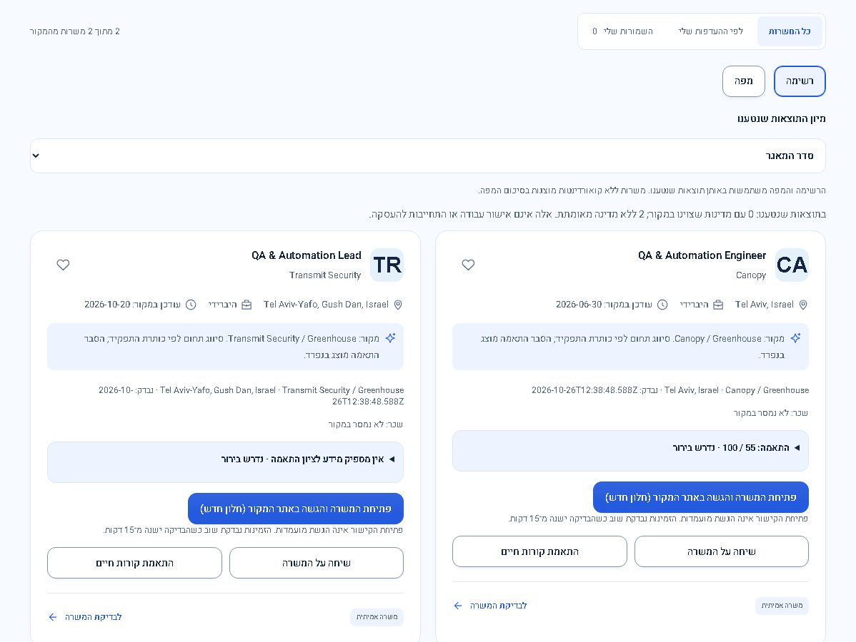
After implementation — two source jobs retained, including Canopy. List totals and accessible map entries agree. Source timestamps differ because the official payloads were reobserved.

Descriptions and compensation evidence
Original audit screenshot, page14 Figure6 — the supplied audit’s annotated Canopy description. This is original audit evidence, not a new before capture.

After implementation — beginning of Canopy description, actual local UI. Safe decoded text preserves sections, lists and original order. Full description and both-theme mobile pairs are in the gallery.

B04 independently verified in source fixtures: Datadog USD149000–198000/year and USD192000–240000/year remain labelled estimates. JFrog USD160000–190000 and USD250000–275000 base ranges remain present but unstructured because period is unspecified. No currency conversion or salary guarantee was added.

Mobile search and salary presentation
Search starts before verbose source explanations. The paired mobile captures use a 390 × 664 viewport on a 390 × 844 screen at scale3. The additional 390 × 844 check below is after-only. Search bottom was y509 at the smaller viewport, fully visible.
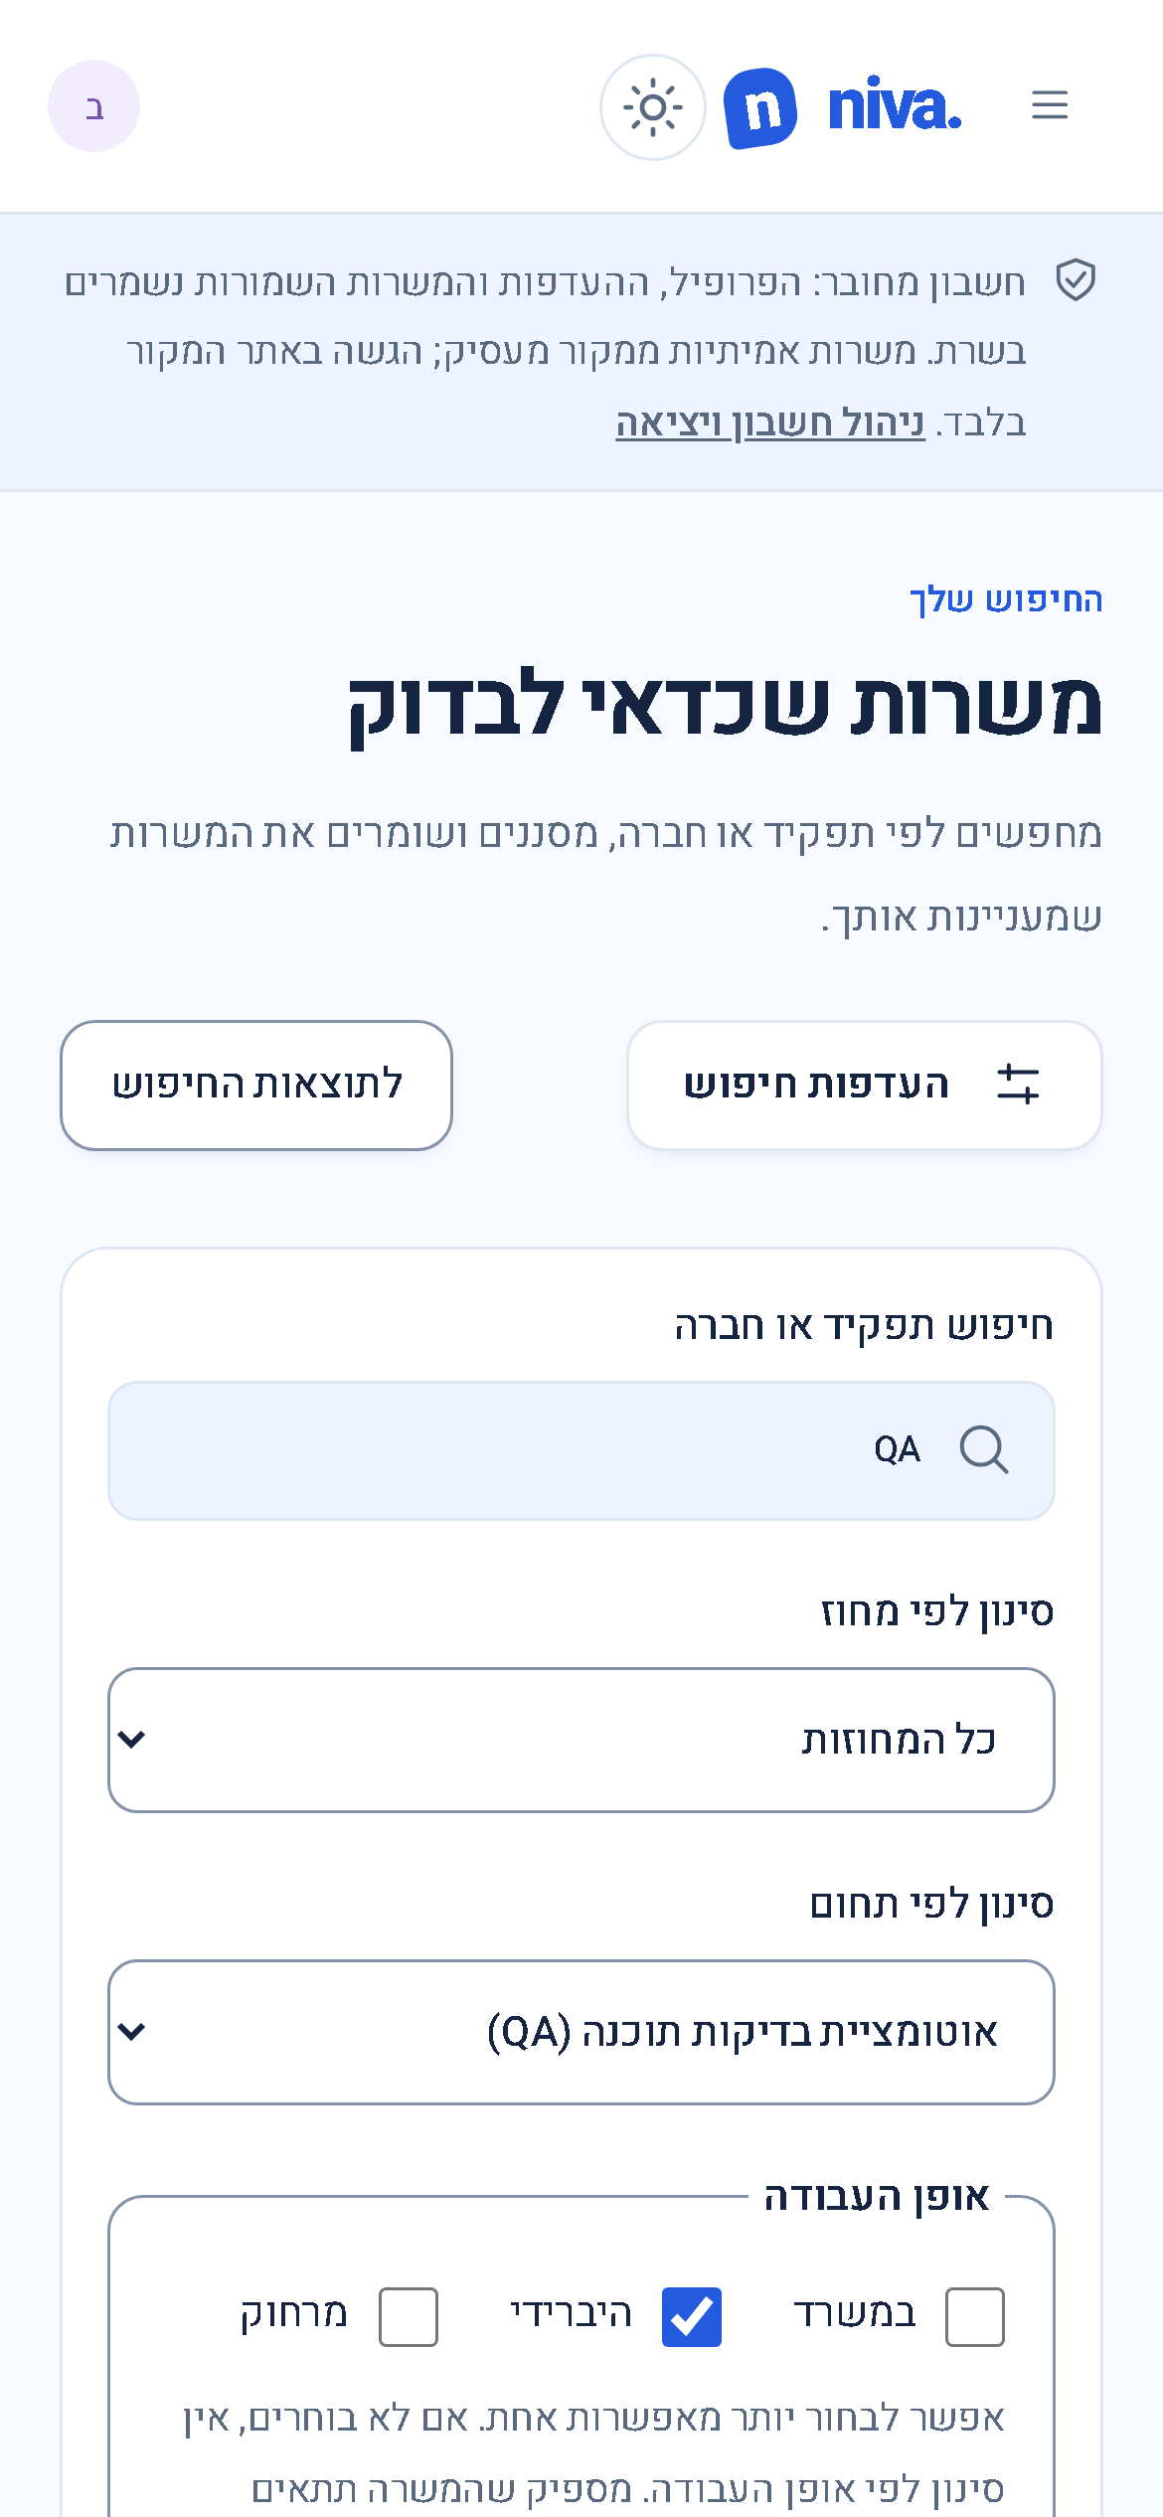  After only — 390 × 844 search viewport | 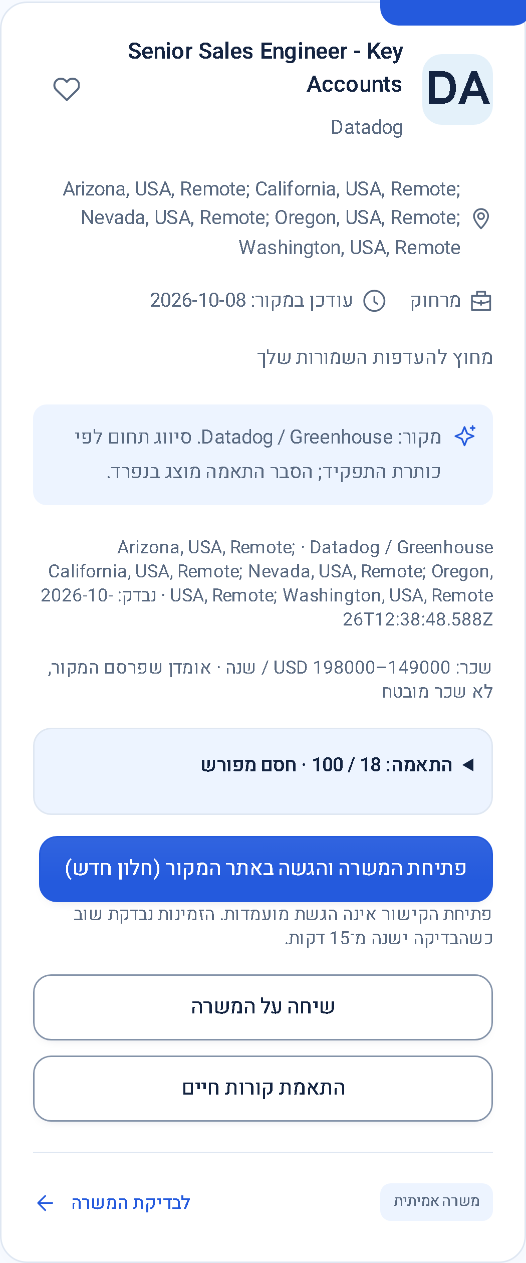  After — R09 estimate and eligibility shown
The salary after capture uses explicit eligibility=all inspection so a foreign-country blocker remains visible. The before salary capture did not use that parameter; this is not an identical-route comparison. Public vacancy content is real; citizenship and other account facts are synthetic.
No horizontal overflow was observed. Four audit-case axe scans returned zero violations. Keyboard, theme, reflow and accessible map fallback regressions passed. Physical phones, spoken Hebrew screen-reader output and full conformance remain untested.

Executed checks and release limits
Check | Actual result and correction
Frontend full suite | 58 passed / 1 failed. Updated Playwright coverage expectation; focused matching 16/16 passed.
Server full suite | 146 passed / 1 failed. Requirements heading added to the cache-test source fixture. Latest career 18 plus audit 13 = 31/31 passed, including5 added audit regressions.
Chromium full suite | 212 passed / 6 failed of 218. Two duplicate stale-copy failures fixed in UI; four onsite-map fixtures made metadata-consistent. All6 plus 4 audit cases passed10/10 on rerun.
Latest audit browser check | 4/4 passed after latest extraction, with explicit390x844 checks in both themes.
Runtime and provenance | Worker request-context 1/1 and source-provenance 1/1 passed.
Build and types | Production build and frontend/server/browser typechecks passed. Formatting finalized with documentation.
The full relevant suite ran once near completion; affected checks were repeated after corrections. The initial full runs were not green. Test receipts identify local SQLite/D1-contract and Chromium scope; they do not certify hosted D1 behavior or real AI quality.

Performance evidence
In a synthetic 5000-row local benchmark, bounded metadata reads reduced sampled heap from 145.7MB to 36.1MB and returned database JSON from 34.6MB to 13.7MB; observed latency 523ms to 428ms. This compares the rich-evidence implementation before/after bounding, not a proven old-production incident. Heap sampling is not true peak. Field Core Web Vitals, Worker memory and D1 latency remain unmeasured.

Review and staging prerequisites
- Review local diffs and the full tracker before release. Recheck first-request cache upgrades and the next due ATS ingestion on staging. Existing missing provider metadata must not become invented facts.
- Close S02 with real operational evidence before making a production-readiness claim. Verify hosted identity isolation, cleanup cycles, alerts and restoration separately.
- Keep unavailable AI/scanning integrations unavailable. Optional per-job hiding/stage tracking, negative-term search and calibrated global ranking are explicitly deferred.

Code evidence and supporting records
Workspace: C:/Users/zivna/Documents/workme/niva-tailwind. All changes are local and uncommitted. The initial workspace was clean. Historical screenshots were preserved; the new audit40 gallery contains genuine implementation comparisons.

Source facts and persistence
server/job-facts.ts; source-evidence.ts; greenhouse-source.ts; reindex-facts.ts; discovery.ts. Official Greenhouse pay/publication/requisition fields and Lever onsite metadata are retained. Public JSON upgrades are bounded and concurrency-safe.

Matching and confirmed profile
src/app/core/requirements.ts; matching.ts; job-assessment.ts; candidate-validation.ts; models/discovery.ts; src/app/shared/candidate-profile.ts. Required/preferred/collaboration scopes and candidate-confirmation boundaries are shared.

Safe content and search UI
src/app/core/description-text.ts; pay-label.ts; src/app/shared/job-description.ts; match-indicator.ts; job card/detail templates; src/app/pages/jobs.ts and jobs.html. The only new direct runtime dependency is entities8.1.0.

Regression evidence
server/audit40.spec.ts; tests/audit40.spec.ts; tests/audit40-data.ts; tests/fixtures/audit40-public.json; scripts/audit40-cohort.ts; scripts/audit40-benchmark.ts. Public vacancy payloads contain no private CV/account data.

Review records
docs/job-finding-audit-20261026.md; docs/verification/audit40-findings.json; audit40-cohort.json; audit40-scenarios.json; audit40-tests.json; audit40-benchmark.json; docs/screenshots/changes/audit40-images.md; CHANGELOG.md.
Run the cohort/benchmark scripts from the repository root. Benchmark writes only disposable synthetic local data. Raw test logs and document QA renders remain in .test-data/audit40; no production secrets or personal records are included in the delivered reports.
Live site — unchanged by this audit pass
Repository — local changes are not yet pushed
The implementation repairs demonstrated source interpretation defects and makes relevant strict-filter leads visible. Missing external facts remain unknown, and successful application submissions are never claimed. The work is ready for review and controlled staging; production operational verification is still required.

