Markdown
Markdown is a way to write content for the web. It’s written in what people like to call “plain text”, which is exactly the sort of text you’re used to writing and seeing. Plain text is just the regular alphabet, with a few familiar symbols, like asterisks ( * ) and backticks ( ` ). It doesn’t do anything fancy like change the font size, color, or type. All you have control over is the display of the text—stuff like making things bold, creating headers, and organizing lists.
1-Italics
To make a phrase italic in Markdown, you can surround words with an underscore (_ ). For example, _this_ word would become italic.
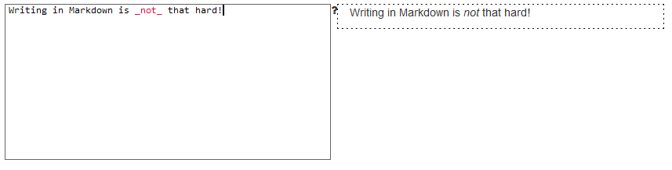
2-Bold
to make phrases bold in Markdown, you can surround words with two asterisks ( ** ). This will **really** get your point across.
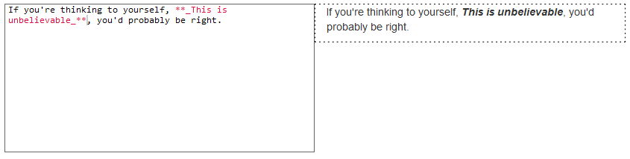

3-Headers
There are six types of headers, in decreasing sizes:

This is header one

This is header two

This is header three

This is header four

This is header five

This is header six
To make headers in Markdown, you preface the phrase with a hash mark (#). You place the same number of hash marks as the size of the header you want. For example, for a header one, you'd use one hash mark (# Header One), while for a header three, you'd use three (### Header Three).
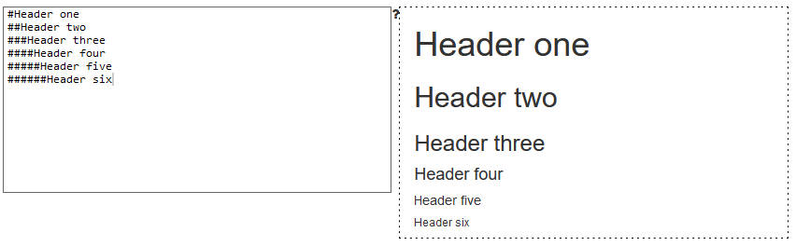

4-Links
There are two different link types in Markdown, but both of them render the exact same way. The first link style is called an inline link. To create an inline link, you wrap the link text in brackets ( [ ] ), and then you wrap the link in parenthesis ( ( ) ). For example, to create a hyperlink to www.github.com, with a link text that says, Visit GitHub!, you'd write this in Markdown: [Visit GitHub!](www.github.com).
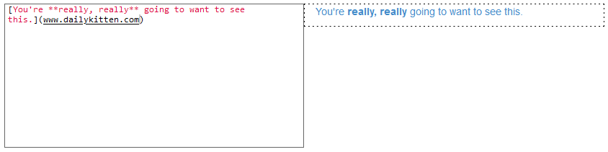
The other link type is called a reference link. As the name implies, the link is actually a reference to another place in the document. Here's an example of what we mean:
Here's [a link to something else][another place].
Here's [yet another link][another-link].
And now back to [the first link][another place].

[another place]: www.github.com
[another-link]: www.google.com
The "references" above are the second set of brackets: [another place] and [another-link]. At the bottom of a Markdown document, these brackets are defined as proper links to outside websites. An advantage of the reference link style is that multiple links to the same place only need to be updated once. For example, if we decide to make all of the [another place] links go somewhere else, we only have to change the single reference link.
Reference links don't appear in the rendered Markdown. You define them by providing the same tag name wrapped in brackets, followed by a colon, followed by the link.
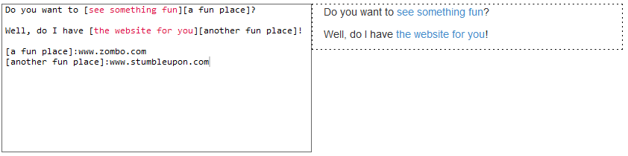
5-Images
Images also have two styles, just like links, and both of them render the exact same way. The difference between links and images is that images are prefaced with an exclamation point ( ! ).
The first image style is called an inline image link. To create an inline image link, enter an exclamation point ( ! ), wrap the alt text in brackets ( [ ] ), and then wrap the link in parenthesis ( ( ) ). (Alt text is a phrase or sentence that describes the image for the visually impaired.)
For example, to create an inline image link to https://octodex.github.com/images/bannekat.png, with an alt text that says, Benjamin Bannekat, you'd write this in Markdown: ![Benjamin Bannekat](https://octodex.github.com/images/bannekat.png).
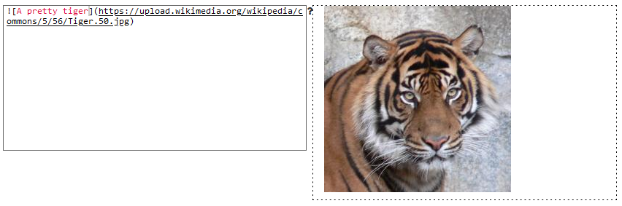
For a reference image, you'll follow the same pattern as a reference link. You'll precede the Markdown with an exclamation point, then provide two brackets for the alt text, and then two more for the image tag, like this: ![The founding father][Father] At the bottom of your Markdown page, you'll define an image for the tag, like this: [Father]: http://octodex.github.com/images/founding-father.jpg.
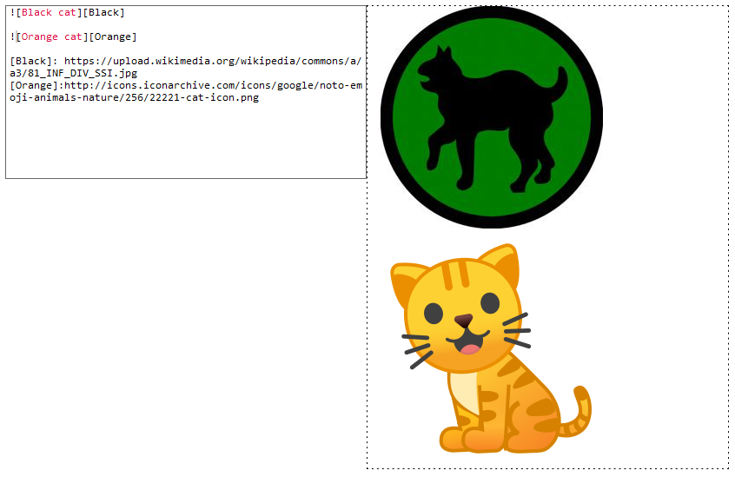
6-Blockquotes
A blockquote is a sentence or paragraph that's been specially formatted to draw attention to the reader.
To create a block quote, all you have to do is preface a line with the "greater than" caret (>). For example:
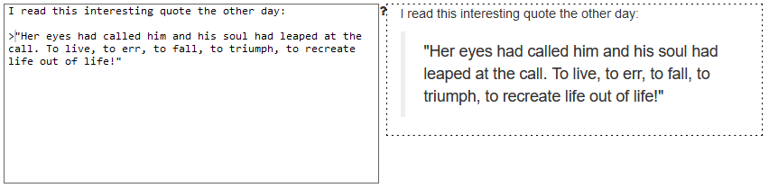

7-Lists
There are two types of lists in the known universe: unordered and ordered. That's a fancy way of saying that there are lists with bullet points, and lists with numbers.
To create an unordered list, you'll want to preface each item in the list with an asterisk ( * ). Each list item also gets its own line. For example,
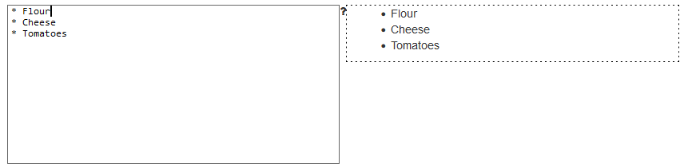
An ordered list is prefaced with numbers, instead of asterisks. Take a look at this recipe:
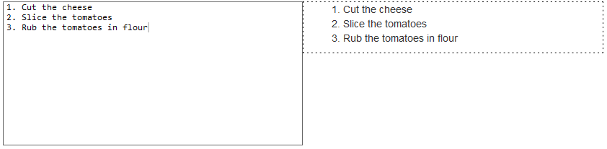
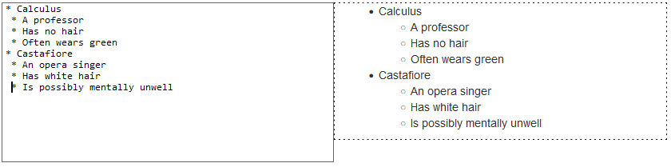
8-Paragraphs
If you forcefully insert a new line, you end up breaking the togetherness:
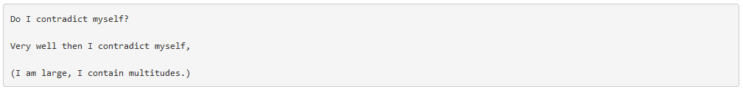
This is what's known as a hard break; what our poetry asks for is a soft break. You can accomplish this by inserting two spaces after each new line. This is not possible to see, since spaces are invisible, but it'd look something like this:
Each dot ( · ) represents a space on the keyboard.

