Git command

What is GIT and Github?
* GIT is a Distributed Version Control System
* GIT is free and open source
* Github is source for project and sources
* Github simplify using Git
* You can use Git without using Github
Why GIT?
* Devs contribute to the same project
* You can revert changes
* You can collaborate to create new features
* You can solve conflicts
* You can organize features

1- create repo and clone it
git clone https://github.comorabi00/GIT_course.git
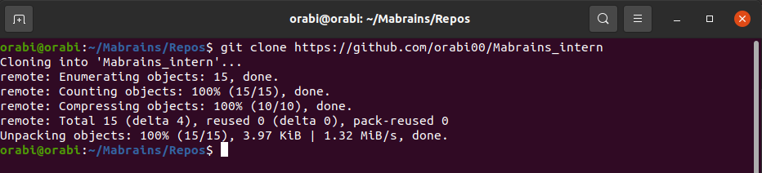

2- Add, reset, and commit
git status //show the current status
git add filename //add to staging area

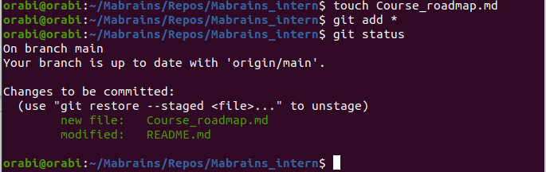
git reset head filename //down from staging area
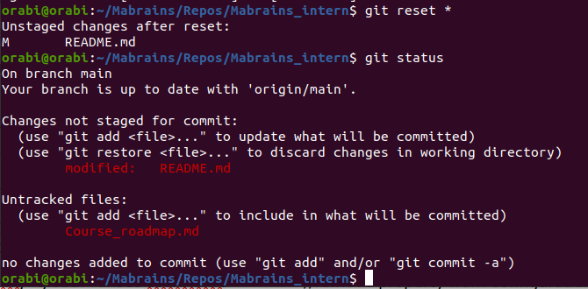

git commit –m “My message” //send new changes to the local repo
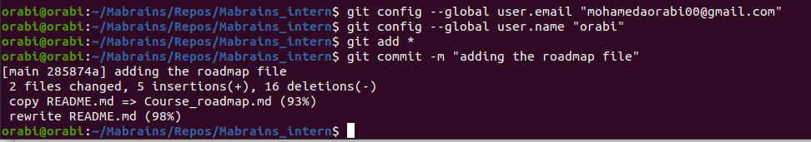
3- push local changes to remote
git branch //show branch name
git remote –v //show remote name
git push remote_name branch_name // push local changes to remote
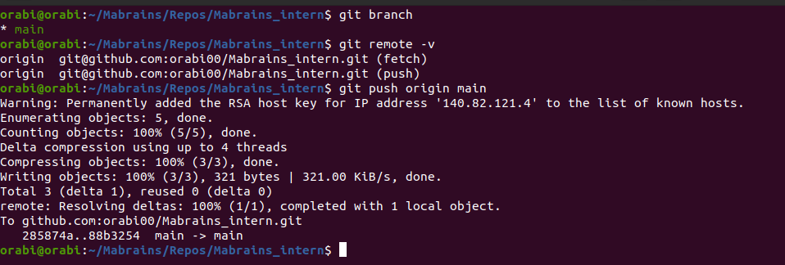
4- pull new changes from remote
git pull remote_name // fitch and merge the repo from the remote repo to the local repo
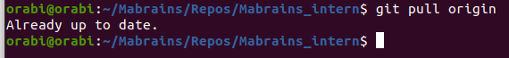

5- Configuration
git config –l // display all config commands
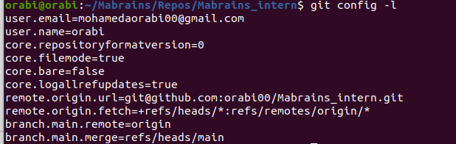

git config –global user.name “myname” //to modify the user name and so on in other configs
git config –global –unset user.name //remove property from configuration
git config –-global –-edit // go to config editor
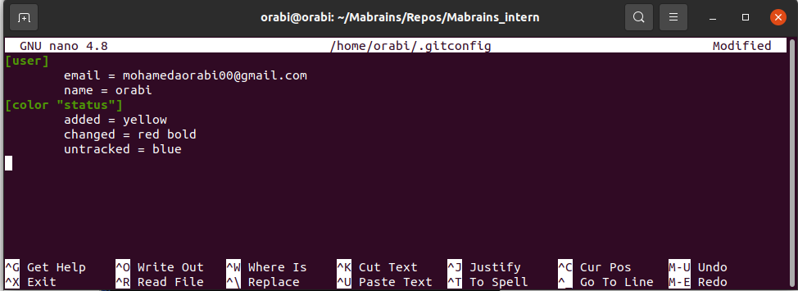

touch file.txt //make a new file
git status //to see changed colors
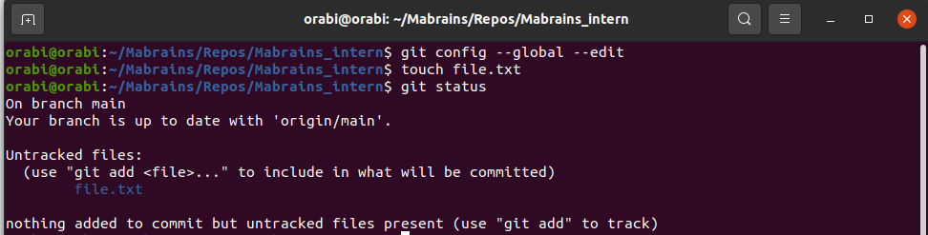
6- Generate and test public key
ssh-keygen –t rsa –b 4096 //to generate a secure key,t for the type of the algorithm, b for the number of bits
cat ~/.ssh/id_rsa.pub //get the key from the file
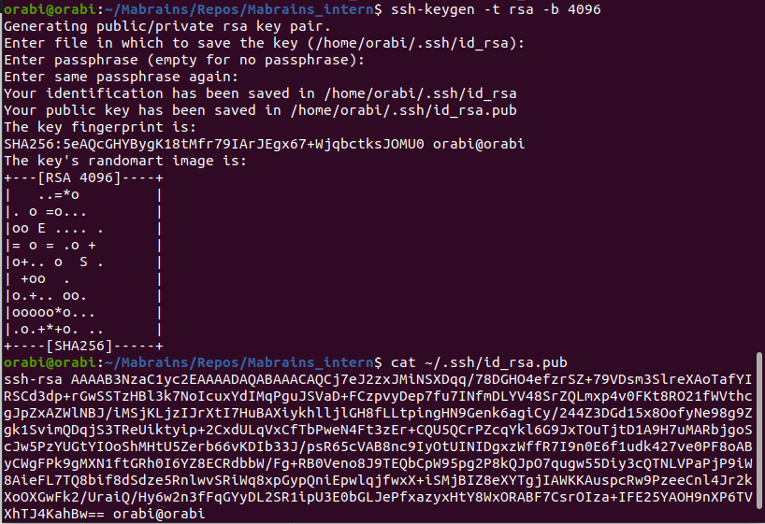
In github from “SSH and GPG Keys” add the the key
Connect the pc with the new key
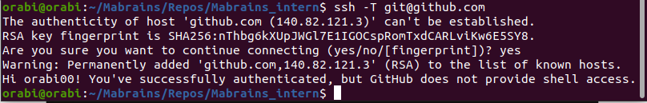
7- Aliases
//making alias to some command to make it easy to use
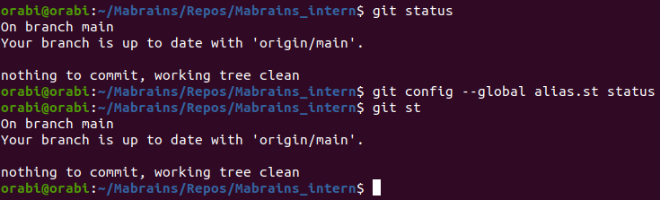
8- branching and merge
git branch new //make a new branch
git checkout new //switch to the new branch
git branch –d new //to delete a branch{-d to check if there is any change and then delete ,-D force delete without checking}
git checkout –b new2 // make a branch and jump to it
git branch –m new2.1 // to rename the branch I’m in it
git merge new2.1 // inside the main branch merge the two branches together
git push remotename new2.1 //to push the new branch to the repo,with message with the pull request link

10- stash
git stash //after adding my files to the staging area I save it in stash for me and they will not commit.
git stash list //to show my stash box content
git stash pop //to drop last box from stash boxes

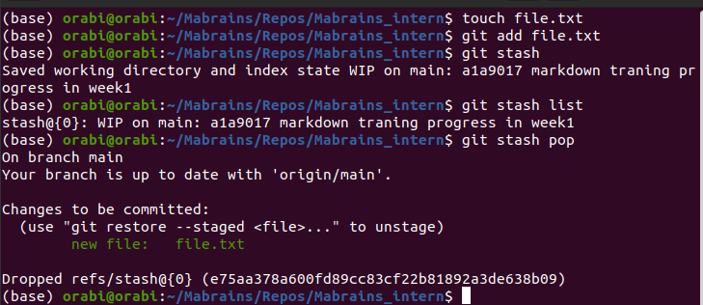
git stash save “message” //stash file with comment
git stash apply // drop a copy of the last box from the stash
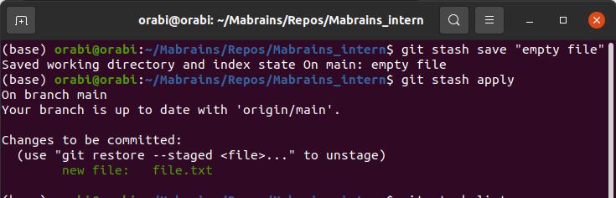
git stash pop stash@{0} //drop a certain box

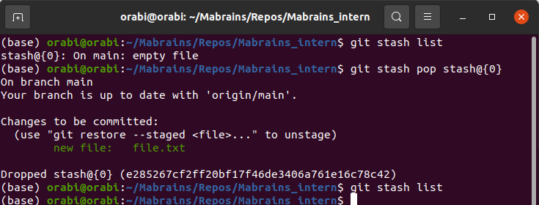

git stash drop //to delete a box from stash
git stash show // to show what is inside the last box in the stash
git stash clear // delete all boxes in the stash

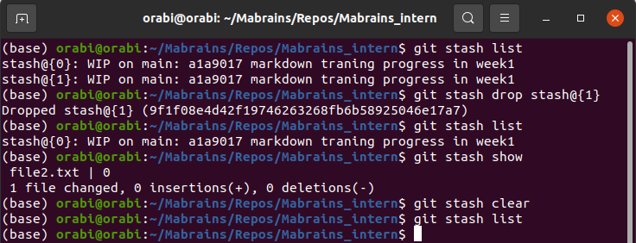

11- restore and clean
git restore –-staged file.txt //restore new.txt from stage area {use * to restore all}
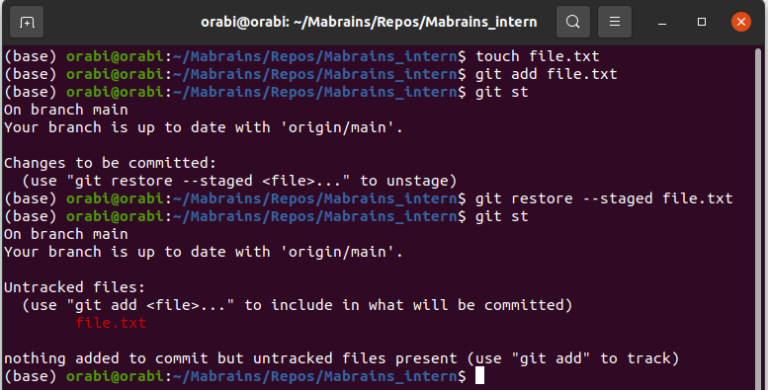

git clean –n //show you the files will delete them
git clean –f //to delete the un-staged files

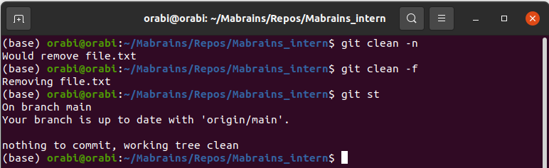

12- resetting the head
git log //show the head pointer and the othe commits
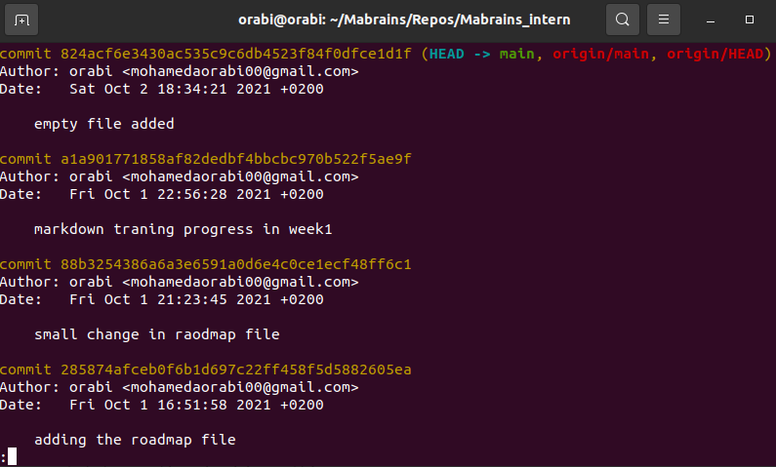
To restore the last commit we need the head pointer to not point to it,every commit has a hash code
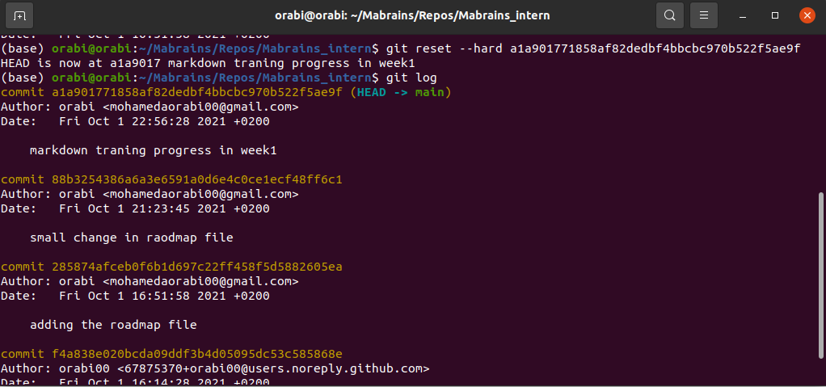
git reset –-hard a1a901771858af82dedbf4bbcbc970b522f5ae9f //make the head to point to another hash(commit)

13- ignoring files and dirs.
touch .gitignore //make a file to write inside it all what I want to ignore when I add files to the stage area {* for all extension,! To except one,node_packs/ is a folder name}
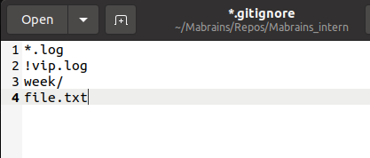

git add –f file.txt //force adding a file even I ignore it

14- tag and release
git tag //to show your tags
-light weight tag take the message from the commit
git tag v1.0 //make a new tag v1.0
git push origin v1.0 //push my tag to github
-annotated tag need new description
git tag –a v2.0 –m “our project second version”
git tag –l “v1.*” //list all version1 tags
git tag –d v1.1 //delete a local tag
git push origin –-delete v1.0 //delete a remote tag

