Ch6:Getting Help

6.1 Introduction
There are thousands of commands available with many options, making the command line a powerful tool. However, with this power comes complexity. Complexity, in turn, can create confusion. As a result, knowing how to find help while working in Linux is an essential skill for any user. Referring to help provides a quick reminder of how a command works, as well as being an information resource when learning new commands.

6.2 Man Pages
UNIX is the operating system that Linux was modeled after. The developers of UNIX created help documents called man pages (short for manual pages).
Man pages are used to describe the features of commands. They provide a basic description of the purpose of the command, as well as details regarding available options.

6.2.1 Viewing Man Pages
To view a man page for a command, use the man command:
man command

6.2.2 Sections Within Man Pages
NAME
Provides the name of the command and a very brief description.
SYNOPSIS
Provides examples of how the command is executed.
DESCRIPTION
Provides a more detailed description of the command.
OPTIONS
Lists the options for the command as well as a description of how they are used. Often this information is found in the DESCRIPTION section and not in a separate OPTIONS section.
FILES
Lists the files that are associated with the command as well as a description of how they are used. These files may be used to configure the command's more advanced features. Often this information is found in the DESCRIPTION section and not in a separate FILES section.
AUTHOR
Provides the name of the person who created the man page and (sometimes) how to contact the person.
REPORTING BUGS
Provides details on how to report problems with the command.
COPYRIGHT
Provides basic copyright information.
SEE ALSO
Provides you with an idea of where you can find additional information. This often includes other commands that are related to this command.

6.2.3 Searching Man Pages
To search a man page for a term, type the / character followed by a search term, then hit the Enter key. The program searches from the current location down towards the bottom of the page to try to locate and highlight the term.

To search for man pages by name, use the -f option to the man command. It displays man pages that match, or partially match, a specific name and provide the section number and a brief description of each man page:
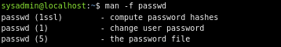

To specify a different section, provide the number of the section as the first argument of the man command. The following command displays the passwd man page located in section 5, which is associated with the passwd file:

The -k option to the man command searches both the names and descriptions of the man pages for a keyword.

6.3.1 Find Any File or Directory
The whereis command is specifically designed to find commands and man pages. While this is useful, it is often necessary to find a file or directory, not just files that are commands or man pages.
To find any file or directory, use the locate command. This command searches a database of all files and directories that were on the system when the database was created. Typically, the command to generate this database is run nightly.
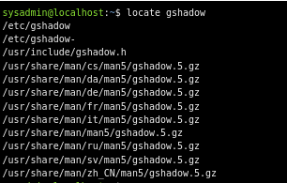

Any files created today will not be searchable with the locate command. If root access is available, it’s possible to update the locate database manually by running the updatedb command. Regular users cannot update the database file.
In many cases, it is helpful to start by finding out how many files match. Do this by using the -c option to the locate command:

To limit the output produced by the locate command use the -b option. This option only includes listings that have the search term in the basename of the filename. The basename is the portion of the filename not including the directory names.
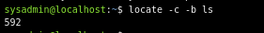

As you can see from the previous output, there will still be many results when the -b option is used. To limit the output even further, place a \ character in front of the search term. This character limits the output to filenames that exactly match the term:
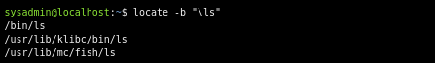

6.4 Info Documentation
The info command also provides documentation on operating system commands and features. The goal is slightly different from man pages: to provide a documentation resource that gives a logical organizational structure, making reading documentation easier.

6.4.1 Viewing Info Documentation
To display the info documentation for a command, use the info command.
info command

6.5 Using the Help Option
Many commands will provide basic information, very similar to the SYNOPSIS found in man pages, by simply using the --help option to the command. This option is useful to learn the basic usage of a command quickly without leaving the command line.

Ch7:Navigating the Filesystem

7.1 Introduction
In Linux, everything is considered a file. Files are used to store data such as text, graphics, and programs. Directories are a type of file used to store other files; Windows and Mac OS X users typically refer to them as folders. In any case, directories are used to provide a hierarchical organization structure.

7.2 Directory Structure
The Linux directory structure, typically called a filesystem, also has a top level. However instead of My Computer, it is called the root directory, and it is symbolized by the slash / character. Additionally, there are no drives in Linux; each physical device is accessible under a directory, as opposed to a drive letter.
The following image shows a visual representation of a typical Linux filesystem:
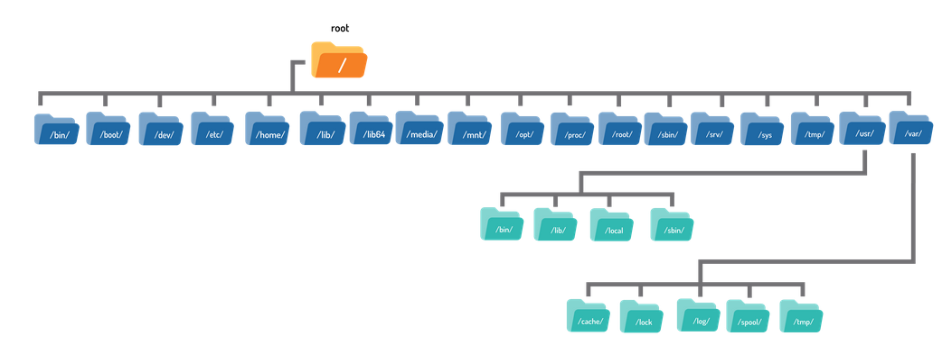
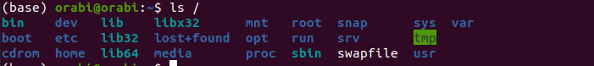

7.2.1 Home Directory
On most Linux distributions there is a directory called home under the root / directory.
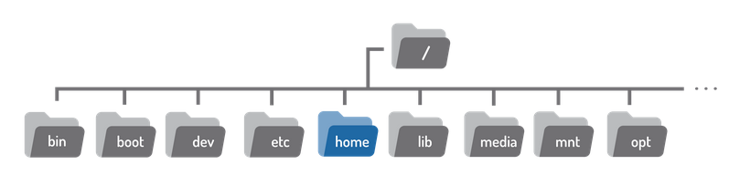

Under this /home directory there is a directory for each user on the system. The directory name is the same as the name of the user, so a user named sysadmin would have a home directory called /home/sysadmin.
The home directory has a special symbol used to represent it; the tilde ~ character. So if the sysadmin user is logged in, the tilde ~ character can be used in place of the /home/sysadmin directory.

7.3 Paths
The argument to the cd command is more than just the name of a directory, it is actually a path. A path is a list of directories separated by the / character. If you think of the filesystem as a map, paths are the directory addresses, which include step-by-step navigation directions; they can be used to indicate the location of any file within the filesystem.
There are two types of paths: absolute and relative.

7.3.1 Absolute Paths
Absolute paths allow the user to specify the exact location of a directory. It always starts at the root directory, and therefore it always begins with the / character. The path /home/sysadmin is an absolute path; it tells the system to begin at the root / directory, move into the home directory, and then into the sysadmin directory.
If the path /home/sysadmin is used as an argument to the cd command, it moves the user into the home directory for the sysadmin user.

7.3.2 Relative Paths
Relative paths start from the current directory. A relative path gives directions to a file relative to the current location in the filesystem. They do not start with the / character. Instead, they start with the name of a directory. More specifically, relative paths start with the name of a directory contained within the current directory.

7.3.3 Shortcuts

The .. Characters
Regardless of which directory the user is in, two period .. characters always represents one directory higher relative to the current directory, sometimes referred to as the parent directory. To move from the Art directory back to the School directory:
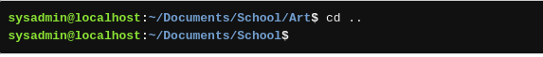

7.4 Listing Files in a Directory
This ls command is used to display the contents of a directory and can provide detailed information about the files. By default, when it is used with no options or arguments, it lists the files in the current directory:
The ls command can also be used to list the contents of any directory in the filesystem. Provide the path to the directory as an argument:

7.4.1 Listing Hidden Files
When the ls command is used to display the contents of a directory, not all files are shown automatically. The ls command omits hidden files by default. A hidden file is any file (or directory) that begins with a dot . character.
To display all files, including hidden files, use the -a option to the ls command:
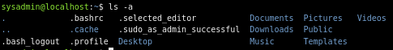

7.4.2 Long Display Listing
Each file has details associated with it called metadata. This can include information such as the size, ownership, or timestamps. To view this information, use the -l option to the ls command.

7.4.3 Recursive Listing
There are times when you want to display all of the files in a directory as well as all of the files in all subdirectories under that directory. This is called a recursive listing.
To perform a recursive listing, use the -R option to the ls command:
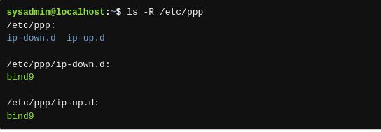

7.4.6 Sort a Listing
By default, the ls command sorts files alphabetically by file name. Sometimes, it may be useful to sort files using different criteria.
To sort files by size, we can use the -S option.
The -t option sorts files based on the time they were modified.
It is possible to perform a reverse sort by using the -r option.

