1-create script

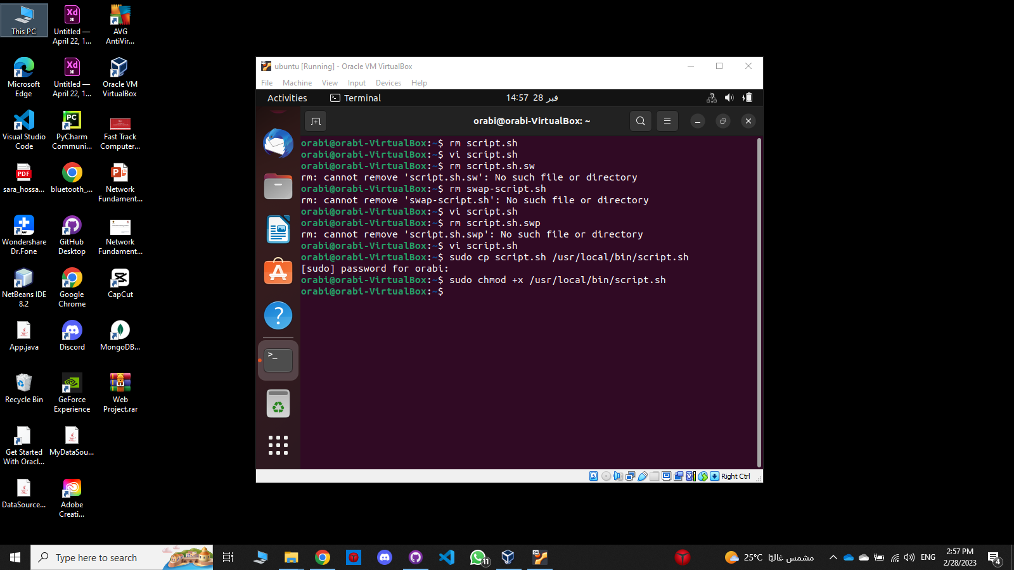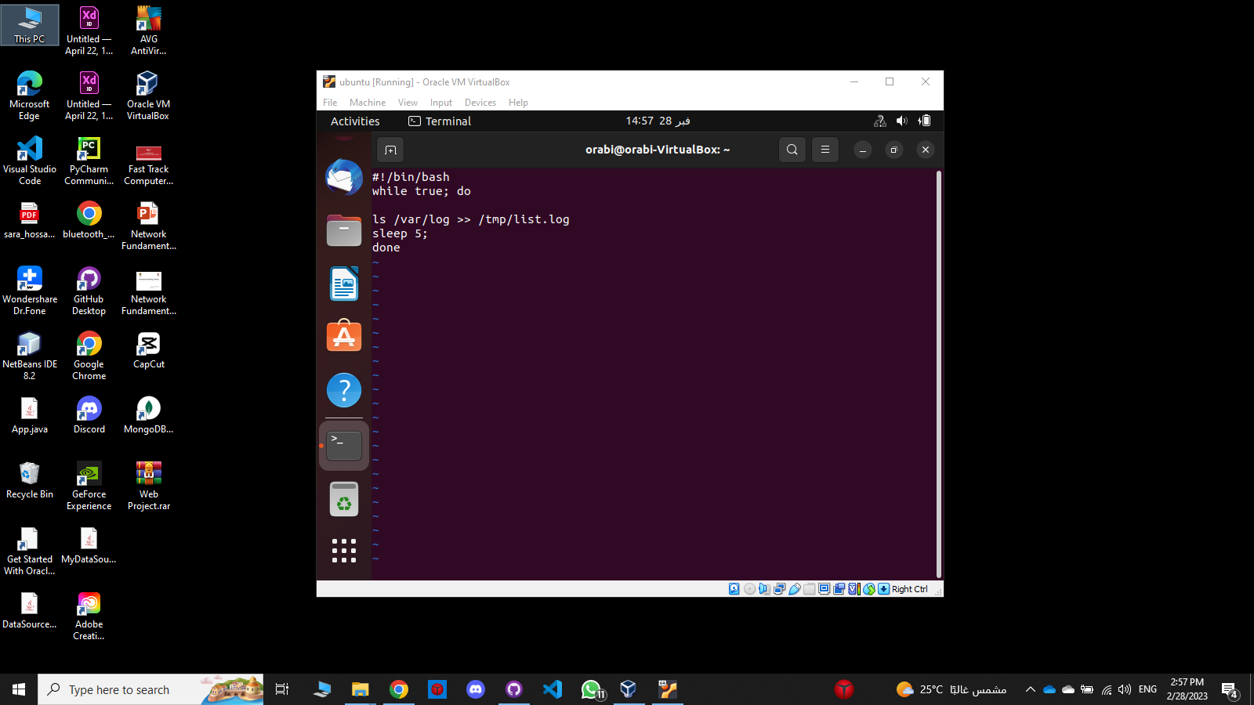

2-copy script:

3-

4-crontab -e then:

