1-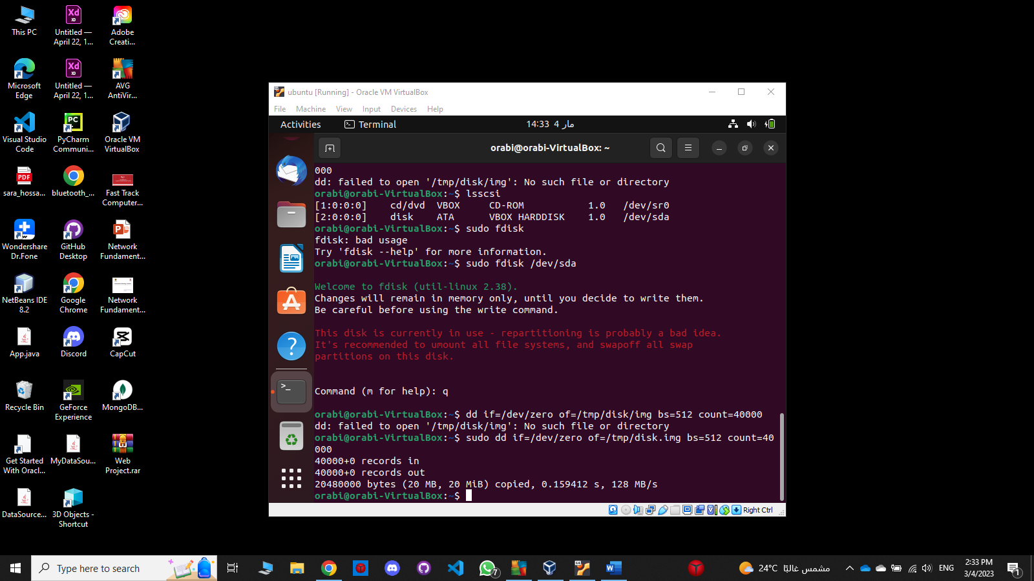

3-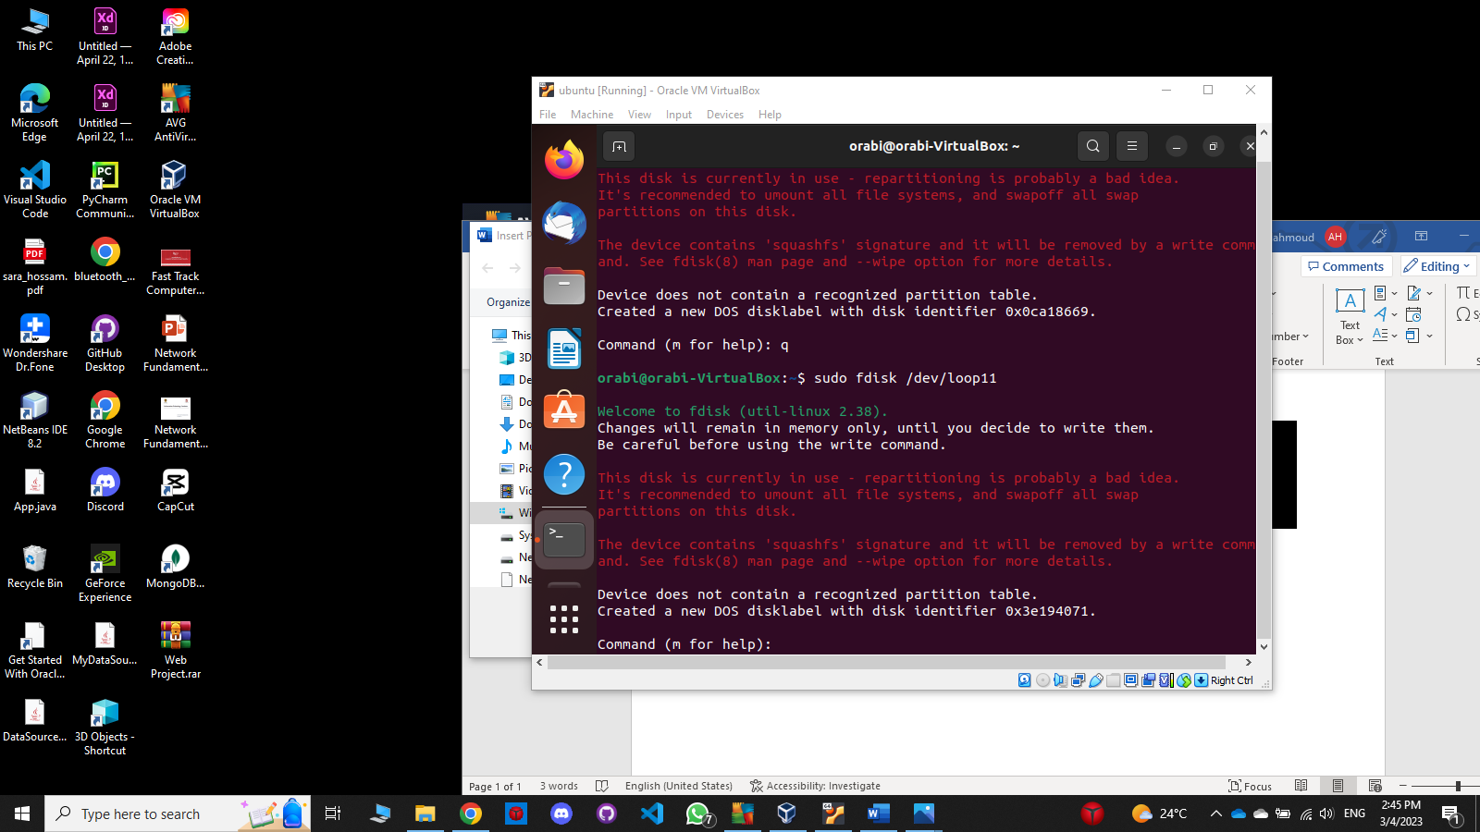

4-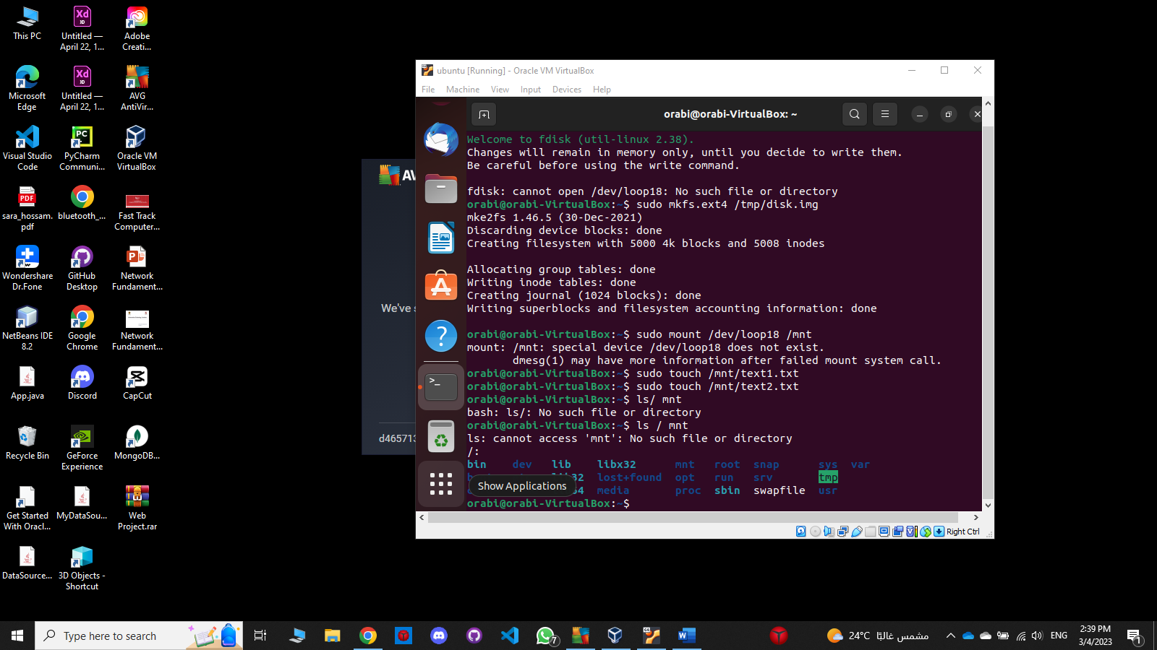

5-

7-

