Ticket Management System
Architecture overview — draft for review
Prepared for internal review before development begins. Sample screens are low-fidelity wireframes for layout and flow discussion only.

1. Purpose
This document describes the intended structure of a Ticket Management System where an Admin (super user) can raise and assign complaints/tickets to one or more users, users can raise their own tickets, and all activity is tracked, logged, and closed only through a confirmed request-and-approval step. It also covers how new users are onboarded through a public registration link that requires Admin approval before access is granted.
The goal of this document is to align on scope and workflow before any development work starts.

2. Roles and access
Role | Can do
Super Admin / Admin | Full visibility of all tickets and users; create and assign tickets to one or multiple users; approve or reject new user registrations; reopen/mark tickets as not completed; manage ticket types, priorities, and statuses; approve closure requests.
User | View tickets assigned to them; update status on their own assigned tickets; raise new tickets/complaints for a customer; request closure once work is done; view tickets they personally raised.

3. Core workflows

3.1 Admin creates and assigns a ticket
- Admin opens a new ticket against a customer, sets type and priority, and assigns it to one user, or multiple users at once.
- Each assigned user sees the ticket in their own queue and can update their own progress.
- When a user marks their part complete, that is logged with their name and timestamp.
- If Admin reviews a completed ticket and finds it is not actually done, Admin can mark it Not completed / reopened, with a required remark — this is an Admin-only action and is fully logged.

3.2 Multiple users on one ticket
- A ticket can be assigned to more than one user at the same time.
- Each assigned user has their own status against the same ticket (for example, one may finish before the other).
- The ticket's overall status is derived from all assignees' progress, though Admin can override it manually if needed.

3.3 User-raised tickets
- Any confirmed user can raise their own ticket/complaint for a customer — this does not require Admin to create it first.
- Admin's dashboard clearly separates “raised by Admin” from “raised by team”, so nothing is mixed up.
- Admin retains full visibility of every ticket regardless of who raised it.

3.4 Closure request and confirmation
- A user does not close a ticket outright — they submit a closure request once work is done.
- The ticket moves to a Pending closure state, visible to Admin.
- Admin reviews and confirms (or sends it back).
- On confirmation, both the requesting user and Admin receive a notification of the final outcome.

3.5 New user registration (public link)
- Admin shares a public link that does not require an existing login.
- The link opens a registration form with mandatory fields and a valid work email.
- On submission, the person is placed in a Pending state — they cannot log in yet.
- Admin sees all pending registrations on a Users page on the dashboard, alongside already-approved users.
- Admin approves or rejects each request.
- On approval, the system sends an email notification to the user confirming they can now log in and use the system.

3.6 Attachments
- A file can be attached wherever a ticket is created or updated — by Admin when raising or assigning it, by an assigned user while working on it, and by a user when submitting a closure request.
- Each attachment records who uploaded it and when, and is shown alongside the ticket's other details and its activity log.
- Allowed file types and a maximum file size will need to be agreed (see open items) so this stays a supporting-evidence feature rather than a general file store.

4. Activity logging
Every status change, assignment, reopen action, closure request, closure confirmation, and user approval is recorded with who performed the action and when. This is intended as a straightforward activity trail for accountability, not a separate feature to configure.

5. Notifications
Event | Who is notified
User registration approved | The new user, by email
Ticket assigned | The assigned user(s)
Closure requested | Admin
Closure confirmed / rejected | The requesting user and Admin
Ticket marked not completed by Admin | The assigned user(s)

6. Sample prototype screens
The following are low-fidelity layout sketches to confirm structure and flow — not final visual design.

6.1 Admin dashboard
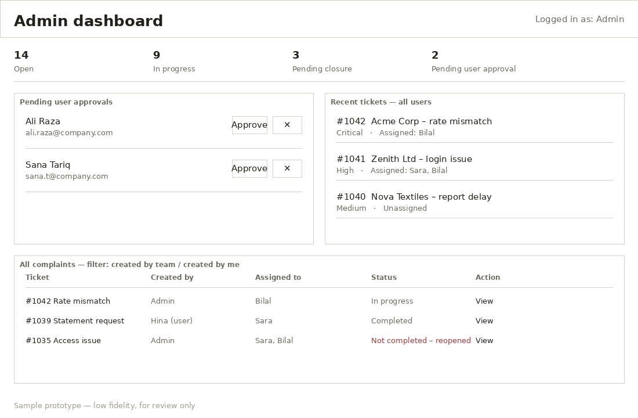
Admin view: pending user approvals, recent tickets across all users, and the full complaints list with created-by / assigned-to visibility.

6.2 Public user registration form
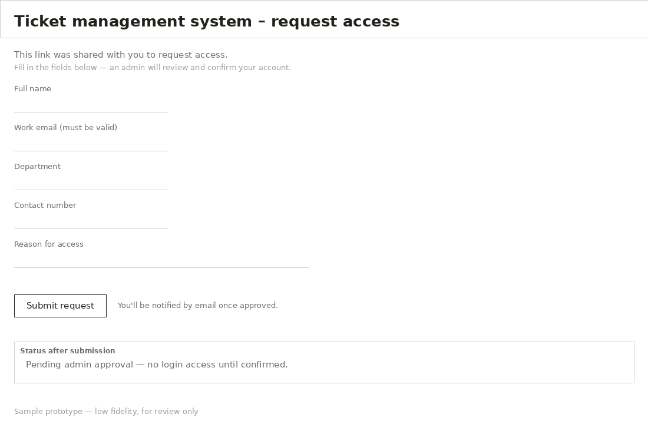
Opens from a shared link, no login required. Submission goes into a pending state awaiting Admin review.

6.3 Ticket detail with multiple assignees
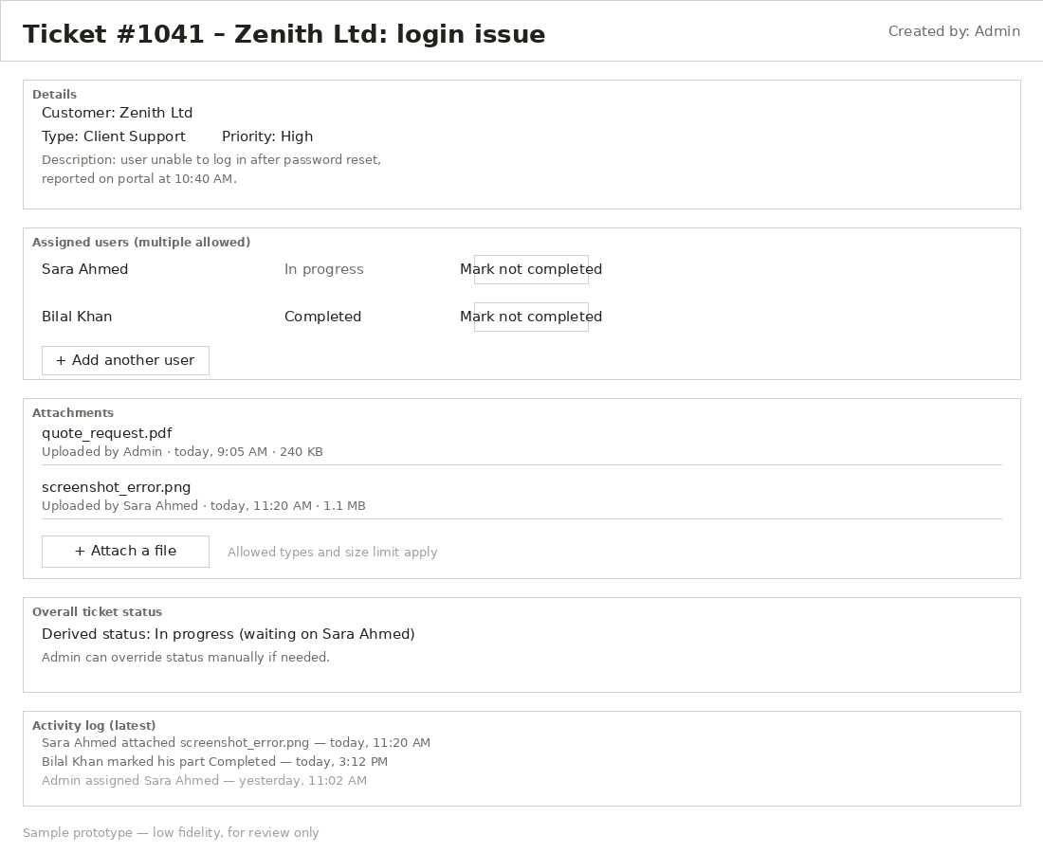
One ticket assigned to more than one user, each with their own status, plus the Admin-only “mark not completed” action.

6.4 User's own view
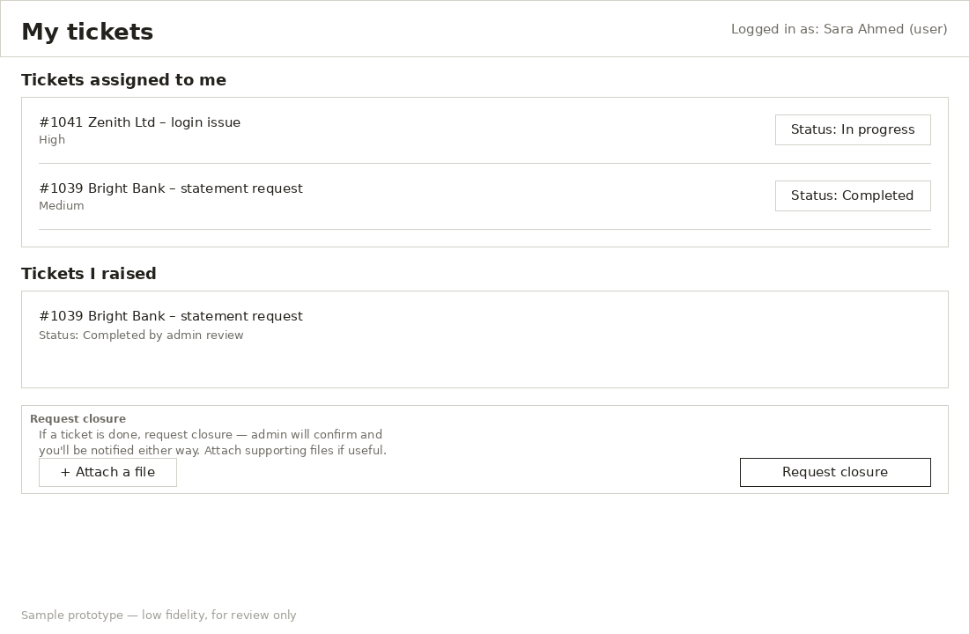
A regular user sees tickets assigned to them and tickets they raised themselves, with a closure request action.

7. Open items to confirm before the data model is finalized
- Should Admin be able to reassign a ticket away from a user entirely, or only add/remove from a multi-assignee list?
- For a multi-assigned ticket, does the overall status require all assignees to complete, or is Admin's manual call always final?
- Email delivery: should this use the mail configuration already available on the Oracle/APEX instance, or a separate mail service?
- Should rejected registration requests also receive an email, or simply be removed silently?
- Retention: how long should activity logs and closed tickets be kept before archiving?
- Attachments: what file types and maximum size should be allowed, and should files be stored in the database (BLOB) or on a file server the database references?
Once these are confirmed, the next step is the full table structure and status workflow diagram.

