
Statement of Direction
Oracle Database@Azure
Customer Onboarding
Activation Runbook

<CUSTOMER NAME>
A concise guide to prepare for commercial activation, onboarding, and provisioning.
<DATE>
Version 1.0
Copyright © 2026, Oracle and/or its affiliates
Confidential – Oracle Restricted
Purpose
This runbook gives the customer, Oracle account team, and Azure stakeholders a single sequence for moving through Azure Marketplace acceptance, OCI tenancy linking, and provisioning readiness. Replace bracketed placeholders before sharing with a specific customer.

Executive Summary
Oracle Database@Azure onboarding has two connected workstreams: (1) commercial activation through the Oracle Ordering Document and Azure Marketplace Private Offer, and (2) technical activation through Azure account readiness, OCI tenancy linking, IAM permissions, networking, service limits, provisioning, and support registration. This guide will focus on technical activation.
The questionnaire on pages 4 to 8 is the customer input Oracle needs to schedule the right people, create the Marketplace Private Offer, and begin technical onboarding without avoidable delays.
The most common avoidable technical delays are incorrect Azure EntraID/account selection, missing Azure Marketplace permissions, Azure service control policies that block onboarding actions, missing OCI tenancy administrator access, and incomplete network or CIDR planning.

What success looks like
Before initial onboarding | At the end of onboarding
The Private Offer is sent to the correct Azure buyer account; the right customer administrators and technical owners are identified. The mailbox specified in the OD is accessible. | The private offer is accepted, an existing or newly created OCI tenancy is linked, access and limits are confirmed, and the team has an agreed provisioning plan.

Key Decisions
Decision | Why it matters | Owner
Which Azure Tenant/ subscription accepts the offer? | Private Offers are issued to one Azure tenant. A wrong tenant/account can require the offer to be recreated. | Billing Account Owner / Contributor
Which Azure account deploys the DB@Azure resources | It can be the Buyer subscription or another subscription within the same tenant. Add new subscription to the buyer subscription before provisioning DB@Azure resources. | Subscription Owner/Contributor
Will you link an existing OCI tenancy or create one? If it’s a new one, is the Home Region chosen? | This determines if an OCI administrator must attend the activation session. | OCI tenancy owner (if using existing OCI tenancy)
Is the network design ready? | CIDRs, Vnet/subnets, region and connectivity choices are prerequisites for delegated subnet/Anchors, Custom or default DNS and database provisioning. | Network owner
Federation SSO (Optional configuration) | Identity federation with Azure EntraID (Optional configuration) | EntraID Administrator/ Identity Domain Administrator
Is the database architecture confirmed? | Each Oracle AI DB@Azure Database service has specific deployment requirements | Database owner

User Journey Overview
(Delete unrequired DB service journey prior to sharing with customer)
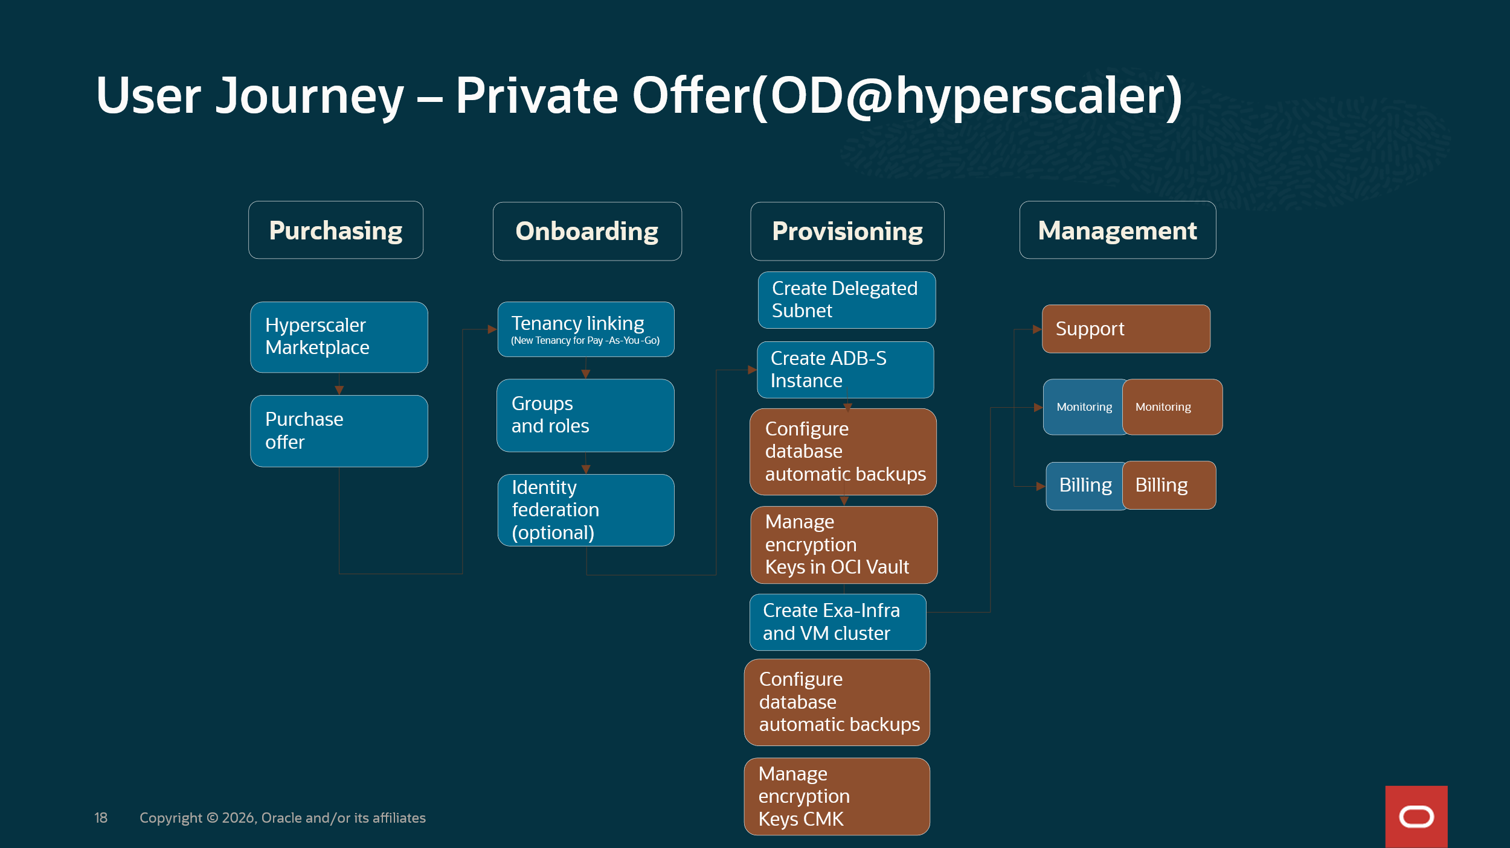
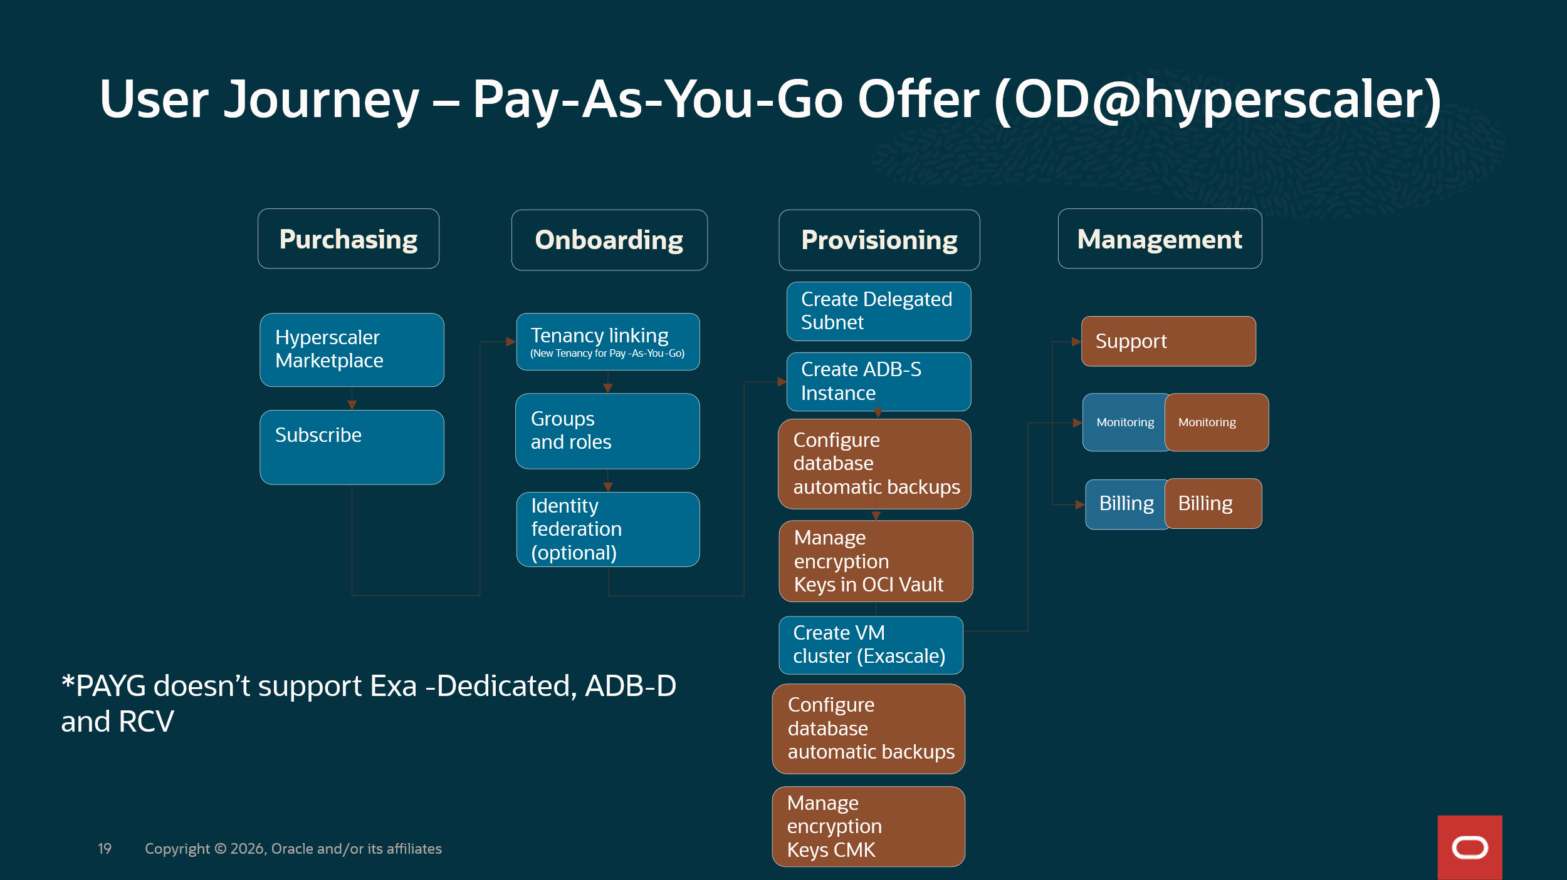

Required Customer Resources
Role | What they need to decide or do | Name/Email
Customer Project Owner | Coordinates customer-side decisions, schedules, owners, and completion of this worksheet.
OD@Azure solution Implementor Team Project Owner | Coordinates between customer and OD@Azure solution implementation teams.
SPOC Oracle Team | SPOC from Oracle side
SPOC Microsoft Team | SPOC from Microsoft side
Azure Account Owner/Contributor/EntraID admin | Confirms the buyer/provisioning Azure Tenant/Subscription, Marketplace permissions, RBAC roles, Azure policies and completes add new subscriptions where required.
Azure subscription owner | Creates or manages ODB Network, Exadata infrastructure, VM clusters, Vnet connectivity, tags, monitoring, and related Azure resources.
OCI Tenancy Administrator | Links the OCI tenancy, validates subscription visibility, compartments, limits, policies, and support registration.
Database Owner / DBA | Plans database homes, CDB/PDB creation, migration approach, backups, encryption, and test execution.
Network Owner | Plans Vnet, delegated subnets, Resource Anchors, Network Anchors, client and backup CIDR ranges, routes, DNS, peering or service networking, and connectivity testing.
Security Owner | Reviews RBACK, least privilege, encryption, key management, audit logging, compliance, and access controls.
Oracle Account Team / Account Cloud Engineer /Cloud Adoption Manager | Coordinates OD, Private Offer, technical onboarding, readiness review, and issue escalation.
Microsoft Account team, when applicable | Supports Marketplace, account/billing, and Azure-side escalation for offer acceptance and onboarding.

Customer Onboarding Questionnaire
Complete the fields below. Mark “TBD” only when an owner and due date are known. This is the minimum information needed to start the onboarding plan. Some of this information may be already included in the Solution Definition Document

Azure Account Information
Question | Customer response | Owner
Which Azure billing ID/Subscription will accept the Private Offer? | [Azure billing ID/subscription name] | [Name / email]
Will a different Azure subscription provision DB@ Azure resources? | [Same account / Subscription name/ID] | [Name / email]
Who has authority to accept the Marketplace offer? (Persona Billing Account Owner / Contributor/ Enterprise Administrator | [Name / email] | [Name / email]
What target Azure Region, AZ and desired activation window apply? | [Region / date / time zone] | [Name / email]
Are any Azure Organizations or Private Marketplace controls in place? | [No / Yes, describe policy or exception] | [Name / email]
Has the accepting role been confirmed to view and accept Private Offers? | [Yes / No / TBD] | [Name / email]

OCI Tenancy and Access
Question | Customer response | Owner
Will you link an existing OCI tenancy or create a new one? What is the OCI tenancy Home Region? | [Existing / New] | [Name / email]
If existing, what is the OCI tenancy OCID? | [ocid1.tenancy...] | [Name / email]
Who is the OCI tenancy administrator for activation? | [Name / email] | [Name / email]
Is the IAM Policy statement capacity enough or has it reached the limit (500 per tenancy)? | [Name / email] | [Name / email]

Network and Security Readiness
Question | Customer response | Owner
Which Vnet and subnets will host the service and application connectivity? | [Vnet / subnet IDs or link to SDD] | [Name/ email]
What client and backup CIDR ranges are planned? Have overlaps been checked? Consider expansion | [CIDRs / Yes/ No] | [Name / email]
What connectivity pattern is required? | [Same Vnet / Peering / Hub and Spoke / Other or link to SDD] | [Name / email]
What DNS, routing, firewall or security group dependencies must be ready? | [Describe or link to SDD] | [Name / email]
What IAM, encryption, key management, audit logging, or compliance approvals are required? | [Describe / approval status/ link to SDD] | [Name / email]

Database Deployment Plan
Question | Customer response | Owner
Which Oracle AI Database@Azure service will be deployed? | [Exadata Database Service / Autonomous AI Database / other] | [Name / email]
What Exadata Infrastructure is required? | [Infrastructure name, model, Azure Region, availability zone, database server count] | [Name / email]
What VM Cluster will be deployed? | [VM Cluster name, Grid Infrastructure cluster name, host name prefix, license model] | [Name / email]
What is the VM Cluster sizing? | [OCPU/ECPU per VM, memory per VM, local storage, Exadata storage] | [Name / email]
What database configuration is required? | [Database and CDB/PDB names, Oracle Database version, DB home/image version, CPU and storage] | [Name / email]

DB@Azure service |  | Question | Customer response | Owner
 | Which Oracle AI Database@Azure service will be deployed? |  | [Exadata Database Service / Autonomous AI Database / other] | [Name / email]
ExaDB-D / ADB-D | What Exadata Infrastructure is required? |  | [Infrastructure name, model, Azure Region, availability zone, database server count] | [Name / email]
 | What VM Cluster will be deployed? |  | [VM Cluster name, delegated Network,RA,NA, Grid Infrastructure cluster name, host name prefix, license model] | [Name / email]
 | What is the VM Cluster sizing? |  | [OCPU/ECPU per VM, memory per VM, local storage, Exadata storage] | [Name / email]
 | What database configuration is required? |  | [Database and CDB/PDB names, Oracle Database version, DB home/image version, CPU and storage] | [Name / email]
ADB-S | What is the network access type? |  | [Secure Access from everywhere / from allowed Ips/CIDR blocks / private endpoint] | [Name / email]
 | If private endpoint, what is the delegated network? |  | [delegated Network name] | [Name / email]
ExaDB-XS | What Exascale Storage Vault is required? |  | [Name, region, AZ, capacity, caches] | [Name / email]
 | What VM Cluster will be deployed? |  | [VM Cluster name, delegated Network, RA.RN, Exascale Storage Vault, Grid Infrastructure cluster name, host name prefix, license model] | [Name / email]
 | What is the VM Cluster sizing? |  | [OCPU/ECPU per VM, memory per VM, local storage, Exadata storage] | [Name / email]
 | What database configuration is required? |  | [Database and CDB/PDB names, Oracle Database version, DB home/image version, CPU and storage] | [Name / email]

Activation day checklist
Done | Check | Customer confirms | Result | Estimated duration
☐ | Accept Marketplace Offer | The authorized owner can find Oracle Database@Azure in Azure Marketplace, open the private offer, review the details, select Commit, then select Accept. | Private offer purchase is confirmed and the subscription is created. | A few minutes
☐ | Subscription validated | Azure Marketplace > Private offer Management shows Oracle AI Database@Azure under Active subscriptions; the product details and active agreement are visible. | Marketplace subscription details are verified. | A few minutes after acceptance
☐ | Welcome letter arrives | The Oracle welcome email with the subject Action Required: Welcome to New Oracle Cloud Service Subscription(s) has been received in the mailbox specified in the Order Document | The team can proceed to tenancy linking and onboarding. | Up to 24 hours
☐ | OCI tenancy creation or link | The OCI administrator links or creates the tenancy and confirms subscription visibility. | Technical activation can continue. | About 1 hour
☐ | Verify DB@Azure subscription and limits | Customer validates the subscription, compartments, limits, and quotas in OCI. | Provisioning can start. | 30-60 minutes
☐ | Create or validate Azure and OCI roles | Customer validates IAM, service-linked roles, ODB permissions, and networking permissions. | Provisioning permissions are ready. | Customer-dependent
☐ | (If applicable) Create delegated Network/RA/NA | Customer creates or validates ODB Network with client and backup CIDRs. | Network base is created. | 30-60 minutes
☐ | (For ExaDB-D and ADB-D)  Provision Exadata infrastructure | Customer provisions Exadata infrastructure in the target region and availability zone. | Infrastructure is available for the VM cluster. | 2-4 hours
☐ | (For ExaDB-XS)  Provision Exadata Storage Vault | Customer provisions Exadata Storage Vault in the target region and availability zone. | Exadata Storage Vault is available for the ExaDB-XS VM cluster. | 2-4 hours
☐ | (For ExaDB-D, ExaDB-XS, ADB-D) Provision VM cluster | Customer provisions the VM cluster | Exadata VM Cluster ready for Database deployment | 4-6 hours
☐ | Provision Database | Customer provisions database home, CDB, and PDB as required. | Database resources are ready for testing. | 1 -2 hours
☐ | Register support and monitoring | Customer validates My Oracle Cloud Support access, monitoring, alerts, backups, and operational contacts. | Environment is ready for workload onboarding and testing. | Customer-dependent

Reference starting points
- Azure Marketplace Private Offers buyer guide: Private offers in Azure Marketplace
- Oracle Database@Azure onboarding documentation: Oracle Database@Azure onboarding
- Oracle Cloud account setup overview: Oracle Cloud accounts
- Oracle service availability page: Distributed cloud service availability

