
Statement of Direction
Oracle Database at GCP
Customer Onboarding
Activation Runbook

<CUSTOMER NAME>
A concise guide to prepare for commercial activation, onboarding, and provisioning.
<DATE>
Version 1.0
Copyright © 2026, Oracle and/or its affiliates
Confidential – Oracle Restricted
Purpose
This runbook gives the customer, Oracle account team, and GCP stakeholders a single sequence for moving through GCP Marketplace acceptance, OCI tenancy linking, and provisioning readiness. Replace bracketed placeholders before sharing with a specific customer.

Executive Summary
Oracle Database@GCP onboarding has two connected workstreams: (1) commercial activation through the Oracle Ordering Document and GCP Marketplace Private Offer, and (2) technical activation through GCP account readiness, OCI tenancy linking, IAM permissions, networking, service limits, provisioning, and support registration. This guide will focus on technical activation.
The questionnaire on pages 4 to 8 is the customer input Oracle needs to schedule the right people, create the Marketplace Private Offer, and begin technical onboarding without avoidable delays.
The most common avoidable technical delays are incorrect GCP Billing account selection, incorrect Google Project, missing GCP Marketplace permissions, missing OCI tenancy administrator access, and incomplete network or CIDR planning.

What success looks like
Before initial onboarding | At the end of onboarding
An email is sent confirming that offer is ready for purchase . The Private Offer is made available in the GCP Marketplace; the right customer administrators and technical owners are identified. The mailbox specified in the OD is accessible. | The private offer is accepted, an existing or newly created OCI tenancy is linked, access and limits are confirmed, and the team has an agreed provisioning plan.

Key Decisions
Decision | Why it matters | Owner
Which GCP Billing account has been used? | One billing Account can be linked to one Private offer only and DB@GCP services can be enabled on all projects which share this Billing Account.  Once the Billing account has been used with one Private offer , it cannot be used for a new DB@GCP private offer . | Customer/Oracle Sales
Do you want to convert from Public Offer to Private offer using same GCP Billing Account and OCI Tenancy? | If yes , Oracle sales should do a replenish and NOT a new private offer. | Customer/Oracle Sales
Do you want to convert from public offer to Private offer using same OCI tenancy , and intent to use a different Billing Account? | One DB@ OCI tenancy can be linked with only 1 Google Billing Account . | Customer/Oracle Sales
Will you link an existing OCI tenancy or create one? If it’s a new one, is the Home Region chosen? | This determines if an OCI administrator must attend the activation session. | OCI tenancy owner (if using existing OCI tenancy)  If it is a new tenancy ,Google Cloud Administrator can perform tenancy linking starting from GCP marketplace.  Or  Starting from ‘Welcome’ email , the user performing onboarding becomes Owner of new tenancy.
Is the network design ready? | CIDRs, VPC/subnets, region and connectivity choices are prerequisites for ODB Network and database provisioning. | Network Owner
Are you using Shared VPC for ODB Network creation ? | ODB network can be created using Shared VPC, however, both the network project and DB project should have same Billing Account (as the one used for Private offer). | Network Owner
Is the database architecture confirmed? | Each Oracle AI DB@GCP Database service has specific deployment requirements. | Database owner

User Journey Overview
(Delete unrequired DB service journey prior to sharing with customer)

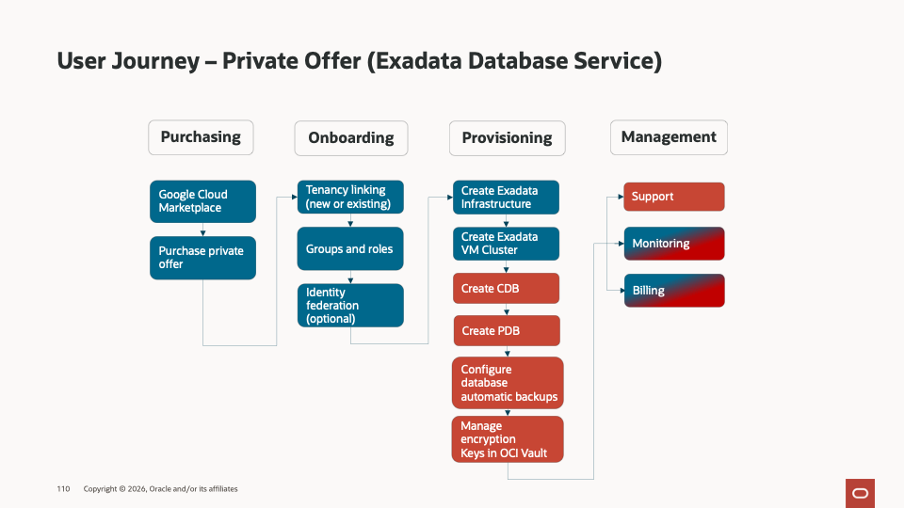
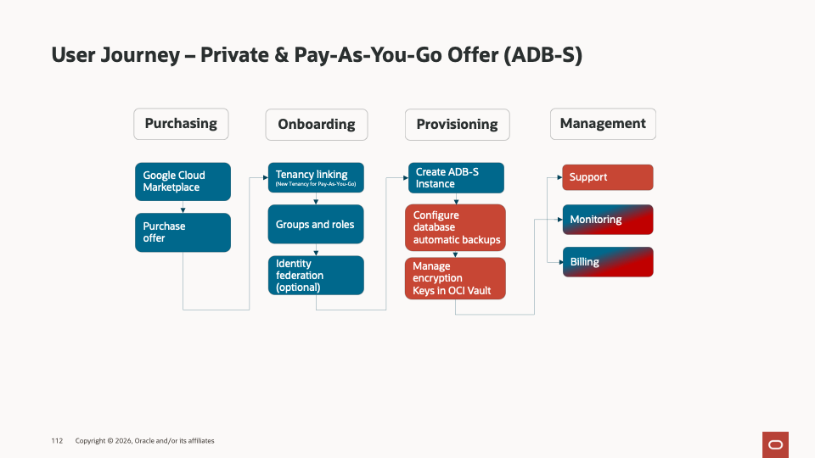
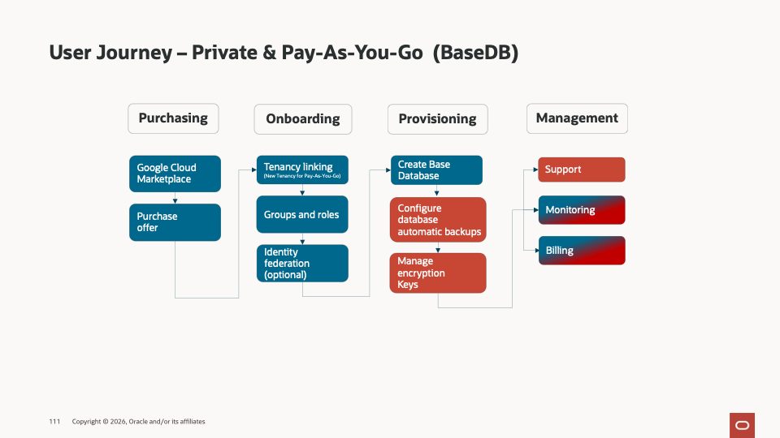

Required Customer Resources
Role | What they need to decide or do | Name/Email
Customer Project Owner | Coordinates customer-side decisions, schedules, owners, and completion of this worksheet.
Google Cloud Billing Administrator | Confirms the GCP Billing Account , Marketplace permissions, IAM roles to accept the Private Offer.
OCI Tenancy Administrator | Links the OCI tenancy, validates subscription visibility, compartments, limits, policies, and support registration.
Database Owner / DBA | Plans database homes, CDB/PDB creation, migration approach, backups, encryption, and test execution.
Network Owner | Plans ODB network ranges , subnets - client and backup CIDR ranges, routes, DNS, peering or service networking, and connectivity testing.
Security Owner | Reviews IAM, least privilege, encryption, key management, audit logging, compliance, and access controls.
Oracle Account Team / Account Cloud Engineer /Cloud Adoption Manager | Coordinates OD, Private Offer, technical onboarding, readiness review, and issue escalation.
GCP Account team, when applicable | Supports Marketplace, account/billing, and GCP-side escalation for offer acceptance and onboarding.

Customer Onboarding Questionnaire
Complete the fields below. Mark “TBD” only when an owner and due date are known. This is the minimum information needed to start the onboarding plan. Some of this information may be already included in the Solution Definition Document

GCP Account Information
Question | Customer response | Owner
What the GCP Billing Account will accept the Private Offer? | [GCP Billing Account] | [Name / email]
What Google Cloud Project will be used for the Private Offer? | [Google Cloud Folder]  [Google Cloud Project] | [Name / email]
Who has authority to accept the Marketplace offer? | [Name / email] | [Name / email]
Are any Private Marketplace controls in place? | [No / Yes, describe policy, other requirements or exceptions] | [Name / email]
Has the accepting role been confirmed to view and accept Private Offers? | [Yes / No / TBD] | [Name / email]
Does an desired activation window apply? | [time frame] | [Name / email]

OCI Tenancy and Access
Question | Customer response | Owner
Will you link an existing OCI tenancy or create a new one? What is the OCI tenancy Home Region? | [Existing / New] | [Name / email]
If existing, what is the OCI tenancy OCID? | [ocid1.tenancy...] | [Name / email]
Who is the OCI tenancy administrator for activation? | [Name / email] | [Name / email]
In Oracle Sales systems, is the Customer registry id of the existing OCI tenancy the same as the Customer registry id related to the order for the Private Offer? | [Yes / No / TBC] | [Name / email] from Customer  [Name / email] from Oracle
Is the IAM Policy statement capacity enough or has it reached the limit (500 per tenancy)? | [Yes / No / TBC] | [Name / email]

Network and Security Readiness
Question | Customer response | Owner
Which VPC/Shared VPC will be used to create ODB network and application connectivity? | [VPC / subnet IDs or link to SDD] | [Name/ email]
What client and backup CIDR ranges are planned? Have overlaps been checked? | [CIDRs / Yes/ No] | [Name / email]
What connectivity pattern is required? | [Same VPC / Peering / Transit Gateway / Other or link to SDD] | [Name / email]
What DNS, routing, firewall or security group dependencies must be ready? | [Describe or link to SDD] | [Name / email]
What IAM, encryption, key management, audit logging, or compliance approvals are required? | [Describe / approval status/ link to SDD] | [Name / email]

Database Deployment Plan
Question | Customer response | Owner
Which Oracle AI Database@GCP service will be deployed? | [Exadata Database Service / Autonomous AI Database / other] | [Name / email]
What Exadata Infrastructure is required? | [Infrastructure name, model, GCP Region, availability zone, database server count] | [Name / email]
What VM Cluster will be deployed? | [VM Cluster name, Grid Infrastructure cluster name, host name prefix, license model] | [Name / email]
What is the VM Cluster sizing? | [OCPU/ECPU per VM, memory per VM, local storage, Exadata storage] | [Name / email]
What database configuration is required? | [Database and CDB/PDB names, Oracle Database version, DB home/image version, CPU and storage] | [Name / email]
What region/AZ the service will be deployed. | [Region/AZ] | [Name / email]

DB@GCP service | Question | Customer response | Owner
 | Which Oracle AI Database@GCP service will be deployed? | [Exadata Database Service / Autonomous AI Database / other] | [Name / email]
ExaDB-D / ADB-D | What Exadata Infrastructure is required? | [Infrastructure name, model, GCP Region, availability zone, database server count] | [Name / email]
 | What VM Cluster will be deployed? | [VM Cluster name, ODB Network, Grid Infrastructure cluster name, host name prefix, license model] | [Name / email]
 | What is the VM Cluster sizing? | [OCPU/ECPU per VM, memory per VM, local storage, Exadata storage] | [Name / email]
 | What database configuration is required? | [Database and CDB/PDB names, Oracle Database version, DB home/image version, CPU and storage] | [Name / email]
ADB-S | What is the network access type? | [Secure Access from everywhere / from allowed Ips/CIDR blocks / private endpoint] | [Name / email]
 | If private endpoint, what is the ODB network? | [ODB Network name] | [Name / email]
ExaDB-XS | What Exascale Storage Vault is required? | [Name, region, AZ, capacity, caches] | [Name / email]
 | What VM Cluster will be deployed? | [VM Cluster name, ODB Network, Exascale Storage Vault, Grid Infrastructure cluster name, host name prefix, license model] | [Name / email]
 | What is the VM Cluster sizing? | [OCPU/ECPU per VM, memory per VM, local storage, Exadata storage] | [Name / email]
 | What database configuration is required? | [Database and CDB/PDB names, Oracle Database version, DB home/image version, CPU and storage] | [Name / email]

Activation day checklist
Done | Check | Customer confirms | Result | Estimated duration
☐ | Accept Marketplace Offer | The authorized owner can find Oracle Database@GCP in GCP Marketplace, open the private offer, review the details, then select Accept. | Private offer purchase is confirmed and the subscription is created. | A few minutes
☐ | Subscription validated | GCP Marketplace > Manage subscriptions shows Oracle AI Database@GCP under Active subscriptions; the product details and active agreement are visible. | Marketplace subscription details are verified. | A few minutes after acceptance
☐ | Welcome letter arrives | The Oracle welcome email with the subject Action Required: Welcome to New Oracle Cloud Service Subscription(s) has been received in the mailbox specified in the Order Document | The team can proceed to tenancy linking and onboarding. | Up to 24 hours
☐ | OCI tenancy creation or link | The OCI administrator links or creates the tenancy and confirms subscription visibility. | Technical activation can continue. | About 1 hour
☐ | Verify DB@GCP subscription and limits | Customer validates the subscription, compartments, limits, and quotas in OCI. | Provisioning can start. | 30-60 minutes
☐ | Enable DB@GCP on other Google Projects linked having same Billing Account(optional) | DB@GCP services can be activated on other projects which share the same Billing Account as Primary Project. | Another GCP account can provision DB@GCP resources | 30-60 minutes
☐ | Create or validate GCP and OCI roles | Customer validates IAM, service-linked roles, ODB permissions, and networking permissions. | Provisioning permissions are ready. | Customer-dependent
☐ | Create ODB Network and subnets. | Customer creates or validates ODB Network with client and backup CIDRs. | Network base is created. | 30-60 minutes
☐ | (For ExaDB-D and ADB-D)  Provision Exadata infrastructure | Customer provisions Exadata infrastructure in the target region and availability zone. | Infrastructure is available for the VM cluster. | 2-4 hours
☐ | (For ExaDB-XS)  Provision Exadata Storage Vault | Customer provisions Exadata Storage Vault in the target region and availability zone. | Exadata Storage Vault is available for the ExaDB-XS VM cluster. | 2-4 hours
☐ | (For ExaDB-D, ExaDB-XS) Provision VM cluster | Customer provisions the VM cluster | Exadata VM Cluster ready for Database deployment | 4-6 hours
☐ | Provision Database | Customer provisions database home, CDB, and PDB as required. | Database resources are ready for testing. | 1 -2 hours
☐ | Register support and monitoring | Customer validates My Oracle Cloud Support access, monitoring, alerts, backups, and operational contacts. | Environment is ready for workload onboarding and testing. | Customer-dependent

Reference starting points
- Marketplace Private Offers buyer guide: Private offers in GCP Marketplace
- Oracle Database@GCP onboarding documentation: Oracle Database@GCP onboarding
- Oracle Cloud account setup overview: Oracle Cloud accounts
- Multicloud Regional availability page: Distributed cloud service availability
- GCP onboarding guide: Getting started with Oracle Database@GCP: A complete onboarding guide
- GCP Markeplace offer Acceptance guide: GCP Marketplace Private offer Guide

