
Statement of Direction
Oracle Database at AWS
Customer Onboarding
Activation Runbook

<CUSTOMER NAME>
A concise guide to prepare for commercial activation, onboarding, and provisioning.
<DATE>
Version 1.0
Copyright © 2026, Oracle and/or its affiliates
Confidential – Oracle Restricted
Purpose
This runbook gives the customer, Oracle account team, and AWS stakeholders a single sequence for moving through AWS Marketplace acceptance, OCI tenancy linking, and provisioning readiness. Replace bracketed placeholders before sharing with a specific customer.

Executive Summary
Oracle Database@AWS onboarding has two connected workstreams: (1) commercial activation through the Oracle Ordering Document and AWS Marketplace Private Offer, and (2) technical activation through AWS account readiness, OCI tenancy linking, IAM permissions, networking, service limits, provisioning, and support registration. This guide will focus on technical activation.
The questionnaire on pages 4 to 8 is the customer input Oracle needs to schedule the right people, create the Marketplace Private Offer, and begin technical onboarding without avoidable delays.
The most common avoidable technical delays are incorrect AWS account selection, missing AWS Marketplace permissions, AWS Organizations service control policies that block onboarding actions, missing OCI tenancy administrator access, and incomplete network or CIDR planning.

What success looks like
Before initial onboarding | At the end of onboarding
The Private Offer is sent to the correct AWS buyer account; the right customer administrators and technical owners are identified. The mailbox specified in the OD is accessible. | The private offer is accepted, an existing or newly created OCI tenancy is linked, access and limits are confirmed, and the team has an agreed provisioning plan.

Key Decisions
Decision | Why it matters | Owner
Which AWS account accepts the offer? | Private Offers are issued to one AWS account; this will be called the Buyer Account. A wrong account can require the offer to be recreated. | AWS Buyer Account
Which AWS account deploys the DB@AWS resources | It can be the Buyer Account or another account where AWS License Manager subscription sharing was enabled before provisioning DB@AWS resources. | AWS Buyer Account
Will you link an existing OCI tenancy or create one? If it’s a new one, is the Home Region chosen? | This determines if an OCI administrator must attend the activation session. | OCI tenancy owner (if using existing OCI tenancy)
Is the network design ready? | CIDRs, VPC/subnets, region and connectivity choices are prerequisites for ODB Network and database provisioning. | Network owner
Is the database architecture confirmed? | Each Oracle AI DB@AWS Database service has specific deployment requirements | Database owner

User Journey Overview
(Delete unrequired DB service journey prior to sharing with customer)
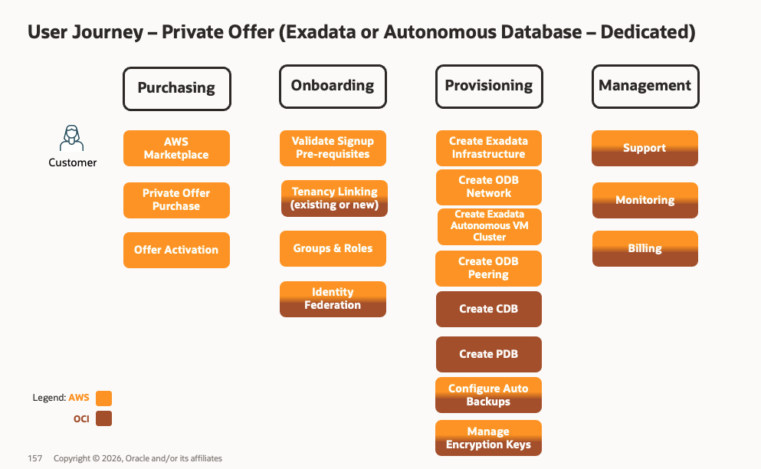
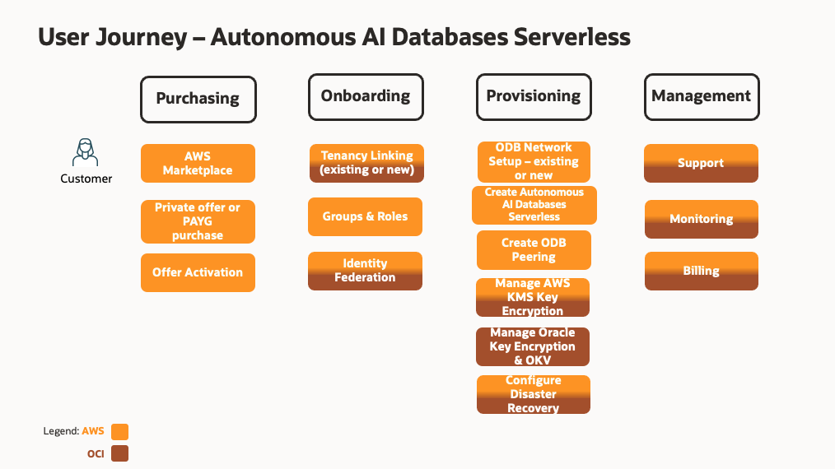

Required Customer Resources
(Note it is best practice to assign both a primary and backup contact to key admin roles)
Role | What they need to decide or do | Name/Email
Customer Project Owner | Coordinates customer-side decisions, schedules, owners, and completion of this worksheet.
AWS Account Administrator | Confirms the buyer/provisioning AWS account, Marketplace permissions, IAM roles, AWS Organizations policies and completes subscription sharing in AWS License manager where required.
AWS Resource Administrator | Creates or manages ODB Network, Exadata infrastructure, VM clusters, VPC connectivity, tags, monitoring, and related AWS resources.
OCI Tenancy Administrator | Links the OCI tenancy, validates subscription visibility, compartments, limits, policies, and support registration.
Database Owner / DBA | Plans database homes, CDB/PDB creation, migration approach, backups, encryption, and test execution.
Network Owner | Plans VPC, subnets, client and backup CIDR ranges, routes, DNS, peering or service networking, and connectivity testing.
Security Owner | Reviews IAM, least privilege, encryption, key management, audit logging, compliance, and access controls.
Oracle Account Team / Account Cloud Engineer /Cloud Adoption Manager | Coordinates OD, Private Offer, technical onboarding, readiness review, and issue escalation.
AWS Account team, when applicable | Supports Marketplace, account/billing, and AWS-side escalation for offer acceptance and onboarding.

Customer Onboarding Questionnaire
Complete the fields below. Mark “TBD” only when an owner and due date are known. This is the minimum information needed to start the onboarding plan. Some of this information may be already included in the Solution Definition Document

AWS Account Information
Question | Customer response | Owner
Which 12-digit AWS account will accept the Private Offer? | [AWS buyer account ID] | [Name / email]
Will a different AWS account provision DB at AWS resources? | [Same account / Account ID] | [Name / email]
Who has authority to accept the Marketplace offer? | [Name / email] | [Name / email]
What target AWS Region, AZ and desired activation window apply? | [Region / date / time zone] | [Name / email]
Are any AWS Organizations or Private Marketplace controls in place? | [No / Yes, describe policy or exception] | [Name / email]
Has the accepting role been confirmed to view and accept Private Offers? | [Yes / No / TBD] | [Name / email]

OCI Tenancy and Access
Question | Customer response | Owner
Will you link an existing OCI tenancy or create a new one? What is the OCI tenancy Home Region? | [Existing / New] | [Name / email]
If existing, what is the OCI tenancy OCID? | [ocid1.tenancy...] | [Name / email]
Who is the OCI tenancy administrator for activation? | [Name / email] | [Name / email]

Network and Security Readiness
Question | Customer response | Owner
Which VPC and subnets will host the service and application connectivity? | [VPC / subnet IDs or link to SDD] | [Name/ email]
What client and backup CIDR ranges are planned? Have overlaps been checked? | [CIDRs / Yes/ No] | [Name / email]
What connectivity pattern is required? | [Same VPC / Peering / Transit Gateway / Other or link to SDD] | [Name / email]
What DNS, routing, firewall or security group dependencies must be ready? | [Describe or link to SDD] | [Name / email]
What IAM, encryption, key management, audit logging, or compliance approvals are required? | [Describe / approval status/ link to SDD] | [Name / email]

Database Deployment Plan
Question | Customer response | Owner
Which Oracle AI Database@AWS service will be deployed? | [Exadata Database Service / Autonomous AI Database / other] | [Name / email]
What Exadata Infrastructure is required? | [Infrastructure name, model, AWS Region, availability zone, database server count] | [Name / email]
What VM Cluster will be deployed? | [VM Cluster name, Grid Infrastructure cluster name, host name prefix, license model] | [Name / email]
What is the VM Cluster sizing? | [OCPU/ECPU per VM, memory per VM, local storage, Exadata storage] | [Name / email]
What database configuration is required? | [Database and CDB/PDB names, Oracle Database version, DB home/image version, CPU and storage] | [Name / email]

DB@AWS service | Question | Customer response | Owner
 | Which Oracle AI Database@AWS service will be deployed? | [Exadata Database Service / Autonomous AI Database / other] | [Name / email]
ExaDB-D / ADB-D | What Exadata Infrastructure is required? | [Infrastructure name, model, AWS Region, availability zone, database server count] | [Name / email]
 | What VM Cluster will be deployed? | [VM Cluster name, ODB Network, Grid Infrastructure cluster name, host name prefix, license model] | [Name / email]
 | What is the VM Cluster sizing? | [OCPU/ECPU per VM, memory per VM, local storage, Exadata storage] | [Name / email]
 | What database configuration is required? | [Database and CDB/PDB names, Oracle Database version, DB home/image version, CPU and storage] | [Name / email]
ADB-S | What is the network access type? | [Secure Access from everywhere / from allowed Ips/CIDR blocks / private endpoint] | [Name / email]
 | If private endpoint, what is the ODB network? | [ODB Network name] | [Name / email]
ExaDB-XS | What Exascale Storage Vault is required? | [Name, region, AZ, capacity, caches] | [Name / email]
 | What VM Cluster will be deployed? | [VM Cluster name, ODB Network, Exascale Storage Vault, Grid Infrastructure cluster name, host name prefix, license model] | [Name / email]
 | What is the VM Cluster sizing? | [OCPU/ECPU per VM, memory per VM, local storage, Exadata storage] | [Name / email]
 | What database configuration is required? | [Database and CDB/PDB names, Oracle Database version, DB home/image version, CPU and storage] | [Name / email]

Activation day checklist
Done | Check | Customer confirms | Result | Estimated duration
☐ | Accept Marketplace Offer | The authorized owner can find Oracle Database@AWS in AWS Marketplace, open the private offer, review the details, select Commit, then select Accept. | Private offer purchase is confirmed and the subscription is created. | A few minutes
☐ | Subscription validated | AWS Marketplace > Manage subscriptions shows Oracle AI Database@AWS under Active subscriptions; the product details and active agreement are visible. | Marketplace subscription details are verified. | A few minutes after acceptance
☐ | Welcome letter arrives | The Oracle welcome email with the subject Action Required: Welcome to New Oracle Cloud Service Subscription(s) has been received in the mailbox specified in the Order Document | The team can proceed to tenancy linking and onboarding. | Up to 24 hours
☐ | OCI tenancy creation or link | The OCI administrator links or creates the tenancy and confirms subscription visibility. | Technical activation can continue. | About 1 hour
☐ | Verify DB@AWS subscription and limits | Customer validates the subscription, compartments, limits, and quotas in OCI. | Provisioning can start. | 30-60 minutes
☐ | Share DB@AWS subscription via AWS License Manager (optional) | Sharing the DB@AWS subscription through AWS License Manager lets authorized AWS accounts in your organization use the subscription to deploy and manage Oracle Database@AWS resources | Another AWS account can provision DB@AWS resources | 30-60 minutes
☐ | Create or validate AWS and OCI roles | Customer validates IAM, service-linked roles, ODB permissions, and networking permissions. | Provisioning permissions are ready. | Customer-dependent
☐ | (If applicable) Create ODB Network | Customer creates or validates ODB Network with client and backup CIDRs. | Network base is created. | 30-60 minutes
☐ | (For ExaDB-D and ADB-D)  Provision Exadata infrastructure | Customer provisions Exadata infrastructure in the target region and availability zone. | Infrastructure is available for the VM cluster. | 2-4 hours
☐ | (For ExaDB-XS)  Provision Exadata Storage Vault | Customer provisions Exadata Storage Vault in the target region and availability zone. | Exadata Storage Vault is available for the ExaDB-XS VM cluster. | 2-4 hours
☐ | (For ExaDB-D, ExaDB-XS, ADB-D) Provision VM cluster | Customer provisions the VM cluster | Exadata VM Cluster ready for Database deployment | 4-6 hours
☐ | Provision Database | Customer provisions database home, CDB, and PDB as required. | Database resources are ready for testing. | 1 -2 hours
☐ | Register support and monitoring | Customer validates My Oracle Cloud Support access, monitoring, alerts, backups, and operational contacts. | Environment is ready for workload onboarding and testing. | Customer-dependent

Reference starting points
- AWS Marketplace Private Offers buyer guide: Private offers in AWS Marketplace
- Oracle Database@AWS onboarding documentation: Oracle Database@AWS onboarding
- Oracle Cloud account setup overview: Oracle Cloud accounts
- Oracle service availability page: Distributed cloud service availability
- AWS onboarding guide: Getting started with Oracle Database@AWS: A complete onboarding guide

