# VMware HCX Automation Tool Kit

User Guide

Contents

ReadMe: 1

Script 1: HCX OVA Deploy & Configure 3

Script 2: Extend On-prem Networks. 4

Script 3: vMotion/Bulk/Cold Migration of VMs 5

Script 4: Protect VMs from On-prem to OCVS 5

# ReadMe:

Objective:

VMware HCX automation, built with VMware PowerCLi Module on PowerShell, extracts data from Excel to execute tasks like HCX Connector setup, service mesh creation, network extension, VM migration, and VM replication. The Excel sheet serves as the VMware HCX infrastructure design document. This automation optimize efficiency, delivering seamless migrations and substantial time savings for users. Ultimately, it facilitates a smooth transition to OCVS, enhancing the overall migration journey and customer experience.

Toolkit Supported OCI Services:

Script 1: HCX OVA Deploy & Configure

Script 2: Extend On-prem Networks.

Script 3: vMotion/Bulk/Cold Migration of VMs

Script 4: Protect VMs from On-prem to OCVS

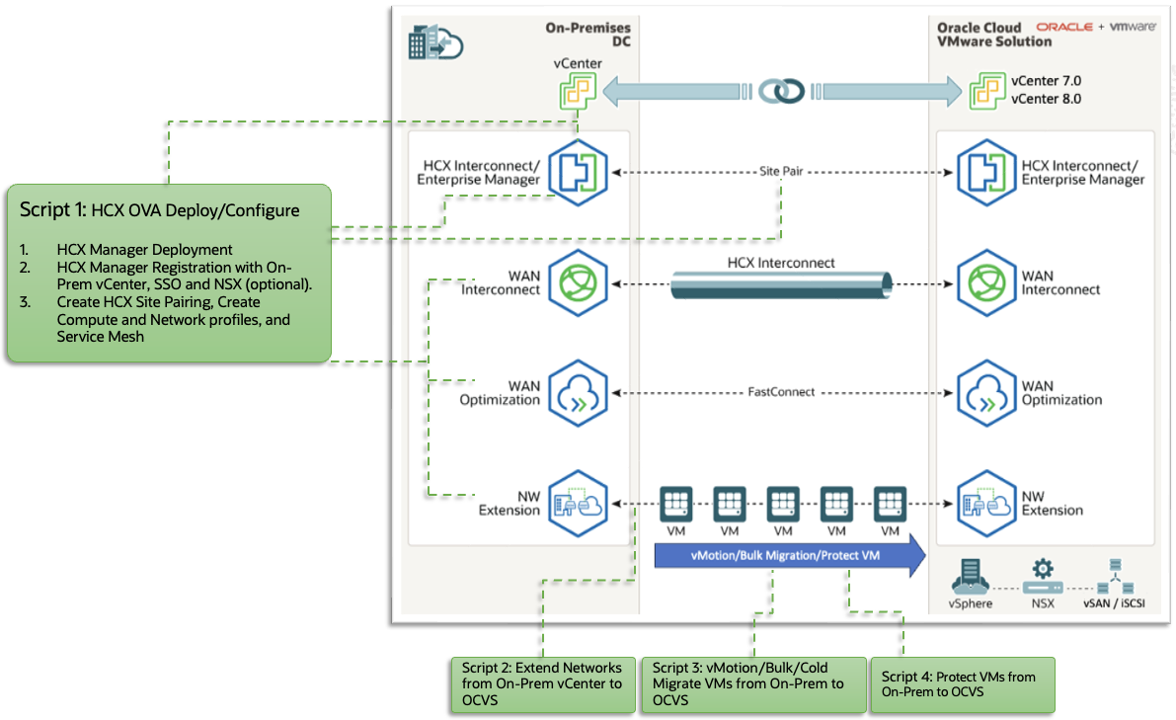

Why VMware-HCX-Automation:

Using the regular console for VMware HCX migration or replication can be quite cumbersome. It involves a lot of clicking and takes a long time to set up migration or replication for just one virtual machine (VM).

Additionally, manually doing this through the console is both tedious and prone to errors.

However, with this automation, you’ll be able to perform single-click migration or replication for a large number of VMs. It streamlines the process and makes it much more efficient and minimal manual effort.

How this toolkit works?

To run these scripts, follow these steps:

1. **Use PowerShell**: You’ll need to use PowerShell, a tool on your computer.
2. **Enter Data**: Open a specific Excel sheet and type in the information related to the task you want to perform.
3. **Run the Script**: After entering the data, run a specific script. The script will use the information from the Excel sheet as input.

Who can use the toolkit??

Customers or Independent Software Vendors (ISVs) aiming to migrate or replicate a large number of virtual machines from an on-premises vCenter to the Oracle Cloud VMware Solution (OCVS).

Pre-Requisites:

1. A Windows Jump box (Preferable in the On-Prem Network) is required to execute the scripts, and it must be able to access the Onprem HCX Manager Network. Ports 22 and 443 should be open.
2. Ensure that the PowerShell version on the Jump box is 5 or higher.
3. The execution policy in PowerShell should be set: Set-ExecutionPolicy -Scope CurrentUser -ExecutionPolicy RemoteSigned.
4. Install the PowerCLi module in PowerShell: Install-Module VMware.PowerCLi -Scope CurrentUser -SkipPublisherCheck -AllowClobber -Force.
5. After installing VMWare PowerCLi, run this command: Set-PowerCLiConfiguration -InvalidCertificateAction Ignore -Confirm:$false -ParticipateInCeip $false.
6. Install the Excel module in PowerShell: Install-Module -Name ImportExcel -Scope CurrentUser.
7. Install the SSH Module: Install-Module -Name Posh-SSH -Scope CurrentUser -Confirm:$false.
8. Ensure that HCX Onprem and HCX Cloud Server can connect to connect.hcx.vmware.com on 443 port for license activation.
9. Verify that the Onprem HCX Manager Network can reach the Cloud Side HCX Manager on Port 443 (for site pairing).
10. The Jump box should have access to the Onprem HCX Manager Network on port 22 and the Onprem vCenter IP or FQDN on Port 443.

Advantages of VMware HCX Automation:

1. Saves time
2. Minimizes manual labour
3. Accelerates migrations
4. Ensures seamless transition to OCVS

Where to get started?

[Click here](https://github.com/oracle-devrel/vmware-hcx-automation) to download the Data Excel file, Scripts and procedure to run each script.

Contributing

This project is open source. Please submit your contributions by raising an Issue or through Discussion topic in this repository. Currently, we do not accept any pull requests. Oracle appreciates any contributions that are made by the open source community.

# Script 1: HCX OVA Deploy & Configure

**Deploy and Configure HCX Connector OVA on On-Premises vCenter**

Procedure to run the script:

1. **Download the HCX Connector OVA File:**
   * Navigate to the HCX Cloud UI (<https://hcxcloudmgr-ip-or-fqdn>). Go to “Administration” > “System Updates.” Click “Request Download Link” to download the HCX Connector OVA file to your Windows Jump box.
2. **Prepare the Data.xlsx File:**
   * Download the Data.xlsx file, Fill in the sheet named “OVADeploy” with the correct details.
   * Refer to the instructions provided in the same sheet to complete each cell in the Excel file.
3. **Get the VMware.HCX.psm1 Module:**
   * Download the VMware.HCX.psm1 module to your Jump box
4. **Download the PowerShell Script:**
   * Obtain the PowerShell script named “HCX-Config.ps1.”
5. **Execute the Script:**
   * On a Windows server, open Windows PowerShell and Run the HCX-Config.ps1 script.
   * When prompted, choose the Data.xlsx Excel file.
   * Follow the onscreen instructions.

End result after successfully running the script:

1. **HCX Manager VM Deployment:**
   * Upon successful execution of the script, the HCX Manager VM will be deployed in the on-premises vCenter. It will have a static IP address.
2. **HCX License and Registration:**
   * The script will apply the HCX license.
   * It will also register with the on-premises vCenter and, if available, the on-premises NSX.
3. **HCX Site-Pairing and Profiles:**
   * The script will create HCX site-pairing.
   * Additionally, it will set up compute profiles and network profiles.
   * A service mesh will also be established.

**Next Script: Script 2: Extend On-prem Networks**

# Script 2: Extend On-prem Networks.

This script extends the Distributed Switch Port Groups from the source vCenter to the destination NSX-T using VMware HCX Network Extension feature.

Note: Port groups with ephemeral bindings, untagged port groups, VMkernel port groups, and port groups from vSphere Standard switch cannot be extended.

Procedure to run the script:

1. **Data Preparation:**
   * Download the Data.xlsx file and Fill in the “NetworkExtension” sheet with the necessary details. Refer to the provided instructions within the same sheet.
2. **Script Execution:**
   * Download the ExtendNetworks.ps1 script.
   * On a Windows server, open Windows PowerShell.
   * Run the ExtendNetworks.ps1 script.
   * Choose the Data.xlsx Excel file when prompted.
   * Follow the onscreen instructions.

End Result: Upon successful completion of the script, your on-premises networks will be extended to the Cloud NSX-T, allowing you to utilize the extended networks.

**Next Script: Script 3: vMotion/Bulk/Cold Migration of VMs**

# Script 3: vMotion/Bulk/Cold Migration of VMs

This script facilitates the migration of virtual machines from the source vCenter to the OCVS vCenter. The customer can choose from three migration options: 1. **Bulk Migration:** Migrate multiple virtual machines simultaneously. 2. **vMotion-Based Migration:** Move powered-on virtual machines. 3. **Cold Migration:** Migrate virtual machines while they are powered off.

Procedure to run the script:

1. **Data Preparation:**
   * Download the Data.xlsx file and Fill in the “**MigrateVMTemplate**” sheet with the necessary details. Refer to the provided instructions within the same sheet.
2. **Script Execution:**
   * Download the **HCX-Migrate-VMs.ps1**script script.
   * On a Windows server, open Windows PowerShell.
   * Run the **HCX-Migrate-VMs.ps1**script.
   * Choose the Data.xlsx Excel file when prompted.
   * Follow the onscreen instructions.

End Result: Once the script finishes successfully, the VM migration begins to Cloud OCVS. You can then monitor the synchronization process using the HCX plugin.

**Next Script: Script 4: Protect VMs from On-prem to OCVS**

# Script 4: Protect VMs from On-prem to OCVS

This script will Replicate Virtual machines from the Source vCenter to the Target vCenter.

Procedure to run the script:

1. **Data Preparation:**
   * Download the Data.xlsx file and Fill in the “**ReplicateVMTemplate**” sheet with the necessary details. Refer to the provided instructions within the same sheet.
2. **Script Execution:**
   * Download the **HCX-Replicate-VMs.ps1** script.
   * On a Windows server, open Windows PowerShell.
   * Run the **HCX-Replicate-VMs.ps1**script.
   * Choose the Data.xlsx Excel file when prompted.
   * Follow the onscreen instructions.

End Result: Once the script finishes successfully, the VM migration begins to Cloud OCVS. You can then monitor the synchronization process using the HCX plugin.