Seer Tech High Tech Product Intelligence LiveStack Guide
  - Oracle AI Database 26ai
Business / Technical Brief
July, 2026, Version 1.1
Copyright © 2026, Oracle and/or its affiliates
Oracle Internal

Purpose statement
This document provides a story-led Oracle LiveLabs runbook for the Seer Tech High Tech Product Intelligence LiveStack, showing how Oracle AI Database 26ai connects product, manufacturing, supply, commitment, analytics, natural-language SQL, and AI-agent workflows on one governed foundation.
Disclaimer
This document in any form, software or printed matter, contains proprietary information that is the exclusive property of Oracle. Your access to and use of this confidential material is subject to the terms and conditions of your Oracle software license and service agreement, which has been executed and with which you agree to comply. This document and information contained herein may not be disclosed, copied, reproduced or distributed to anyone outside Oracle without prior written consent of Oracle. This document is not part of your license agreement nor can it be incorporated into any contractual agreement with Oracle or its subsidiaries or affiliates.
This document is for informational purposes only and is intended solely to assist you in planning for the implementation and upgrade of the product features described. It is not a commitment to deliver any material, code, or functionality, and should not be relied upon in making purchasing decisions. The development, release, timing, and pricing of any features or functionality described in this document remains at the sole discretion of Oracle. Due to the nature of the product architecture, it may not be possible to safely include all features described in this document without risking significant destabilization of the code.
Table of contents
Purpose statement 2
Disclaimer 2
Runbook overview 3
Scene 1 Seer Tech Control Tower 6
Scene 2 Seer Tech 26ai Data Foundation 10
Scene 3 Product & Commitment Intelligence Control Tower 15
Scene 4 Enterprise Buyer Signal Monitor 19
Scene 5 Product Signal Graph 23
Scene 6 Supply & Commitment Map 28
Scene 7 Customer Commitments 33
Scene 8 Predictive Product & Commitment Analytics 38
Scene 9 Ask Seer Tech Data 45
Scene 10 AI Agent Console 51
Scene 11 Use Your Own Product Data 55
Take It Home: Run LiveStack with Podman Compose 59

Seer Tech High Tech Product Intelligence LiveStack Guide

Introduction
High Tech organizations coordinate semiconductor manufacturing, fab capacity, product lifecycle management, component supply, customer commitments, field quality, warranty exposure, connected-product telemetry, service operations, and AI-assisted decisions while keeping operational data governed. Those teams need the same trusted operating picture when a product launch, supplier constraint, quality signal, and customer promise collide.
The Seer Tech Product Intelligence LiveStack demonstrates how Oracle AI Database 26ai can bring those High Tech workflows together on one governed data platform. The demo follows one AI infrastructure release train from early pressure to coordinated action. The control tower detects rising demand and limited supply flexibility; product signals explain the pressure; lifecycle paths expose substrate, wafer-start, engineering-change, quality, and allocation dependencies; spatial evidence identifies response options; commitments show customer impact; and predictive analytics identifies the next likely constraint.
Visible examples include AI Accelerator Module, AI Edge Gateway Reference Kit, Wafer Probe Exception Detector, Engineering Change Order Copilot, Supplier Risk Heatmap Service, Autonomous Test Cell Controller, Connected Device Health Twin, and Customer Commitment Console. Together they represent the products, planning services, and operational controls required to deliver a complex High Tech launch rather than a disconnected catalog of demonstrations.
The runbook is a story-led walkthrough, not a feature checklist. Each scene shows how relational transactions, JSON Relational Duality, property graph, Oracle Spatial, vector search, Oracle Machine Learning, natural-language SQL, PL/SQL tools, and auditable AI agent actions work against the same governed High Tech foundation.
In the demo, Seer Tech uses Oracle AI Database to connect product portfolios, semiconductor manufacturing records, fab operations capacity, wafer-start and yield signals, bill of materials dependencies, engineering change orders, supplier risk, contract manufacturing capacity, channel inventory, customer commitments, connected-product telemetry, field quality cases, warranty analytics, service and support operations, spatial allocation data, predictive analytics, conversational data access, and agent-assisted operations.
Estimated Workshop Time: 90 minutes
Each scene is designed to take between 5 and 10 minutes.
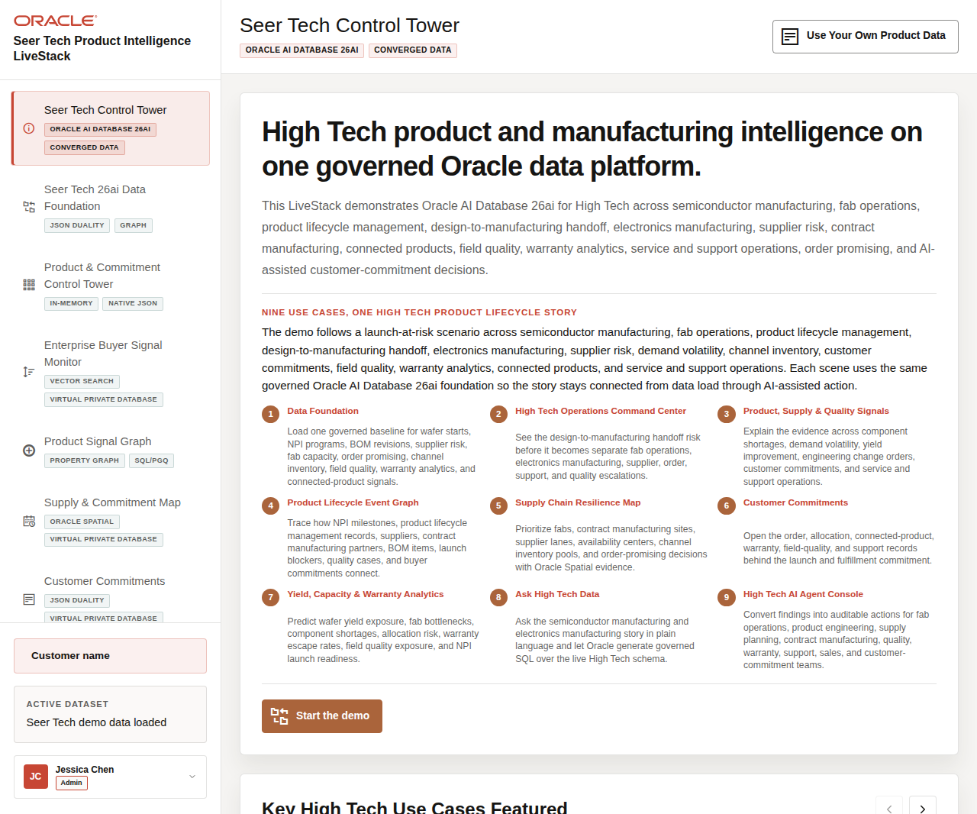
Figure 1. Seer Tech High Tech LiveStack welcome page

Objectives
In this LiveStack demo, you will learn how Oracle AI Database supports product-launch resilience, component availability, manufacturing and fab coordination, product lifecycle governance, customer commitment management, quality and warranty intelligence, predictive analytics, governed data questions, and AI-assisted operating action across a High Tech product organization.

Prerequisites
Before you begin, confirm that you can open the running Seer Tech High Tech Product Intelligence LiveStack in a modern browser. No coding or database administration knowledge is required for the guided demo scenes.
Note: Podman and Podman Compose are required only if you plan to run the portable LiveStack locally in the download lab.

Demo Flow
• Scene 1: Seer Tech Control Tower.
• Scene 2: Seer Tech 26ai Data Foundation.
• Scene 3: Product & Commitment Intelligence Control Tower.
• Scene 4: Enterprise Buyer Signal Monitor.
• Scene 5: Product Signal Graph.
• Scene 6: Supply & Commitment Map.
• Scene 7: Customer Commitments.
• Scene 8: Predictive Product & Commitment Analytics.
• Scene 9: Ask Seer Tech Data.
• Scene 10: AI Agent Console.
• Scene 11: Use Your Own Product Data.
• Download and run the portable High Tech LiveStack.

Learn More
• Oracle AI Database 26ai documentation
• Oracle AI Agent Memory
• Oracle AI Vector Search
• Oracle Spatial and Graph documentation: Oracle Spatial and Oracle Property Graph
• Oracle Machine Learning for SQL documentation
• Oracle REST Data Services documentation
• Oracle LiveLabs catalog

Credits & Build Notes
• Author - Oracle LiveLabs Team
• Last Updated By/Date - Oracle LiveLabs Team, 2026-07-02
• Source Bundle - livestack-hightech.zip

Scene 1 Seer Tech Control Tower

Introduction
The Seer Tech Control Tower establishes the demo story: Seer Tech's AI infrastructure release train is under pressure from rising demand, advanced-component availability, wafer-start and fab capacity, product lifecycle changes, field quality signals, warranty exposure, and customer commitments.
Use this scene to make clear that the LiveStack is broader than one product dashboard. Semiconductor manufacturing, electronics manufacturing, product lifecycle management, supply chain, service, warranty, connected-device, and customer operations all appear as parts of one operating picture.
Estimated Time: 7 minutes
Figure 2. Seer Tech Control Tower welcome page with High Tech lifecycle story

Objectives
In this scene, you will learn how the demo story is organized, which High Tech operating domains are represented, and how the rest of the runbook follows one launch-risk story through Oracle AI Database capabilities.

Task 1: Review the lifecycle story
Perform the following set of steps to orient the audience to the headline and story rail:
1. Open Seer Tech Control Tower from the sidebar.
2. Read the welcome headline and launch-risk story.
3. Review the numbered lifecycle sequence that moves from data foundation through AI-assisted action.
4. Point out the covered domains: product portfolio, semiconductor manufacturing, fab capacity, supplier risk, bill-of-materials readiness, product lifecycle management, engineering change orders, customer commitments, field quality, warranty, service, and connected-device telemetry.
Use this first screen to anchor the business conversation before you move into the data model or Oracle capability details.
Figure 3. Seer Tech Control Tower welcome page with High Tech lifecycle story

Task 2: Review the use case carousel
Perform the following set of steps to show how the same governed Oracle AI Database foundation supports the entire demo flow:
1. Review Key High Tech Use Cases Featured.
2. Use the carousel controls to move through the use-case groups.
3. Call out examples such as High Tech Data Foundation, Product & Commitment Intelligence Control Tower, Enterprise Buyer Signal Monitor, Product Signal Graph, Supply & Commitment Map, Customer Commitments, Predictive Product & Commitment Analytics, Ask Seer Tech Data, and AI Agent Console.
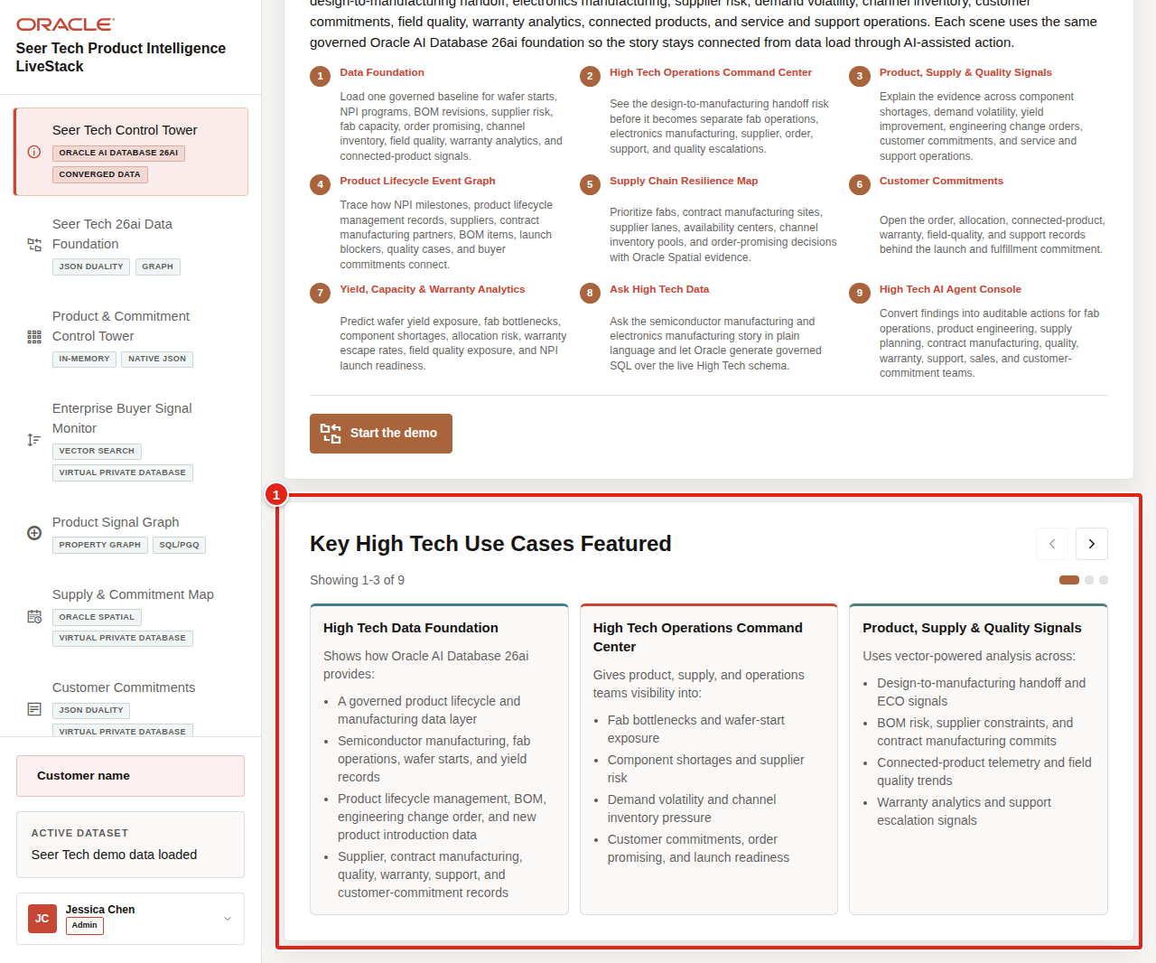
Figure 4. High Tech use case carousel highlighted on the welcome page
Each page is a different operating lens on the same launch-risk story: the data foundation prepares the governed baseline, the control tower detects pressure, signals explain the demand and quality evidence, the graph connects lifecycle dependencies, the map coordinates capacity and allocation, customer commitments show commercial exposure, analytics predicts the next constraint, Ask Data supports governed questions, and agents coordinate audited action.

Task 3: Continue the demo
After the audience understands the story, continue to the data foundation page to load or verify the governed baseline.
1. Click Start the demo.
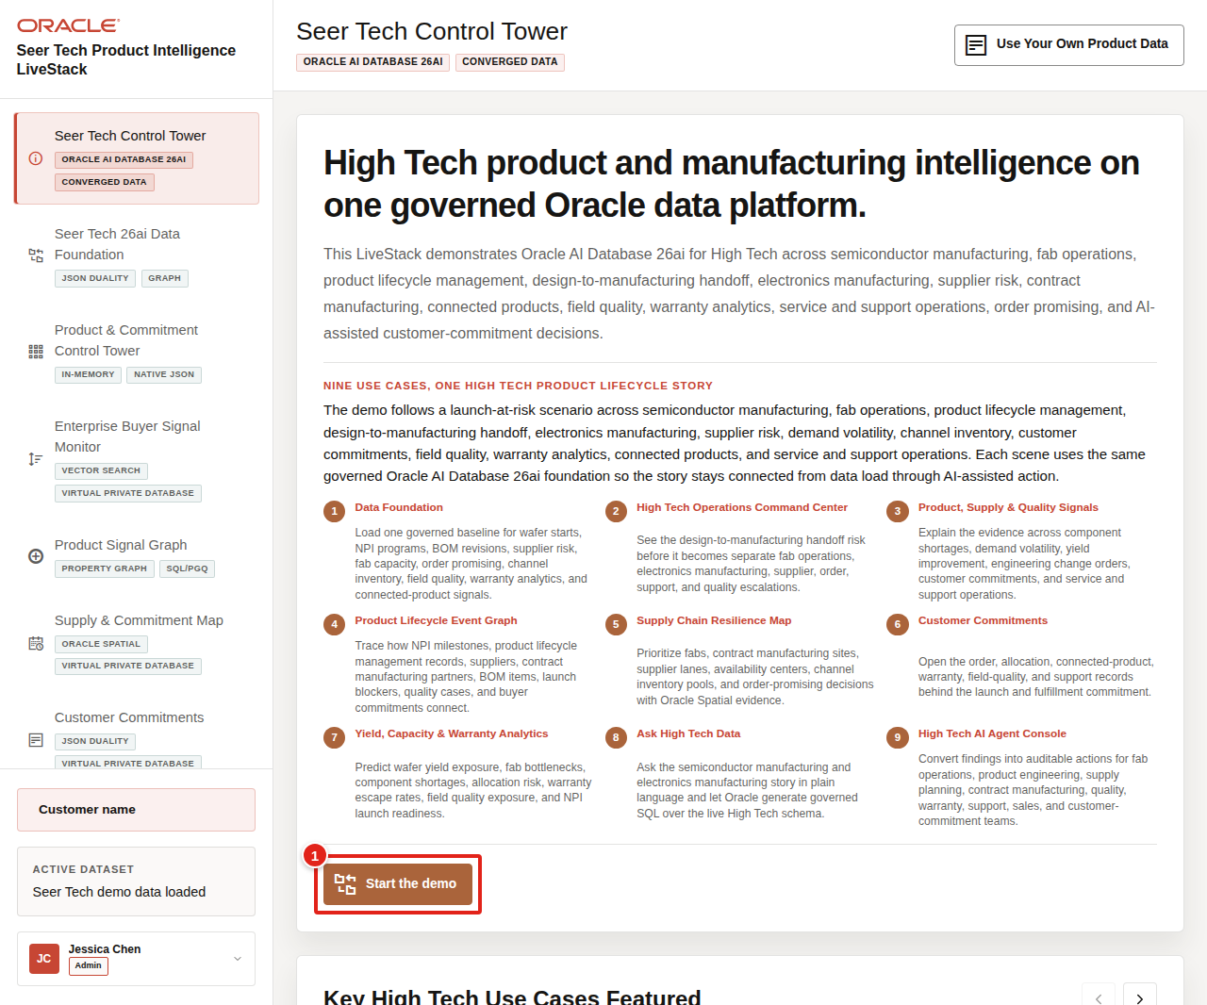
Figure 5. Start the demo button highlighted on the welcome page
2. Confirm that the app moves to Seer Tech 26ai Data Foundation.
Use this transition to explain that every later scene uses the same High Tech dataset. The current story follows products and operating controls such as AI Accelerator Module, AI Edge Gateway Reference Kit, Wafer Probe Exception Detector, Engineering Change Order Copilot, Supplier Risk Heatmap Service, and Autonomous Test Cell Controller into supply, lifecycle, customer, and predictive decisions.
Note: Sample values may change after data refreshes or rebuilds. Verify live output before presenting, then explain the business takeaway.
You can move to the next scene.

Credits & Build Notes
• Author - Oracle LiveLabs Team
• Last Updated By/Date - Oracle LiveLabs Team, 2026-07-02
• Source Bundle - livestack-hightech.zip

Scene 2 Seer Tech 26ai Data Foundation

Introduction
The Seer Tech 26ai Data Foundation prepares the trusted High Tech operating baseline used across the demo. Whether the data is loaded or restored, every subsequent screen starts from the same governed records.
That baseline includes product portfolios, semiconductor manufacturing records, fab and wafer-start context, yield-improvement signals, product lifecycle management records, design-to-manufacturing handoff evidence, electronics manufacturing capacity, contract manufacturing capacity, engineering change orders, bill-of-materials dependencies, component shortage and supplier-risk signals, demand volatility, channel inventory, customer commitments, order-promising dates, connected-product telemetry, field quality, warranty analytics, support operations, spatial allocation data, vector embeddings, machine learning outputs, and agent audit history.
This page makes clear that the runbook is a connected end-to-end workflow, not a series of isolated mini-demos. The same Oracle-backed records power launch-constraint detection, vector search, product lifecycle paths, supply allocation, customer commitments, predictive analytics, Ask Data, data import, and agent workflows.
Estimated Time: 8 minutes
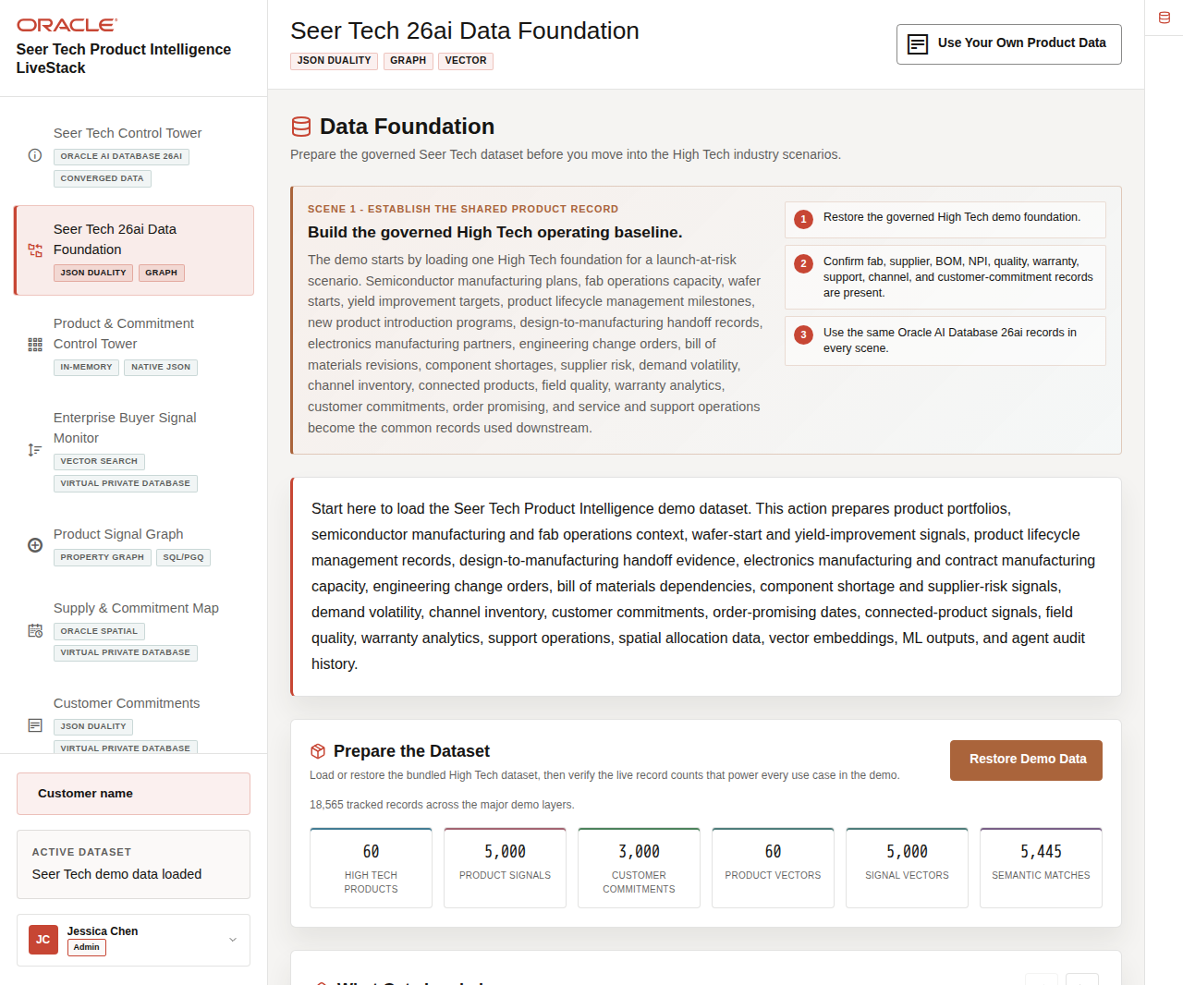
Figure 6. Data Foundation page with restore controls and live High Tech record counts

Objectives
In this scene, you will confirm that the demo has a governed baseline for product portfolios, fab operations, component supply, customer commitments, lifecycle records, field quality, warranty, connected products, service operations, vector search, graph traversal, analytics, Ask Data, and agent workflows.
Note: Oracle Internals is collapsed by default. Expand it only after the business flow is clear so you can connect the visible data foundation to the database capabilities behind the page.

Task 1: Restore and verify the demo dataset
Start the demo by restoring the seeded High Tech baseline so the audience sees the database prepare the shared operating record before any scene depends on it:
1. From the welcome page, click Start the demo, or click Seer Tech 26ai Data Foundation in the sidebar.
2. In Prepare the Dataset, click Restore Demo Data as the first live action.
3. Explain that this reloads the governed High Tech dataset into Oracle AI Database 26ai and prepares the records, vectors, semantic matches, graph relationships, machine learning outputs, and audit history used by the rest of the runbook.
4. Wait for the restore operation to complete, then review the live record counts below the action.
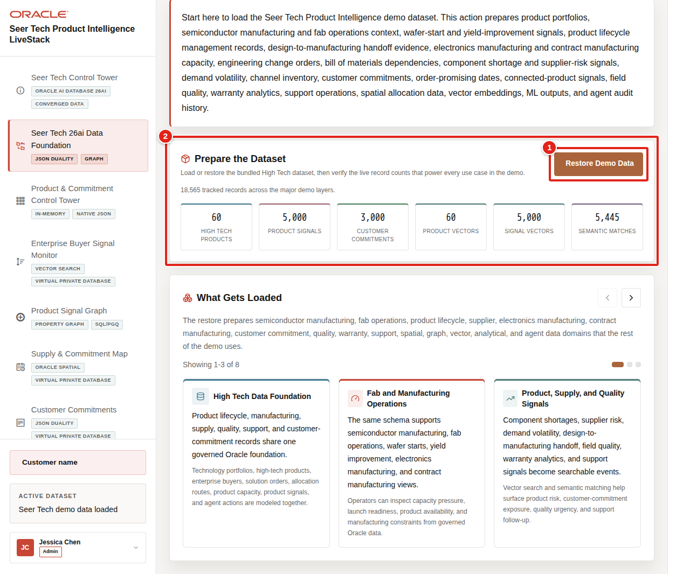
Figure 7. Restore Demo Data button and live High Tech counts highlighted
In the current live demo, the page shows 60 High Tech products, 5,000 product signals, 3,000 customer commitments, 60 product vectors, 5,000 signal vectors, and 5,475 semantic matches. These numbers prove that Oracle AI Database has prepared enough product, signal, vector, graph, machine learning, and commitment evidence for the later scenes.
Notes:
• Sample values may change after data refreshes or rebuilds. Verify live output before presenting, then explain the business takeaway.
• Use these counts to show that the dataset supports operational, analytical, spatial, graph, vector, machine learning, natural-language SQL, and audit workflows.

Task 2: Review what gets loaded
Perform the following set of steps to show that the demo uses recognizable High Tech data, not only generic product records:
1. Scroll to What Gets Loaded.
2. Review the data cards for product portfolios, products, product signals, customer commitments, supply and commitment sites, route zones, demand regions, vector embeddings, graph relationships, machine learning outputs, agent actions, and import history.
3. Use the carousel controls to review the remaining data groups.
4. Click the Oracle Internals icon on the far-right rail to expand the sidebar, then review the Oracle capability notes.
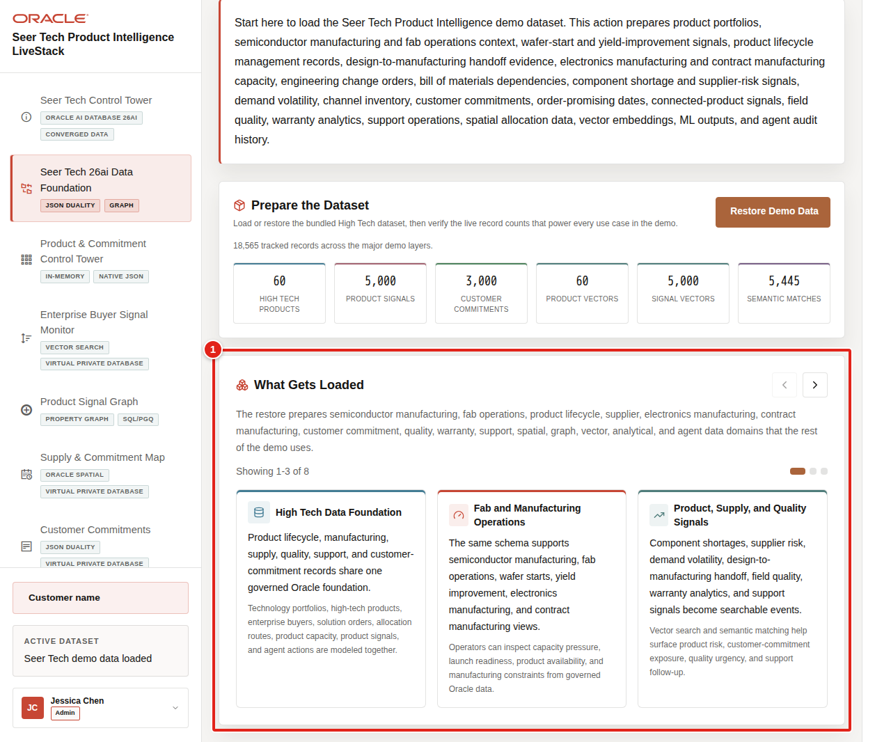
Figure 8. What Gets Loaded carousel highlighted with High Tech data domains
The carousel should make the shared data model concrete: fab, supplier, bill of materials, new product introduction, engineering change order, warranty, service, product telemetry, and customer commitment data are prepared from one foundation and reused by multiple Oracle AI Database capabilities.

Task 3: Connect the foundation to the rest of the demo
Use this page as the bridge into the operating story. The same governed foundation supports the control tower, enterprise buyer signal monitor, product signal graph, supply and commitment map, customer commitments, analytics, Ask Data, data import, and AI agent workflows.
1. Explain that the control tower will summarize the foundation as product-launch and customer-commitment indicators.
2. Explain that vector search will connect supply, demand, quality, and service signals to affected products and commitments.
3. Explain that graph, spatial, JSON Relational Duality, Oracle Machine Learning, Ask Data, bring-your-own-data, and agent pages all read from the same governed records.
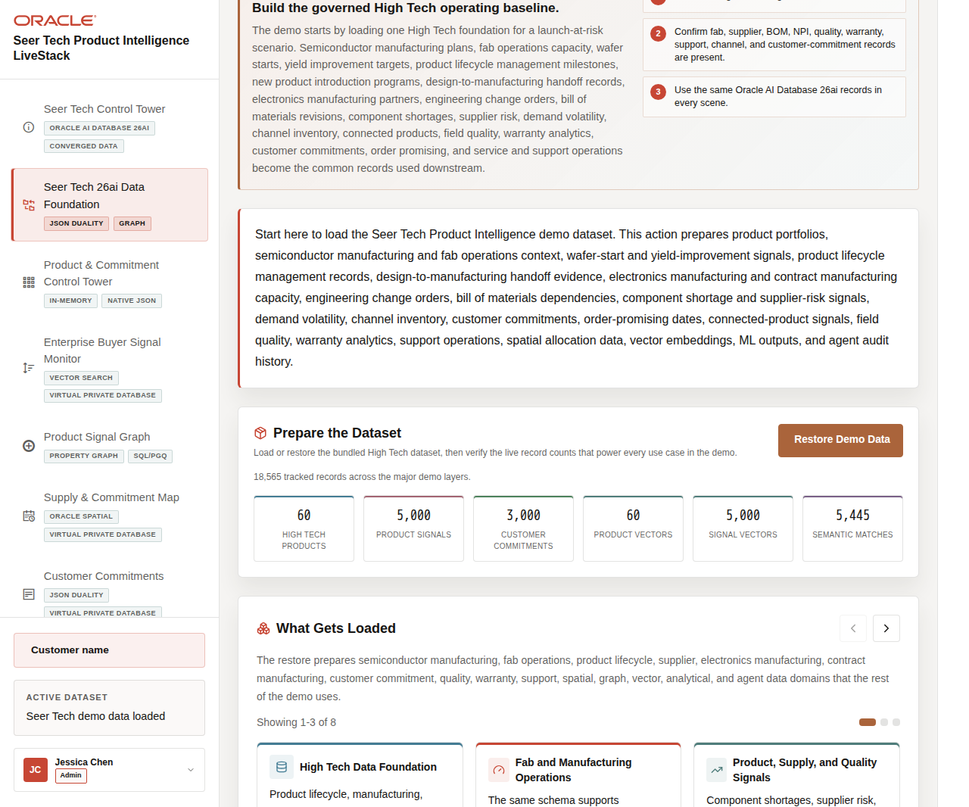
Figure 9. Data Foundation downstream handoff narrative highlighted
The business value is that the release-train story begins from one known operating baseline. Every metric and screenshot in later scenes can be traced back to the same product, signal, supply, customer, lifecycle, and predictive records.
You can move to the next scene.

Credits & Build Notes
• Author - Oracle LiveLabs Team
• Last Updated By/Date - Oracle LiveLabs Team, 2026-07-02
• Source Bundle - livestack-hightech.zip

Scene 3 Product & Commitment Intelligence Control Tower

Introduction
The Product & Commitment Intelligence Control Tower detects the first sign that Seer Tech's AI infrastructure release train may miss its launch window. Demand is accelerating across products such as Wafer Probe Exception Detector, Engineering Change Order Copilot, Supplier Risk Heatmap Service, Autonomous Test Cell Controller, and AI Edge Gateway Reference Kit, while component, fab, supplier, and allocation flexibility remain finite.
Instead of treating every signal as a separate alert, the control tower combines demand-signal velocity, signal concentration, matched-record volume, recent requested units, available inventory, and supply-site flexibility into one launch-exposure view. The objective is not simply to find the most popular product; it is to identify where rising demand and limited supply options can affect a launch or customer commitment.
Estimated Time: 10 minutes
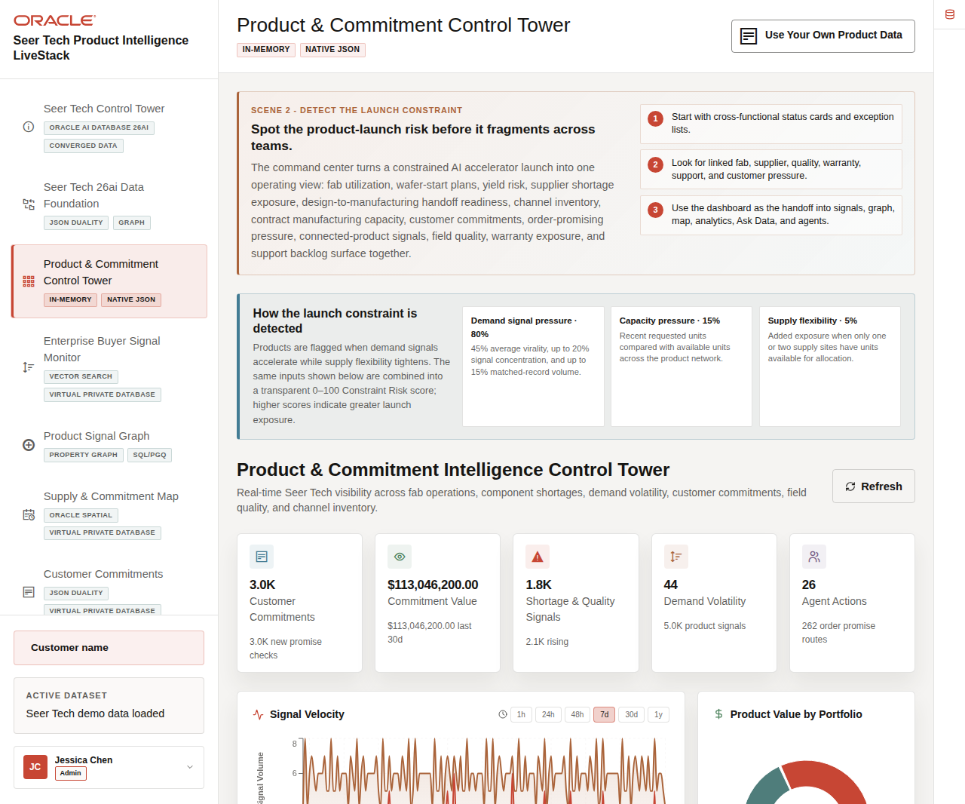
Figure 10. Product and Commitment Intelligence Control Tower showing launch-constraint guidance, KPIs, and demand charts

Objectives
In this scene, you will learn how Seer Tech detects a launch constraint, validates the demand trend over different time horizons, and identifies the products with the greatest constraint exposure.
Note: Oracle Internals is collapsed by default. Keep the business explanation visible first, then expand Oracle Internals when the audience wants implementation evidence.

Task 1: Understand why the launch is being flagged
Use the explanation panel and status cards to connect the detected constraint to visible business evidence:
1. Click Product & Commitment Control Tower in the sidebar and confirm the page title Product & Commitment Intelligence Control Tower.
2. Read How the launch constraint is detected.
3. Review the contribution of demand-signal pressure, capacity pressure, and supply flexibility.
4. Compare those inputs with the status cards for customer commitments, commitment value, shortage and quality signals, demand volatility, and agent actions.
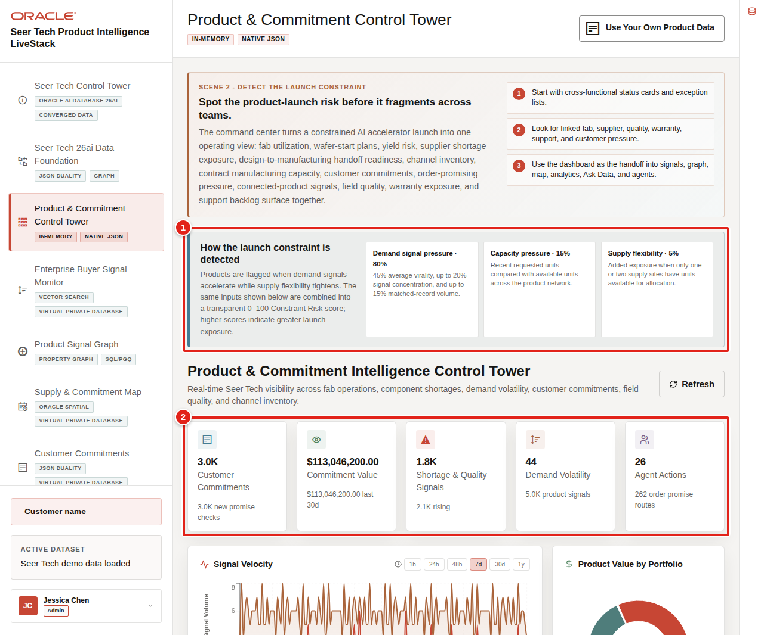
Figure 11. Launch-constraint calculation and control-tower status cards highlighted
The displayed Constraint Risk score is a transparent 0–100 demo score. Demand-signal pressure contributes 80%: up to 45 points from average virality, 20 from signal concentration, and 15 from matched-record volume. Capacity pressure contributes up to 15 points from recently requested units compared with available units. Supply flexibility contributes up to 5 points when only one or two sites can allocate the product.
The current dataset typically shows about 3.0K customer commitments, more than $113M in commitment value, and substantial shortage, quality, and demand-volatility activity. Live values can change after a restore or refresh, so present the relationship between the values rather than memorizing a single count.

Task 2: Validate signal velocity across time
Use the chart to determine whether the pressure is a short spike or a sustained planning issue:
1. Scroll to Signal Velocity.
2. Select 24h, 48h, 7d, or 30d and observe how the time buckets change.
3. Select 1y and confirm that the chart displays the full twelve-month history.
4. Read the horizontal Date axis and vertical Signal Volume axis.
5. Hover over the chart to inspect the values for a time bucket.
6. Hover over Product Value by Portfolio to retain the dollar-value context for each portfolio.
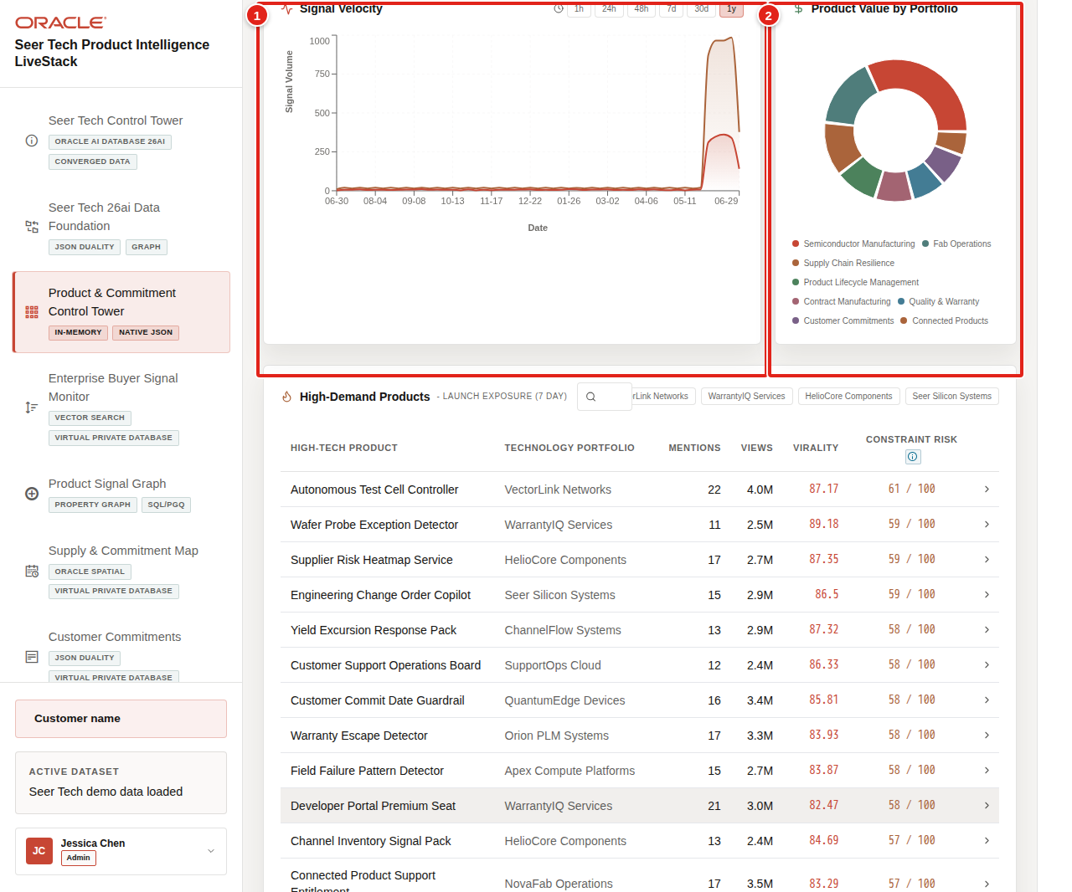
Figure 12. One-year Signal Velocity chart with Date and Signal Volume axes and the product-value distribution highlighted
The one-year view distinguishes a repeatable demand pattern from a temporary burst. Product value then adds materiality: a rising signal matters more when it affects a high-value portfolio, a scarce component path, or a large customer-commitment pool.

Task 3: Prioritize high-demand products by constraint risk
Move from portfolio-level pressure to specific products that require review:
1. Scroll to High-Demand Products - Launch Exposure (7 Day).
2. Compare Mentions, Views, Virality, and Constraint Risk.
3. Use the search field to find a product or launch program.
4. Select a row when you want to inspect its unit price, inventory, signals, and allocation context.
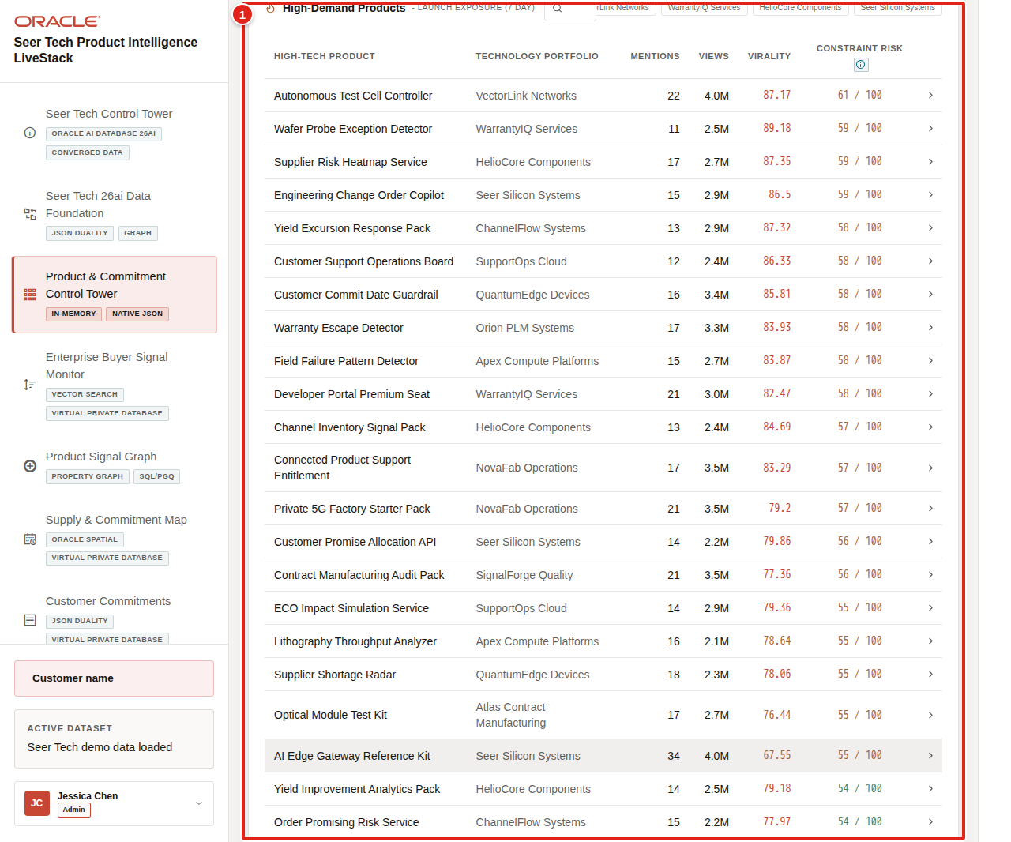
Figure 13. High-demand product table with varied signal values and Constraint Risk highlighted
The rows intentionally vary. A product with fewer mentions can still rank highly if its views accelerate, virality is strong, requested units exceed available inventory, or only a small number of supply sites can respond. That makes Constraint Risk more useful to a launch leader than a repeated generic momentum label.
The decision from this scene is clear: Seer Tech has enough evidence to investigate the launch path. Continue to Product Signals to understand which supply, demand, quality, and customer signals are creating the pressure.
You can move to the next scene.

Credits & Build Notes
• Author - Oracle LiveLabs Team
• Last Updated By/Date - Oracle LiveLabs Team, 2026-07-02
• Source Bundle - livestack-hightech.zip

Scene 4 Enterprise Buyer Signal Monitor

Introduction
The Enterprise Buyer Signal Monitor explains why the launch constraint detected in the control tower matters. Seer Tech searches product and signal records for evidence of GPU capacity pressure, component shortages, supplier exposure, wafer-start changes, engineering change orders, field quality patterns, warranty risk, connected-product telemetry, service demand, and customer-commitment impact.
Oracle AI Vector Search lets an operator describe the operating concern in business language. The database compares that phrase with governed High Tech product vectors and returns semantically related products even when the records do not contain the same keywords.
Estimated Time: 10 minutes
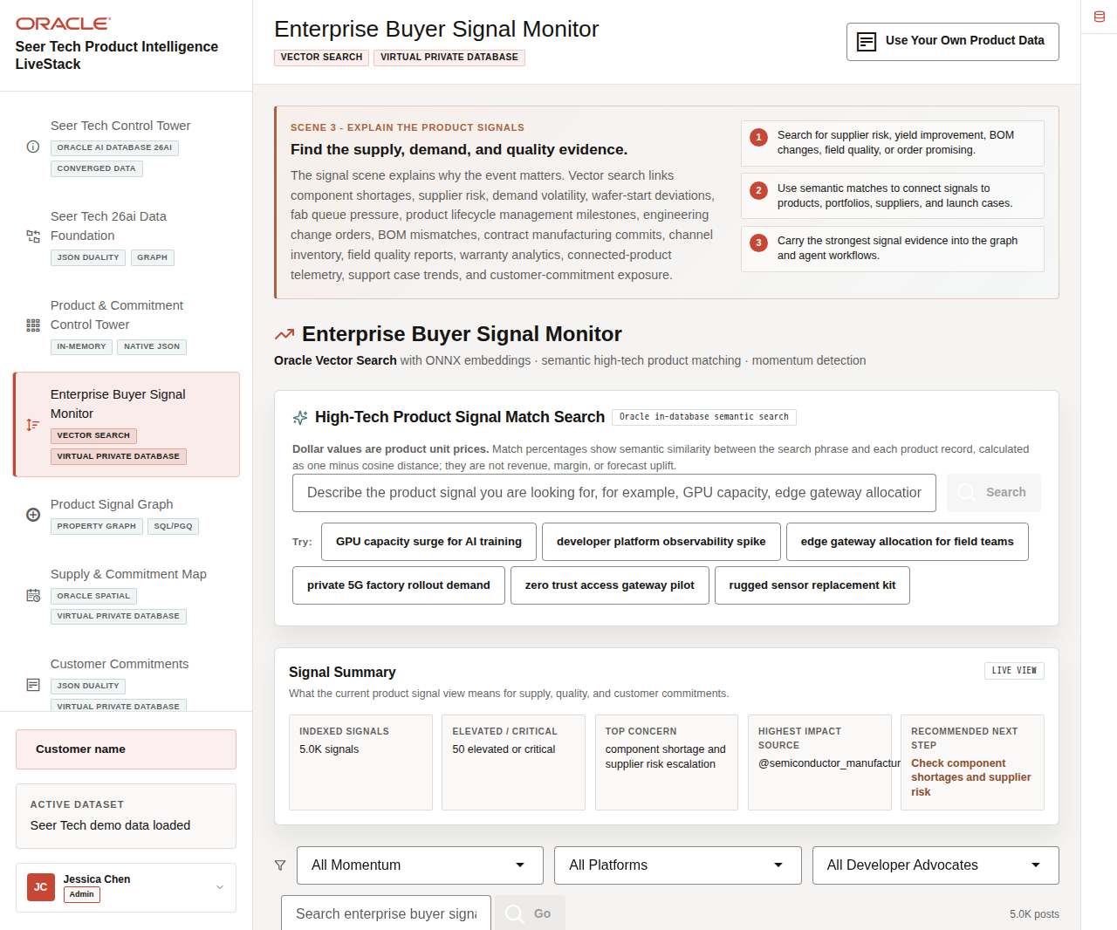
Figure 14. Enterprise Buyer Signal Monitor with product-signal search and signal summary

Objectives
In this scene, you will learn how to interpret product-signal search results, distinguish unit price from business impact, understand match percentages, and carry the strongest evidence into the product lifecycle graph.

Task 1: Review the current signal situation
Start with the search and summary panels before opening individual signal cards:
1. Click Enterprise Buyer Signal Monitor in the sidebar.
2. Review High-Tech Product Signal Match Search.
3. Read the explanation beneath the search title.
4. Review Signal Summary, including indexed signals, elevated or critical activity, the top concern, the highest-impact source, and the recommended next step.
5. Review the signal-feed filters and first product-signal cards.
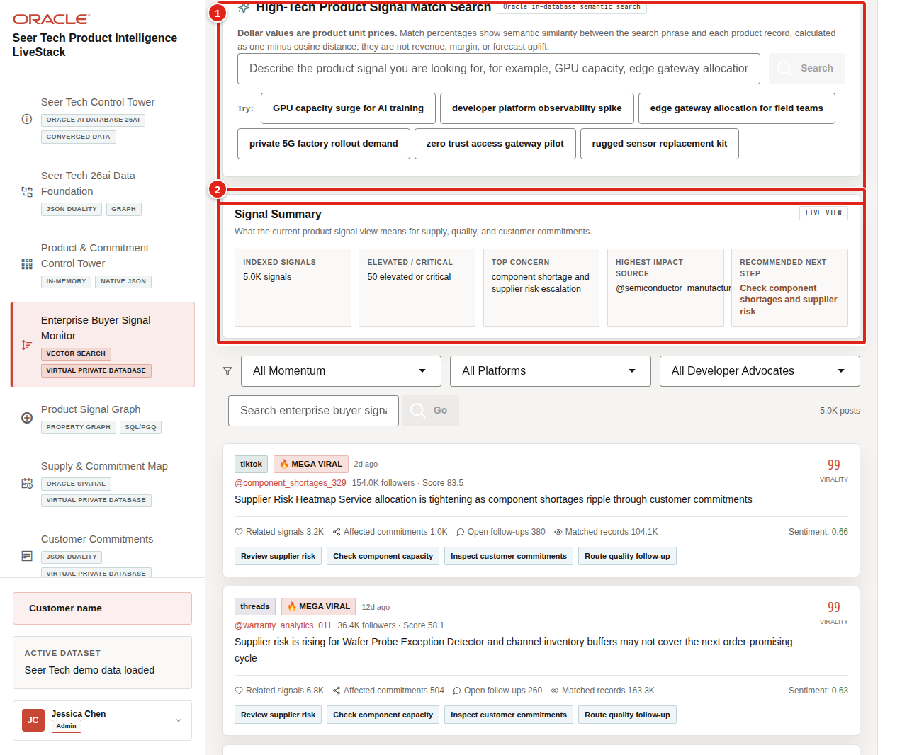
Figure 15. Product-signal search and Signal Summary panels highlighted
The summary converts a large signal feed into an operational handoff. In the current dataset, component shortage and supplier-risk escalation is a common top concern, and the recommended next step directs the operator toward capacity, supplier, or customer-commitment review.

Task 2: Run a semantic product-signal search
Search by operating intent rather than by an exact stock-keeping unit or product name:
1. Select GPU capacity surge for AI training, or enter a similar High Tech phrase.
2. Click Search.
3. Review the returned products and technology portfolios.
4. Compare Unit Price and Signal Match for each result.
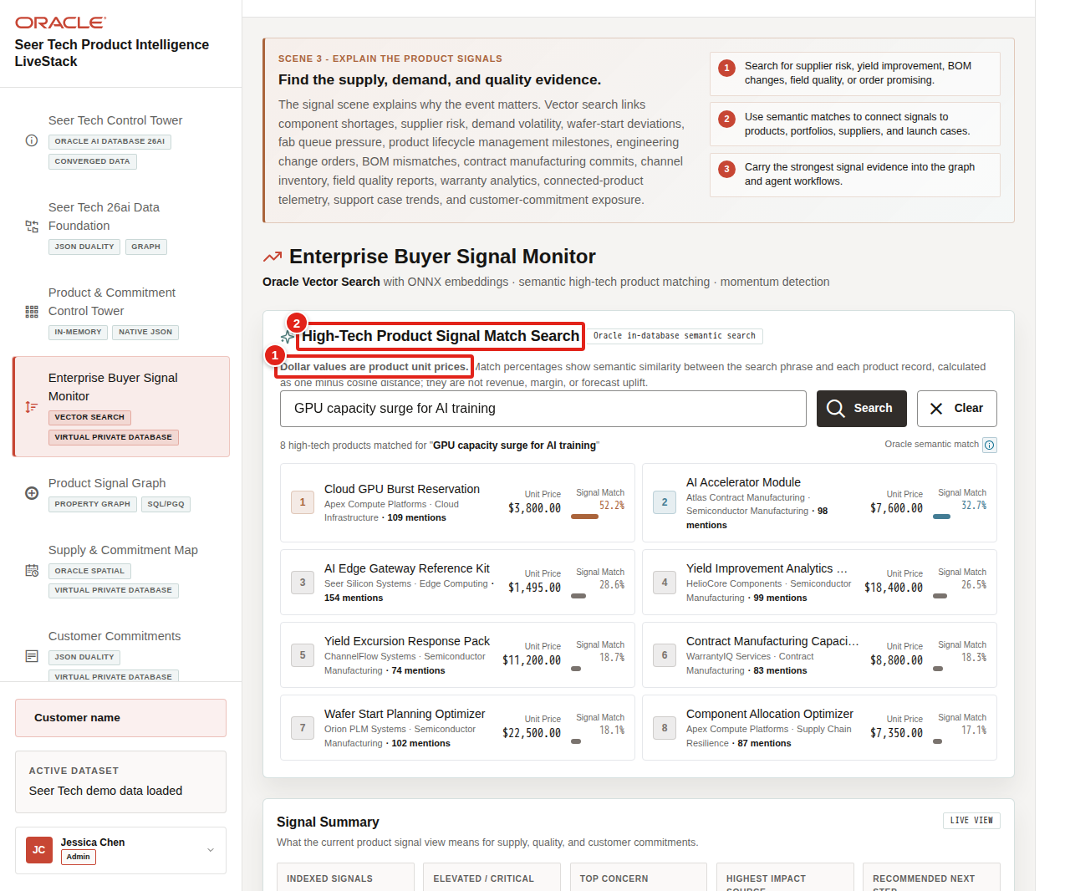
Figure 16. Semantic product results with Unit Price and Signal Match highlighted
Unit Price is the catalog price of one product or solution unit. It is not estimated revenue impact, margin, shortage cost, or forecast value. Signal Match is semantic similarity between the search phrase and the product record, calculated as one minus cosine distance and shown as a percentage. A 92% match therefore means the language is highly related; it does not mean demand will rise by 92%.
The result can connect a GPU-capacity question to products such as AI Accelerator Module, Cloud GPU Burst Reservation, AI Edge Gateway Reference Kit, or related allocation and capacity solutions even when the exact search phrase is absent from the source record.

Task 3: Interpret product-signal cards
Use the signal cards to understand severity and the downstream operating response:
1. Scroll to the first populated signal cards.
2. Review the source, posting date, audience reach, product-specific message, and Virality value.
3. Compare related signals, affected commitments, open follow-ups, matched records, and sentiment.
4. Review action chips such as Review supplier risk, Check component capacity, Inspect customer commitments, and Route quality follow-up.
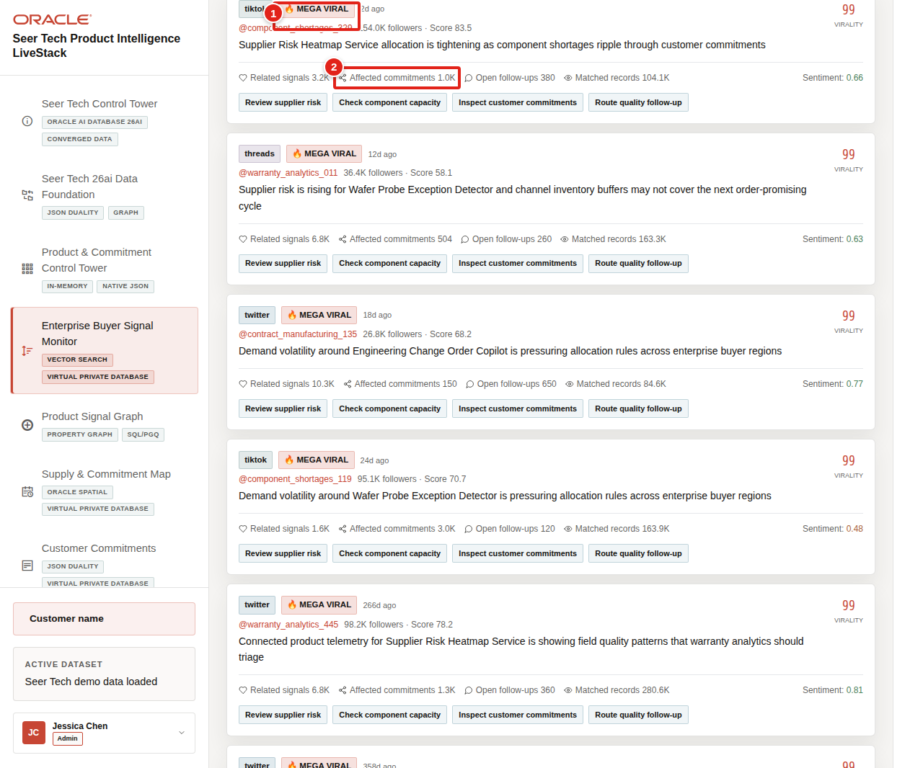
Figure 17. High Tech signal card with virality, affected commitments, and operating actions highlighted
Virality is a 0–100 signal-acceleration measure for the current product evidence. The supporting counts explain whether the signal has material operating reach. A highly viral signal with many affected commitments is a stronger launch-risk indicator than virality alone.
The decision from this scene is to trace the strongest evidence through the lifecycle network. Continue to Product Signal Graph to identify the bill of materials, supplier, fab, engineering change, quality, and customer relationships that can propagate the constraint.
You can move to the next scene.

Credits & Build Notes
• Author - Oracle LiveLabs Team
• Last Updated By/Date - Oracle LiveLabs Team, 2026-07-02
• Source Bundle - livestack-hightech.zip

Scene 5 Product Signal Graph

Introduction
The Product Signal Graph traces the detected launch pressure through Seer Tech's product lifecycle. A supplier signal may connect to an advanced substrate component, a bill of materials, an engineering change order, wafer-start capacity, outsourced assembly and test, a product portfolio, an allocation plan, and finally a customer commitment.
Oracle Property Graph keeps those relationships queryable as one governed network. The graph helps an operator answer a business question that a flat alert list cannot: Which dependency path can carry this constraint into the launch or a promised customer date?
Estimated Time: 10 minutes
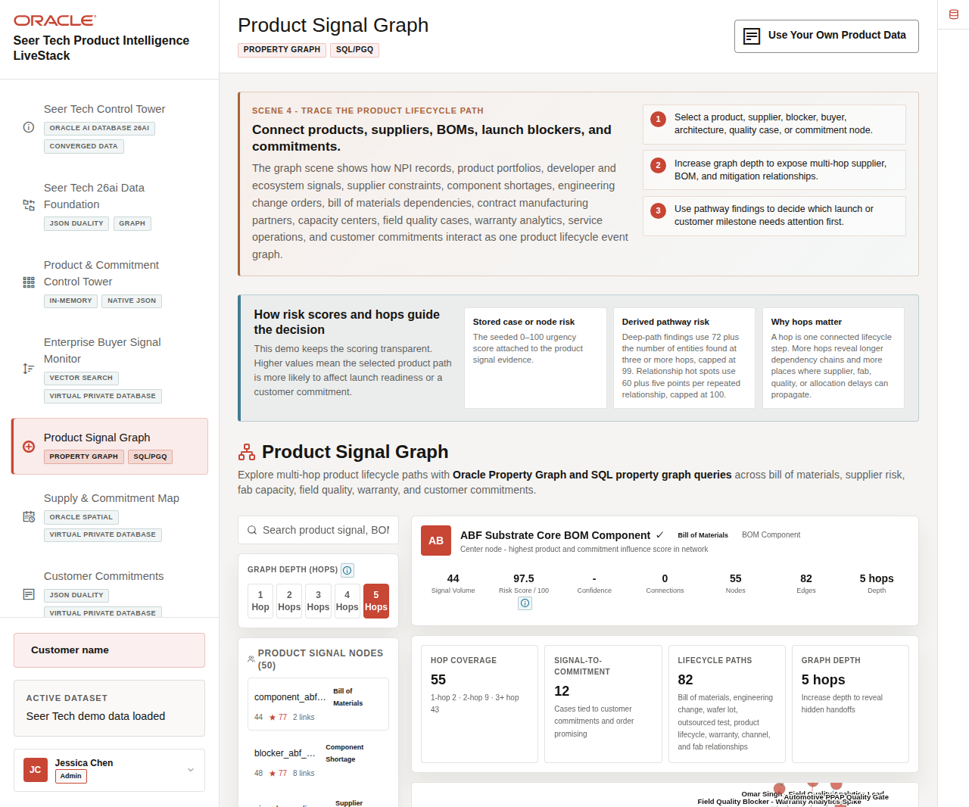
Figure 18. Product Signal Graph with risk guidance, graph-depth controls, and lifecycle network

Objectives
In this scene, you will learn how risk scores prioritize lifecycle paths, why graph hops matter, how the Edge Legend explains relationships, and how a business user can run a focused lifecycle query without interpreting raw internal identifiers.

Task 1: Review risk and graph-depth guidance
Start by understanding the two values that control the investigation:
1. Click Product Signal Graph in the sidebar.
2. Read How risk scores and hops guide the decision.
3. Select 1 Hop, then increase the view through 5 Hops.
4. Observe how additional suppliers, components, fabs, product records, quality evidence, and commitments enter the network.
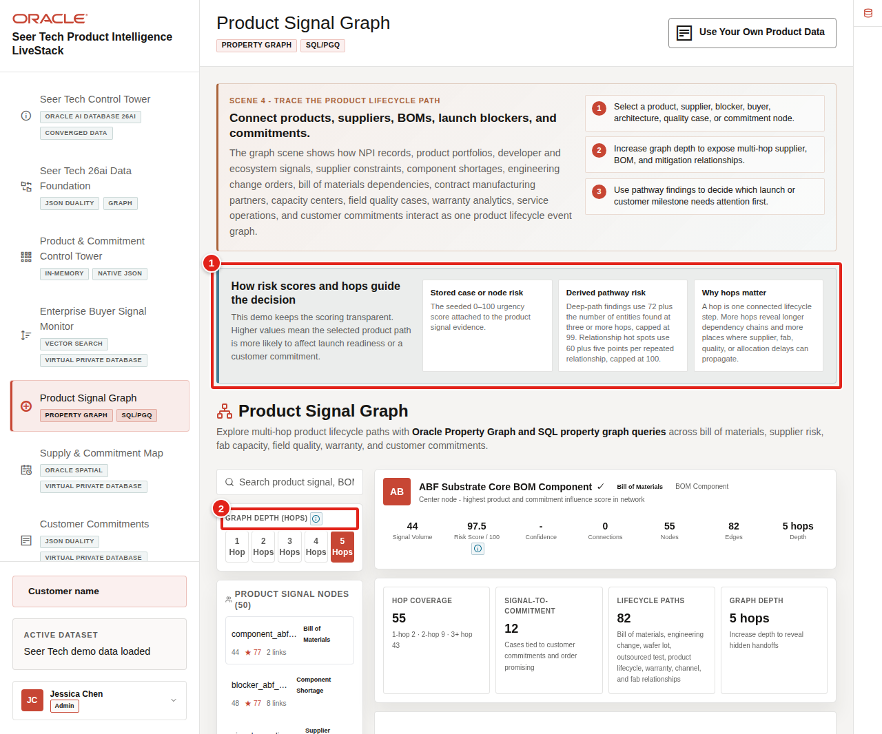
Figure 19. Risk-score explanation and graph-depth controls highlighted
The seeded Stored case or node risk is a 0–100 urgency value attached to the demo evidence. Derived pathway risk makes the demo calculation explicit: deep-path findings begin at 72 and add one point for each entity found at three or more hops, capped at 99; relationship hot spots begin at 60 and add five points for each repeated relationship, capped at 100.
A hop is one connected lifecycle step. More hops reveal a longer dependency chain and more places where supplier, fab, engineering, quality, allocation, or fulfillment delays can propagate. More hops do not automatically mean a worse outcome; they provide broader dependency evidence for the decision.

Task 2: Inspect a lifecycle-risk path
Use the selected business entity and pathway findings to connect the graph to launch readiness:
1. Select a product, bill-of-materials component, supplier, capacity blocker, engineering change, quality case, or customer-commitment node.
2. Review the display name and plain-language entity type.
3. Compare Signal Volume, Risk Score / 100, connections, node and edge counts, and graph depth.
4. Review Hop Coverage, Signal-to-Commitment, Lifecycle Paths, and the connected business entities.
5. Scroll to Key Pathway Findings and compare the risk, description, pathway roles, value at risk, and recommended action.
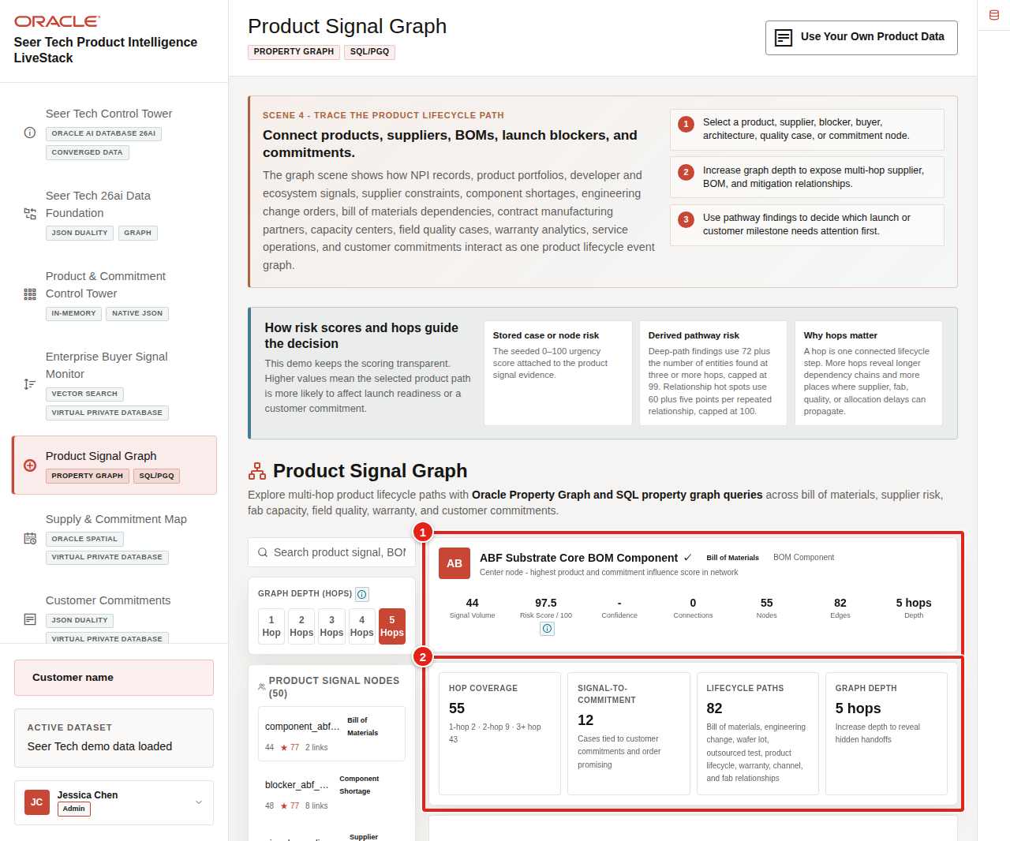
Figure 20. Selected lifecycle entity with Risk Score and Hop Coverage highlighted
The current graph commonly surfaces paths involving advanced substrate availability, wafer-start variance, engineering changes, capacity reservations, outsourced semiconductor assembly and test, order promising, field quality, and warranty containment. These are business dependencies, not isolated database keys.
Keep the Edge Legend visible during the walkthrough. It explains relationship groups such as demand signals, customer commitments, supply resilience, fab and manufacturing flow, product data and engineering change control, and quality and service intelligence.

Task 3: Run a focused graph query
Use a prepared business query to validate a specific lifecycle path:
1. Scroll to Graph Query Explorer.
2. Select BOM and ECO Commitment Path. Here, BOM means bill of materials and ECO means engineering change order.
3. Review the plain-language description and maximum hop count.
4. Click Run Query.
5. Review the returned product portfolio, lifecycle signal, customer commitment, relationship path, and value at risk.
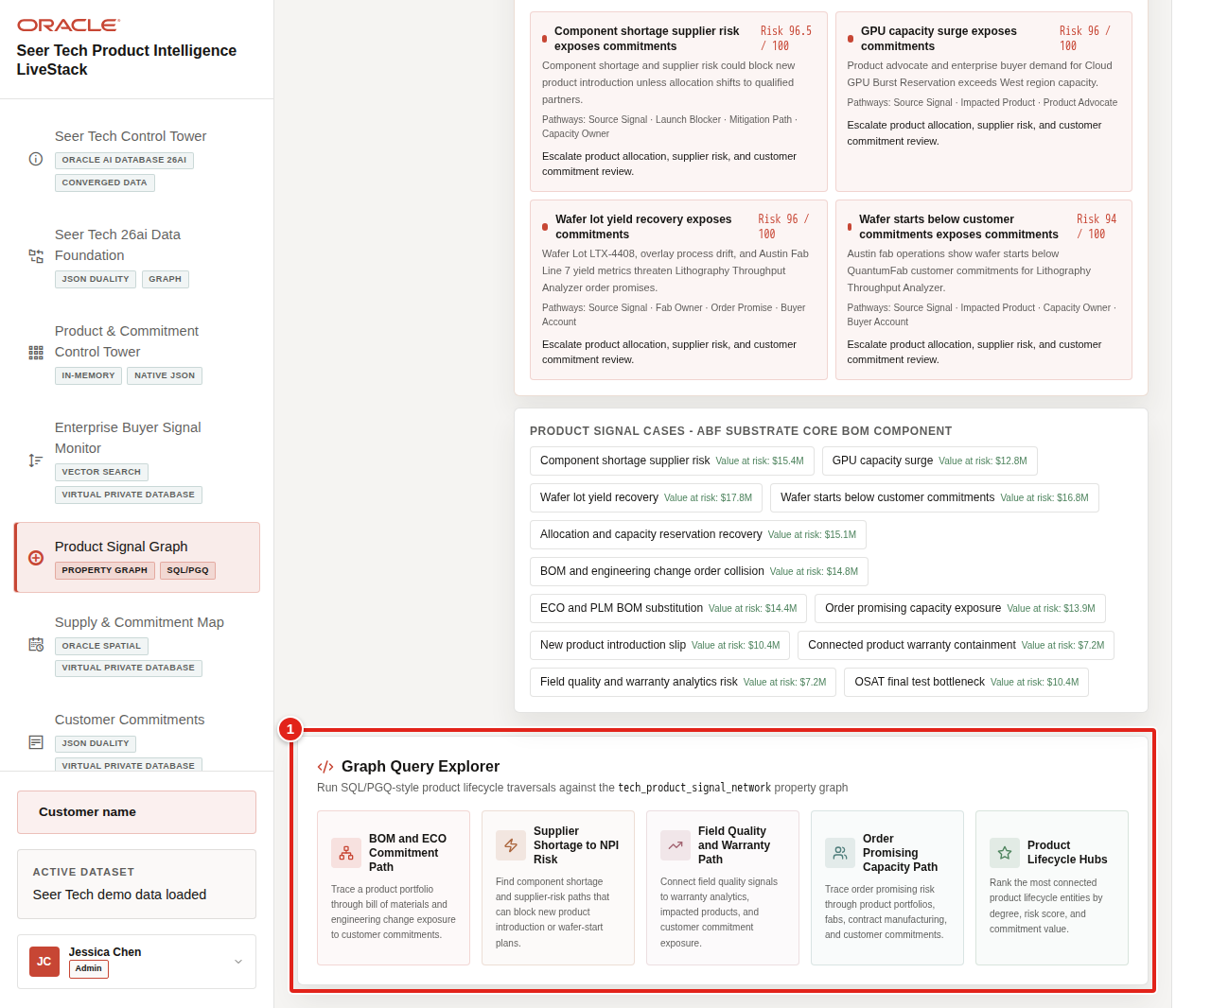
Figure 21. Graph Query Explorer with plain-language lifecycle queries highlighted
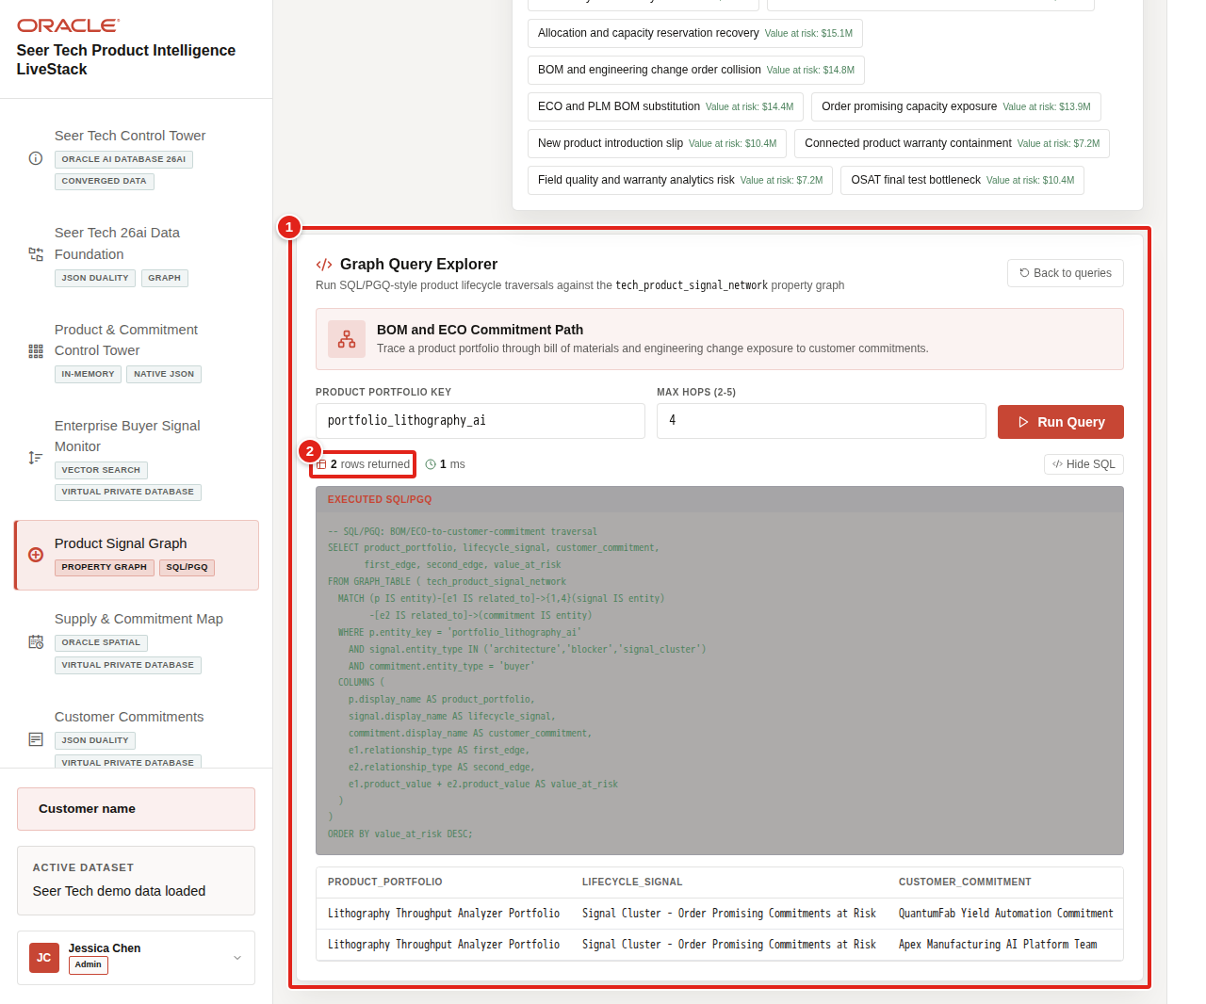
Figure 22. Bill-of-materials and engineering-change commitment query results highlighted
The query confirms whether the launch issue is connected to a real customer or fulfillment dependency. It also gives supply and product teams a shared path to discuss instead of asking each group to reconcile separate records.
The decision from this scene is to coordinate capacity and allocation using the locations that can respond. Continue to the Supply & Commitment Map.
You can move to the next scene.

Credits & Build Notes
• Author - Oracle LiveLabs Team
• Last Updated By/Date - Oracle LiveLabs Team, 2026-07-02
• Source Bundle - livestack-hightech.zip

Scene 6 Supply & Commitment Map

Introduction
The Supply & Commitment Control Tower turns lifecycle risk into a capacity and allocation decision. Seer Tech can compare fabs, contract manufacturing hubs, supplier-direct allocation, channel inventory, field-quality buffers, product availability centers, order-promise routes, and customer destinations on one spatial operating view.
This scene answers the next launch question: Which locations have inventory and flexibility, and which products have a supported immediate shortage rather than a generic warning?
Estimated Time: 10 minutes
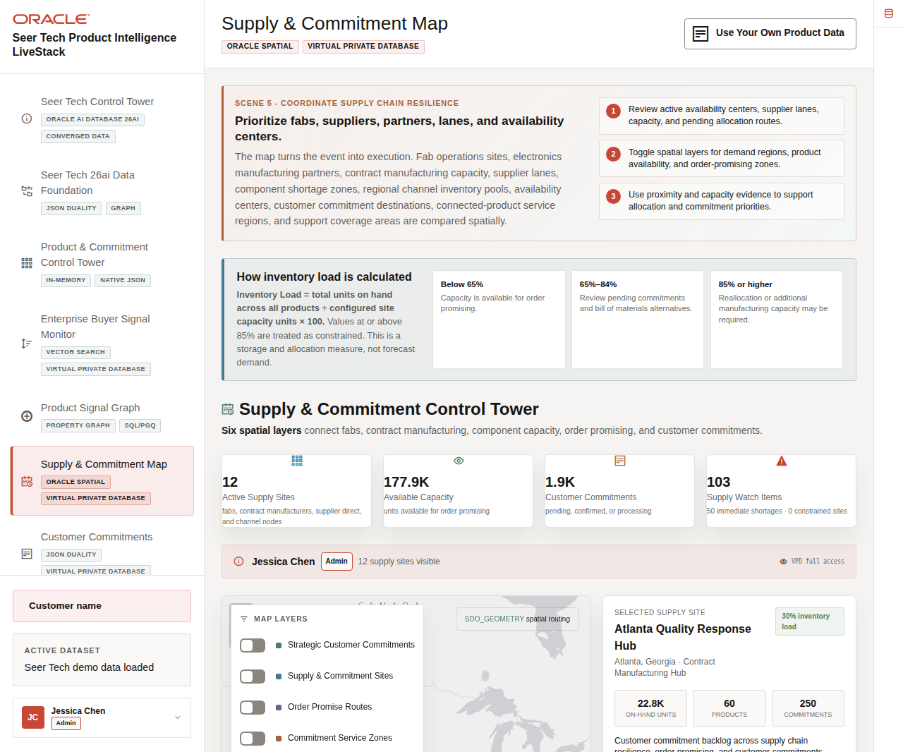
Figure 23. Supply and Commitment Control Tower with Inventory Load guidance, spatial map, and selected site

Objectives
In this scene, you will learn how Inventory Load is calculated, how spatial layers support allocation, how site-level actions protect commitments, and how Immediate Shortages differ from watchlist monitoring.

Task 1: Understand Inventory Load and supply priorities
Use the calculation panel and status cards before choosing a site:
1. Click Supply & Commitment Map in the sidebar.
2. Read How inventory load is calculated.
3. Review the thresholds below 65%, from 65% through 84%, and at or above 85%.
4. Compare active supply sites, available capacity, customer commitments, and supply watch items.
Figure 24. Inventory Load calculation, supply status cards, and selected site highlighted
Inventory Load = total units on hand across all products ÷ configured site capacity units × 100. It is a storage and allocation measure, not forecast demand. Below 65% indicates available order-promising capacity. From 65% through 84%, planners should review pending commitments and bill-of-materials alternatives. At 85% or higher, reallocation or added manufacturing capacity may be required.
The live demo typically shows 12 active supply sites, about 177.9K available units, and roughly 1.9K open customer commitments. Values can change after a dataset refresh.

Task 2: Use spatial layers to compare response options
Use the map to understand which facilities and routes can respond to the launch pressure:
1. Review Map Layers.
2. Toggle strategic customer commitments, supply and commitment sites, order-promise routes, service zones, density, and product-demand regions.
3. Select a supply site.
4. Review the site type, location, Inventory Load, on-hand units, supported products, and commitments.
5. Review the recommended actions: Protect customer commitments, Confirm contract manufacturing capacity, Check BOM alternates, and Update order promising. In the action label, BOM means bill of materials.
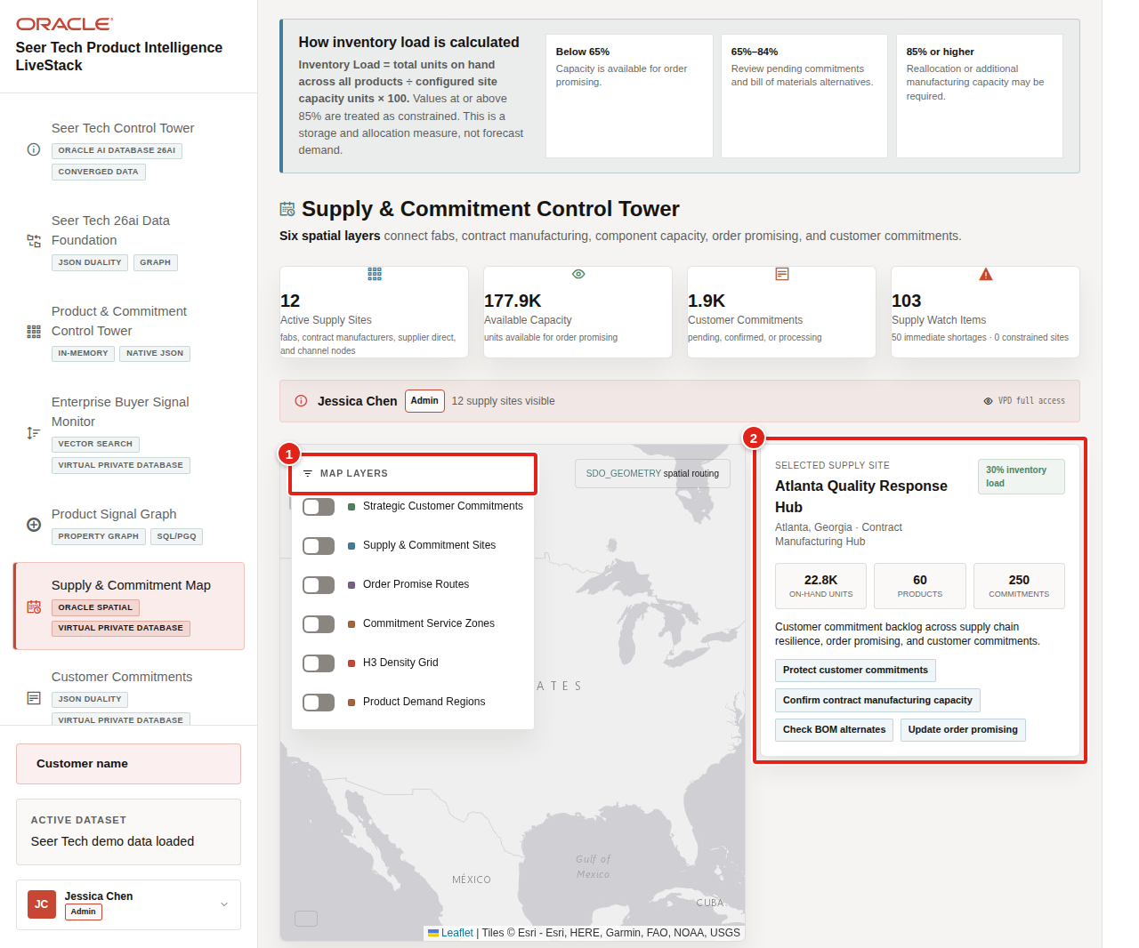
Figure 25. Spatial map layers and selected supply-site evidence highlighted
The actions remain prominent because the map is an execution surface, not only a visualization. A product or supply leader should leave this view knowing which facility, alternative component, allocation pool, or promise date needs review.

Task 3: Distinguish shortages from watchlist items
Compare the site table with the evidence in Capacity Alerts:
1. Scroll to Supply & Commitment Sites.
2. Compare On-Hand Units, commitments, and Inventory Load by site.
3. Scroll to Capacity Alerts - Immediate Shortages and Watchlist.
4. Review an Immediate shortage card.
5. Confirm that the card shows stock on hand, forecast need, the demand factor, and a reason such as Forecast need exceeds stock on hand by 674 units.
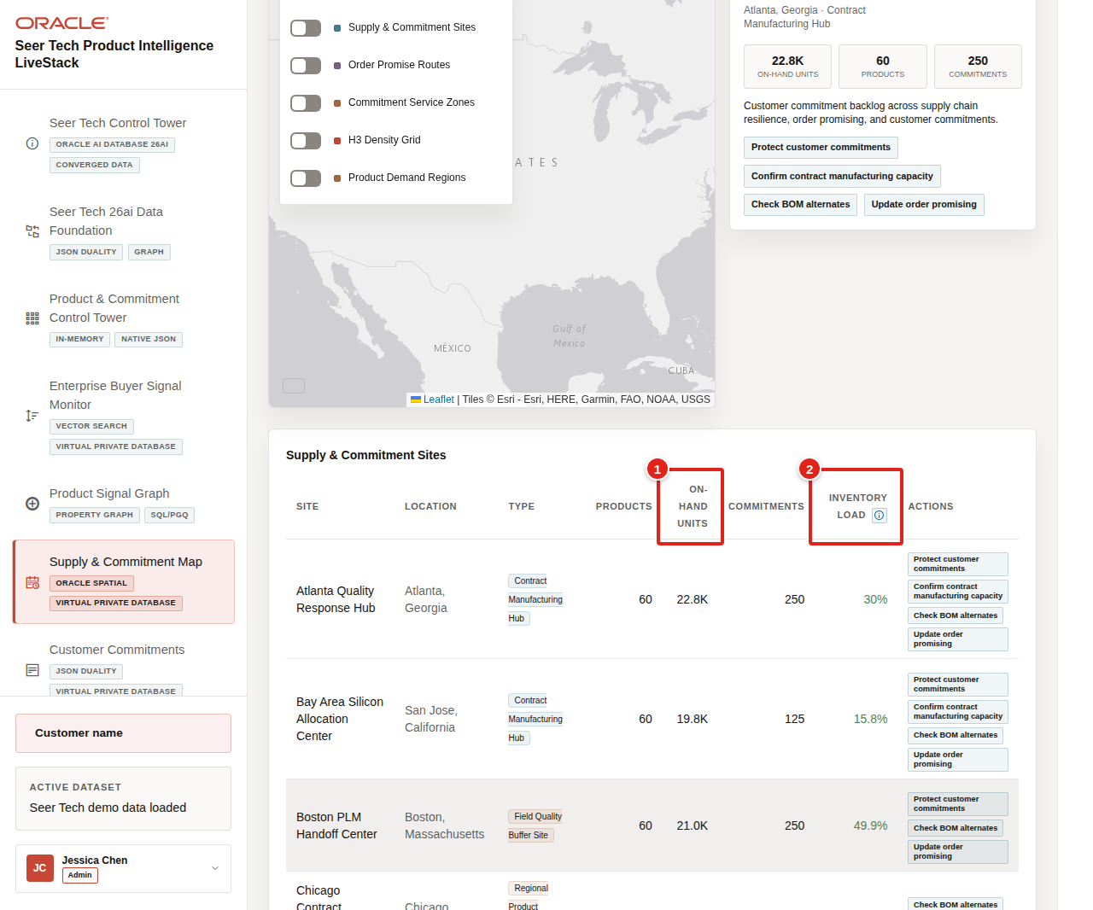
Figure 26. Supply-site table with On-Hand Units and Inventory Load highlighted
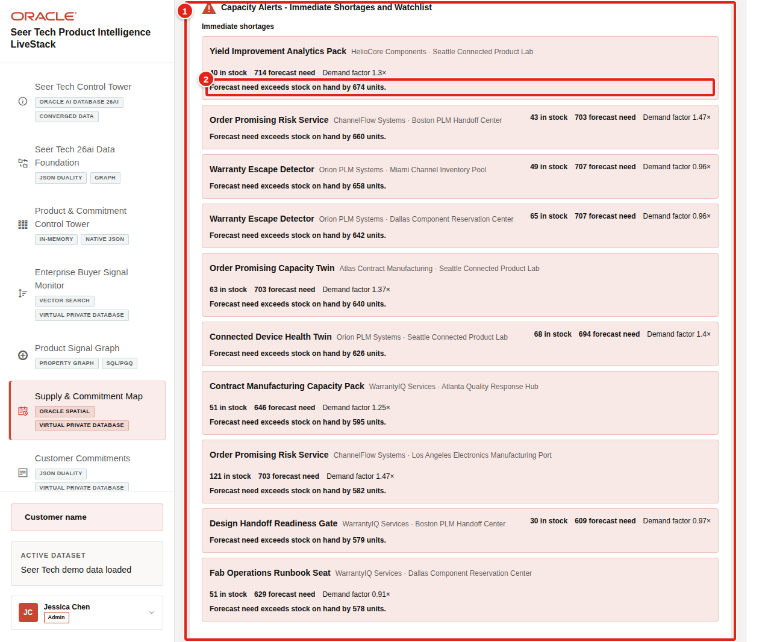
Figure 27. Immediate shortage cards with supported forecast-need reasons highlighted
A component is an Immediate shortage only when current stock is zero or forecast demand exceeds stock. A product with stock and zero current need must not be presented as a shortage. If such an item is retained for forecast monitoring, it belongs on the watchlist and must state the reason, such as forecast volatility or future demand exposure.
The decision from this scene is to identify which customer promises depend on the constrained path. Continue to Customer Commitments.
You can move to the next scene.

Credits & Build Notes
• Author - Oracle LiveLabs Team
• Last Updated By/Date - Oracle LiveLabs Team, 2026-07-02
• Source Bundle - livestack-hightech.zip

Scene 7 Customer Commitments

Introduction
Customer Commitments shows the commercial consequence of the launch constraint. Seer Tech can connect a product or supply issue to the enterprise buyer, commitment value, supply site, target date, actual completion status, and any cancellation reason.
The same governed commitment can be viewed as an operational row, an application-friendly JSON Relational Duality document, or a spatial fulfillment route. This keeps product operations, customer teams, and application developers aligned on one record.
Estimated Time: 10 minutes
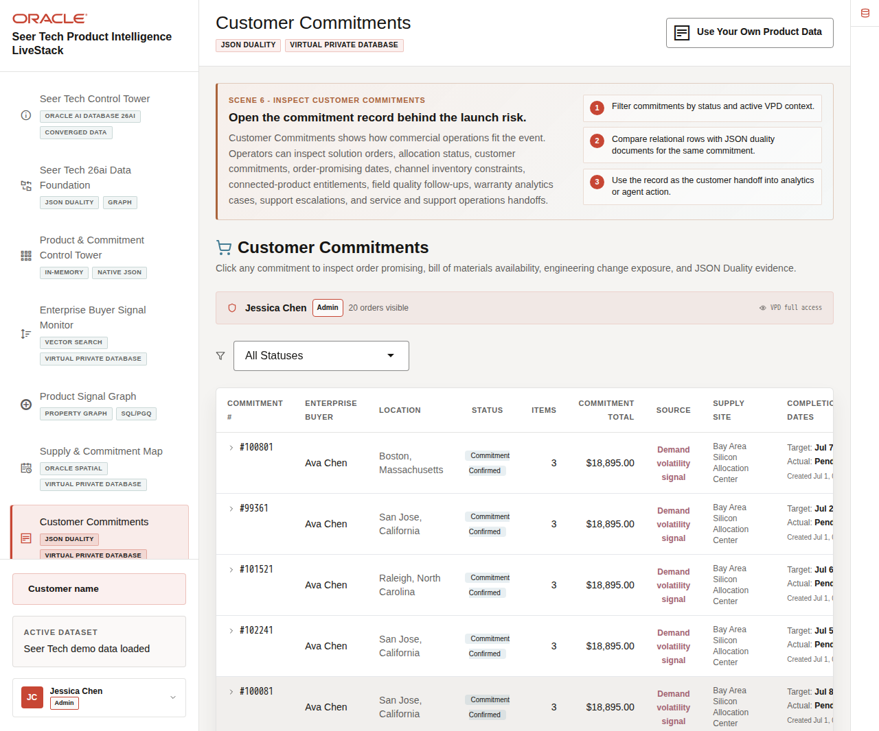
Figure 28. Customer Commitments workspace with completion dates and cancellation context

Objectives
In this scene, you will learn how target and actual completion dates improve commitment triage, how cancellation reasons add business context, and how relational, JSON, and spatial views remain connected.

Task 1: Review operational commitment dates
Start with the table as the customer-operations queue:
1. Click Customer Commitments in the sidebar.
2. Review the active user and Virtual Private Database access context.
3. Compare commitment number, enterprise buyer, location, status, items, commitment total, source, and supply site.
4. Review Completion Dates.
5. Compare Target, Actual, and the secondary Created timestamp.
6. Review Cancellation Reason.
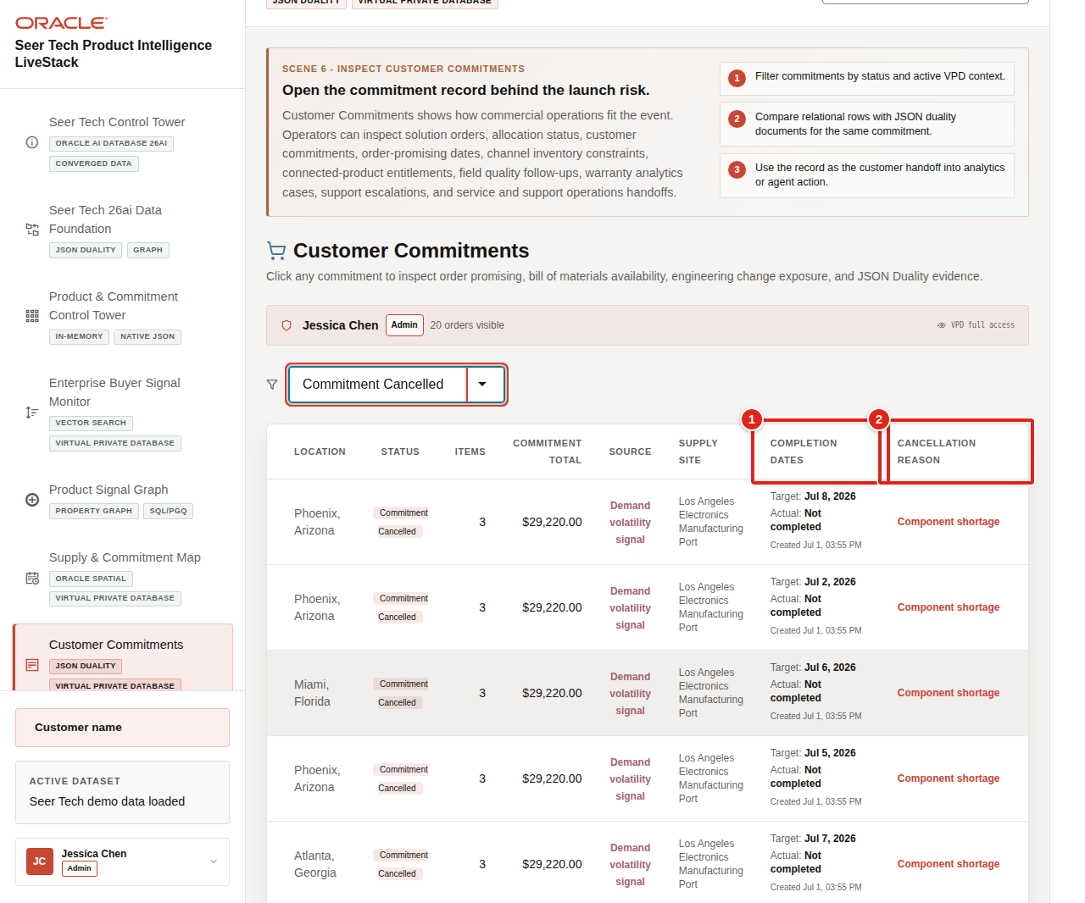
Figure 29. Customer commitment table with Completion Dates and Cancellation Reason highlighted
The Target Completion Date is the operational date the team is working toward. A completed commitment shows an Actual Completion Date. An active commitment shows Pending, which avoids implying that fulfillment has already occurred. Creation date remains visible for context but is secondary to target and actual completion.

Task 2: Inspect a cancelled commitment
Use the status filter to understand why a commitment left the active queue:
1. Open the status filter and select Cancelled.
2. Review the cancellation reason in the table.
3. Select a cancelled commitment.
4. Review Target Completion Date, Actual Completion Date, and Cancellation Reason in the detail panel.
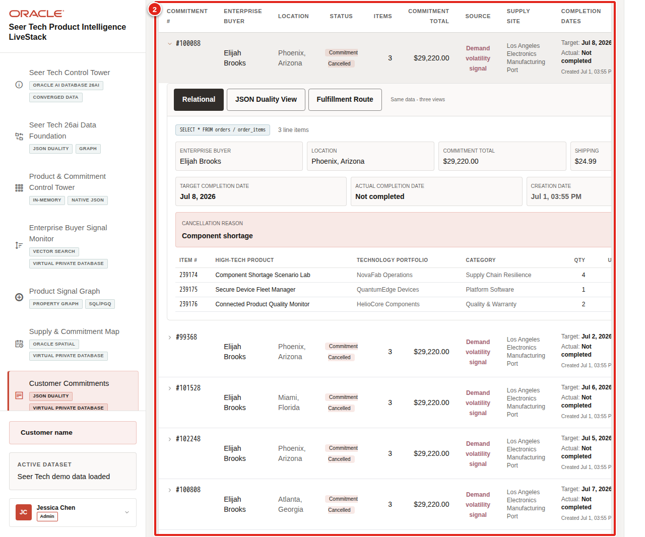
Figure 30. Cancelled customer commitment with target date and cancellation reason highlighted
Cancellation reasons can include component shortage, customer configuration change, duplicate order, missed delivery date, expired pricing approval, or a delayed customer project. The reason is shown only when it is relevant. Cancelled commitments display Not completed rather than a misleading actual completion date.

Task 3: Compare the JSON Relational Duality document
Review the same commitment in the document shape used by applications:
1. Select JSON Duality View in the expanded commitment panel.
2. Review customer, status, value, source, target and actual delivery fields, demand score, and nested line items.
3. Compare the JSON values with the relational detail.
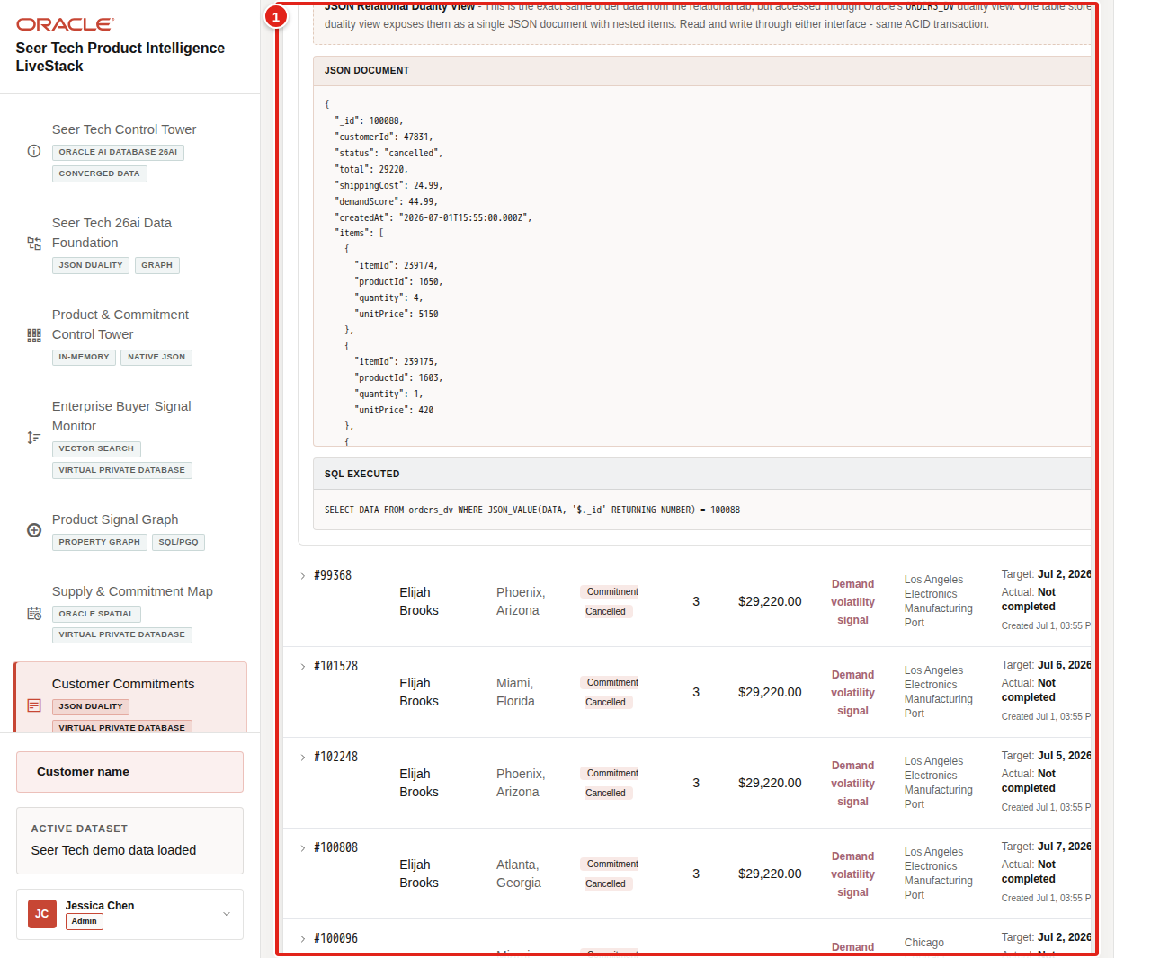
Figure 31. JSON Relational Duality document for the selected commitment highlighted
The commitment is not copied into a separate document store. JSON Relational Duality exposes an application-friendly document over the same governed relational data.

Task 4: Review fulfillment-route context
Connect the commitment to the supply path that must meet the target date:
1. Select Fulfillment Route.
2. Review the supply site and customer destination.
3. Compare distance, estimated transit time, route cost, route status, and commitment progress.
4. Relate the route to the capacity and allocation decision from the previous scene.
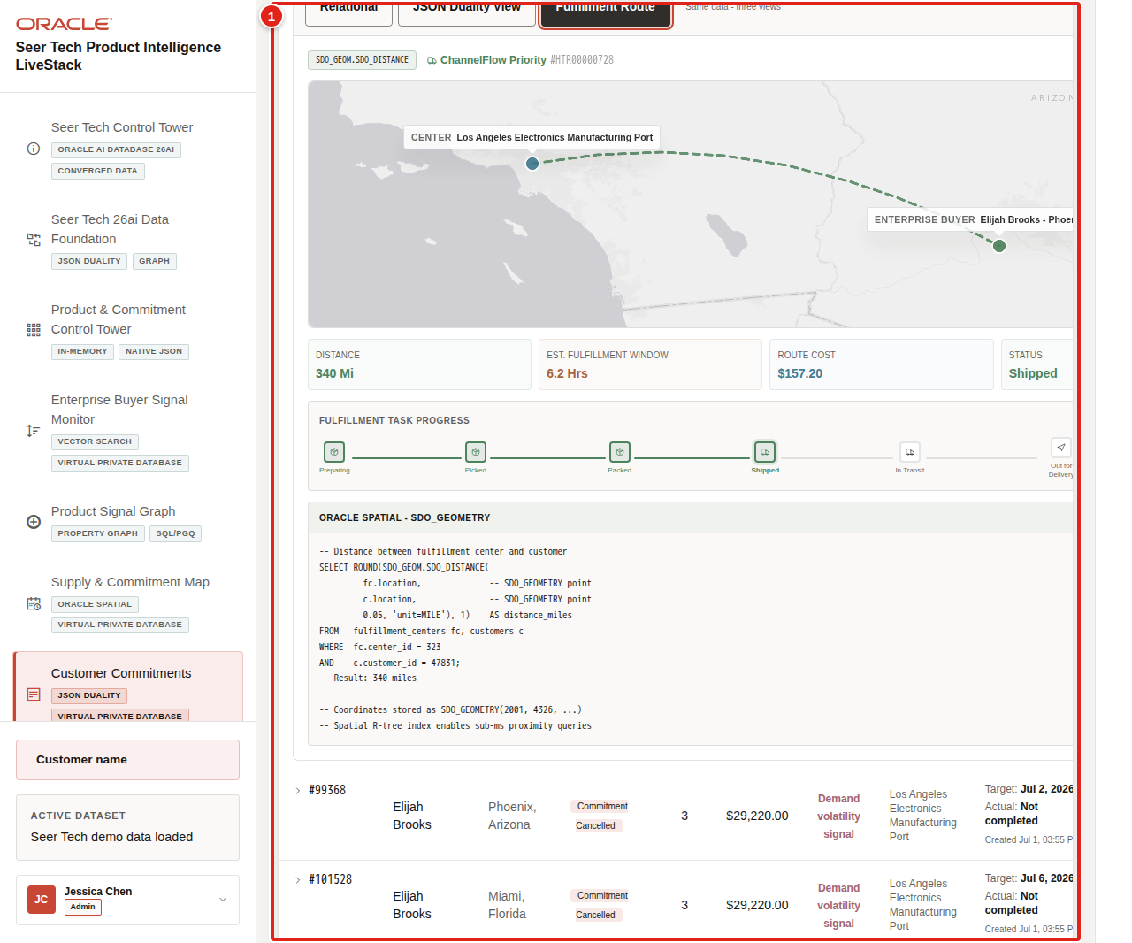
Figure 32. Fulfillment route for the selected customer commitment highlighted
The decision from this scene is to quantify future exposure before more commitments move into exception or cancellation status. Continue to Predictive Product & Commitment Analytics.
You can move to the next scene.

Credits & Build Notes
• Author - Oracle LiveLabs Team
• Last Updated By/Date - Oracle LiveLabs Team, 2026-07-02
• Source Bundle - livestack-hightech.zip

Scene 8 Predictive Product & Commitment Analytics

Introduction
Predictive Product & Commitment Analytics estimates where Seer Tech's next launch constraint may emerge. Oracle Machine Learning connects recent product signals with requested units, customer commitments, value, bill-of-materials exposure, and capacity evidence so product and supply teams can act before the next exception reaches a promise date.
The page leads with business predictions and durable result readiness. Technical database model object names remain available in the collapsed Technical model details section for specialists, without making internal identifiers the main operator story.
Estimated Time: 12 minutes
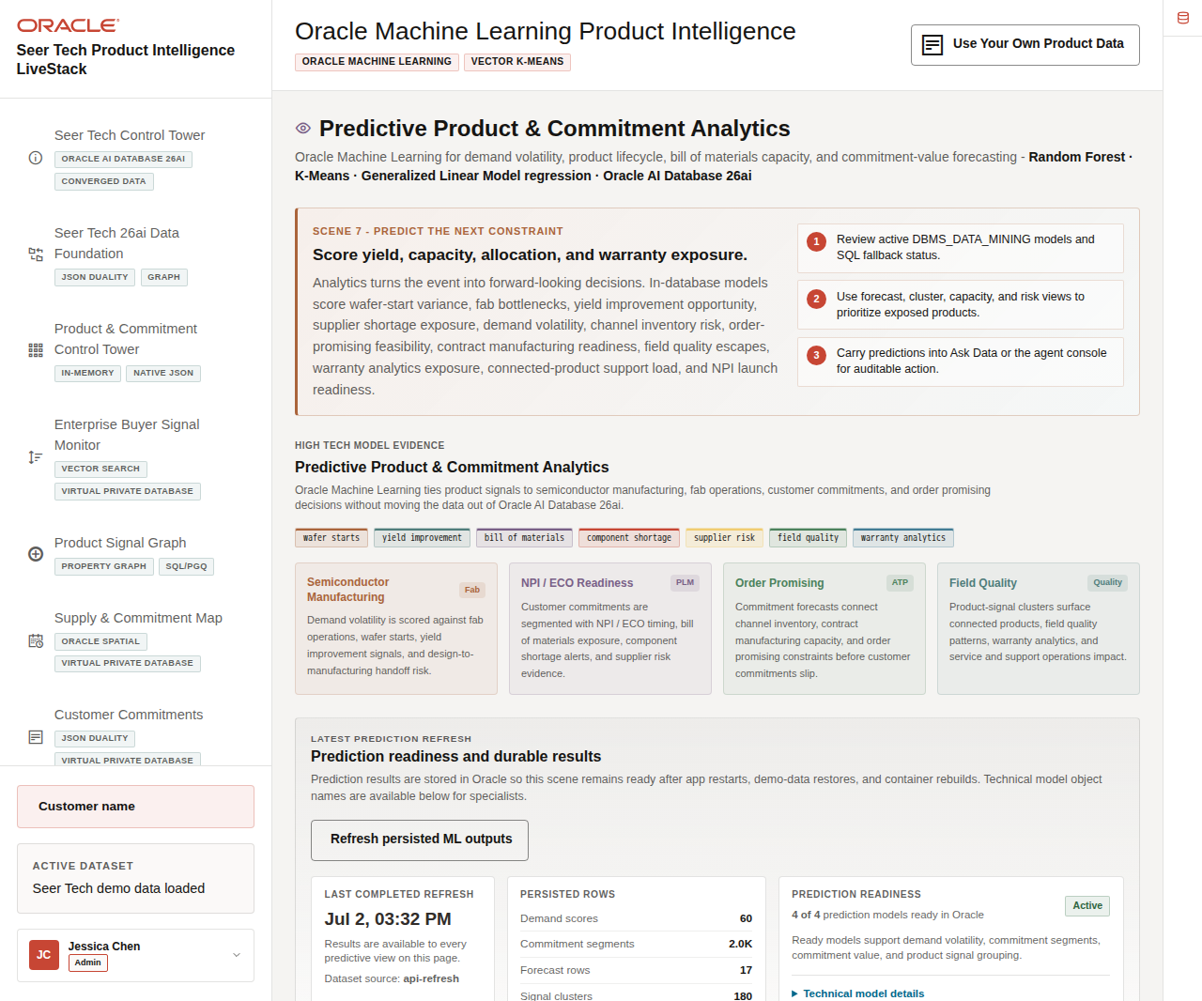
Figure 33. Predictive Product and Commitment Analytics with Prediction Readiness and current model results

Objectives
In this scene, you will learn how Virality, Demand Uplift, Predicted Orders, value opportunity, and confidence are interpreted; how forecasts lead product details; and how related predictive views support customer, signal, and capacity decisions.

Task 1: Confirm prediction readiness
Start with the persisted result status rather than raw model lifecycle identifiers:
1. Click Oracle Machine Learning Product Intelligence in the sidebar.
2. Review Prediction readiness and durable results.
3. Confirm the last completed refresh, dataset source, persisted-row counts, and Prediction Readiness status.
4. Expand Technical model details only when the audience needs database model names or catalog evidence.
Figure 34. Prediction Readiness and persisted analytics results highlighted
The readiness panel explains the business value of persistence: demand scores, commitment segments, forecast rows, product-signal groups, and capacity alerts remain available after application restarts, demo restores, and container rebuilds.

Task 2: Interpret Demand Volatility Forecasting
Use the forecast first, then inspect the products behind it:
1. Keep Demand Volatility selected.
2. Read How these values are calculated.
3. Review the Top 10 - Predicted Solution Orders bar chart.
4. Hover over a bar to inspect the product and predicted order value.
5. Review the product-detail table below the chart.
6. Compare Virality, Uplift Indicator, Predicted Orders, Estimated Product Value Opportunity, Confidence, and signal status.
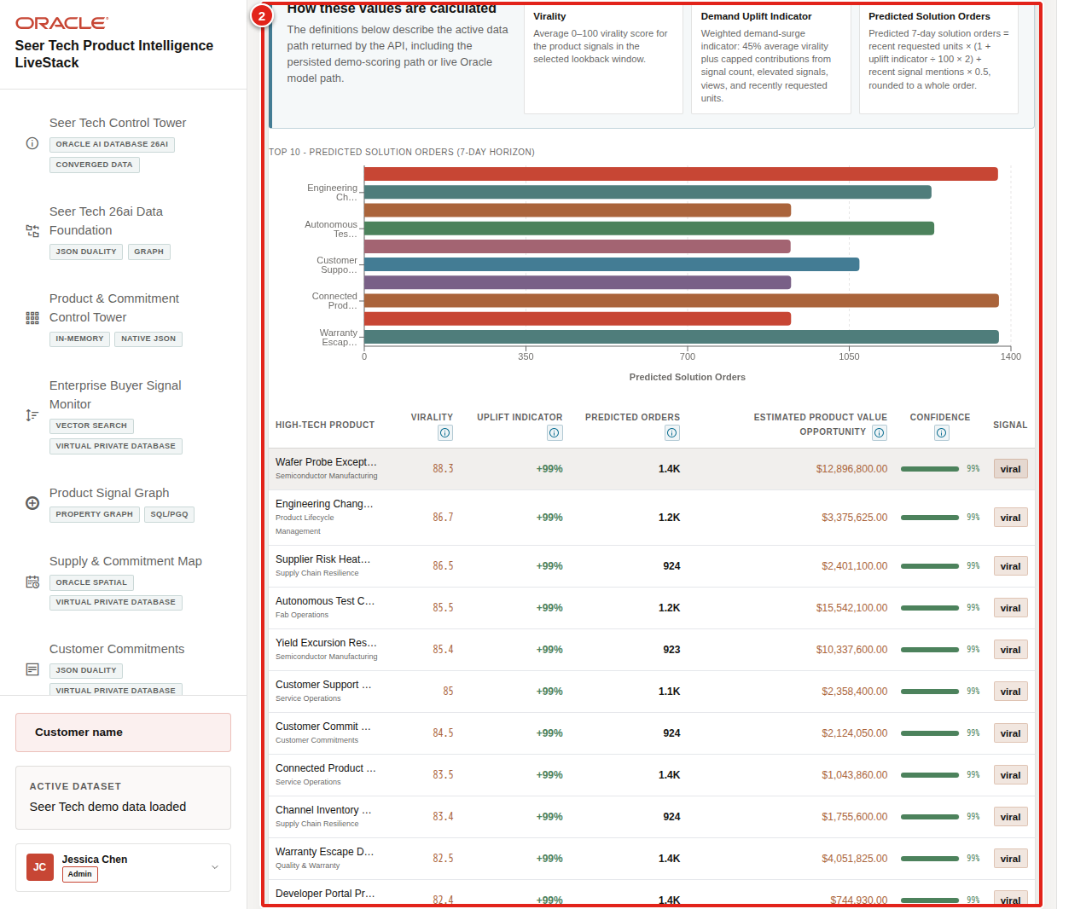
Figure 35. Demand Volatility calculation guidance, forecast chart, and product details highlighted
The active persisted demo path uses these definitions:
• Virality is the product's average 0–100 virality score during the selected lookback window.
• Demand Uplift Indicator is a weighted demand-surge indicator: 45% average virality plus capped contributions from signal count, elevated signals, views, and recently requested units. It is not margin or price growth.
• Predicted Solution Orders equals recent requested units multiplied by 1 + (uplift ÷ 100 × 2), plus half of recent signal mentions, rounded to a whole order.
• Estimated Product Value Opportunity multiplies predicted orders by product unit price. It is a directional opportunity, not recognized revenue.
• Confidence is capped at 99% and reflects the strength of the uplift indicator plus the presence of recent product signals.
The forecast chart appears before the product table so the operator sees the portfolio-level demand pattern first and then inspects the individual products driving it.

Task 3: Review customer commitment segments
Determine whether exposure is concentrated in a particular enterprise-buyer group:
1. Select Commitment Segments.
2. Review the K-Means segmentation explanation.
3. Compare segment distribution, commitment behavior, and the highest-value or highest-risk members.
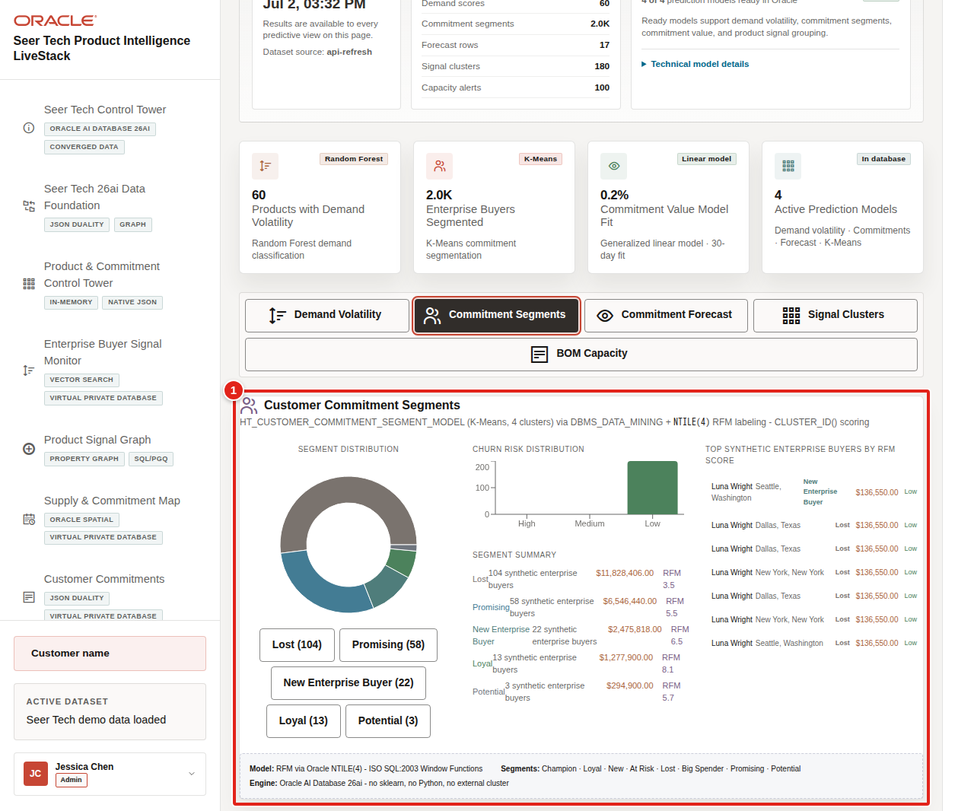
Figure 36. Customer commitment segmentation analytics highlighted
Segmentation helps distinguish a broad launch issue from a constraint concentrated in strategic customers, regions, or order patterns.

Task 4: Compare commitment forecasts and signal clusters
Use the supporting predictive views to understand value and related evidence:
1. Select Commitment Forecast and review the horizon, model-fit guidance, and forecast values.
2. Treat a weak fit as directional evidence rather than certainty.
3. Select Signal Clusters.
4. Review cluster counts, embedding dimensions, distance metric, and the products or signals grouped by operational meaning.
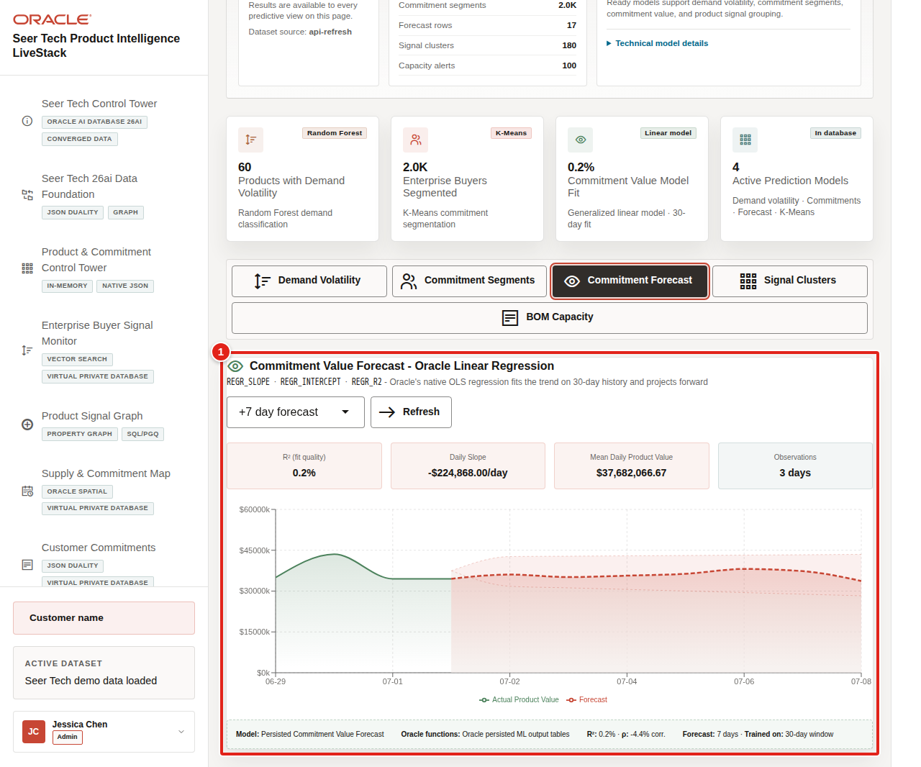
Figure 37. Commitment value forecast with model-quality guidance highlighted
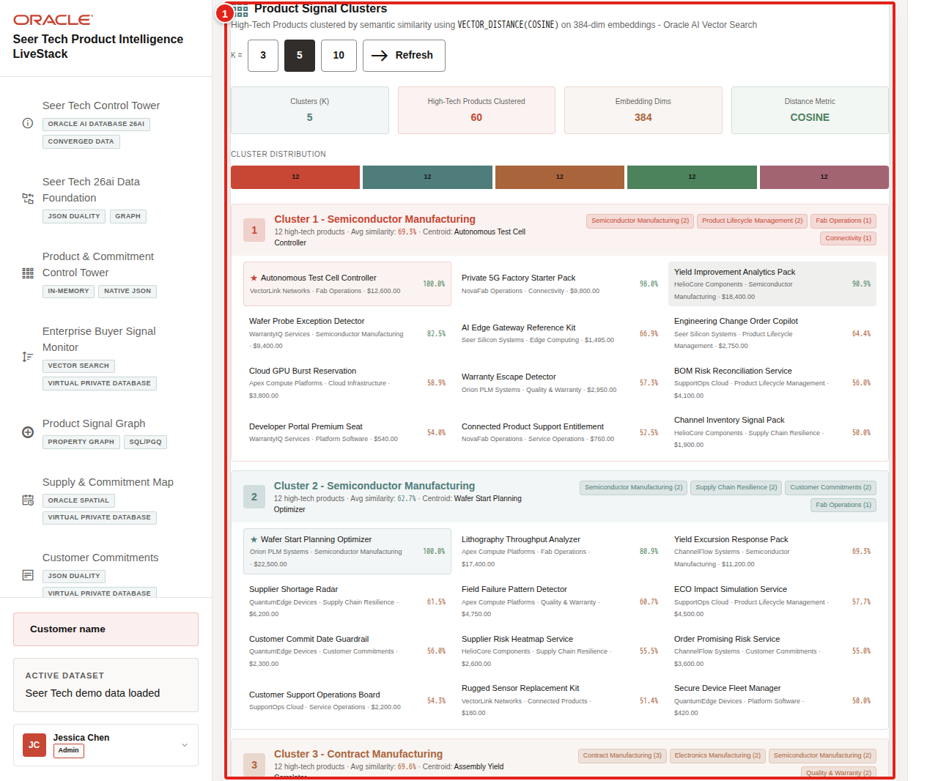
Figure 38. Product signal clusters and related High Tech evidence highlighted
Vector grouping can connect component shortages, GPU capacity, field quality, connected-device telemetry, and warranty signals even when the source records use different language.

Task 5: Connect predictions to bill-of-materials capacity
Close the analytics scene with an operating decision:
1. Select BOM Capacity. BOM means bill of materials.
2. Review summary cards for capacity and exposure.
3. Compare products by surge probability, shortage exposure, and value at risk.
4. Identify the product, dependency, or supply site that should move into Ask Data or agent action.
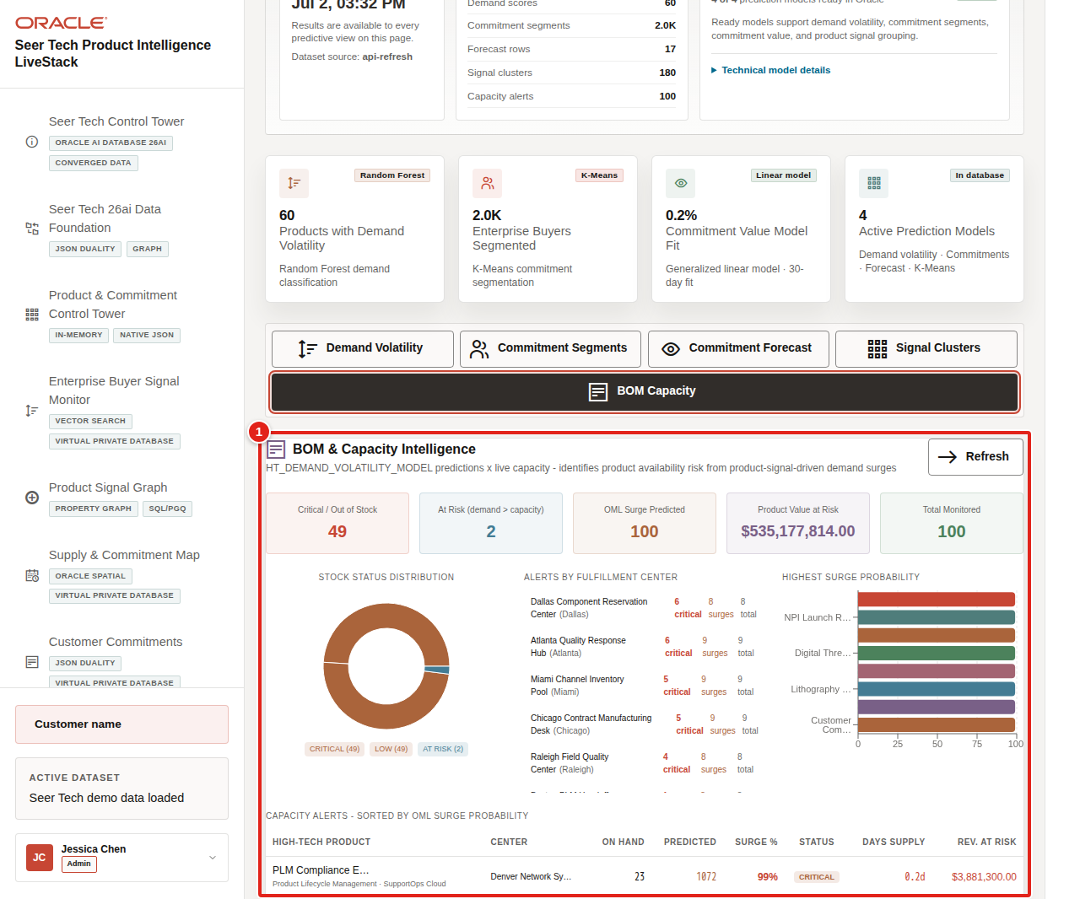
Figure 39. Bill-of-materials and capacity intelligence highlighted
The predictive story now connects directly back to the runbook: demand pressure was detected, signal evidence explained it, graph paths located the dependencies, the map identified response options, commitments showed customer exposure, and analytics identified where the next constraint may appear.
You can move to the next scene.

Credits & Build Notes
• Author - Oracle LiveLabs Team
• Last Updated By/Date - Oracle LiveLabs Team, 2026-07-02
• Source Bundle - livestack-hightech.zip

Scene 9 Ask Seer Tech Data

Introduction
Ask Seer Tech Data lets the launch team interrogate the same constraint story in plain language while keeping the answer path visible. Users can compare narrated answers, conversational responses, generated SQL, and returned rows across product portfolios, component supply, fab capacity, customer commitments, quality and warranty, service operations, connected-product telemetry, and agent audit data.
Natural-language data access can create governance risk if the language model generates invalid SQL, references the wrong objects, hides the query path, or exposes more data than the user should see. Oracle AI Database keeps query execution grounded in the live High Tech schema while the UI shows the selected mode and generated SQL path.
Note: Ollama provides the local AI runtime used for reasoning, while Oracle remains the governed source for data access and execution.
Estimated Time: 10 minutes
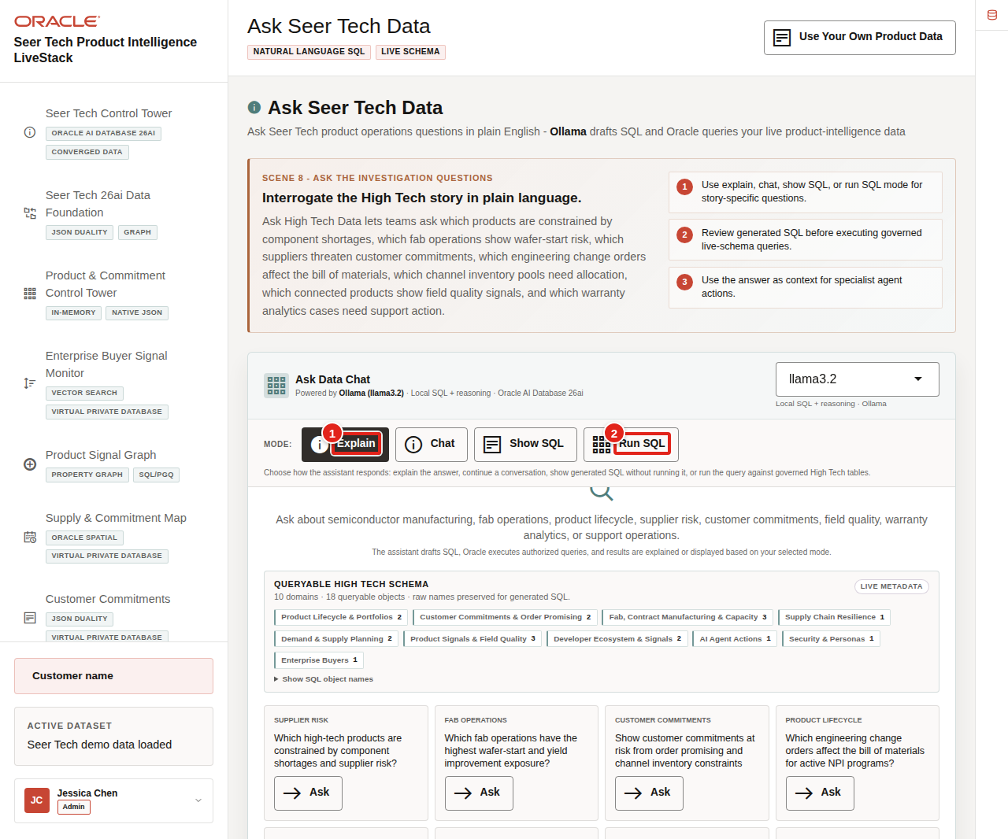
Figure 40. Ask Seer Tech Data workspace with modes, schema metadata, and example questions

Objectives
In this scene, you will learn how governed natural-language SQL can support High Tech operating questions without hiding the query path.

Task 1: Review the assistant workspace
Perform the following set of steps to show how High Tech users can ask questions in plain language while still keeping the query path visible and controlled:
1. Click Ask Seer Tech Data in the sidebar.
2. Review the runtime profile in the top right of the assistant card.
3. Review the queryable schema summary and domain groups.
4. Review the available modes: Explain, Chat, Show SQL, and Run SQL.
5. Review the example questions.
Figure 41. Ask Seer Tech Data workspace with modes, schema metadata, and example questions
Use this opening view to explain that the assistant is not a generic chatbot. It is a governed High Tech data assistant that uses schema metadata, visible query modes, and Oracle-backed execution.

Task 2: Use Explain mode for a narrated answer
Perform the following set of steps when the user wants a business-readable answer first:
1. Click Clear if a previous result is visible.
2. Click Explain.
3. Ask Which products are constrained by component shortages and supplier risk?
4. Review the narrated answer and generated SQL details when they are visible.
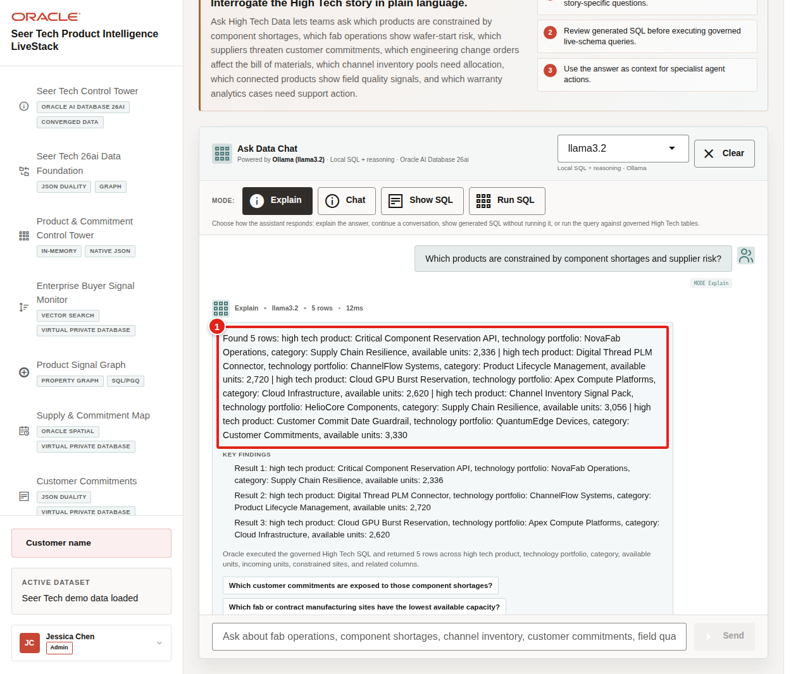
Figure 42. Ask Seer Tech Data Explain mode response highlighted
Expected result: The assistant returns a narrated answer and key findings without making generated SQL the main artifact. The response should connect the business answer to governed High Tech data rather than returning raw rows as the main story.
Notes:
• Sample values may change after data refreshes or rebuilds. Verify live output before presenting, then explain the business takeaway.
• Use this mode when the user wants a business-readable answer first. The system still uses governed SQL behind the scenes.

Task 3: Use Chat mode for a conversational answer
Perform the following set of steps when the user is exploring the data interactively and may want follow-up questions, regional breakdowns, or a more conversational explanation:
1. Click Clear if the Explain result is still visible.
2. Click Chat.
3. Ask Which customer commitments are at risk from shortage signals?
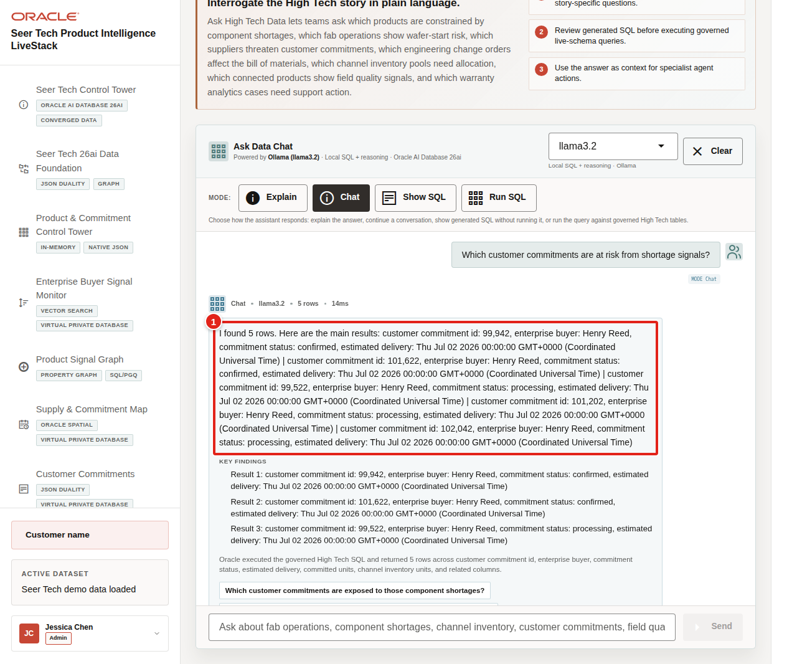
Figure 43. Ask Seer Tech Data Chat mode response highlighted
Expected result: The assistant returns a conversational response and follow-up prompts grounded in the live High Tech schema.

Task 4: Use Show SQL mode to inspect the query path
Perform the following set of steps when a data steward, planner, engineer, or reviewer needs to see the query path before rows are returned:
1. Click Clear if the Chat result is still visible.
2. Click Show SQL.
3. Ask Which products have the highest demand volatility this week?
4. Review the generated SQL.
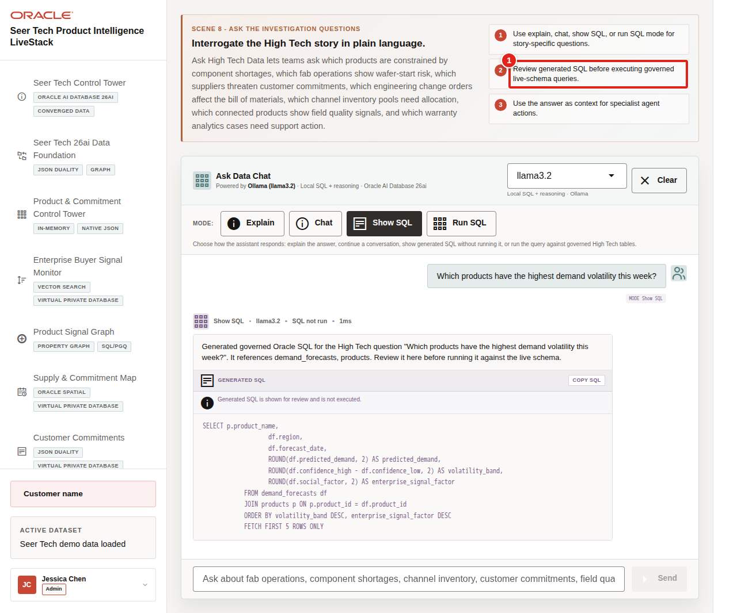
Figure 44. Ask Seer Tech Data generated SQL highlighted
This is the governance moment: the user can inspect the generated SQL before asking the database to return rows.

Task 5: Use Run SQL mode to inspect returned rows
Perform the following set of steps to inspect the live rows behind the answer. This helps the user connect a plain-English question to specific products, supply sites, commitments, quality records, warranty cohorts, service operations, or agent actions:
1. Click Clear if the generated SQL result is still visible.
2. Click Run SQL.
3. Ask Which products have the highest demand volatility this week? This carries the reviewed question from Show SQL into governed execution.
4. Review the returned table.
5. Expand View generated SQL if you want to show the query behind the result.
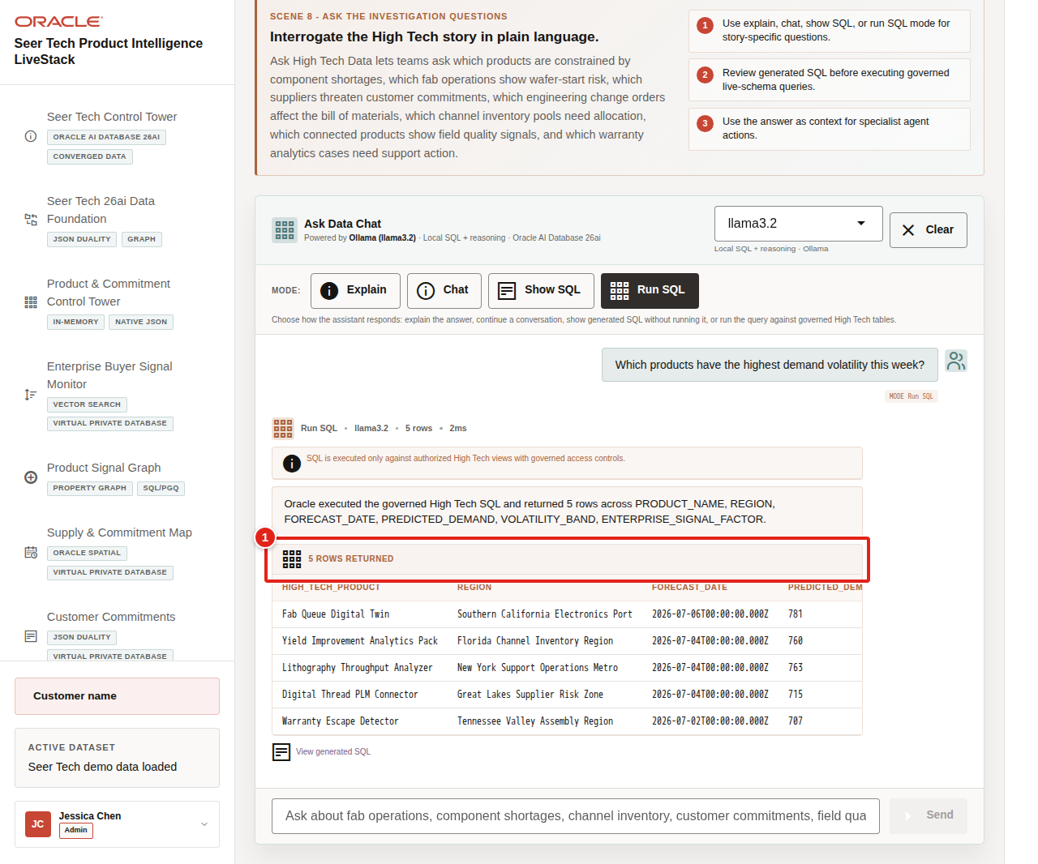
Figure 45. Ask Seer Tech Data Run SQL results highlighted
Use the completed mode examples to explain the governance pattern behind the page:
1. The user asks a High Tech question in plain English.
2. The app builds prompt and schema context for the selected runtime profile.
3. Ollama drafts SQL or a response plan.
4. Oracle AI Database executes authorized SQL against the live schema.
5. The UI returns visible SQL, rows, or a narrated answer depending on the selected mode.
The business value is that product, manufacturing, supply, quality, service, and customer operations teams can interrogate the release-train evidence from different perspectives without losing visibility into the governed query path.
This pattern matters because teams want faster answers, but they also need governed access, visible query logic, and a trusted execution layer.
You can move to the next scene.

Credits & Build Notes
• Author - Oracle LiveLabs Team
• Last Updated By/Date - Oracle LiveLabs Team, 2026-07-02
• Source Bundle - livestack-hightech.zip

Scene 10 AI Agent Console

Introduction
The AI Agent Console turns the release-train findings into a visible operating action without becoming a black box. The page positions specialist agents as observable tools that can connect product demand, capacity, supplier, quality, and customer evidence rather than returning a generic chat response.
Oracle AI Database keeps the source data, SQL execution, PL/SQL tools, graph and spatial context, in-database analytics, and durable action logging connected to the same governed High Tech data foundation. The app orchestrates the agent workflow, Ollama provides local reasoning when available, and Oracle AI Database 26ai executes governed data operations and records action evidence.
Estimated Time: 10 minutes
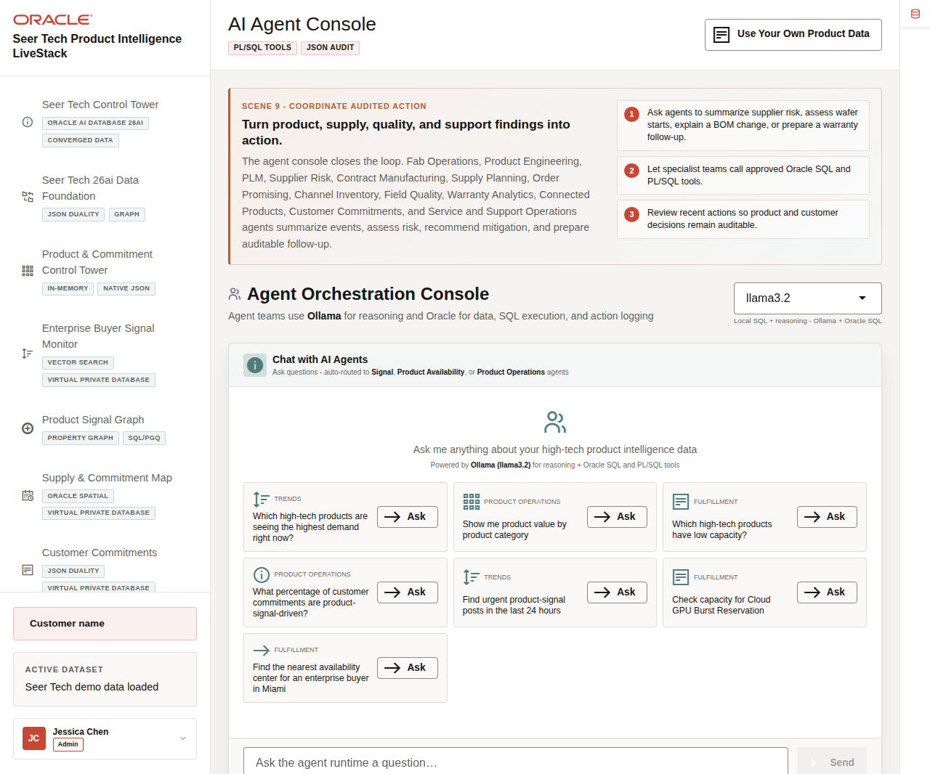
Figure 46. AI Agent Console overview with example questions and recent actions

Objectives
In this scene, you will learn how specialist agents convert product, capacity, signal, quality, and commitment findings into auditable operating actions.

Task 1: Review the agent console workspace
Perform the following set of steps to review the agent console as an operational workspace before running an agent task:
1. Click AI Agent Console in the sidebar.
2. Review the runtime profile selector.
3. Review the specialist example questions for product signals, capacity, product operations, supplier risk, customer commitments, and service follow-up.
4. Review Recent Agent Actions below the workspace.
5. Focus on a capacity or commitment example such as Which high-tech products have low capacity?
Use this opening view to explain that the page is an operational agent console. The user can see routing, tools, results, confidence, fallback status, and action history, not just a chat response.
Figure 47. AI Agent Console overview with example questions and recent actions

Task 2: Run an agent question
Perform the following set of steps to show how the agent summarizes product capacity evidence while exposing the data, tool path, runtime status, and fallback context behind the answer:
1. Type or select the following question:
Which high-tech products have low capacity?
2. Click Send.
3. Review the agent response at the top of the chat output.
4. Review the agent team badge, response, returned rows, tools used, runtime badge, or fallback status.
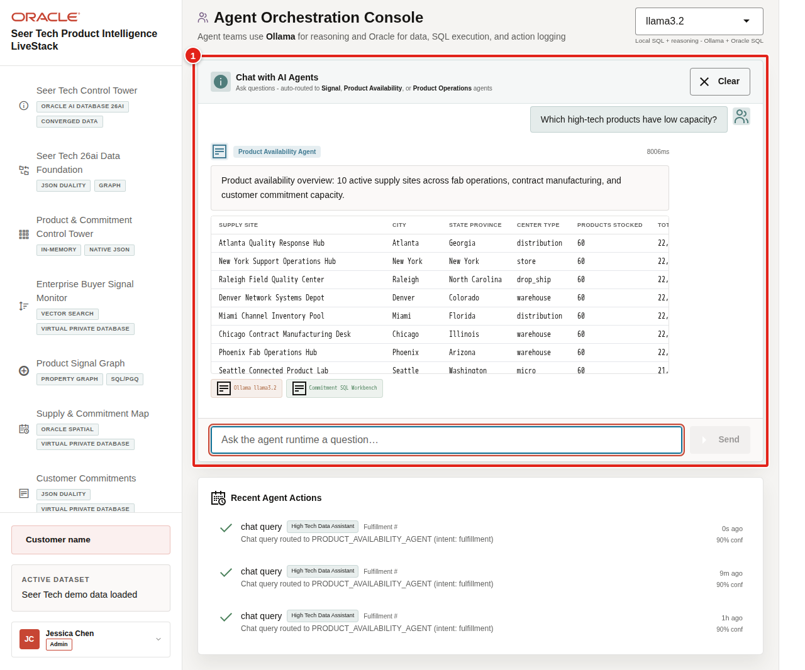
Figure 48. AI Agent Console product capacity response highlighted
Expected result: The response summarizes constrained products or capacity signals using Oracle-backed product and supply evidence. It should connect the answer to product availability, supply sites, supported shortage alerts, customer commitments, and the next operating step.
If the runtime shows a timeout or fallback, use it as an observability example: the operator can see whether the answer came from a complete LLM/tool path or from Oracle SQL and PL/SQL fallback evidence.
Note: Sample values may change after data refreshes or rebuilds. Verify live output before presenting, then explain the business takeaway.

Task 3: Review the agent action audit trail
Perform the following set of steps to show that AI-assisted actions do not disappear after the conversation. Operators, planners, engineers, architects, and auditors can review what the agent did, which route it used, and how confident the system was:
1. Scroll to Recent Agent Actions.
2. Review the newest action row when the action list is populated.
3. Confirm that the row captures the agent action type, operational intent, confidence, related evidence, and runtime path.
4. Compare the visible action trail with the Oracle Internals diagram.
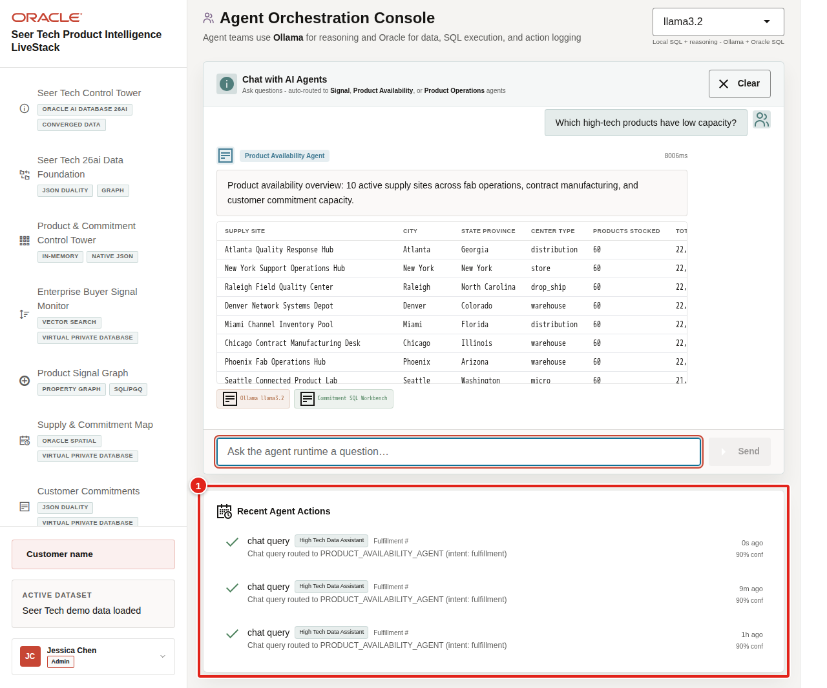
Figure 49. Recent agent action audit trail highlighted
The governance point is that agent decisions should remain observable after the conversation, with action history available for supply review, product operations, customer follow-up, quality escalation, warranty response, service operations, and continuous improvement.
This closes the story: Seer Tech detected launch pressure, explained the signals, traced lifecycle dependencies, identified supply options, inspected customer promises, predicted the next constraint, interrogated the evidence, and recorded an auditable agent-assisted response.
You can move to the next scene.

Credits & Build Notes
• Author - Oracle LiveLabs Team
• Last Updated By/Date - Oracle LiveLabs Team, 2026-07-02
• Source Bundle - livestack-hightech.zip

Scene 11 Use Your Own Product Data

Introduction
Use Your Own Product Data shows how a team can map the LiveStack pattern to its own High Tech operating data while preserving the seeded Seer Tech baseline as a known-good demo state.
This workflow matters because customers may bring product portfolio, supplier, component, bill-of-materials, product lifecycle management, engineering change order, manufacturing, capacity, customer commitment, quality, warranty, connected-device, service, and support data. The dataset tool makes the import path explicit while keeping destructive actions controlled and reinforcing that demo uploads should use synthetic, de-identified, or anonymized data.
Estimated Time: 8 minutes
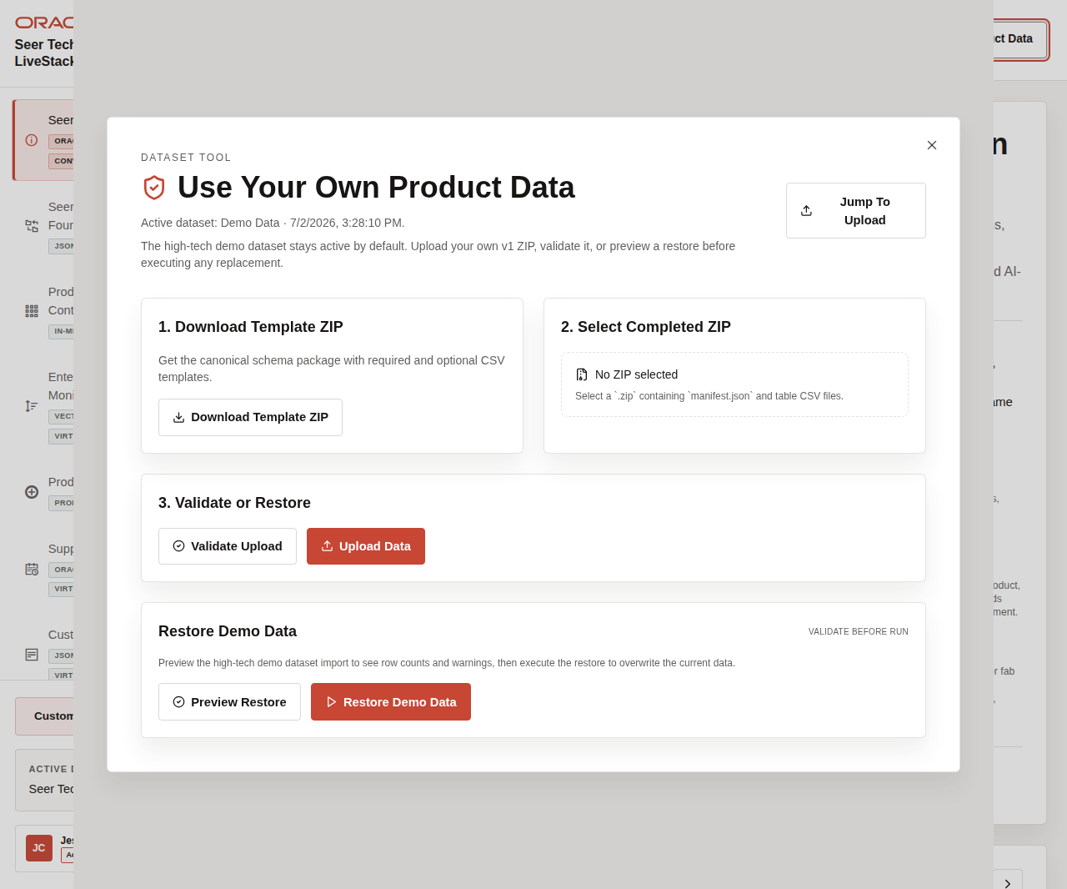
Figure 50. Use Your Own Product Data modal with template, upload, validation, and restore controls

Objectives
In this scene, you will learn how the dataset tool supports template ZIP download, completed ZIP upload/replace, validation, restore-demo preview, restore-demo execution, active dataset state, and data-safety expectations.
Use synthetic, de-identified, or anonymized data for workshop uploads. Do not upload confidential product, customer, supplier, warranty, support, employee, or export-controlled information into a shared demo environment.

Task 1: Open the dataset tool
Perform the following set of steps to open the dataset workflow from the app shell:
1. Click Use Your Own Product Data in the top-right application header.
2. In the live application, review the active dataset state when the tool opens.
3. In the live application, review the available actions for template ZIP download, completed ZIP upload/replace, validation, and restore-demo.
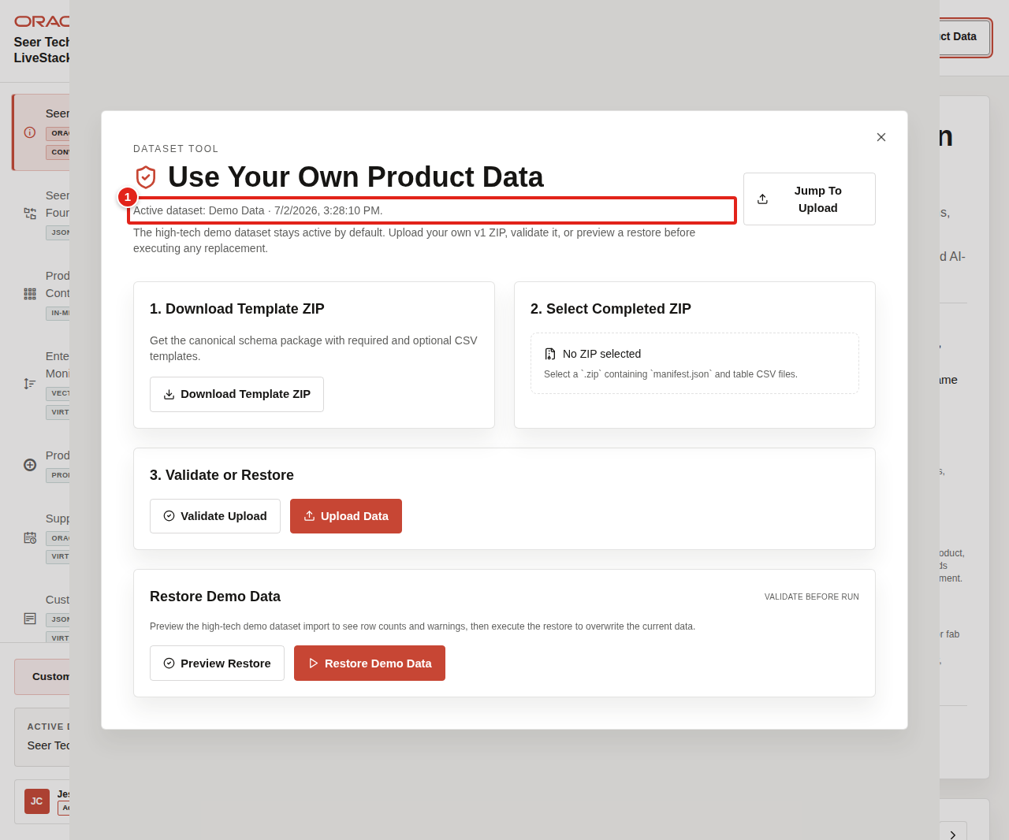
Figure 51. Use Your Own Product Data entry control and modal highlighted
Use this first view to explain that the dataset tool is part of the demo workflow, not a separate admin-only appendix. The seeded High Tech demo dataset stays active by default, and replacement data goes through a validate-and-upload path.

Task 2: Review the template and upload workflow
Perform the following set of steps to explain what a customer would replace when they bring their own data:
1. Review Download Template ZIP.
2. Review Select Completed ZIP.
3. Explain that a completed ZIP must contain manifest.json and table CSV files.
4. Emphasize that replacement data should preserve the required schema shape while using synthetic or de-identified customer-specific High Tech records.
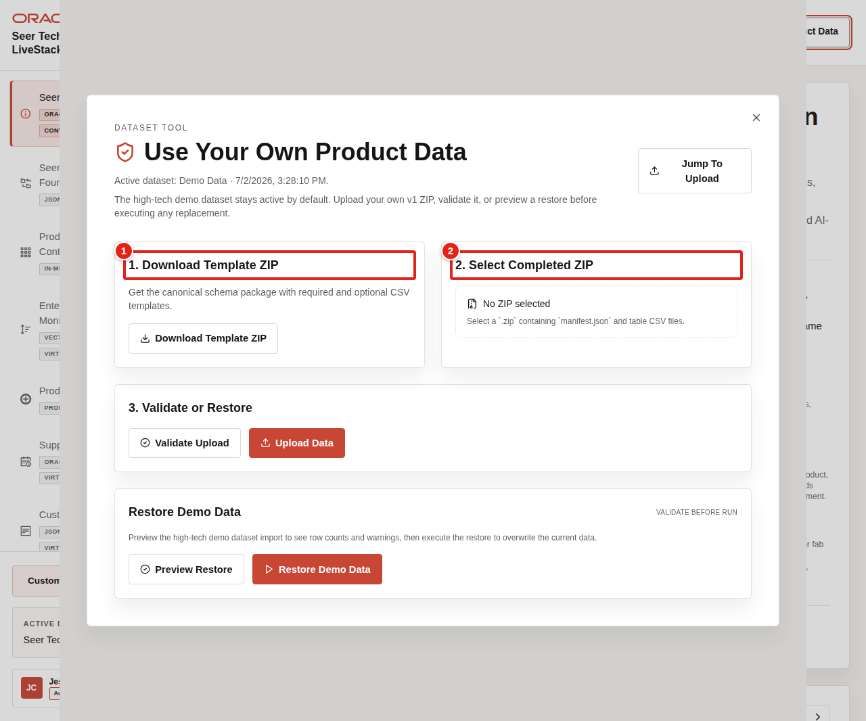
Figure 52. Template download and completed ZIP upload workflow highlighted
The key point is that customers can map their own terminology to the same Oracle AI Database capability pattern without changing the runbook story. A customer's product hierarchy, component names, supplier sites, commitment statuses, or quality codes can fit the same guided flow when the data shape is preserved.

Task 3: Preview or restore the seeded dataset
Perform the following set of steps to show the demo-safe reset path:
1. Review Restore Demo Data.
2. Click Preview Restore.
3. Review the preview message, row counts, or validation issues.
4. Do not click Restore Demo Data during a shared workshop unless the presenter intentionally wants to reset the app for everyone.
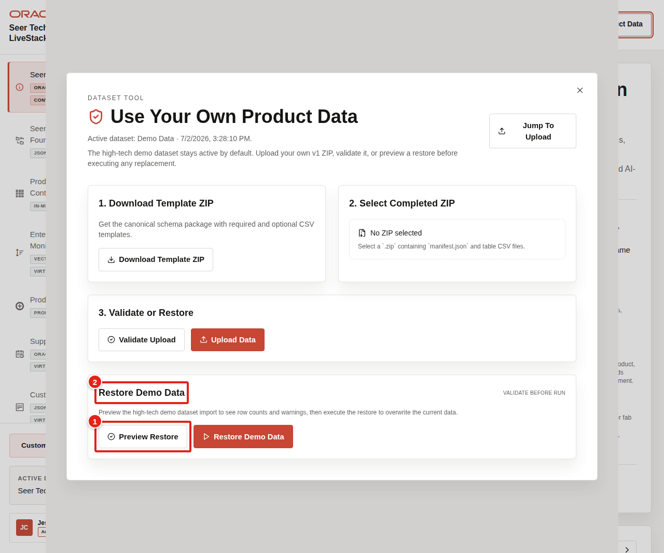
Figure 53. Preview Restore workflow highlighted in the dataset tool
Use this scene to close the runbook with a practical adoption point: the same LiveStack can tell the seeded Seer Tech AI infrastructure release-train story or help customers reason about their own High Tech operating data while preserving a known-good demo baseline.
The business value is that teams can test their own product and commitment story without losing the demo-safe reset path that keeps workshops repeatable.
This completes the guided High Tech demo scenes.

Credits & Build Notes
• Author - Oracle LiveLabs Team
• Last Updated By/Date - Oracle LiveLabs Team, 2026-07-02
• Source Bundle - livestack-hightech.zip

Take It Home: Run LiveStack with Podman Compose

Introduction
This lab shows how to run the portable Seer Tech High Tech Product Intelligence LiveStack package in your own environment using Podman Compose.
Use this appendix when you want to take the same High Tech product-launch story home: Oracle Database, ORDS, Ollama, and the Seer Tech application run together so the local environment can support the same product, manufacturing, supply, commitment, analytics, Ask Data, and agent scenes from the guided runbook.
This guide is intended for technical users who can install Podman and run terminal commands. If you are new to containers, complete the Podman readiness checks before starting. If any readiness check fails, ask your workshop facilitator or system administrator for help before continuing.
Estimated Time: 30 minutes for a local run, or 45 minutes when deploying to an OCI Compute VM.

Objectives
In this lab, you will:
• Download the portable LiveStack package.
• Confirm that Podman and Podman Compose are ready.
• Extract the package into a clean local working directory.
• Create a local runtime environment file from .env.example.
• Configure proxy settings only when your network requires them.
• Start Oracle Database, ORDS, Ollama, and the application with Podman Compose.
• Validate the application health endpoint and open the local LiveStack.
• Troubleshoot common startup, port, proxy, and first-run issues.
• Optionally deploy the same LiveStack package on an OCI Compute VM.
• Stop the stack cleanly when the demo is complete.

Before you begin
Before starting, confirm that you have:
• Podman installed.
• Podman Compose support available.
• On macOS or Windows, Podman Desktop is recommended.
• On Linux, confirm that either podman compose version or podman-compose version works.
• A running Podman machine on macOS or Windows.
• Terminal access:
• Terminal on macOS or Linux.
• PowerShell on Windows.
• Internet access to pull container images and download required application or model assets.
• Enough local resources for database and model containers.
• Recommended minimum: 8 CPU available for containers.
• Recommended minimum: 16 GB RAM available for containers.
• Recommended minimum: 150 GB free disk space.
• Use larger limits if your package includes larger Ollama models or additional data.
• The required local application port available:
• 8505 for the LiveStack application.

New to Podman?
Podman is the local container runtime used by this LiveStack package. Podman Compose reads the compose.yml file and starts the required services together, including Oracle Database, ORDS, Ollama, and the LiveStack application.
If you are new to Podman, complete these checks before starting the lab.

1. Confirm Podman is installed
podman --version
Expected result:
• The command prints a Podman version.

2. Confirm compose support is available
podman compose version
If that command does not work, try:
podman-compose version
Expected result:
• One of the commands prints a compose version.

3. Start the Podman machine on macOS or Windows
Podman on macOS and Windows runs containers inside a lightweight Linux virtual machine. Start it before running the stack.
podman machine start
If the machine has not been created yet, create it first:
podman machine init
podman machine start
Expected result:
• The Podman machine starts successfully.

4. Run a quick container test
podman run --rm hello-world
Expected result:
• Podman pulls a small test image and prints a success message.
If this test fails, fix Podman setup before continuing with LiveStack.

Task 1: Download the portable package
1. Download the LiveStack package using this link.
2. Save or rename the file as livestack.zip.
Expected result:
• You have livestack.zip available on your machine.

Task 2: Prepare the working directory
Do not extract or run the stack from your Downloads folder. Create a new empty working directory first. The package extracts its files into the current folder, so a clean directory keeps the LiveStack contents organized and avoids Podman issues caused by working from Downloads.

For macOS or Linux
1. Open a terminal.
2. Create a new working directory outside of Downloads.
mkdir -p ~/livestack
3. Move into the new working directory.
cd ~/livestack
4. Move the downloaded package from Downloads into this directory.
mv ~/Downloads/livestack.zip .
5. Extract the package.
unzip livestack.zip
6. Move into the extracted High Tech application directory.
cd hightech
7. Confirm that you are in the directory that contains the compose file.
ls
Expected result:
• You see compose.yml or compose.yaml in the current directory.
8. Create or refresh the runtime environment file.
cp .env.example .env

For Windows
1. Open PowerShell.
2. Create a new working directory outside of Downloads.
New-Item -ItemType Directory -Force -Path "$HOME\livestack" | Out-Null
3. Move into the new working directory.
Set-Location "$HOME\livestack"
4. Move the downloaded package from Downloads into this directory.
Move-Item "$HOME\Downloads\livestack.zip" .
5. Extract the package.
tar -xf .\livestack.zip
6. Move into the extracted LiveStack application folder.
The High Tech package is expected to be extracted into a folder named hightech. If your archive tooling creates a different folder name, use that generated folder instead.
Set-Location .\hightech
Example:
Set-Location .\hightech
7. Confirm that you are in the directory that contains the compose file.
Get-ChildItem
Expected result:
• You see compose.yml or compose.yaml in the current directory.
8. Create or refresh the runtime environment file.
Copy-Item .env.example .env -Force
Expected result:
• You are in a clean working directory outside Downloads.
• The extracted hightech directory contains compose.yml, .env, .env.example, application source, database setup files, runtime demo data, and supporting scripts.
• The clean deployment package does not include ip.md, verification scripts, test fixtures, dependency folders, or generated build output.
• You created a local .env file from .env.example.

Task 3: Configure proxy settings, if your network requires them
Most home, cloud VM, and unrestricted corporate networks do not need this step. Skip this task when your network allows direct access to container registries, npm, Object Storage, and Ollama model downloads.
1. If your network requires a proxy, configure the proxy in Podman or Podman Desktop before starting the stack. Image pulls happen before the compose containers exist, so Podman itself must be able to reach external registries.
2. Open .env and add proxy values if your environment requires them.
HTTP_PROXY=http://proxy.example.com:8080
HTTPS_PROXY=http://proxy.example.com:8080
http_proxy=http://proxy.example.com:8080
https_proxy=http://proxy.example.com:8080
3. Keep local service names in NO_PROXY and no_proxy.
NO_PROXY=localhost,127.0.0.1,::1,db,ords,ollama,app,host.containers.internal
no_proxy=localhost,127.0.0.1,::1,db,ords,ollama,app,host.containers.internal
Expected result:
• Podman can pull external images through the network proxy when one is required.
• Local compose services still talk to db, ords, ollama, and app directly on the internal Podman network.

Task 4: Start the LiveStack with Podman Compose
1. If you are using Podman on macOS or Windows and your Podman machine is not already running, start it now.
podman machine start
2. Confirm that you are in the directory that contains the compose file.
ls compose.yml compose.yaml 2>/dev/null
On Windows PowerShell, use:
Get-ChildItem compose.yml,compose.yaml -ErrorAction SilentlyContinue
3. Start all services.
podman compose up -d --build
If your environment uses the standalone podman-compose command, use:
podman-compose up -d --build
4. Watch the service state.
podman compose ps
If your environment uses the standalone podman-compose command, use:
podman-compose ps
Expected result:
• db, ords, ollama, and app move toward a healthy state.
• The initialization containers complete successfully.
• The application listens on the host port defined by the LiveStack package.

Task 5: Understand first-run downloads
On a clean install, the first startup can take several minutes. The stack pulls container images, installs application dependencies, downloads and warms the configured Ollama models, and loads the ONNX embedding model used by Oracle vector search when the package includes one.
To avoid downloading the ONNX model at first run, place all_MiniLM_L12_v2.onnx in db/data/onnx/ before starting the stack. The database bootstrap uses the packaged file before falling back to the configured ONNX_MODEL_URL.
Expected result:
• First-run startup time is expected to be longer than later restarts.
• Subsequent starts reuse the Podman volumes for Oracle data and Ollama models unless you remove the volumes.

Task 6: Validate health and open the application
1. Check the application health endpoint.
curl http://localhost:8505/api/health
2. Open the LiveStack UI in a browser.
open http://localhost:8505
3. If you are not on macOS, open this URL manually in your browser:
http://localhost:8505
Expected result:
• The health check returns a healthy JSON response after Oracle is ready.
• The browser opens the LiveStack locally.

Task 7: Stop the stack when finished
1. Stop and remove running containers while preserving volumes.
podman compose down
If your environment uses the standalone podman-compose command, use:
podman-compose down
2. Use this command only when you intentionally want to delete the local Oracle and Ollama volumes for a complete reset.
podman compose down -v
If your environment uses the standalone podman-compose command, use:
podman-compose down -v
Expected result:
• podman compose down stops the local LiveStack cleanly.
• Demo data and downloaded models remain available on the next startup unless you use the explicit volume-removal command.

Troubleshooting
Use this section when the stack does not start, a service is unhealthy, the application does not open, or first startup appears to be slow.

Check service status
podman compose ps
If your environment uses the standalone podman-compose command, use:
podman-compose ps

View service logs
Database logs:
podman compose logs db
ORDS logs:
podman compose logs ords
Ollama logs:
podman compose logs ollama
Application logs:
podman compose logs app
Follow application logs in real time:
podman compose logs -f app
If your environment uses podman-compose, replace podman compose with podman-compose in the commands above.

Port 8505 is already in use
The LiveStack application uses local port 8505. If the application does not start or the browser opens another application, check whether another process is already using that port.
For macOS or Linux:
lsof -i :8505
For Windows PowerShell:
netstat -ano | Select-String ":8505"
Stop the conflicting process or update the compose port mapping if your package supports changing it.

First startup takes a long time
The first run can take several minutes because Podman may need to pull images, install dependencies, download Ollama models, initialize Oracle Database, and load model files. Later starts are usually faster because container images and volumes are reused.
Check progress with:
podman compose logs -f db
podman compose logs -f ollama
podman compose logs -f app

Image pulls fail
If image pulls fail, check these items:
• Confirm that your machine has internet access.
• Confirm that Podman can pull a small public test image with podman run --rm hello-world.
• If your network requires a proxy, configure the proxy in Podman or Podman Desktop and update .env as described in Task 3.
• If you are on a corporate network or VPN, ask your network administrator whether container registry access is allowed.

Health check is not ready
If curl http://localhost:8505/api/health does not return a healthy response immediately, wait for the database and application startup to finish, then try again.
Check logs with:
podman compose logs db
podman compose logs app

Reset the stack
Stop containers but keep data and downloaded models:
podman compose down
Completely reset local data and downloaded models:
podman compose down -v
Use the volume-removal command only when you intentionally want a clean reset.

Task 8: Deploy the LiveStack on an OCI Compute VM with Podman (Optional)
Use this task when you want to run the LiveStack on an OCI Compute VM instead of your laptop.
Prerequisites:
• A created Virtual Cloud Network (VCN).
• Security rules configured for the VM subnet.
• Ingress to TCP port 8505 allowed from your approved client CIDR.
• An OCI Compute VM running Oracle Linux 9.
• SSH access to the VM, using the private key paired with the public key added during VM creation.
• The LiveStack package download URL for your workshop.
1. SSH into the OCI VM from your local terminal.
ssh -i ~/.ssh/<private-key-file> opc@<vm-public-ip>
2. Update the VM and install Podman plus common download tools.
sudo dnf update -y
sudo dnf install -y container-tools podman-docker unzip curl dnf-plugins-core
podman --version
3. Install and enable Podman Compose support on Oracle Linux 9.
sudo dnf install -y oracle-epel-release-el9
sudo dnf config-manager --enable ol9_developer_EPEL
sudo dnf install -y podman-compose
podman compose version || podman-compose version
4. If the VM firewall is running, allow the LiveStack application port.
if sudo systemctl is-active --quiet firewalld; then
sudo firewall-cmd --permanent --add-port=8505/tcp
sudo firewall-cmd --reload
fi
5. Create a working directory on the VM.
mkdir -p ~/livestack
cd ~/livestack
6. Download the LiveStack package to the VM.
curl -L -o livestack.zip "<livestack-package-url>"
7. Extract the package and move into the directory that contains the compose file.
unzip livestack.zip
COMPOSE_FILE="$(find . -maxdepth 3 \( -name compose.yml -o -name compose.yaml \) | head -n 1)"
cd "$(dirname "$COMPOSE_FILE")"
8. Create the runtime environment file.
cp .env.example .env
9. Confirm that the compose file exposes the application on port 8505.
grep -n "8505" compose.yml compose.yaml 2>/dev/null
The application should be exposed on port 8505. To reach it from your browser, both the OCI subnet security rules and the VM firewall must allow inbound TCP traffic on port 8505 from your approved client CIDR.
10. Start the LiveStack with Podman Compose.
podman compose up -d --build || podman-compose up -d --build
11. Watch the service state from the VM.
podman compose ps || podman-compose ps
12. Validate the application health endpoint from the VM.
curl http://localhost:8505/api/health
13. Open the public LiveStack URL from your browser.
http://<vm-public-ip>:8505
Expected result:
• The OCI VM is running the LiveStack with Podman Compose.
• The application health endpoint responds locally on the VM.
• The LiveStack UI is reachable from your browser at http://<vm-public-ip>:8505.

Why this matters
A portable LiveStack runbook turns this guide into something teams can reproduce instead of just read. By shipping the application as a Podman Compose package with a clear startup flow, you reduce environment drift, make scene validation repeatable, and give teams a practical way to explore the same Oracle-backed experience on macOS, Linux, Windows, and OCI Compute.
This guide is self-service for technical users who can install Podman and run terminal commands. Users who are new to containers should complete the Podman readiness checks before starting and ask for help if those checks fail.

Credits & Build Notes
• Author - LiveLabs Team
• Last Updated By/Date - Oracle LiveLabs Team, 2026-07-02

