State and Local Government Service Operations LiveStack Guide
  - Seer State and Local Government LiveStack Go-Live Runbook
Live demo: http://158.178.146.34:8505/
June, 2026, Version 1.0
Copyright © 2026, Oracle and/or its affiliates
Oracle Confidential

Purpose statement
This document provides an Oracle-branded Word version of the Seer State and Local Government LiveStack runbook. It follows the finished application story and embeds the refreshed screenshots captured from the live public-sector demo application.
Disclaimer
This document in any form, software or printed matter, contains proprietary information that is the exclusive property of Oracle. Your access to and use of this confidential material is subject to the terms and conditions of your Oracle software license and service agreement, which has been executed and with which you agree to comply. This document and information contained herein may not be disclosed, copied, reproduced or distributed to anyone outside Oracle without prior written consent of Oracle. This document is not part of your license agreement nor can it be incorporated into any contractual agreement with Oracle or its subsidiaries or affiliates.
This document is for informational purposes only and is intended solely to assist you in planning for the implementation and upgrade of the product features described. It is not a commitment to deliver any material, code, or functionality, and should not be relied upon in making purchasing decisions. The development, release, timing, and pricing of any features or functionality described in this document remains at the sole discretion of Oracle. Due to the nature of the product architecture, it may not be possible to safely include all features described in this document without risking significant destabilization of the code.

Executive Summary
This runbook presents the Seer State and Local Government LiveStack as a finished application walkthrough. It follows a realistic public-sector operations story from governed data preparation through resident demand, service pressure, partner coordination, geographic access, predictive analytics, conversational data access, and audited AI-assisted action.
The document is designed for a go-live quality review of the runbook and application experience. It keeps the story focused on public outcomes: service delivery, transparency, compliance, responsiveness, and operational efficiency.
Table 1. Public-sector outcomes demonstrated by the State and Local Government LiveStack.
OUTCOME | WHAT THE RUNBOOK SHOWS
Service delivery | Urgent demand, service value, capacity pressure, and request detail are visible in one guided flow.
Transparency | Each major screen connects the visible decision to source data or Oracle evidence.
Compliance | Access control, governed APIs, SQL traceability, and agent history keep decisions explainable.
Responsiveness | Staff can move from resident signal to service request, map, analytics, or agent recommendation quickly.
Operational efficiency | One Oracle AI Database foundation supports the dashboard, search, graph, map, ML, natural-language SQL, and agents.
The runbook embeds 48 screenshots captured from the running State and Local Government demo at http://158.178.146.34:8505/.

Runbook Contents
- State and Local Government Service Operations LiveStack Guide
- Scene 1 Welcome and Demo Orientation
- Scene 2 Data Foundation
- Scene 3 Public Service Command Center
- Scene 4 Resident Demand Signals
- Scene 5 Community Partner Network
- Scene 6 Service Access and Coverage Map
- Scene 7 Service Request Workbench
- Scene 8 Demand and Capacity Analytics
- Scene 9 Ask State and Local Government Data
- Scene 10 Public Service AI Agent Console
- Scene 11 Use Your Own Public Service Data
- Appendix: Take It Home: Run LiveStack with Podman Compose

State and Local Government Service Operations LiveStack Guide

Introduction
State and local agencies must coordinate constituent services, permits, benefits, inspections, public works, service requests, emergency response, and transparency obligations while keeping data governed. The Seer State and Local Government LiveStack shows how those signals can come together so agency leaders can understand service pressure earlier, see the evidence behind a response, and act with more confidence.
This runbook tells the story of the final application before go-live. It focuses on practical outcomes: better service delivery visibility, clearer public transparency, stronger compliance posture, faster responsiveness, and more efficient operations without moving sensitive data into disconnected tools.
This runbook supports the Seer State and Local Government LiveStack Demo. The demo shows how Oracle AI Database 26ai can bring public-sector operational workloads together on one connected data platform. Instead of splitting relational transactions, JSON documents, graph relationships, spatial analysis, vector search, in-database machine learning, natural-language SQL, and AI agent workflows across different systems, the LiveStack shows how those capabilities can work against the same governed Oracle data model.
In the demo, Jessica Chen, a state digital services lead, is preparing a go-live operations briefing. She uses the application to follow constituent demand from resident signals into service requests, partner coordination, access geography, capacity forecasts, conversational data access, and audited AI-assisted action.
Each scene connects a public-sector operations challenge to a visible decision path and the Oracle capability supporting it.
Estimated Demo Time: 90 minutes
Each scene is designed to take between 5 and 10 minutes.
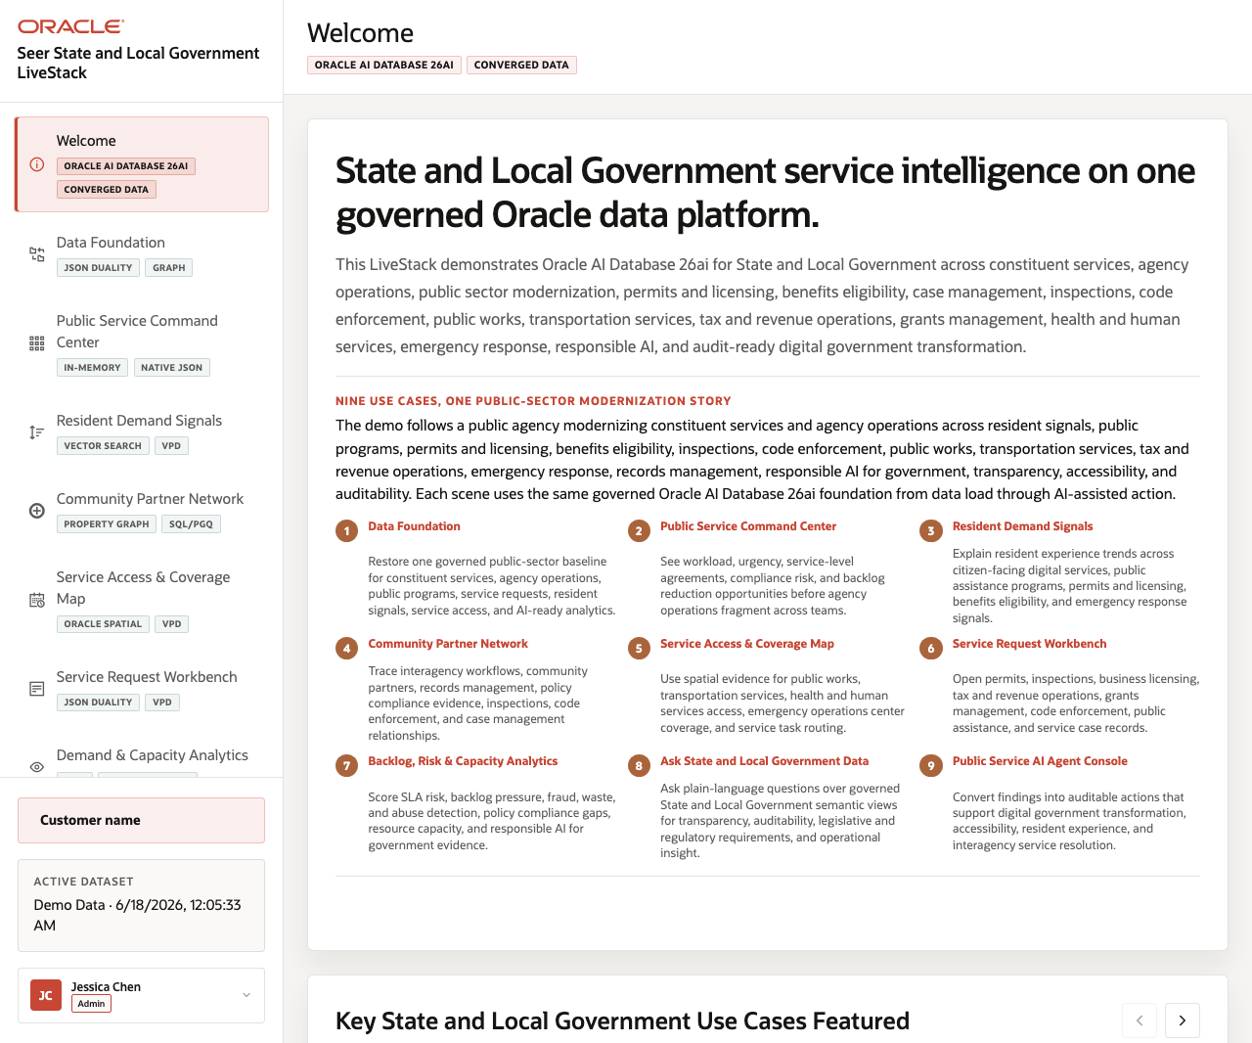
Figure 1. State and Local Government LiveStack welcome page

Application Story
The story follows a state digital services team preparing for a service operations briefing. The team starts with a governed data foundation, then follows resident demand through service pressure, community partner relationships, access geography, service request detail, predictive analytics, natural-language data access, and audited AI-assisted action.
The application is designed to show a complete public-sector operating pattern: agency leaders see where service pressure is building, program teams inspect the evidence behind a response, analysts use predictive signals to plan capacity, and AI-assisted workflows remain tied to governed data and audit history.

Go-Live Outcome Map
- Service delivery: Leaders can see urgent demand, service value, access constraints, and request detail in one flow.
- Transparency: Each major screen connects the visible business outcome to source data, SQL, graph, spatial, vector, OML, or agent evidence.
- Compliance: Governed access, VPD, JSON Duality, ORDS APIs, and action history keep sensitive workflows controlled and explainable.
- Responsiveness: Staff can move from resident signal to service request, partner coordination, capacity view, or agent recommendation without switching systems.
- Operational efficiency: The same Oracle AI Database foundation supports dashboards, search, maps, graph analysis, machine learning, natural-language SQL, and AI agents.

Objectives
In this LiveStack demo, you will see how connected public-sector data can help teams:
- Monitor service delivery pressure, urgent demand, and operational value.
- Identify resident signals, access gaps, partner relationships, and capacity constraints.
- Use predictive analytics and natural-language data access to support faster decisions.
- Apply AI-assisted recommendations with auditability, security controls, and governed evidence.

Scenario
The application opens with a State and Local Government service operations briefing, then moves through the data foundation, public service command center, resident demand signals, partner graph, service access map, request workbench, predictive analytics, conversational data access, AI agent console, and data onboarding workflow. By the end of the story, the same governed data foundation supports executive visibility, staff action, transparent evidence, and operational readiness.

Prerequisites
Before you begin, confirm that you can open the running Seer State and Local Government LiveStack in a modern browser. No coding or database administration knowledge is required for the guided demo scenes.
Podman and Podman Compose are required only if you plan to run the portable LiveStack locally in the download lab.

Demo Flow
- Scene 1: Welcome and Demo Orientation.
- Scene 2: Data Foundation.
- Scene 3: Public Service Command Center.
- Scene 4: Resident Demand Signals.
- Scene 5: Community Partner Network.
- Scene 6: Service Access and Coverage Map.
- Scene 7: Service Request Workbench.
- Scene 8: Demand and Capacity Analytics.
- Scene 9: Ask State and Local Government Data.
- Scene 10: Public Service AI Agent Console.
- Scene 11: Use Your Own Public Service Data.
- Download and run the portable State and Local Government LiveStack.

Learn More
- Oracle AI Database 26ai documentation (https://docs.oracle.com/en/database/oracle/oracle-database/26/index.html)
- Oracle AI Agent Memory (https://www.oracle.com/database/ai-agent-memory/)
- Oracle AI Vector Search (https://www.oracle.com/database/ai-vector-search/)
- Oracle Spatial and Graph documentation: Oracle Spatial (https://docs.oracle.com/en/database/oracle/oracle-database/26/spatl/toc.htm) and Oracle Property Graph (https://docs.oracle.com/en/database/property-graph/26.2/index.html)
- Oracle Machine Learning for SQL documentation (https://docs.oracle.com/en/database/oracle/machine-learning/oml4sql/tasks.html)
- Oracle REST Data Services documentation (https://docs.oracle.com/en/database/oracle/oracle-rest-data-services/25.4/orddg/index.html)
- Oracle LiveLabs catalog (https://livelabs.oracle.com/)

Credits & Build Notes
- Author - Oracle LiveLabs Team
- Last Updated By/Date - Oracle LiveLabs Team, 2026-06-18

Scene 1 Welcome and Demo Orientation

Introduction
This opening scene gives users a quick roadmap for the State and Local Government demo. The page frames a public agency modernization story that starts with a governed data foundation and then moves through constituent demand, service pressure, community partner relationships, access geography, analytics, natural-language data access, and AI-assisted action.
Use this scene to orient the audience before showing any single feature. Jessica Chen, the agency digital services lead, needs a shared operating picture for programs that span resident services, permits and licensing, benefits, inspections, public works, and emergency response. The welcome page explains how the rest of the demo follows that story on one Oracle AI Database 26ai foundation.
Estimated Time: 5 minutes
Figure 2. Welcome page with State and Local Government modernization story

Objectives
In this scene, you will learn how the demo is organized, what public-sector decisions the application supports, and how to move from orientation into the guided workflow.

Task 1: Review the modernization story
Review the welcome page first so the audience understands the complete public-sector journey. The page introduces the agency scenario, the governed Oracle data platform, and the use cases that will be explored during the demo.
1. Click Welcome in the sidebar if the page is not already open.
2. Read the State and Local Government service intelligence statement.
3. Review the use-case tiles for data foundation, constituent services, agency operations, public programs, service access, analytics, Ask Data, and AI agent action.
4. Point out the active dataset and user context in the left navigation.
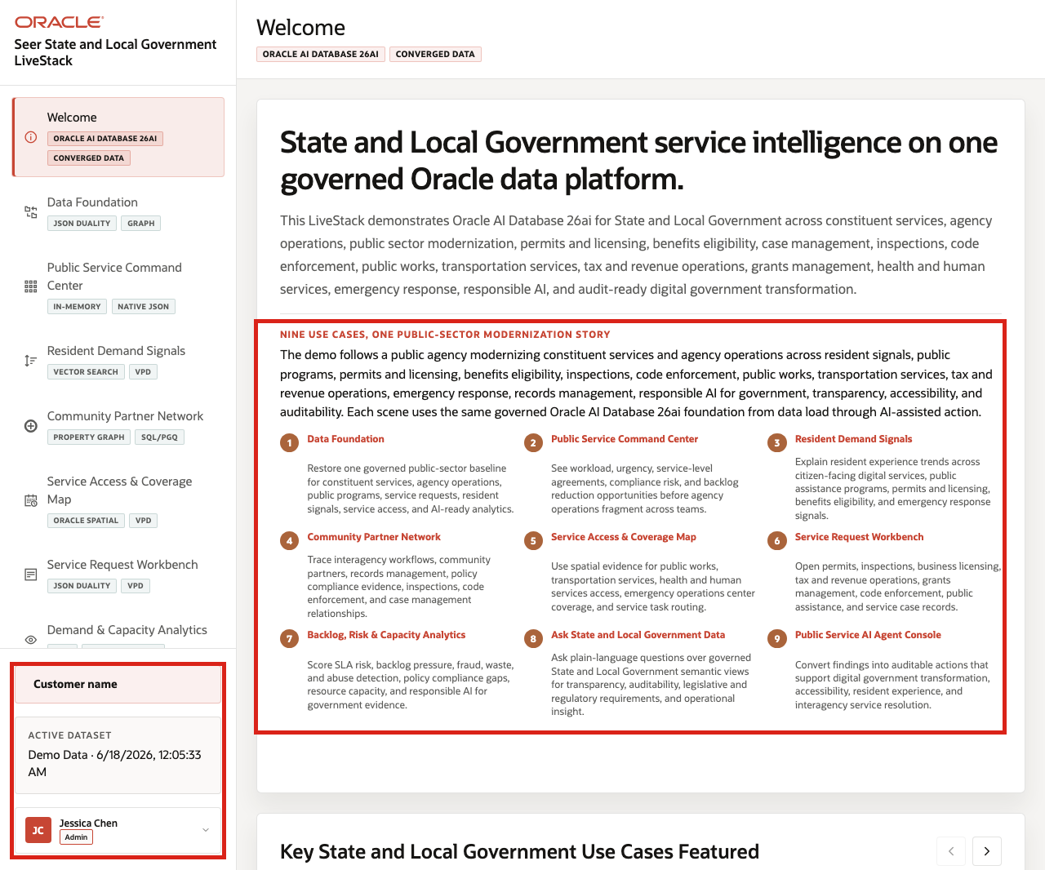
Figure 3. Welcome page workflow stages and public-sector use cases
The welcome page frames the demo as service intelligence on one governed Oracle data platform. It prepares the audience to see public-sector operations as one connected workflow instead of a set of disconnected point tools.

Task 2: Start the guided workflow
After the audience understands the demo themes, start the guided workflow. The application moves from the orientation page into the governed data foundation that powers every later public-sector scene.
1. Click Start the demo.
2. Confirm the demo moves to Data Foundation.
3. Return to Welcome if you want to show the orientation page again.
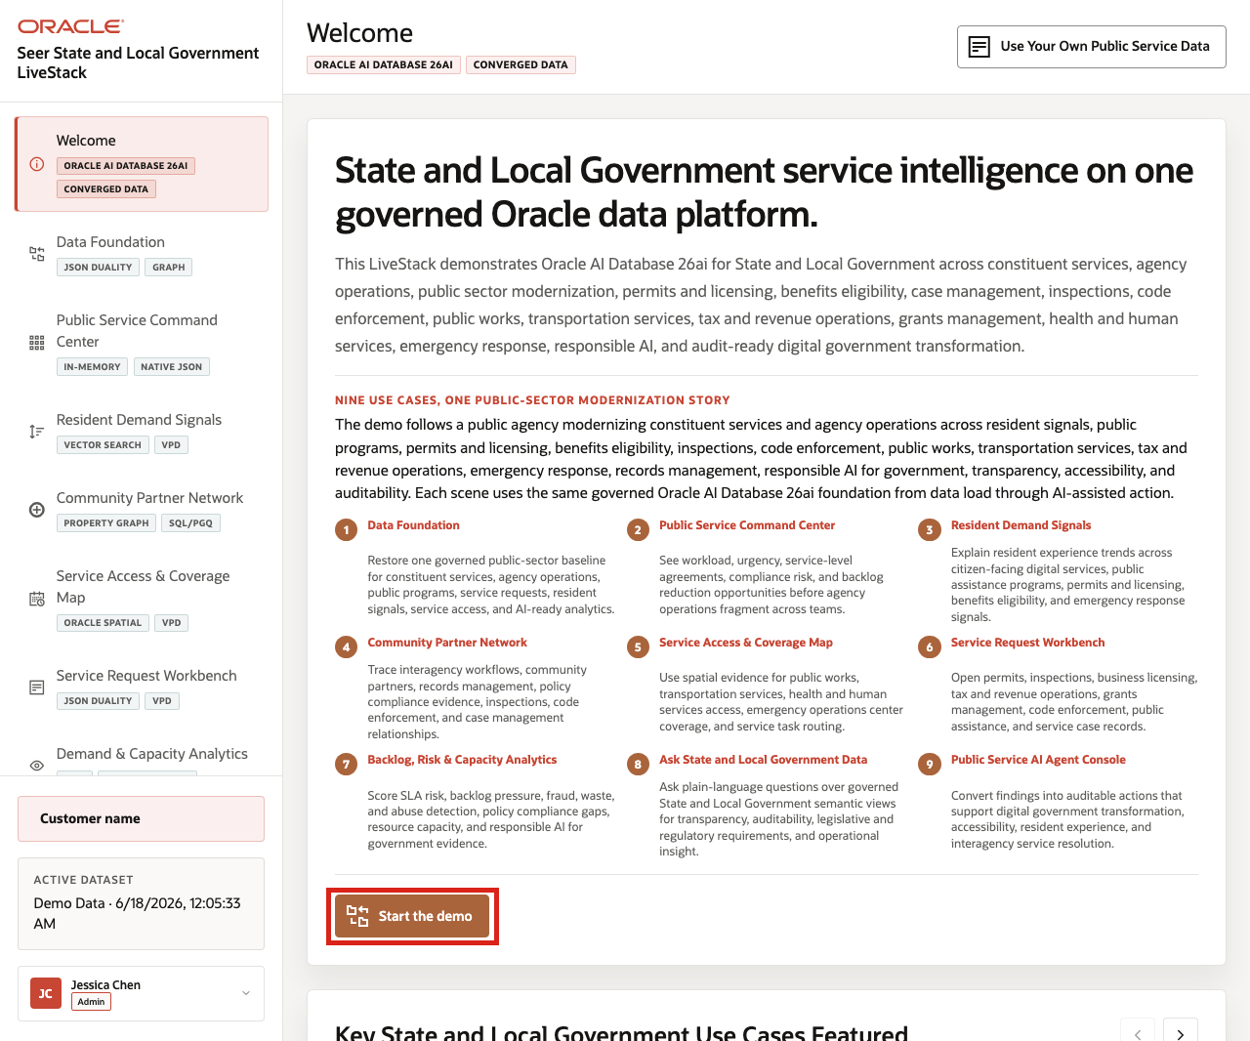
Figure 4. Start the demo action on the welcome page
Use this transition to explain that the welcome page is the orientation layer. The next scenes use the same public-sector dataset to inspect service pressure, resident demand, partner coordination, and response options.
You can move to the next scene.

Credits & Build Notes
- Author - Oracle LiveLabs Team
- Last Updated By/Date - Oracle LiveLabs Team, 2026-06-17

Scene 2 Data Foundation

Introduction
This scene prepares the trusted public-sector dataset used throughout the demo. Loading or restoring the data gives every later screen the same governed starting point, so dashboards, vector search, graph views, maps, service requests, analytics, Ask Data, and agent actions all reflect the same State and Local Government data foundation.
Use this scene to show that later pages are not separate demos. They are different agency workflows running on one governed Oracle AI Database 26ai foundation.
Estimated Time: 5 minutes
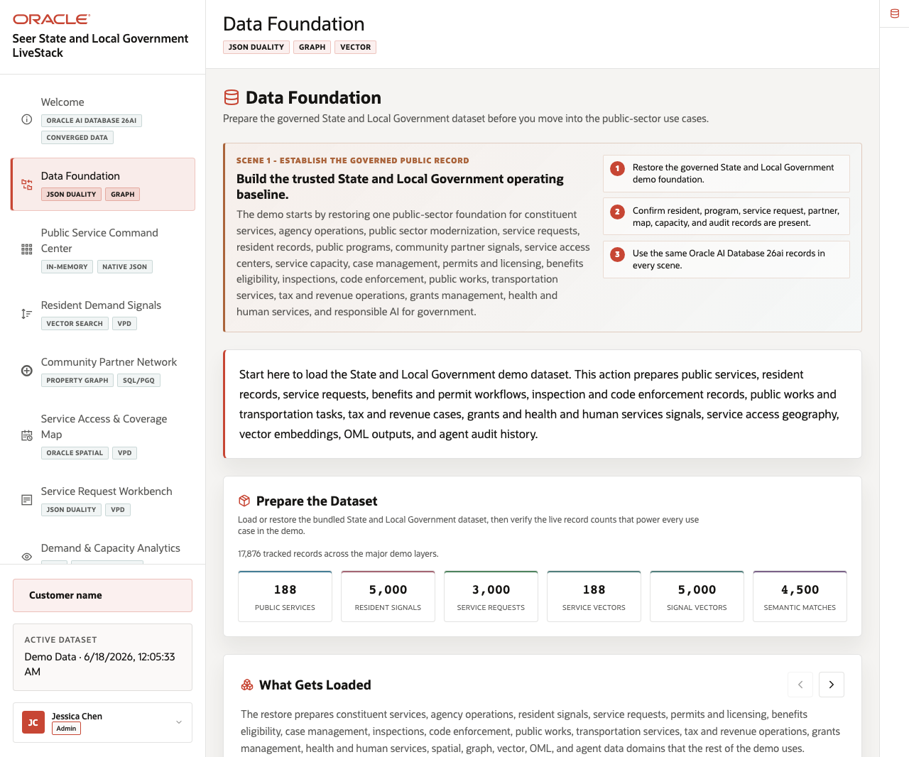
Figure 5. Data Foundation page with State and Local Government data domains

Objectives
In this scene, you will learn what public-sector decision the page supports, what evidence the user should inspect, and what action the team may take next.
Note: Review the Oracle Confidentials sidebar after the business flow is clear. Use it to connect the visible public-sector outcome to the database capabilities behind the page.

Task 1: Prepare the dataset
Perform the following set of steps so every later scene starts from the same trusted agency baseline. This makes the command center, signal search, graph, map, service requests, analytics, Ask Data, and agent results easier to compare and trust.
1. Click Data Foundation in the sidebar.
2. Review the data foundation summary for constituent services, agency operations, public programs, service requests, resident signals, service access, and AI-ready analytics.
3. Review the Prepare the Dataset record counts for public services, resident signals, service requests, vectors, and semantic matches.
4. Use the dataset manager in Scene 11 when the environment needs a restore, upload, or validation workflow.
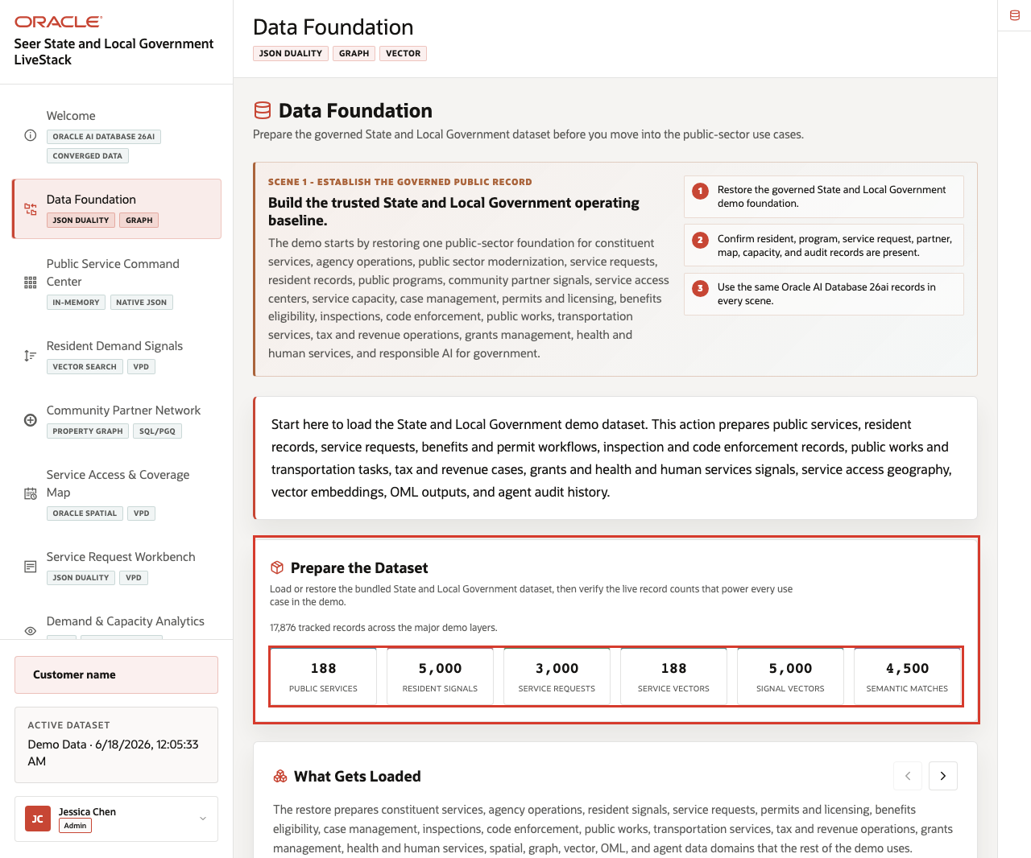
Figure 6. Data Foundation counts and loaded public-sector data domains
Use these counts to show that the dataset supports operational, analytical, spatial, graph, vector, machine learning, and audit workflows, not just a single dashboard.
Note: Sample values may change after data refreshes or rebuilds. Verify live output before presenting, then explain the business takeaway.

Task 2: Review what gets loaded
Perform the following set of steps to show that the dataset is broad enough to support the full public-sector story.
1. Scroll to What Gets Loaded.
2. Review the visible data domains for constituent service operations, resident and agency signals, public programs, service requests, service sites, and related public-sector records.
3. Explain that later scenes use the same prepared data rather than separate, disconnected samples.
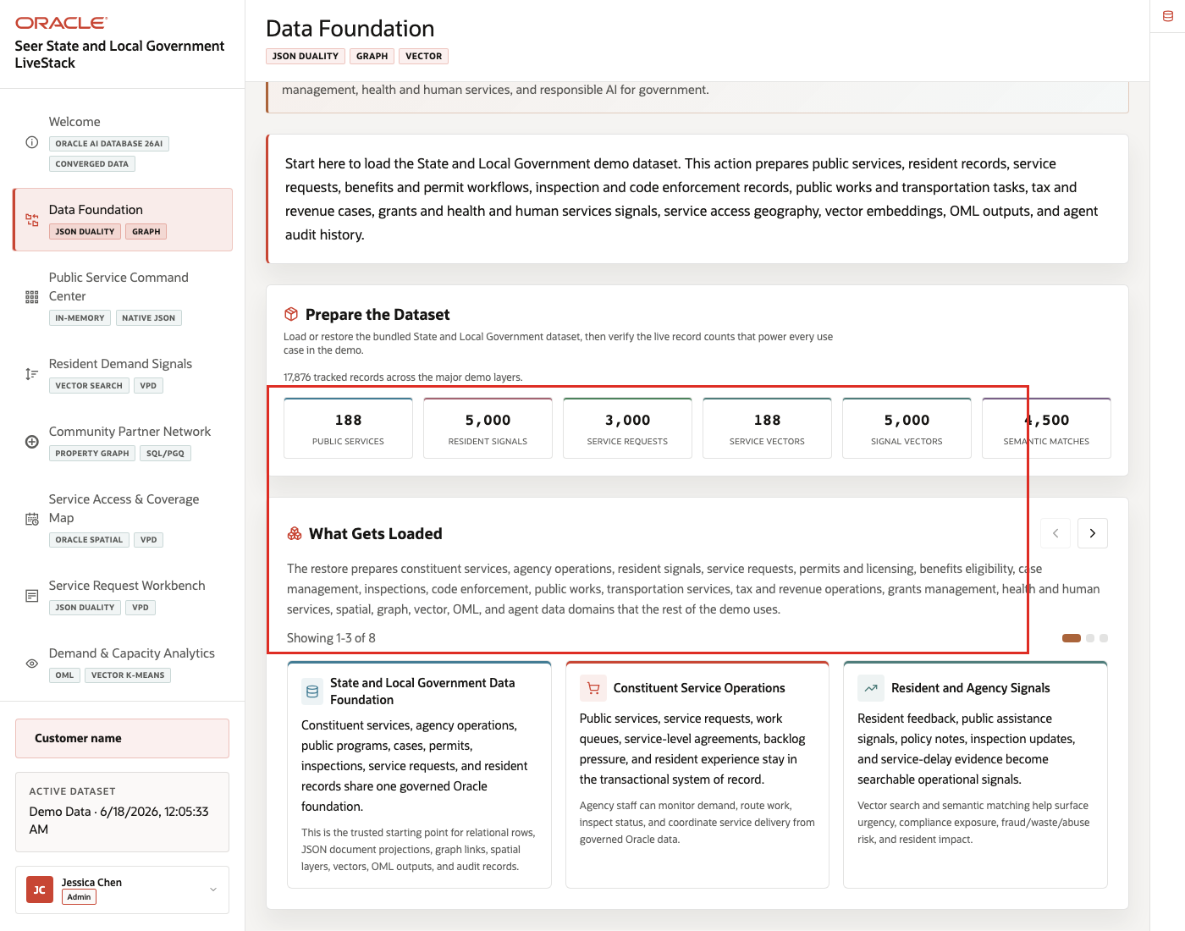
Figure 7. What Gets Loaded carousel with State and Local Government data domains
This step helps the audience understand why the rest of the runbook can move from dashboards to vectors, graphs, maps, service requests, machine learning, Ask Data, and agents without changing data foundations.

Task 3: Connect the foundation to downstream scenes
Perform the following set of steps to show how the same agency data foundation powers the rest of the demo.
1. Review the capability groups for relational operations, JSON duality, property graph, spatial access, vector search, OML, natural-language SQL, and agent audit records.
2. Open the Oracle Confidentials rail if it is collapsed.
3. Connect each capability group to a later scene in the sidebar.
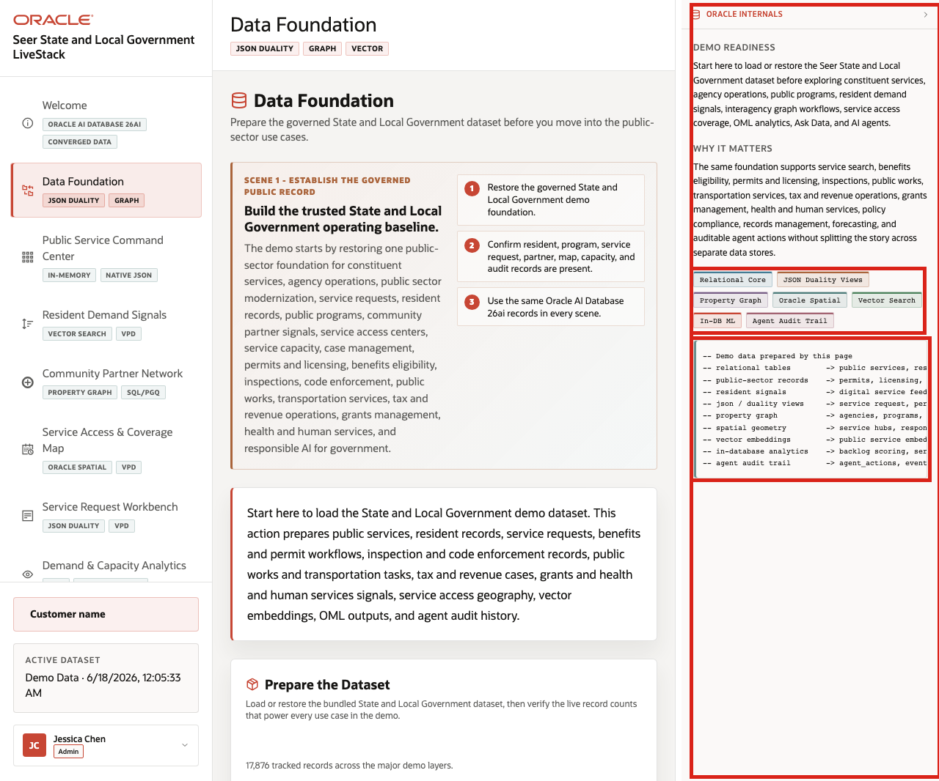
Figure 8. Data Foundation handoff to downstream public-sector scenes
The business value is that teams can make the decision from connected, governed data. Oracle AI Database provides the shared foundation that keeps operational data, analytics, and AI workflows aligned.
You can move to the next scene.

Credits & Build Notes
- Author - Oracle LiveLabs Team
- Last Updated By/Date - Oracle LiveLabs Team, 2026-06-17

Scene 3 Public Service Command Center

Introduction
The Public Service Command Center helps agency leaders answer a daily operating question: Which public services need attention right now?
The page brings together service request volume, public service value, urgent resident signals, services under pressure, and AI activity so a state or local government team can decide where to investigate first.
Dashboards like this are difficult to implement when service requests, resident messages, program data, partner relationships, capacity information, and agent activity live in different systems. Teams often need copied extracts, separate BI models, and reconciliation logic before a dashboard can show a trustworthy view.
Oracle AI Database helps address that challenge by keeping operational, analytical, JSON, in-memory, and AI-ready data close to the same governed data foundation. In this scene, the dashboard brings together live public-sector KPIs, signal velocity, service category value, and services under pressure without sending the user to another application.
Estimated Time: 10 minutes
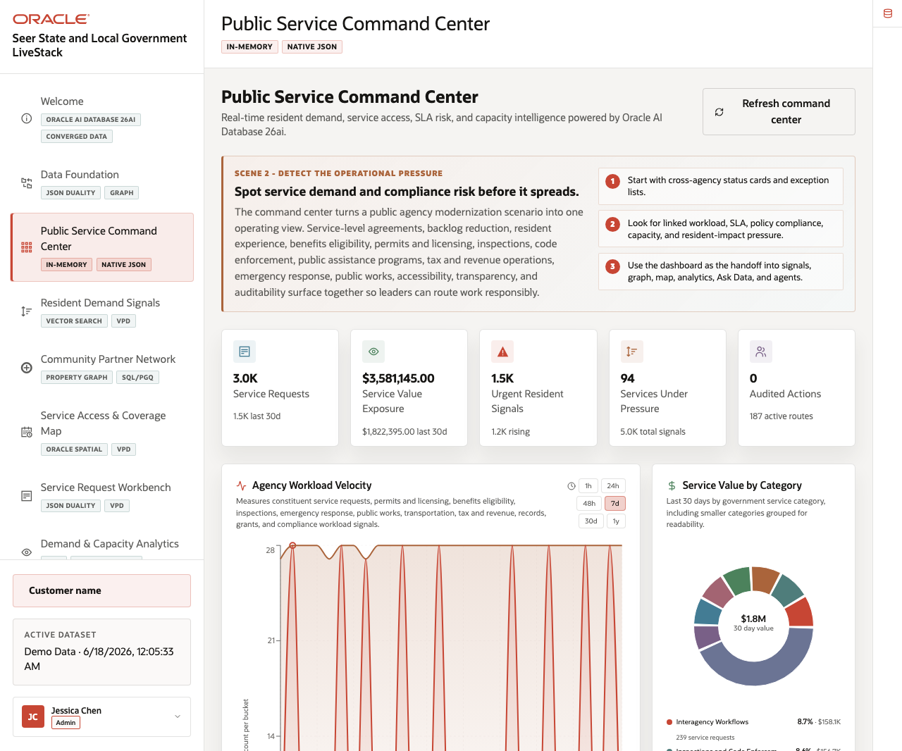
Figure 9. Public Service Command Center with KPI cards, signal velocity, service value, and services under pressure

Objectives
In this scene, you will learn what public-sector decision the page supports, what evidence the user should inspect, and what action the team may take next.
Note: Review the Oracle Confidentials sidebar after the business flow is clear. Use it to connect the visible public-sector outcome to the database capabilities behind the page.

Task 1: Review the command center dashboard
Use the dashboard as a daily triage view. The goal is to see where service demand, value, urgent resident signals, capacity pressure, or AI activity suggests the agency needs attention.
1. Click Public Service Command Center in the sidebar.
2. Review the KPI cards across the top of the page.
3. Note where the resident signal velocity and service value panels sit in the daily triage view.
4. Review the services-under-pressure table.
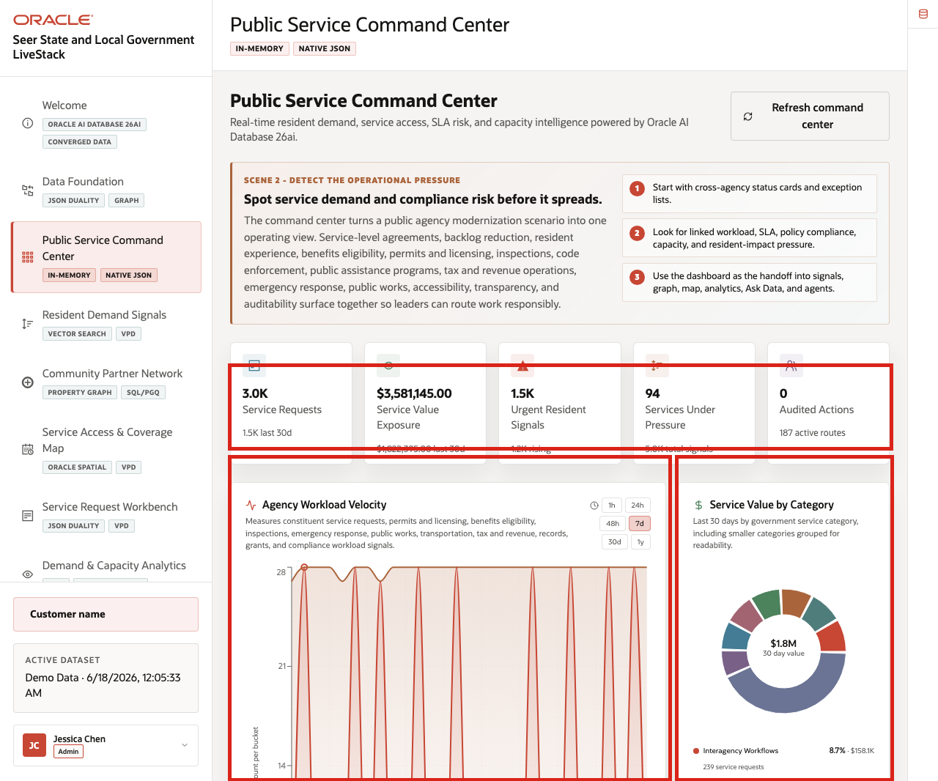
Figure 10. Command Center KPI cards, resident signal velocity, and service value areas
Use the KPI cards to frame the command center as a triage surface: the user can see request volume, service value, urgent signals, watched services, and AI activity in one place.
Note: Sample values may change after data refreshes or rebuilds. Verify live output before presenting, then explain the business takeaway.

Task 2: Interpret signal velocity and service value
Perform the following set of steps when the audience needs to understand why the dashboard is more than a set of counters.
1. Review Agency Workload Velocity to see how resident signals and service demand are moving over time.
2. Review Service Value by Category to see which public-service categories carry the most operating exposure.
3. Compare the chart direction with the KPI cards above it.
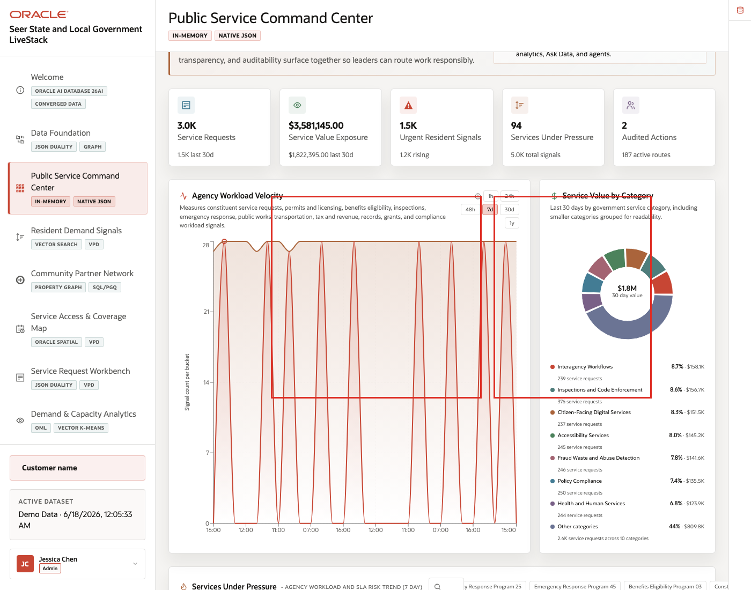
Figure 11. Agency workload velocity chart and public service value by category
The velocity and value panels help a leader decide whether pressure is isolated, recurring, or tied to a high-value public-service category.

Task 3: Inspect services under pressure
Perform the following set of steps to move from dashboard-level pressure to specific services, programs, or locations that may need attention.
1. Use the search or filter control in the services-under-pressure area.
2. Select or review a service with notable demand or signal momentum.
3. Compare the service row with the signal velocity and value charts.
4. Open the Oracle Confidentials rail to explain how live data supports the view.
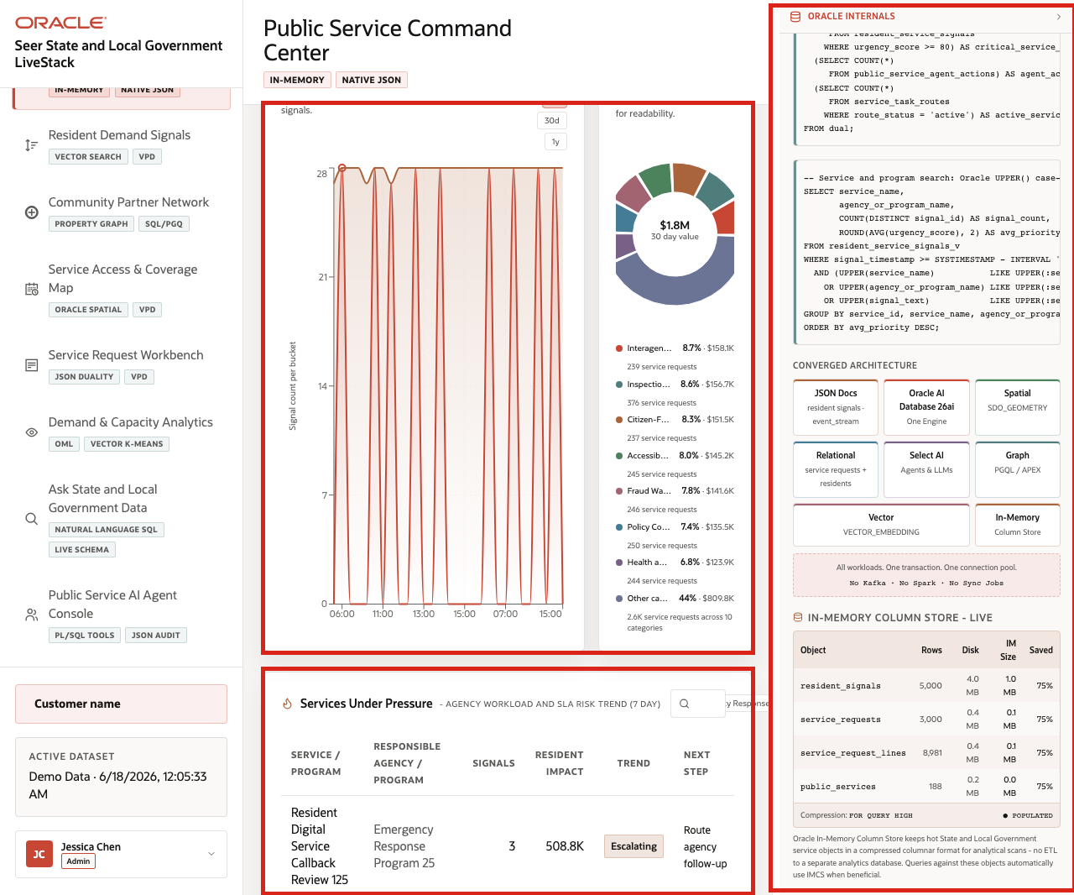
Figure 12. Services under pressure table with public-sector operating signals
The services-under-pressure table turns the KPI story into a set of operating decisions. A public-sector leader can move from "urgent signals are rising" to a specific service, partner, or operating response that needs review.
You can move to the next scene.

Credits & Build Notes
- Author - Oracle LiveLabs Team
- Last Updated By/Date - Oracle LiveLabs Team, 2026-06-17

Scene 4 Resident Demand Signals

Introduction
Resident Demand Signals helps an agency analyst connect plain-language constituent concerns to the services and programs already governed in Oracle AI Database. A resident may describe the same issue as "rental help," "housing assistance," "eviction support," or "benefits intake." The application uses vector search so analysts can find related public services even when the wording is not exact.
This scene matters because demand often appears before a formal service request is created. Resident messages, contact-center notes, outreach summaries, community partner updates, and public feedback can all point to pressure that the agency should understand earlier.
Estimated Time: 10 minutes
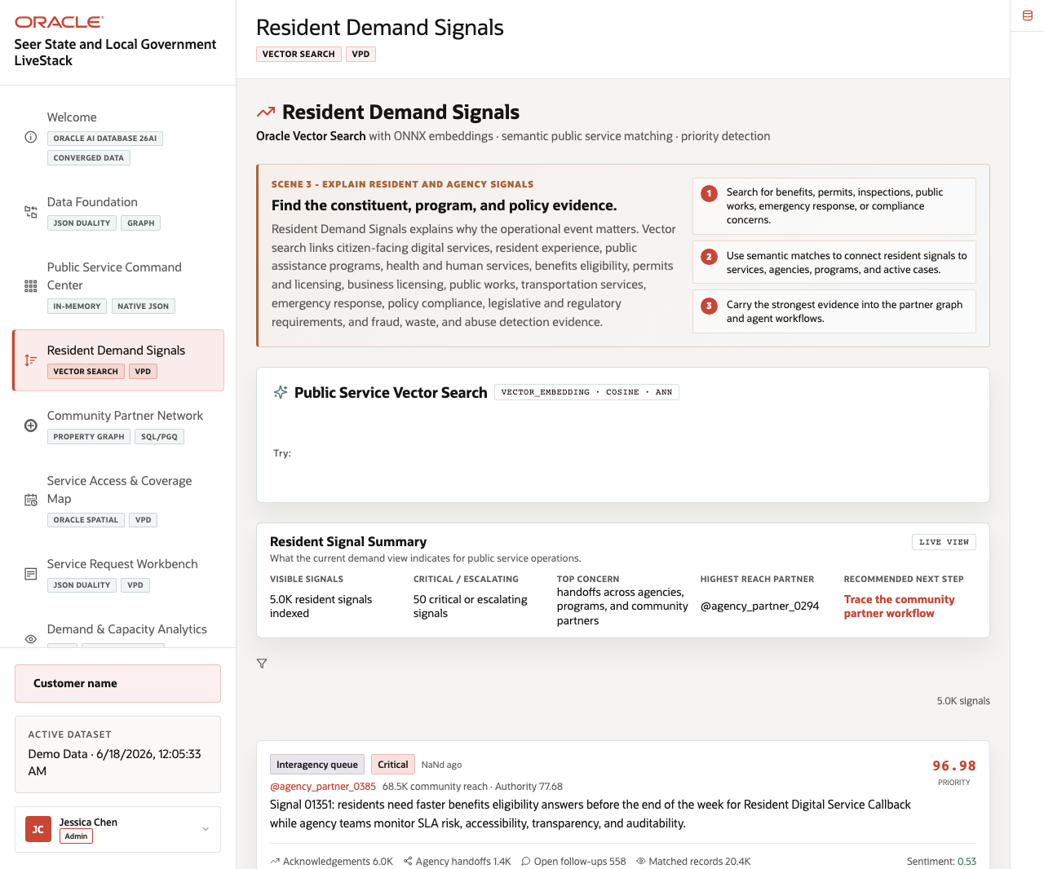
Figure 13. Resident Demand Signals page with vector search and resident signal feed

Objectives
In this scene, you will learn how State and Local Government teams can use in-database embeddings to discover related public services, review resident signal momentum, and connect emerging demand to the operating response.

Task 1: Run public service vector search
Perform the following set of steps when the audience wants to see semantic search instead of keyword matching.
1. Click Resident Demand Signals in the sidebar.
2. In Public Service Vector Search, enter a phrase such as emergency rental assistance, permit intake, or food assistance.
3. Click Search.
4. Review the ranked public services and similarity scores.
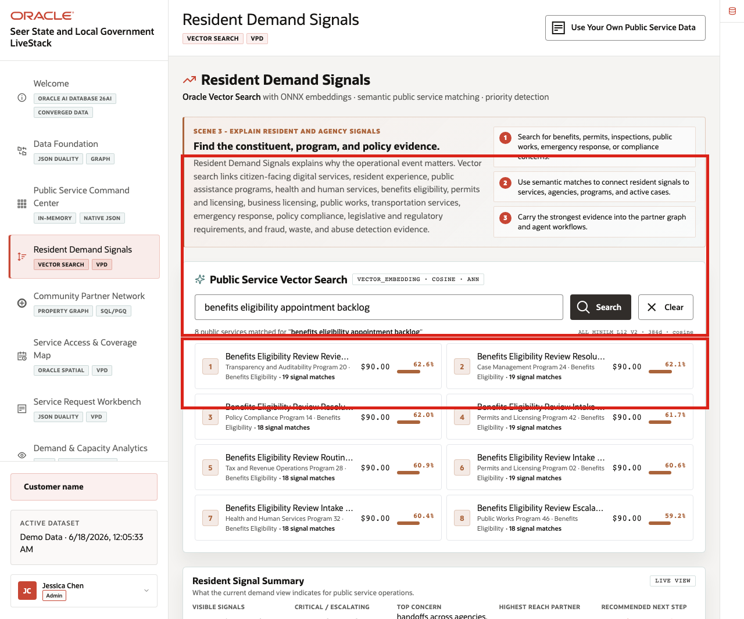
Figure 14. Public Service Vector Search results for a resident need phrase
Expected result: The page returns semantically related services, not just exact keyword matches. The Oracle evidence connects the result to vector embeddings, vector distance, ONNX embeddings, and approximate nearest-neighbor search.

Task 2: Review resident signal summary
Perform the following set of steps to connect the search result to the visible signal summary.
1. Review Resident Signal Summary.
2. Compare total resident signals, critical or escalating signals, top concerns, impact area, and recommended next step.
3. Explain how this summary gives the analyst a fast operating read before opening individual signal cards.
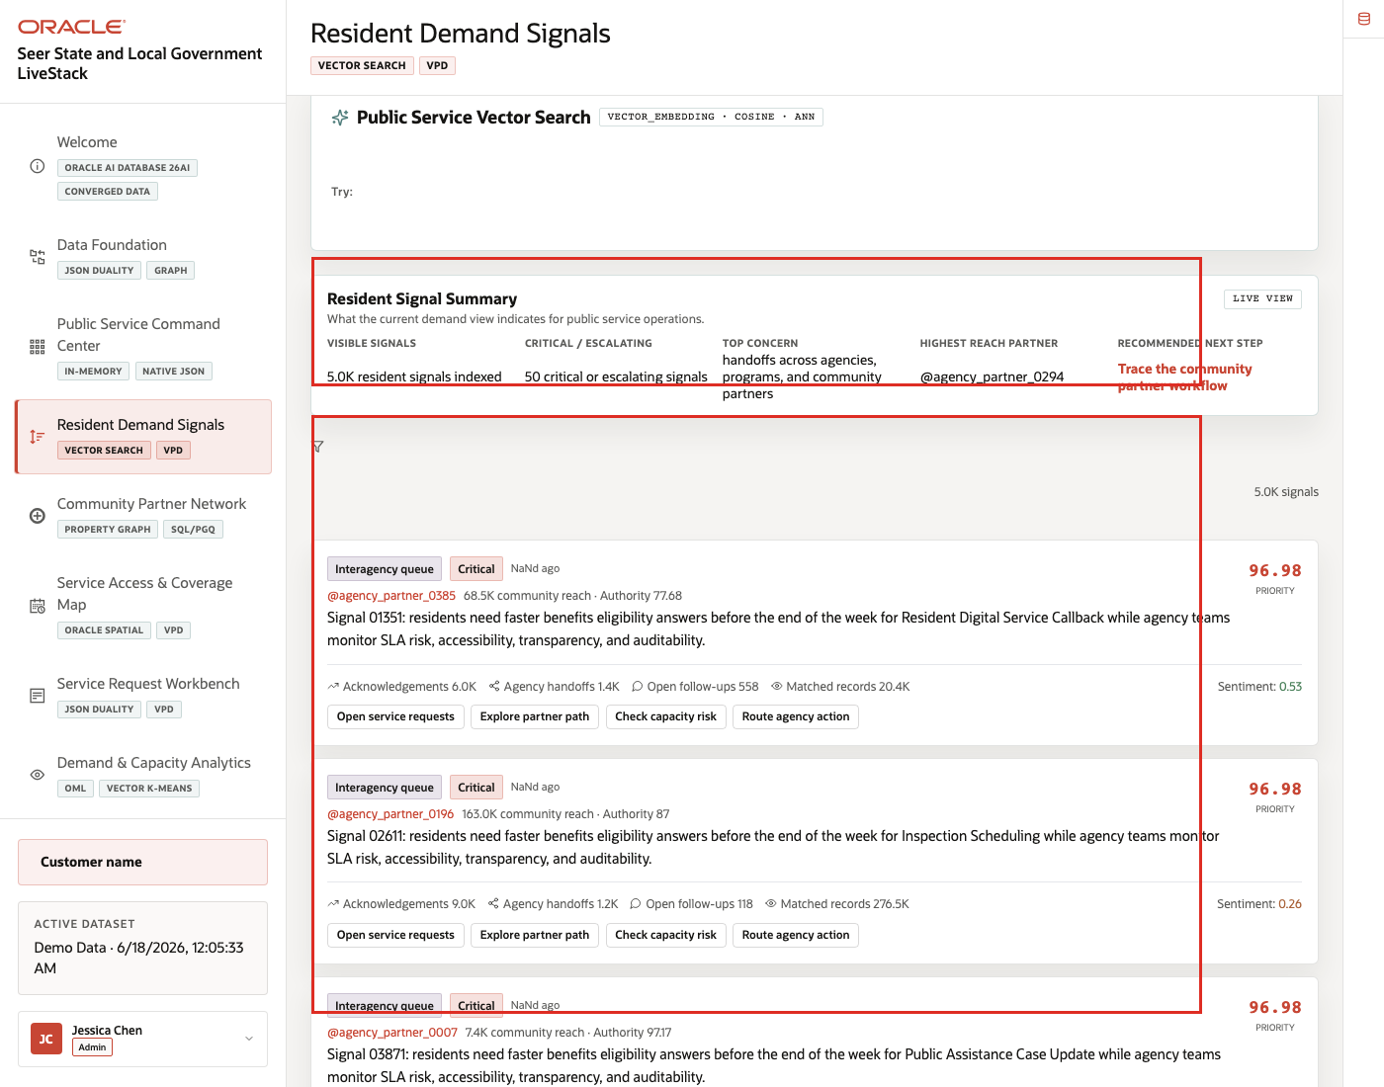
Figure 15. Resident Signal Summary with top concerns and recommended next step
The summary turns many resident messages into a concise operating signal that a constituent-services team can use for triage.

Task 3: Interpret resident signal cards
Perform the following set of steps to connect a plain-language resident concern to the signals that may require agency attention.
1. Review the resident signal feed.
2. Compare the highest-priority signal cards with the matched service results from Task 1.
3. Use the visible status labels to explain which resident needs should move into service intake, partner coordination, or follow-up.
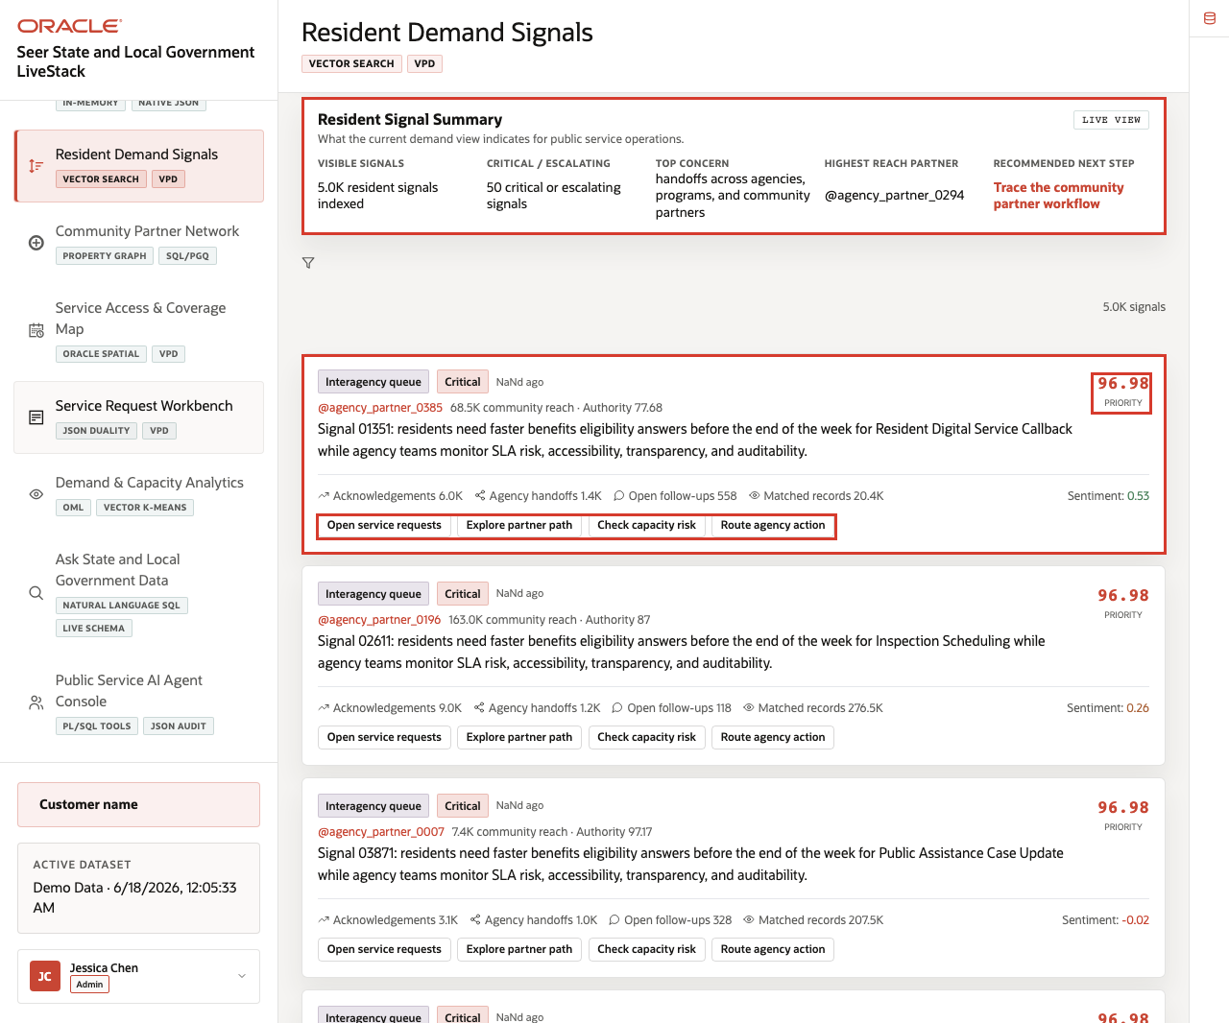
Figure 16. Resident signal momentum cards and urgency labels
The signal feed helps the agency understand where public demand is moving. Use this page to explain that constituent service teams can connect early resident concerns to service definitions and response paths already governed in Oracle.
You can move to the next scene.

Credits & Build Notes
- Author - Oracle LiveLabs Team
- Last Updated By/Date - Oracle LiveLabs Team, 2026-06-17

Scene 5 Community Partner Network

Introduction
The Community Partner Network uses graph relationships to show how agencies, departments, public programs, community partners, service domains, source channels, and resident signals are connected. It helps an operator understand which partners can support a response and why a service need may span several organizations.
Public-sector response is rarely linear. A constituent service issue can involve a city department, county benefits office, nonprofit partner, inspection team, public works crew, and emergency operations coordinator. Graph analysis helps the agency see those relationships without flattening them into a single table.
Estimated Time: 10 minutes
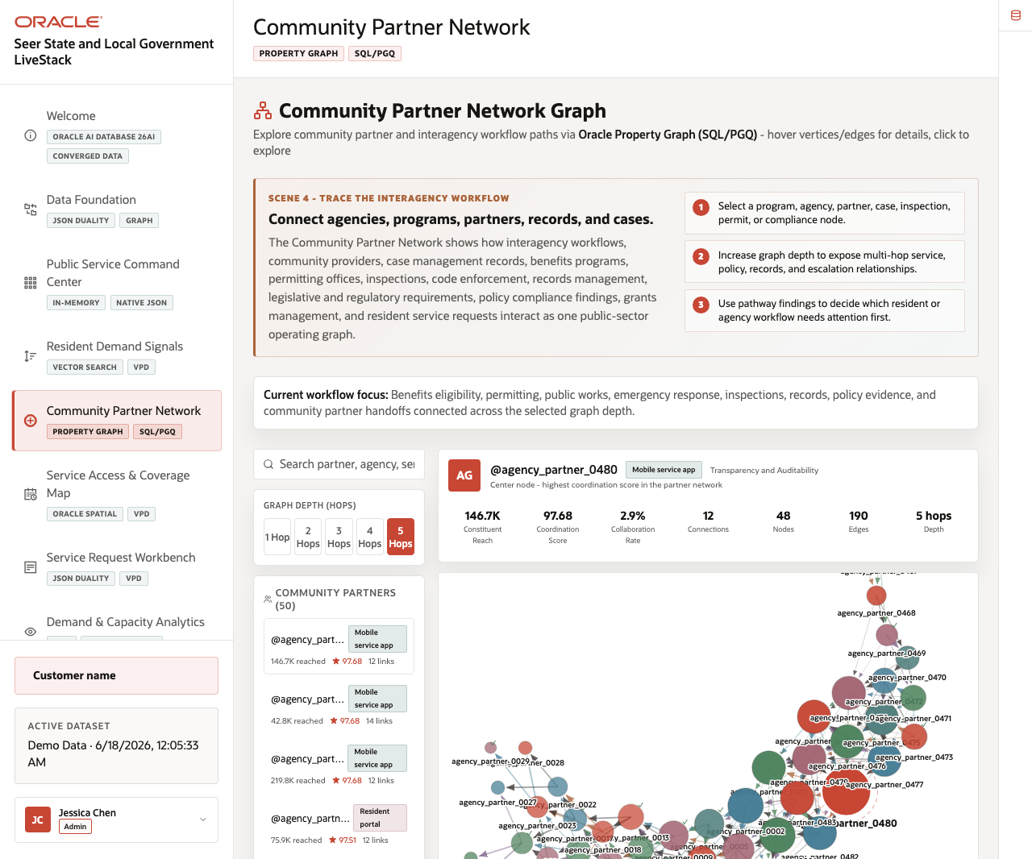
Figure 17. Community Partner Network graph and partner coordination workspace

Objectives
In this scene, you will learn how graph relationships support partner coordination, how to inspect relationship depth, and how SQL/PGQ evidence makes the graph explainable.

Task 1: Explore the partner graph
Perform the following set of steps to move from a service issue to the organizations and relationships that may help resolve it.
1. Click Community Partner Network in the sidebar.
2. Review the graph visualization and the partner list.
3. Select a partner, agency, service domain, or coordination node.
4. Increase or decrease relationship depth if the control is available.
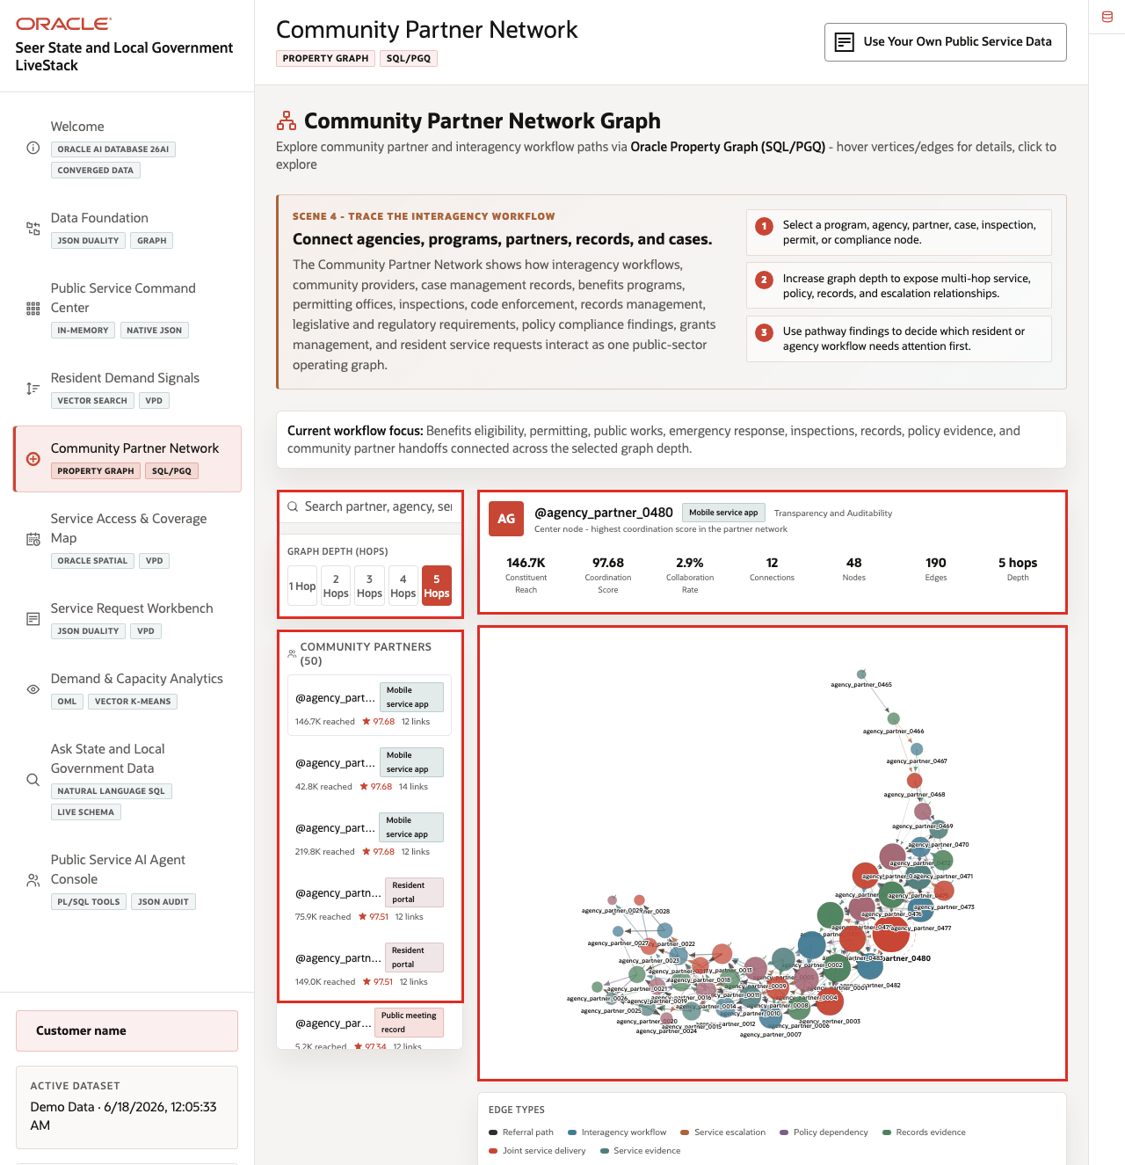
Figure 18. Community partner graph workspace with relationship controls
Expected result: The graph updates around the selected node or relationship depth. The operator can identify connected organizations, public services, evidence links, and coordination paths.

Task 2: Review partner relationship evidence
Perform the following set of steps to connect the graph visualization to the relationship evidence below it.
1. Review the selected partner summary.
2. Scroll to the public program relationship section.
3. Compare connected programs, inferred relationship paths, and edge types.
4. Explain how these relationships help identify which agency, partner, or program should coordinate next.
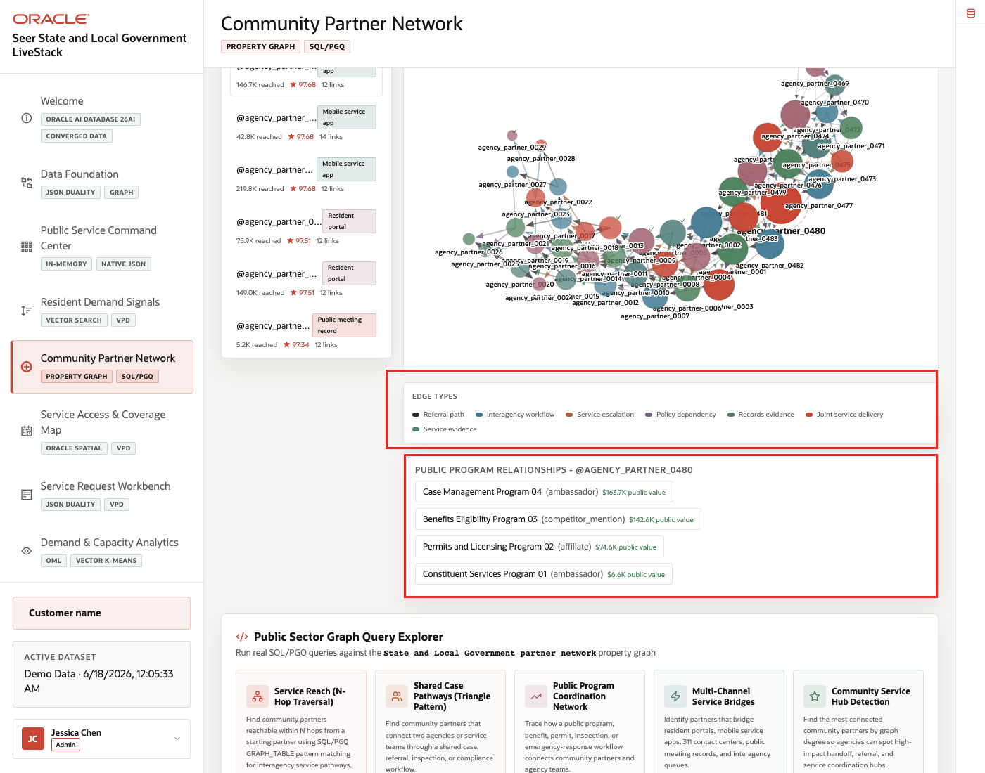
Figure 19. Partner program relationships and graph edge evidence
This step turns the graph from a visual network into an operational decision aid. The agency can see why a partner matters and which public-service relationships support that conclusion.

Task 3: Run a graph query
Perform the following set of steps when the audience wants to see that the visual graph is backed by governed database evidence.
1. Open the example query explorer.
2. Select a provided SQL/PGQ or graph query.
3. Click Run Query.
4. Review the result rows and the expanded SQL/PGQ statement.
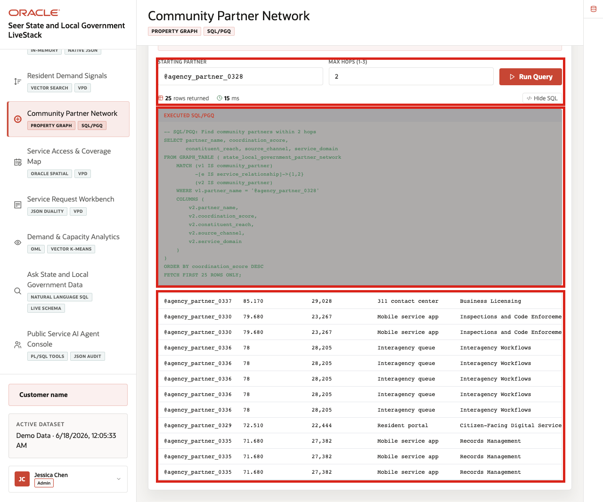
Figure 20. Graph query explorer with SQL/PGQ evidence for partner relationships
The query returns relationship evidence from the Oracle property graph. Use the visible SQL or SQL/PGQ to reinforce that the graph is backed by database tables and graph metadata, not an unmanaged diagram.
You can move to the next scene.

Credits & Build Notes
- Author - Oracle LiveLabs Team
- Last Updated By/Date - Oracle LiveLabs Team, 2026-06-17

Scene 6 Service Access and Coverage Map

Introduction
Service Access & Coverage Map helps a state or local agency understand how geography changes the response. A high-demand service may require a different action depending on nearby service capacity, partner coverage, travel distance, neighborhood access tier, or emergency operations constraints.
This scene uses Oracle Spatial to keep location intelligence close to the same public-sector operating data used by the command center, service request workbench, and analytics pages.
Estimated Time: 10 minutes
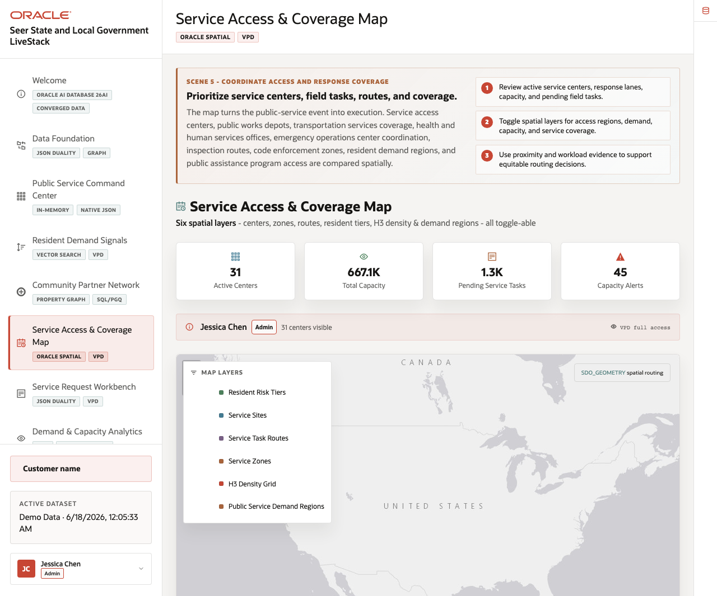
Figure 21. Service Access and Coverage Map with layer controls and capacity signals

Objectives
In this scene, you will inspect the service access map, compare capacity and access signals, and explain why spatial analysis is part of the operating workflow.

Task 1: Inspect the service access map
Perform the following set of steps to show how the map organizes place-based service access evidence.
1. Click Service Access & Coverage Map in the sidebar.
2. Review the Map Layers panel and the active layer legend.
3. Note the available layer types for resident risk tiers, service sites, task routes, service zones, H3 density grid, and public service demand regions.
4. Connect the layer evidence to the active center count, total capacity, pending service tasks, and capacity alerts.
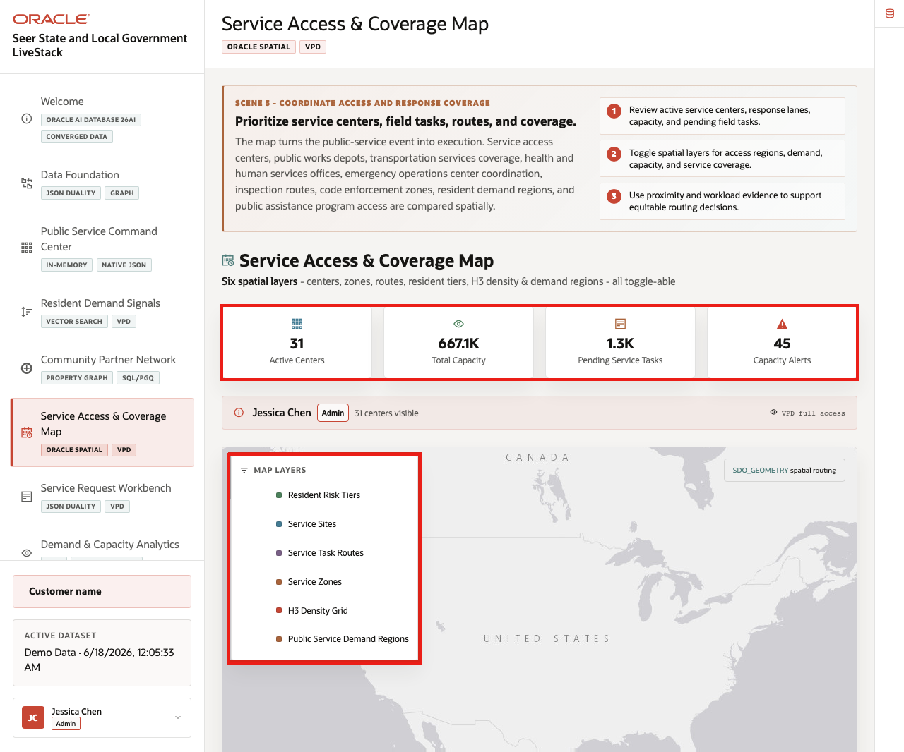
Figure 22. Service access map layers and coverage controls
The map turns service demand into a place-based decision. In this task, the layer list is the proof point: it shows the spatial data the agency can combine with capacity and service-request evidence.

Task 2: Compare service sites with the map
Perform the following set of steps to show how the map connects to service-site records.
1. Review the visible Service Sites table below the map.
2. Compare center, location, type, services, capacity, pending work, and load values.
3. Use the map and table together to explain which sites may need follow-up.
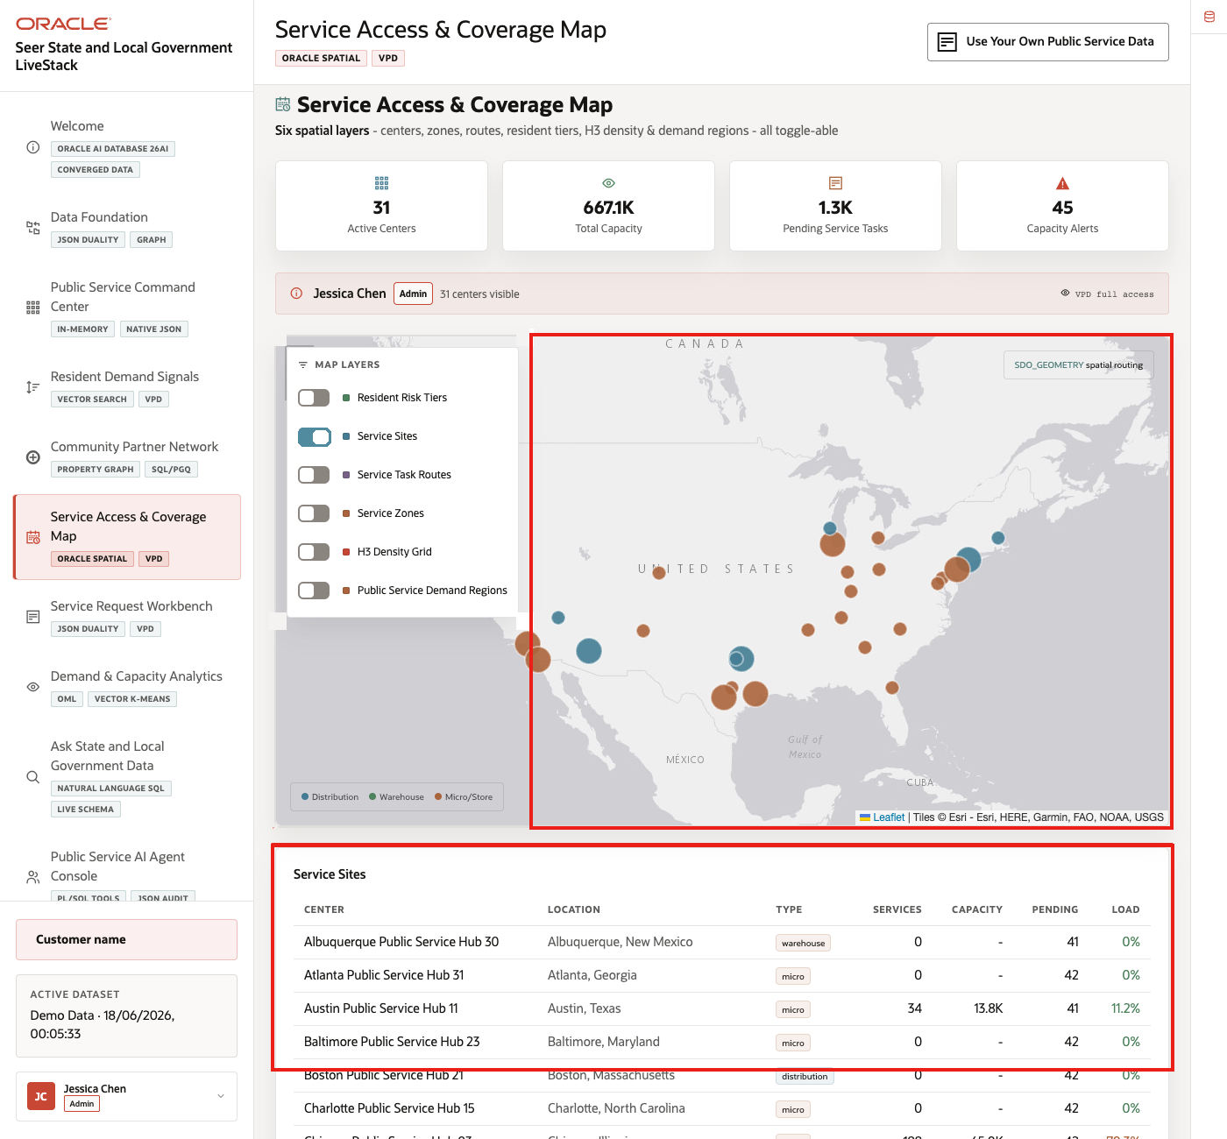
Figure 23. Service sites table connected to the service access map
The table gives the map operational grounding. It lets the audience connect place-based coverage to the actual service centers and pending work the agency must manage.

Task 3: Compare capacity and access signals
Perform the following set of steps to connect geography with service operations.
1. Review the capacity, alert, or access cards next to the map.
2. Compare the spatial context with services under pressure from the command center.
3. Use the active-center, total-capacity, pending-task, and capacity-alert cards to explain where the agency would investigate coverage next.
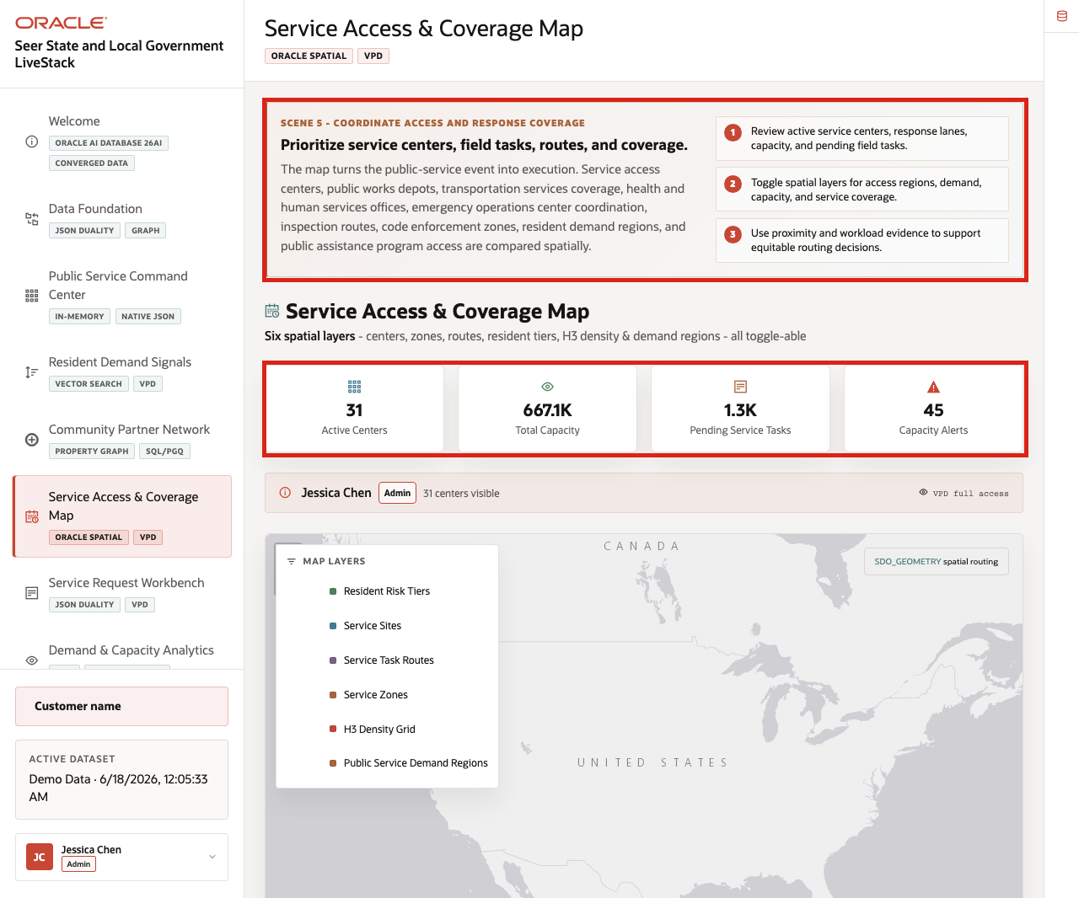
Figure 24. Capacity and access signals beside the service coverage map
For State and Local Government teams, geography changes the decision. Oracle Spatial lets those signals stay close to the operational data instead of forcing users into a separate mapping system.
You can move to the next scene.

Credits & Build Notes
- Author - Oracle LiveLabs Team
- Last Updated By/Date - Oracle LiveLabs Team, 2026-06-17

Scene 7 Service Request Workbench

Introduction
The Service Request Workbench shows how a public-service request moves from a table of operational records into a row-level case detail. The live page lets the agency review service request status, resident context, line count, service value, and line-level public program detail from the same governed dataset.
For a state or local agency, a service request may represent a resident contact, permit follow-up, benefits eligibility review, inspection task, public works issue, or emergency-response support item. Different users need different levels of evidence: an analyst may start with the request list, a supervisor may open the row-level detail, and a data steward may use Oracle Confidentials to explain how JSON Duality and VPD support the application pattern.
Estimated Time: 10 minutes
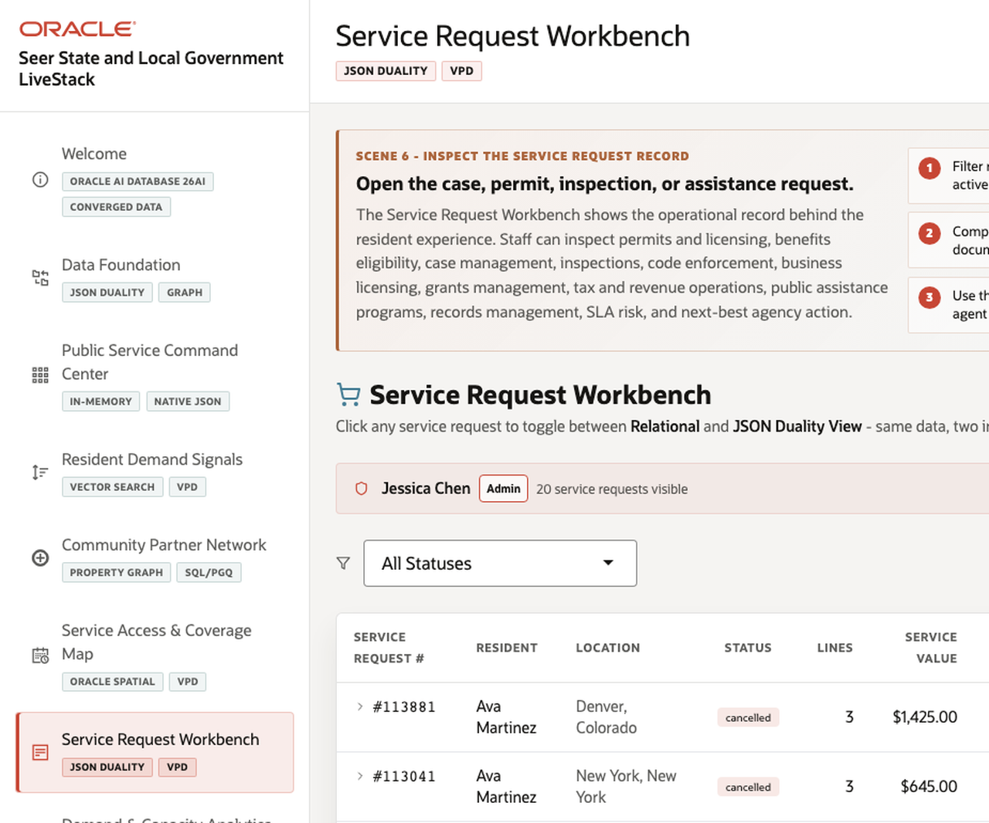
Figure 25. Service Request Workbench with request list and detail panel

Objectives
In this scene, you will open a service request, review the expanded request detail, and connect the visible workflow to Oracle-backed JSON Duality and access-control evidence.

Task 1: Review the request list
Perform the following set of steps to move from the service request list into a detailed public-sector case or task.
1. Click Service Request Workbench in the sidebar.
2. Review the visible request list, including request number, resident, location, status, line count, and service value.
3. Use Prev or Next if you need to move through the visible request pages.
4. Identify one request that should be opened for detail review.
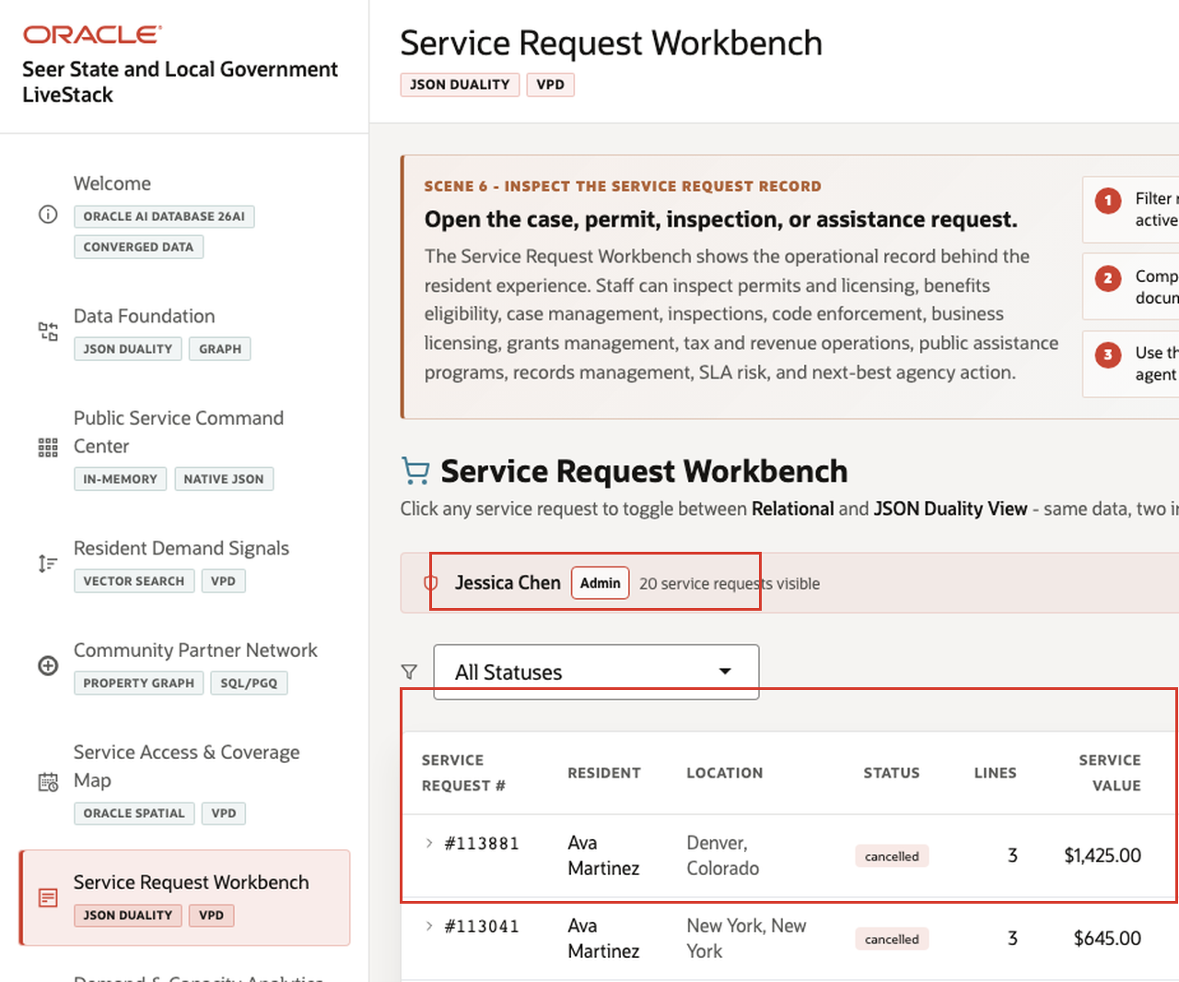
Figure 26. Service request workspace with request list and visible request columns
The workbench helps the agency move from an aggregate service-pressure signal to the individual requests that need review.

Task 2: Inspect the request detail
Perform the following set of steps to inspect the request-level evidence available on the page.
1. Click a service request row, such as #113881.
2. Review the expanded Same data - three views panel.
3. Compare resident, location, service value, route cost, and line-count context.
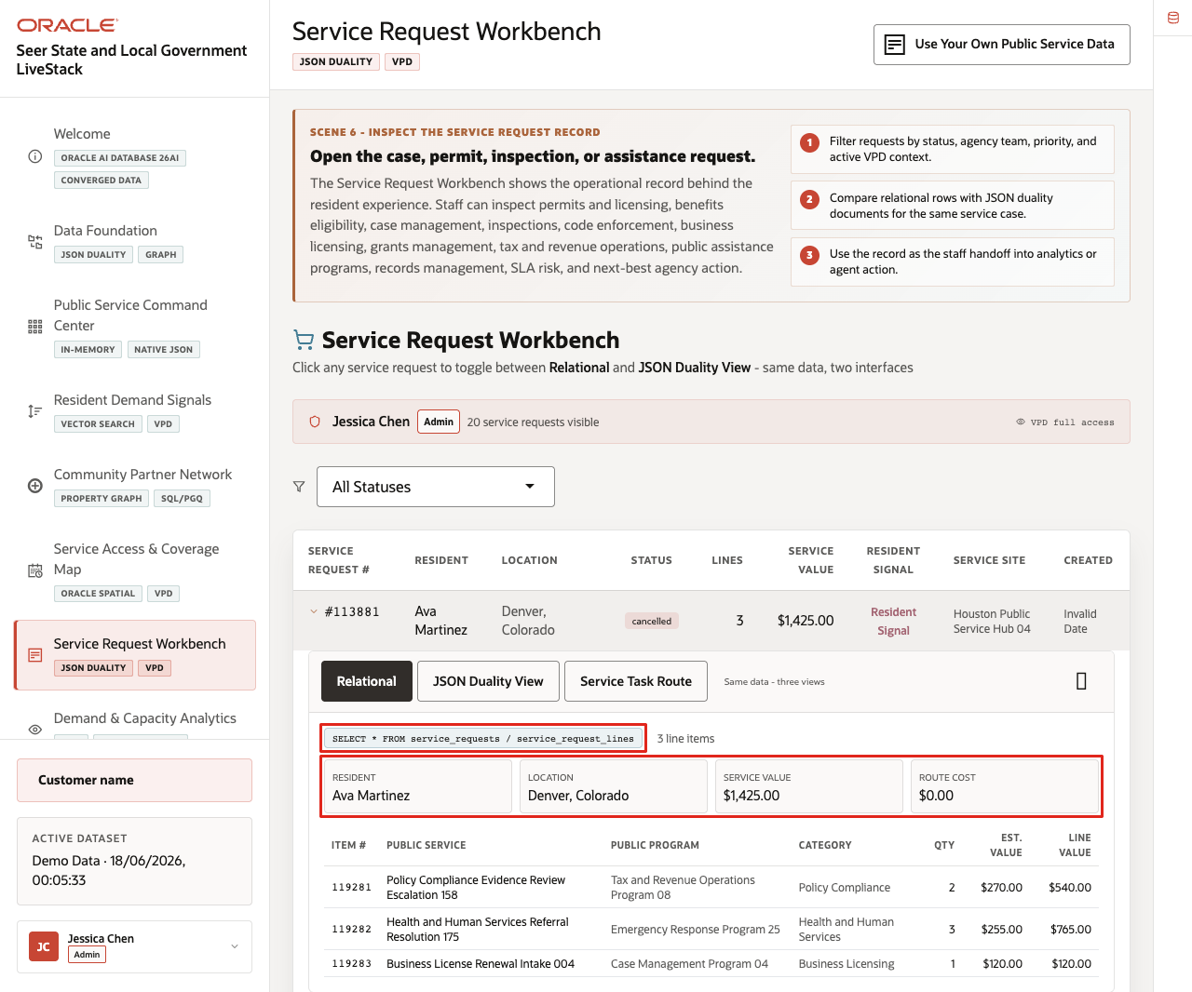
Figure 27. Expanded service request detail with request-level fields
The request-level detail gives the staff member the basic context needed before they inspect line items, escalate, or route the request.

Task 3: Compare line-level service evidence
Perform the following set of steps to inspect the public-service evidence attached to the request.
1. Keep the request expanded.
2. Review the line-level service table.
3. Compare public service, public program, category, quantity, estimated value, and line value fields.
4. Use the expanded detail to explain what a staff member would inspect before escalating or routing the request.
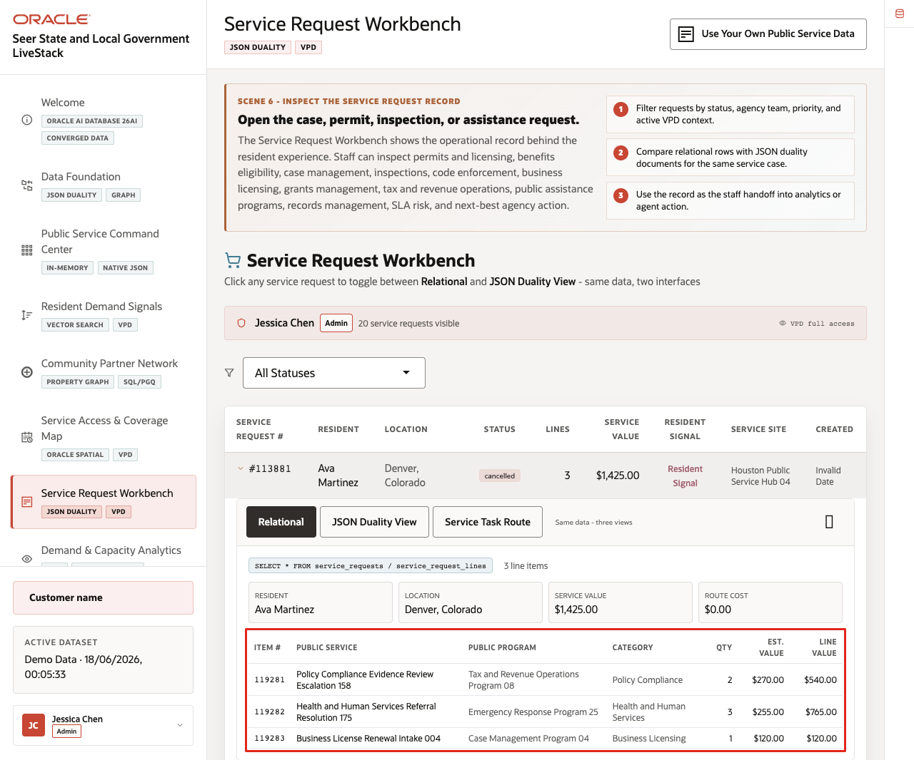
Figure 28. Expanded service request detail with line-level public program evidence
The expanded row connects the request table to line-level service evidence without sending the user to another application. This is the visible decision point in the scene: the staff member can inspect the request and the related service lines before choosing the next action.

Task 4: Connect the row detail to Oracle evidence
Perform the following set of steps after the business workflow is clear.
1. Keep the request row expanded.
2. Click Show Oracle Confidentials.
3. Review the Oracle evidence for JSON Duality, VPD, SQL access, and the governed service request model.
4. Explain that Oracle keeps the operational record, document-oriented application pattern, and access control close to the same data foundation.
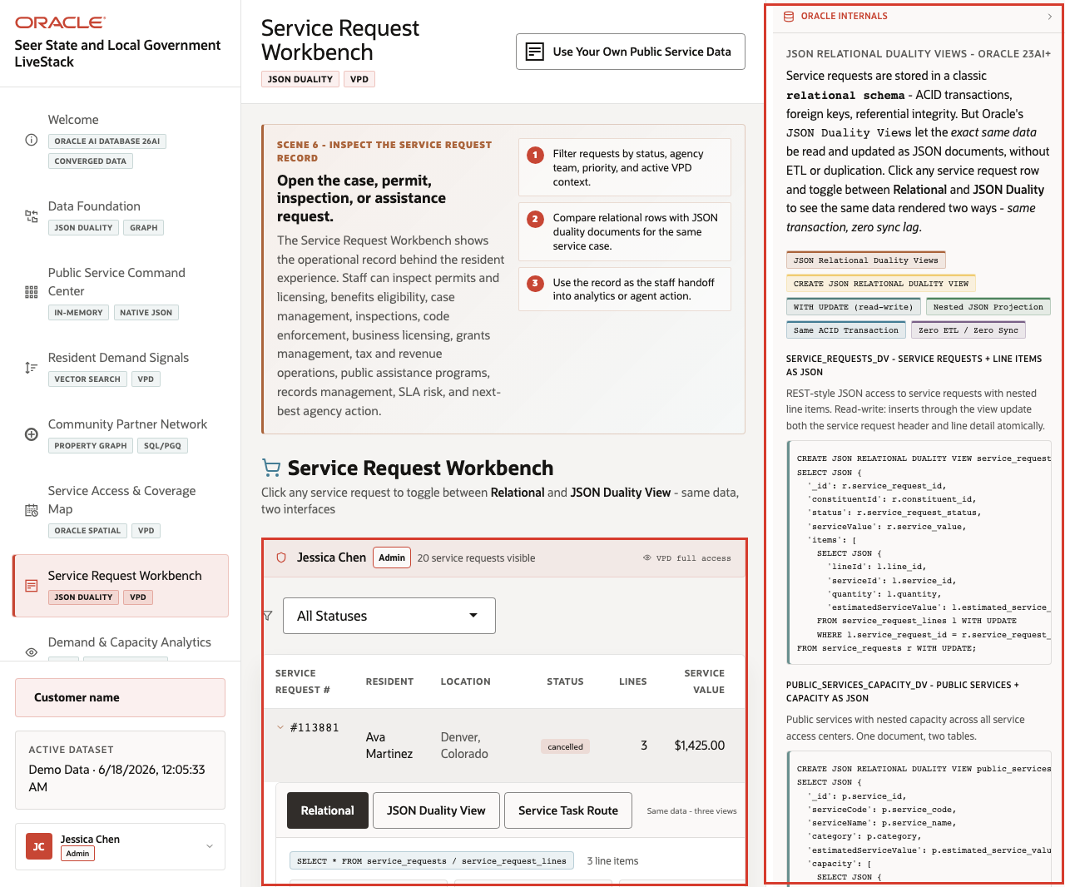
Figure 29. Oracle Confidentials evidence for the Service Request Workbench
Public-service applications often need transactional integrity, document-style application access, and governed row-level permissions. This scene shows how one Oracle data model can support the staff workflow without duplicating or syncing separate databases.
You can move to the next scene.

Credits & Build Notes
- Author - Oracle LiveLabs Team
- Last Updated By/Date - Oracle LiveLabs Team, 2026-06-18

Scene 8 Demand and Capacity Analytics

Introduction
Demand & Capacity Analytics demonstrates Oracle Machine Learning over State and Local Government operations data. It includes demand surge prediction, resident need segmentation, service value forecasting, vector K-Means clustering, and capacity intelligence.
This scene is the planning checkpoint in the story. Jessica Chen has already seen which services are under pressure, which resident signals are rising, where service access may be constrained, and which requests require attention. Now the agency needs predictive evidence to plan staffing, partner coordination, field response, or program capacity.
Estimated Time: 12 minutes
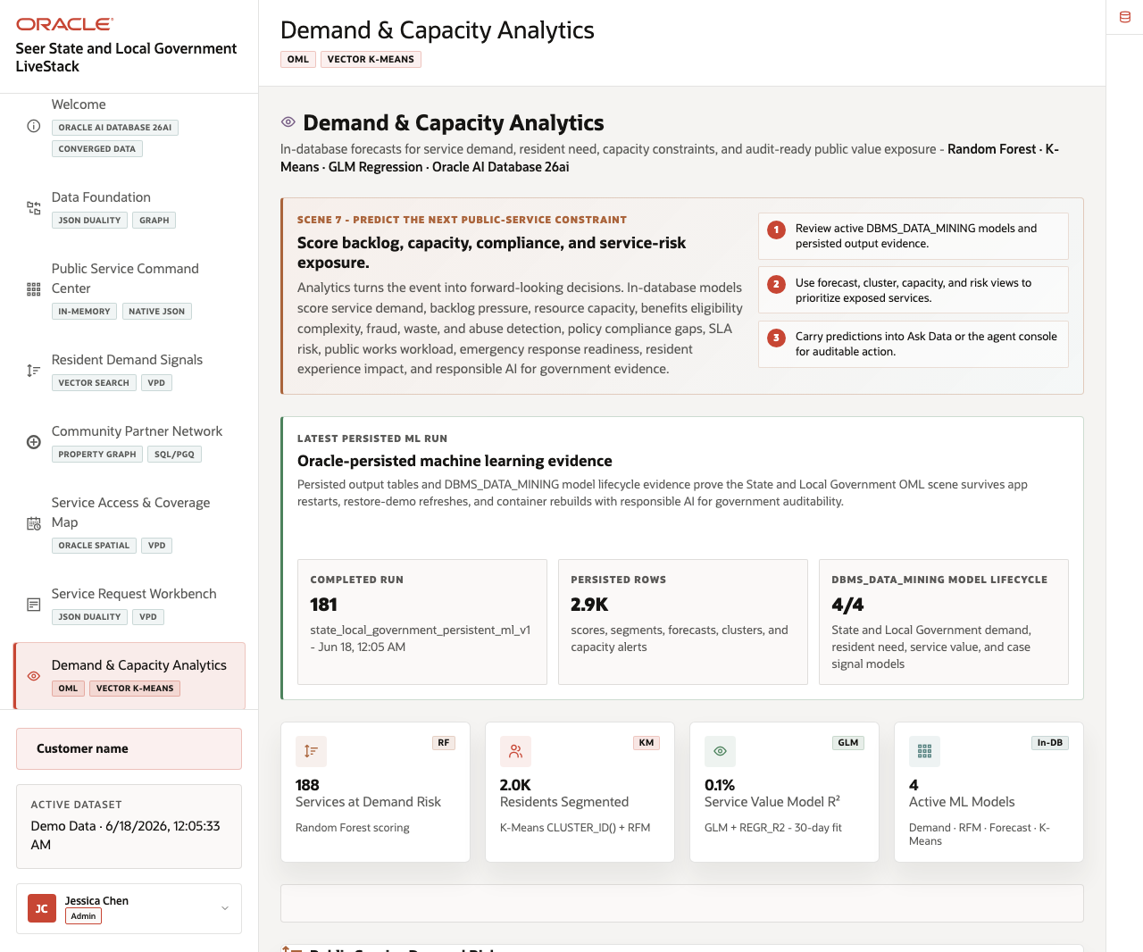
Figure 30. Demand and Capacity Analytics page with OML summary and tabs

Objectives
In this scene, you will review OML summary metrics, switch between analytics tabs, compare model outputs, and explain the operational meaning of the scores.

Task 1: Review demand surge risk
Perform the following set of steps when the audience wants to see predictive demand scoring.
1. Click Demand & Capacity Analytics in the sidebar.
2. Review the summary cards for services with demand surge, residents segmented, model fit, and active ML models.
3. Click Demand Risk.
4. Review the demand window, score, service category, and risk context.
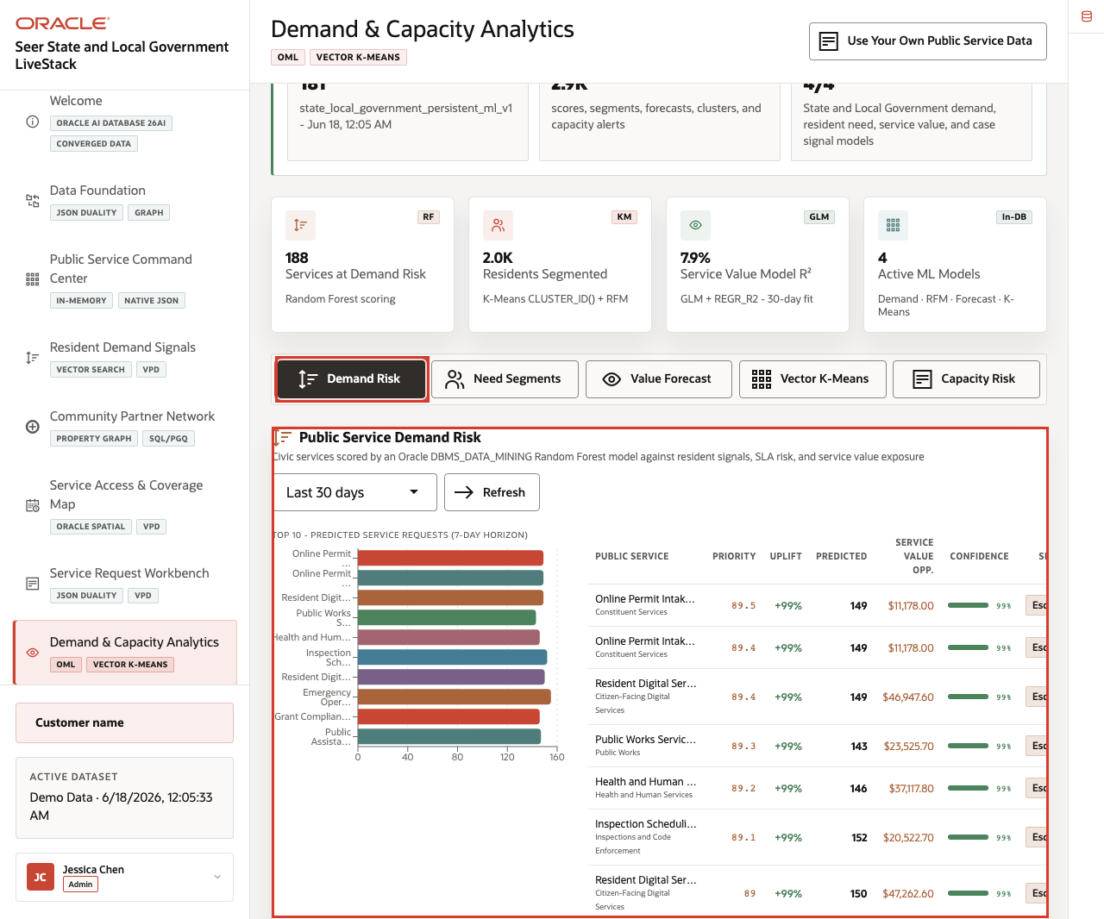
Figure 31. Demand surge risk scoring for public services
Expected result: The user sees OML scores directly in the application. The evidence panel identifies in-database model scoring and persisted outputs rather than offline analytics.

Task 2: Inspect resident need segments
Perform the following set of steps to show how segmentation helps the agency tailor response.
1. Click Need Segments.
2. Review the resident segment mix.
3. Compare the segment mix, service-access risk chart, and top resident profiles.
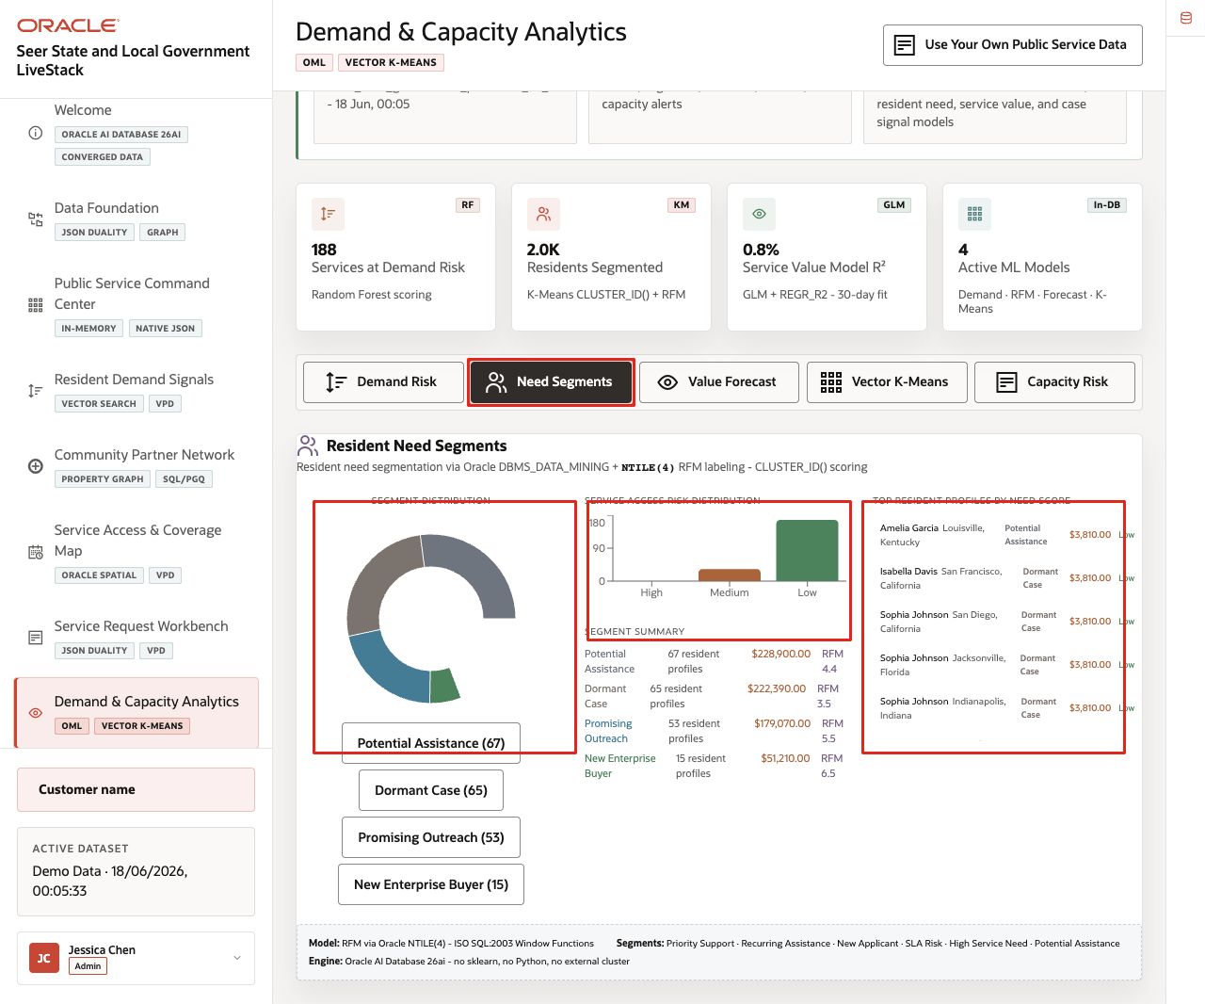
Figure 32. Resident need segmentation model output
Need segments help a state or local agency see patterns across residents, services, and operating regions. This can guide outreach, staffing, and partner coordination.

Task 3: Interpret service value forecast
Perform the following set of steps to connect forecasted demand to public-service value.
1. Click Value Forecast.
2. Review the forecast horizon, trend line, forecast region, and model context.
3. Compare the forecast with the demand-risk and segment results from the prior tasks.
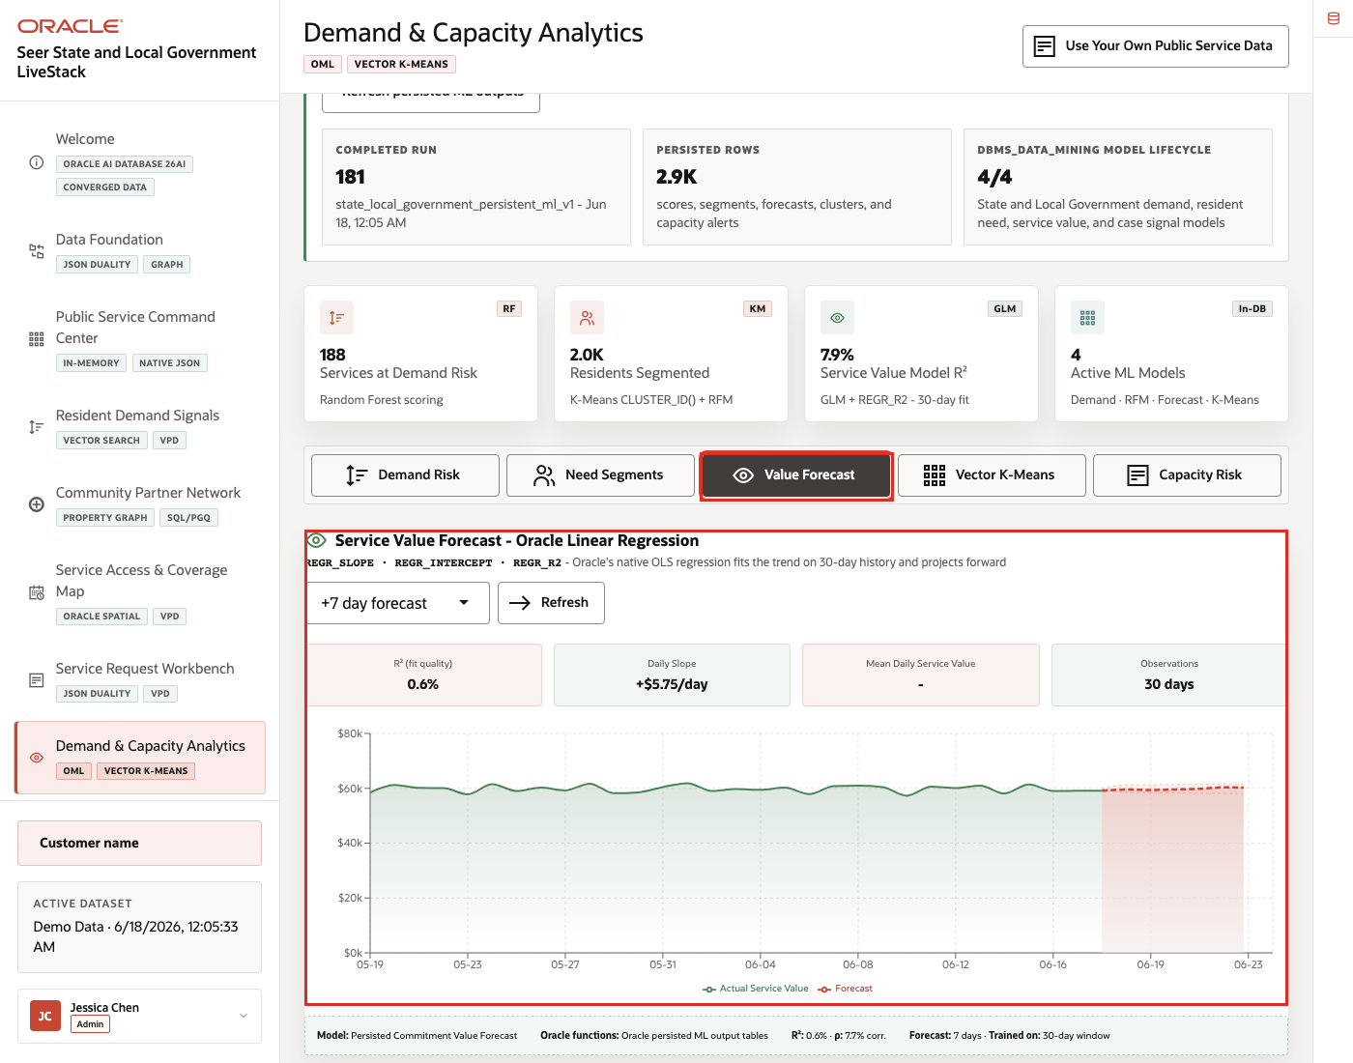
Figure 33. Service value forecast with model output and forecast trend
The forecast view helps the agency explain what may happen next, not just what has already happened. It is useful when leaders need to plan staffing, partner engagement, or service capacity before pressure becomes visible in the request queue.

Task 4: Explore Vector K-Means clusters
Perform the following set of steps to show how clustering groups related demand and service patterns.
1. Click Vector K-Means.
2. Review the visible cluster controls and cluster distribution.
3. Compare cluster examples across public services, resident signals, service access, and capacity context.
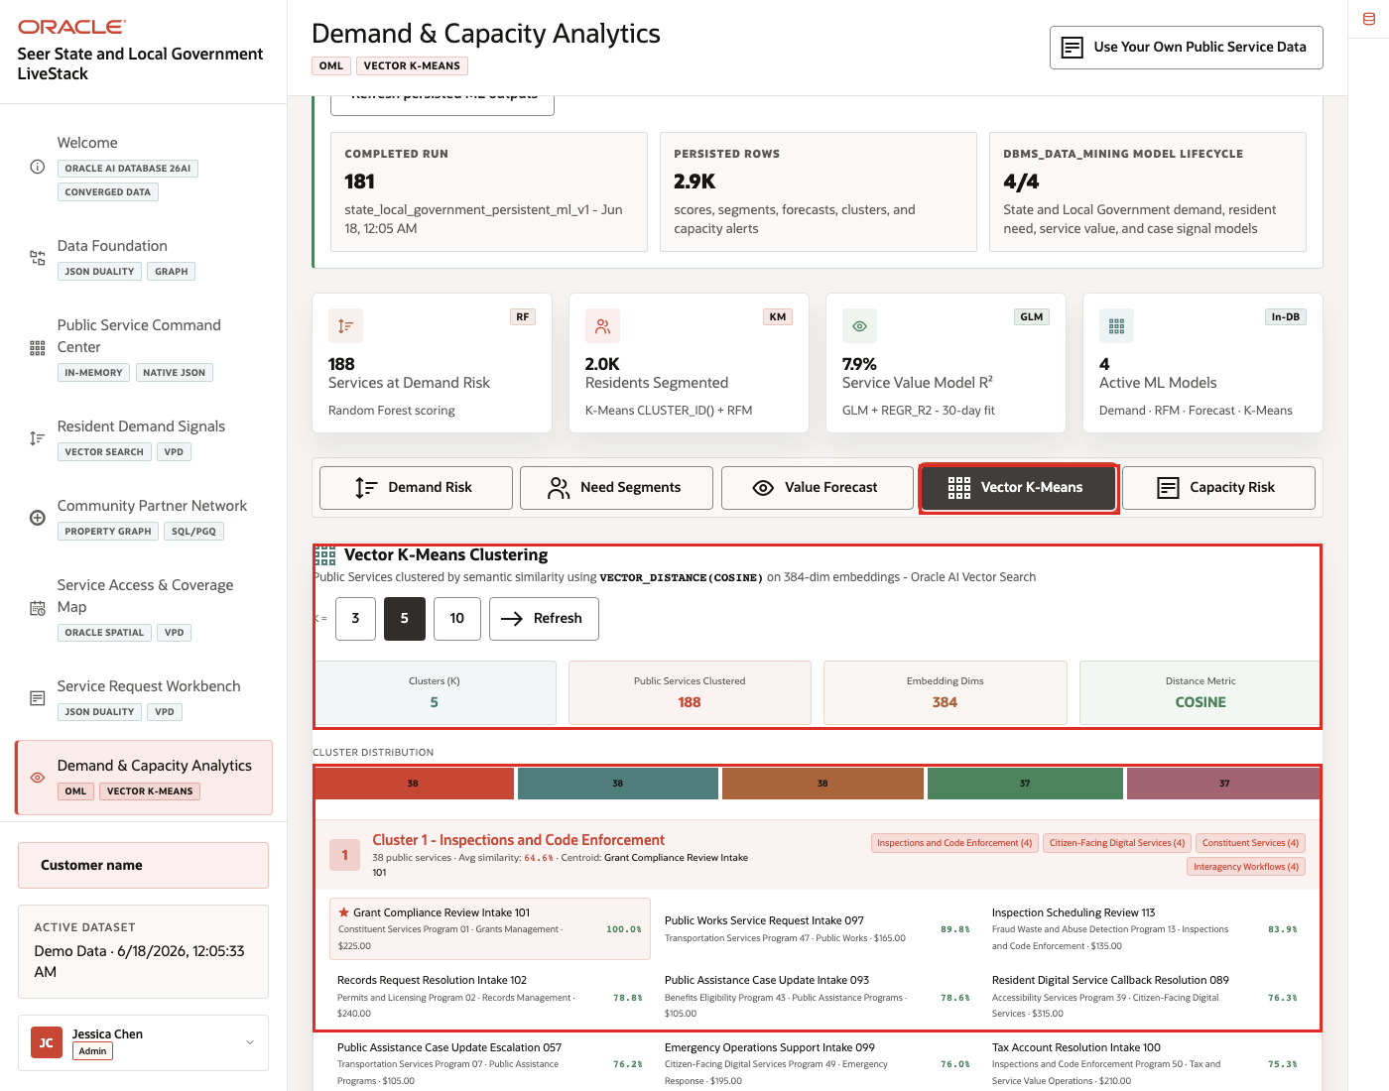
Figure 34. Vector K-Means clustering view with cluster distribution and examples
Vector K-Means helps the audience see how similar operating patterns can be grouped for planning and follow-up. This is useful when many service signals look different individually but share similar response needs.

Task 5: Compare capacity intelligence
Perform the following set of steps to connect forecasted demand to service capacity.
1. Click Capacity Risk.
2. Review capacity status, days of capacity, and public service value at risk.
3. Use Refresh in any tab if you need to rerun the visible scoring workflow.
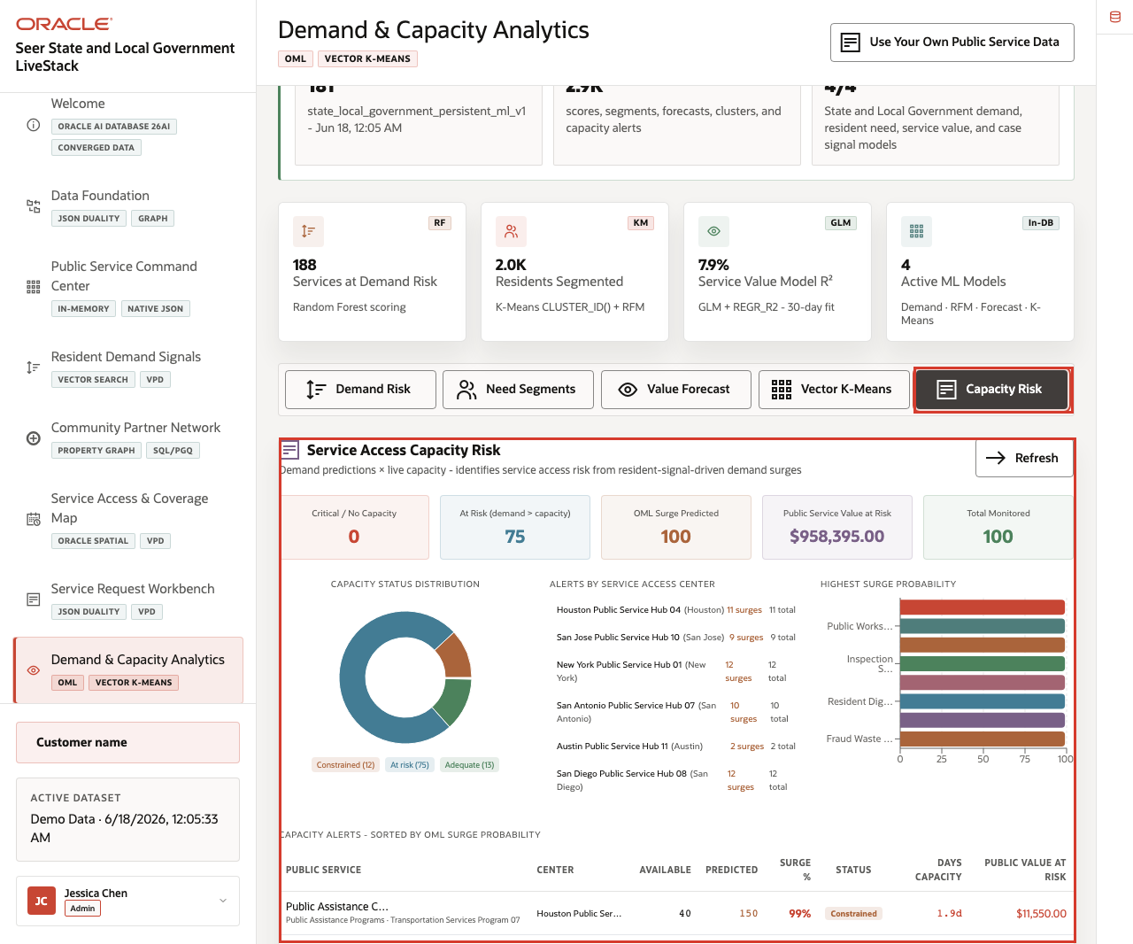
Figure 35. Capacity intelligence view with service capacity risk
Capacity intelligence connects forecasted demand to service access constraints. Use this view to explain how analytics become more useful when they are embedded in the operator workflow and run against governed Oracle data.
You can move to the next scene.

Credits & Build Notes
- Author - Oracle LiveLabs Team
- Last Updated By/Date - Oracle LiveLabs Team, 2026-06-17

Scene 9 Ask State and Local Government Data

Introduction
Ask State and Local Government Data helps agency users ask operational questions in plain language while keeping the answer path visible. Users can compare narrated answers, conversational responses, generated SQL, and result rows, making self-service analytics faster and easier to trust.
Natural-language data access can create governance risk if the language model generates invalid SQL, references the wrong tables, hides the query path, or exposes more data than the user should see. Public-sector teams need self-service analytics, but data teams still need traceability, read-only execution, and a clear source of truth.
Oracle AI Database helps address these challenges by keeping query execution grounded in the live State and Local Government schema. In this LiveStack Demo, the app sends the question and schema context to the local Ollama runtime, validates the generated SQL path, and uses Oracle AI Database 26ai as the execution authority.
Note: Ollama provides the local AI runtime used for reasoning, while Oracle remains the governed source for data access and execution.
Estimated Time: 10 minutes
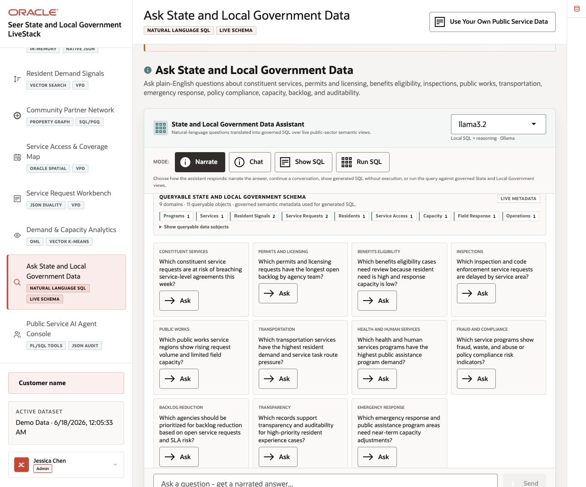
Figure 36. Ask State and Local Government Data workspace with modes, schema metadata, and example questions

Objectives
In this scene, you will learn how public-sector users can ask operational questions, compare answer modes, inspect SQL evidence, and validate result rows.

Task 1: Use Narrate mode for an operations brief
Perform the following set of steps when the user wants a business-readable answer first. The system still relies on governed SQL behind the scenes, but the response is shaped for agency operations users.
1. Click Ask State and Local Government Data in the sidebar.
2. Review the runtime profile in the assistant card.
3. Review the queryable schema summary.
4. Click Narrate.
5. Click Ask on the constituent-services example question: Which constituent service requests are at risk of breaching service-level agreements this week?
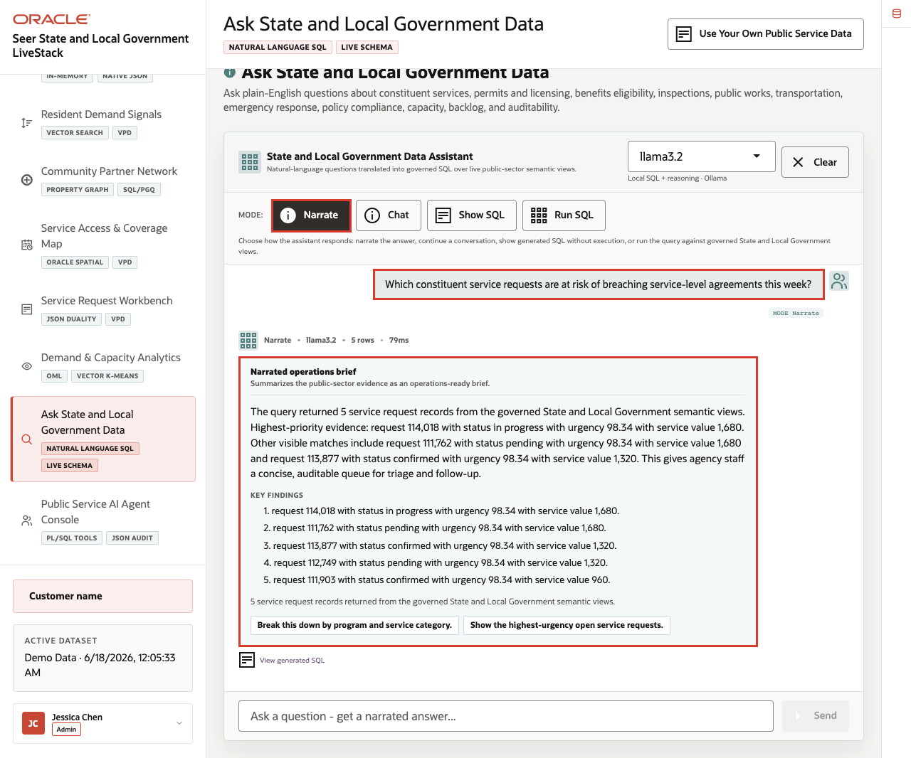
Figure 37. Narrate mode response for a service request SLA risk question
Expected result: The assistant returns an operations brief with key findings and follow-up prompts without making generated SQL the main artifact.
Note: Sample values may change after data refreshes or rebuilds. Verify live output before presenting, then explain the business takeaway.

Task 2: Use Chat mode for a conversational answer
Perform the following set of steps when the user is exploring the data interactively and may want follow-up questions or a more conversational explanation.
1. Click Clear if the Narrate result is still visible.
2. Click Chat.
3. Click Ask on the same service request SLA risk question.
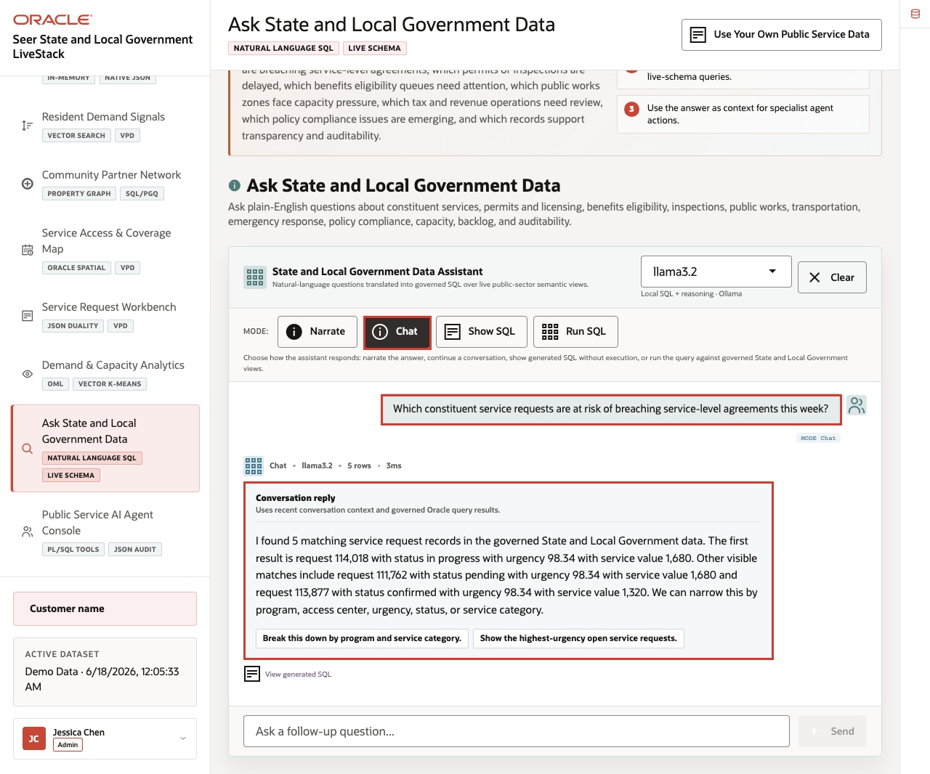
Figure 38. Chat mode response for a service request SLA risk question
Expected result: The assistant returns a conversational response and follow-up prompts grounded in the live public-sector schema.

Task 3: Use Show SQL mode to inspect the query path
Perform the following set of steps when a user, data steward, or agency leader needs to see the query path before rows appear. This keeps the answer traceable instead of hidden behind an AI response.
1. Click Clear if the Chat result is still visible.
2. Click Show SQL.
3. Click Ask on the same question.
4. Review the generated SQL.
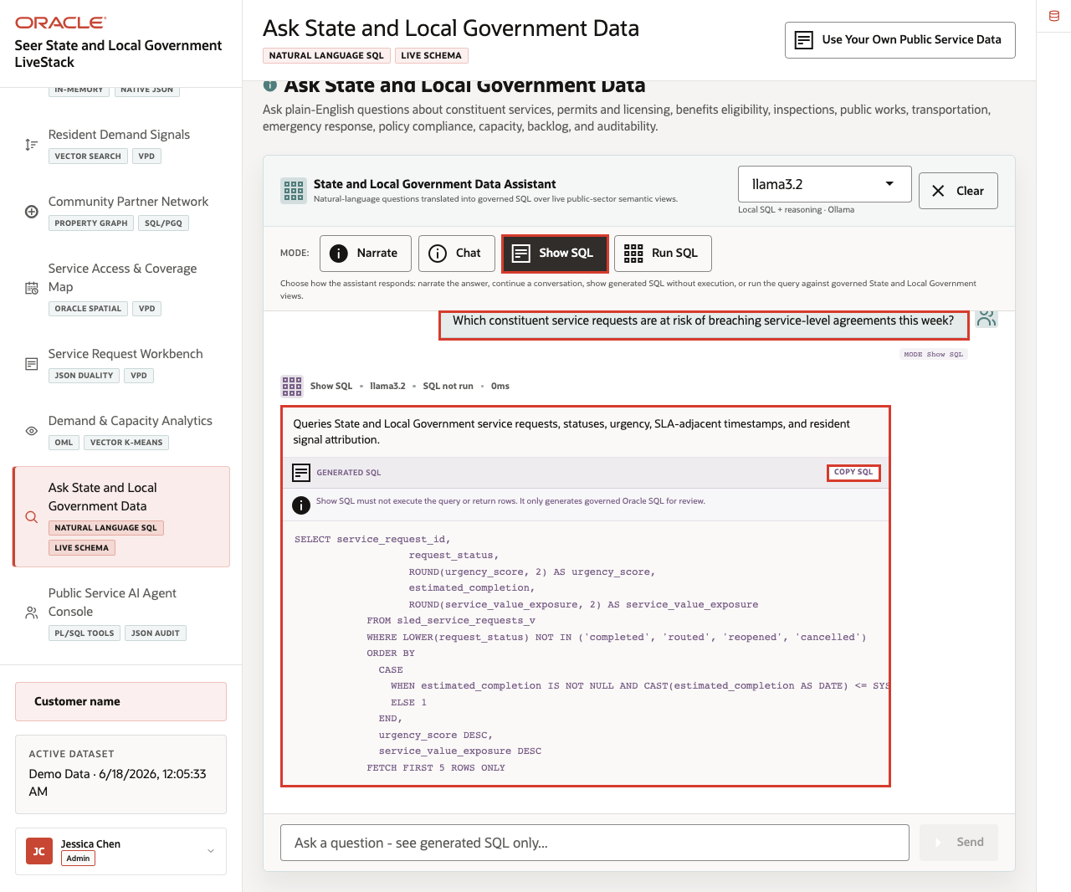
Figure 39. Generated SQL for the service request SLA risk question
The generated SQL is the governance moment: the user can inspect the query before asking the database to return rows.

Task 4: Use Run SQL mode to inspect result rows
Perform the following set of steps to inspect the live rows behind the answer. This helps the user connect a plain-English question to specific services, categories, regions, demand, capacity, or risk factors.
1. Click Clear if the generated SQL result is still visible.
2. Click Run SQL.
3. Click Ask on the same question.
4. Review the result table.
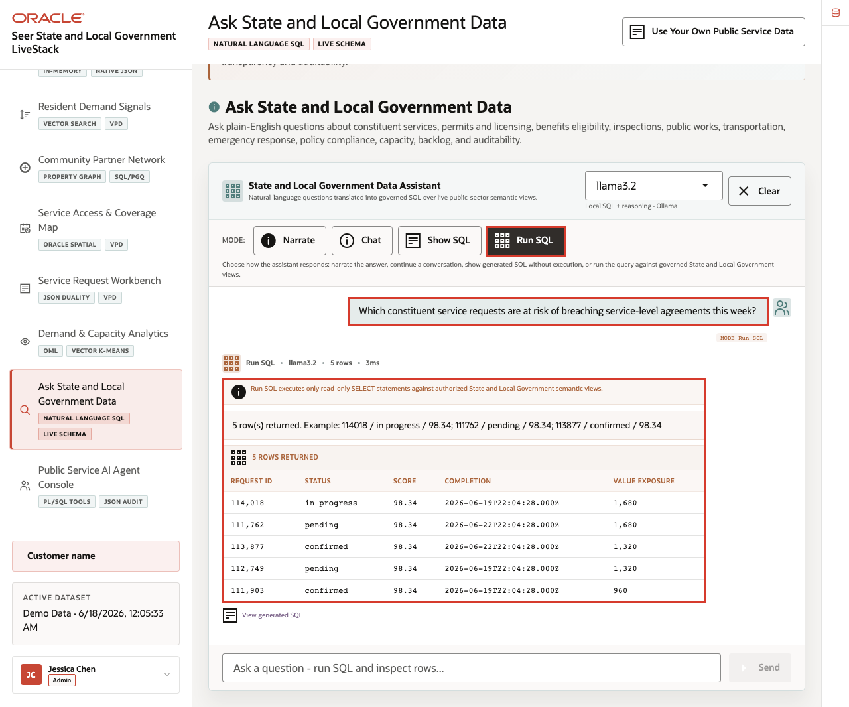
Figure 40. Run SQL results for the service request SLA risk question
Use the four completed mode examples to explain the governance pattern behind the page:
1. The user asks a public-sector question in plain English.
2. The app builds prompt and schema context for the selected runtime profile.
3. Ollama drafts SQL or a response plan.
4. Oracle AI Database executes authorized SQL against the live schema.
5. The UI returns visible SQL, rows, or a narrated answer depending on the selected mode.
This pattern matters because agency users want faster answers, but they also need governed access, visible query logic, and a trusted execution layer.
You can move to the next scene.

Credits & Build Notes
- Author - Oracle LiveLabs Team
- Last Updated By/Date - Oracle LiveLabs Team, 2026-06-17

Scene 10 Public Service AI Agent Console

Introduction
The Public Service AI Agent Console shows how AI-assisted operations can remain grounded in governed public-sector data. A user can ask questions that route to resident signal, service access, or public service operations agents, while Oracle records tool use and action history.
This scene is the action checkpoint in the story. The agency has seen resident demand, services under pressure, partner relationships, access geography, service requests, and capacity forecasts. The agent console helps the team ask what to do next while keeping the evidence path and audit trail visible.
Estimated Time: 12 minutes
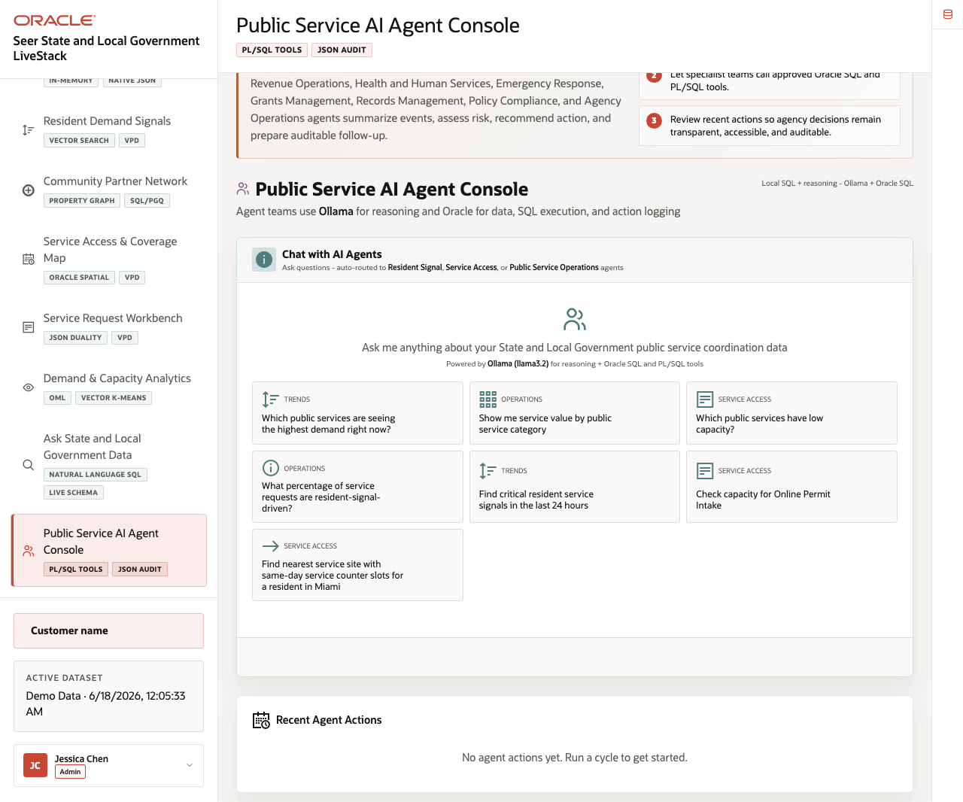
Figure 41. Public Service AI Agent Console with prompt examples and agent history

Objectives
In this scene, you will review the agent workspace, ask an example agent question, inspect the response, and review the action history that supports audit-ready AI operations.

Task 1: Review the agent console workspace
Perform the following set of steps to orient the audience before running an agent question.
1. Click Public Service AI Agent Console in the sidebar.
2. Review the available agent teams for resident signals, service access, and public service operations.
3. Review the example prompt cards, input box, runtime profile, and recent action area.
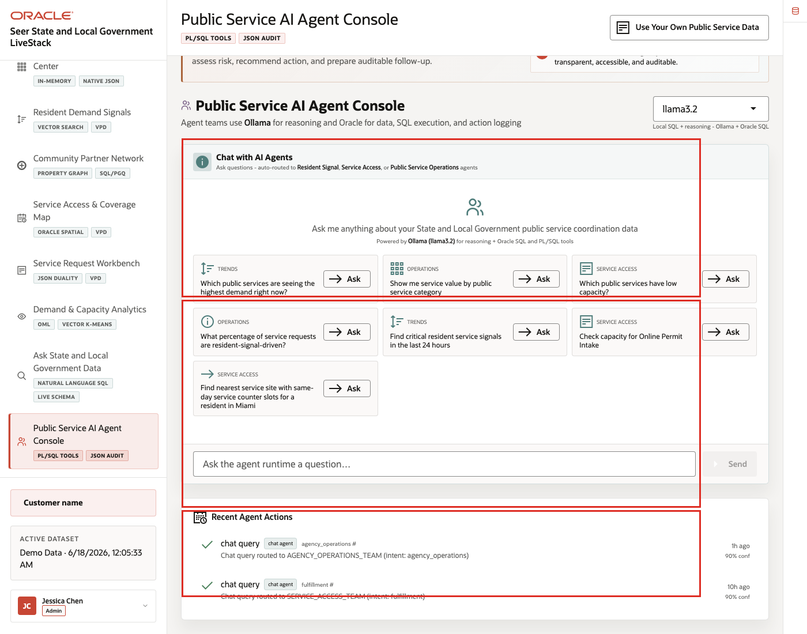
Figure 42. Public Service AI Agent Console workspace with example prompts and action history
The workspace shows that the agent experience is tied to public-sector operating tasks, not an open-ended chat surface.

Task 2: Ask an agent question
Perform the following set of steps when the audience wants to see AI-assisted public-service operations.
1. Click an example question such as What percentage of service requests are resident-signal-driven?, or type your own question.
2. Click Ask or Send.
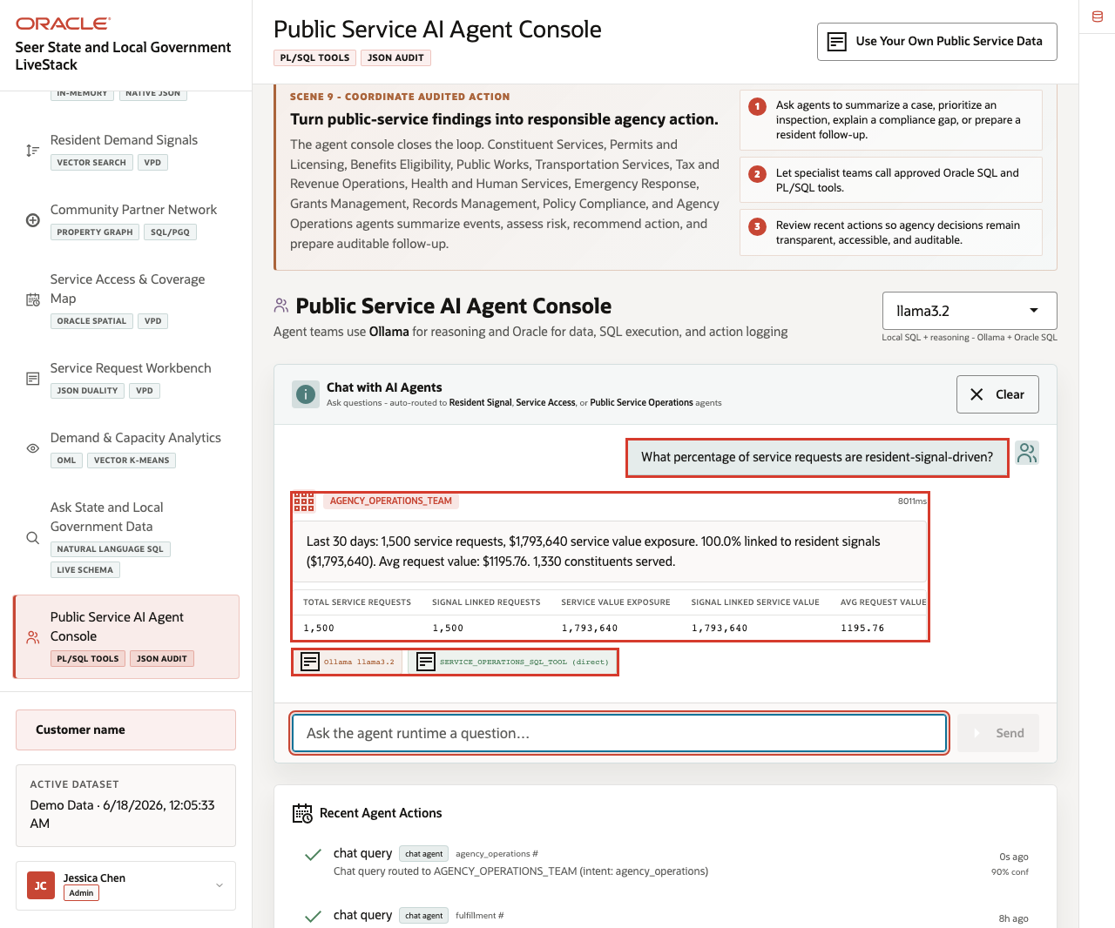
Figure 43. Agent response for resident-signal-driven service requests
Expected result: The agent response references public-service evidence instead of generic model prose. Use the response to connect agent reasoning to the same service, signal, map, and capacity data shown in earlier scenes.

Task 3: Inspect action history
Perform the following set of steps to show how AI activity remains reviewable.
1. Review the latest action history or event stream on the page.
2. Look for tool names, status badges, and agent action records.
3. Switch runtime profile if the control is available and explain what changes.
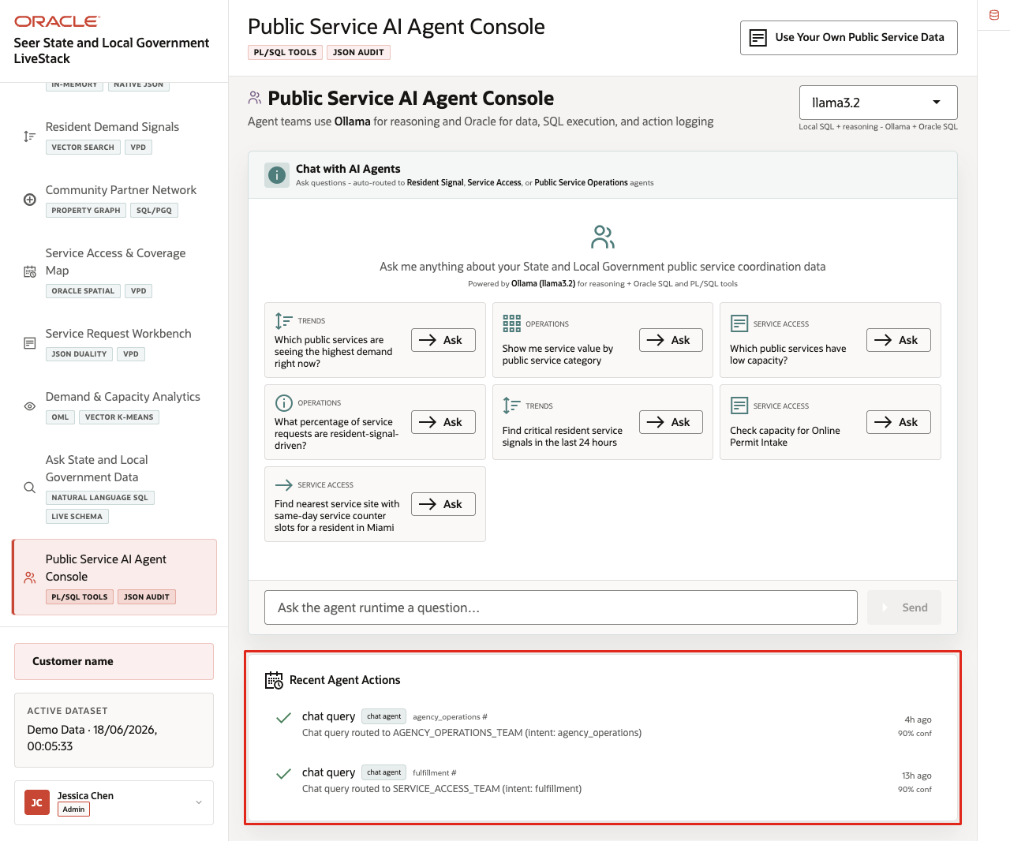
Figure 44. Agent action audit trail and tool history
The audit trail is the governance story for this scene. The agency can show what was asked, which tools were used, and which records supported the response.
You can move to the next scene.

Credits & Build Notes
- Author - Oracle LiveLabs Team
- Last Updated By/Date - Oracle LiveLabs Team, 2026-06-17

Scene 11 Use Your Own Public Service Data

Introduction
Use Your Own Public Service Data shows how users can replace or restore the dataset through the application while keeping the demo safe and repeatable.
The workflow supports template download, ZIP validation, upload, seeded-data restore, and the expectation that only synthetic or anonymized public-sector data is used.
This scene matters because a State and Local Government LiveStack is most useful when teams can map the demo pattern to their own terminology and sample data. The application makes that workflow explicit while keeping the seeded Seer public-sector data available as a known-good baseline.
Estimated Time: 10 minutes
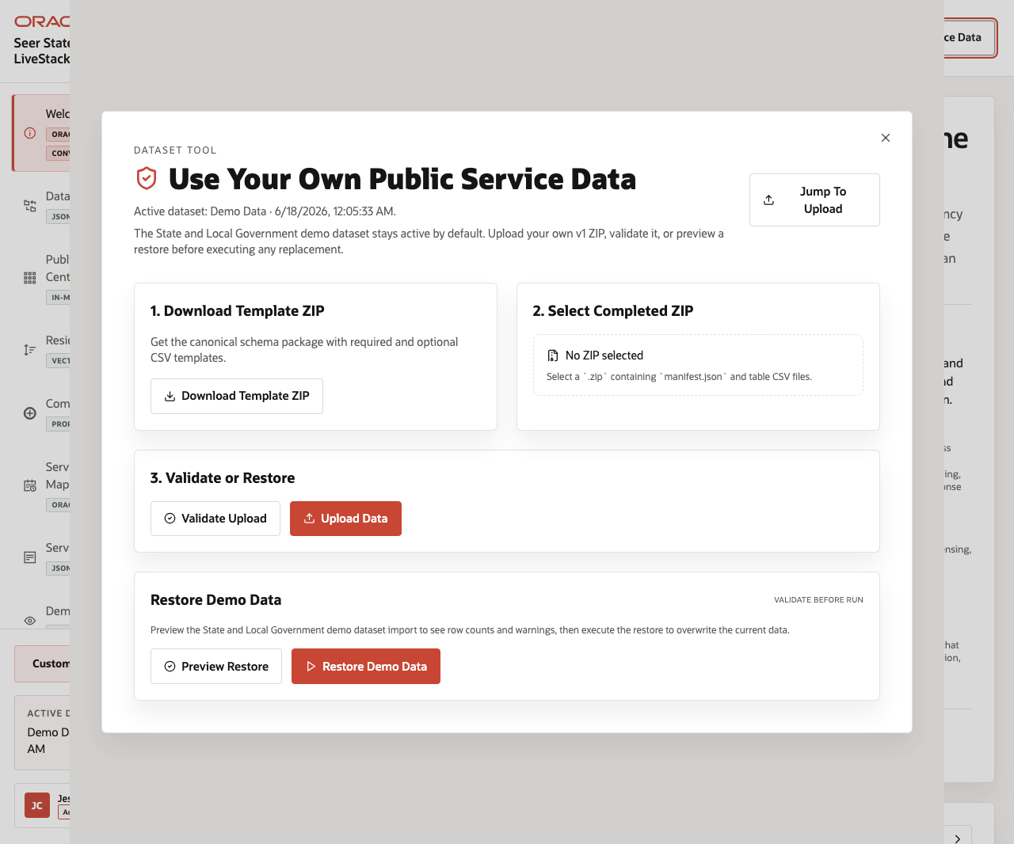
Figure 45. Use Your Own Public Service Data modal with template, upload, validation, and restore controls

Objectives
In this scene, you will learn how to open the dataset manager, review the template and upload workflow, and restore the seeded demo data when needed.

Task 1: Open the dataset tool
Perform the following set of steps to show where users can manage datasets and to reinforce the key safety rule: use only synthetic or anonymized public-sector data.
1. From any application scene, click Use Your Own Public Service Data in the top bar.
2. Review the modal title and active dataset line.
3. Confirm that the modal explains the guided path for loading data or continuing with the current demo dataset.
4. Review the main sections for template download, completed ZIP selection, validation, upload, and restore demo data.
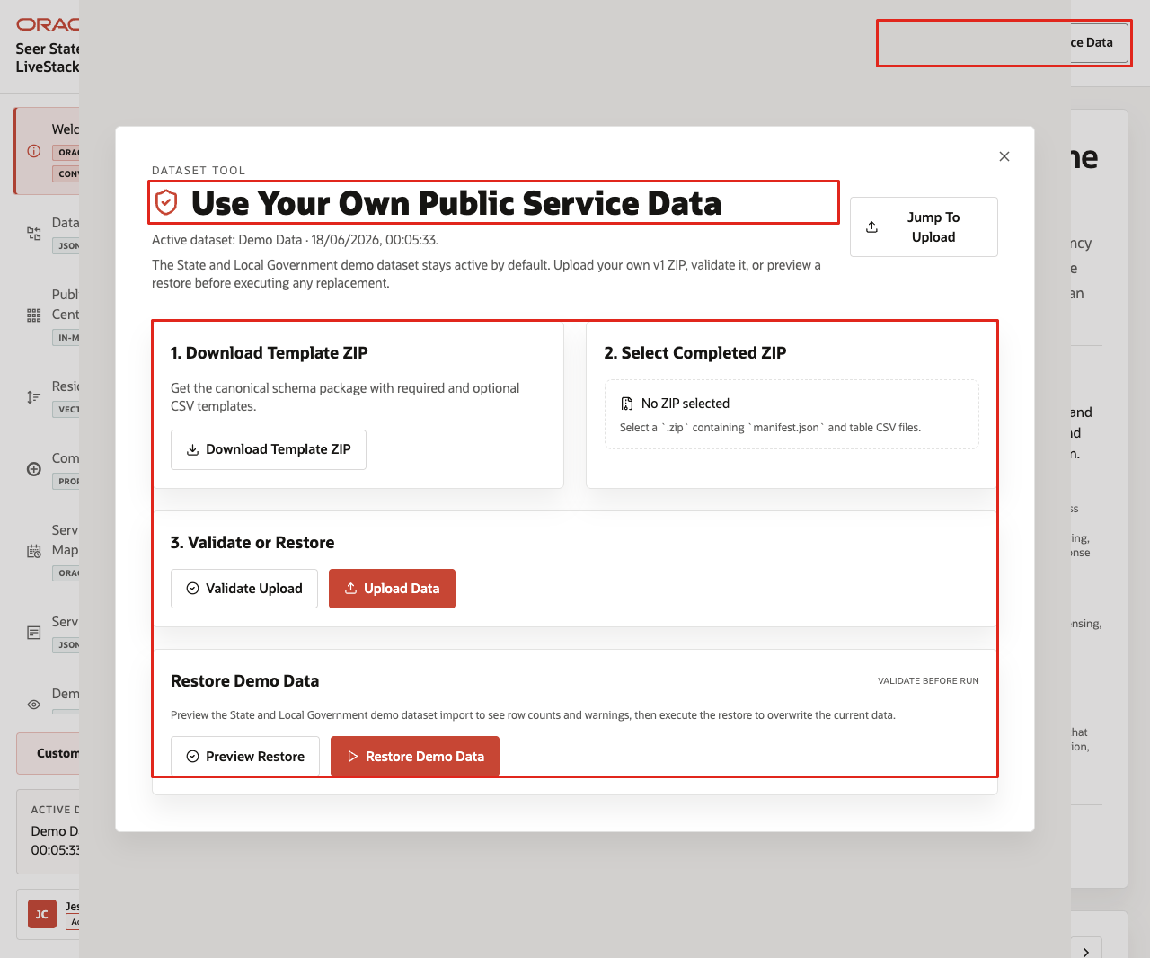
Figure 46. Use Your Own Public Service Data top-bar control and modal
In the current demo, the modal shows the active dataset as Demo Data and provides a workflow for a ZIP package containing a manifest and table CSV files.
Note: Use only synthetic or anonymized public-sector data in a demo environment.

Task 2: Review the template and upload workflow
Perform the following set of steps to show how custom datasets stay repeatable. The template defines the expected structure, validation checks the completed ZIP, and upload remains a deliberate action.
1. Click Download Template ZIP to download the canonical schema package.
2. Review Select Completed ZIP. The control expects a .zip containing a manifest and table CSV files.
3. Review the Validate Upload and Upload Data actions.
4. Explain that validation should run before data replacement.
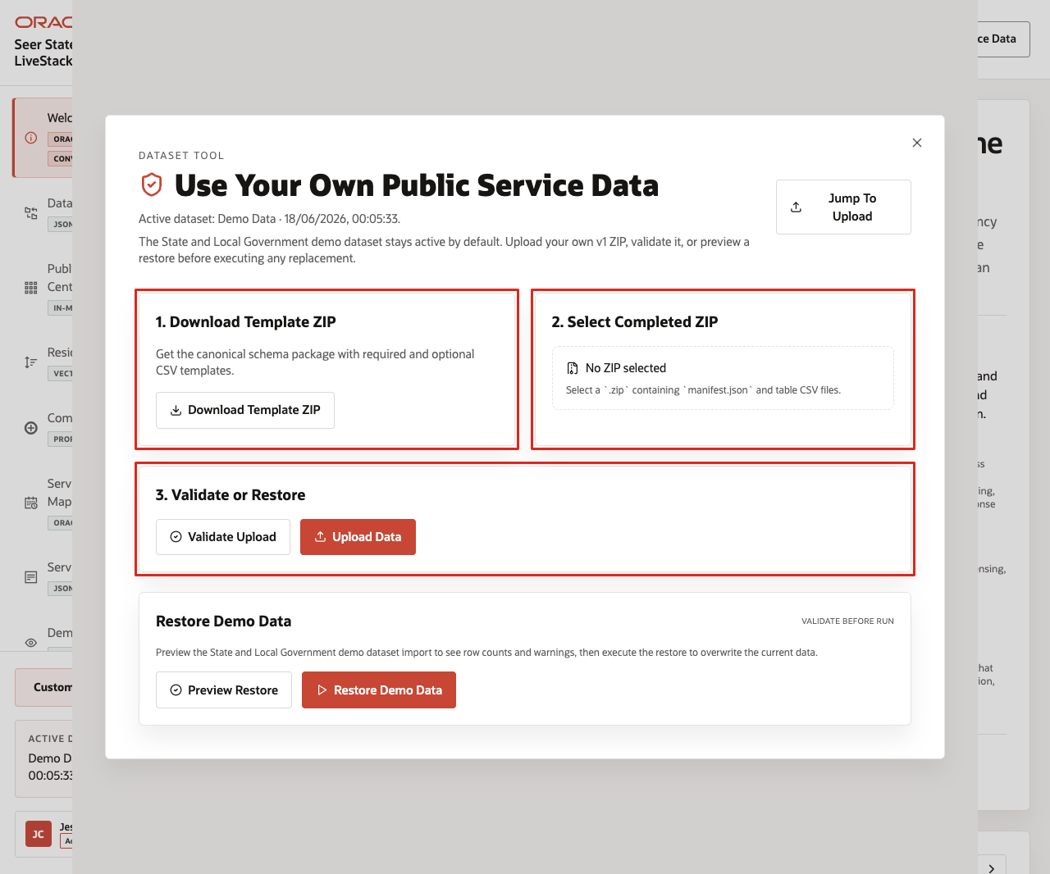
Figure 47. Dataset template download, ZIP selection, validate, and upload controls
This workflow keeps custom demos repeatable and safe: the template defines the structure, validation checks the package, upload is explicit, and seeded data remains available for reset.

Task 3: Preview or restore the seeded dataset
Perform the following set of steps to return the demo to a known-good baseline after testing custom synthetic or anonymized data.
1. In the restore section, click Preview Restore.
2. Review the validation status shown by the preview.
3. If you need to return the demo to the seeded baseline, click Restore Demo Data after the successful preview.
4. Close the dataset manager when finished.
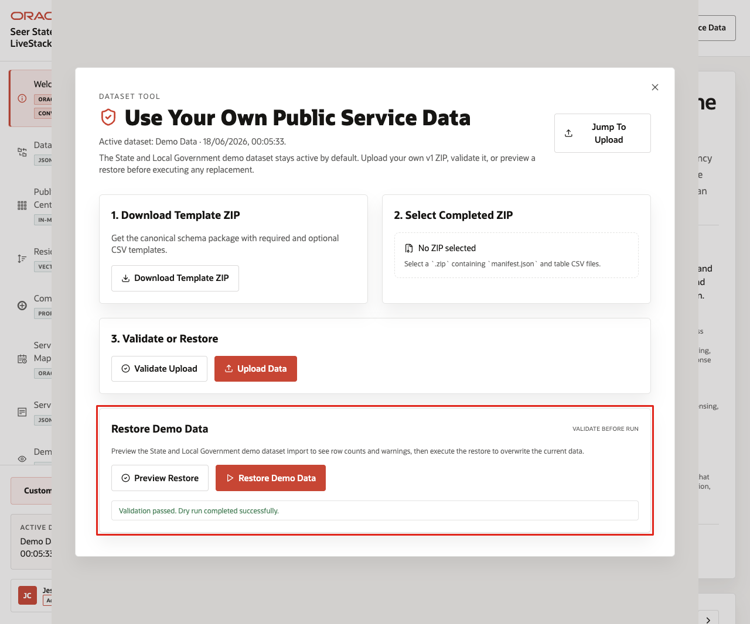
Figure 48. Preview Restore, restore demo data, and validation result
Use this scene to explain the operating guardrail: teams can bring synthetic or anonymized data into the LiveStack, but the seeded dataset remains available as a known baseline.
You can move to the download lab when you want to run the State and Local Government LiveStack locally.

Credits & Build Notes
- Author - Oracle LiveLabs Team
- Last Updated By/Date - Oracle LiveLabs Team, 2026-06-17

Take It Home: Run LiveStack with Podman Compose

Introduction
This lab shows how to run the portable State and Local Government LiveStack package in your own environment using Podman Compose.
This guide is intended for technical users who can install Podman and run terminal commands. If you are new to containers, complete the Podman readiness checks before starting. If any readiness check fails, ask your workshop facilitator or system administrator for help before continuing.
Estimated Time: 30 minutes for a local run, or 45 minutes when deploying to an OCI Compute VM.

Objectives
In this lab, you will:
- Download the portable State and Local Government LiveStack package.
- Confirm that Podman and Podman Compose are ready.
- Extract the package into a clean local working directory.
- Create a local runtime environment file from .env.example.
- Configure proxy settings only when your network requires them.
- Start Oracle Database, ORDS, Ollama, and the application with Podman Compose.
- Validate the application health endpoint and open the local LiveStack.
- Troubleshoot common startup, port, proxy, and first-run issues.
- Optionally deploy the same LiveStack package on an OCI Compute VM.
- Stop the stack cleanly when the demo is complete.

Before you begin
Before starting, confirm that you have:
- Podman installed.
- Podman Compose support available.
- On macOS or Windows, Podman Desktop is recommended.
- On Linux, confirm that either podman compose version or podman-compose version works.
- A running Podman machine on macOS or Windows.
- Terminal access:
- Terminal on macOS or Linux.
- PowerShell on Windows.
- Internet access to pull container images and download required application or model assets.
- Enough local resources for database and model containers.
- Recommended minimum: 8 CPU available for containers.
- Recommended minimum: 16 GB RAM available for containers.
- Recommended minimum: 150 GB free disk space.
- Use larger limits if your package includes larger Ollama models or additional data.
- The required local application port available:
- 8505 for the LiveStack application.

New to Podman?
Podman is the local container runtime used by this LiveStack package. Podman Compose reads the compose.yml file and starts the required services together, including Oracle Database, ORDS, Ollama, and the LiveStack application.
If you are new to Podman, complete these checks before starting the lab.

1. Confirm Podman is installed
podman --version
Expected result:
- The command prints a Podman version.

2. Confirm compose support is available
podman compose version
If that command does not work, try:
podman-compose version
Expected result:
- One of the commands prints a compose version.

3. Start the Podman machine on macOS or Windows
Podman on macOS and Windows runs containers inside a lightweight Linux virtual machine. Start it before running the stack.
podman machine start
If the machine has not been created yet, create it first:
podman machine init
podman machine start
Expected result:
- The Podman machine starts successfully.

4. Run a quick container test
podman run --rm hello-world
Expected result:
- Podman pulls a small test image and prints a success message.
If this test fails, fix Podman setup before continuing with LiveStack.

Task 1: Download the portable package
1. Download the State and Local Government LiveStack package using this link (https://objectstorage.us-ashburn-1.oraclecloud.com/p/4Au3jJ-t8Wtw3LWyYsDMqQk2FdlXDvXCb1MYRS0J6P4QS-GCrv2YNOolWdtFMLZq/n/c4u04/b/livelabsfiles/o/livestack/livestack-sled.zip).
2. Save or rename the file as livestack-sled.zip.
Expected result:
- You have livestack-sled.zip available on your machine.

Task 2: Prepare the working directory
Do not extract or run the stack from your Downloads folder. Create a new empty working directory first. The package extracts its files into the current folder, so a clean directory keeps the LiveStack contents organized and avoids Podman issues caused by working from Downloads.

For macOS or Linux
1. Open a terminal.
2. Create a new working directory outside of Downloads.
mkdir -p ~/livestack-sled
3. Move into the new working directory.
cd ~/livestack-sled
4. Move the downloaded package from Downloads into this directory.
mv ~/Downloads/livestack-sled.zip .
5. Extract the package.
unzip livestack-sled.zip
6. Move into the extracted State and Local Government LiveStack folder.
cd sled
7. Confirm that you are in the directory that contains the compose file.
ls
Expected result:
- You see compose.yml or compose.yaml in the current directory.
8. Create or refresh the runtime environment file.
cp .env.example .env

For Windows
1. Open PowerShell.
2. Create a new working directory outside of Downloads.
New-Item -ItemType Directory -Force -Path "$HOME\livestack-sled" | Out-Null
3. Move into the new working directory.
Set-Location "$HOME\livestack-sled"
4. Move the downloaded package from Downloads into this directory.
Move-Item "$HOME\Downloads\livestack-sled.zip" .
5. Extract the package.
tar -xf .\livestack-sled.zip
6. Move into the extracted State and Local Government LiveStack application folder.
Set-Location .\sled
7. Confirm that you are in the directory that contains the compose file.
Get-ChildItem
Expected result:
- You see compose.yml or compose.yaml in the current directory.
8. Create or refresh the runtime environment file.
Copy-Item .env.example .env -Force
Expected result:
- You are in a clean working directory outside Downloads.
- The extracted sled package contains compose.yml or compose.yaml, .env.example, application source files, database setup files, and supporting scripts.
- You created a local .env file from .env.example.

Task 3: Configure proxy settings, if your network requires them
Most home, cloud VM, and unrestricted corporate networks do not need this step. Skip this task when your network allows direct access to container registries, npm, Object Storage, and Ollama model downloads.
1. If your network requires a proxy, configure the proxy in Podman or Podman Desktop before starting the stack. Image pulls happen before the compose containers exist, so Podman itself must be able to reach external registries.
2. Open .env and add proxy values if your environment requires them.
HTTP_PROXY=http://proxy.example.com:8080
HTTPS_PROXY=http://proxy.example.com:8080
http_proxy=http://proxy.example.com:8080
https_proxy=http://proxy.example.com:8080
3. Keep local service names in NO_PROXY and no_proxy.
NO_PROXY=localhost,127.0.0.1,::1,db,ords,ollama,app,host.containers.internal
no_proxy=localhost,127.0.0.1,::1,db,ords,ollama,app,host.containers.internal
Expected result:
- Podman can pull external images through the network proxy when one is required.
- Local compose services still talk to db, ords, ollama, and app directly on the internal Podman network.

Task 4: Start the LiveStack with Podman Compose
1. If you are using Podman on macOS or Windows and your Podman machine is not already running, start it now.
podman machine start
2. Confirm that you are in the directory that contains the compose file.
ls compose.yml compose.yaml 2>/dev/null
On Windows PowerShell, use:
Get-ChildItem compose.yml,compose.yaml -ErrorAction SilentlyContinue
3. Start all services.
podman compose up -d --build
If your environment uses the standalone podman-compose command, use:
podman-compose up -d --build
4. Watch the service state.
podman compose ps
If your environment uses the standalone podman-compose command, use:
podman-compose ps
Expected result:
- db, ords, ollama, and app move toward a healthy state.
- The initialization containers complete successfully.
- The application listens on the host port defined by the LiveStack package.

Task 5: Understand first-run downloads
On a clean install, the first startup can take several minutes. The stack pulls container images, installs application dependencies, downloads and warms the configured Ollama models, and loads the ONNX embedding model used by Oracle vector search when the package includes one.
To avoid downloading the ONNX model at first run, place all_MiniLM_L12_v2.onnx in db/data/onnx/ before starting the stack. The database bootstrap uses the packaged file before falling back to the configured ONNX_MODEL_URL.
Expected result:
- First-run startup time is expected to be longer than later restarts.
- Subsequent starts reuse the Podman volumes for Oracle data and Ollama models unless you remove the volumes.

Task 6: Validate health and open the application
1. Check the application health endpoint.
curl http://localhost:8505/api/health
2. Open the LiveStack UI in a browser.
open http://localhost:8505
3. If you are not on macOS, open this URL manually in your browser:
http://localhost:8505
Expected result:
- The health check returns a healthy JSON response after Oracle is ready.
- The browser opens the LiveStack locally.

Task 7: Stop the stack when finished
1. Stop and remove running containers while preserving volumes.
podman compose down
If your environment uses the standalone podman-compose command, use:
podman-compose down
2. Use this command only when you intentionally want to delete the local Oracle and Ollama volumes for a complete reset.
podman compose down -v
If your environment uses the standalone podman-compose command, use:
podman-compose down -v
Expected result:
- podman compose down stops the local LiveStack cleanly.
- Demo data and downloaded models remain available on the next startup unless you use the explicit volume-removal command.

Troubleshooting
Use this section when the stack does not start, a service is unhealthy, the application does not open, or first startup appears to be slow.

Check service status
podman compose ps
If your environment uses the standalone podman-compose command, use:
podman-compose ps

View service logs
Database logs:
podman compose logs db
ORDS logs:
podman compose logs ords
Ollama logs:
podman compose logs ollama
Application logs:
podman compose logs app
Follow application logs in real time:
podman compose logs -f app
If your environment uses podman-compose, replace podman compose with podman-compose in the commands above.

Port 8505 is already in use
The LiveStack application uses local port 8505. If the application does not start or the browser opens another application, check whether another process is already using that port.
For macOS or Linux:
lsof -i :8505
For Windows PowerShell:
netstat -ano | Select-String ":8505"
Stop the conflicting process or update the compose port mapping if your package supports changing it.

First startup takes a long time
The first run can take several minutes because Podman may need to pull images, install dependencies, download Ollama models, initialize Oracle Database, and load model files. Later starts are usually faster because container images and volumes are reused.
Check progress with:
podman compose logs -f db
podman compose logs -f ollama
podman compose logs -f app

Image pulls fail
If image pulls fail, check these items:
- Confirm that your machine has internet access.
- Confirm that Podman can pull a small public test image with podman run --rm hello-world.
- If your network requires a proxy, configure the proxy in Podman or Podman Desktop and update .env as described in Task 3.
- If you are on a corporate network or VPN, ask your network administrator whether container registry access is allowed.

Health check is not ready
If curl http://localhost:8505/api/health does not return a healthy response immediately, wait for the database and application startup to finish, then try again.
Check logs with:
podman compose logs db
podman compose logs app

Reset the stack
Stop containers but keep data and downloaded models:
podman compose down
Completely reset local data and downloaded models:
podman compose down -v
Use the volume-removal command only when you intentionally want a clean reset.

Task 8: Deploy the LiveStack on an OCI Compute VM with Podman (Optional)
Use this task when you want to run the LiveStack on an OCI Compute VM instead of your laptop.
Prerequisites:
- A created Virtual Cloud Network (VCN).
- Security rules configured for the VM subnet.
- Ingress to TCP port 8505 allowed from your approved client CIDR.
- An OCI Compute VM running Oracle Linux 9.
- SSH access to the VM, using the private key paired with the public key added during VM creation.
- The State and Local Government LiveStack package download URL for your workshop.
1. SSH into the OCI VM from your local terminal.
ssh -i ~/.ssh/<private-key-file> opc@<vm-public-ip>
2. Update the VM and install Podman plus common download tools.
sudo dnf update -y
sudo dnf install -y container-tools podman-docker unzip curl dnf-plugins-core
podman --version
3. Install and enable Podman Compose support on Oracle Linux 9.
sudo dnf install -y oracle-epel-release-el9
sudo dnf config-manager --enable ol9_developer_EPEL
sudo dnf install -y podman-compose
podman compose version || podman-compose version
4. If the VM firewall is running, allow the LiveStack application port.
if sudo systemctl is-active --quiet firewalld; then
sudo firewall-cmd --permanent --add-port=8505/tcp
sudo firewall-cmd --reload
fi
5. Create a working directory on the VM.
mkdir -p ~/livestack-sled
cd ~/livestack-sled
6. Download the LiveStack package to the VM.
curl -L -o livestack-sled.zip "https://objectstorage.us-ashburn-1.oraclecloud.com/p/4Au3jJ-t8Wtw3LWyYsDMqQk2FdlXDvXCb1MYRS0J6P4QS-GCrv2YNOolWdtFMLZq/n/c4u04/b/livelabsfiles/o/livestack/livestack-sled.zip"
7. Extract the package and move into the directory that contains the compose file.
unzip livestack-sled.zip
cd sled
8. Create the runtime environment file.
cp .env.example .env
9. Confirm that the compose file exposes the application on port 8505.
grep -n "8505" compose.yml compose.yaml 2>/dev/null
The application should be exposed on port 8505. To reach it from your browser, both the OCI subnet security rules and the VM firewall must allow inbound TCP traffic on port 8505 from your approved client CIDR.
10. Start the LiveStack with Podman Compose.
podman compose up -d --build || podman-compose up -d --build
11. Watch the service state from the VM.
podman compose ps || podman-compose ps
12. Validate the application health endpoint from the VM.
curl http://localhost:8505/api/health
13. Open the public LiveStack URL from your browser.
http://<vm-public-ip>:8505
Expected result:
- The OCI VM is running the LiveStack with Podman Compose.
- The application health endpoint responds locally on the VM.
- The LiveStack UI is reachable from your browser at http://<vm-public-ip>:8505.

Why this matters
A portable LiveStack runbook turns this guide into something teams can reproduce instead of just read. By shipping the State and Local Government application as a Podman Compose package with a clear startup flow, you reduce environment drift, make scene validation repeatable, and give agency teams a practical way to explore the same Oracle-backed experience on macOS, Linux, Windows, and OCI Compute.
This guide is self-service for technical users who can install Podman and run terminal commands. Users who are new to containers should complete the Podman readiness checks before starting and ask for help if those checks fail.

Credits & Build Notes
- Author - LiveLabs Team
- Last Updated By/Date - LiveLabs Team, 2026-06-18
Connect with us
Call +1.800.ORACLE1 or visit oracle.com. Outside North America, find your local office at: oracle.com/contact.
blogs.oracle.com facebook.com/oracle twitter.com/oracle
Copyright © 2026, Oracle and/or its affiliates. This document is provided for information purposes only, and the contents hereof are subject to change without notice. This document is not warranted to be error-free, nor subject to any other warranties or conditions, whether expressed orally or implied in law, including implied warranties and conditions of merchantability or fitness for a particular purpose. We specifically disclaim any liability with respect to this document, and no contractual obligations are formed either directly or indirectly by this document. This document may not be reproduced or transmitted in any form or by any means, electronic or mechanical, for any purpose, without our prior written permission.
Oracle, Java, MySQL, and NetSuite are registered trademarks of Oracle and/or its affiliates. Other names may be trademarks of their respective owners.

