Seer Higher Education Student Success LiveStack Guide

Introduction
Higher education institutions are navigating their most demanding operational environment in decades. Declining traditional-age enrollment, FAFSA simplification disruptions, escalating FERPA and Title IV compliance requirements, and rising student service expectations are forcing teams to make faster, more confident decisions while the data they need remains fragmented across dozens of systems. The Seer Higher Education LiveStack shows how an institution can bring those signals together, understand where students need help, and move from insight to action with more confidence than peer institutions still relying on disconnected point solutions.
This runbook supports the Seer Higher Education Student Success LiveStack Demo. The demo shows how Oracle AI Database 26ai can help higher education teams bring those workloads together on one connected data foundation. Instead of splitting student records, service requests, JSON documents, support networks, campus geography, vector search, machine learning, natural-language SQL, and AI agent workflows across separate systems, the LiveStack shows how those capabilities can work against the same governed Oracle data model.
In the demo, Seer Higher Education uses Oracle AI Database to connect students, academic programs, campus services, advising requests, community and alumni signals, support networks, capacity, predictive analytics, conversational data access, and agent-assisted operations. The demo follows Campus Shuttle Pass as the opening service-demand thread: student demand is visible in the command center, signal evidence explains why, service coverage shows where capacity is available, and analytics, natural-language SQL, and AI agents help teams act from the same governed student-success foundation.
Estimated Demo Time: 90 minutes
Each scene is designed to take between 5 and 10 minutes.
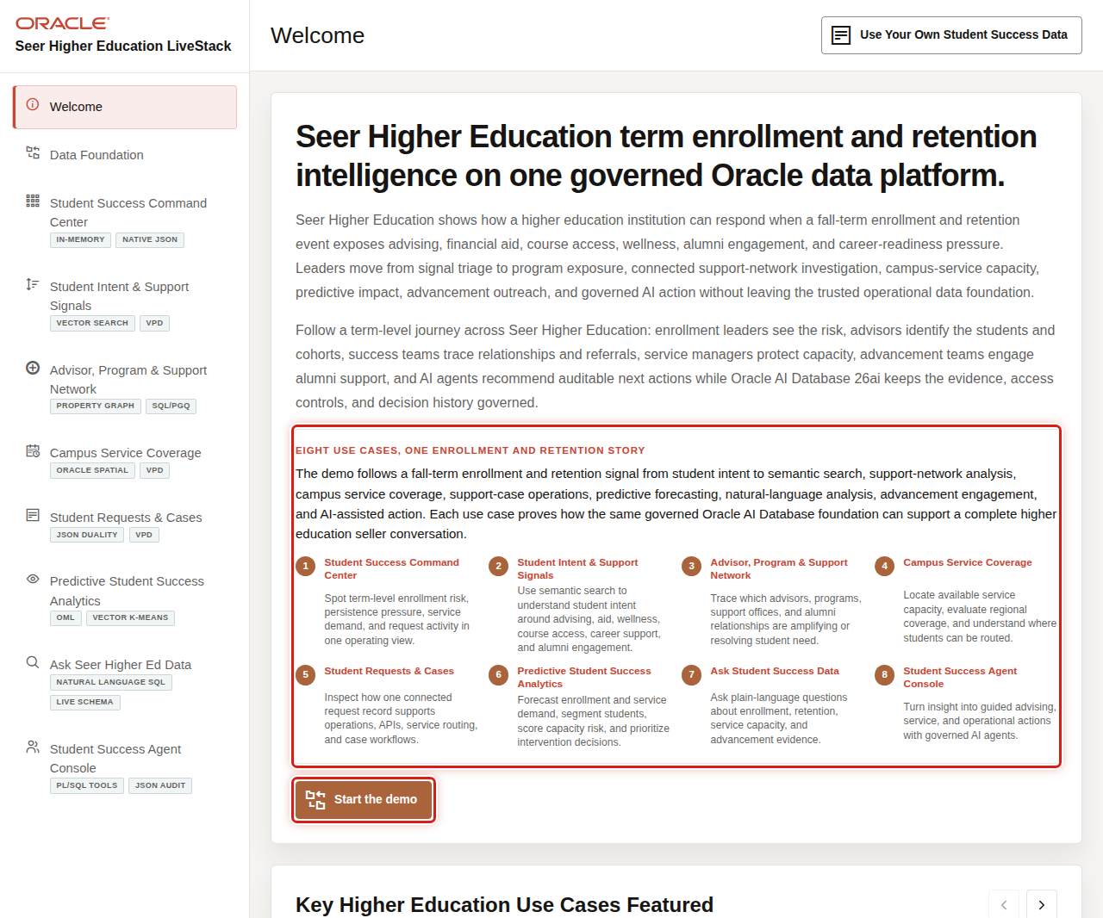

Objectives
In this LiveStack demo, you will see how a college, university, community college, public system, private institution, online learning provider, or student success team can use connected data and AI-assisted workflows to improve enrollment, retention, advising, student support, service access, and institutional performance.

Prerequisites
Before you begin, confirm that you can open the running Seer Higher Education LiveStack in a modern browser. No database or coding knowledge is required to follow the business workflow.

Demo Flow
- Scene 1: Welcome and Demo Orientation.
- Scene 2: Data Foundation.
- Scene 3: Student Success Command Center.
- Scene 4: Student Intent and Support Signals.
- Scene 5: Advisor, Program, and Support Network.
- Scene 6: Campus Service Coverage.
- Scene 7: Student Requests and Cases.
- Scene 8: Predictive Student Success Analytics.
- Scene 9: Ask Seer Higher Ed Data.
- Scene 10: Student Success Agent Console.

Learn More
- Oracle AI Database 26ai documentation
- Oracle AI Agent Memory
- Oracle AI Vector Search
- Oracle Spatial and Graph documentation: Oracle Spatial and Oracle Property Graph
- Oracle Machine Learning for SQL documentation
- Oracle REST Data Services documentation
- Oracle LiveLabs catalog

Credits & Build Notes
- Author - Oracle LiveLabs Team
- Last Updated By/Date - Oracle LiveLabs Team, 2026-05-29

Scene 1 Welcome and Demo Orientation

Introduction
Welcome and Demo Orientation gives the seller a clean opening story for Seer Higher Education. It frames the demo as a connected student lifecycle journey, not a collection of separate database features.
Higher education leaders are under pressure on every front: enrollment yield is declining as the pipeline of traditional-age students shrinks, persistence rates are under scrutiny from accreditors and boards, scarce student services are being stretched across growing at-risk populations, and compliance risk from FERPA and Title IV is intensifying. Leaders need trusted, governed evidence not another dashboard that requires a data team to validate before anyone will act on it. The welcome page gives the presenter a guided way to introduce that journey before drilling into the operational scenes.
Oracle AI Database helps by bringing the operational data, signal data, graph relationships, spatial service coverage, vector search, machine learning, natural-language SQL, and agent workflows into one governed data foundation. The seller can start with the business challenge and then show how each scene contributes evidence.
Estimated Time: 5 minutes

Objectives
In this scene, you will learn how to open the demo, frame the institutional story, and orient the audience to the student lifecycle use cases.

Task 1: Start with the student-success story
Use the welcome page as the opening hook. It positions Seer Higher Education as an institution that wants to connect enrollment, retention, advising, service access, and advancement evidence on one trusted platform.
- Review the Welcome page.
- Point out the student lifecycle framing across the use-case cards.
- Click Start the demo when you are ready to move into the command center.

Task 2: Review the use-case carousel
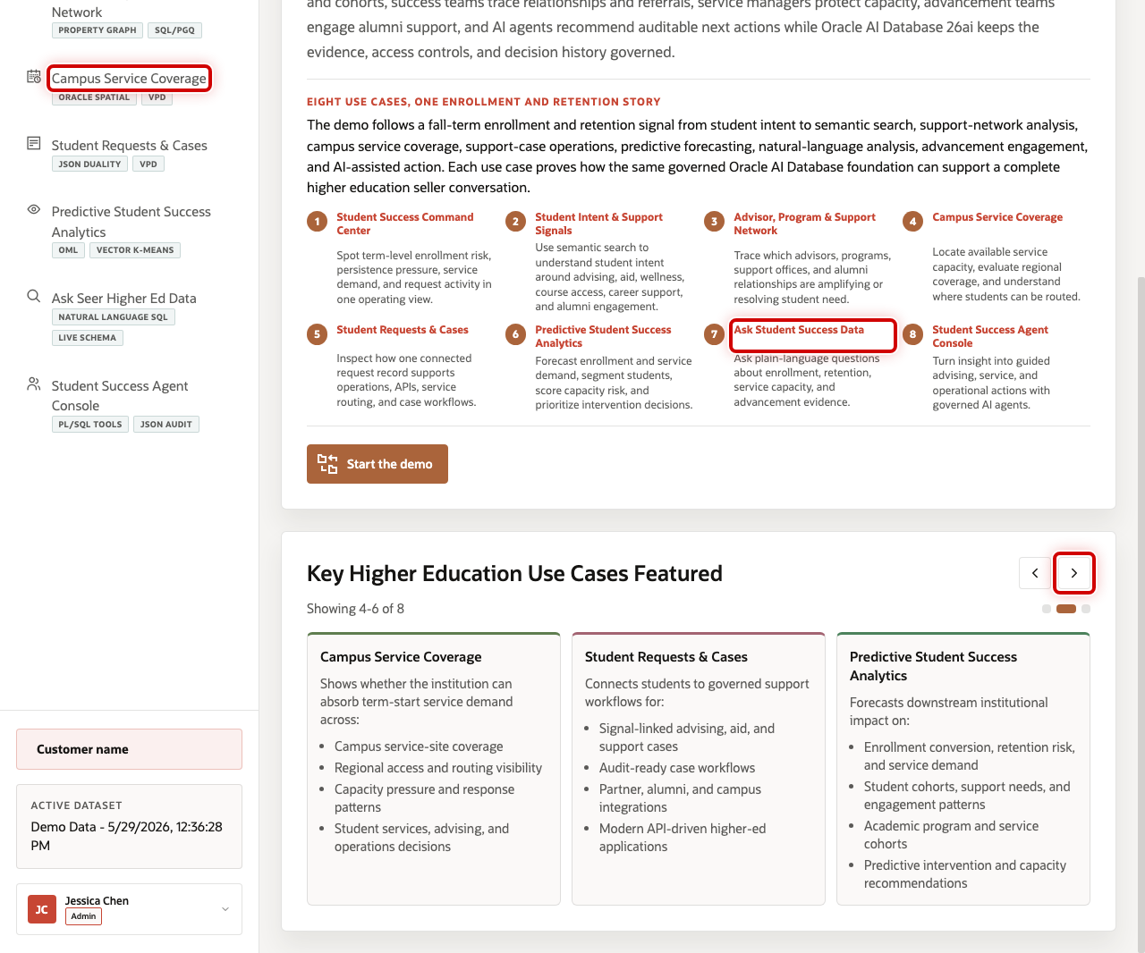
Use the carousel to preview the full demo journey. The first group introduces the command center, student signals, and support network. The next group connects campus coverage, request evidence, predictive analytics, Ask Data, and agents.
- Click the carousel arrow to review the next group of use cases.
- Highlight Campus Service Coverage as the access and capacity scene.
- Highlight Ask Student Success Data as the governed natural-language analytics scene.
- Explain that the rest of the runbook follows the same connected student-success journey.
You can move to the next scene.

Credits & Build Notes
- Author - Oracle LiveLabs Team
- Last Updated By/Date - Oracle LiveLabs Team, 2026-05-29

Scene 2 Data Foundation

Introduction
Data Foundation shows that the demo is backed by a loaded, governed higher education data model. It is the seller's proof point that the application is not running from disconnected fallback screens.
Student-success teams usually work across SIS records, CRM engagement, advising notes, financial aid activity, course access, case management, campus operations, alumni support, and institutional research datasets. Those systems often require reconciliation before leaders trust the result.
Oracle AI Database helps address that challenge by keeping relational data, JSON documents, vector embeddings, graph edges, spatial service coverage, OML models, and agent audit records close to the same governed schema. In the current live dataset, the app shows 60 student services, 5,000 student signals, 3,000 student requests, 5,000 signal vectors, 15,000 semantic matches, and 4 OML models.
Estimated Time: 5 minutes
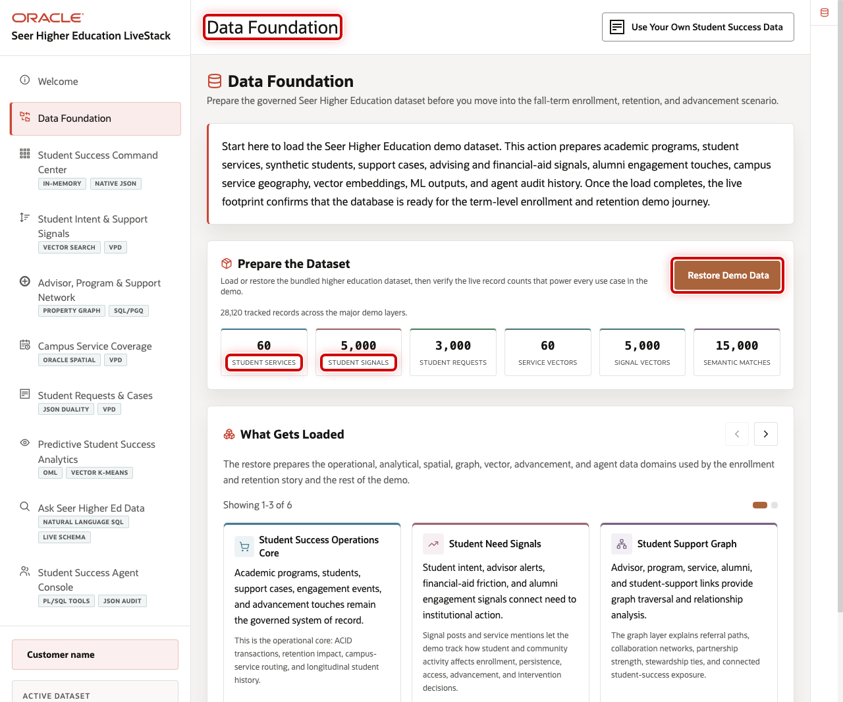

Objectives
In this scene, you will confirm that the demo has valid data loaded and explain how the data foundation supports the rest of the student-success journey.

Task 1: Confirm the loaded data foundation
Use the top of the page to show that the LiveStack is running with valid demo data.
- Click Data Foundation in the sidebar.
- Review the loaded-data metrics for student services, student signals, student requests, vectors, semantic matches, and OML models.
- Use Restore Demo Data only when you need to reset the running demo to a known good dataset.

Task 2: Review the loaded data domains
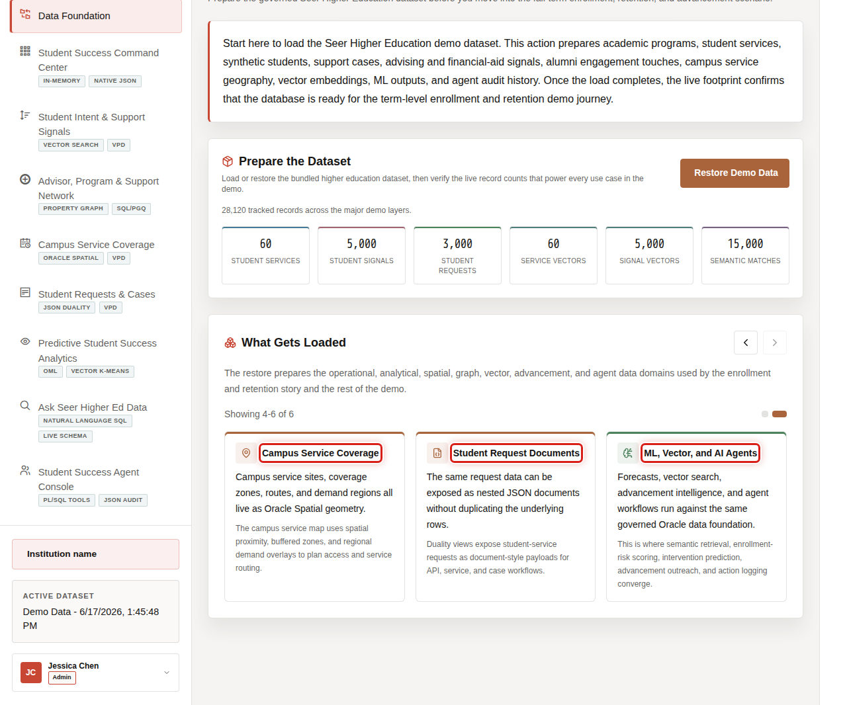
The loaded data domains connect the business story to the physical data model.
- Scroll to Loaded Data Domains.
- Review Student Success Operations Core to explain students, services, requests, cases, and capacity.
- Review the AI and analytics domains to explain vectors, semantic matches, graph connections, OML models, and agent audit data.
- Explain that every later scene uses this same governed data foundation.
You can move to the next scene.

Credits & Build Notes
- Author - Oracle LiveLabs Team
- Last Updated By/Date - Oracle LiveLabs Team, 2026-05-29

Scene 3 Student Success Command Center

Introduction
Student Success Command Center gives enrollment, student success, advising, and operations leaders a clear daily view of the institution. It tracks student requests, service value proxy, urgent signals, high-demand services, and agent actions in one place.
Across the industry, institutions that respond to early signals before a student misses a deadline, drops a course, or disengages consistently achieve stronger retention outcomes. This command center provides enrollment, advising, and operations leaders with a unified daily view of student demand, risk, and service activity, enabling them to act before small issues become long-term retention challenges.
Dashboards like this are difficult to implement when higher education data is split across SIS, CRM, LMS, case-management, advising, social listening, advancement, and analytics systems. Teams often need copied data, ETL jobs, separate search indexes, and reconciliation logic before a dashboard can show a trustworthy view.
Oracle AI Database helps address that challenge by keeping operational, analytical, JSON, in-memory, and AI-ready data close to the same governed data foundation. In this scene, Campus Shuttle Pass gives the seller a concrete opening example: demand is visible at the dashboard level and then traceable down to capacity, student signals, and JSON application shape.
Estimated Time: 10 minutes
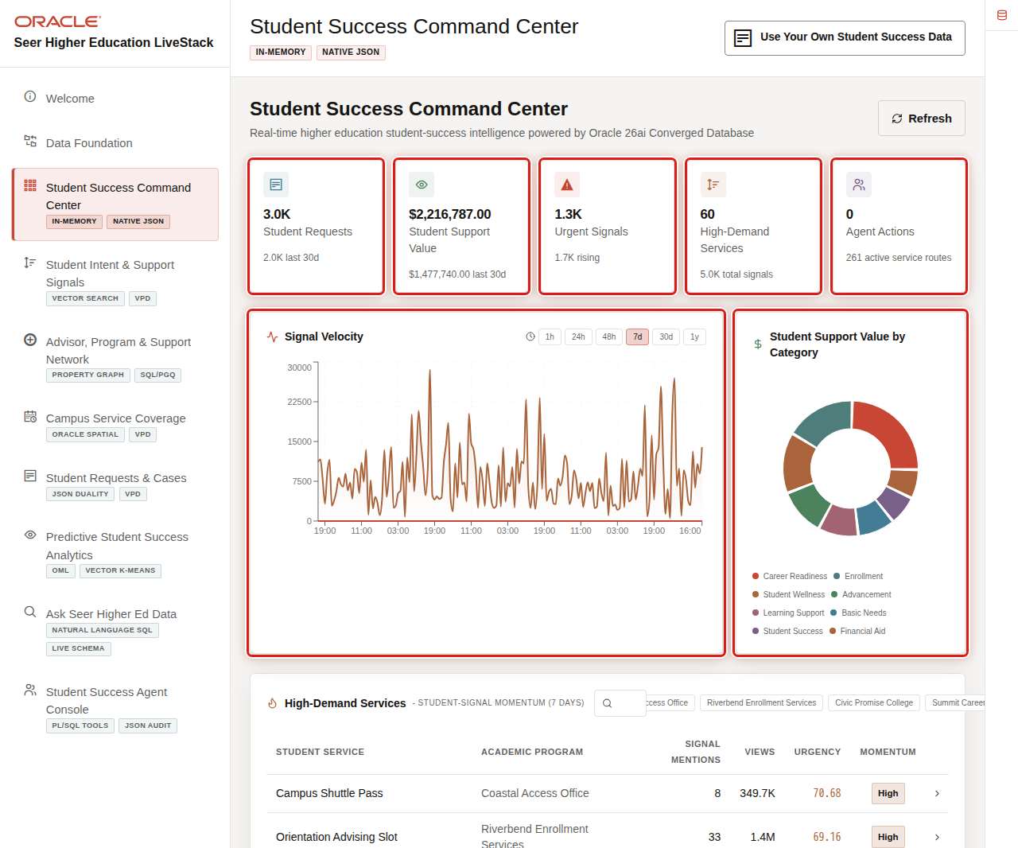

Objectives
In this scene, you will learn what institutional decision the page supports, what evidence the user should inspect, and what action the business may take next.

Task 1: Review the command center dashboard
Use the dashboard as a triage view. In the current demo dataset, the opening KPI row shows 3,000 student requests, about $2.2M in service value proxy, 1,269 urgent signals, 60 high-demand services, and the current agent action count.
- Click Student Success Command Center in the sidebar.
- Review the KPI cards across the top of the page.
- Review Signal Velocity to see how student and community activity changes over time.
- Review Service Value Proxy by Category to see which service categories are carrying institutional demand.

Task 2: Review high-demand services
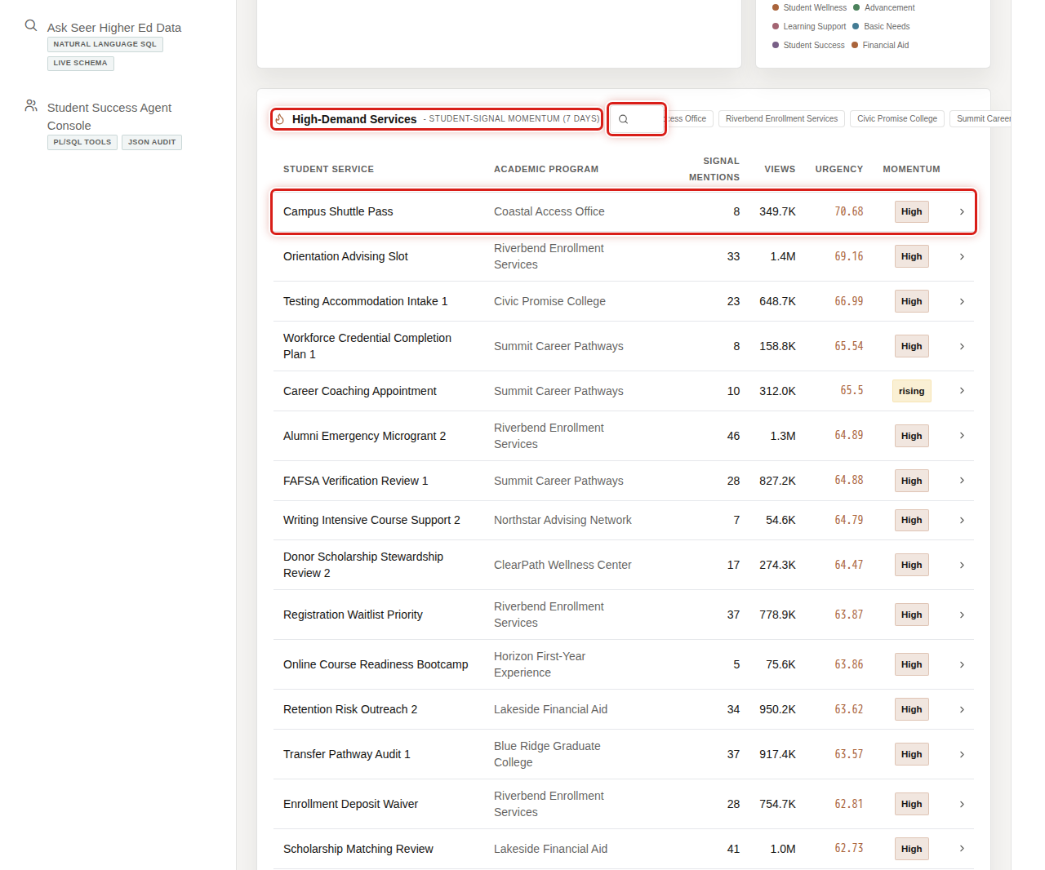
The table helps the user move from dashboard-level signals to service-level evidence. In the current demo dataset, Campus Shuttle Pass appears as a leading student service with 8 recent signal mentions, about 349.7K views, and High peak momentum.
- Scroll to High-Demand Services.
- Review the service rows and the columns for academic program, signal mentions, views, urgency, and momentum.
- Use the search field or program chips if you want to narrow the table.
- Click the Campus Shuttle Pass row.

Task 3: Inspect the service detail modal
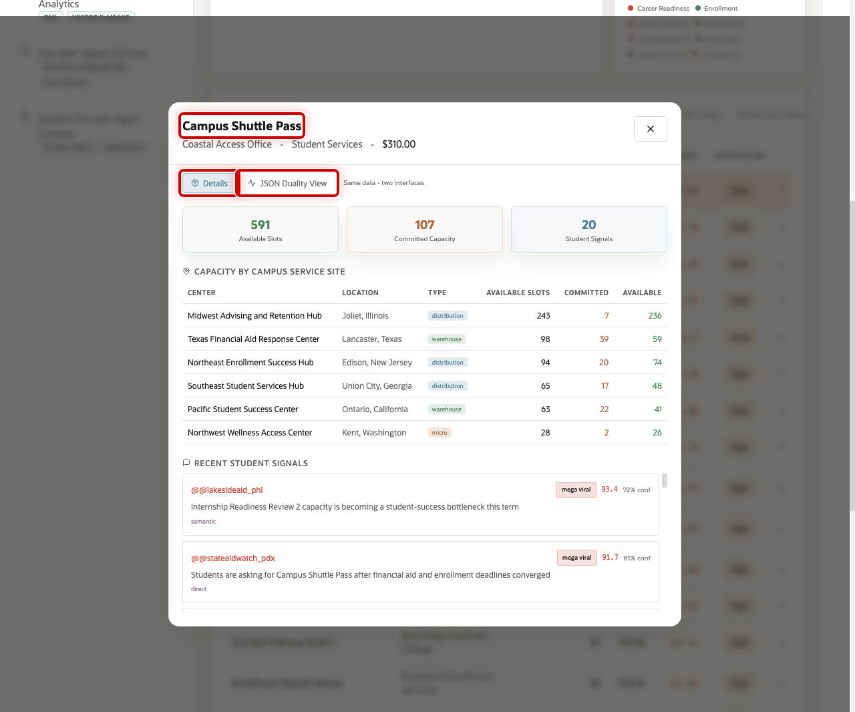
Open the service detail modal to connect student demand with operational readiness. The modal shows 591 available slots, 107 committed capacity, and 20 student signals for Campus Shuttle Pass.
- Review the Details view.
- Review Capacity by Campus Service Site to see where capacity exists.
- Review Recent Student Signals to connect operational demand with student voice and community evidence.

Task 4: Review the JSON Duality View
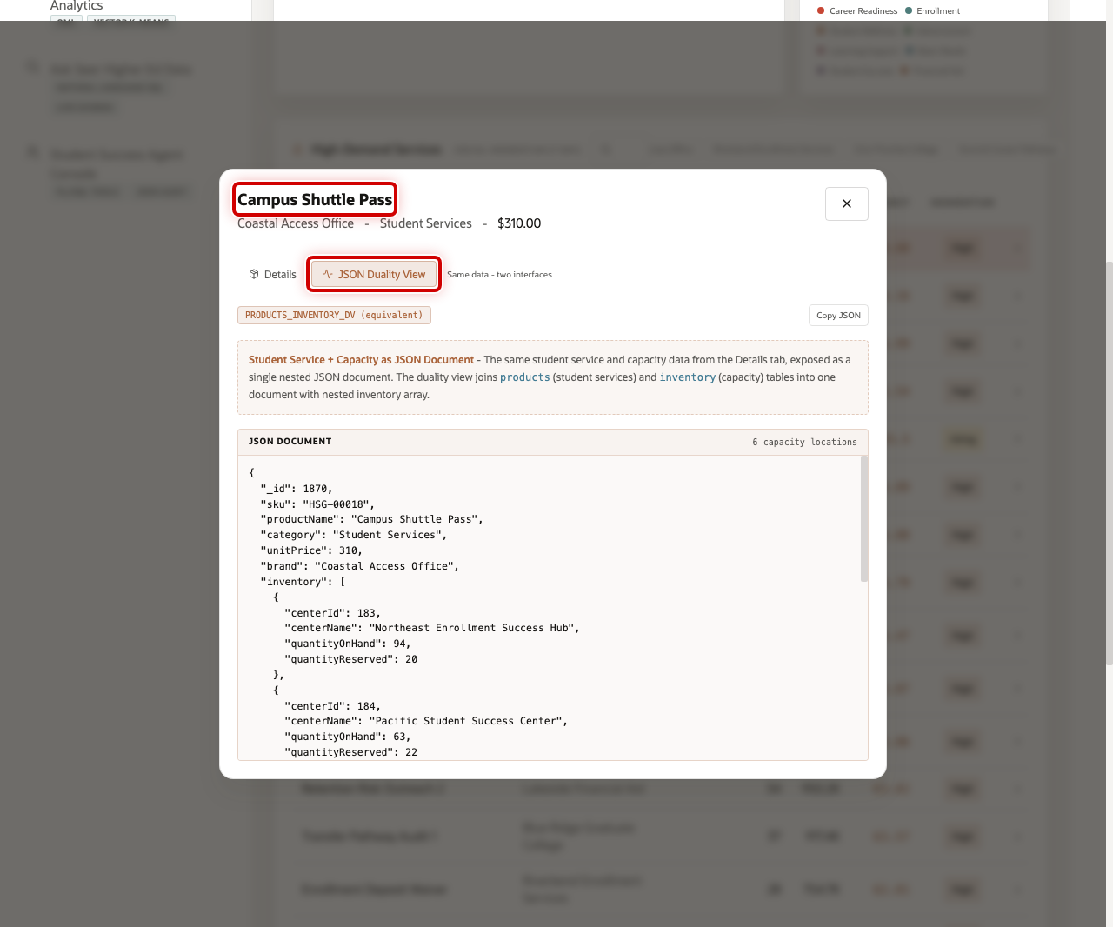
Review the JSON Duality View to show that the same trusted service data can support different users. Business users see service details in the interface, while applications can use the same information as a structured document.
- In the service modal, click JSON Duality View.
- Review the JSON document for the selected service.
- Explain that Oracle JSON Relational Duality lets the application expose document-shaped data over trusted relational tables.
You can move to the next scene.

Credits & Build Notes
- Author - Oracle LiveLabs Team
- Last Updated By/Date - Oracle LiveLabs Team, 2026-05-29

Scene 4 Student Intent and Support Signals

Introduction
Student Intent and Support Signals helps student success, enrollment, advising, financial aid, and engagement teams understand what students and communities are asking for before demand becomes a late intervention.
Students often signal their needs long before they submit a request, open a case, or contact an advisor. Those signals appear across financial aid communities, peer networks, alumni advocacy channels, and other student-driven conversations. When institutions can identify and interpret those signals early, they gain valuable time to intervene. With 5,000 signal posts across the live dataset, this scene shows how semantic search and AI-powered signal monitoring convert unstructured student voice into actionable operational intelligence, enabling student success teams to respond before challenges become escalations.
Oracle AI Database helps address that challenge with vector embeddings, semantic matching, SQL filtering, row-level security, and live signal analytics in the same data platform. The current dataset includes 5,000 student signal posts from realistic higher education sources such as @riverbendfinaid_bos, @firstgenpathways_hou, and @campusbasicneeds_sea.
Estimated Time: 10 minutes
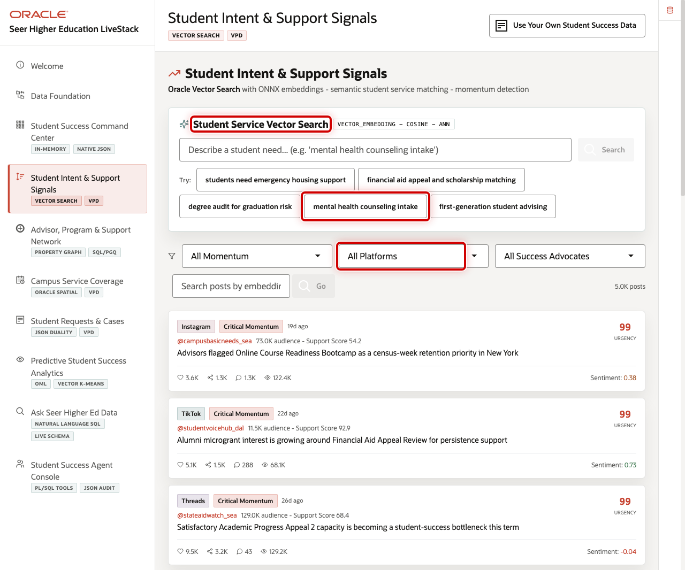

Objectives
In this scene, you will learn how semantic search and signal monitoring help teams detect student needs and connect them to student services.

Task 1: Review the student signal workspace
Use the top of the page to show how a business user can search by need, not by exact keyword.
- Click Student Intent & Support Signals in the sidebar.
- Review Student Service Vector Search.
- Review the example prompts, platform filter, success advocate filter, and feed controls.

Task 2: Search for a student need
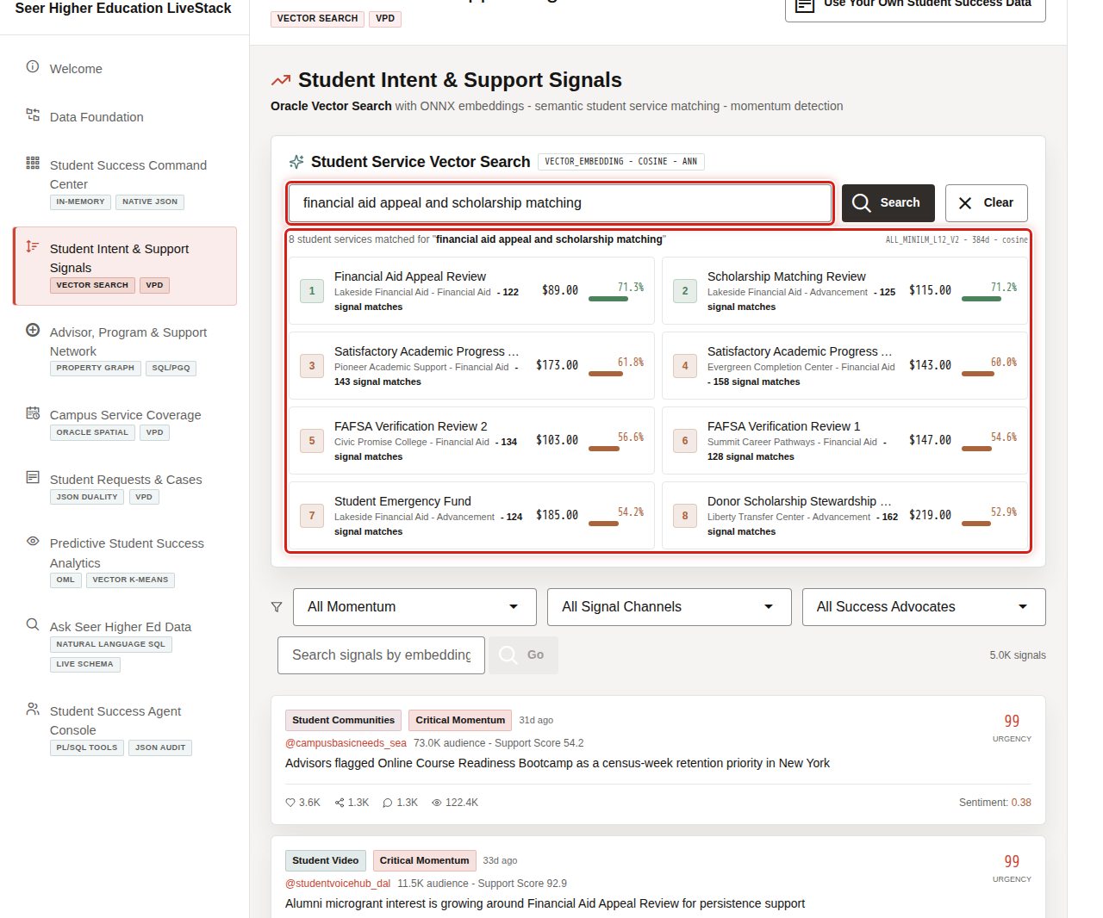
Vector search helps the institution find relevant services even when the user's language does not match exact service names.
- Click financial aid appeal and scholarship matching.
- Review the ranked student service matches.
- Explain that the query is embedded and compared against student service vectors in Oracle AI Database.

Task 3: Review live student signal posts
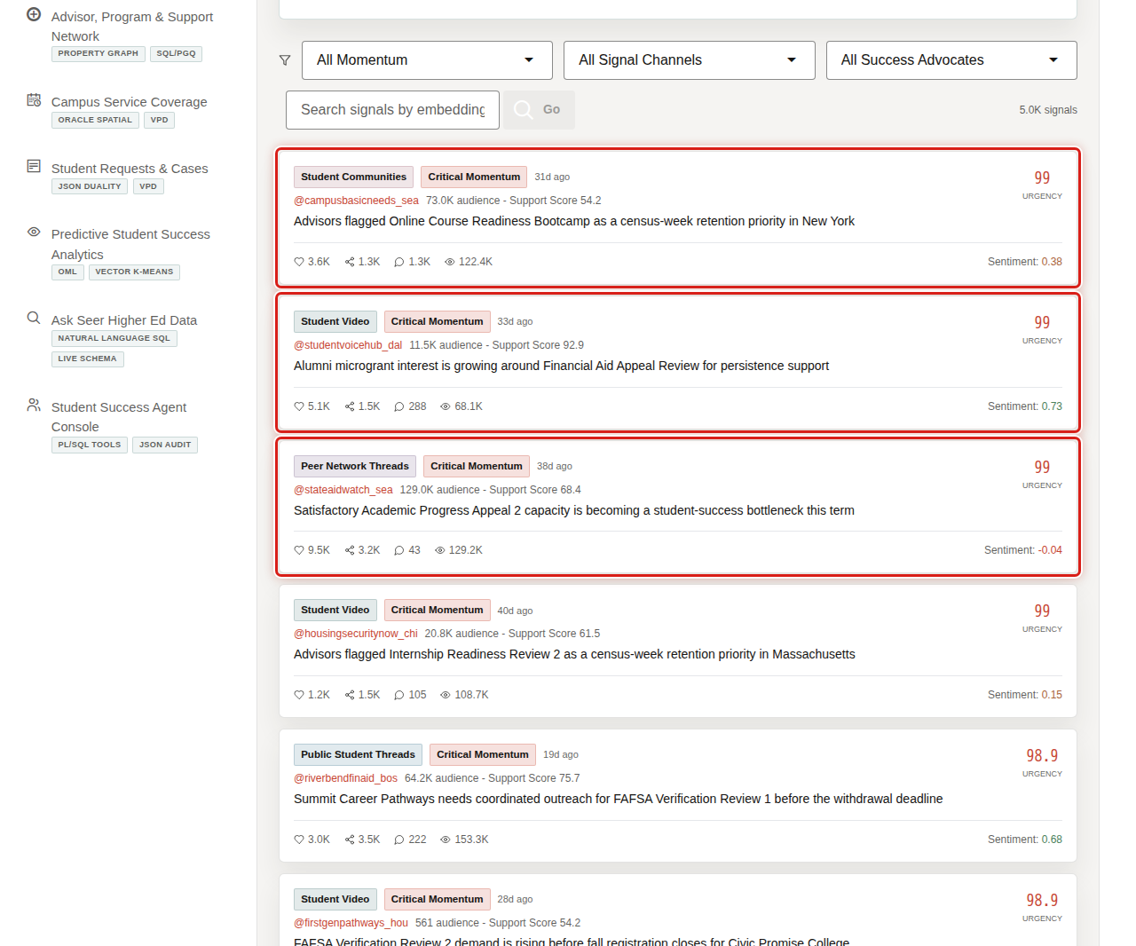
The feed turns student and community activity into operational evidence. It uses an uneven, realistic mix of higher education signal channels such as student communities, student video, campus video, peer network threads, and public student threads while preserving governed source data.
- Scroll to the signal feed.
- Review the signal-channel badges, momentum labels, urgency scores, and advocate handles.
- Focus on the institutional handle pattern, such as @riverbendfinaid_bos, and explain why the channel names are normalized for a governed higher education demo.
- Explain that student signal monitoring becomes useful only when it is tied back to services and interventions.
You can move to the next scene.

Credits & Build Notes
- Author - Oracle LiveLabs Team
- Last Updated By/Date - Oracle LiveLabs Team, 2026-05-29

Scene 5 Advisor, Program, and Support Network

Introduction
Advisor, Program, and Support Network helps the seller show relationship intelligence across advisors, student communities, academic programs, alumni groups, financial aid offices, and community partners.
Higher education interventions rarely move through one system or one team. A retention issue may involve an advisor, a program chair, a first-generation student community, financial aid, basic needs support, and an alumni-funded emergency grant. Institutions need to know who is connected to whom and which relationships can move outreach faster.
Oracle AI Database helps address that challenge with property graph relationships and SQL/PGQ queries over the same governed data foundation. The current live graph includes 3,739 graph nodes, 3,047 graph edges, and 692 academic program relationship links.
Estimated Time: 10 minutes
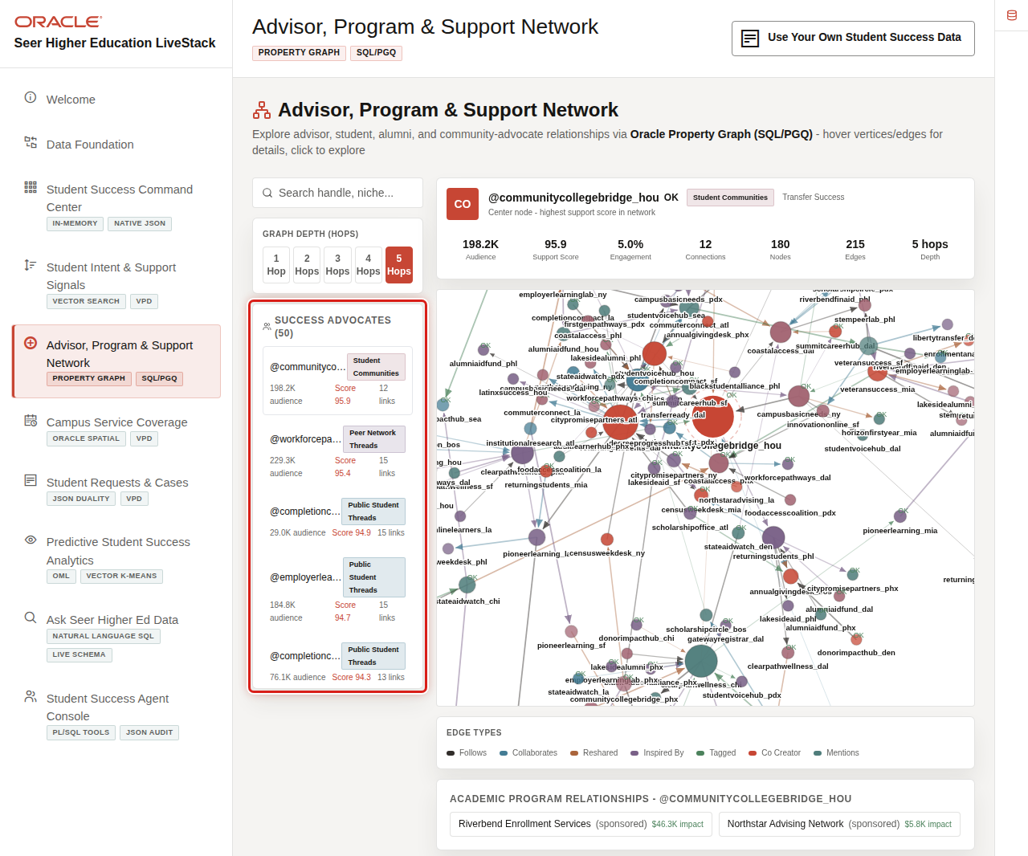

Objectives
In this scene, you will learn how graph analysis helps identify support paths, cross-channel advocates, and program relationships that matter to student success.

Task 1: Explore the support network
Use the network view to explain that student success is a relationship problem as much as a data problem.
- Click Advisor, Program & Support Network in the sidebar.
- Review the Success Advocates list.
- Review the graph visualization and the selected advocate metrics.
- Adjust graph depth if you want to show broader support reach.

Task 2: Review graph query options
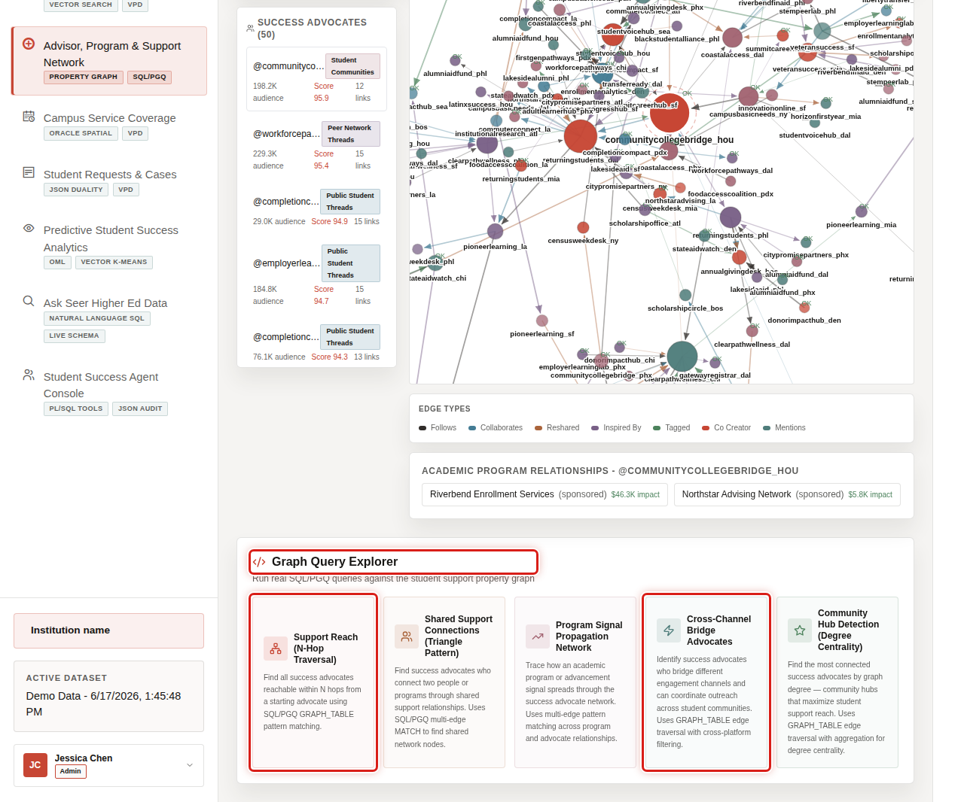
The query explorer turns graph analytics into guided business questions.
- Scroll to Graph Query Explorer.
- Review the available graph query cards.
- Focus on Support Reach (N-Hop) and Cross-Channel Bridge Advocates.
- Explain that SQL/PGQ lets the application query connected support relationships without moving data into a separate graph database.
You can move to the next scene.

Credits & Build Notes
- Author - Oracle LiveLabs Team
- Last Updated By/Date - Oracle LiveLabs Team, 2026-05-29

Scene 6 Campus Service Coverage

Introduction
Campus Service Coverage helps campus operations, advising, access, and student services teams see whether students can reach the right support at the right time.
Institutions must coordinate service sites, online support, advising hubs, financial aid centers, wellness access, and regional student demand. This is difficult when geography, capacity, student demand, and request data are stored in separate tools.
Oracle AI Database helps address that challenge with Oracle Spatial, service-site geometry, demand regions, service zones, H3 density grids, and capacity data in the same database that supports the rest of the student-success workflow.
Estimated Time: 10 minutes
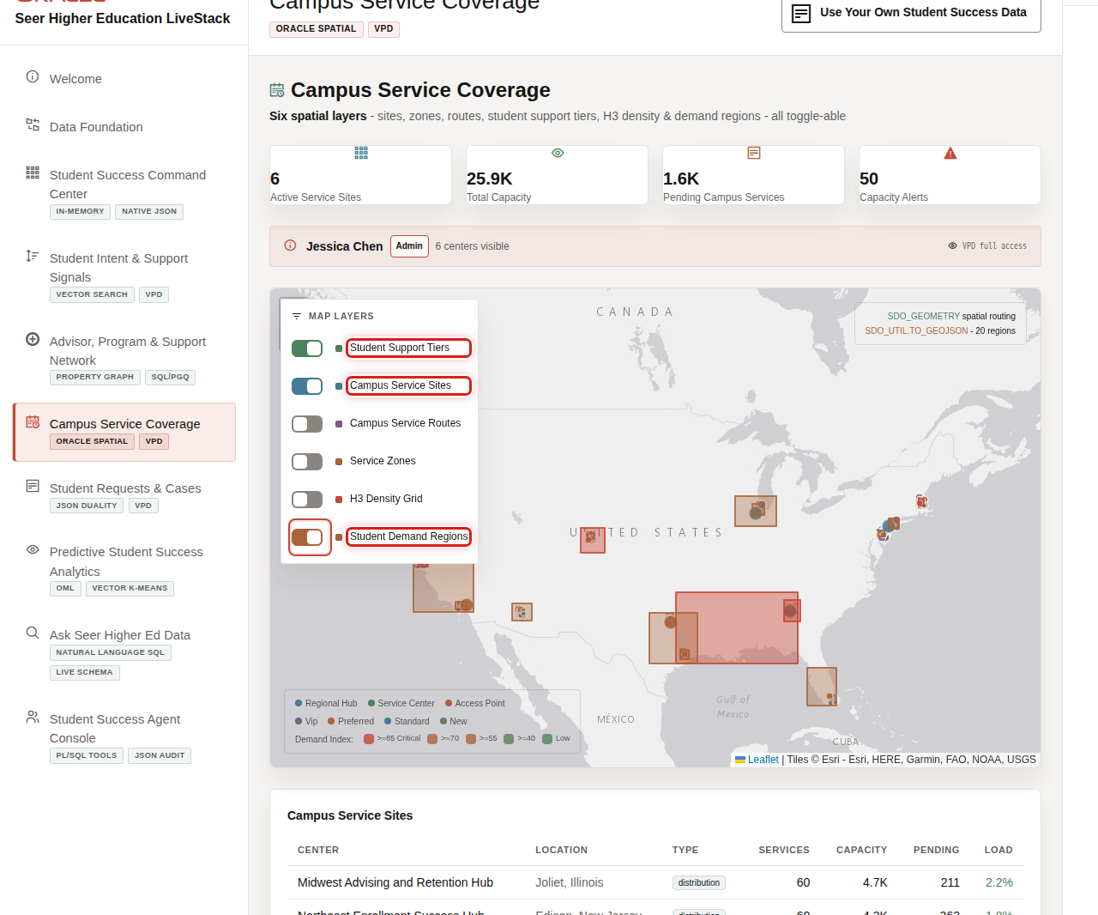

Objectives
In this scene, you will learn how spatial data helps teams evaluate student access, service capacity, and regional demand pressure.

Task 1: Review service coverage on the map
Use the map to show that the institution can connect student demand to physical and operational service access.
- Click Campus Service Coverage in the sidebar.
- Review the map and the active service layers.
- Point out student support tiers, campus service sites, service routes, service zones, H3 density grid, and demand regions.

Task 2: Toggle spatial layers
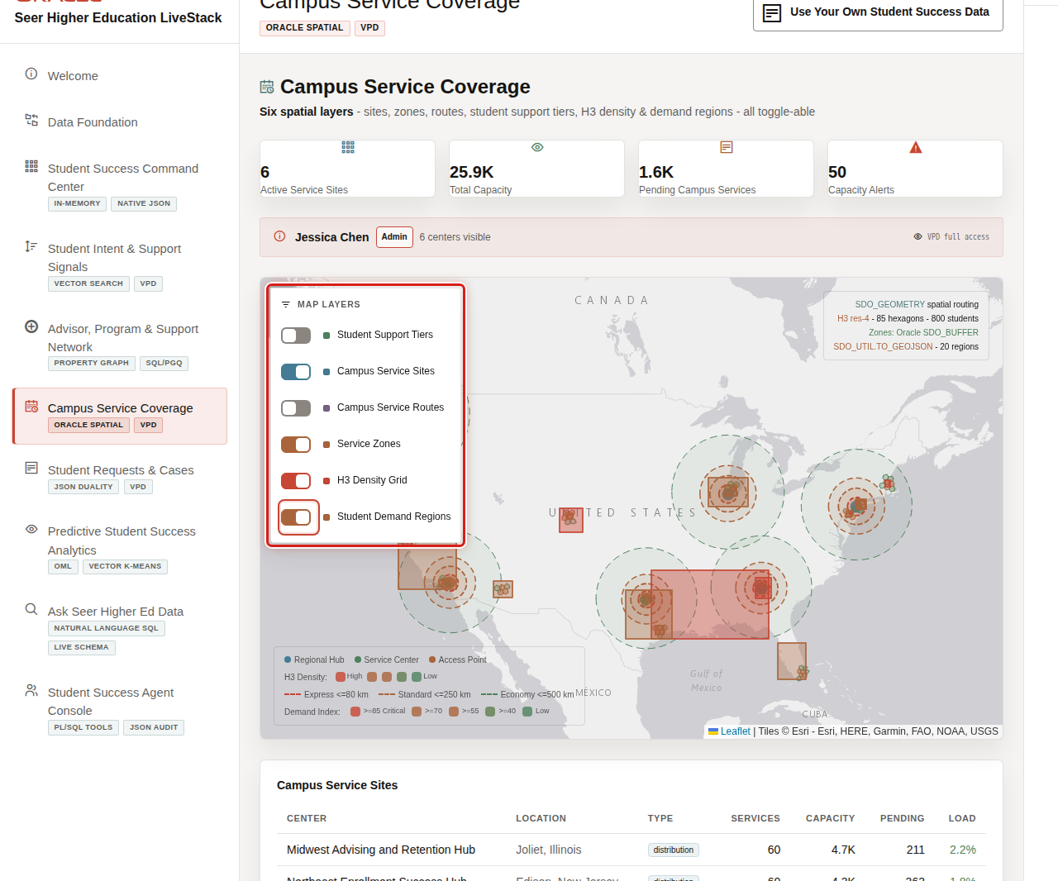
Layer toggles let the presenter show the map from different operational perspectives.
- Review Campus Service Sites to show available support locations.
- Review Service Zones to explain coverage boundaries.
- Review H3 Density Grid and Student Demand Regions to explain demand pressure.
- Explain that Oracle Spatial lets the application calculate and visualize service access without leaving the database platform.
That is the Oracle AI Database point: spatial and GeoJSON data can sit beside relational student records, JSON service requests, capacity data, vectors, graph relationships, and governed operations data in one engine. The map can therefore answer a business question: where are students, what do they need, and can the institution reach them with the right support?
You can move to the next scene.

Credits & Build Notes
- Author - Oracle LiveLabs Team
- Last Updated By/Date - Oracle LiveLabs Team, 2026-05-29

Scene 7 Student Requests and Cases

Introduction
Student Requests and Cases connects the student-support workflow to individual request evidence. It helps advisors, student success teams, financial aid offices, and campus service teams inspect the operational records behind aggregate demand.
Student requests often include relational transaction data, request lines, case state, service routing, signal attribution, and document-style application payloads. When those records are split across systems, teams struggle to explain what happened and why.
Oracle AI Database helps address that challenge by keeping the request workflow and JSON application shape connected. Business users can inspect a request in the UI, while applications can consume the same trusted data through JSON Duality.
Estimated Time: 10 minutes
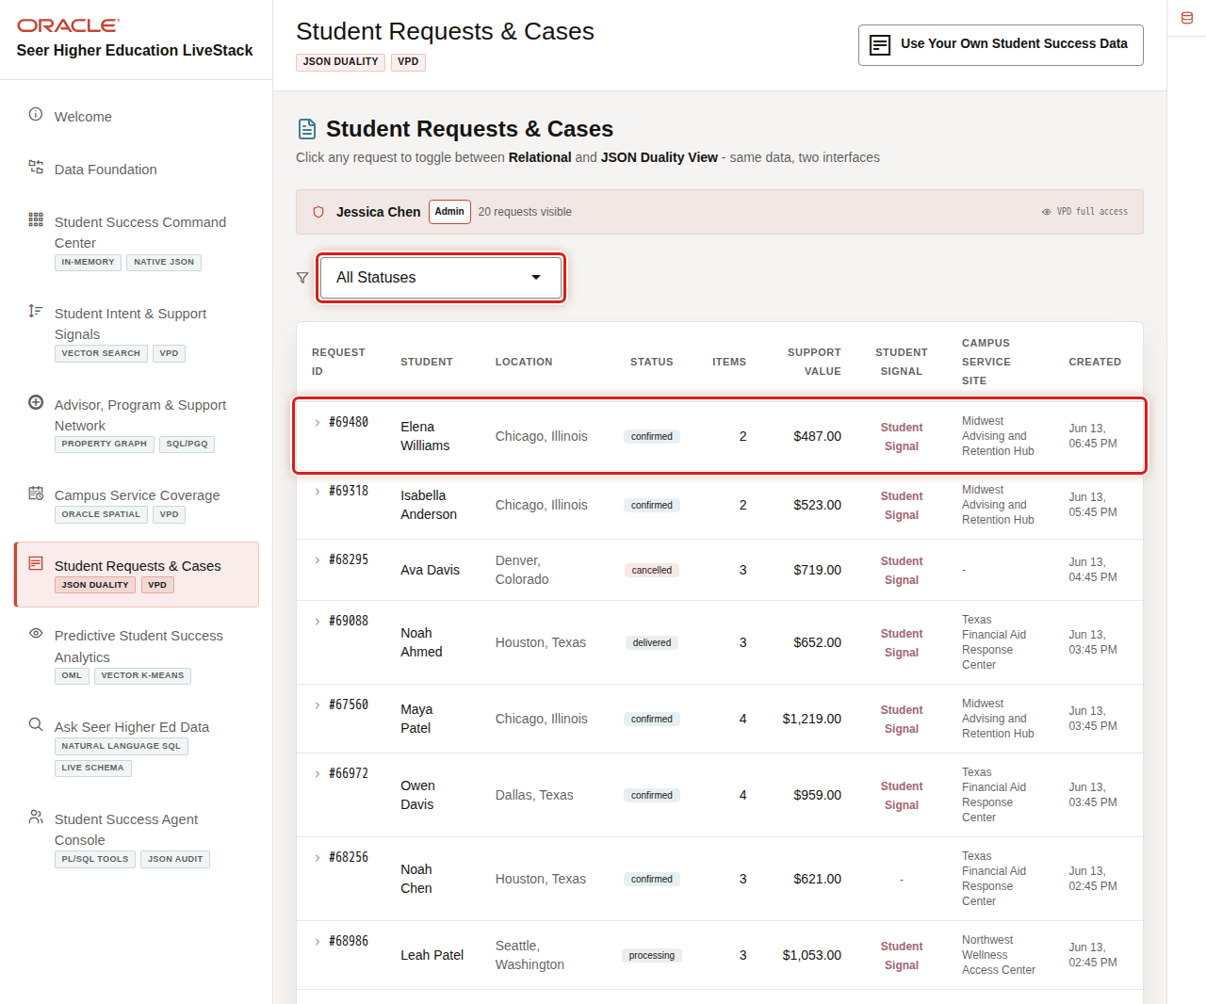

Objectives
In this scene, you will learn how to move from institutional metrics to a specific student request and inspect both relational and JSON views.

Task 1: Review student request records
Use the page to show how the command center evidence connects to individual student cases.
- Click Student Requests & Cases in the sidebar.
- Review the search and filter controls.
- Review the request rows, including status, total service value, demand score, student name, location, and service site.
- Focus on the request for Elena Williams.

Task 2: Inspect a request detail
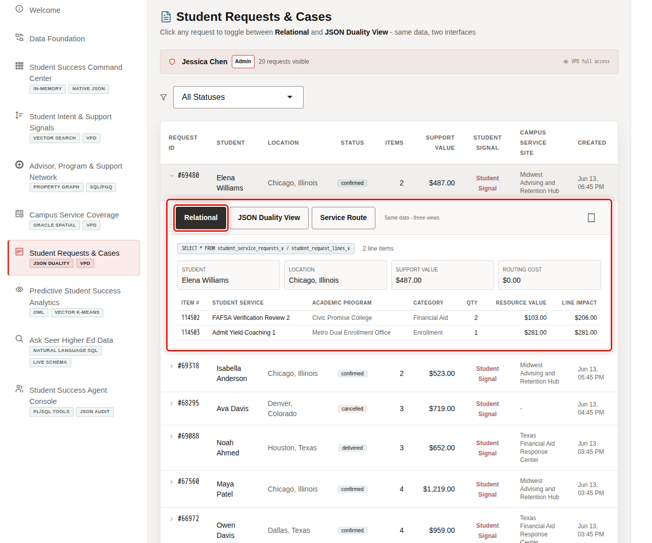
The detail modal helps a user inspect the case behind the metric.
- Click the Elena Williams request row.
- Review the request status, student, service site, request lines, and signal-driven context.
- Explain how this view supports advising, service coordination, and operations follow-up.

Task 3: Review the JSON Duality View
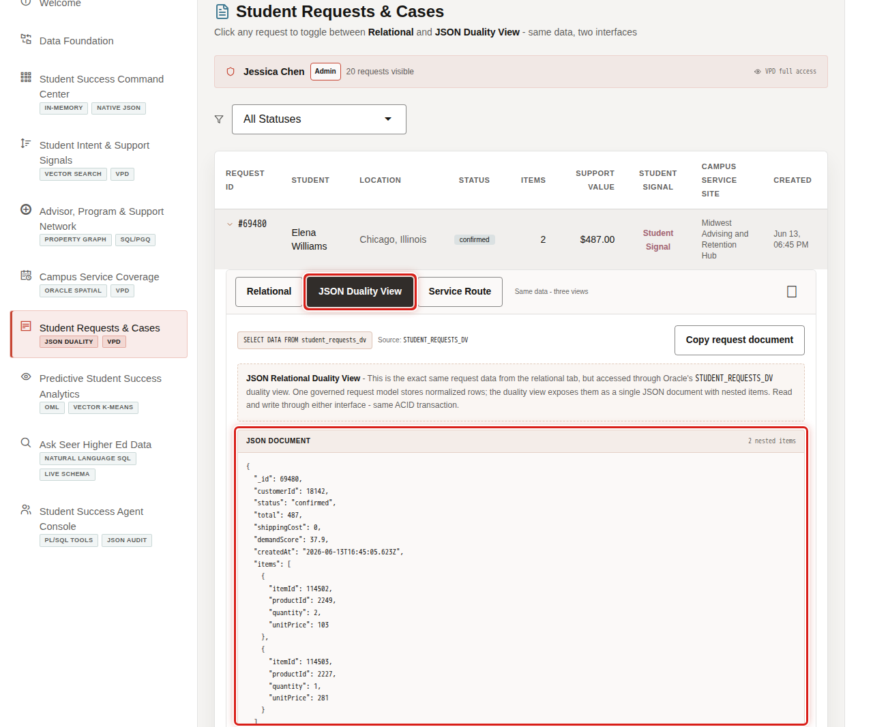
JSON Duality shows how the same request can support application developers without creating a separate document store.
- In the request modal, click JSON Duality View.
- Review the generated JSON document.
- Explain that the user interface and application document view remain tied to the same trusted Oracle data.
You can move to the next scene.

Credits & Build Notes
- Author - Oracle LiveLabs Team
- Last Updated By/Date - Oracle LiveLabs Team, 2026-05-29

Scene 8 Predictive Student Success Analytics

Introduction
Predictive Student Success Analytics helps institutional research, enrollment management, student success, advising, and operations teams move from historical reporting to predictive decisions.
With a projected 15% decline in the 18-year-old population by 2029, institutions can no longer afford to learn about retention risk after the fact. The institutions winning in this environment are the ones scoring demand, segmenting student populations, and forecasting service pressure in advance, not in a quarterly IR report, but in the same workflow where advisors and operations teams are already working. This scene shows how Oracle Machine Learning trains, stores, and scores predictive models inside Oracle AI Database, with no data export, no separate ML pipeline, and no reconciliation before someone will trust the result.
Oracle Machine Learning helps address that challenge by training, storing, and scoring models inside Oracle AI Database. In this scene, the application exposes demand prediction, engagement segmentation, service value forecasting, vector clustering, and capacity intelligence from the same student-success data foundation.
Estimated Time: 10 minutes
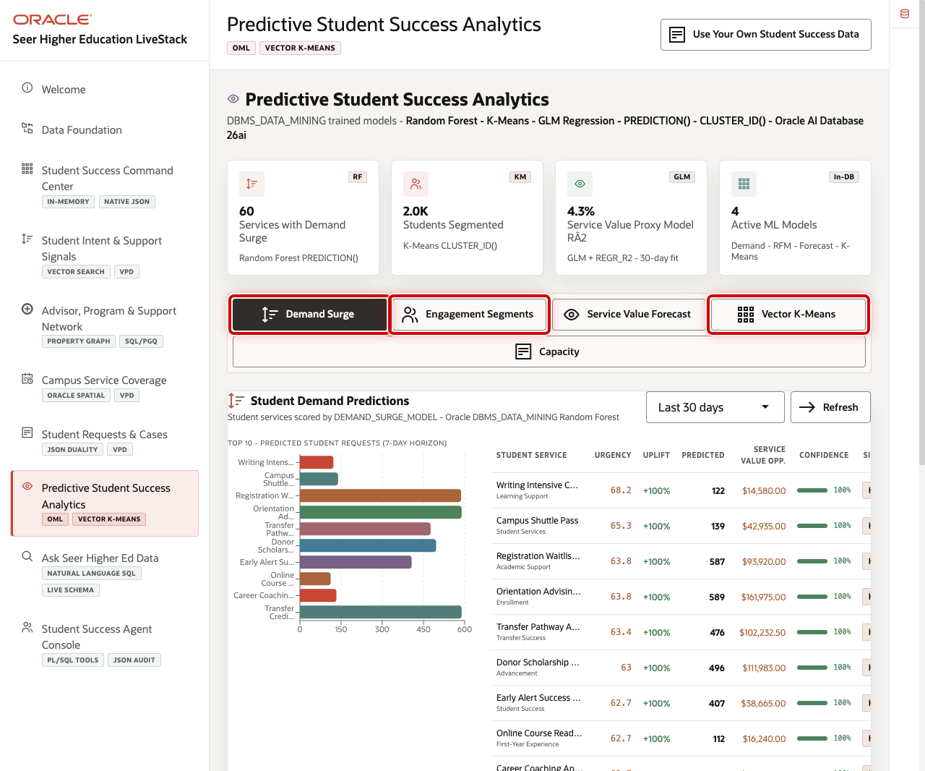

Objectives
In this scene, you will learn how in-database machine learning helps identify demand pressure, student engagement patterns, and service risk.

Task 1: Review the analytics workspace
Use the page to show the institution's model-driven decision options.
- Click Predictive Student Success Analytics in the sidebar.
- Review the model action buttons.
- Point out Demand Surge, Engagement Segments, Service Value Forecast, Vector K-Means, and Capacity.

Task 2: Run demand surge scoring
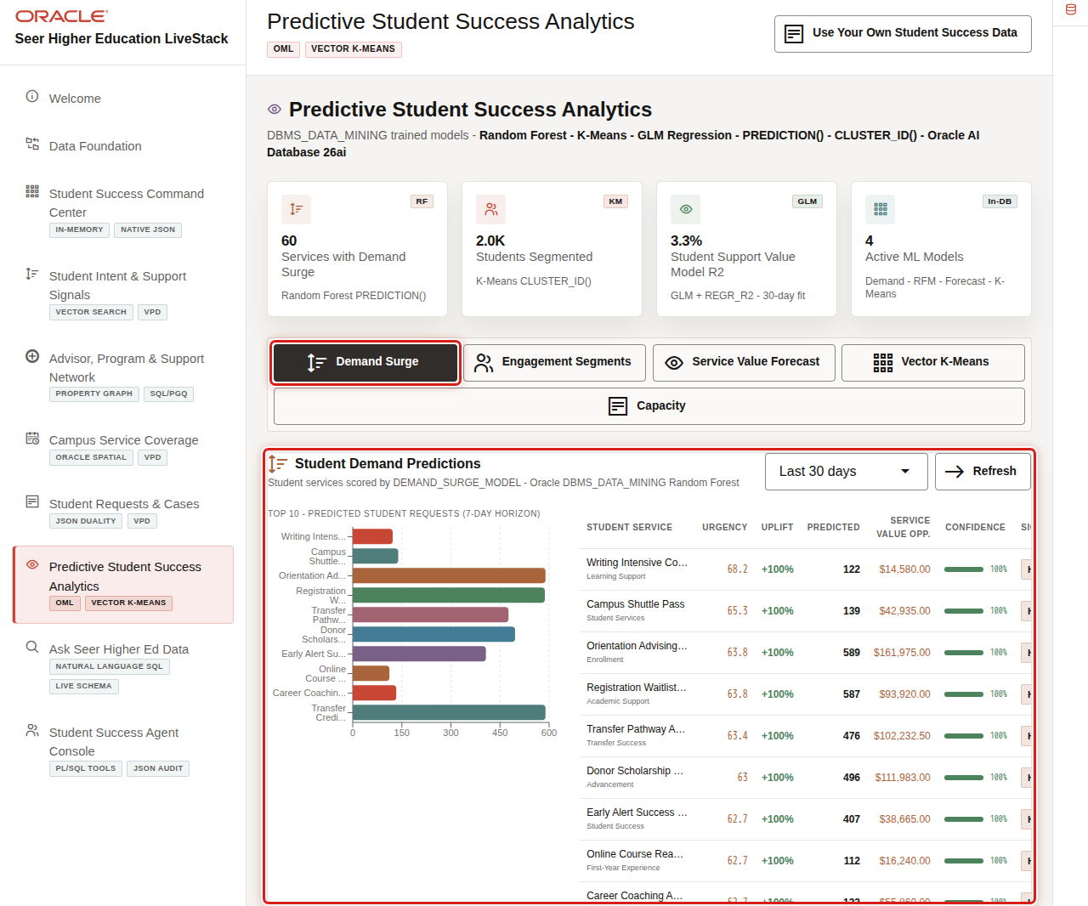
Demand surge scoring helps the seller connect current student signals to likely service pressure.
- Click Demand Surge.
- Review the returned student service demand predictions.
- Explain that Oracle Machine Learning scores the current data in SQL without exporting the dataset.

Task 3: Review student engagement segmentation
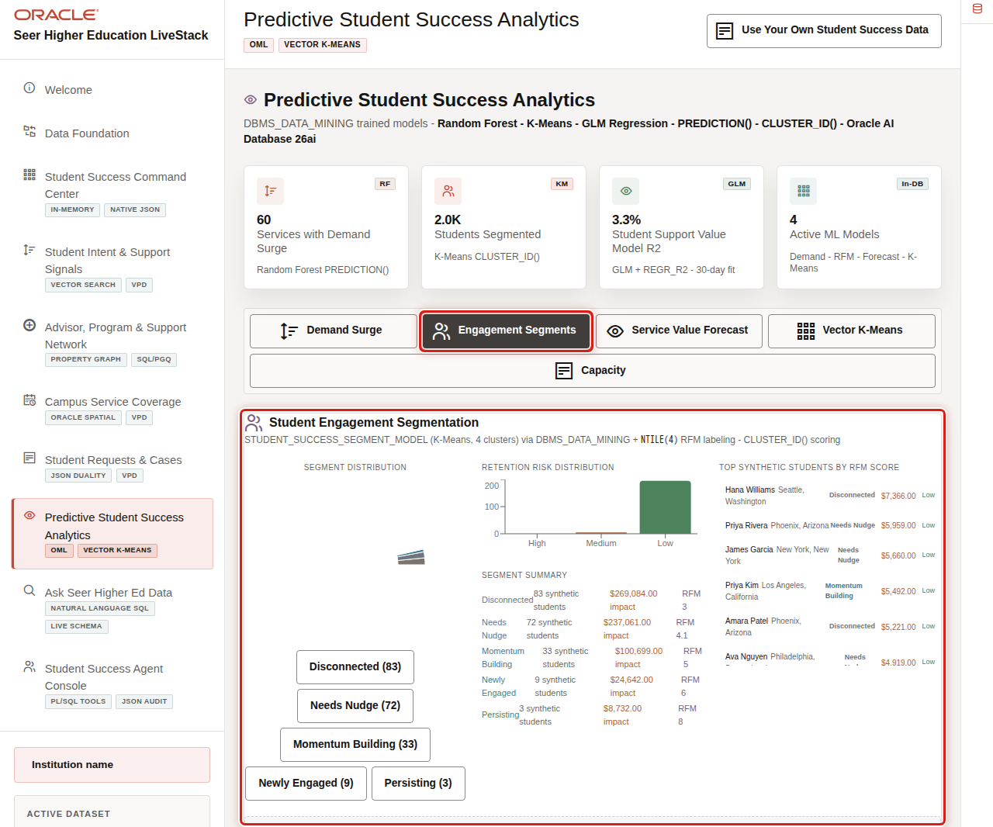
Engagement segmentation helps teams understand student populations by behavior, recency, request value, and risk.
- Click Engagement Segments.
- Review the segment output.
- Explain how student success teams can use segments to prioritize outreach.

Task 4: Review vector clustering
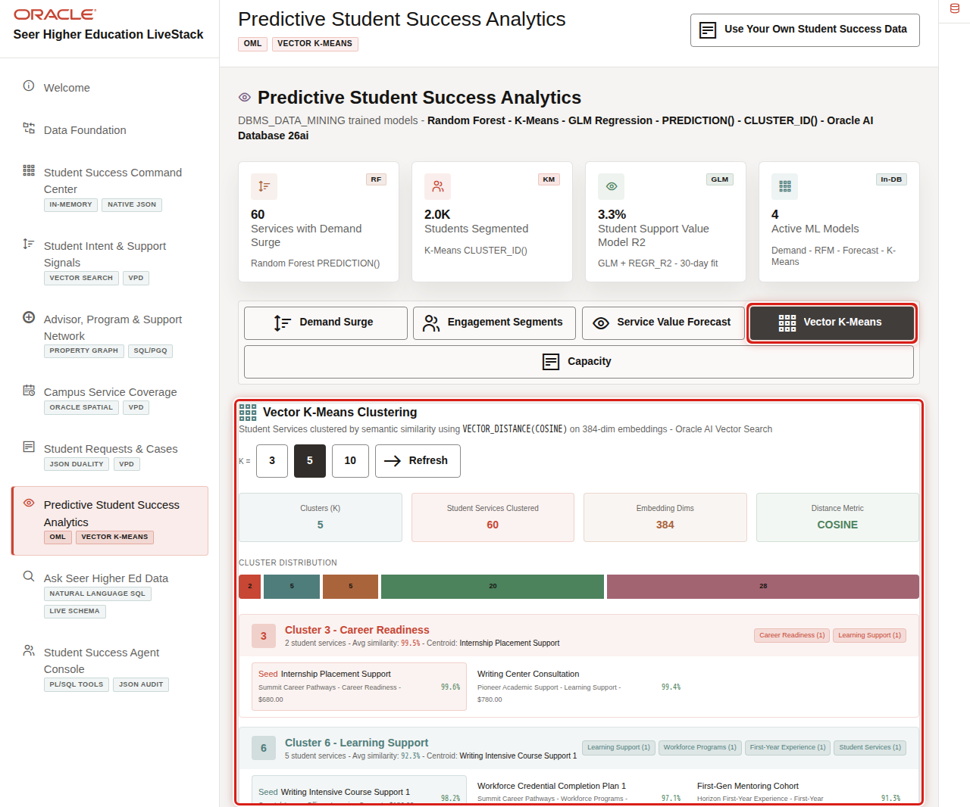
Vector clustering groups semantically similar services or signals, which helps teams spot related student needs.
- Click Vector K-Means.
- Review the cluster output.
- Explain that vector and ML workloads can stay close to governed operational data.
You can move to the next scene.

Credits & Build Notes
- Author - Oracle LiveLabs Team
- Last Updated By/Date - Oracle LiveLabs Team, 2026-05-29

Scene 9 Ask Seer Higher Ed Data

Introduction
Ask Seer Higher Ed Data helps business users ask higher education questions in plain language without losing transparency. Users can inspect generated SQL, run it against trusted Oracle data, and review returned rows, which makes self-service analytics faster and easier to trust.
This is difficult to implement safely because natural-language data access can create governance risk. A language model may generate invalid SQL, reference the wrong views, hide the logic behind an answer, or expose more data than the user should see. Higher education teams need self-service analytics, but data teams still need traceability, read-only execution, and a clear source of truth.
Oracle AI Database helps address these challenges by keeping query execution grounded in the live higher education schema. In this LiveStack Demo, the app sends the business question and schema context to the local Ollama runtime, validates the generated SQL path, and uses Oracle AI Database 26ai as the execution authority.
Estimated Time: 10 minutes
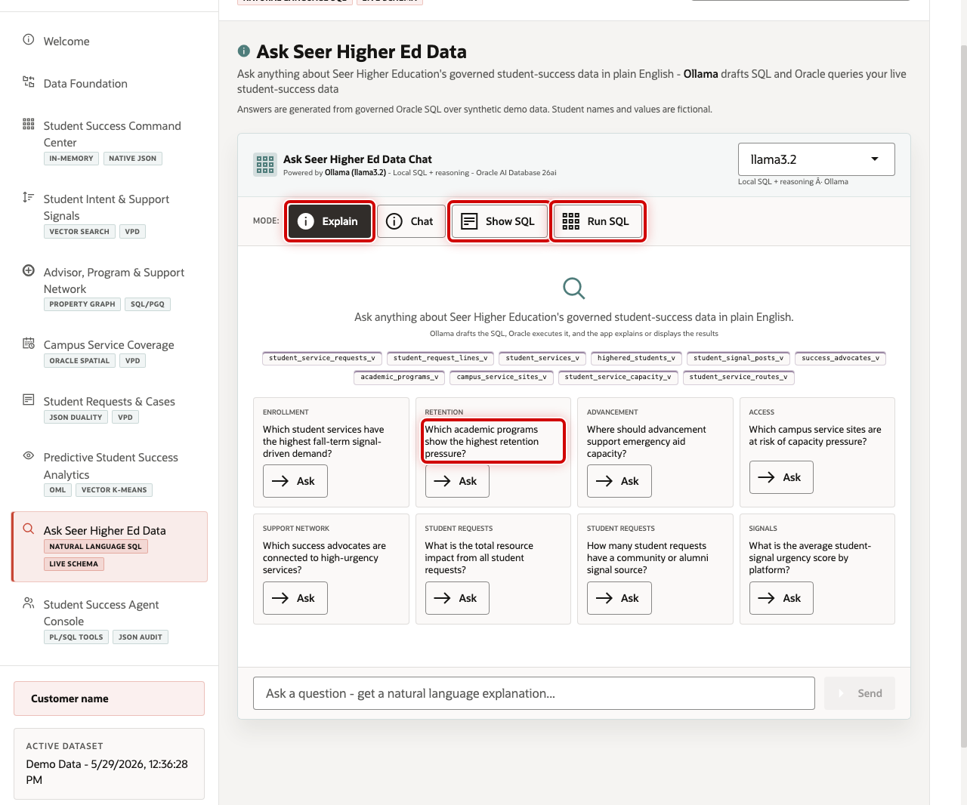

Objectives
In this scene, you will learn how natural-language analytics can support student success while keeping the SQL path visible and governed.

Task 1: Review the Ask Data workspace
Review the workspace to show how business users can ask questions in plain language while still keeping the query path visible and controlled.
- Click Ask Seer Higher Ed Data in the sidebar.
- Review the four modes: Explain, Chat, Show SQL, and Run SQL.
- Review the example question tiles.
- Focus on the Retention question: Which academic programs show the highest retention pressure?

Task 2: Inspect generated SQL
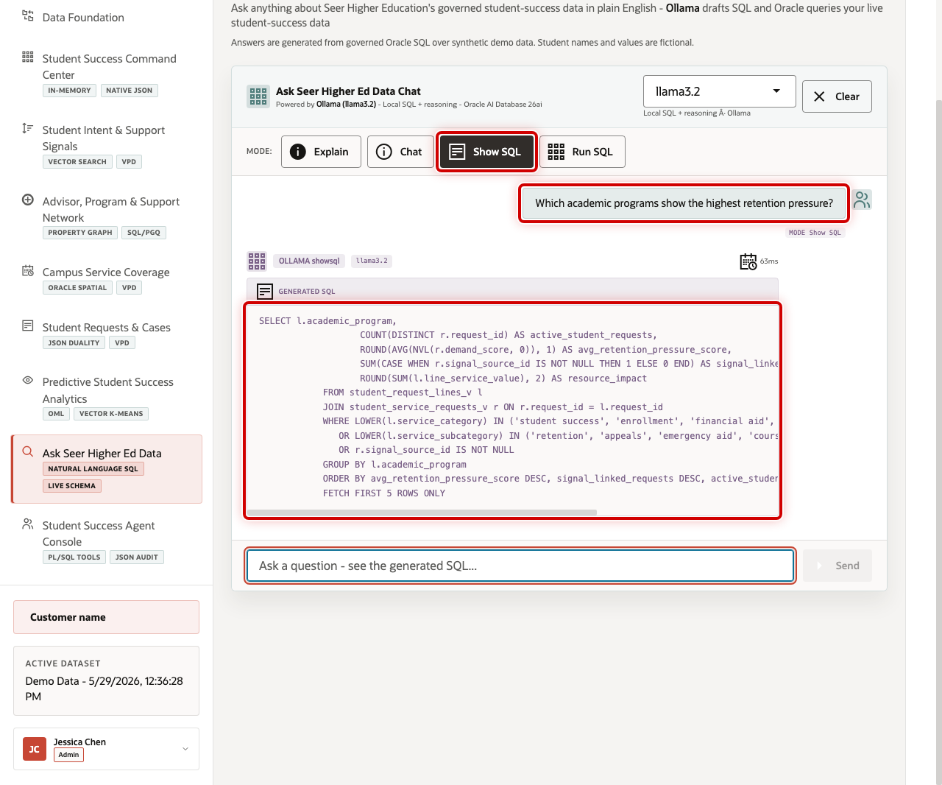
Inspect the generated SQL to show that the answer is traceable. Even if the user does not read every line, the query can be reviewed instead of trusting a hidden AI response.
- Click Show SQL.
- Ask Which academic programs show the highest retention pressure?
- Review the generated SQL.
The generated SQL groups student request and signal evidence by academic program. This is the governance moment in the scene: the business user can inspect the query path before asking the database to return rows.

Task 3: Run the SQL and inspect the returned data
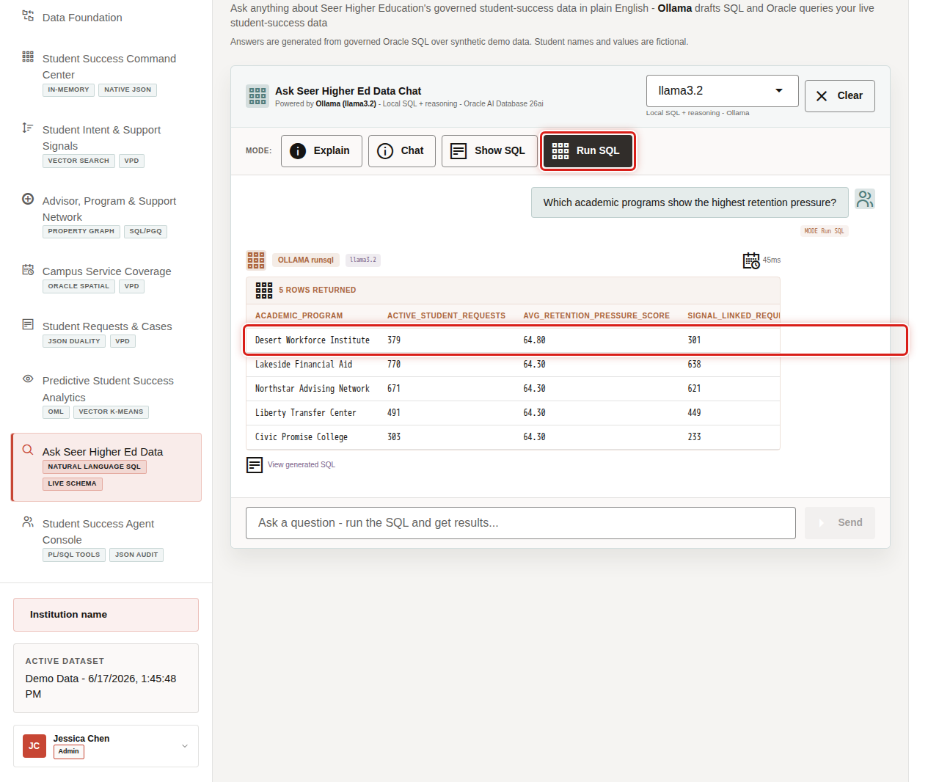
Run the SQL and inspect the returned rows to find concrete institutional pressure points.
- Click Clear if the generated SQL result is still visible.
- Click Run SQL.
- Ask the same Retention question.
- Review the returned table.
- Focus on Desert Workforce Institute, which appears with 379 active student requests, an average retention pressure score of 64.80, and 301 signal-linked requests.
A business user can discover the issue without writing SQL, while the SQL and database result remain visible for trust.
You can move to the next scene.

Credits & Build Notes
- Author - Oracle LiveLabs Team
- Last Updated By/Date - Oracle LiveLabs Team, 2026-05-29

Scene 10 Student Success Agent Console

Introduction
Student Success Agent Console shows how AI-assisted operations can help a student success team move from insight to coordinated action. It routes questions to specialist agents for student signals, campus services, and student-success operations.
Institutions want AI assistance, but they also need auditability, grounded data access, and clear operational boundaries. A useful agent experience should query the live system, explain what it found, and leave a record of the action path.
Oracle AI Database helps address that challenge by keeping SQL tools, PL/SQL tool calls, JSON event streams, vector retrieval, model scoring, and action audit records together. The app uses Ollama for reasoning and Oracle for the data, execution, and logging layer.
Estimated Time: 10 minutes
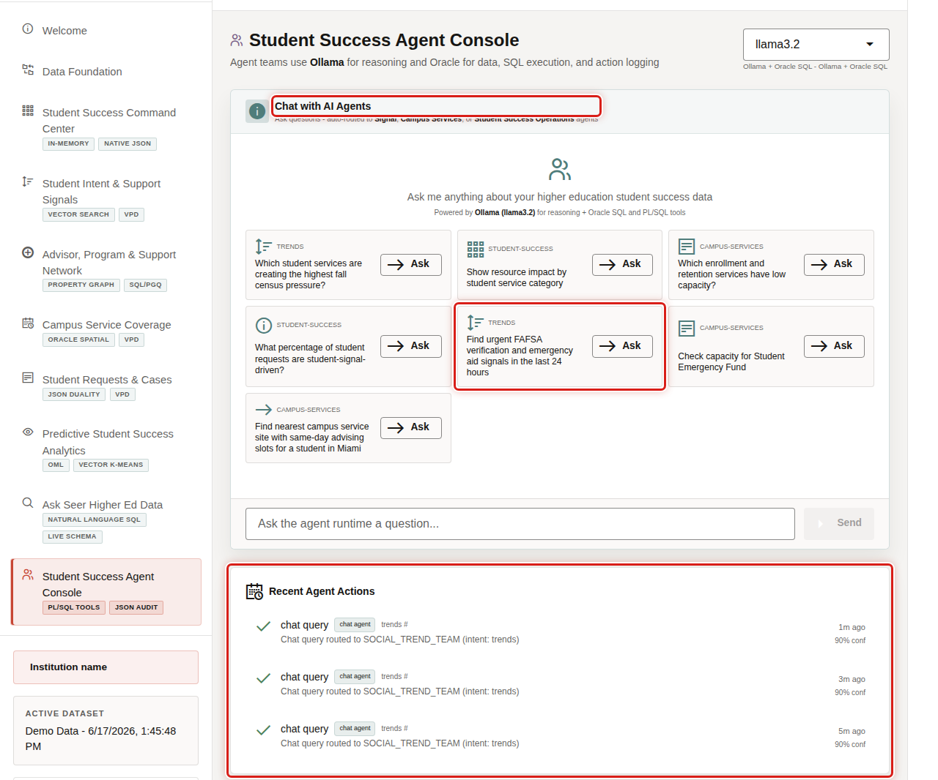

Objectives
In this scene, you will learn how agent-assisted workflows can help student success teams analyze signals, service capacity, and request impact while keeping actions traceable.

Task 1: Review the agent console
Use the console to show the governed AI operations pattern.
- Click Student Success Agent Console in the sidebar.
- Review Chat with AI Agents.
- Review the example questions.
- Review Recent Agent Actions as the audit trail area.

Task 2: Ask an agent question
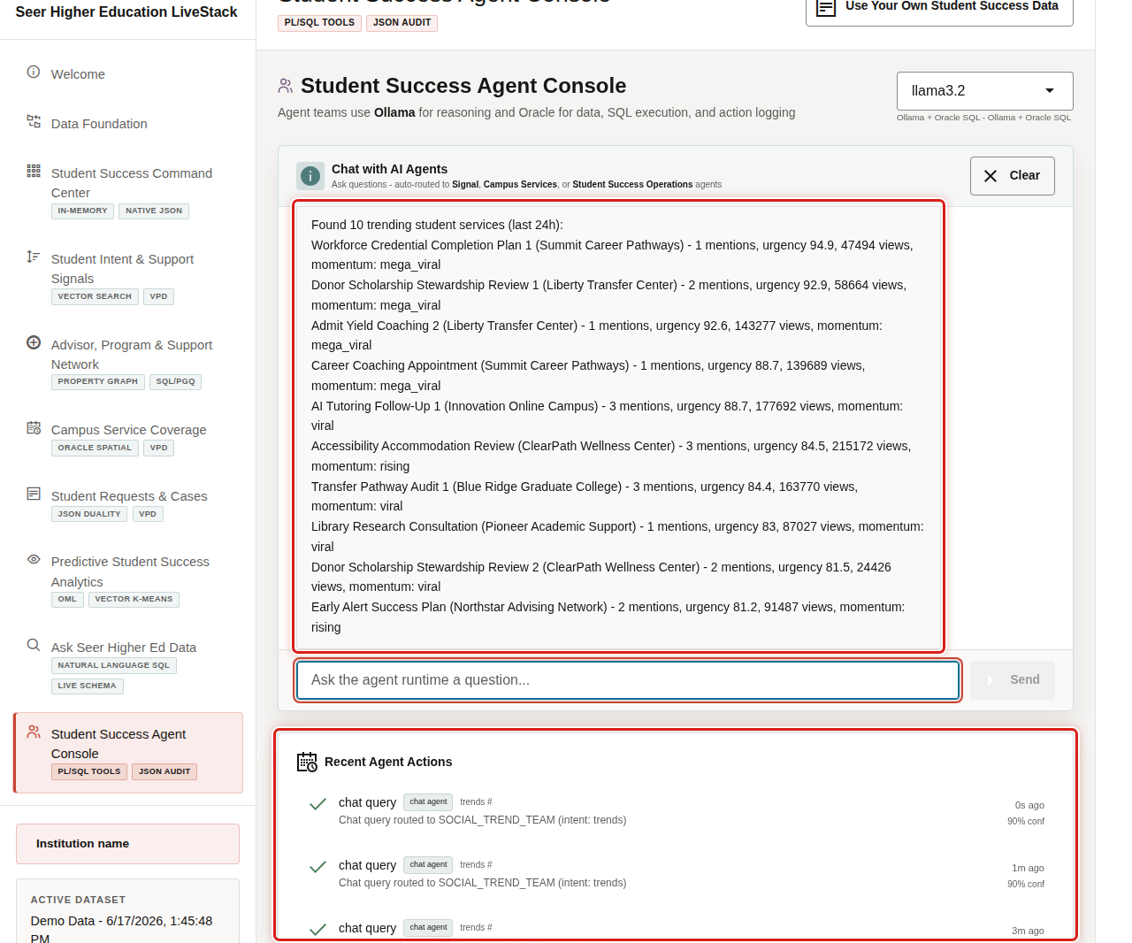
Ask a trend-oriented question to show how the agent routes work to the right team and grounds the answer in student-success data.
- Click Find urgent FAFSA verification and emergency aid signals in the last 24 hours.
- Review the response from the agent runtime.
- Review the recent action log area.
- Explain that the system uses AI for reasoning but keeps data access, tool execution, and audit evidence inside the governed Oracle-backed application.
You have completed the Seer Higher Education Student Success LiveStack Demo.

Credits & Build Notes
- Author - Oracle LiveLabs Team
- Last Updated By/Date - Oracle LiveLabs Team, 2026-05-29

