Seer Manufacturing LiveStack Guide

Oracle AI Database 26ai manufacturing operations runbook
Story-driven guide with live annotated screenshots
June, 2026, Version 1.0
Copyright (c) 2026, Oracle and/or its affiliates
Confidential - Oracle Internal

Purpose statement
This document provides an Oracle-branded Word version of the Seer Manufacturing LiveStack runbook. It follows the scene-by-scene manufacturing operations story, task guidance, screenshots, checkpoints, and Oracle AI Database 26ai evidence captured from the live manufacturing application.

Disclaimer
This document in any form, software or printed matter, contains proprietary information that is the exclusive property of Oracle. Your access to and use of this confidential material is subject to the terms and conditions of your Oracle software license and service agreement, which has been executed and with which you agree to comply. This document and information contained herein may not be disclosed, copied, reproduced or distributed to anyone outside Oracle without prior written consent of Oracle. This document is not part of your license agreement nor can it be incorporated into any contractual agreement with Oracle or its subsidiaries or affiliates.
This document is for informational purposes only and is intended solely to assist you in planning for the implementation and upgrade of the product features described. It is not a commitment to deliver any material, code, or functionality, and should not be relied upon in making purchasing decisions. The development, release, timing, and pricing of any features or functionality described in this document remains at the sole discretion of Oracle.

Runbook contents
- 1. Seer Manufacturing LiveStack Guide
- 2. Scene 1 Manufacturing Control Tower Orientation
- 3. Scene 2 Manufacturing Data Foundation
- 4. Scene 3 Operations Command Center
- 5. Scene 4 Production Signal Monitor
- 6. Scene 5 Supplier and Signal Network Graph
- 7. Scene 6 Plant Capacity and Routing Map
- 8. Scene 7 Work Orders and JSON Duality
- 9. Scene 8 OML Demand and Capacity Analytics
- 10. Scene 9 Ask Manufacturing Data
- 11. Scene 10 Manufacturing Agent Console
- 12. Scene 11 Use Your Own Manufacturing Data
- 13. Take It Home: Run LiveStack with Podman Compose

Seer Manufacturing LiveStack Guide

Introduction
Manufacturing teams need to coordinate plant performance, work orders, supplier risk, quality inspections, machine telemetry, inventory constraints, predictive maintenance, production variance, and AI-assisted decisions while keeping operational data governed. Those workflows often live in separate execution systems, planning tools, quality systems, spreadsheets, analytics marts, search services, mapping tools, notebooks, and AI experiments. The result is a slower operating model: users can see part of the factory picture, but they cannot easily trace a corrective action back to the same trusted manufacturing data foundation.
This runbook supports the Seer Manufacturing LiveStack Demo. The demo shows how Oracle AI Database 26ai can bring manufacturing operations workloads together on one connected data platform. Instead of splitting relational work orders, JSON documents, supplier and production-risk graphs, plant spatial analysis, vector search, in-database machine learning, natural-language SQL, and AI agent workflows across different systems, the LiveStack shows how those capabilities can work against the same governed Oracle data model.
In the demo, Seer Manufacturing uses Oracle AI Database to recover the Servo Drive Controller AX-400 production plan from constrained PCB material, work-order schedule variance, supplier delay, plant-capacity pressure, scrap risk, and machine telemetry signals. Each scene is designed to help you explain a practical manufacturing operations challenge and then show how a converged Oracle database capability supports a clearer decision path.
Estimated Demo Time: 90 minutes
Each scene is designed to take between 5 and 10 minutes.
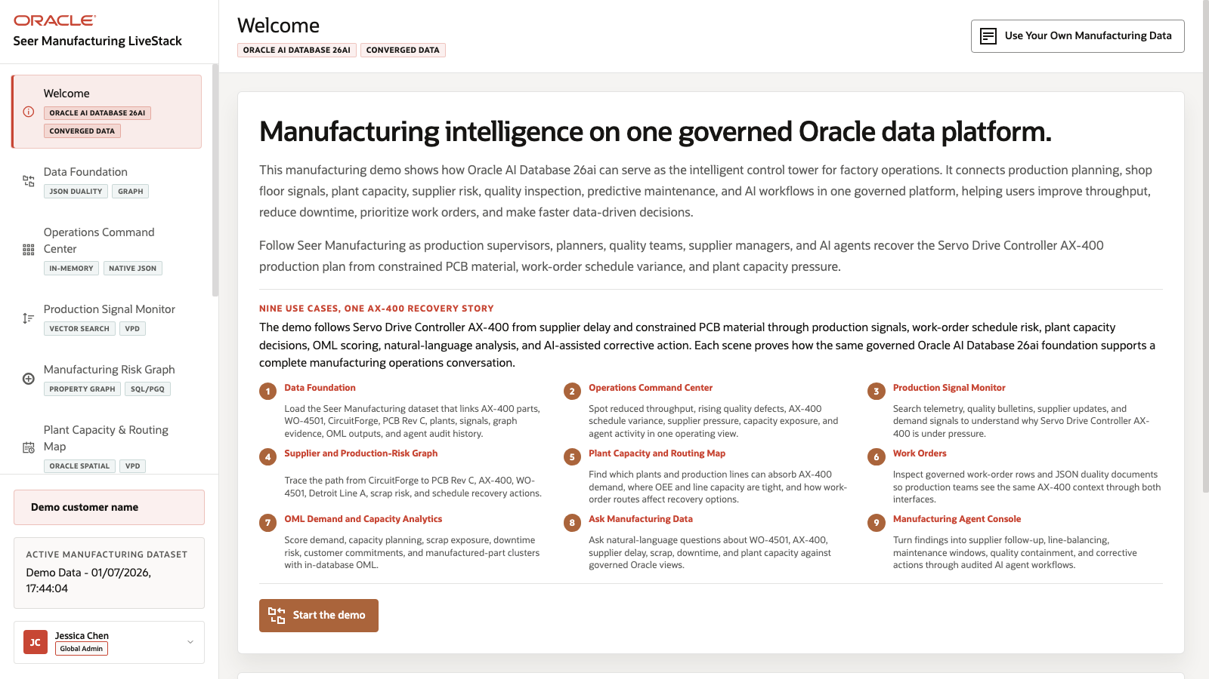
Figure 1. Manufacturing LiveStack welcome page

Objectives
In this LiveStack Demo, you will:
Explore the key manufacturing use cases featured in the Seer Manufacturing demo, from the data foundation and command center to production signals, supplier graph analysis, plant routing, work orders, predictive analytics, conversational data access, and AI agent workflows.
Understand how common manufacturing operations challenges such as fragmented production data, supplier delay, capacity pressure, quality inspection failures, scrap risk, downtime risk, limited self-service analytics, and governed AI adoption are addressed in the demo flow.
See how Oracle AI Database 26ai supports each use case with converged capabilities including relational data, JSON, graph, spatial, vector search, machine learning, natural-language SQL, and AI-assisted operations.
Connect each scene to a practical business outcome, so the demo shows not only what the application does, but why the Oracle data platform matters for manufacturing operations.

Prerequisites
This LiveStack Demo assumes you have:
Access to the running Seer Manufacturing LiveStack.
A modern browser open to the application URL.
The seeded Seer Manufacturing demo dataset loaded, or an imported synthetic manufacturing dataset loaded through the application dataset tool.
For the download lab, Podman and Podman Compose available on the machine where you run the portable stack.

Demo Flow
Scene 1: Manufacturing Control Tower Orientation.
Scene 2: Manufacturing Data Foundation.
Scene 3: Operations Command Center.
Scene 4: Production Signal Monitor.
Scene 5: Supplier and Signal Network Graph.
Scene 6: Plant Capacity and Routing Map.
Scene 7: Work Orders and JSON Duality.
Scene 8: OML Demand and Capacity Analytics.
Scene 9: Ask Manufacturing Data.
Scene 10: Manufacturing Agent Console.
Scene 11: Use Your Own Manufacturing Data.
Download and run the portable Manufacturing LiveStack.

Learn More
Oracle AI Database 26ai documentation
Oracle AI Agent Memory
Oracle AI Vector Search
Oracle Spatial and Graph documentation: Oracle Spatial and Oracle Property Graph
Oracle Machine Learning for SQL documentation
Oracle REST Data Services documentation
Oracle LiveLabs catalog

Credits & Build Notes
Author - Oracle LiveLabs Team
Last Updated By/Date - Oracle LiveLabs Team, 2026-06-09

Scene 1 Manufacturing Control Tower Orientation

Introduction
This opening scene orients users to the Seer Manufacturing LiveStack Demo. The welcome page introduces the manufacturing operations story and uses a carousel to preview the use cases available in the demo.
The story follows the Servo Drive Controller AX-400 production plan as Seer Manufacturing works through constrained PCB material, supplier delay, work-order schedule variance, plant-capacity pressure, scrap risk, and AI-assisted corrective action. Use this scene to establish the user role: an operations leader, plant manager, production supervisor, maintenance planner, quality engineer, or supply chain analyst who needs one governed view of factory operations.
Estimated Time: 5 minutes
Figure 2. Welcome page with the manufacturing use case carousel

Objectives
In this scene, you will:
Review the use case carousel on the welcome page.
Learn which manufacturing use cases are available to explore in the LiveStack Demo.
Connect the use cases to the AX-400 recovery story.
Use the carousel controls to move through the use case tiles.
Click Start the demo to continue to the data foundation page.

Task 1: Review the use case carousel
- Read the three visible use case tiles.
- Click the right carousel arrow to move forward.
- Continue until you have reviewed all visible manufacturing use cases.
- Use the left carousel arrow if you want to return to earlier tiles.
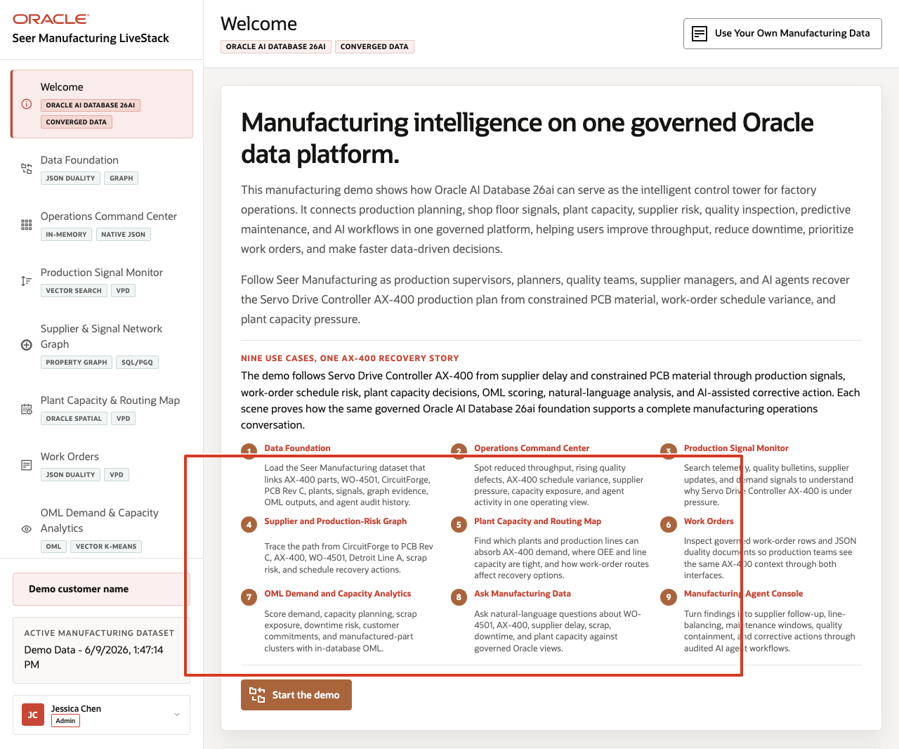
Figure 3. Welcome page use case carousel with navigation controls highlighted
The welcome page frames the demo as manufacturing intelligence on one governed Oracle data platform. The carousel introduces how the LiveStack connects the data foundation, operations command center, production and quality signals, supplier and production-risk graph, plant capacity map, work orders, OML analytics, Ask Manufacturing Data, and agent-assisted operations.

Task 2: Connect the story to AX-400 recovery
- Review the main welcome story.
- Focus on the line that explains the Servo Drive Controller AX-400 recovery plan.
- Explain that the same production issue will move through supplier risk, production signals, work orders, plant capacity, predictive analytics, natural-language exploration, and AI agent action.
Figure 4. Welcome page AX-400 recovery story and demo orientation highlighted
Use this as the narrative anchor for the rest of the runbook. The demo is not a feature checklist. It is a manufacturing operations investigation that starts with a production plan under pressure and ends with auditable corrective action.

Task 3: Continue the demo
- Click Start the demo.
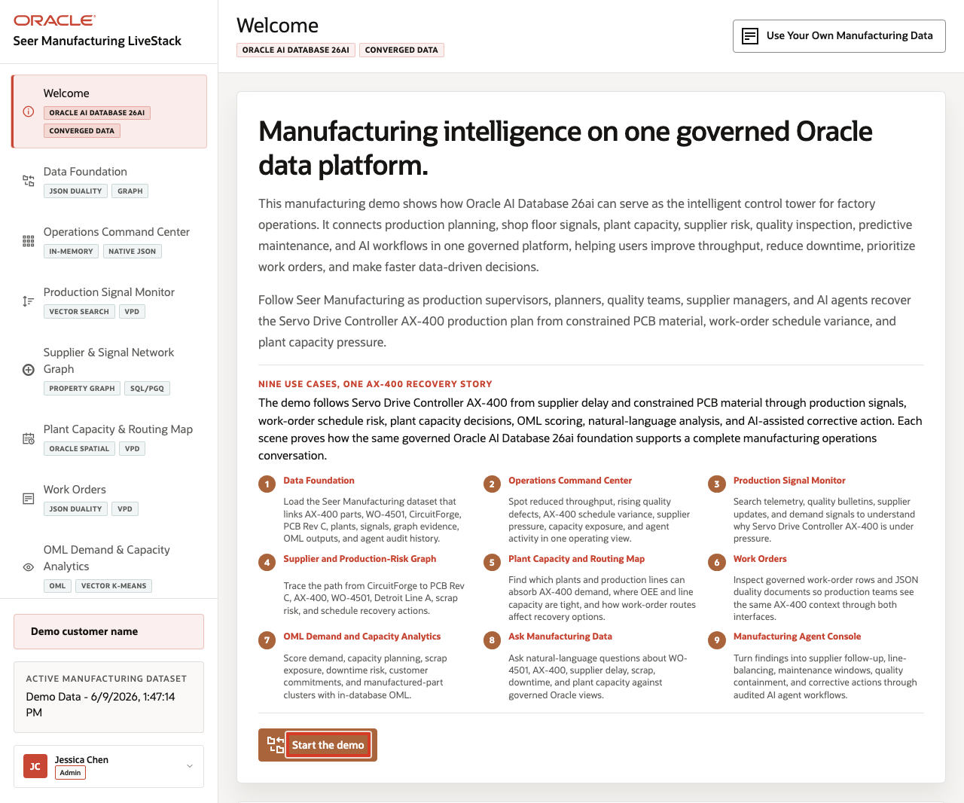
Figure 5. Welcome page Start the demo button highlighted
- Confirm the demo moves to Data Foundation.
Use this transition to explain that the welcome page is the orientation layer. The next scene prepares the governed manufacturing dataset that powers every later workflow.

Credits & Build Notes
Author - Oracle LiveLabs Team
Last Updated By/Date - Oracle LiveLabs Team, 2026-06-09

Scene 2 Manufacturing Data Foundation

Introduction
This scene prepares the Seer Manufacturing dataset that powers the rest of the LiveStack Demo. The page loads or restores the governed Oracle AI Database 26ai data foundation, then shows the major manufacturing domains and data types used across the application.
The scene is useful at the start of a customer walkthrough because it establishes that the later pages are not separate demos. Manufactured parts, work orders, production signals, supplier relationships, plant capacity, route geography, vectors, semantic matches, machine learning outputs, and agent audit records are all prepared from the same Oracle-backed foundation.
Estimated Time: 5 minutes
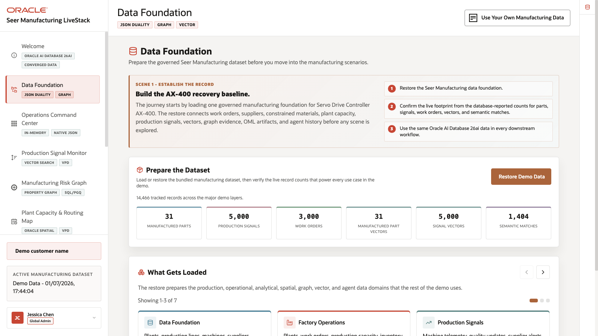
Figure 6. Manufacturing Data Foundation page with dataset restore controls and loaded data domains

Objectives
In this scene, you will:
Load or restore the Seer Manufacturing demo dataset.
Review the live record counts that confirm the demo foundation is ready.
Understand what manufacturing data domains are prepared for downstream scenes.
Use the What Gets Loaded carousel to connect each domain to the rest of the demo.
Use the Oracle Internals sidebar to connect the page to Oracle AI Database capabilities.

Task 1: Prepare the dataset
- From the welcome page, click Start the demo, or click Data Foundation in the sidebar.
- In Prepare the Dataset, click Restore Demo Data if the dataset needs to be reset to the seeded baseline.
- Wait for the operation to complete.
- Review the record counts below the action.
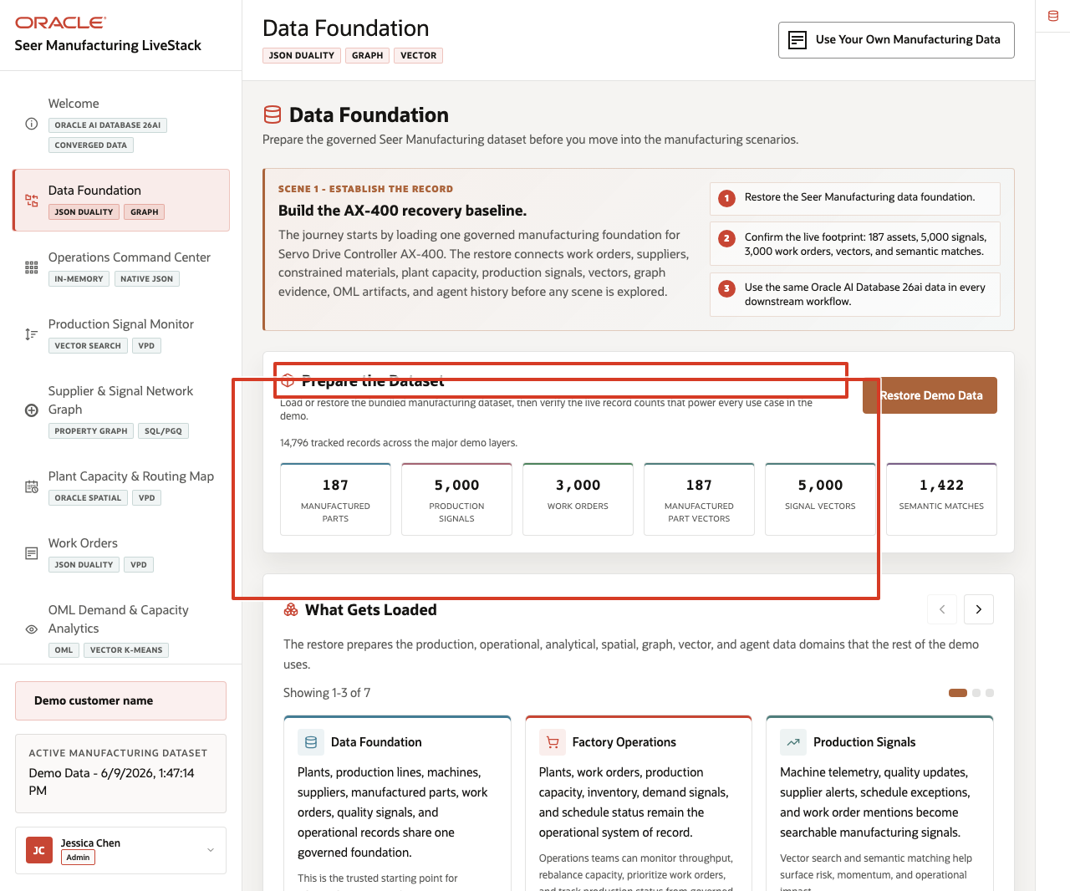
Figure 7. Prepare the Dataset restore action and manufacturing record counts highlighted
In the current demo dataset, the page shows 14,796 tracked records across the major demo layers, including 187 manufactured parts, 5,000 production signals, 3,000 work orders, 187 manufactured-part vectors, 5,000 signal vectors, and 1,422 semantic matches.
Use these counts to frame the demo. The user is not loading a single table for a dashboard. The page prepares the operational, analytical, spatial, graph, vector, and audit data that each later scene uses.

Task 2: Review what gets loaded
- Scroll to What Gets Loaded.
- Review the first three carousel cards: Data Foundation, Factory Operations, and Production Signals.
- Use the right carousel arrow to review the remaining data groups.
- Click the Oracle Internals icon on the far-right rail to expand the sidebar, then review the Oracle capability notes.
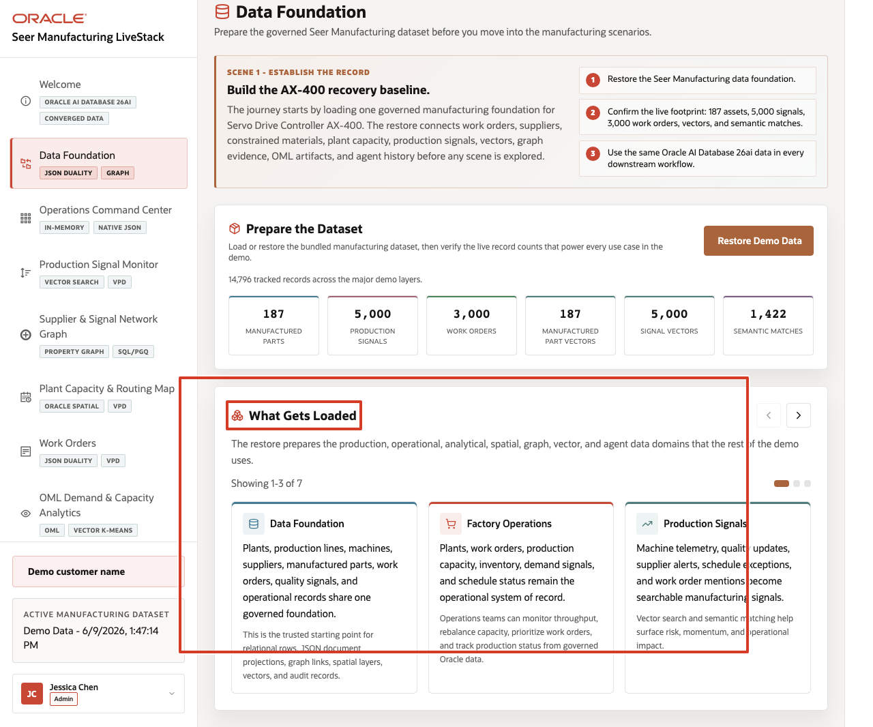
Figure 8. What Gets Loaded carousel and Oracle Internals manufacturing foundation notes highlighted
The carousel explains the shared data model in business terms: plants, production lines, machines, suppliers, manufactured parts, work orders, quality signals, inventory and capacity records, route geography, graph links, vectors, ML outputs, and agent actions. The sidebar ties that story to Oracle capabilities such as relational data, JSON Duality Views, property graph, Oracle Spatial, vector search, in-database ML, and the agent audit trail.

Task 3: Connect the foundation to the rest of the demo
Use this page as the handoff into the operating story:
- Explain that the command center will summarize the foundation as manufacturing operating indicators.
- Explain that production signals will use vector search over the signal data prepared here.
- Explain that supplier graph, plant routing, work orders, OML analytics, Ask Data, and agent pages all read from the same governed foundation.
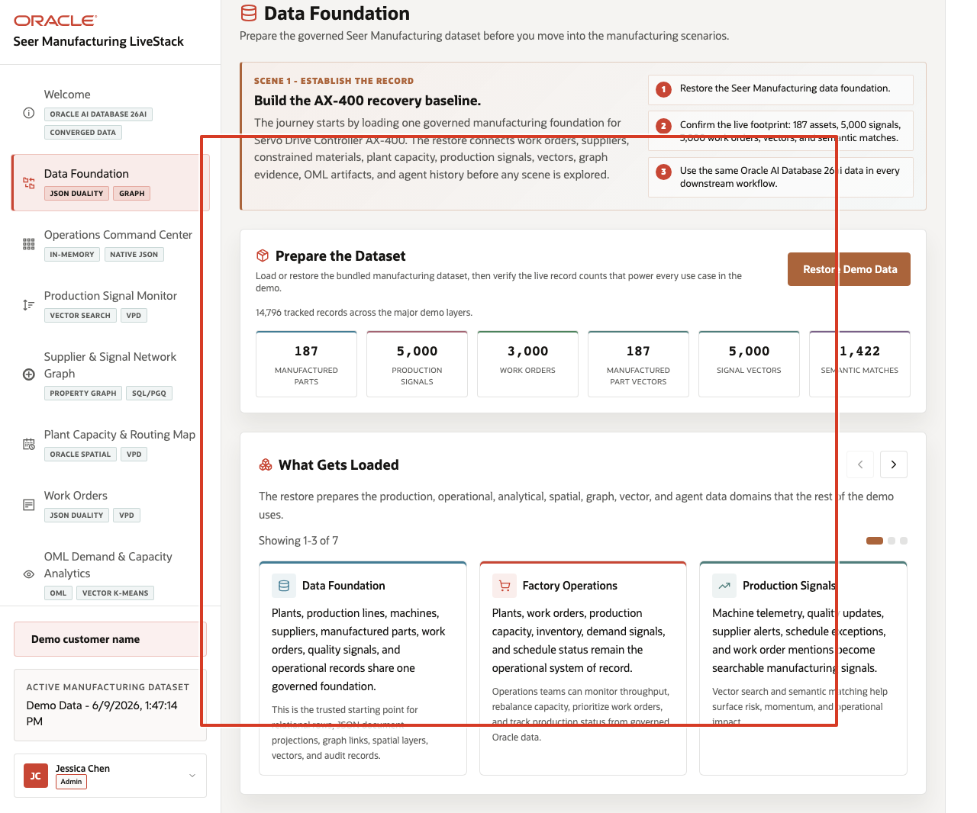
Figure 9. Downstream manufacturing scenes and loaded data domains highlighted from the Data Foundation page
The value of Oracle AI Database is that the demo can move across these workloads without sending the audience to separate systems or asking them to trust duplicated data. The later scenes show different interfaces over one governed manufacturing data platform.
You can move to the next scene.

Credits & Build Notes
Author - Oracle LiveLabs Team
Last Updated By/Date - Oracle LiveLabs Team, 2026-06-09

Scene 3 Operations Command Center

Introduction
The Operations Command Center is built for a manufacturing operations leader, plant manager, production supervisor, capacity planner, or manufacturing analyst who needs a daily operating view of work-order volume, production value, production signals, high-demand parts, plant capacity pressure, and AI-assisted actions. The goal is to see where the AX-400 recovery plan is under pressure before the issue becomes a missed-output escalation.
Dashboards like this are difficult to implement when work orders, production signals, supplier updates, capacity records, machine telemetry, and agent activity live in different systems. Teams often need duplicated extracts, separate BI models, and reconciliation logic before a dashboard can show a trustworthy view.
Oracle AI Database helps address that challenge by keeping operational, analytical, JSON, in-memory, and AI-ready data close to the same governed data foundation. In this scene, the dashboard brings together live manufacturing KPIs, production signal velocity, order value by part category, and high-demand manufactured parts without sending the user to another application.
Estimated Time: 10 minutes
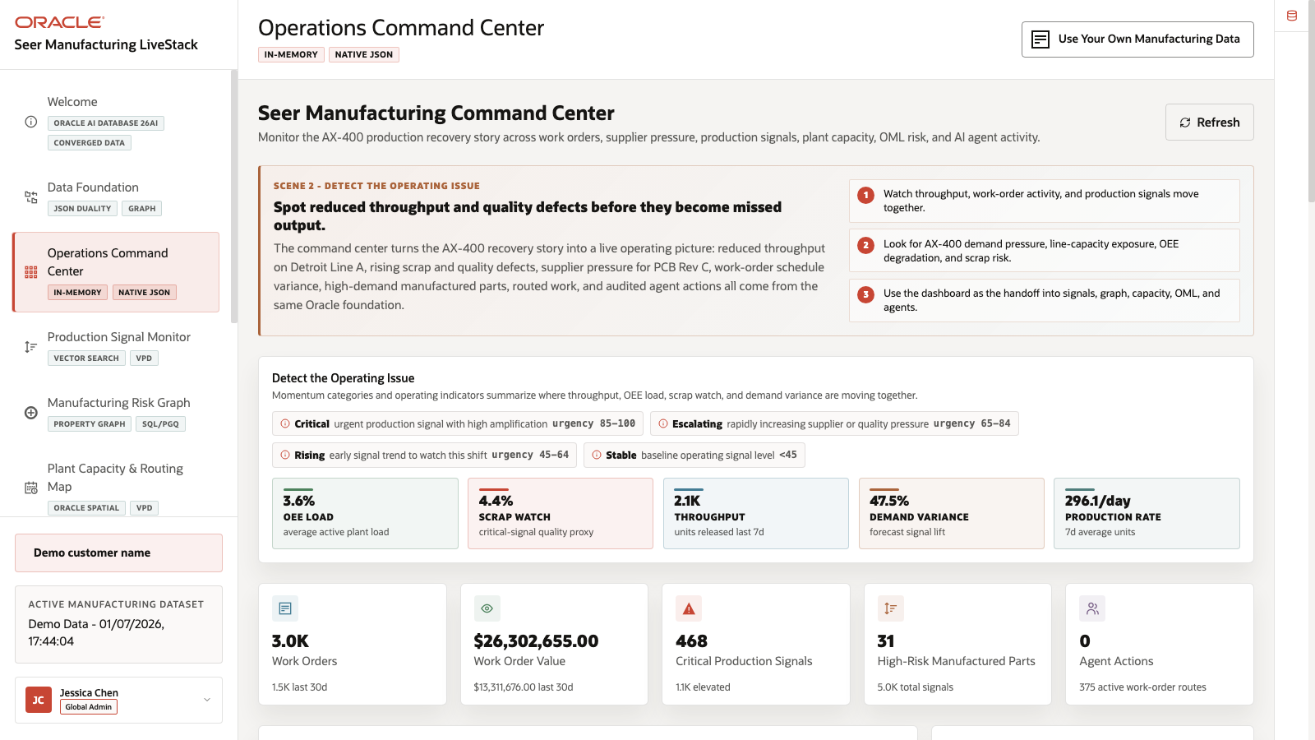
Figure 10. Operations Command Center with KPI cards, signal velocity, order value, and high-demand parts

Objectives
In this scene, you will:
Review the command center as a manufacturing operations user.
Interpret the KPI cards, production signal velocity chart, order value chart, and high-demand manufactured parts table.
Change the signal velocity time window.
Search or filter high-demand manufactured parts.
Use the Oracle Internals sidebar to explain why this dashboard can stay connected to governed Oracle data.

Task 1: Review the command center dashboard
- Click Operations Command Center in the sidebar.
- Review the KPI cards across the top of the page.
- Review Production Signal Velocity.
- Review Order Value by Part Category.
- Review High-Demand Manufactured Parts.
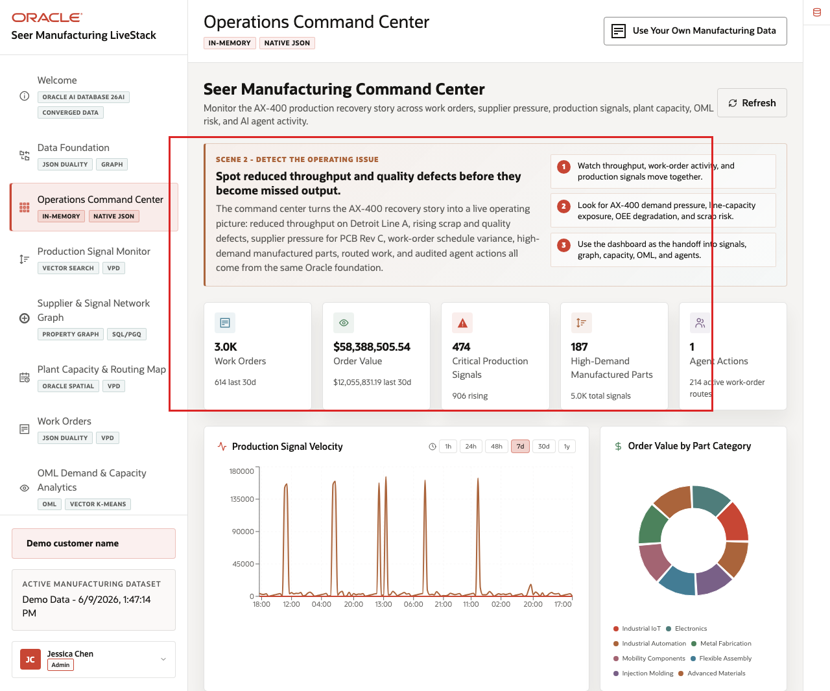
Figure 11. Operations Command Center KPI cards, signal velocity, and order value areas highlighted
- Open or review the Oracle Internals sidebar on the right.
In the current demo dataset, the page shows 3.0K work orders logged, about $12.06M in order value over the last 30 days, 474 critical production signals, 187 high-demand manufactured parts, and 2 completed agent actions. Use those numbers to frame the command center as a triage surface: the user can see work-order load, value exposure, signal pressure, watched parts, and AI activity in one place.

Task 2: Interpret signal velocity and order value
- Click a signal velocity time range such as 24h, 48h, or 7d.
- Review how the signal chart changes by time bucket.
- Review the order value chart by part category.
- Focus on visible categories such as Industrial IoT, Electronics, Industrial Automation, Metal Fabrication, and Mobility Components.
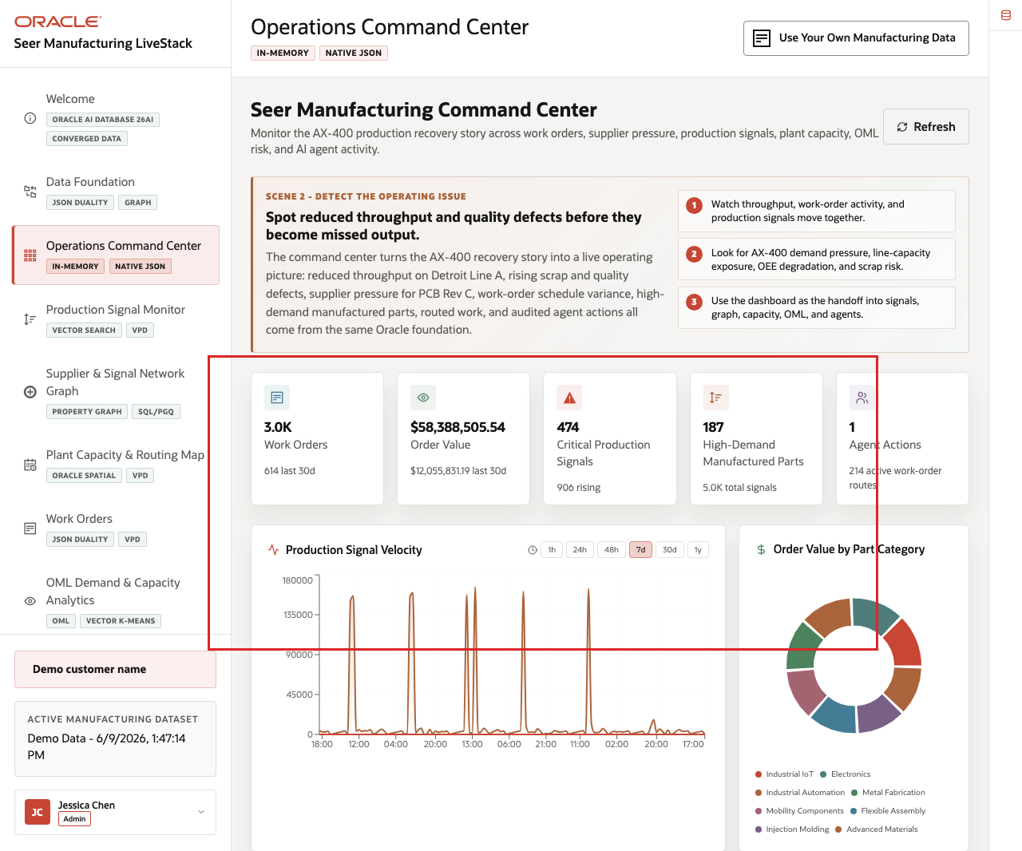
Figure 12. Signal velocity time controls, chart, and order value breakdown highlighted
This is the business story to emphasize: manufacturing users need to know where value, volume, and risk are moving together. A category with high order value and rising production signals may need a different operating response than a low-value category with stable capacity.

Task 3: Review high-demand manufactured parts
- Use the high-demand parts search box to filter for a part, product family, or program.
- Review the top watched rows.
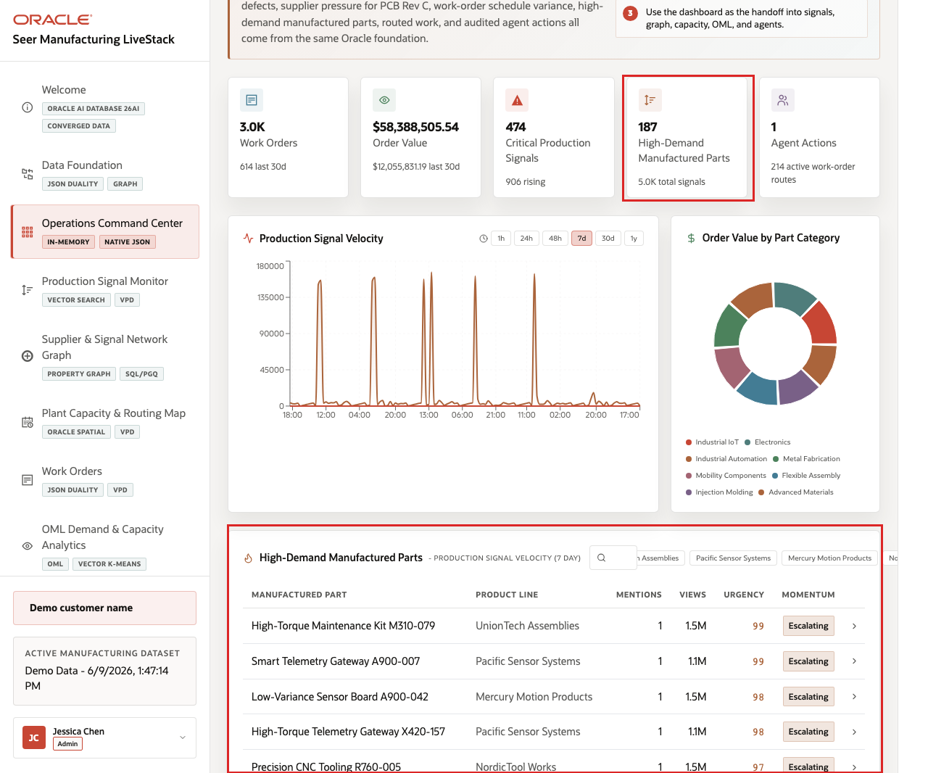
Figure 13. High-demand manufactured parts table with search and top rows highlighted
- Focus on rows such as High-Torque Maintenance Kit M310-079, Smart Telemetry Gateway A900-007, or Low-Variance Sensor Board A900-042.
- Review the columns for category, supplier or brand, signal count, urgency, views, and next operating context.
The high-demand parts table turns the KPI story into a set of manufacturing decisions. A plant manager or production supervisor can move from "critical production signals are high" to a specific manufactured part, supplier, or production line that needs review.
You can move to the next scene.

Credits & Build Notes
Author - Oracle LiveLabs Team
Last Updated By/Date - Oracle LiveLabs Team, 2026-06-09

Scene 4 Production Signal Monitor

Introduction
A quality engineer, production supervisor, maintenance planner, supplier manager, or manufacturing analyst uses this page to understand what production signals are saying before the risk is obvious in work-order volume alone. This persona is looking for patterns in machine telemetry, quality inspection findings, supplier updates, procurement alerts, rework notes, scrap risk, and work-order mentions. The goal is to connect operational language to affected manufactured parts quickly enough to act.
Semantic search is difficult to implement when signals, part catalogs, embeddings, search indexes, and access policies live in separate systems. Manufacturing teams often have to move operational text into external search services, synchronize vector indexes, and then rebuild access control outside the database.
Oracle AI Database helps address these challenges by keeping vector search close to governed manufacturing data. In this LiveStack Demo, the page uses natural-language search over manufactured-part and signal embeddings, shows match evidence, and keeps the operating feed tied to database access policies.
Estimated Time: 10 minutes
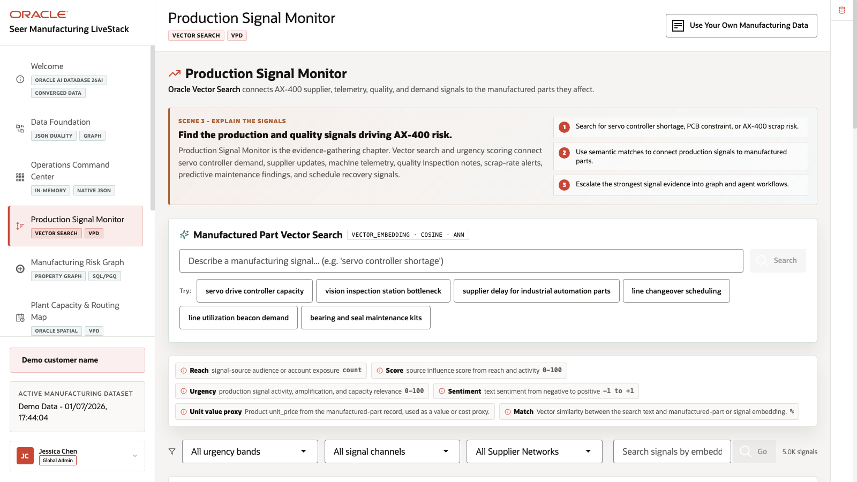
Figure 14. Production Signal Monitor page with semantic search controls and signal feed

Objectives
In this scene, you will:
Review the Production Signal Monitor workspace.
Run a semantic search for an AX-400 or servo controller capacity phrase.
Inspect matched manufactured parts and production signals.
Review the signal summary and matched production signal cards.
Understand why vector search and governed access matter for manufacturing signal discovery.

Task 1: Review the signal feed
- Click Production Signal Monitor in the sidebar.
- Review Manufactured Part Vector Search at the top of the page.
- Review the example query chips, including servo drive controller capacity, supplier delay for industrial automation parts, and line changeover scheduling.
- Review the signal count and active signal cards.
- Review urgency, source channel, reach, score, and signal text on the visible cards.
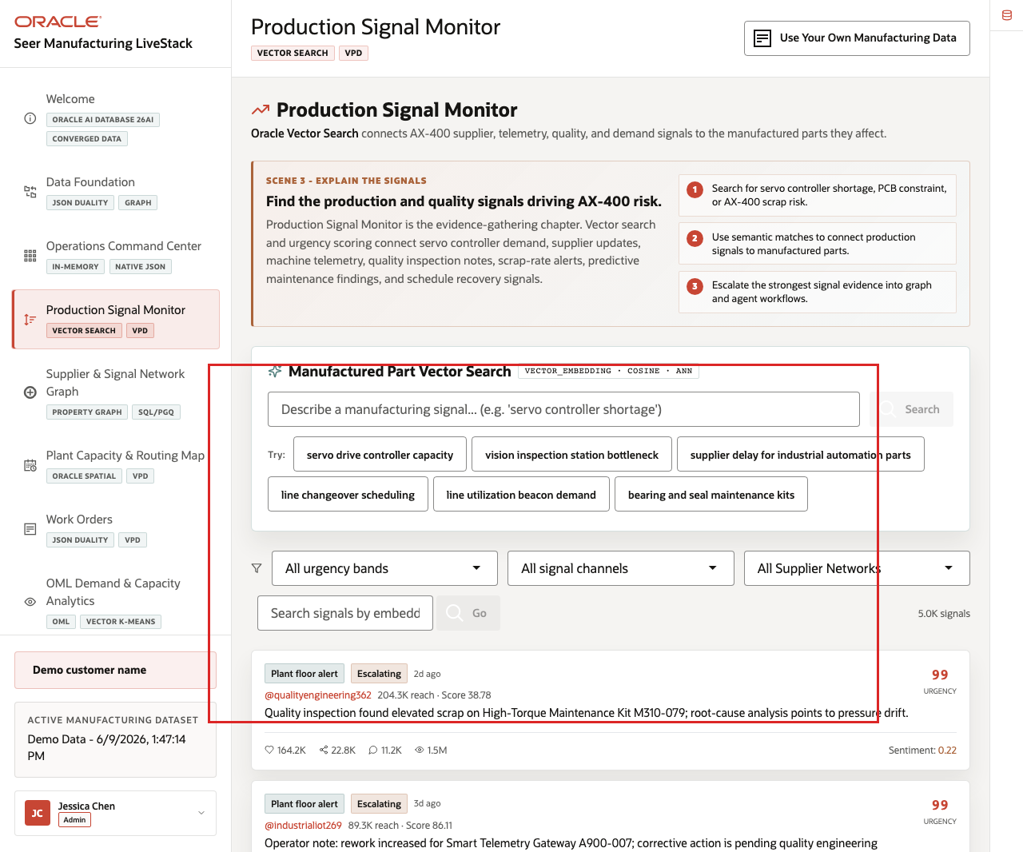
Figure 15. Production Signal Monitor search workspace, signal count, and signal feed highlighted
In the current demo dataset, the page shows 5.0K indexed production signals. Visible examples include quality inspection scrap findings, machine telemetry vibration alerts, procurement risk updates, and rework notes. Use this opening view to explain that the AX-400 recovery story is driven by many operational signals, not by a single dashboard number.

Task 2: Run manufactured-part semantic search
- Click the servo drive controller capacity example query chip, or enter servo drive controller capacity in the search field.
- Click Search.
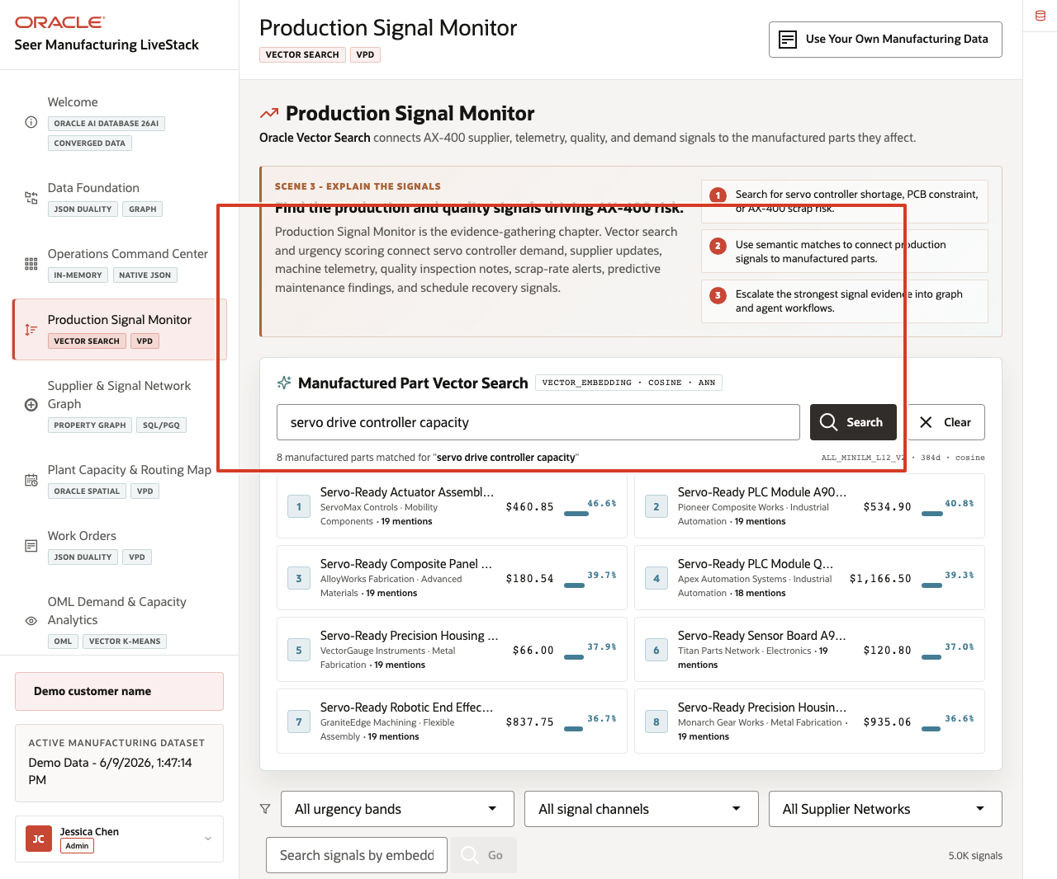
Figure 16. Semantic search results for servo drive controller capacity
- Review the matched manufactured parts or related signal evidence returned above the feed.
- Connect the result to the AX-400 story: the search is looking for semantically related part-capacity and production-risk language, not only exact keyword matches.
This is the data point to emphasize. A production supervisor can search for the operating concept they want to investigate, such as servo controller capacity, and the system can find related parts and signal evidence by vector similarity.

Task 3: Interpret the signal cards
- Scroll through the production signal cards.
- Review signal source, urgency, reach, score, sentiment, and the production issue described in each card.
- Focus on examples such as elevated scrap, abnormal vibration, constrained raw material allocation, or pending quality engineering corrective action.
- Use the action labels and scene transition to explain where the operator could go next: supplier graph, plant capacity map, work orders, OML analytics, Ask Data, or the agent console.
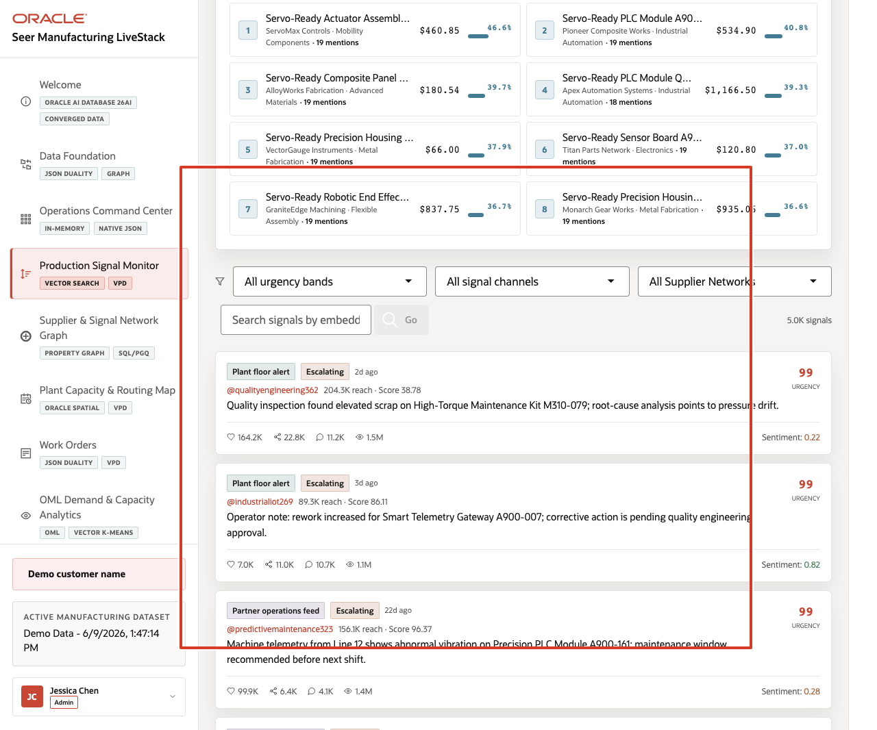
Figure 17. Production signal cards with urgency and manufacturing evidence highlighted
The value of Oracle AI Database is that operational text can become searchable manufacturing intelligence without leaving the governed data platform. Vector search helps users find related signals by meaning, while the Oracle-backed application still shows source, score, and operating context.
You can move to the next scene.

Credits & Build Notes
Author - Oracle LiveLabs Team
Last Updated By/Date - Oracle LiveLabs Team, 2026-06-09

Scene 5 Supplier and Signal Network Graph

Introduction
A supply chain analyst, plant manager, production supervisor, maintenance planner, quality engineer, or data architect uses this page to understand manufacturing relationships that are hard to see in isolated rows. The persona needs to reason across suppliers, constrained materials, manufactured parts, work orders, production lines, machines, maintenance events, quality issues, production signals, and risk cases.
This is difficult when relationship analysis requires data movement into a separate graph database or offline notebook. Manufacturing users may know that a supplier delay is creating schedule risk, but they need to see how CircuitForge, PCB Rev C, AX-400, WO-4501, Detroit Line A, machine telemetry, and scrap-risk findings connect without losing governance.
Oracle AI Database helps address these challenges by supporting graph analysis over the operational manufacturing schema. In this scene, the application exposes supplier and production-risk relationships while the sidebar explains the Oracle Property Graph and SQL/PGQ pattern behind the view.
Estimated Time: 10 minutes
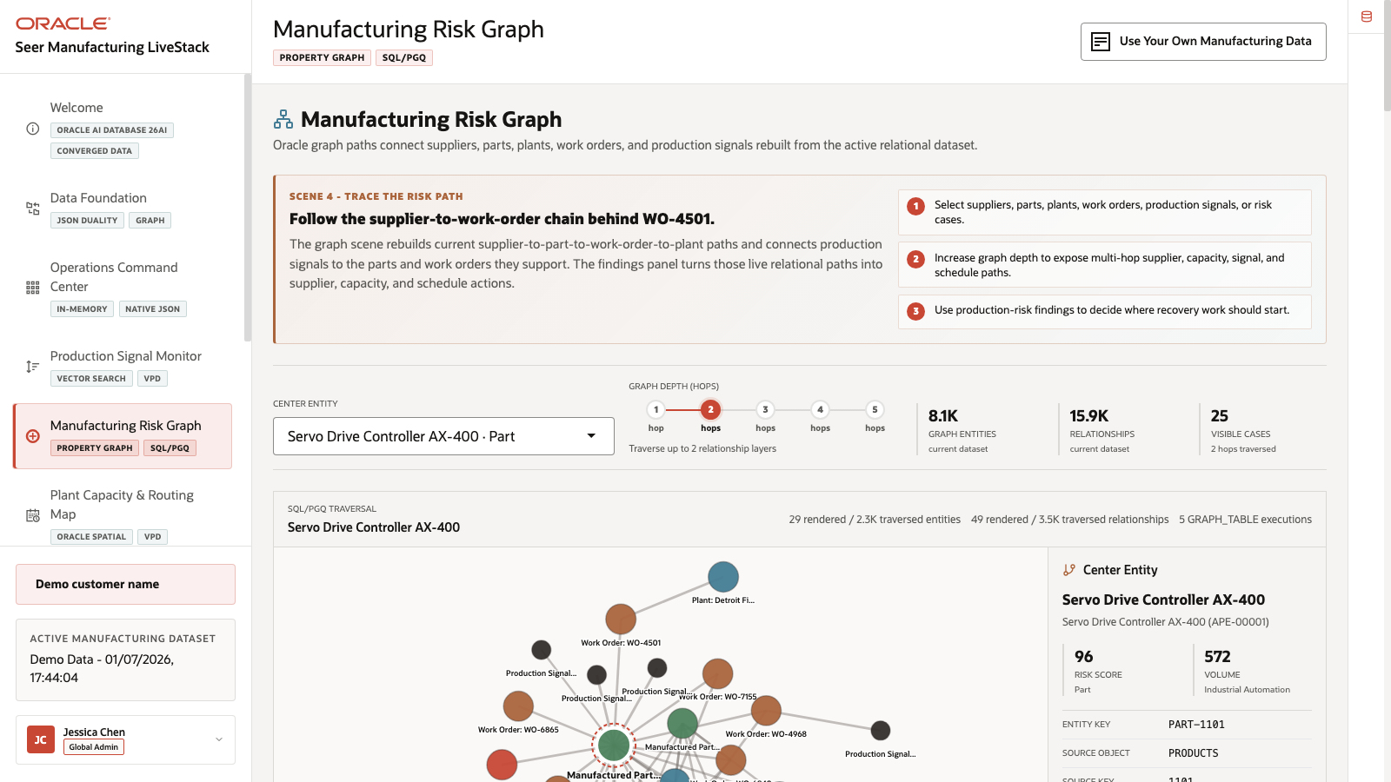
Figure 18. Supplier and Production-Risk Graph page with graph depth controls and manufacturing nodes

Objectives
In this scene, you will:
Review the Supplier and Production-Risk Graph workspace.
Inspect graph depth controls and the graph entity list.
Focus on the Supplier Delay Signal - PCB Rev C risk node.
Explain how graph relationships help identify connected production risk.
Connect the user-facing graph to Oracle Property Graph and SQL/PGQ.

Task 1: Review the graph workspace
- Click Supplier & Signal Network Graph in the sidebar.
- Review the graph depth controls: 1 Hop, 2 Hops, 3 Hops, 4 Hops, and 5 Hops.
- Review the search field for supplier, work order, machine, or risk lookup.
- Review Graph Entities.
- Open or review the Oracle Internals sidebar on the right.
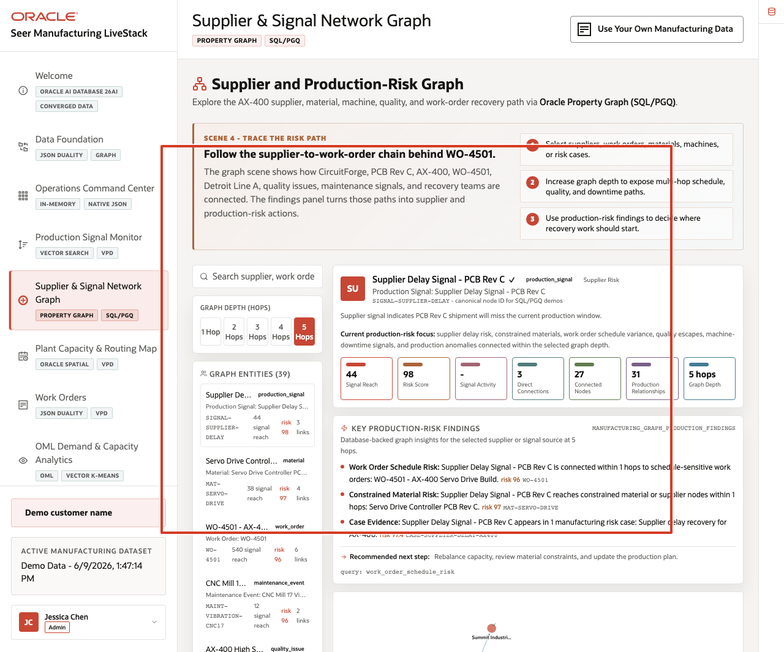
Figure 19. Supplier and production-risk graph workspace with depth controls, entity list, selected node metrics, findings, and graph canvas highlighted
In the current demo dataset, the page shows 39 graph entities. Visible nodes include Supplier Delay Signal - PCB Rev C, Servo Drive Controller PCB Rev C, WO-4501 - AX-400 Servo Drive Build, AX-400 High Scrap Rate, AX-400 Servo Drive Controller, CircuitForge Electronics Supplier Desk, CNC Mill 17, Line A - Servo Drive Assembly, and Detroit Final Assembly Plant.

Task 2: Explore a production-risk example
- In the entity list, locate Supplier Delay Signal - PCB Rev C.
- Review the node type, signal reach, risk score, link count, connected nodes, and production relationships.
- Compare it with nearby risk nodes such as Servo Drive Controller PCB Rev C, WO-4501 - AX-400 Servo Drive Build, AX-400 High Scrap Rate, and CircuitForge Electronics Supplier Desk.
- Change the graph depth from 1 Hop to 2 Hops, 3 Hops, or 5 Hops to explain how relationship scope changes.
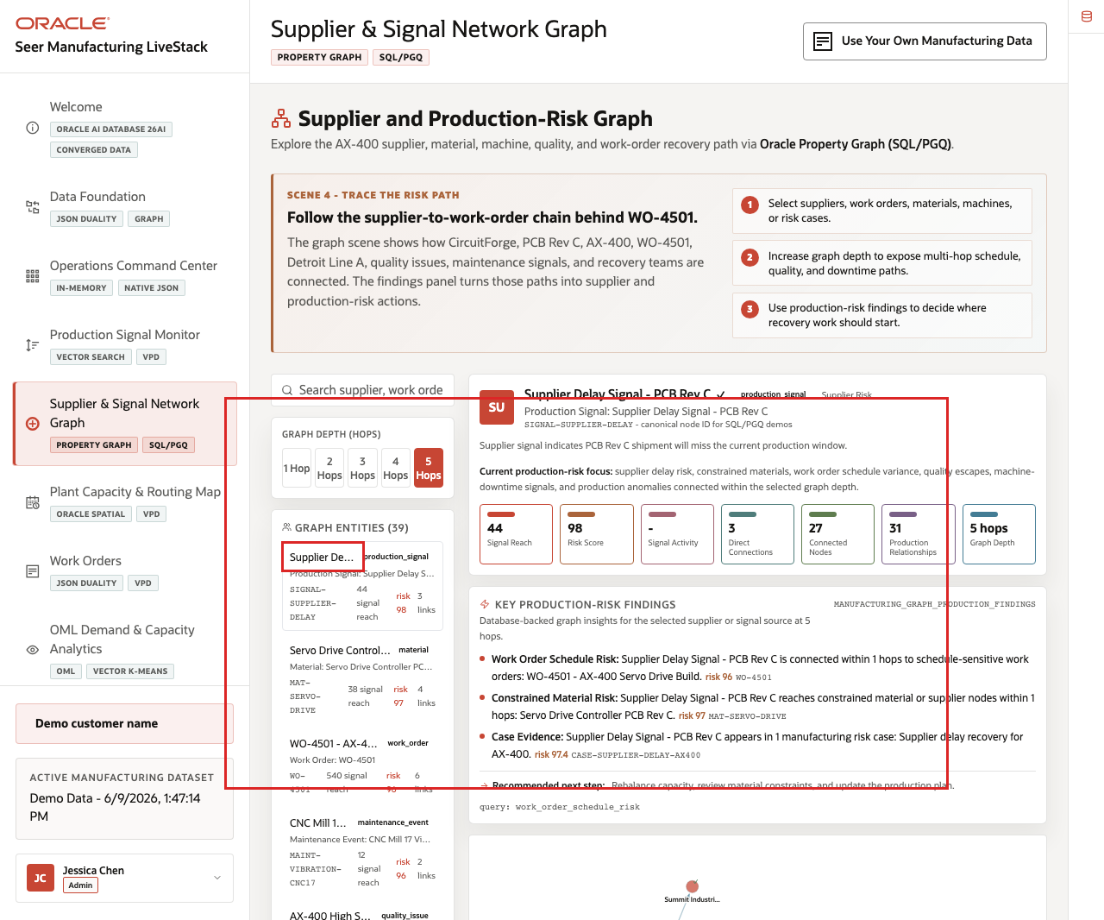
Figure 20. Supplier Delay Signal PCB Rev C node, risk findings, and connected production relationships highlighted
Use this example to explain why graph context matters. A supplier delay, constrained material, manufactured part, work order, production line, quality issue, and maintenance signal are more informative together than as independent records. The graph view helps the operator see the recovery path as connected evidence.

Task 3: Explain the Oracle graph pattern
- Scroll to the Graph Query Explorer area.
- Review example questions such as Supplier Delay Paths, Work Order Schedule Risk, Downtime Risk Paths, Constrained Material Paths, Quality Escape Paths, Risk Case Evidence Map, and Production Hub Detection.
- Review the Oracle Internals content that references property graph and SQL/PGQ.
- Explain that the graph is an analysis view over governed manufacturing data rather than a disconnected copy.
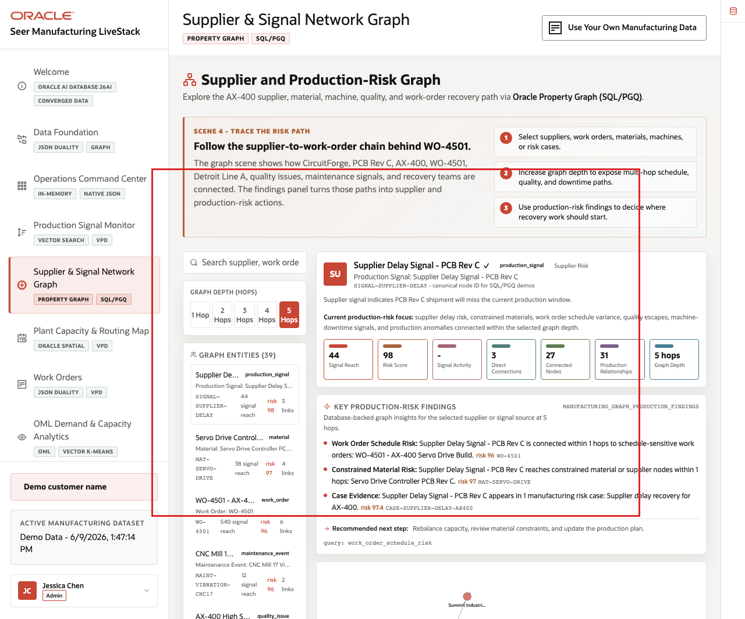
Figure 21. Graph Query Explorer SQL/PGQ options highlighted
The value of Oracle AI Database is that manufacturing teams can ask relationship-aware questions inside the same governed platform that stores the operational data. That reduces data movement and lets the graph story stay connected to the rest of the demo.
You can move to the next scene.

Credits & Build Notes
Author - Oracle LiveLabs Team
Last Updated By/Date - Oracle LiveLabs Team, 2026-06-09

Scene 6 Plant Capacity and Routing Map

Introduction
A plant capacity planner, production supervisor, supply chain analyst, field operations lead, or manufacturing operations leader uses this page to understand where plant capacity, demand regions, work-order routes, inventory constraints, and customer risk intersect. This persona needs a geographic operating view, not just a list of plants.
Location-aware manufacturing decisions are difficult when plant sites, work-order routes, demand regions, capacity zones, and customer risk tiers live outside the operational data platform. Teams may export to a GIS tool, but then lose the connection to current work orders, capacity levels, access controls, and operational status.
Oracle AI Database helps address these challenges by keeping spatial geometry and operational records together. In this scene, Oracle Spatial powers plant locations, routes, coverage zones, density grids, demand regions, and proximity context in the same application that manages the rest of the manufacturing data.
Estimated Time: 10 minutes
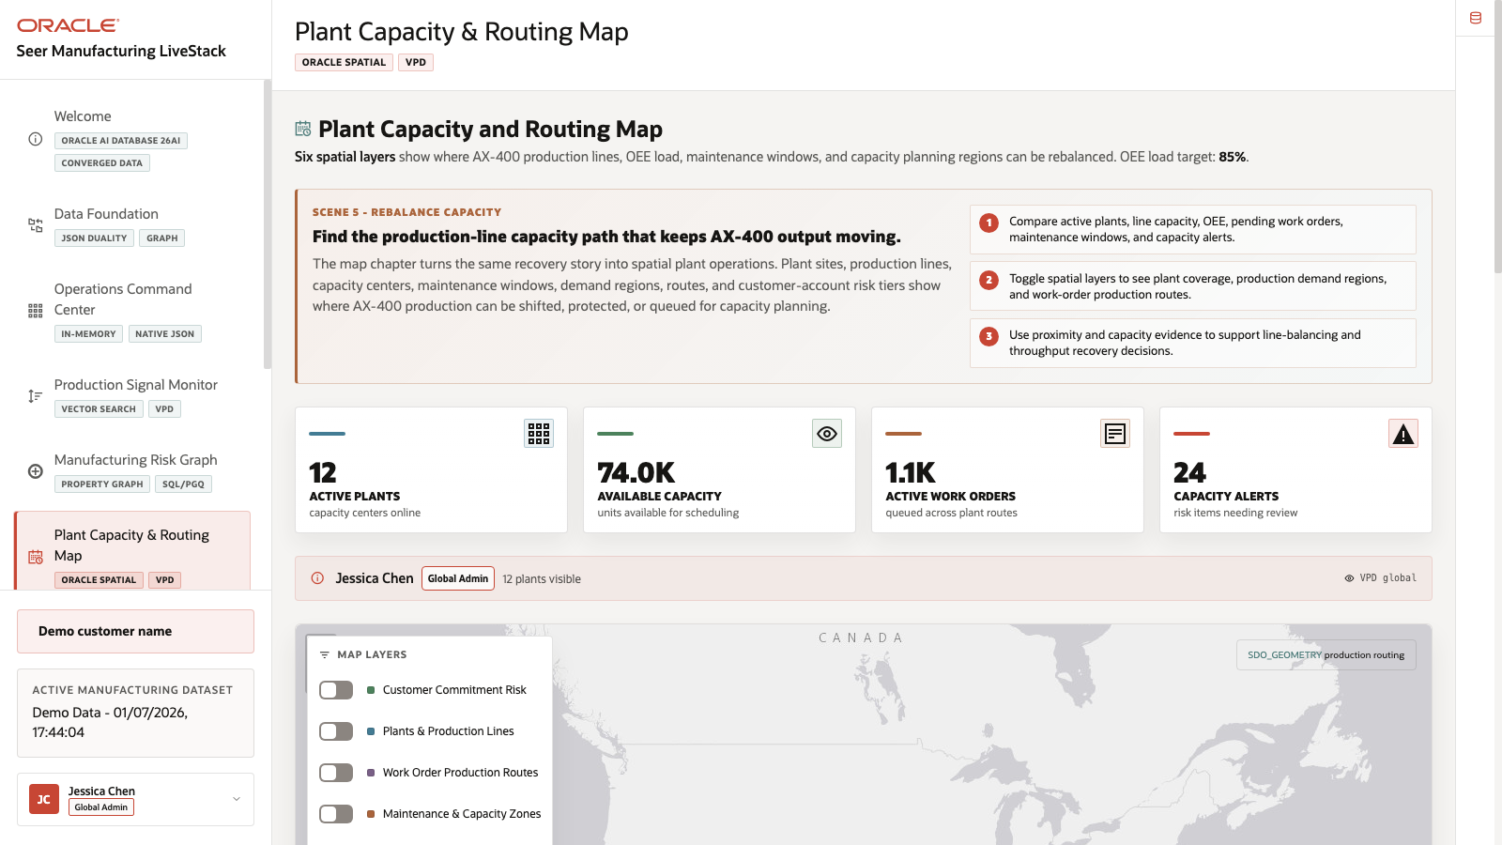
Figure 22. Plant Capacity and Routing Map with spatial layers, capacity cards, and plant table

Objectives
In this scene, you will:
Review the Plant Capacity and Routing Map as a geographic operating view.
Interpret the active plant, available capacity, pending work order, and capacity alert cards.
Toggle map layers for customer commitment risk, plants and production lines, work-order routes, maintenance and capacity zones, account density, and capacity planning regions.
Compare map evidence with the plant table.
Explain how Oracle Spatial supports location-aware manufacturing decisions.

Task 1: Review plant capacity priorities
- Click Plant Capacity & Routing Map in the sidebar.
- Review the stat cards across the top of the page.
- Review the current user and VPD banner.
- Review the map and the plant-capacity summary before changing layers.
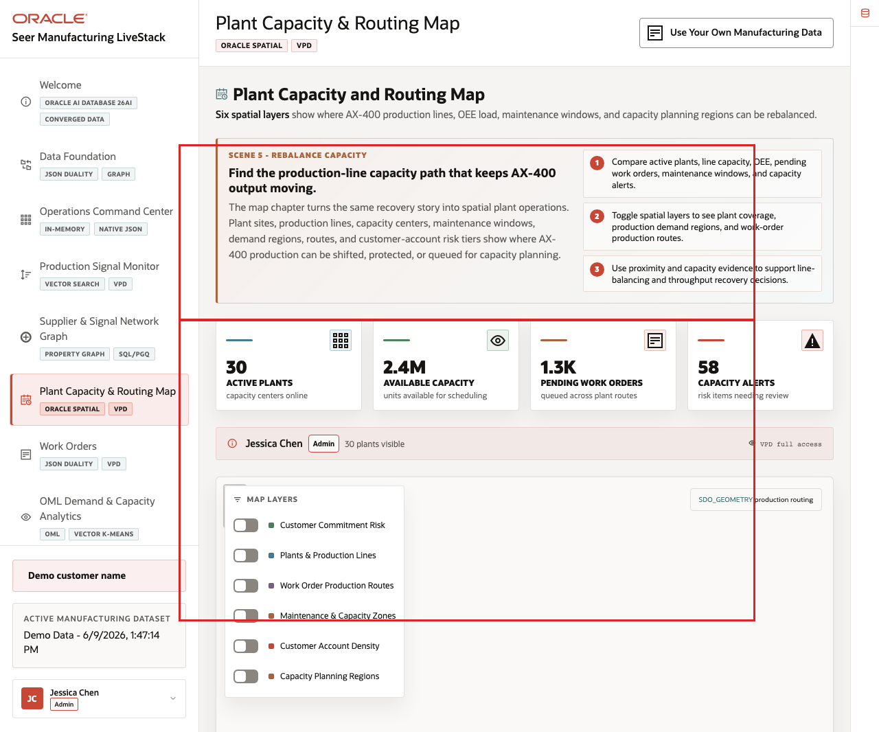
Figure 23. Plant capacity priority cards, active user, and VPD context highlighted
Use this opening view to explain the manufacturing problem. The AX-400 recovery plan needs to know where production can be shifted, which plants have available capacity, how many work orders are pending, and where capacity alerts may block a schedule recovery action.

Task 2: Toggle spatial layers
- Review the map and its layer controls.
- Toggle Customer Commitment Risk.
- Toggle Plants & Production Lines and Work Order Production Routes.
- Toggle Maintenance & Capacity Zones, Customer Account Density, and Capacity Planning Regions.
- Review how the map changes as layers are added or removed.
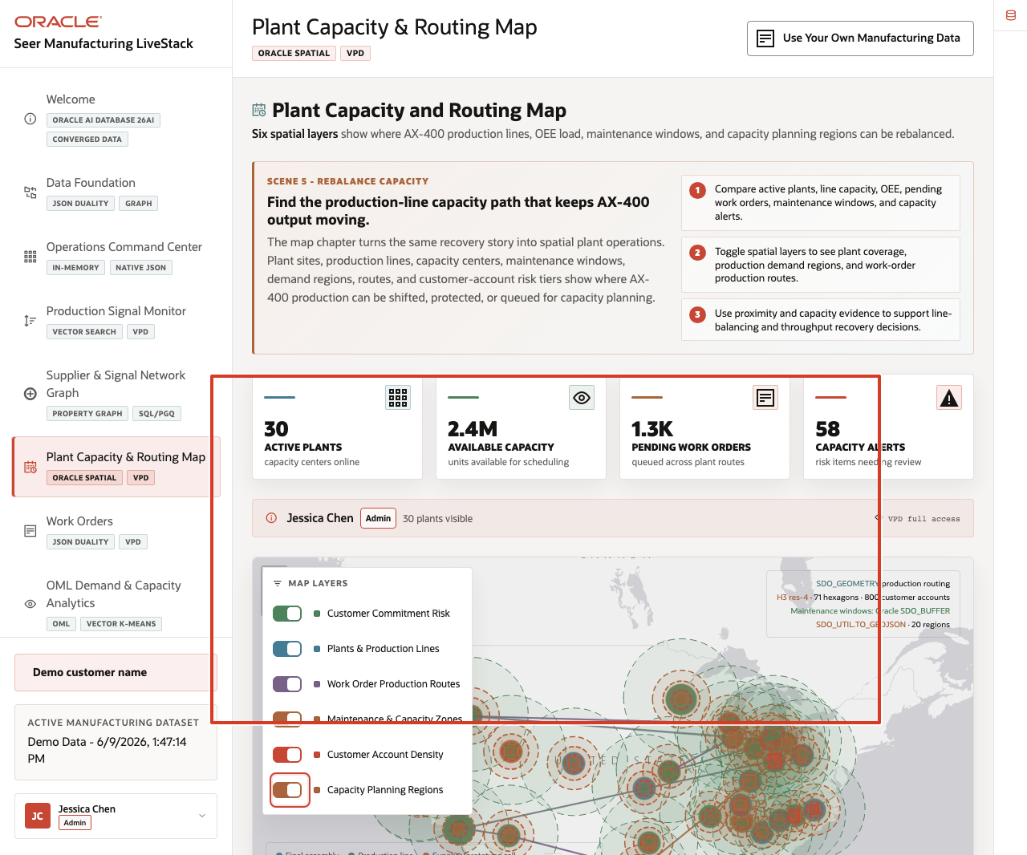
Figure 24. Plant capacity map layers with customer commitment risk, production lines, routes, density, and capacity planning overlays highlighted
The layer controls make the same map useful for different questions. A plant manager may start with plant locations and coverage zones. A supply chain analyst may focus on work-order routes. A capacity planner may compare demand regions and density with available production capacity.

Task 3: Compare plant data with the map
- Scroll to the Plants table.
- Review columns for center, location, type, supported products, capacity, pending work orders, load, and status.
- Use the table to connect map markers to concrete operating records.
- Explain how the same plant records can support both operational planning and spatial routing.
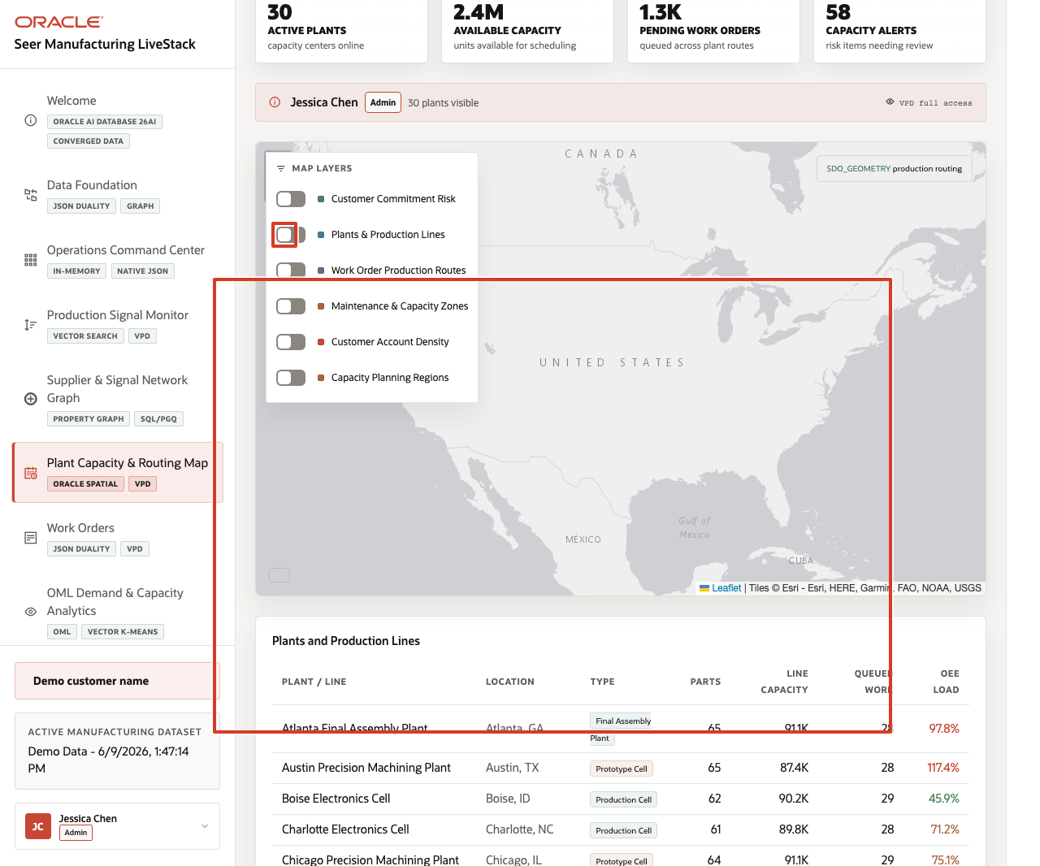
Figure 25. Plants table and selected operating rows highlighted
The value of Oracle AI Database is that location intelligence is not detached from the operational data. Oracle Spatial can support route coverage and proximity analysis while the application still shows capacity, pending work, alerts, and VPD-aware access from the same data foundation.
You can move to the next scene.

Credits & Build Notes
Author - Oracle LiveLabs Team
Last Updated By/Date - Oracle LiveLabs Team, 2026-06-09

Scene 7 Work Orders and JSON Duality

Introduction
A production supervisor, order operations manager, plant planner, supply chain analyst, or application architect uses this page to understand the same manufacturing transaction from multiple angles. The persona needs a reliable operational list, relational line-item detail, API-friendly JSON document access, and route context.
This is difficult to implement when work-order headers, line items, customer accounts, plant assignments, route state, and API payloads are handled in separate systems. Each copy creates synchronization risk and extra engineering work when the work-order model changes.
Oracle AI Database helps address these challenges by keeping the work-order record in one governed platform while exposing it through the shape each workflow needs. Relational tables provide transactional detail. JSON Relational Duality Views expose the same work order as a nested JSON document. Oracle Spatial adds plant route and distance context.
Estimated Time: 10 minutes
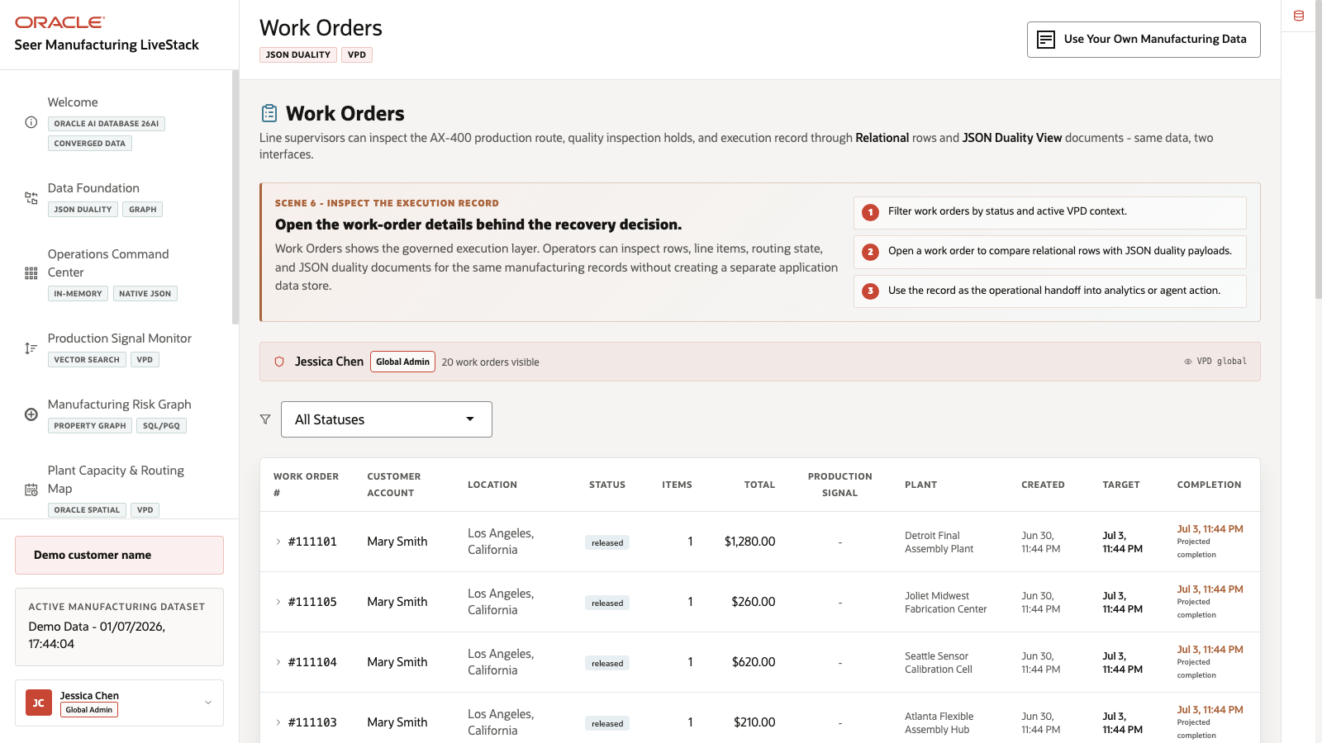
Figure 26. Work Orders page with VPD banner, status filter, and work-order table

Objectives
In this scene, you will:
Review the Work Orders page and active work-order table.
Inspect a specific work-order row.
Open the same work order as relational operational detail.
Compare that same work order with the JSON document returned by ORDERS_DV.
Review the work-order route context for the record.

Task 1: Review the work-order workspace
- Click Work Orders in the sidebar.
- Review the active user banner. The current demo user is Jessica Chen, with Admin access and 20 visible work orders on the page.
- Review the status filter.
- Review the table columns: work order number, customer, location, status, line items, total, production signal, plant, and created time.
- Focus on work order #142691.
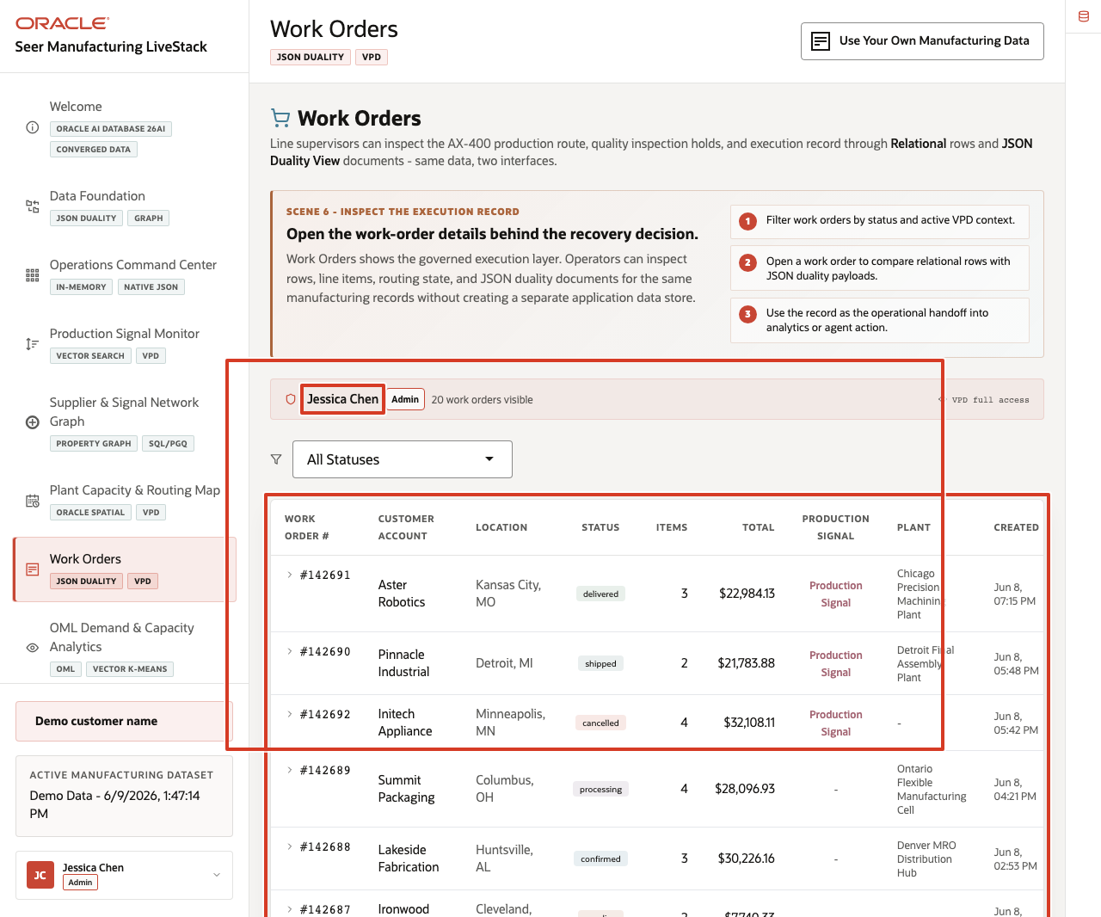
Figure 27. Work Orders workspace with active user banner, status filter, table, and work order 142691 highlighted
In the current demo dataset, work order #142691 is for Aster Robotics in Kansas City, Missouri. It is Delivered, has 3 line items, totals $22,984.13, and is fulfilled by Chicago Precision Machining Plant. This work order will be the data point used through the rest of the scene.

Task 2: Inspect the relational work-order detail
- Click work order #142691.
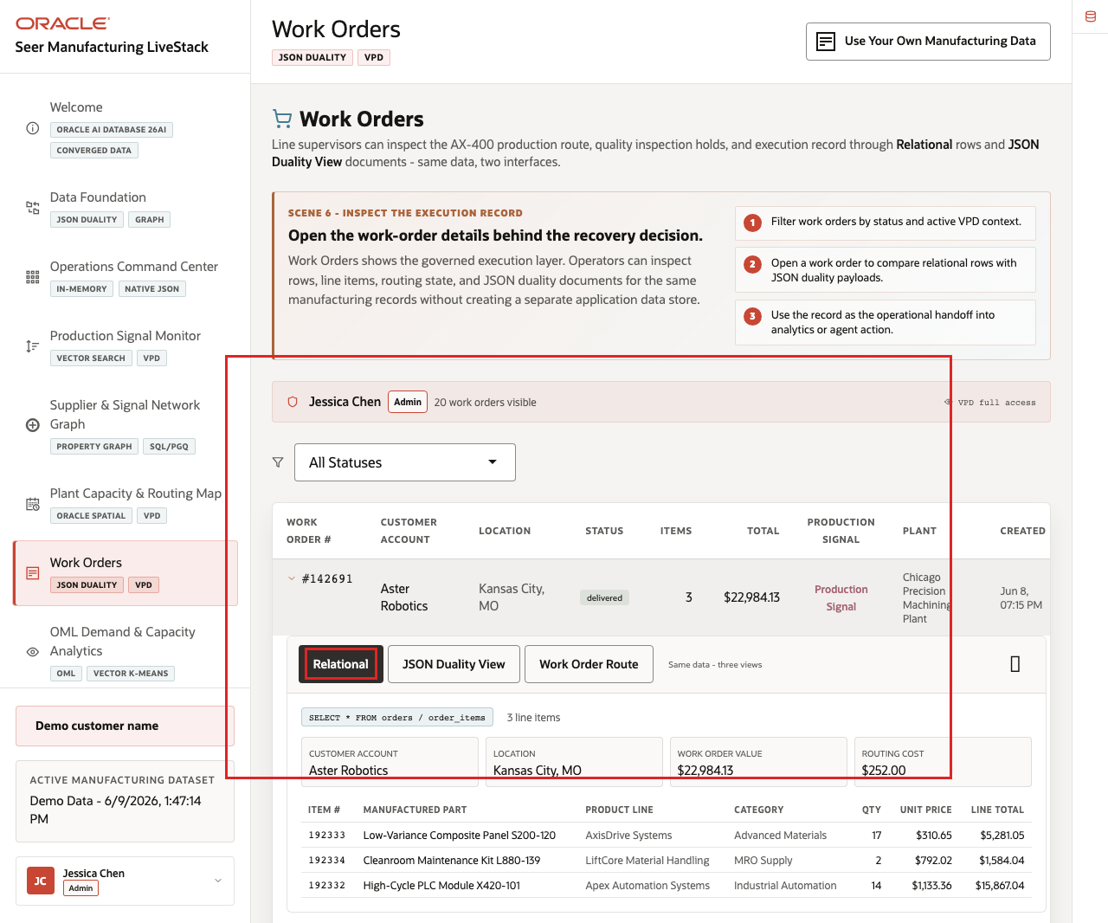
Figure 28. Relational detail for work order 142691
- Confirm the Relational tab is selected.
- Review customer, location, work-order value, plant assignment, and route cost.
- Review the line-item table.
For work order #142691, the relational view shows line items such as Low-Variance Composite Panel S200-120, Cleanroom Maintenance Kit L880-139, and High-Cycle PLC Module X420-101. This view is useful for operations because the work-order header and item detail remain normalized and easy to validate.

Task 3: Compare the JSON Duality View
- Click JSON Duality View in the expanded work-order panel.
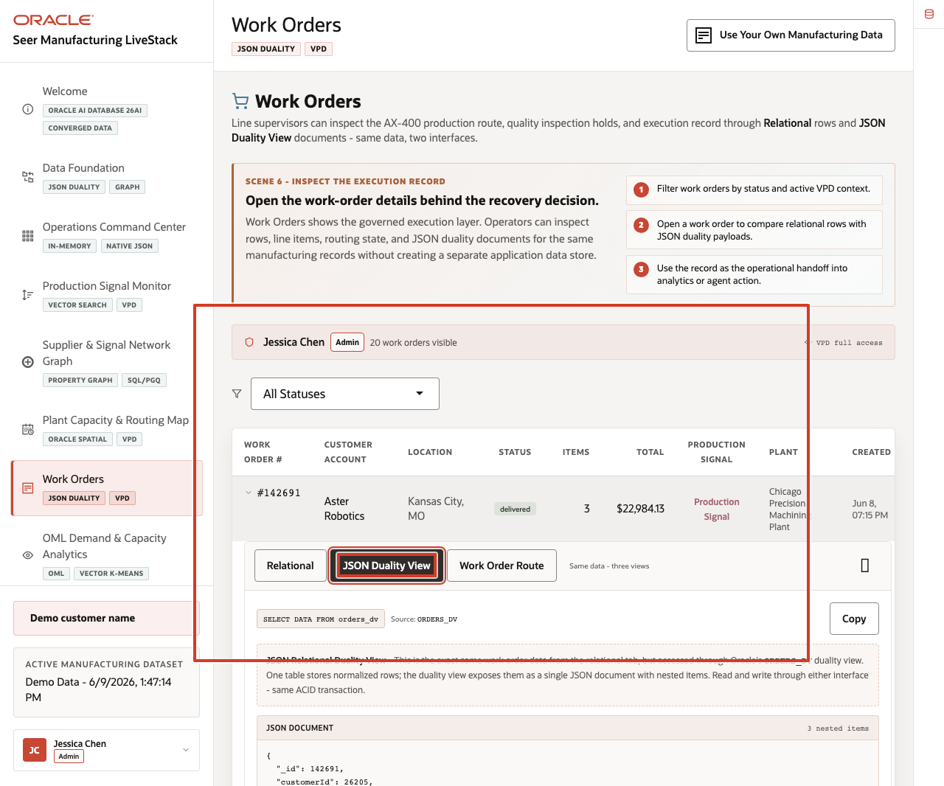
Figure 29. JSON Duality View for work order 142691
- Review the source label ORDERS_DV.
- Review the JSON document for work order 142691.
- Notice that the document contains _id, customerId, status, total, shippingCost, demandScore, createdAt, and nested items.
This is the key point of the page. The JSON document is not a separate copy of the work order. It is the same governed work-order data exposed through an Oracle JSON Relational Duality View. Application teams can use document-shaped access while operations teams continue to work with relational tables and SQL.

Task 4: Review route context
- Click Work Order Route in the expanded work-order panel.
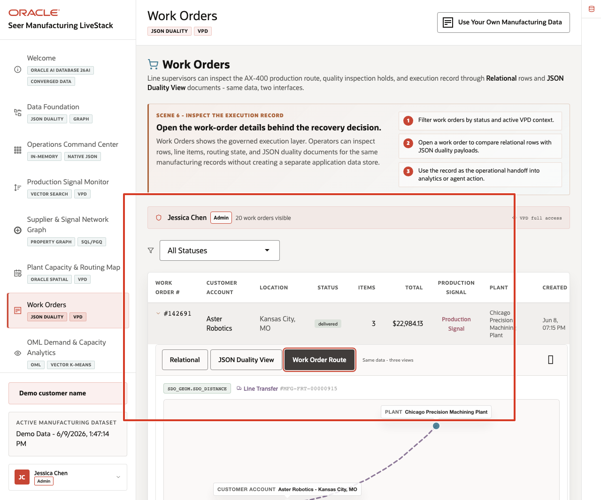
Figure 30. Work-order route context for work order 142691
- Review the assigned plant and customer location.
- Review distance, shipping or route cost, status, and work-order progress.
- Use the route view to explain how spatial context stays connected to the same governed work-order record.
For work order #142691, the page connects Chicago Precision Machining Plant to Aster Robotics in Kansas City, Missouri. The page shows how Oracle Spatial can provide route context while JSON Duality and relational views expose the same work-order truth.
The value of Oracle AI Database is that the same work order can support operations, API access, and route analysis without splitting the story across separate persistence layers.
You can move to the next scene.

Credits & Build Notes
Author - Oracle LiveLabs Team
Last Updated By/Date - Oracle LiveLabs Team, 2026-06-09

Scene 8 OML Demand and Capacity Analytics

Introduction
A manufacturing analytics manager, capacity planner, quality engineer, maintenance planner, or data science stakeholder uses this page to understand which predictive signals should drive action. This persona needs to know which manufactured parts have demand surge risk, how customers and OEMs segment by ordering pattern, whether order value is trending, which parts cluster semantically, and where capacity risk needs attention.
This is difficult when predictive work is split across notebooks, exported CSV files, BI extracts, external ML services, and separate operational systems. Manufacturing teams can lose trust in predictions when model features are stale, scoring jobs run away from live data, or the explanation behind a forecast is disconnected from the work-order and capacity records that business users rely on.
Oracle AI Database helps address these challenges by keeping machine learning close to governed manufacturing data. Oracle Machine Learning models and SQL analytics can run from the same connected data foundation that powers the rest of the LiveStack Demo.
Estimated Time: 12 minutes
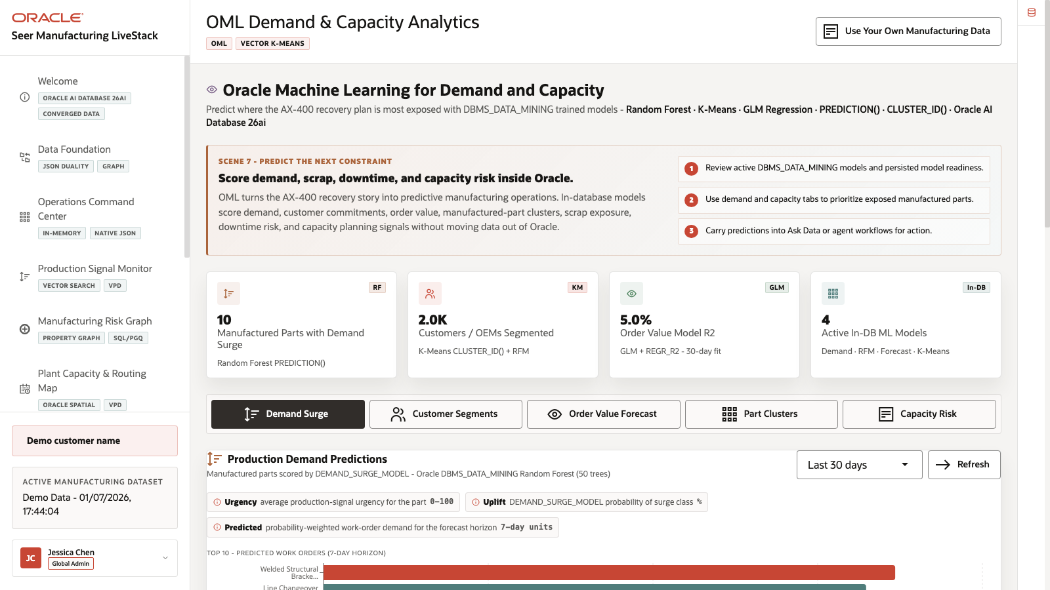
Figure 31. OML Demand and Capacity Analytics page with KPI cards and five analytics tabs

Objectives
In this scene, you will:
Review the OML Demand and Capacity Analytics workspace, KPI cards, and five analytics tabs.
Inspect Demand Surge predictions.
Review Customer Segments.
Interpret the Order Value Forecast.
Explore Part Clusters.
Review Capacity Risk intelligence and risk indicators.

Task 1: Inspect Demand Surge predictions
- Click OML Demand & Capacity Analytics in the sidebar.
- Review the four KPI cards at the top of the page: Manufactured Parts with Demand Surge, Customers / OEMs Segmented, Order Value Model R2, and Active In-DB ML Models.
- Review the five analytics tabs: Demand Surge, Customer Segments, Order Value Forecast, Part Clusters, and Capacity Risk.
- Confirm that Demand Surge is selected.
- Review the scoring window, Refresh control, bar chart, and prediction table.
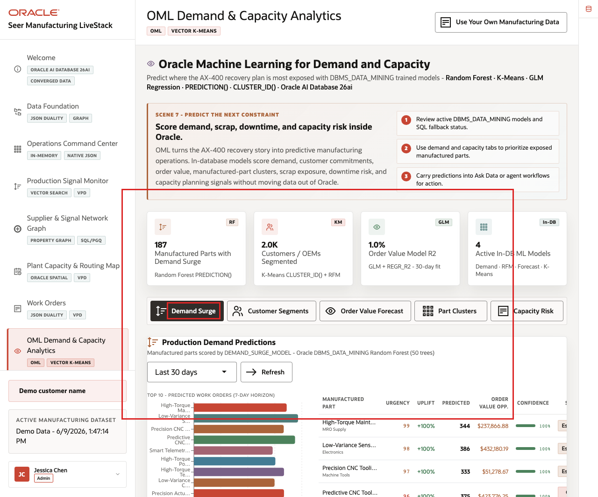
Figure 32. Demand Surge predictions with active tab, chart, and prediction table highlighted
Use this opening view to set the scene: this page is not a separate data science notebook. It is a business-facing analytics surface backed by in-database analytics. The demand predictions help the team decide which parts, suppliers, and plant-capacity decisions deserve attention before schedule risk becomes missed output.

Task 2: Review Customer Segments
- Click Customer Segments.
- Review the Segment Distribution chart.
- Review the repeat-order risk distribution.
- Review Segment Summary and Top customer accounts by RFM score.
- Optionally click a segment filter to focus the account list.
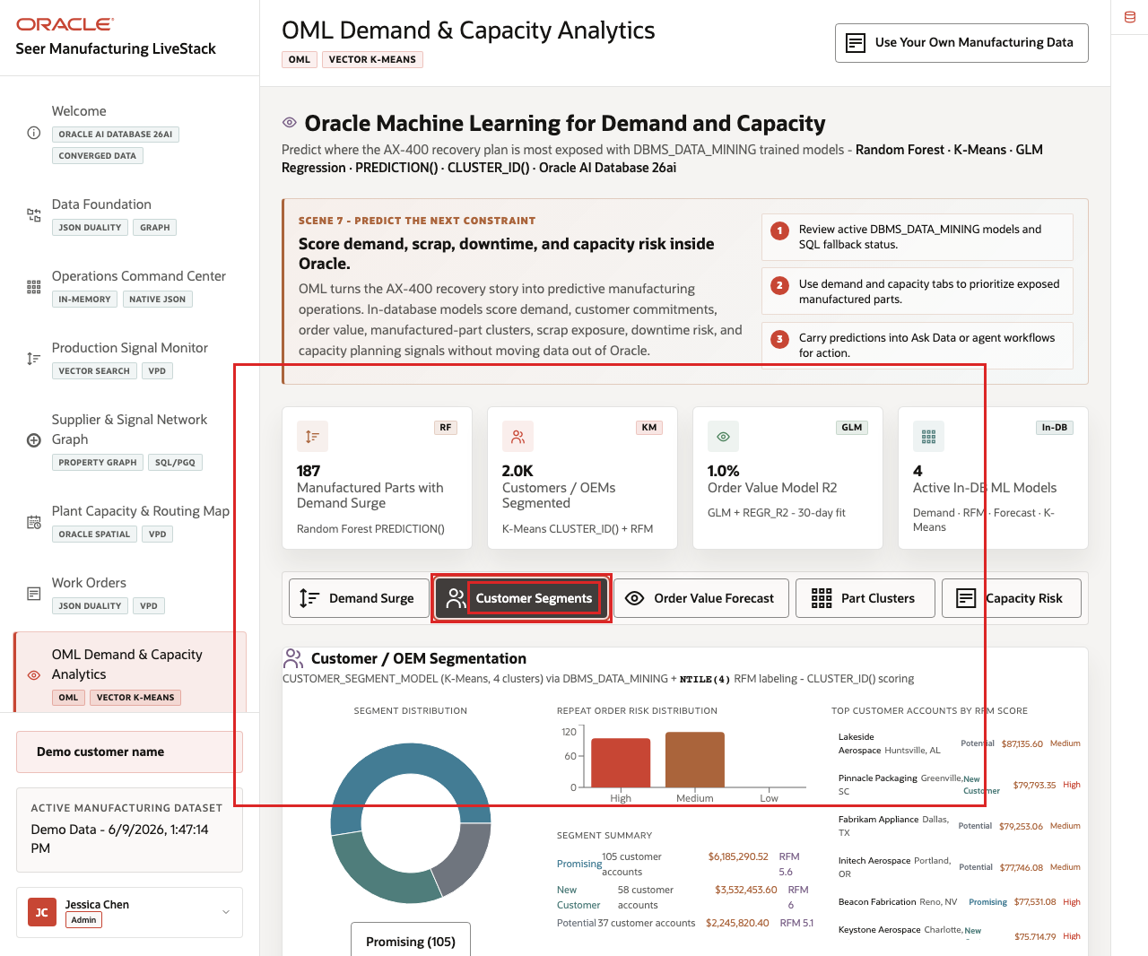
Figure 33. Customer Segments tab with segment distribution and top accounts highlighted
This is useful for manufacturing operations teams because segmentation becomes operational. The team can move from a model result to the accounts, OEMs, or demand patterns that need follow-up, production planning, or capacity allocation.

Task 3: Interpret Order Value Forecast
- Click Order Value Forecast.
- Review the forecast horizon selector and Refresh control.
- Review the model quality cards: R² (fit quality), Daily Slope, Mean Daily Order Value, and Observations.
- Review the order value trend chart and forecast band.
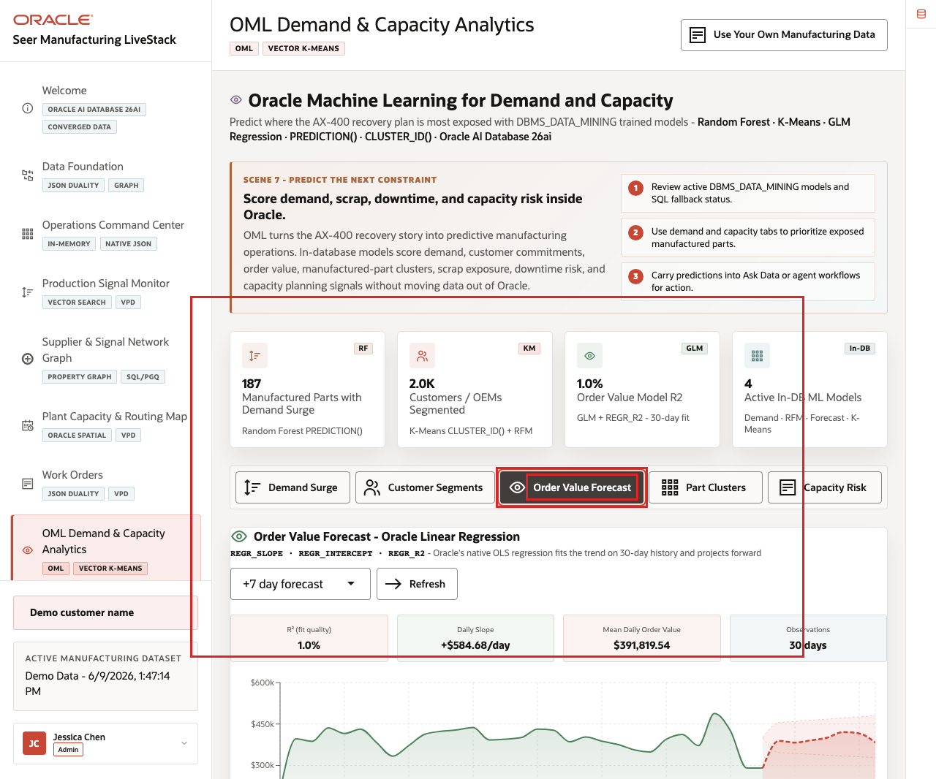
Figure 34. Order Value Forecast tab with model quality cards and forecast chart highlighted
Use this forecast as a trust discussion. The page does not hide model quality. It shows the fit, slope, and observation window so a planner can treat the forecast as operational context instead of over-trusting a black-box prediction.

Task 4: Explore Part Clusters
- Click Part Clusters.
- Review the K = controls.
- Review the cluster count, parts clustered, embedding dimensions, and distance metric.
- Review a cluster card and its related manufactured parts.
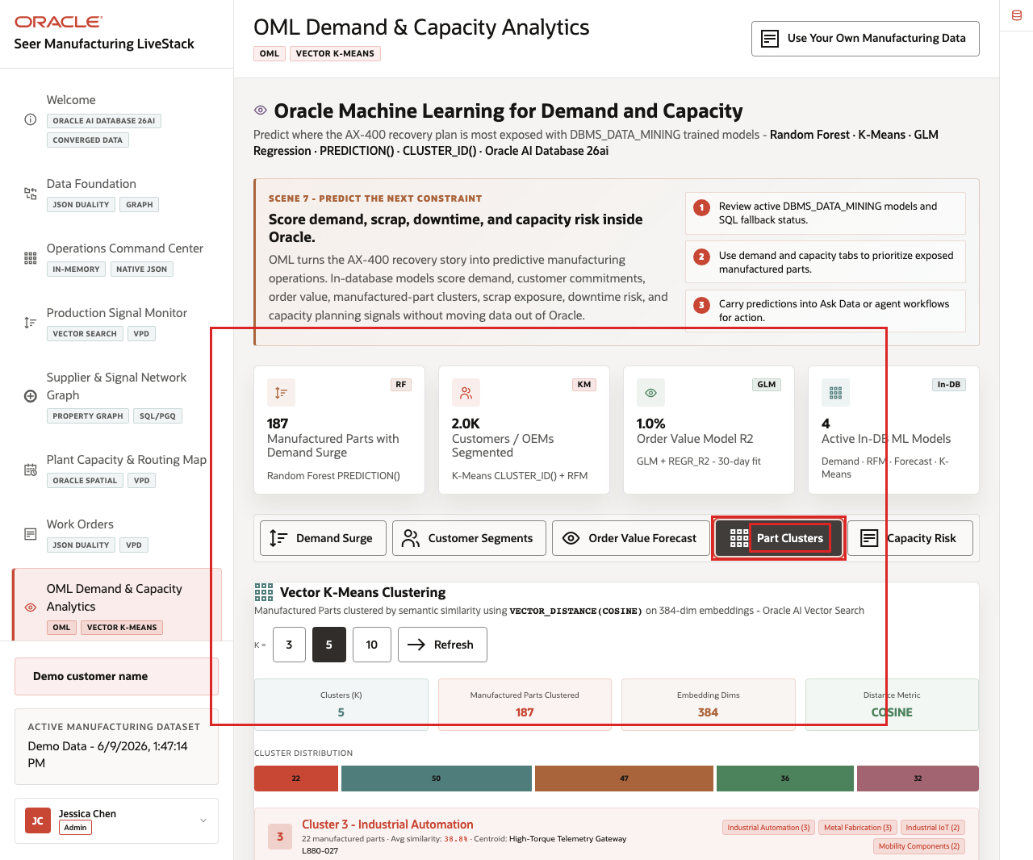
Figure 35. Part Clusters tab with vector K-Means controls and cluster cards highlighted
This helps users understand how vector similarity can group manufactured parts without leaving the governed data platform. The same vector infrastructure that supports production-signal search can also support manufacturing analytics.

Task 5: Review Capacity Risk
- Click Capacity Risk.
- Review the summary cards.
- Review the capacity status distribution.
- Review monitored capacity by plant or capacity center.
- Scan the highest risk indicators for parts or plants that need attention.
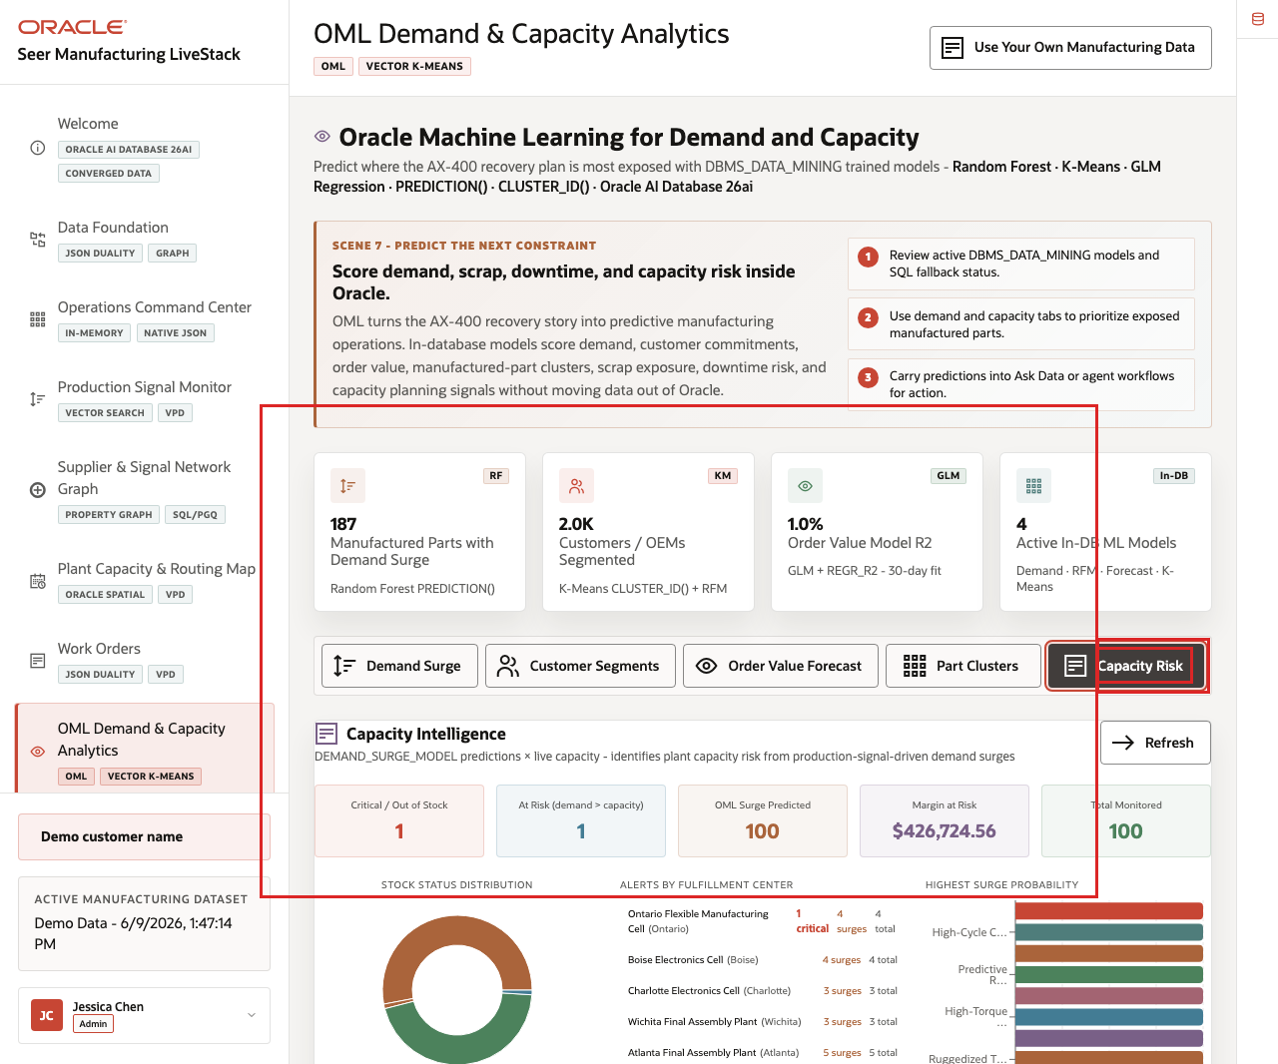
Figure 36. Capacity Risk Intelligence tab with risk counts and monitored capacity highlighted
This turns model output into an operating view: the user can see which parts, plants, and capacity centers need attention before a constraint affects the AX-400 recovery plan.
You can move to the next scene.

Credits & Build Notes
Author - Oracle LiveLabs Team
Last Updated By/Date - Oracle LiveLabs Team, 2026-06-09

Scene 9 Ask Manufacturing Data

Introduction
A manufacturing business analyst, operations leader, plant manager, production supervisor, quality engineer, maintenance planner, or data steward uses this page when they need an answer before a custom report can be built. The persona may understand the production question clearly but not know the exact schema, joins, filters, or SQL required to answer it.
Natural-language data access can create governance risk if the language model generates invalid SQL, references the wrong tables, hides the query path, or exposes more data than the user should see. Manufacturing teams need self-service analytics, but data teams still need traceability, read-only execution, and a clear source of truth.
Oracle AI Database helps address these challenges by keeping query execution grounded in the live manufacturing schema. In this LiveStack Demo, the app sends the question and schema context to the local Ollama runtime, validates the generated SQL path, and uses Oracle AI Database 26ai as the execution authority.
Estimated Time: 10 minutes
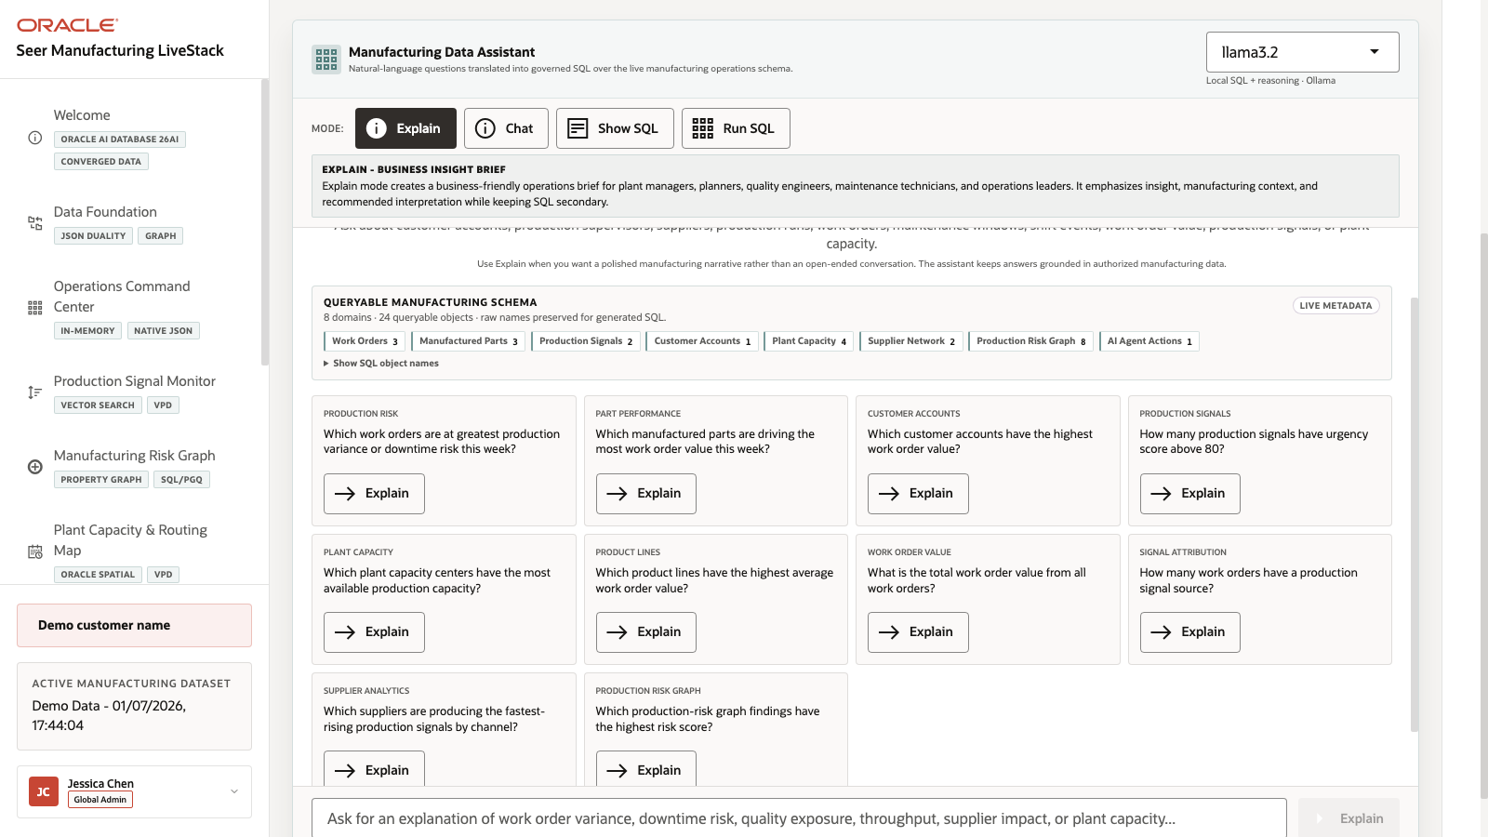
Figure 37. Ask Manufacturing Data workspace with modes, schema metadata, and example questions

Objectives
In this scene, you will:
Review the Ask Manufacturing Data workspace, runtime profile, and modes.
Compare Explain, Chat, Show SQL, and Run SQL against the same manufacturing question.
Use Explain to return a plain-English answer without foregrounding SQL.
Use Chat to return a conversational answer with follow-up prompts.
Use Show SQL to inspect generated SQL before execution.
Use Run SQL to return live rows from Oracle AI Database.
Explore a production-risk graph question grounded in AX-400 recovery evidence.
Understand how natural-language analytics can remain transparent and database-governed.

Task 1: Use Explain mode for a narrated answer
- Click Ask Manufacturing Data in the sidebar.
- Review the runtime profile in the top right of the assistant card. The current demo uses llama3.2 through the local Ollama runtime.
- Review the queryable schema summary. The current page shows 8 domains and 23 queryable objects.
- Click Explain.
- Click Explain on the Production Risk Graph question: Which production-risk graph findings have the highest risk score?
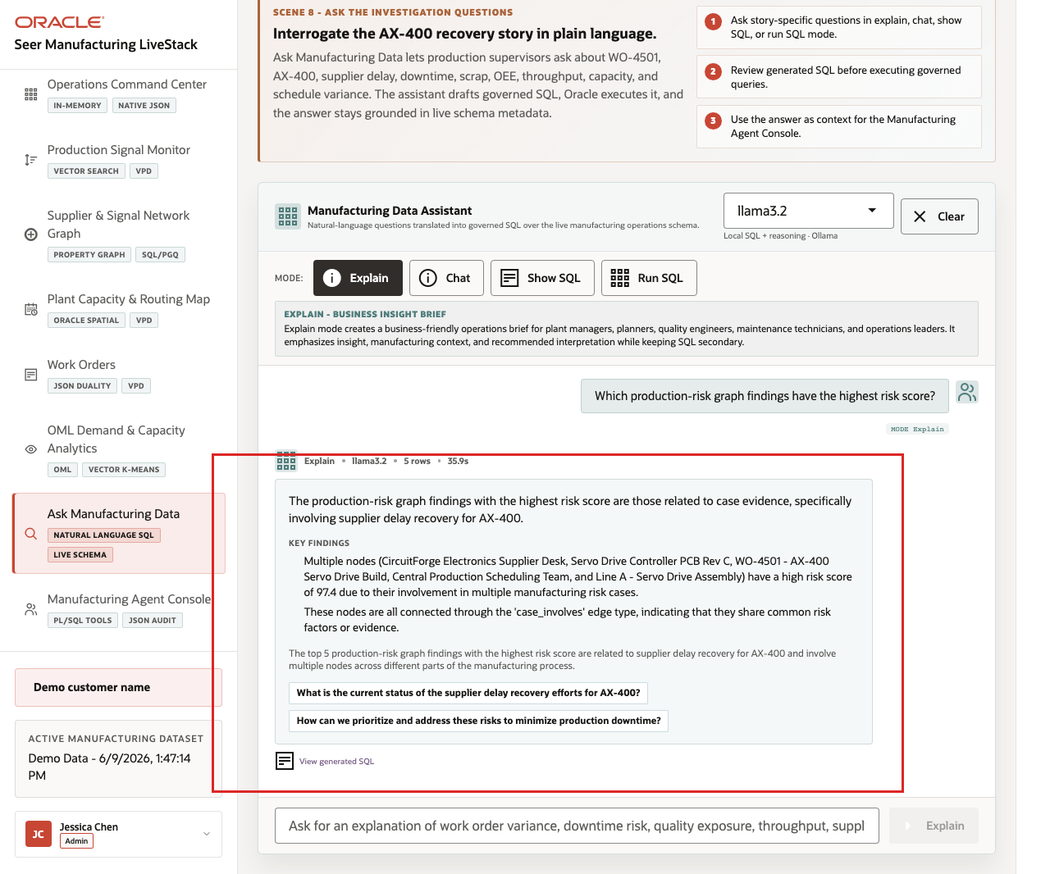
Figure 38. Explain mode response for the manufacturing production-risk graph question
Expected result: The assistant returns a narrated answer and key findings without making the generated SQL the main artifact. Use this mode when the user wants a business-readable answer first. The system still uses governed SQL behind the scenes, but the presentation is optimized for a plant manager, production supervisor, or operations analyst.

Task 2: Use Chat mode for a conversational answer
- Click Clear if the Explain result is still visible.
- Click Chat.
- Click Chat on the same Production Risk Graph question.
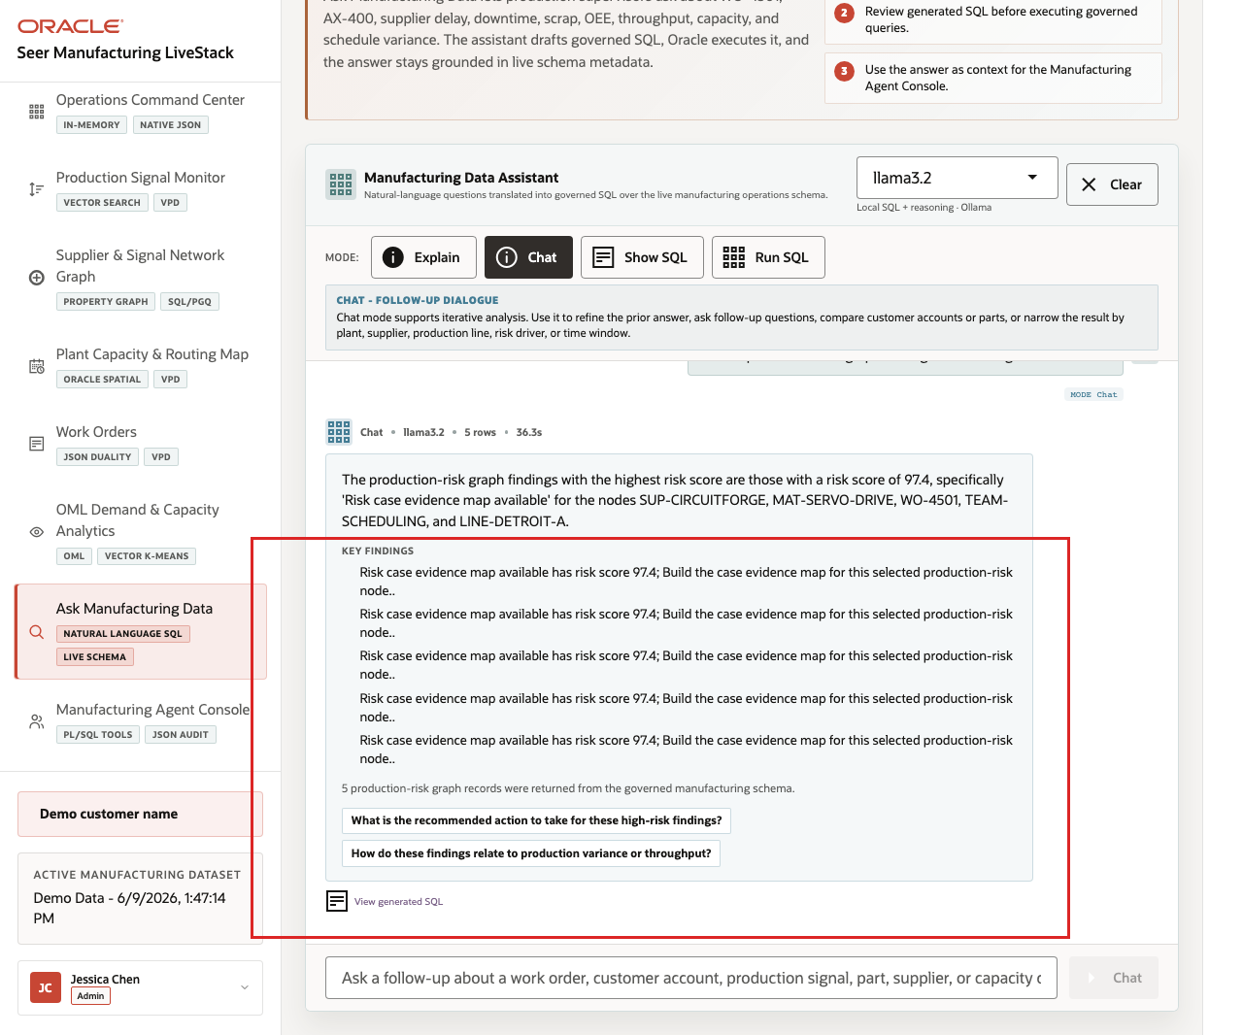
Figure 39. Chat mode response for the manufacturing production-risk graph question
Expected result: The assistant returns a conversational response and follow-up prompts. Use this mode when the user is exploring the data interactively. Chat mode keeps the answer grounded in the live manufacturing schema, but it is shaped for follow-up questions such as breaking the result down by work order, supplier, production line, or risk case.

Task 3: Use Show SQL mode to inspect the query path
- Click Clear if the Chat result is still visible.
- Click Show SQL.
- Click Show SQL on the same Production Risk Graph question.
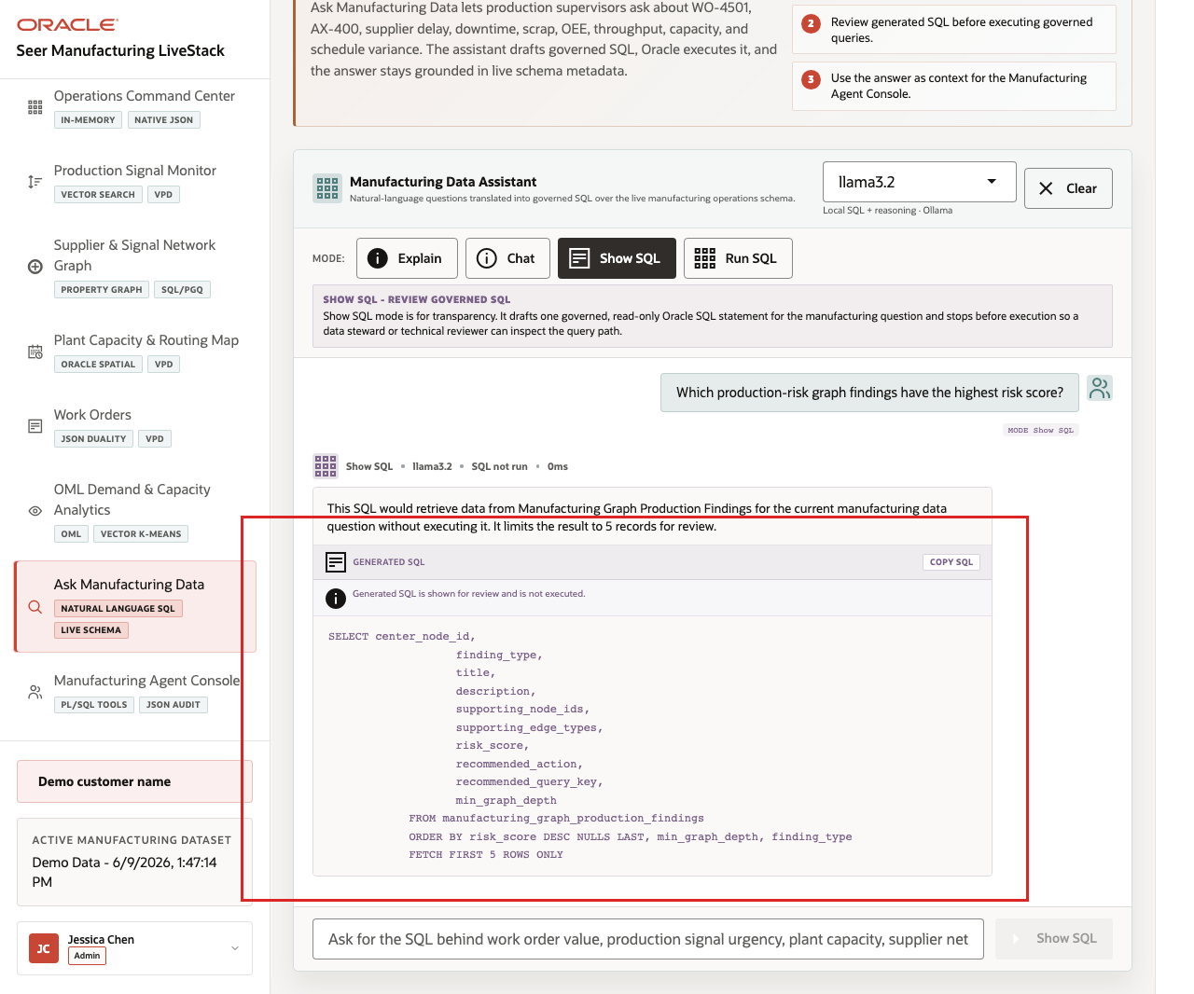
Figure 40. Generated SQL for the manufacturing production-risk graph question
- Review the generated SQL.
The generated SQL reads from manufacturing_graph_production_findings, orders by risk_score DESC NULLS LAST, then by graph depth and finding type, and limits the result with FETCH FIRST 5 ROWS ONLY. This is the governance moment in the scene: the user can inspect the query path before asking the database to return rows.
Use this mode when the user, data steward, or technical reviewer wants to verify what will run before rows are returned. The language model proposes the SQL, but the query path remains visible and reviewable.

Task 4: Use Run SQL mode to inspect returned rows
- Click Clear if the generated SQL result is still visible.
- Click Run SQL.
- Click Run SQL on the same Production Risk Graph question.
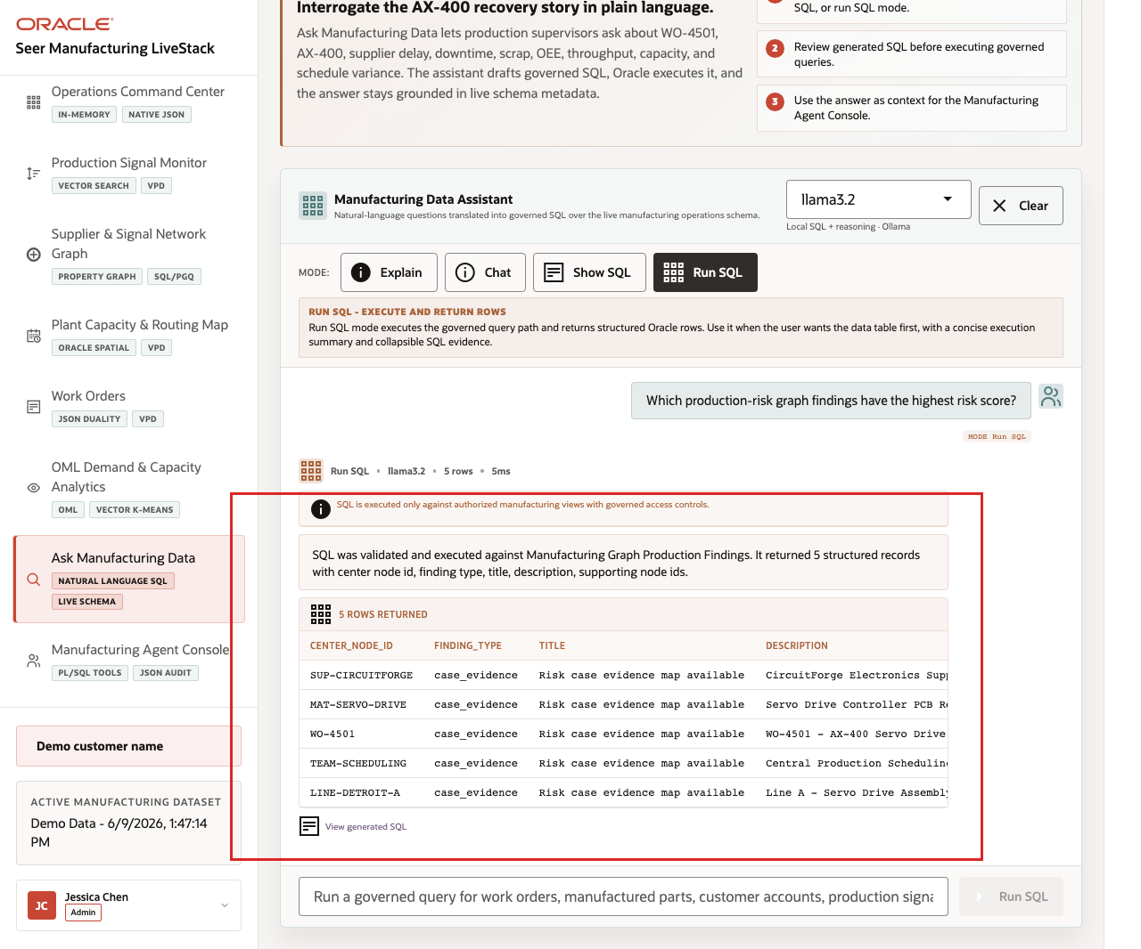
Figure 41. Run SQL results for the manufacturing production-risk graph question
- Review the returned table.
In the current demo dataset, the question returns 5 rows. The top risk findings are tied to CircuitForge Electronics Supplier Desk, Servo Drive Controller PCB Rev C, WO-4501 - AX-400 Servo Drive Build, Central Production Scheduling Team, and Line A - Servo Drive Assembly, each with a 97.4 risk score and case-evidence recommendations.
This is the data point to emphasize during the demo. A plain-English question surfaces specific operating risk by supplier, material, work order, scheduling team, production line, score, and recommended action. The business user can discover the issue without writing SQL, while the SQL and database result remain visible for trust.
Use the four completed mode examples to explain the governance pattern behind the page:
- The user asks a manufacturing question in plain English.
- The app builds prompt and schema context for the selected runtime profile.
- Ollama drafts SQL or a response plan.
- Oracle AI Database executes authorized SQL against the live schema.
- The UI returns visible SQL, rows, or a narrated answer depending on the selected mode.
This pattern matters because manufacturing users want faster answers, but they also need governed access. Ask Manufacturing Data shows how natural-language analytics can support self-service exploration without hiding the query path or replacing the database as the trusted execution layer.
You can move to the next scene.

Credits & Build Notes
Author - Oracle LiveLabs Team
Last Updated By/Date - Oracle LiveLabs Team, 2026-06-09

Scene 10 Manufacturing Agent Console

Introduction
A manufacturing operations leader, production supervisor, plant capacity planner, quality engineer, maintenance planner, or AI platform owner uses this page to see how agentic assistance can support day-to-day manufacturing decisions. This persona is not only interested in whether an AI agent can answer a question. They need to know which specialist path handled the request, which tools were used, what data was returned, and whether the action was recorded for later review.
This is difficult to implement when AI agents operate as black boxes outside the operational data platform. Manufacturing teams may get a recommendation, but not the routing decision, SQL or PL/SQL tool path, confidence, or audit record behind it.
Oracle AI Database helps address these challenges by keeping the source data, SQL execution, PL/SQL tools, and durable action logging in the database. In this LiveStack Demo, the app orchestrates the agent workflow, Ollama provides reasoning, and Oracle AI Database 26ai executes the governed data operations.
Estimated Time: 10 minutes
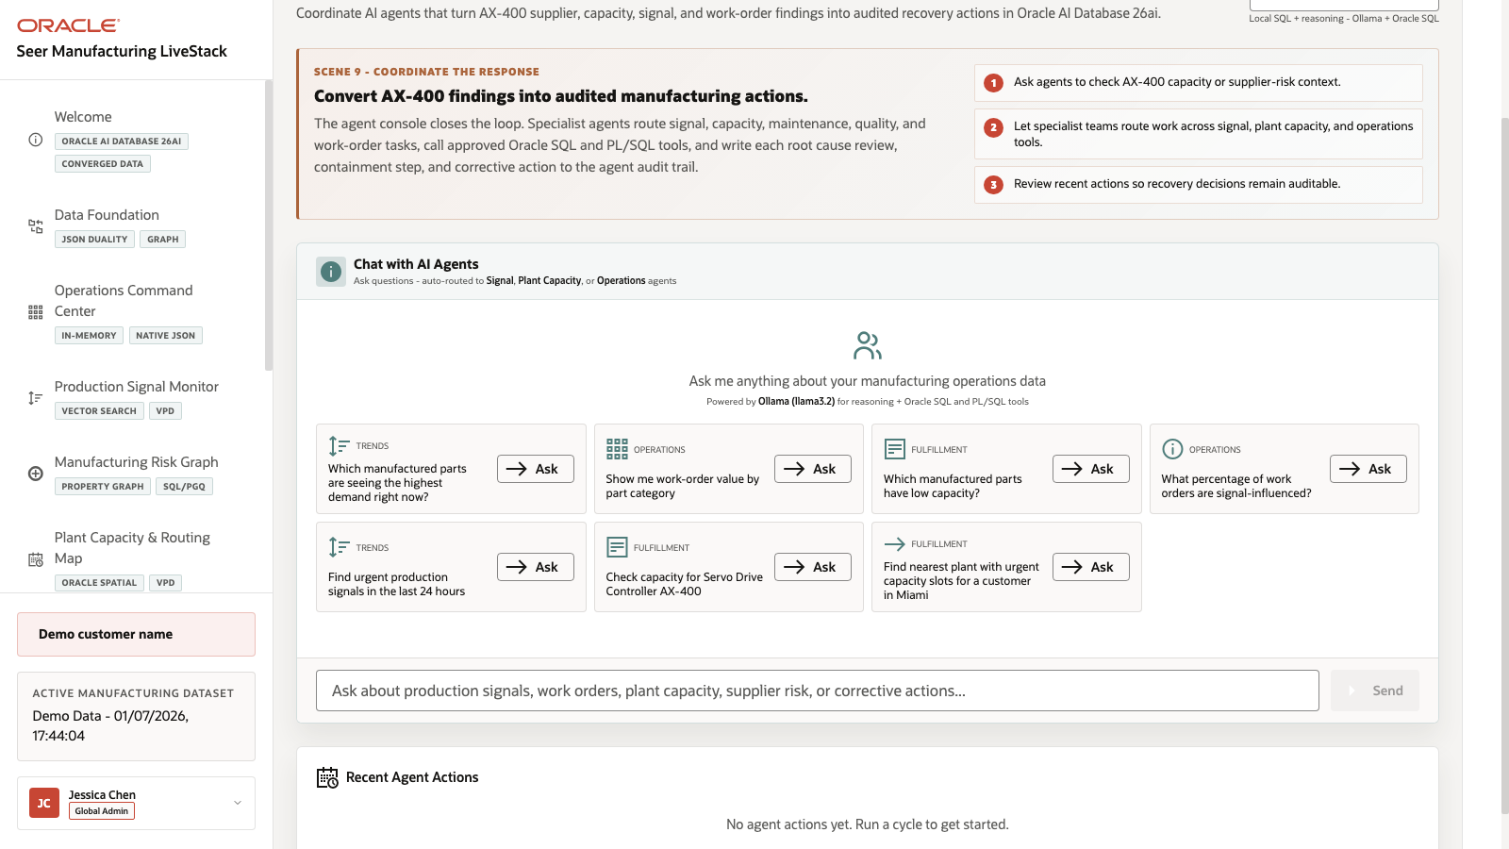
Figure 42. Manufacturing Agent Console overview with agent examples and recent actions

Objectives
In this scene, you will:
Review the Manufacturing Agent Console workspace and runtime profile.
Review the production signal, work-order, plant capacity, and corrective-action example questions.
Run a plant-capacity agent question.
Inspect the agent response and returned plant capacity table.
Review the Recent Agent Actions audit trail.
Understand why observable agent behavior matters for enterprise manufacturing workflows.

Task 1: Review the agent console workspace
- Click Manufacturing Agent Console in the sidebar.
- Review the runtime profile selector. The current demo uses llama3.2 through Ollama-backed reasoning.
- Review the example questions in the agent workspace.
- Review Recent Agent Actions below the workspace.
- Focus on the plant-capacity example: Check capacity for Servo Drive Controller AX-400.
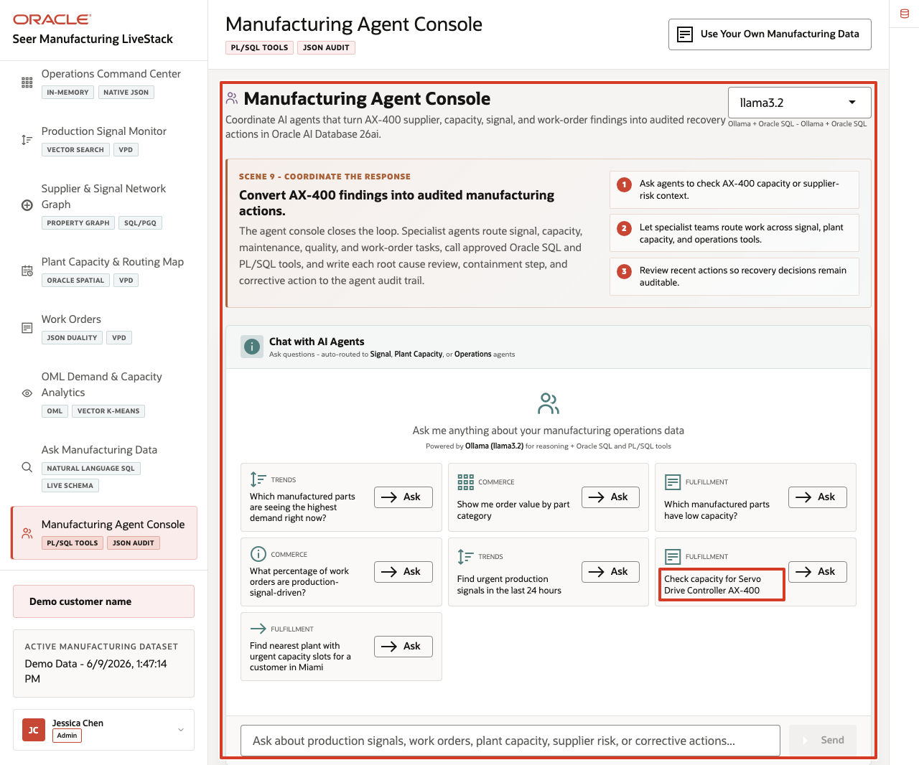
Figure 43. Manufacturing Agent Console workspace with runtime profile, example questions, and Recent Agent Actions highlighted
Use this opening view to explain the role of the page. The user is not looking at a generic chatbot. They are looking at an operational agent surface where manufacturing questions are routed to specialist teams such as signal review, plant capacity, and work-order follow-up.

Task 2: Run the plant-capacity agent question
- Click Ask on Check capacity for Servo Drive Controller AX-400.
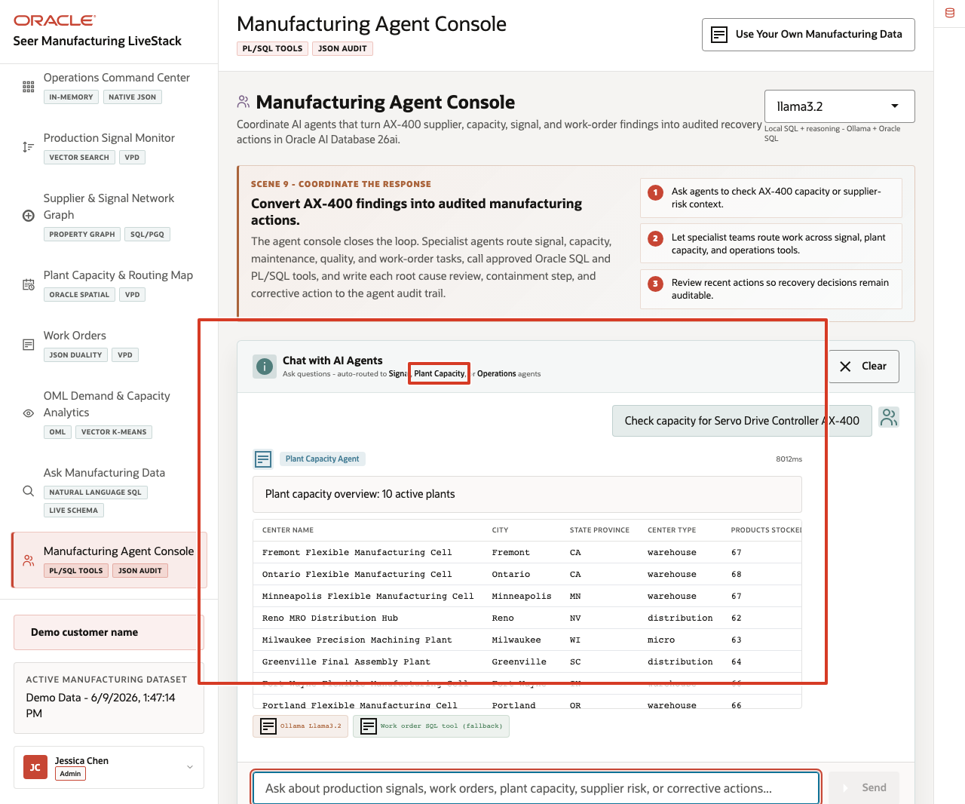
Figure 44. Manufacturing plant-capacity agent response with active plant table
- Review the agent response at the top of the chat output.
- Review the returned plant capacity table.
- Review the tool and runtime badges below the response.
In the current demo dataset, the agent routes the request to the Plant Capacity path and returns a capacity overview with 10 active plants. The visible table includes Fremont Flexible Manufacturing Cell, Ontario Flexible Manufacturing Cell, Minneapolis Flexible Manufacturing Cell, Reno MRO Distribution Hub, and Milwaukee Precision Machining Plant. The response exposes the Ollama runtime and SQL tool path.
This is the data point to emphasize during the demo. The agent did more than answer a text question. It classified the manufacturing capacity intent, queried governed plant data, returned a structured table, and exposed enough runtime information for an operator to understand the path.

Task 3: Review the agent action audit trail
- Scroll to Recent Agent Actions.
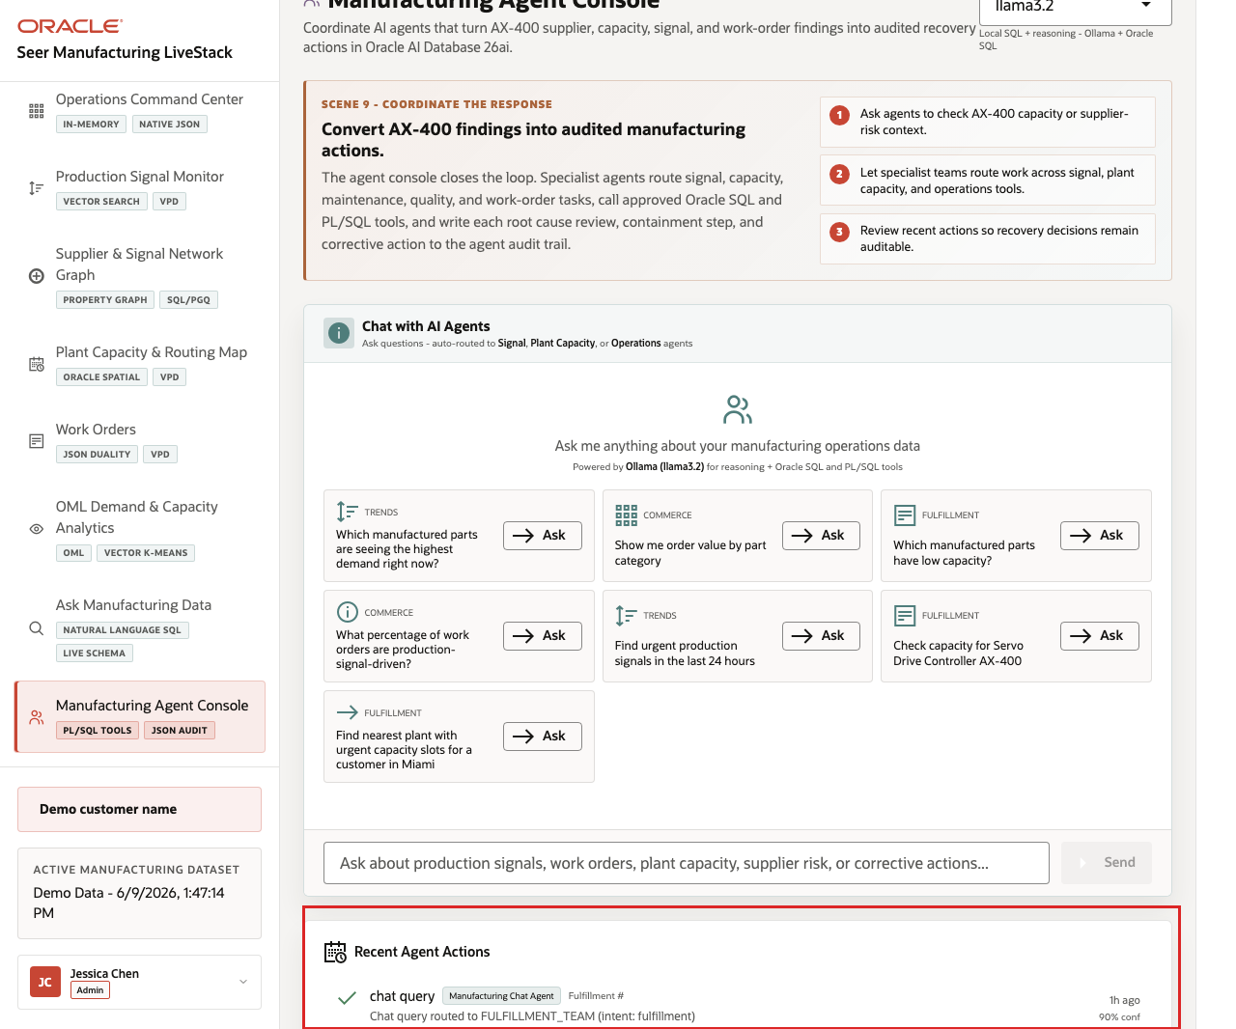
Figure 45. Recent Agent Actions audit trail after the manufacturing capacity agent request
- Review the panel as the audit surface for completed action-cycle records.
- If action rows are present, confirm the action type, routed agent path, execution status, and confidence value.
- If the panel is empty after a chat-only response, explain that the answer still exposes runtime and tool badges in the chat result, while action-cycle records appear when the application writes them to the event history.
This is the governance point of the scene: agent decisions should be observable after the conversation or action cycle. The page separates the live chat response from the durable action history so operators can distinguish immediate assistance from recorded operational actions.
The value of Oracle AI Database is that the agent workflow stays connected to governed operational data. The AI runtime can reason and orchestrate, while Oracle remains responsible for data access, SQL and PL/SQL execution, spatial and operational calculations, and durable audit records.
You can move to the next scene.

Credits & Build Notes
Author - Oracle LiveLabs Team
Last Updated By/Date - Oracle LiveLabs Team, 2026-06-09

Scene 11 Use Your Own Manufacturing Data

Introduction
This operator workflow shows how a demo user can replace or restore the manufacturing dataset through the application. The workflow supports downloading a template ZIP, selecting a completed ZIP, validating it, uploading it, and restoring the seeded demo data.
This scene matters because a manufacturing LiveStack is most useful when teams can map the demo pattern to their own terminology and sample data. The application makes that workflow explicit while keeping the seeded Seer Manufacturing data available as a known-good baseline.
Estimated Time: 10 minutes
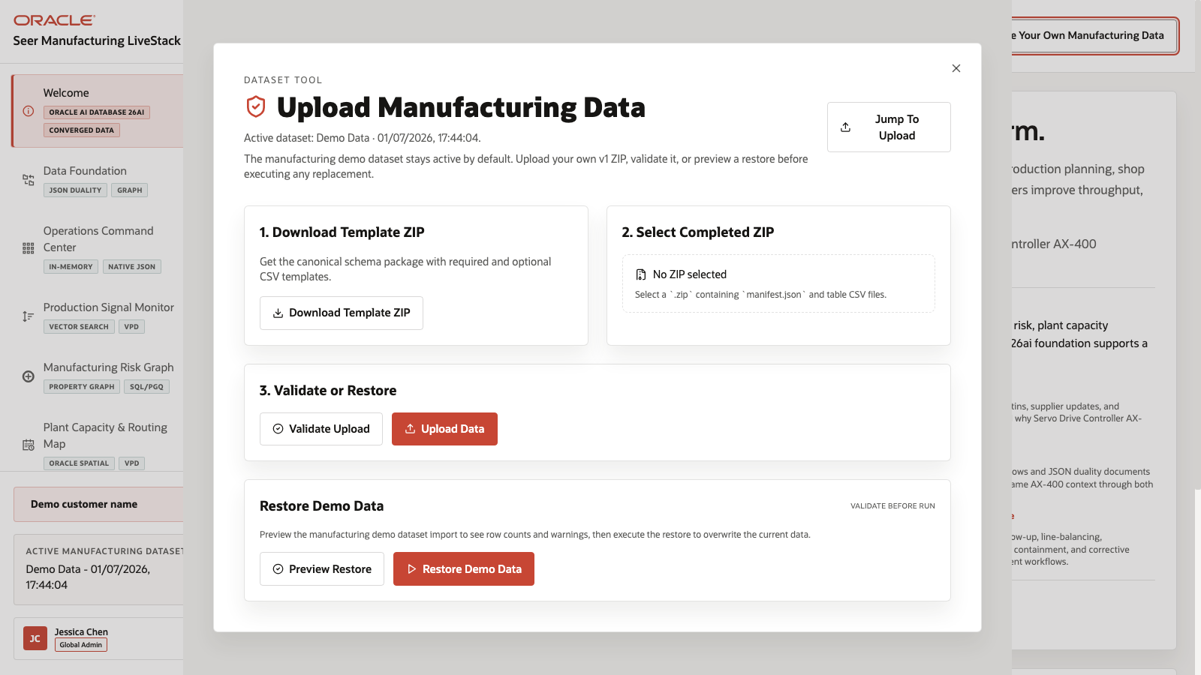
Figure 46. Use Your Own Manufacturing Data modal with template, upload, validation, and restore controls

Objectives
In this scene, you will:
Open the dataset tool from the application top bar.
Review the active dataset label.
Download the canonical manufacturing dataset template.
Review the completed ZIP upload and validation path.
Preview or restore the seeded manufacturing demo dataset.
Explain the data safety expectation for synthetic manufacturing data.

Task 1: Open the dataset tool
- From any application scene, click Use Your Own Manufacturing Data in the top bar.
- Review the modal title and active dataset line.
- Confirm that the modal presents the data replacement workflow for manufacturing sample data.
- Review the main sections: Download Template ZIP, Select Completed ZIP, Validate or Restore, and Restore Manufacturing Demo Data.
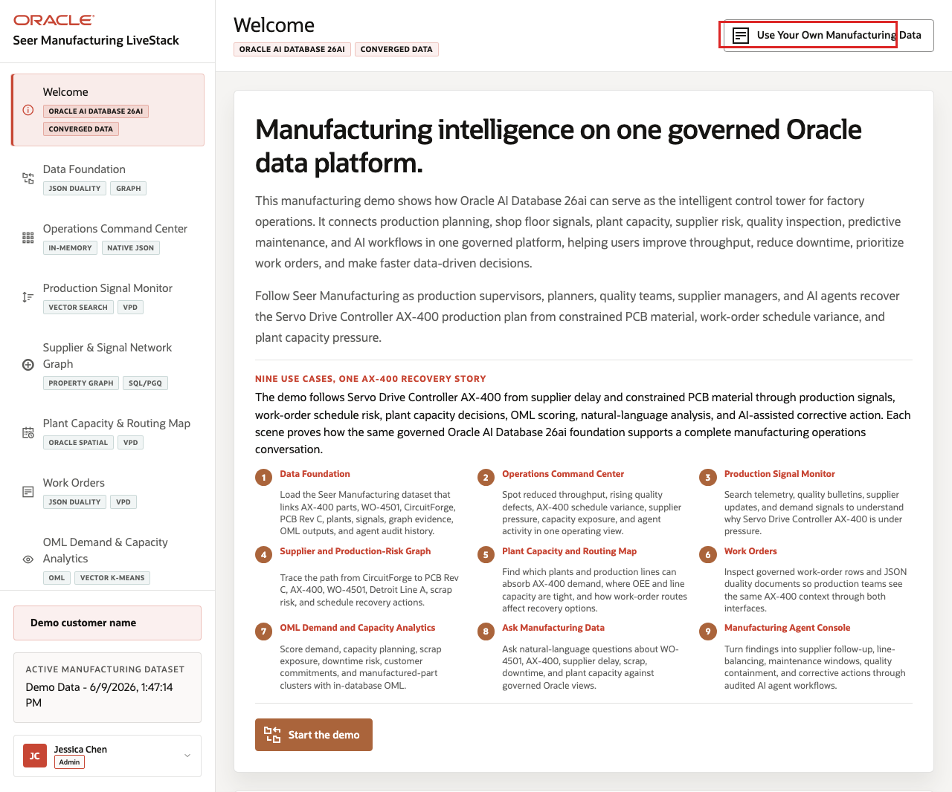
Figure 47. Use Your Own Manufacturing Data top-bar control highlighted
In the current demo, the modal shows the active dataset as Demo Data and provides a workflow for a v1 ZIP that contains manifest.json and table CSV files.

Task 2: Review the template and upload workflow
- Click Download Template ZIP to download the canonical schema package.
- Review Select Completed ZIP. The control expects a .zip containing manifest.json and table CSV files.
- Review the Validate Upload and Upload Data actions.
- Explain that validation should run before data replacement.
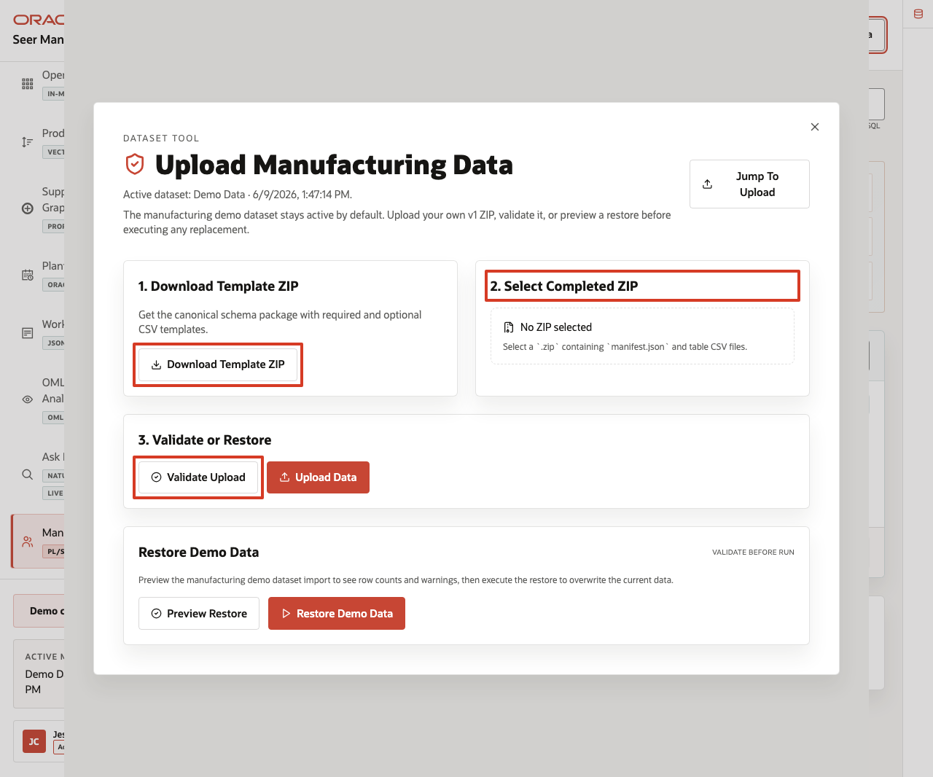
Figure 48. Dataset template download, ZIP selection, validate, and upload controls highlighted
This workflow helps keep custom demos repeatable. The template sets the expected structure, validation checks the completed ZIP before import, and upload remains an explicit action.

Task 3: Preview or restore the seeded dataset
- In Restore Demo Data, review the Preview Restore and Restore Demo Data controls.
- Click Preview Restore when you are ready to validate the seeded dataset before resetting the demo.
- When the preview response completes, review row counts, warnings, or issues returned by the validation.
- If you need to return the demo to the seeded baseline, click Restore Demo Data after validating the restore path.
- Close the dataset manager when finished.
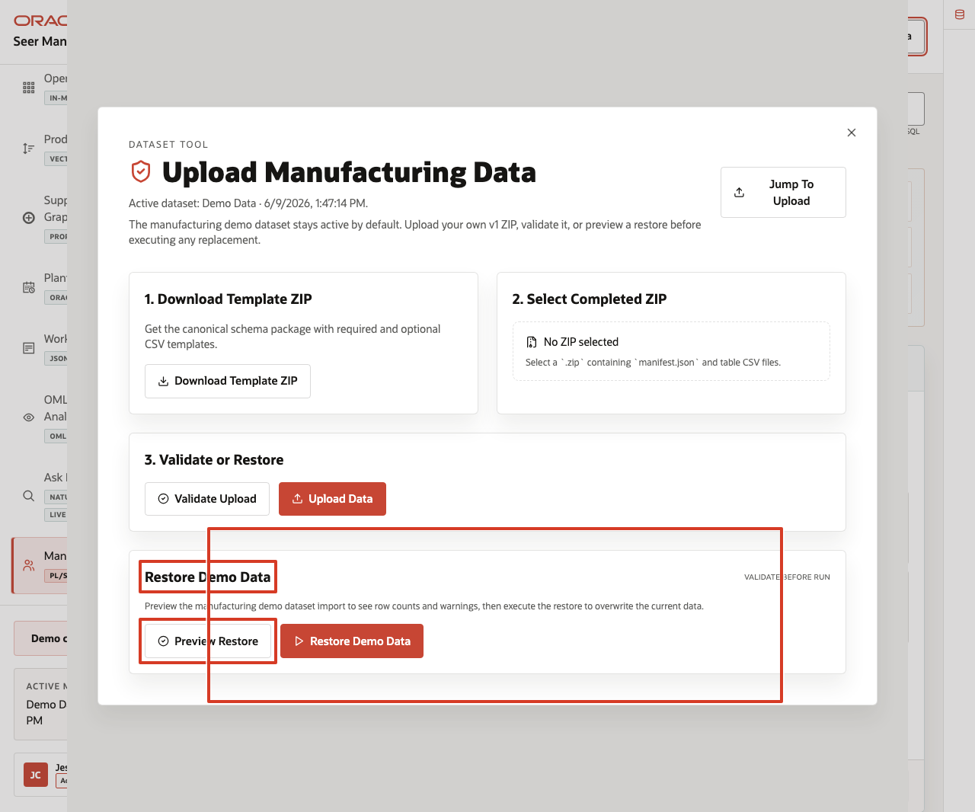
Figure 49. Preview Restore and Restore Demo Data controls highlighted
Use this scene to explain the operating guardrail. Teams can bring their own synthetic manufacturing data into the LiveStack, but the seeded dataset remains available so the demo can always return to a known baseline.
You can move to the download lab when you want to run the Manufacturing LiveStack locally.

Credits & Build Notes
Author - Oracle LiveLabs Team
Last Updated By/Date - Oracle LiveLabs Team, 2026-06-09

Take It Home: Run LiveStack with Podman Compose

Introduction
This lab shows how to run a portable LiveStack package in your own environment using Podman Compose.
This guide is intended for technical users who can install Podman and run terminal commands. If you are new to containers, complete the Podman readiness checks before starting. If any readiness check fails, ask your workshop facilitator or system administrator for help before continuing.
Estimated time: 30 minutes for a local run, or 45 minutes when deploying to an OCI Compute VM.

Objectives
In this lab, you will:
Download the portable LiveStack package.
Confirm that Podman and Podman Compose are ready.
Extract the package into a clean local working directory.
Create a local runtime environment file from .env.example.
Configure proxy settings only when your network requires them.
Start Oracle Database, ORDS, Ollama, and the application with Podman Compose.
Validate the application health endpoint and open the local LiveStack.
Troubleshoot common startup, port, proxy, and first-run issues.
Optionally deploy the same LiveStack package on an OCI Compute VM.
Stop the stack cleanly when the demo is complete.

Before you begin
Before starting, confirm that you have:
Podman installed.
Podman Compose support available.
On macOS or Windows, Podman Desktop is recommended.
On Linux, confirm that either podman compose version or podman-compose version works.
A running Podman machine on macOS or Windows.
Terminal access:
Terminal on macOS or Linux.
PowerShell on Windows.
Internet access to pull container images and download required application or model assets.
Enough local resources for database and model containers.
Recommended minimum: 8 CPU available for containers.
Recommended minimum: 16 GB RAM available for containers.
Recommended minimum: 150 GB free disk space.
Use larger limits if your package includes larger Ollama models or additional data.
The required local application port available:
8505 for the LiveStack application.

New to Podman?
Podman is the local container runtime used by this LiveStack package. Podman Compose reads the compose.yml file and starts the required services together, including Oracle Database, ORDS, Ollama, and the LiveStack application.
If you are new to Podman, complete these checks before starting the lab.

1. Confirm Podman is installed
<copy>
podman --version
</copy>
Expected result:
The command prints a Podman version.

2. Confirm compose support is available
<copy>
podman compose version
</copy>
If that command does not work, try:
<copy>
podman-compose version
</copy>
Expected result:
One of the commands prints a compose version.

3. Start the Podman machine on macOS or Windows
Podman on macOS and Windows runs containers inside a lightweight Linux virtual machine. Start it before running the stack.
<copy>
podman machine start
</copy>
If the machine has not been created yet, create it first:
<copy>
podman machine init
podman machine start
</copy>
Expected result:
The Podman machine starts successfully.

4. Run a quick container test
<copy>
podman run --rm hello-world
</copy>
Expected result:
Podman pulls a small test image and prints a success message.
If this test fails, fix Podman setup before continuing with LiveStack.

Task 1: Download the portable package
- Download the LiveStack package using this link.
- Save or rename the file as livestack.zip.
Expected result:
You have livestack.zip available on your machine.

Task 2: Prepare the working directory
Do not extract or run the stack from your Downloads folder. Create a new empty working directory first. The package extracts its files into the current folder, so a clean directory keeps the LiveStack contents organized and avoids Podman issues caused by working from Downloads.

For macOS or Linux
- Open a terminal.
- Create a new working directory outside of Downloads.
``bash <copy> mkdir -p ~/livestack </copy> ``
- Move into the new working directory.
``bash <copy> cd ~/livestack </copy> ``
- Move the downloaded package from Downloads into this directory.
``bash <copy> mv ~/Downloads/livestack.zip . </copy> ``
- Extract the package.
``bash <copy> unzip livestack.zip </copy> ``
- Confirm that you are in the directory that contains the compose file.
``bash <copy> ls </copy> ``
Expected result:
You see compose.yml or compose.yaml in the current directory.
- Create or refresh the runtime environment file.
``bash <copy> cp .env.example .env </copy> ``

For Windows
- Open PowerShell.
- Create a new working directory outside of Downloads.
``powershell <copy> New-Item -ItemType Directory -Force -Path "$HOME\livestack" | Out-Null </copy> ``
- Move into the new working directory.
``powershell <copy> Set-Location "$HOME\livestack" </copy> ``
- Move the downloaded package from Downloads into this directory.
``powershell <copy> Move-Item "$HOME\Downloads\livestack.zip" . </copy> ``
- Extract the package.
``powershell <copy> tar -xf .\livestack.zip </copy> ``
- Move into the extracted LiveStack application folder.
The folder name can vary by package. For this runbook, replace <extracted-folder-name> with manufacturing unless your facilitator provides a package with a different extracted folder name.
``powershell <copy> Set-Location .\<extracted-folder-name> </copy> ``
Example:
``powershell <copy> Set-Location .\manufacturing </copy> ``
- Confirm that you are in the directory that contains the compose file.
``powershell <copy> Get-ChildItem </copy> ``
Expected result:
You see compose.yml or compose.yaml in the current directory.
- Create or refresh the runtime environment file.
``powershell <copy> Copy-Item .env.example .env -Force </copy> ``
Expected result:
You are in a clean working directory outside Downloads.
The extracted package contains compose.yml or compose.yaml, .env.example, application source files, database setup files, and supporting scripts.
You created a local .env file from .env.example.

Task 3: Configure proxy settings, if your network requires them
Most home, cloud VM, and unrestricted corporate networks do not need this step. Skip this task when your network allows direct access to container registries, npm, Object Storage, and Ollama model downloads.
- If your network requires a proxy, configure the proxy in Podman or Podman Desktop before starting the stack. Image pulls happen before the compose containers exist, so Podman itself must be able to reach external registries.
- Open .env and add proxy values if your environment requires them.
``env <copy> HTTP_PROXY=http://proxy.example.com:8080 HTTPS_PROXY=http://proxy.example.com:8080 http_proxy=http://proxy.example.com:8080 https_proxy=http://proxy.example.com:8080 </copy> ``
- Keep local service names in NO_PROXY and no_proxy.
``env <copy> NO_PROXY=localhost,127.0.0.1,::1,db,ords,ollama,app,host.containers.internal no_proxy=localhost,127.0.0.1,::1,db,ords,ollama,app,host.containers.internal </copy> ``
Expected result:
Podman can pull external images through the network proxy when one is required.
Local compose services still talk to db, ords, ollama, and app directly on the internal Podman network.

Task 4: Start the LiveStack with Podman Compose
- If you are using Podman on macOS or Windows and your Podman machine is not already running, start it now.
``bash <copy> podman machine start </copy> ``
- Confirm that you are in the directory that contains the compose file.
``bash <copy> ls compose.yml compose.yaml 2>/dev/null </copy> ``
On Windows PowerShell, use:
``powershell <copy> Get-ChildItem compose.yml,compose.yaml -ErrorAction SilentlyContinue </copy> ``
- Start all services.
``bash <copy> podman compose up -d --build </copy> ``
If your environment uses the standalone podman-compose command, use:
``bash <copy> podman-compose up -d --build </copy> ``
- Watch the service state.
``bash <copy> podman compose ps </copy> ``
If your environment uses the standalone podman-compose command, use:
``bash <copy> podman-compose ps </copy> ``
Expected result:
db, ords, ollama, and app move toward a healthy state.
The initialization containers complete successfully.
The application listens on the host port defined by the LiveStack package.

Task 5: Understand first-run downloads
On a clean install, the first startup can take several minutes. The stack pulls container images, installs application dependencies, downloads and warms the configured Ollama models, and loads the ONNX embedding model used by Oracle vector search when the package includes one.
To avoid downloading the ONNX model at first run, place all_MiniLM_L12_v2.onnx in db/data/onnx/ before starting the stack. The database bootstrap uses the packaged file before falling back to the configured ONNX_MODEL_URL.
Expected result:
First-run startup time is expected to be longer than later restarts.
Subsequent starts reuse the Podman volumes for Oracle data and Ollama models unless you remove the volumes.

Task 6: Validate health and open the application
- Check the application health endpoint.
``bash <copy> curl http://localhost:8505/api/health </copy> ``
- Open the LiveStack UI in a browser.
``bash <copy> open http://localhost:8505 </copy> ``
- If you are not on macOS, open this URL manually in your browser:
``text <copy> http://localhost:8505 </copy> ``
Expected result:
The health check returns a healthy JSON response after Oracle is ready.
The browser opens the LiveStack locally.

Task 7: Stop the stack when finished
- Stop and remove running containers while preserving volumes.
``bash <copy> podman compose down </copy> ``
If your environment uses the standalone podman-compose command, use:
``bash <copy> podman-compose down </copy> ``
- Use this command only when you intentionally want to delete the local Oracle and Ollama volumes for a complete reset.
``bash <copy> podman compose down -v </copy> ``
If your environment uses the standalone podman-compose command, use:
``bash <copy> podman-compose down -v </copy> ``
Expected result:
podman compose down stops the local LiveStack cleanly.
Demo data and downloaded models remain available on the next startup unless you use the explicit volume-removal command.

Troubleshooting
Use this section when the stack does not start, a service is unhealthy, the application does not open, or first startup appears to be slow.

Check service status
<copy>
podman compose ps
</copy>
If your environment uses the standalone podman-compose command, use:
<copy>
podman-compose ps
</copy>

View service logs
Database logs:
<copy>
podman compose logs db
</copy>
ORDS logs:
<copy>
podman compose logs ords
</copy>
Ollama logs:
<copy>
podman compose logs ollama
</copy>
Application logs:
<copy>
podman compose logs app
</copy>
Follow application logs in real time:
<copy>
podman compose logs -f app
</copy>
If your environment uses podman-compose, replace podman compose with podman-compose in the commands above.

Port 8505 is already in use
The LiveStack application uses local port 8505. If the application does not start or the browser opens another application, check whether another process is already using that port.
For macOS or Linux:
<copy>
lsof -i :8505
</copy>
For Windows PowerShell:
<copy>
netstat -ano | Select-String ":8505"
</copy>
Stop the conflicting process or update the compose port mapping if your package supports changing it.

First startup takes a long time
The first run can take several minutes because Podman may need to pull images, install dependencies, download Ollama models, initialize Oracle Database, and load model files. Later starts are usually faster because container images and volumes are reused.
Check progress with:
<copy>
podman compose logs -f db
podman compose logs -f ollama
podman compose logs -f app
</copy>

Image pulls fail
If image pulls fail, check these items:
Confirm that your machine has internet access.
Confirm that Podman can pull a small public test image with podman run --rm hello-world.
If your network requires a proxy, configure the proxy in Podman or Podman Desktop and update .env as described in Task 3.
If you are on a corporate network or VPN, ask your network administrator whether container registry access is allowed.

Health check is not ready
If curl http://localhost:8505/api/health does not return a healthy response immediately, wait for the database and application startup to finish, then try again.
Check logs with:
<copy>
podman compose logs db
podman compose logs app
</copy>

Reset the stack
Stop containers but keep data and downloaded models:
<copy>
podman compose down
</copy>
Completely reset local data and downloaded models:
<copy>
podman compose down -v
</copy>
Use the volume-removal command only when you intentionally want a clean reset.

Task 8: Deploy the LiveStack on an OCI Compute VM with Podman (Optional)
Use this task when you want to run the LiveStack on an OCI Compute VM instead of your laptop.
Prerequisites:
A created Virtual Cloud Network (VCN).
Security rules configured for the VM subnet.
Ingress to TCP port 8505 allowed from your approved client CIDR.
An OCI Compute VM running Oracle Linux 9.
SSH access to the VM, using the private key paired with the public key added during VM creation.
The LiveStack package download URL for your workshop.
- SSH into the OCI VM from your local terminal.
``bash <copy> ssh -i ~/.ssh/<private-key-file> opc@<vm-public-ip> </copy> ``
- Update the VM and install Podman plus common download tools.
``bash <copy> sudo dnf update -y sudo dnf install -y container-tools podman-docker unzip curl dnf-plugins-core podman --version </copy> ``
- Install and enable Podman Compose support on Oracle Linux 9.
``bash <copy> sudo dnf install -y oracle-epel-release-el9 sudo dnf config-manager --enable ol9_developer_EPEL sudo dnf install -y podman-compose podman compose version || podman-compose version </copy> ``
- If the VM firewall is running, allow the LiveStack application port.
``bash <copy> if sudo systemctl is-active --quiet firewalld; then sudo firewall-cmd --permanent --add-port=8505/tcp sudo firewall-cmd --reload fi </copy> ``
- Create a working directory on the VM.
``bash <copy> mkdir -p ~/livestack cd ~/livestack </copy> ``
- Download the LiveStack package to the VM.
``bash <copy> curl -L -o livestack.zip "<livestack-package-url>" </copy> ``
- Extract the package and move into the directory that contains the compose file.
``bash <copy> unzip livestack.zip COMPOSE_FILE="$(find . -maxdepth 3 \( -name compose.yml -o -name compose.yaml \) | head -n 1)" cd "$(dirname "$COMPOSE_FILE")" </copy> ``
- Create the runtime environment file.
``bash <copy> cp .env.example .env </copy> ``
- Confirm that the compose file exposes the application on port 8505.
``bash <copy> grep -n "8505" compose.yml compose.yaml 2>/dev/null </copy> ``
The application should be exposed on port 8505. To reach it from your browser, both the OCI subnet security rules and the VM firewall must allow inbound TCP traffic on port 8505 from your approved client CIDR.
- Start the LiveStack with Podman Compose.
``bash <copy> podman compose up -d --build || podman-compose up -d --build </copy> ``
- Watch the service state from the VM.
``bash <copy> podman compose ps || podman-compose ps </copy> ``
- Validate the application health endpoint from the VM.
``bash <copy> curl http://localhost:8505/api/health </copy> ``
- Open the public LiveStack URL from your browser.
``text <copy> http://<vm-public-ip>:8505 </copy> ``
Expected result:
The OCI VM is running the LiveStack with Podman Compose.
The application health endpoint responds locally on the VM.
The LiveStack UI is reachable from your browser at http://<vm-public-ip>:8505.

Why this matters
A portable LiveStack runbook turns this guide into something teams can reproduce instead of just read. By shipping the application as a Podman Compose package with a clear startup flow, you reduce environment drift, make scene validation repeatable, and give teams a practical way to explore the same Oracle-backed experience on macOS, Linux, Windows, and OCI Compute.
This guide is self-service for technical users who can install Podman and run terminal commands. Users who are new to containers should complete the Podman readiness checks before starting and ask for help if those checks fail.

Credits and build notes
Author - LiveLabs Team
Last Updated By/Date - LiveLabs Team, 2026-06-09

List of figures
- Figure 1. Manufacturing LiveStack welcome page
- Figure 2. Welcome page with the manufacturing use case carousel
- Figure 3. Welcome page use case carousel with navigation controls highlighted
- Figure 4. Welcome page AX-400 recovery story and demo orientation highlighted
- Figure 5. Welcome page Start the demo button highlighted
- Figure 6. Manufacturing Data Foundation page with dataset restore controls and loaded data domains
- Figure 7. Prepare the Dataset restore action and manufacturing record counts highlighted
- Figure 8. What Gets Loaded carousel and Oracle Internals manufacturing foundation notes highlighted
- Figure 9. Downstream manufacturing scenes and loaded data domains highlighted from the Data Foundation page
- Figure 10. Operations Command Center with KPI cards, signal velocity, order value, and high-demand parts
- Figure 11. Operations Command Center KPI cards, signal velocity, and order value areas highlighted
- Figure 12. Signal velocity time controls, chart, and order value breakdown highlighted
- Figure 13. High-demand manufactured parts table with search and top rows highlighted
- Figure 14. Production Signal Monitor page with semantic search controls and signal feed
- Figure 15. Production Signal Monitor search workspace, signal count, and signal feed highlighted
- Figure 16. Semantic search results for servo drive controller capacity
- Figure 17. Production signal cards with urgency and manufacturing evidence highlighted
- Figure 18. Supplier and Production-Risk Graph page with graph depth controls and manufacturing nodes
- Figure 19. Supplier and production-risk graph workspace with depth controls, entity list, selected node metrics, findings, and graph canvas highlighted
- Figure 20. Supplier Delay Signal PCB Rev C node, risk findings, and connected production relationships highlighted
- Figure 21. Graph Query Explorer SQL/PGQ options highlighted
- Figure 22. Plant Capacity and Routing Map with spatial layers, capacity cards, and plant table
- Figure 23. Plant capacity priority cards, active user, and VPD context highlighted
- Figure 24. Plant capacity map layers with customer commitment risk, production lines, routes, density, and capacity planning overlays highlighted
- Figure 25. Plants table and selected operating rows highlighted
- Figure 26. Work Orders page with VPD banner, status filter, and work-order table
- Figure 27. Work Orders workspace with active user banner, status filter, table, and work order 142691 highlighted
- Figure 28. Relational detail for work order 142691
- Figure 29. JSON Duality View for work order 142691
- Figure 30. Work-order route context for work order 142691
- Figure 31. OML Demand and Capacity Analytics page with KPI cards and five analytics tabs
- Figure 32. Demand Surge predictions with active tab, chart, and prediction table highlighted
- Figure 33. Customer Segments tab with segment distribution and top accounts highlighted
- Figure 34. Order Value Forecast tab with model quality cards and forecast chart highlighted
- Figure 35. Part Clusters tab with vector K-Means controls and cluster cards highlighted
- Figure 36. Capacity Risk Intelligence tab with risk counts and monitored capacity highlighted
- Figure 37. Ask Manufacturing Data workspace with modes, schema metadata, and example questions
- Figure 38. Explain mode response for the manufacturing production-risk graph question
- Figure 39. Chat mode response for the manufacturing production-risk graph question
- Figure 40. Generated SQL for the manufacturing production-risk graph question
- Figure 41. Run SQL results for the manufacturing production-risk graph question
- Figure 42. Manufacturing Agent Console overview with agent examples and recent actions
- Figure 43. Manufacturing Agent Console workspace with runtime profile, example questions, and Recent Agent Actions highlighted
- Figure 44. Manufacturing plant-capacity agent response with active plant table
- Figure 45. Recent Agent Actions audit trail after the manufacturing capacity agent request
- Figure 46. Use Your Own Manufacturing Data modal with template, upload, validation, and restore controls
- Figure 47. Use Your Own Manufacturing Data top-bar control highlighted
- Figure 48. Dataset template download, ZIP selection, validate, and upload controls highlighted
- Figure 49. Preview Restore and Restore Demo Data controls highlighted

