Table of Contents

1 Seer Telecom Service Assurance LiveStack Guide

1.1 Introduction
Communications service providers need to keep subscribers connected while network alarms, subscriber signals, field capacity, service orders, SLA exposure, churn risk, and revenue impact change quickly. The Seer Telecom LiveStack shows how those signals can come together so service assurance, care, field, network operations, and retention teams can spot subscriber-impacting issues earlier, understand the evidence behind them, and coordinate the next action.
This runbook supports the Seer Telecom Service Assurance LiveStack Demo. The demo shows how Oracle AI Database 26ai helps communications service providers bring service orders, JSON documents, graph relationships, spatial context, vector search, machine learning, natural-language SQL, and AI-assisted action logging together on one governed data foundation. It is not positioned as a replacement for a full NOC, OSS, or trouble-ticketing platform; it demonstrates the data foundation and application patterns that connect those systems for service-assurance decisions.
The demo follows a South Florida 5G subscriber-impact scenario. Subscriber signals and congestion indicators appear first. Graph and spatial views show who and what is affected. Service orders and field dispatches show the operational response. Predictive models quantify service-impact risk, churn exposure, revenue exposure, and SLA pressure, and AI-assisted workflows recommend governed next actions.
Estimated Demo Time: 90 minutes
Each scene is designed to take between 5 and 10 minutes.
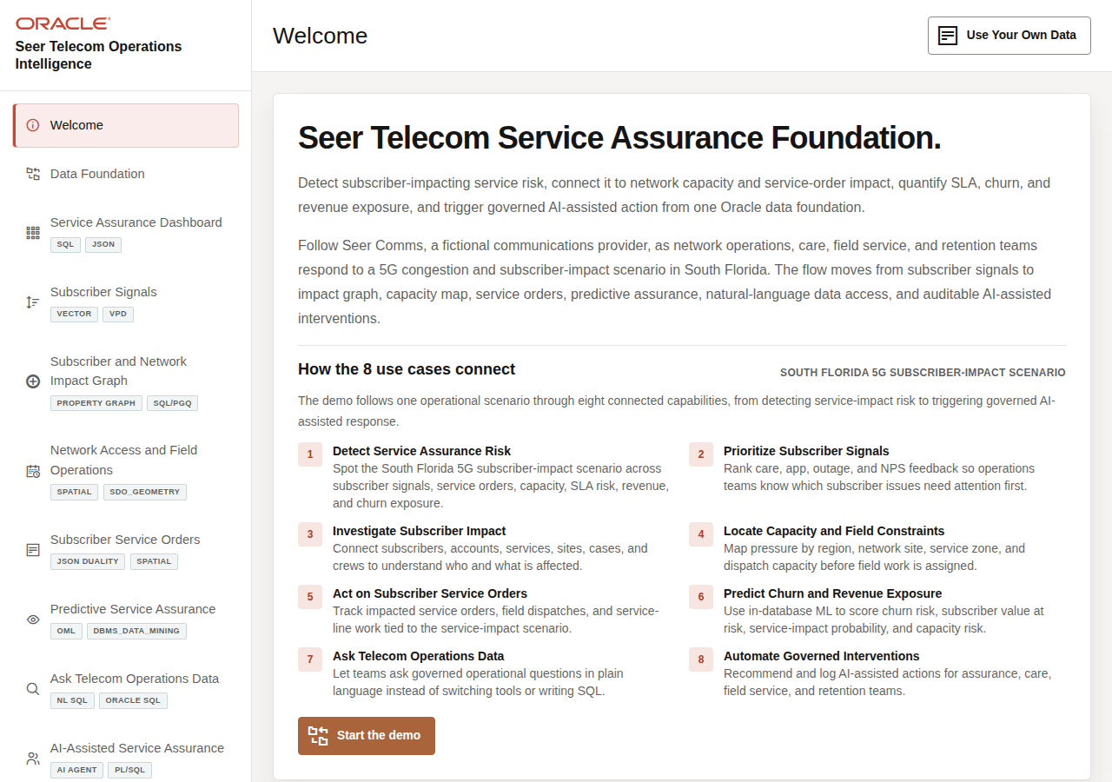
Seer Telecom welcome page

1.1.1 Objectives
In this LiveStack demo, you will see how connected telecom data can help teams detect service-assurance risk, prioritize subscriber signals, investigate network impact, coordinate field capacity, manage service orders, use predictive assurance, and apply AI with stronger governance.

1.1.2 Prerequisites
Before you begin, confirm that you can open the running Seer Telecom Service Assurance LiveStack in a modern browser. No coding or database administration knowledge is required for the guided demo scenes.

1.2 Demo Flow
- Scene 1: Welcome and Demo Orientation.
- Scene 2: Data Foundation.
- Scene 3: Telecom Service Assurance Dashboard.
- Scene 4: Subscriber Experience Signal Feed.
- Scene 5: Subscriber and Network Impact Graph.
- Scene 6: Network Access and Field Operations.
- Scene 7: Subscriber Service Orders.
- Scene 8: Predictive Service Assurance.
- Scene 9: Ask Telecom Operations Data.
- Scene 10: AI-Assisted Service Assurance.

1.3 Learn More
- Oracle AI Database 26ai documentation
- Oracle AI Agent Memory
- Oracle AI Vector Search
- Oracle Spatial and Graph documentation: Oracle Spatial and Oracle Property Graph
- Oracle Machine Learning for SQL documentation
- Oracle REST Data Services documentation
- Oracle LiveLabs catalog

1.4 Credits & Build Notes
- Author - Oracle LiveLabs Team
- Last Updated By/Date - Oracle LiveLabs Team, 2026-06-29

2 Scene 1 Welcome and Demo Orientation

2.1 Introduction
This opening scene frames the demo around a South Florida 5G subscriber-impact scenario. The top panel and carousel show how the use cases connect into one service-assurance journey: service pressure appears, subscriber signals explain urgency, network and field views show impact, service orders capture response, predictive assurance quantifies risk, and AI-assisted workflows recommend next actions.
Estimated Time: 5 minutes
Welcome page with the South Florida 5G subscriber-impact scenario and use case carousel

2.1.1 Objectives
In this scene, you will learn what telecom decision the page supports, what evidence the user should inspect, and what action the team may take next.

2.2 Task 1: Review the South Florida 5G subscriber-impact scenario
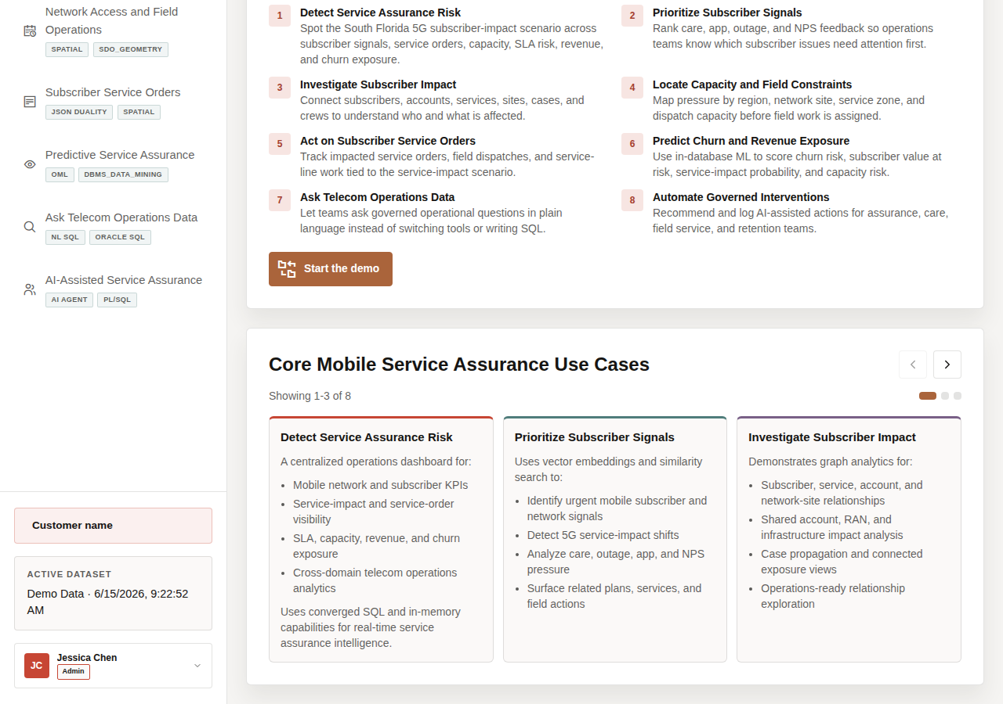
Eight connected use cases in the top panel
- Review the South Florida 5G subscriber-impact scenario first so the audience understands the full service-assurance journey. The scenario connects service pressure, subscriber urgency, graph impact, field capacity, service orders, predictive risk, and AI-assisted action into one narrative.
- Use the welcome page to make the demo feel like one connected telecom service-assurance story, not eight separate feature stops.
- Read the three visible use case tiles in Core Mobile Service Assurance Use Cases.
- Click the right carousel arrow to move forward.
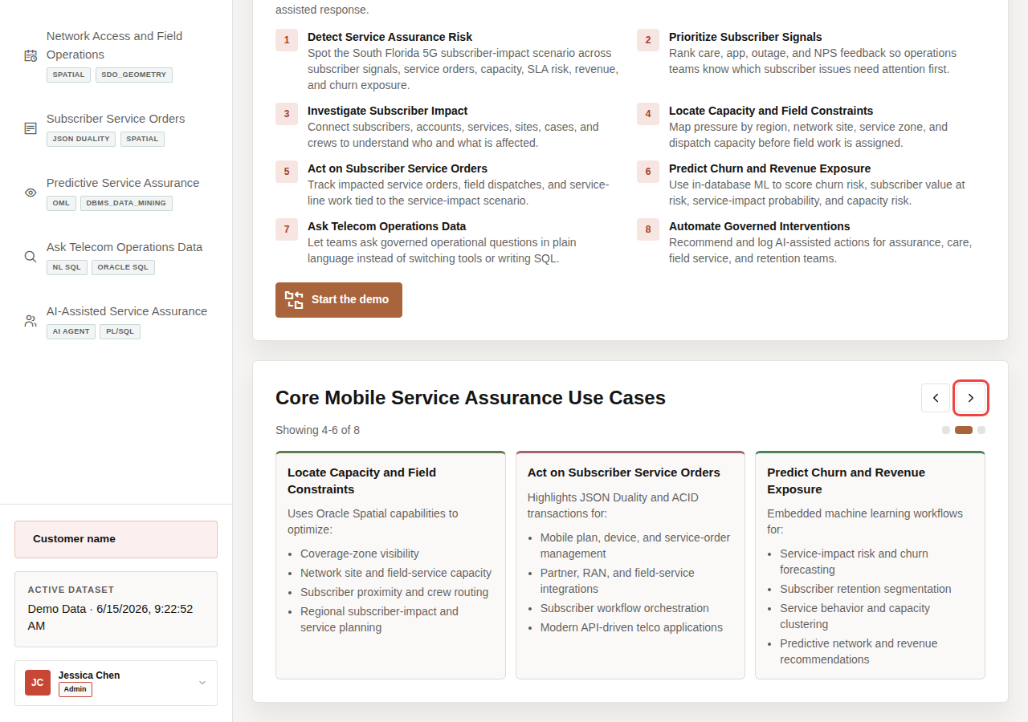
Use case carousel showing the next group of telecom assurance use cases
- Continue until you have reviewed all eight use cases.
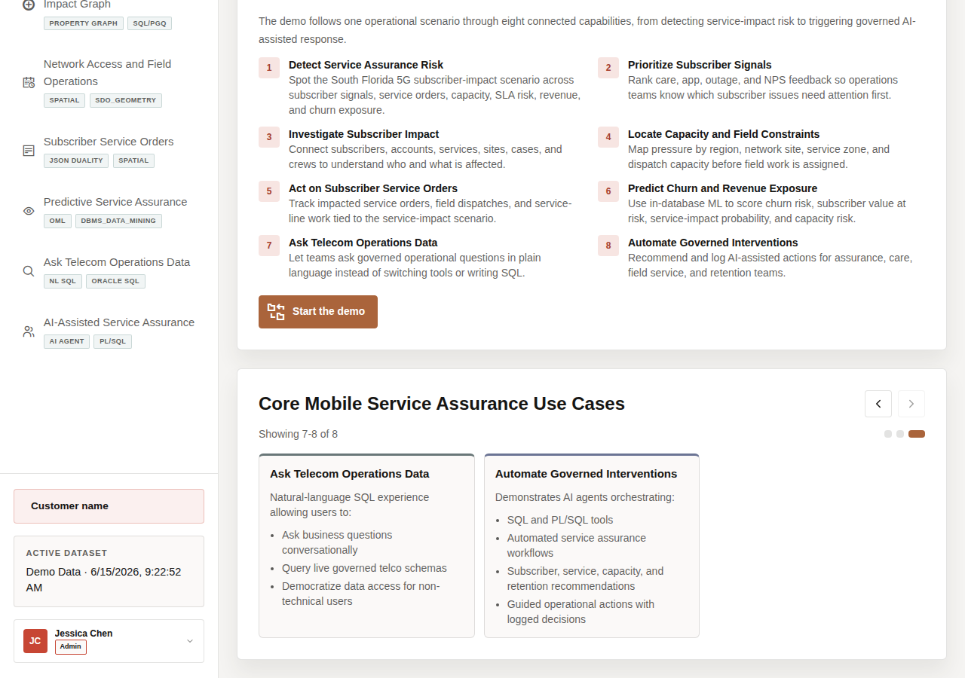
Use case carousel showing the final telecom assurance use cases
- Use the left carousel arrow if you want to return to earlier tiles.

2.3 Task 2: Continue the demo
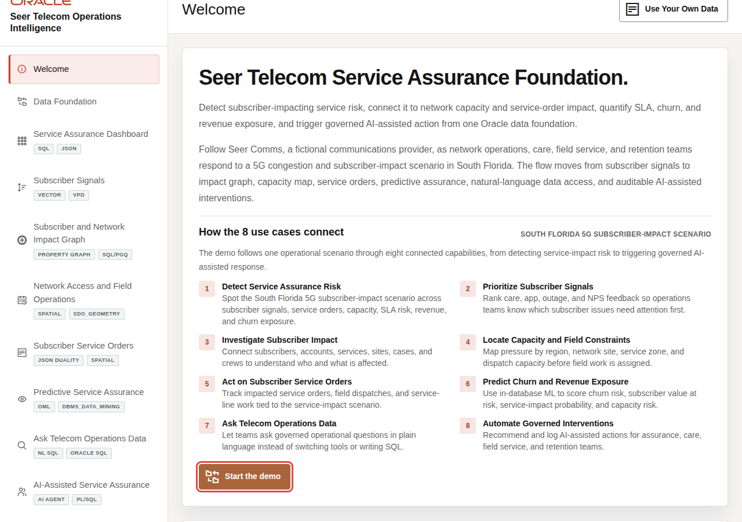
Start the demo button
After the audience understands the South Florida 5G subscriber-impact storyline, continue to Data Foundation to prepare the governed telecom dataset that powers the rest of the demo.
- Click Start the demo.
- Confirm the demo moves to Data Foundation.

2.4 Credits & Build Notes
- Author - Oracle LiveLabs Team
- Last Updated By/Date - Oracle LiveLabs Team, 2026-06-29

3 Scene 2 Data Foundation

3.1 Introduction
This scene prepares the trusted Seer Telecom dataset used throughout the demo. Loading or restoring the data gives every later screen the same governed starting point, so dashboards, signal search, graph analysis, field operations, service orders, predictive assurance, Ask Data, and AI-assisted workflows all reflect the same telecom data foundation.
Estimated Time: 5 minutes
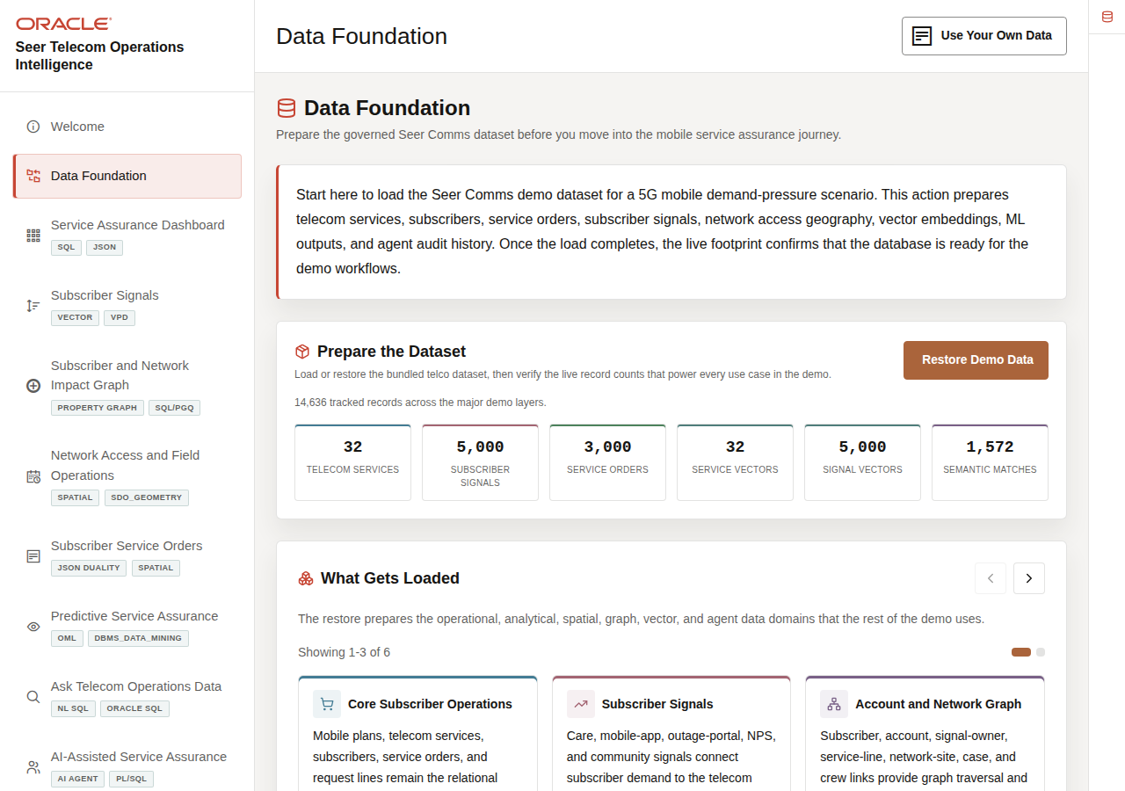
Data Foundation page with dataset status and loaded telecom data domains

3.1.1 Objectives
In this scene, you will learn what telecom decision the page supports, what evidence the user should inspect, and what action the team may take next.

3.2 Task 1: Prepare the dataset
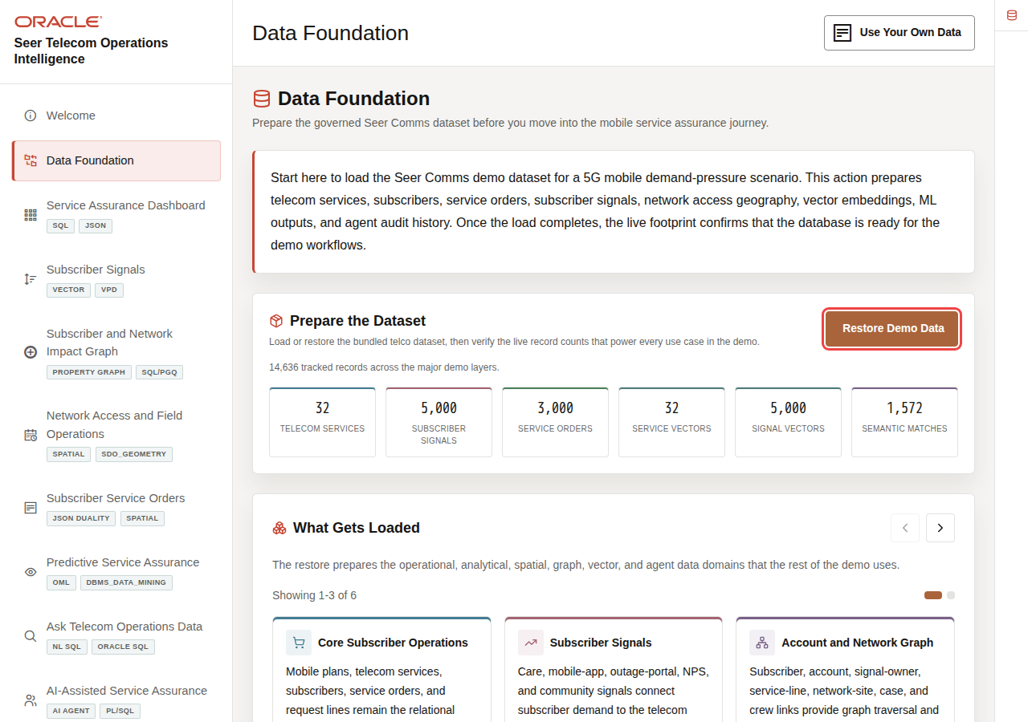
Prepare the Dataset action area
Prepare the dataset so every later scene starts from the same trusted telecom baseline. This makes the operations dashboard, signal search, impact graph, field operations map, service orders, predictive assurance, Ask Data, and AI agent results easier to compare and trust.
- Click Data Foundation in the sidebar.
- In Prepare the Dataset, click Load Demo Data.
- If the dataset is already loaded, click Restore Demo Data to reset the demo data to a clean state.
- Wait for the progress indicator to finish and review the refreshed record counts.
The load prepares telecom services, subscriber signals, service orders, network sites, demand regions, field dispatch context, vector embeddings, graph relationships, machine learning outputs, and agent audit history. The system compares subscriber and service text by meaning, with embeddings providing the representation that makes this possible.
In this example, the live data-foundation page shows 32 telecom services, 5,000 subscriber signals, 3,000 service orders, 32 service vectors, 5,000 signal vectors, and 1,572 semantic matches.
Note: These are sample values from the current demo dataset and may change after a refresh, seed update, or custom dataset import. Treat these numbers as an example of the current operating pattern. Review the live values in the UI and connect them to the operational pattern: subscriber impact, capacity exposure, SLA risk, revenue exposure, dispatch load, or restoration status.

3.3 Task 2: Review what gets loaded
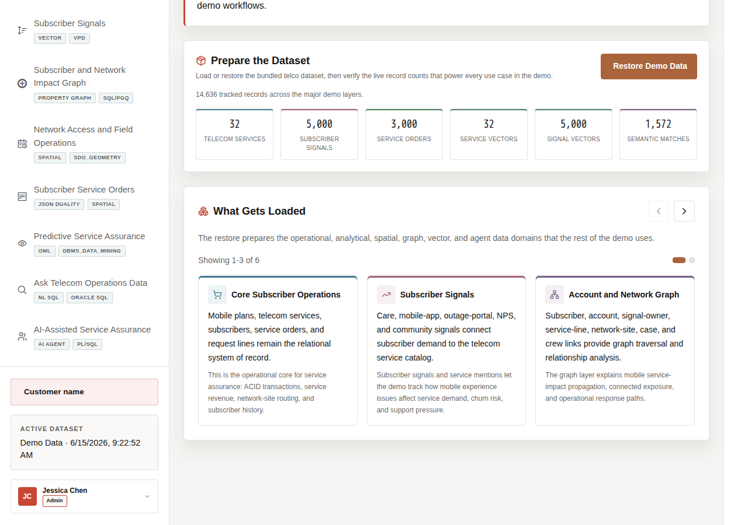
Loaded telecom data domains and record counts
Review what gets loaded to show that the demo uses recognizable telecom data: services, subscriber signals, service orders, network sites, demand regions, field dispatch context, vectors, graph relationships, machine learning outputs, and agent action history.
- Scroll to What Gets Loaded.
- Read the three visible carousel tiles.
- Use the right carousel arrow to review the remaining tiles.
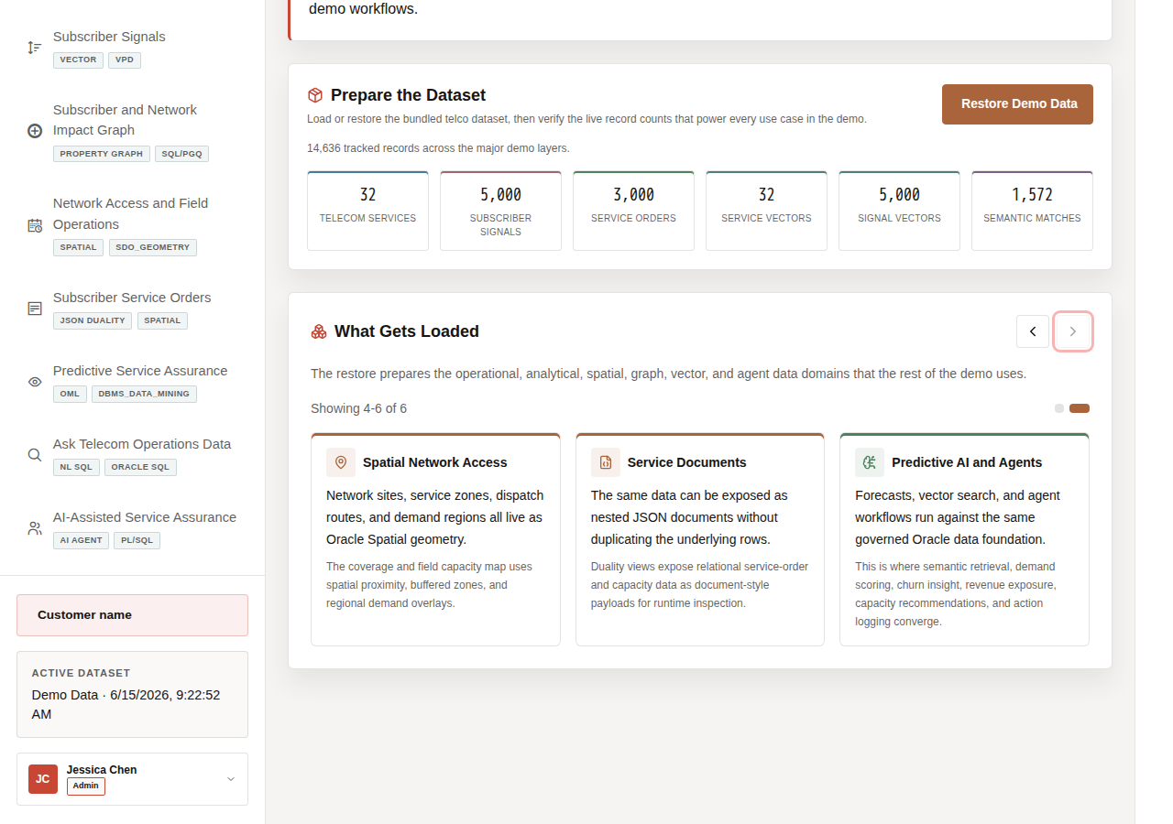
Remaining loaded telecom data domains in the carousel
- Look for the major data types used in the demo: relational tables, JSON duality views, graph relationships, spatial geometry, vector embeddings, machine learning results, and agent audit records.
Note: The system compares subscriber and service text by meaning, with embeddings providing the representation that makes this possible.
You can move to the next scene.

3.4 Credits & Build Notes
- Author - Oracle LiveLabs Team
- Last Updated By/Date - Oracle LiveLabs Team, 2026-06-29

4 Scene 3 Telecom Service Assurance Dashboard

4.1 Introduction
The Telecom Service Assurance Dashboard helps telecom teams answer a daily service-assurance question: which services are creating subscriber impact, SLA exposure, and operational response pressure right now? The page brings together service orders, revenue exposure, subscriber signals, services with service-impact risk, dispatches, AI-assisted interventions, and assurance evidence markers so teams can decide where to investigate first.
Dashboards like this are difficult to implement when telecom data is split across OSS, BSS, NOC tools, care systems, outage portals, field dispatch systems, and analytics pipelines. Teams often need copied data, ETL jobs, separate search indexes, and reconciliation logic before a dashboard can show a trustworthy view.
Oracle AI Database helps address that challenge by keeping operational, analytical, JSON, in-memory, and AI-ready data close to the same governed data foundation. In this scene, the dashboard brings together live telecom KPIs, subscriber signal velocity, service revenue, service-impact risk, alarm severity, incident status, ticket aging, and restoration status without sending the user to a different application.
Use Fixed Wireless Home Internet as the running example for moving from service-impact risk to subscriber signals, service orders, capacity checks, SLA exposure, and predictive risk.
Estimated Time: 10 minutes
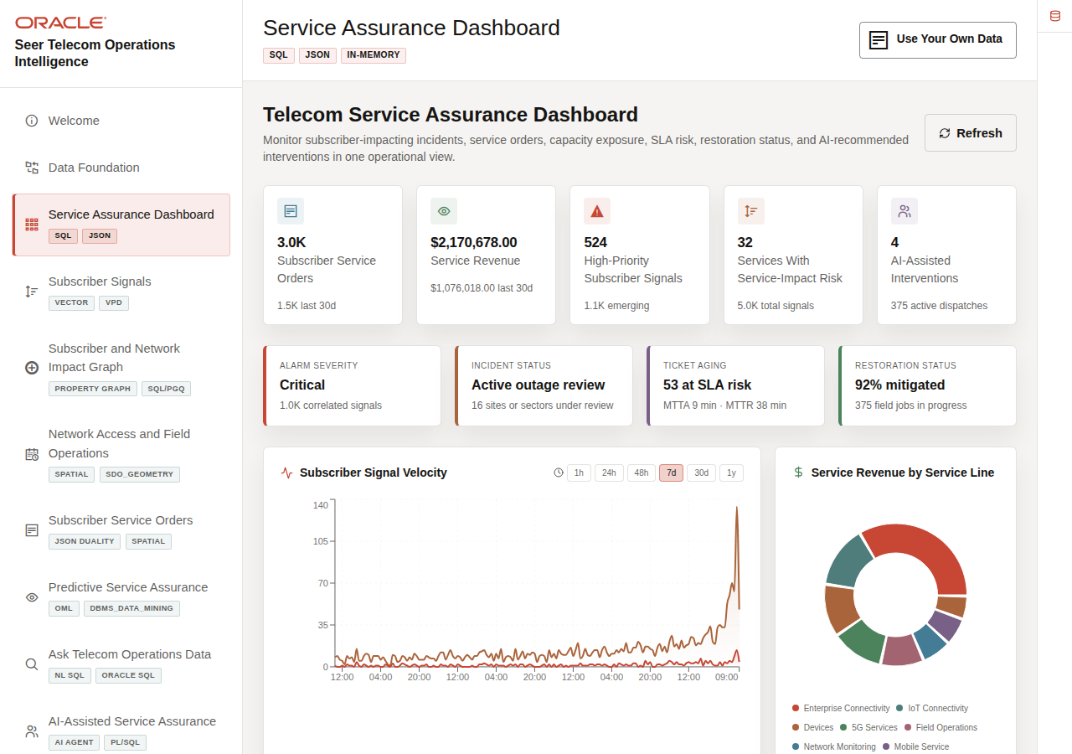
Telecom Service Assurance Dashboard with KPI cards, charts, assurance evidence, and service-impact table

4.1.1 Objectives
In this scene, you will learn what telecom decision the page supports, what evidence the user should inspect, and what action the team may take next.

4.2 Task 1: Review the service-assurance dashboard
Operations dashboard KPI cards
Use the dashboard as a daily triage view. The goal is to see where subscriber impact, SLA exposure, revenue exposure, high-priority signals, field dispatches, restoration status, or AI-assisted interventions suggest that a service needs attention.
- Click Service Assurance Dashboard in the sidebar.
- Review the KPI cards across the top of the page. These summarize the current operating picture: subscriber service orders, service revenue, high-priority subscriber signals, services with service-impact risk, active dispatches, and AI-assisted interventions.
- Review Subscriber Signal Velocity. This chart measures the rate and intensity of subscriber activity across care, app, outage, and NPS-style signal sources.
- Review Service Revenue by Service Line to see which service categories are contributing most to revenue.
- Review the assurance evidence row: alarm severity, incident status, ticket aging, and restoration status. These markers make the dashboard feel like a service-assurance view instead of a generic business dashboard.
The current dashboard shows 3,000 service orders, $2.17M in service revenue, 524 high-priority subscriber signals, 32 services with service-impact risk, and 375 active dispatches.
Note: These are sample values from the current demo dataset and may change after a refresh, seed update, or custom dataset import. Treat these numbers as an example of the current operating pattern. Review the live values in the UI and connect them to the operational pattern: subscriber impact, capacity exposure, SLA risk, revenue exposure, dispatch load, or restoration status.
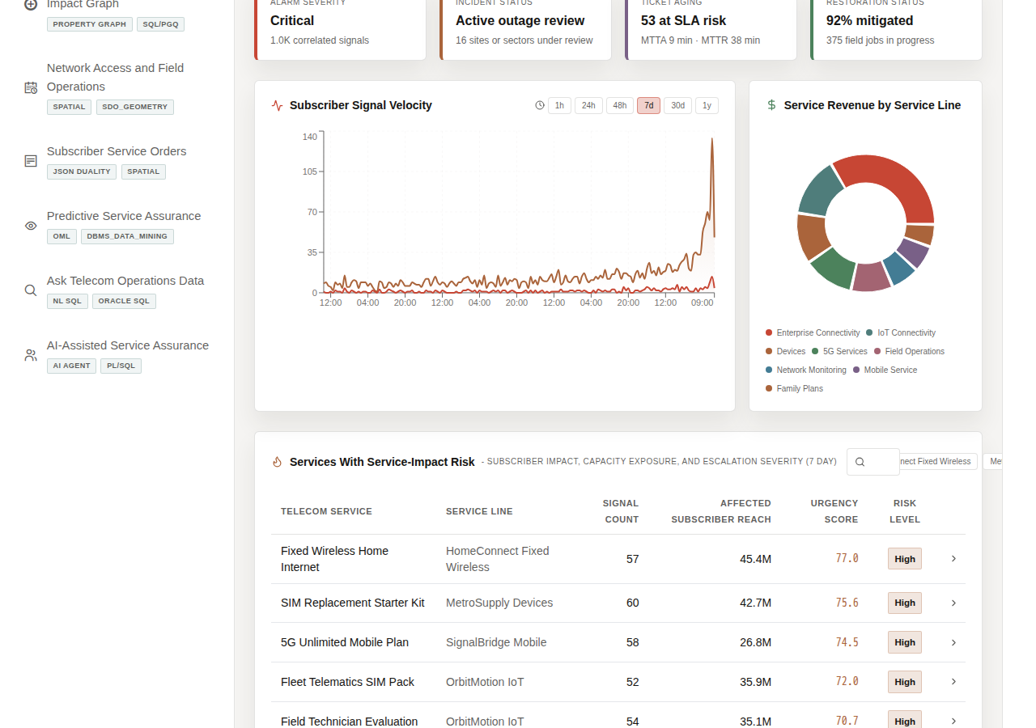
Subscriber signal velocity and service revenue charts

4.3 Task 2: Review services with service-impact risk
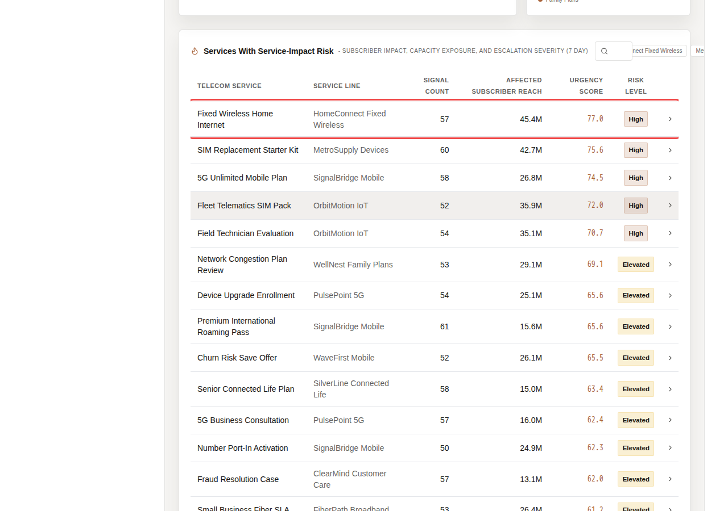
Services With Service-Impact Risk table
Review service-impact risk to identify which telecom services are carrying the strongest combination of subscriber signals, affected reach, urgency, SLA exposure, and operational risk.
- Scroll to Services With Service-Impact Risk.
- Review the service rows. The table ranks telecom services by signal count, affected subscriber reach, urgency score, and risk level.
- Use the search field or service-line chips if you want to narrow the table.
- Focus on Fixed Wireless Home Internet.
The current service-impact table shows 57 signal mentions, 45.4M affected subscriber reach, an urgency score of 77.0, and High risk.
Note: These are sample values from the current demo dataset and may change after a refresh, seed update, or custom dataset import. Treat these numbers as an example of the current operating pattern. Review the live values in the UI and connect them to the operational pattern: subscriber impact, capacity exposure, SLA risk, revenue exposure, dispatch load, or restoration status.

4.4 Task 3: Inspect the service detail modal
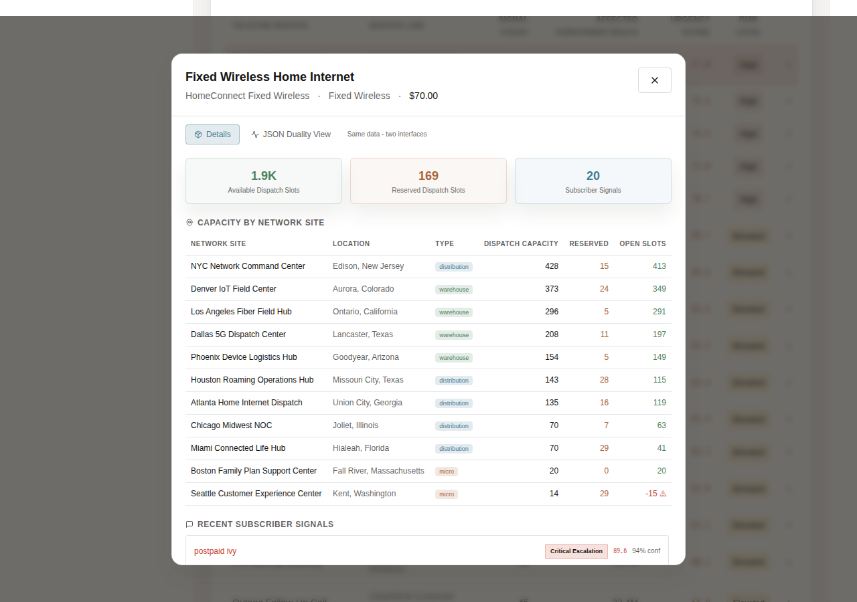
Fixed Wireless Home Internet service detail modal with capacity and subscriber-signal evidence
Open the service detail modal to move from dashboard-level pressure to service-level evidence, including capacity exposure, subscriber signals, service-line context, SLA risk, restoration status, and operational details that can guide the next action.
- Click Fixed Wireless Home Internet.
- Review the default details view.
- Inspect available dispatch slots, service-line context, subscriber signals, SLA risk, restoration status, and operational evidence.
This view is useful for network operations and care because it moves from dashboard-level pressure to service-level evidence. The user can see which service is under pressure, which signals are driving it, and which operational data should be checked before acting.

4.5 Task 4: Review the JSON Duality View
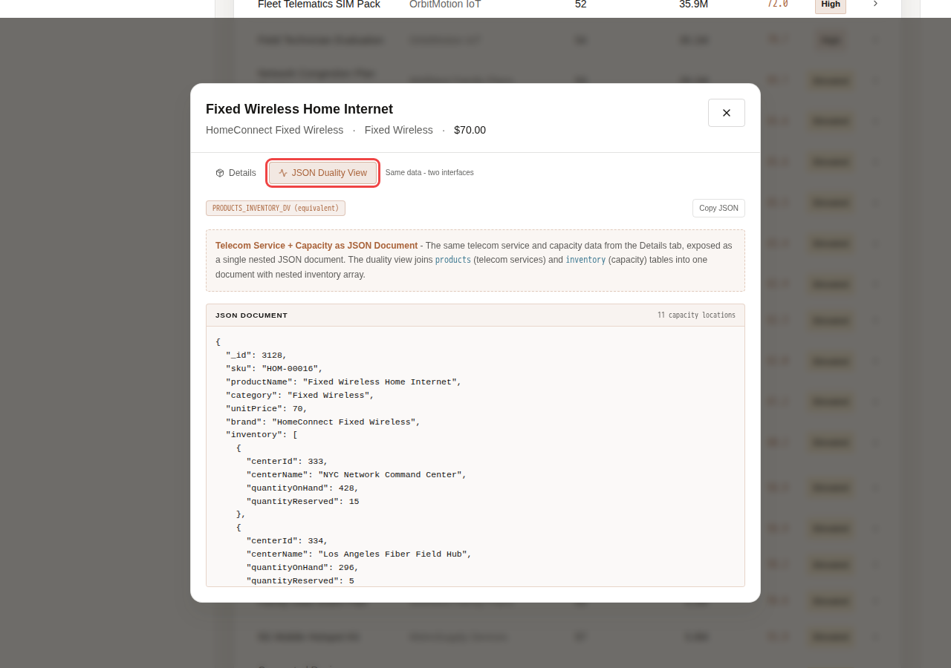
Fixed Wireless Home Internet JSON Duality View document
Review the JSON Duality View to show that the same trusted service data can support different users. Business users see operational details, while applications and APIs can use the same information as a structured document.
- In the service modal, click JSON Duality View.
- Review the JSON document generated for the same service and operational data.
The point of this view is to show that the same data can support different application needs. The Details tab presents the data as an operational user interface for business users.
The JSON Duality View presents the same service and capacity information as a nested JSON document that is useful for APIs and application developers. Oracle JSON Relational Duality lets the application expose document-style access without copying the data into a separate document store.
You can move to the next scene.

4.6 Credits & Build Notes
- Author - Oracle LiveLabs Team
- Last Updated By/Date - Oracle LiveLabs Team, 2026-06-29

5 Scene 4 Subscriber Experience Signal Feed

5.1 Introduction
Subscriber Experience Signal Feed helps care and network teams understand what subscribers are reporting before the issue is fully visible in traditional network KPIs. The page connects care chats, app feedback, outage reports, call-center notes, NPS comments, community posts, and field observations to services, regions, and emerging service-impact pressure quickly enough to act.
Secure semantic search is difficult to implement when service data, subscriber conversations, embeddings, search indexes, and security policies live in separate systems. Telecom teams often have to move sensitive text into external AI services, synchronize vector indexes, duplicate service catalogs, and then rebuild access control outside the database.
Oracle AI Database helps address these challenges by keeping vector search, SQL, row-level security, and operational telecom data together. The system compares subscriber and service text by meaning, with embeddings being the representation that makes this possible.
In this scene, Oracle AI Database can create embeddings inside the database, so sensitive subscriber-signal data does not need to be sent to external AI services or exposed through another processing layer. Oracle Vector Search can embed a business query, compare it against service or signal embeddings, and return ranked matches while Oracle security policies continue to govern which data the user can see.
Estimated Time: 10 minutes
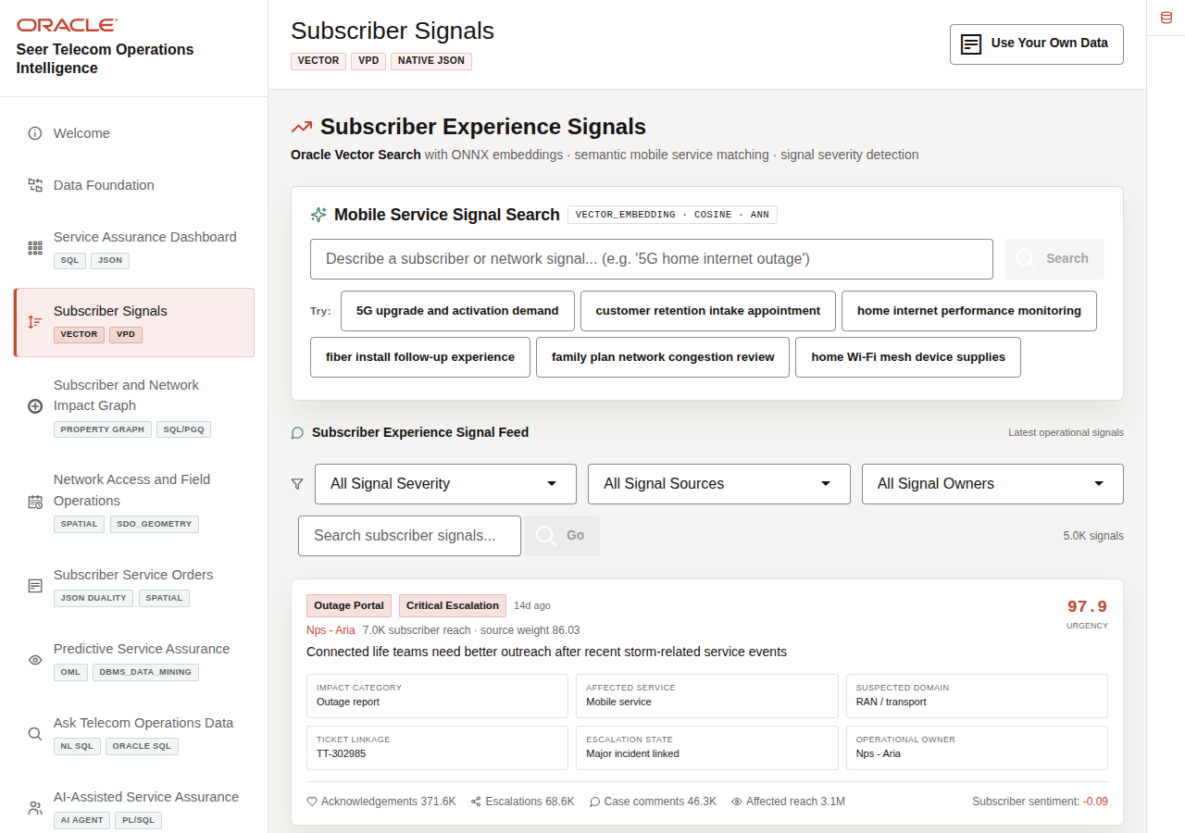
Subscriber Experience Signal Feed with signal search, filters, and signal cards

5.1.1 Objectives
In this scene, you will learn what telecom decision the page supports, what evidence the user should inspect, and what action the team may take next.

5.2 Task 1: Review the Subscriber Signals page
Subscriber Signals search and feed workspace
Review the Subscriber Signals page to see how subscriber language from care, app, outage, and community sources becomes an operational signal feed.
- Click Subscriber Signals in the sidebar.
- Review Mobile Service Signal Search at the top of the page. This section searches the telecom service catalog by meaning, not only by exact keywords.
- Review Subscriber Experience Signal Feed below it. This section searches and filters subscriber signals across operational signal sources such as mobile app feedback, care chat, call-center notes, outage portal, and community forum.
- Review the filters for All Signal Severity, All Signal Sources, and All Signal Owners.
- Review the operational context fields on the signal cards: impact category, affected service, suspected domain, ticket linkage, escalation state, and operational owner.

5.3 Task 2: Search telecom service intent
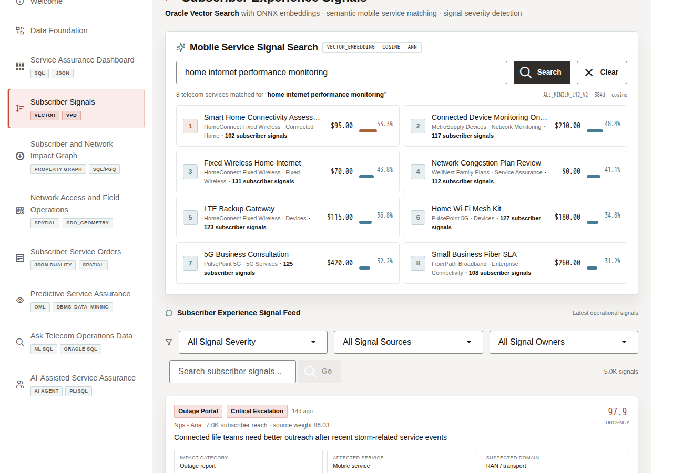
Mobile Service Signal Search results for home internet performance monitoring
Search telecom service intent to show how teams can find related services by meaning, not only by exact service names or keywords.
- In Mobile Service Signal Search, click home internet performance monitoring.
- Review the returned service matches.
- Compare the service name, service line, category, and similarity score.
The demo query is embedded at runtime and compared against service embeddings stored in Oracle AI Database. This helps care and network teams search by subscriber intent instead of relying only on exact service names.

5.4 Task 3: Review high-priority subscriber signals
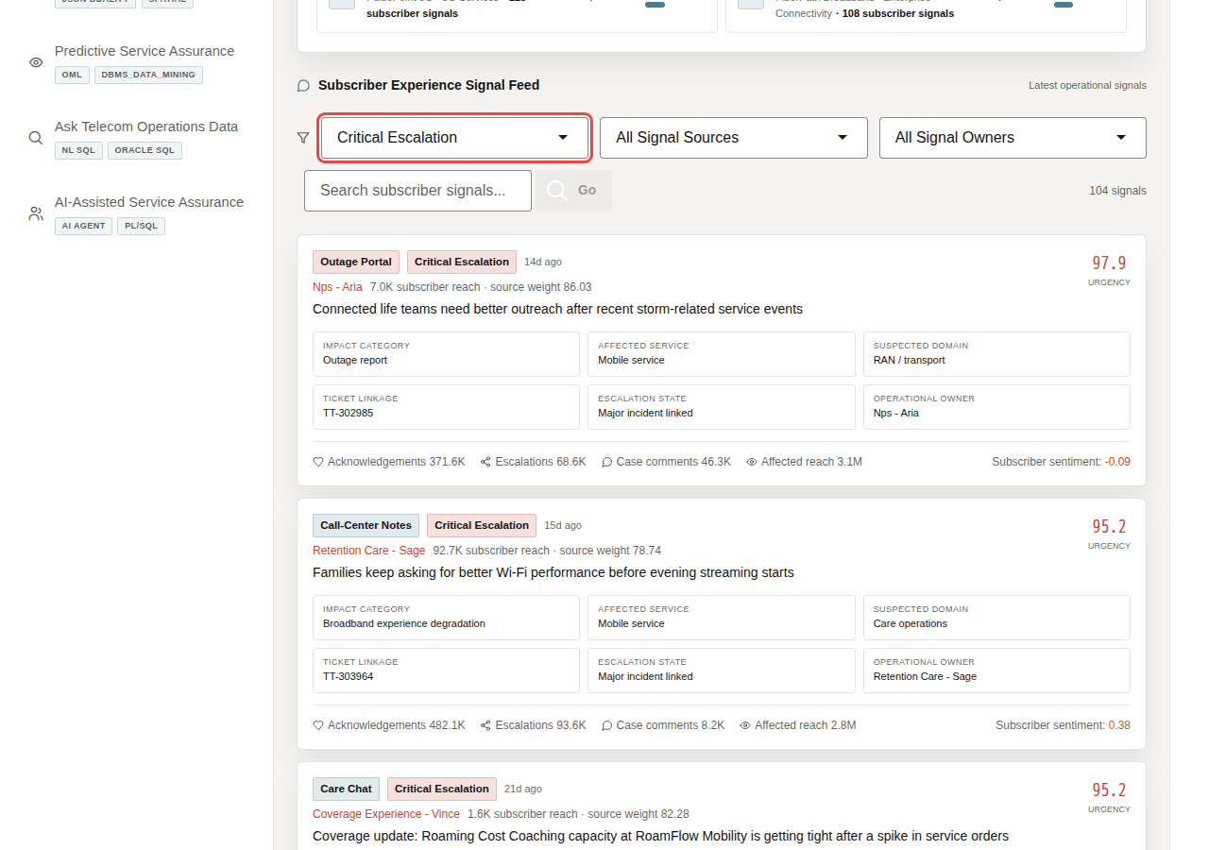
Signal feed filters
Review high-priority subscriber signals to identify the subscriber pain, affected reach, urgency, and escalation activity that may require care, network, or field follow-up.
- In the feed filters, select Critical Escalation or High Priority.
- Review the visible signal cards.
- Focus on a high-priority signal such as Connected life teams need better outreach after recent storm-related service events.
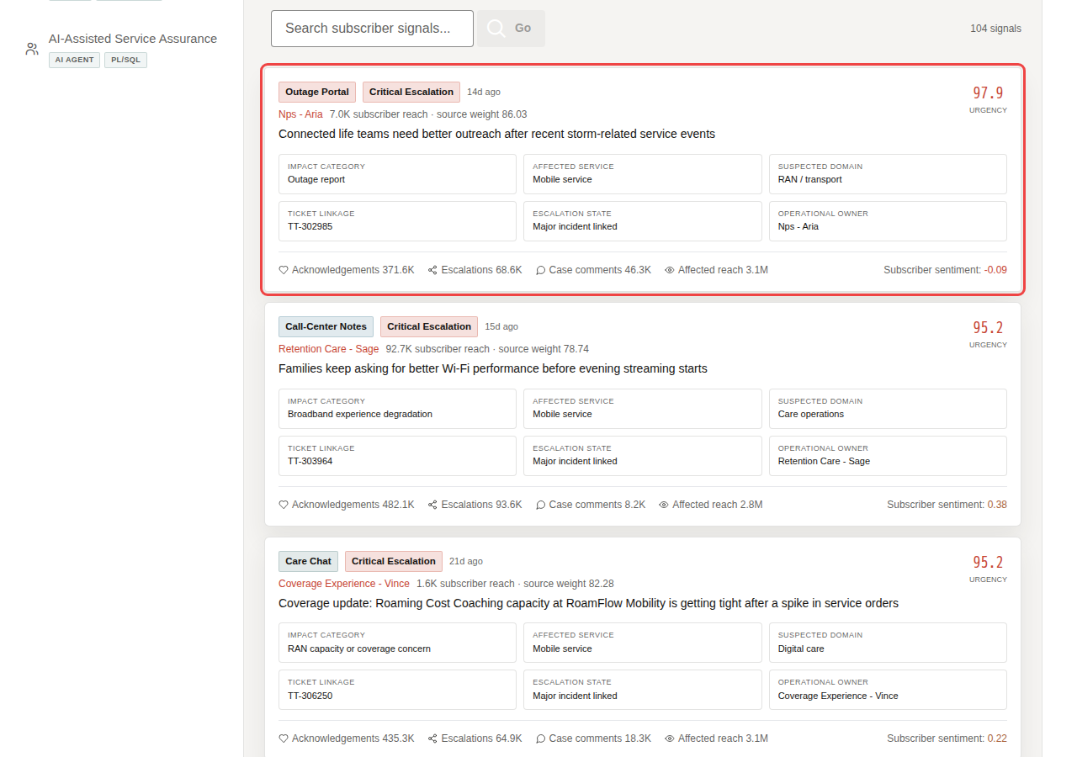
High-priority subscriber signal card
The current page shows 5,000 subscriber signals, a signal urgency of 97.9, and 3.1M affected reach. The important pattern is that each card should read as an operational signal with linked service, suspected domain, ticket state, escalation state, and owner context.
Note: These are sample values from the current demo dataset and may change after a refresh, seed update, or custom dataset import. Treat these numbers as an example of the current operating pattern. Review the live values in the UI and connect them to the operational pattern: subscriber impact, capacity exposure, SLA risk, revenue exposure, dispatch load, or restoration status.
Important: This page is not a social-media wall. It is an operational signal feed that helps service assurance teams detect urgent subscriber pain before it becomes churn.

5.5 Task 4: Explain the governance pattern
Explain the governance pattern as meaningful search with control: subscriber signals stay in Oracle, embeddings support semantic matching, access policies scope what users can see, and business teams can triage without copying sensitive signal text into a separate vector-only system.
- Subscriber signal text is stored in Oracle AI Database.
- Embeddings are generated and stored with governed operational data.
- Semantic search finds similar services and signals by meaning.
- VPD-aware access keeps data scoped to the active demo user.
- Business users can triage subscriber experience without copying the signal corpus into a separate vector-only system.
Access controls help ensure users see only the telecom data they are allowed to see, which matters for subscribers, service orders, network regions, enterprise accounts, and AI governance.
You can move to the next scene.

5.6 Credits & Build Notes
- Author - Oracle LiveLabs Team
- Last Updated By/Date - Oracle LiveLabs Team, 2026-06-29

6 Scene 5 Subscriber and Network Impact Graph

6.1 Introduction
Subscriber and Network Impact Graph helps teams understand how a subscriber-impact event propagates through services, sites, tickets, enterprise accounts, and field crews. Instead of reviewing one incident or ticket at a time, users can see connected impact and prioritize response based on subscriber reach, dependencies, and intervention value.
Important: The user is not only asking whether an incident exists; they need to know who is affected, which dependencies matter, and where action will reduce the most impact.
Telecom teams struggle when the information needed for one service-assurance decision lives in separate OSS, BSS, care, NOC, field, and analytics tools. That separation slows action, increases reconciliation work, and makes it harder to trust the result.
Oracle AI Database helps address these challenges with property graph and SQL/PGQ on top of the same governed operational data. SQL/PGQ helps answer relationship questions, such as how an outage connects to subscribers, service lines, network sites, support cases, and crews.
In this scene, the graph uses telecom impact entities and relationships to let users explore connected impact and run business-facing graph queries without moving the data into a separate graph-only platform. The detail panel also exposes network evidence so the graph reads like a service-assurance investigation, not just a relationship visualization.
Estimated Time: 10 minutes
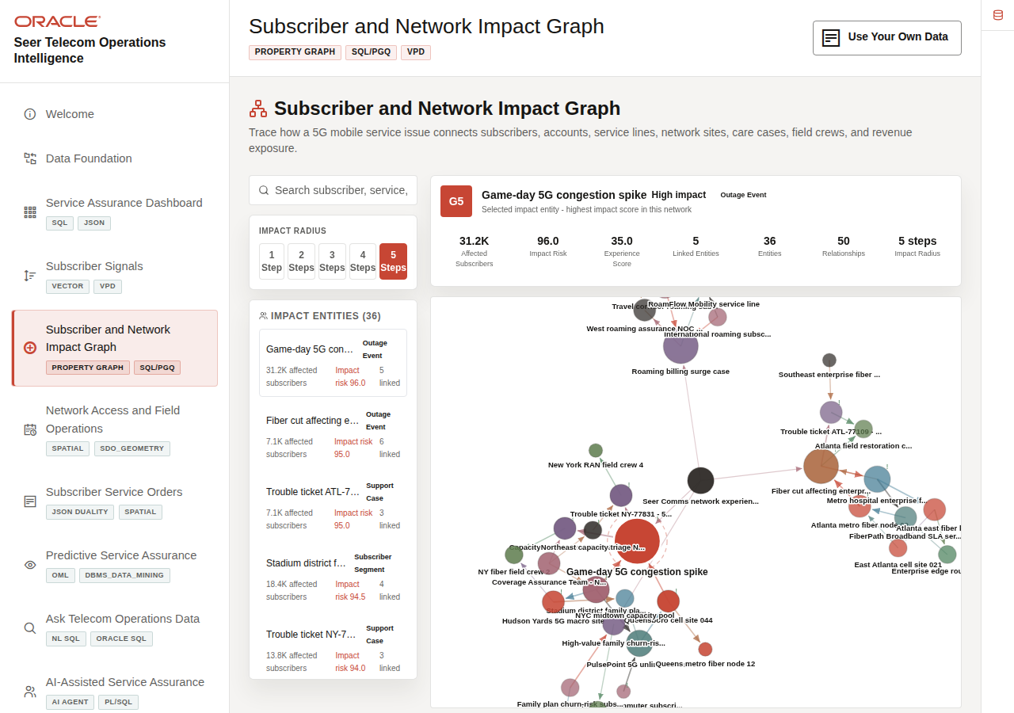
Subscriber and Network Impact Graph with impact entities and SQL/PGQ explorer

6.1.1 Objectives
In this scene, you will learn what telecom decision the page supports, what evidence the user should inspect, and what action the team may take next.

6.2 Task 1: Review the graph workspace
Impact entity workspace and graph canvas
Review the graph workspace to see how subscriber-impact relationships connect outage events, service lines, network sites, cases, accounts, and field crews.
- Click Subscriber and Network Impact Graph in the sidebar.
- Review the search field, Impact Radius control, Impact Entities list, relationship legend, and graph canvas.
- Review the metric labels in the selected entity panel: Affected Subscribers, Impact Risk, Experience Score, and Impact Radius.
In this example, the graph contains 36 telecom impact entities and 50 telecom graph relationships. The top entities include Game-day 5G congestion spike, Fiber cut affecting enterprise corridor, and trouble tickets such as ATL-77109 and NY-77831.
Note: These are sample values from the current demo dataset and may change after a refresh, seed update, or custom dataset import. Treat these numbers as an example of the current operating pattern. Review the live values in the UI and connect them to the operational pattern: subscriber impact, capacity exposure, SLA risk, revenue exposure, dispatch load, or restoration status.

6.3 Task 2: Investigate a high-impact outage event
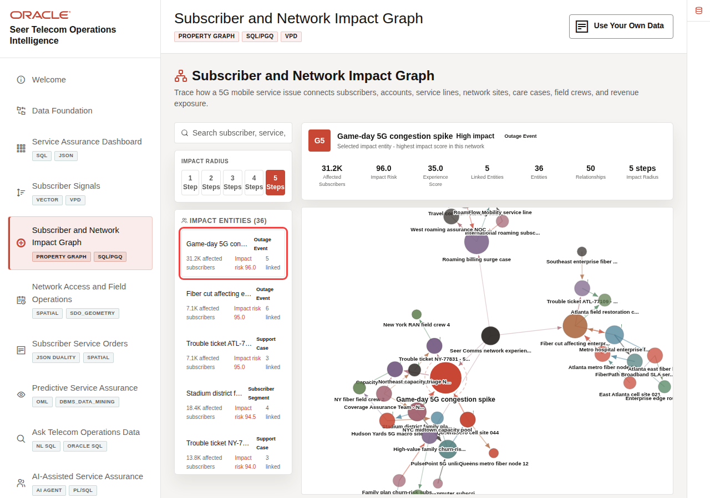
High-impact outage event detail
Investigate a high-impact outage event to show how teams can move from a named incident to affected subscribers, connected dependencies, related cases, and response priorities.
- Search for or select Game-day 5G congestion spike.
- Review the entity detail panel.
- Note the affected subscribers, impact risk, experience score, region, connected relationships, and network evidence.
- Click Explore if the graph is not already centered on that entity.
In the current demo dataset, Game-day 5G congestion spike affects 31,200 subscribers, carries 96 impact risk, and has a low 35 experience score. The network evidence panel adds service-assurance context such as cells and sectors, PRB utilization, RRC setup failures, handover failures, throughput, latency, packet loss, backhaul state, and restoration status. That is the data point to emphasize: the graph lets the operator move from a named event to subscriber impact, technical evidence, and connected operational dependencies.
Note: These are sample values from the current demo dataset and may change after a refresh, seed update, or custom dataset import. Treat these numbers as an example of the current operating pattern. Review the live values in the UI and connect them to the operational pattern: subscriber impact, capacity exposure, SLA risk, revenue exposure, dispatch load, or restoration status.

6.4 Task 3: Run a SQL/PGQ impact query
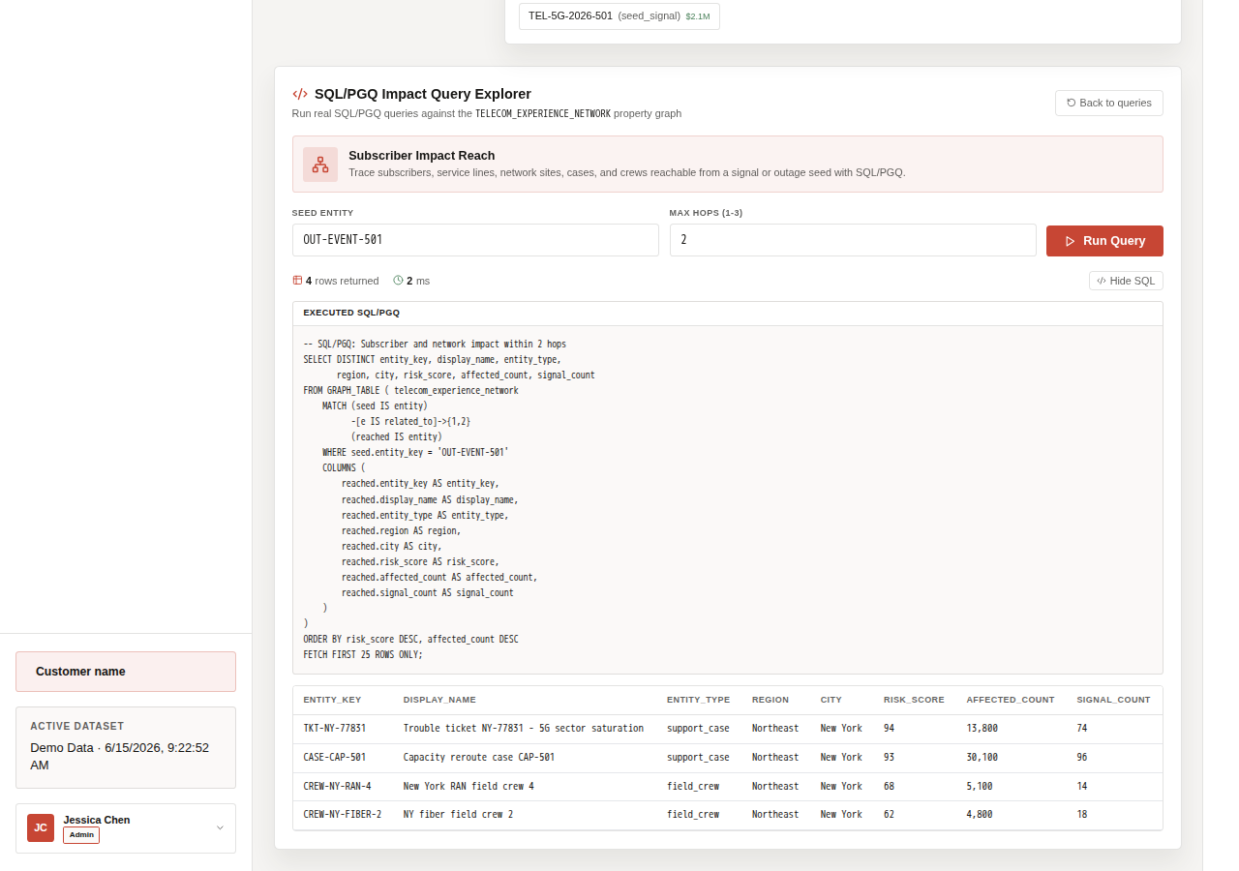
SQL/PGQ Impact Query Explorer
Run a SQL/PGQ impact query to show how service assurance teams can trace subscriber, service, site, case, and crew relationships from an outage or signal seed.
- Scroll to SQL/PGQ Impact Query Explorer.
- Select Subscriber Impact Reach.
- Keep the seed entity OUT-EVENT-501 and the default max hops.
- Click Run Query.
- Review the query result table.
The query helps service assurance teams trace who and what is affected from a signal or outage seed, including subscribers, service lines, sites, cases, and crews.

6.5 Task 4: Explain the investigation pattern
Explain the investigation pattern as connected impact analysis: the graph helps teams prioritize response based on subscriber reach and operational dependencies, not only ticket order.
- Impact entities are stored as governed telecom data.
- SQL/PGQ traverses relationships among subscribers, service lines, sites, cases, and crews.
- The UI turns graph results into operational labels such as affected subscribers and impact risk.
- The graph helps teams prioritize response based on connected impact, not only ticket order.
You can move to the next scene.

6.6 Credits & Build Notes
- Author - Oracle LiveLabs Team
- Last Updated By/Date - Oracle LiveLabs Team, 2026-06-29

7 Scene 6 Network Access and Field Operations

7.1 Introduction
Network Access and Field Operations helps teams see where subscriber demand intersects with network sites, service zones, field dispatch routes, and capacity constraints. The map gives a geographic operating view so users can compare subscriber-impact pressure, site capacity, dispatch routes, field readiness, and subscriber priority in one place.
Telecom teams struggle when the information needed for one service-assurance decision lives in separate OSS, BSS, care, NOC, field, and analytics tools. That separation slows action, increases reconciliation work, and makes it harder to trust the result.
Oracle AI Database helps address these challenges by keeping spatial data, service orders, capacity forecasts, subscriber locations, and operational metrics together. In this scene, Oracle Spatial supports service-zone visualization, proximity analysis, demand density, and field dispatch routing from the same data foundation used by the rest of the LiveStack Demo.
Estimated Time: 10 minutes
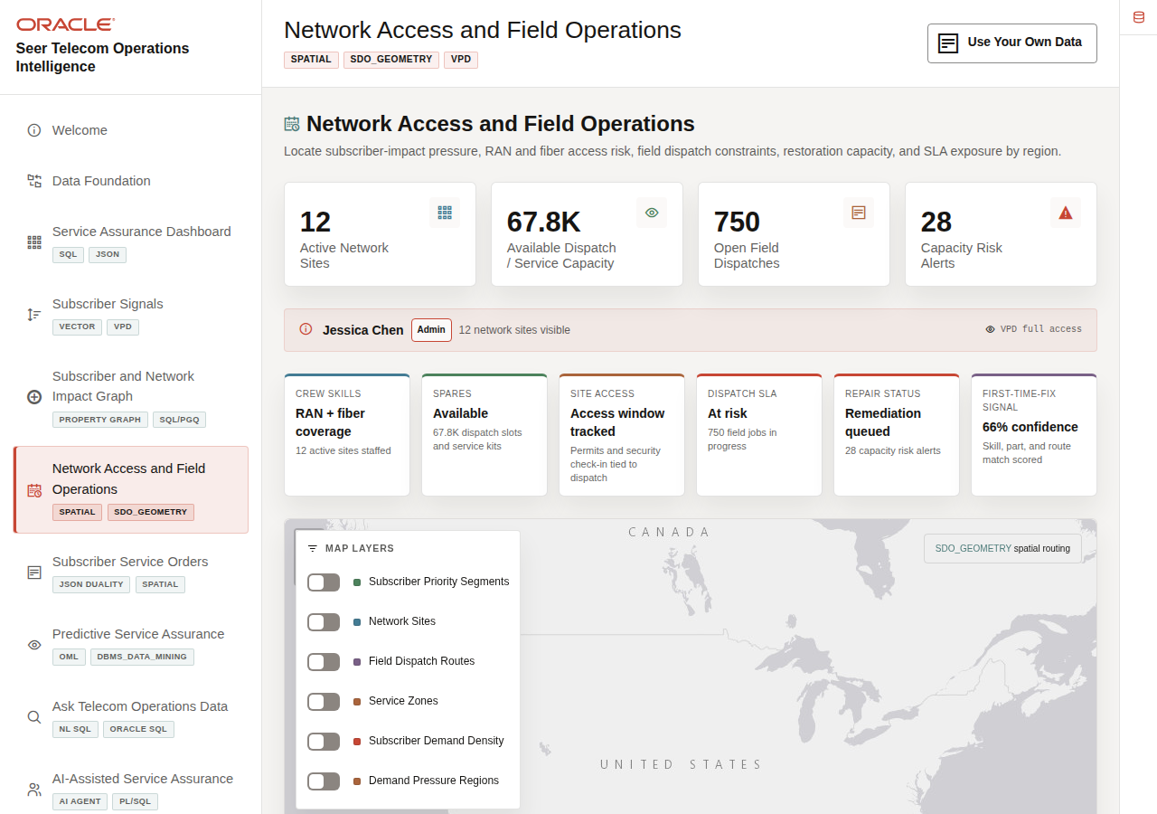
Network Access and Field Operations map with sites, routes, demand layers, and alerts

7.1.1 Objectives
In this scene, you will learn what telecom decision the page supports, what evidence the user should inspect, and what action the team may take next.

7.2 Task 1: Review the field operations map
Network access metrics and map layer controls
Review the field operations map to understand where network access, subscriber demand, demand regions, field dispatch routes, field readiness, and capacity constraints intersect.
- Click Network Access and Field Operations in the sidebar.
- Review the top metric tiles: Active Network Sites, Available Field / Service Capacity, Open Field Dispatches, and Capacity Risk Alerts.
- Review the map legend and layer controls. The map layers initialize off.
- Toggle the controls if you want to isolate Network Sites, Field Dispatch Routes, Service Zones, Subscriber Demand Density, or Demand Pressure Regions.
- Review the field readiness strip: crew skills, spares, site access, dispatch SLA, repair status, and first-time-fix signal.
The map is not just showing points; it connects subscriber-impact pressure, network access, field capacity, demand regions, field readiness, and subscriber density to the same service-assurance story.

7.3 Task 2: Inspect network sites and field capacity
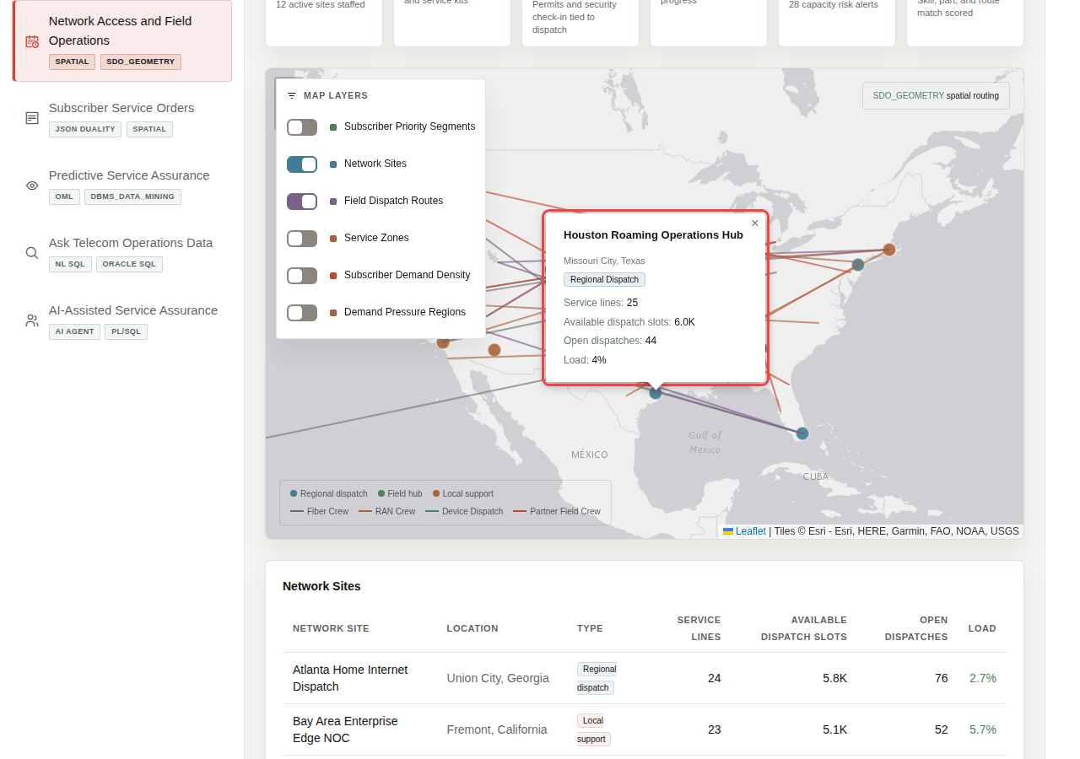
Network site map and route workspace
Inspect network sites and field capacity to compare current load, available dispatch slots, service readiness, and pending dispatches before deciding where field support or capacity relief may be needed.
- Review the active network site markers on the map.
- Focus on sites such as Atlanta Home Internet Dispatch, Dallas 5G Dispatch Center, and Miami Connected Life Hub.
- Compare current load, available dispatch slots, service lines tracked, and pending dispatches.
In the current demo dataset, the page uses 12 active network sites. The selected Houston Roaming Operations Hub example shows 25 service lines, about 6.0K available dispatch slots, 44 open dispatches, and 4% load. The table also supports comparison across sites such as Atlanta Home Internet Dispatch, Dallas 5G Dispatch Center, and Chicago Midwest NOC.
Note: These are sample values from the current demo dataset and may change after a refresh, seed update, or custom dataset import. Treat these numbers as an example of the current operating pattern. Review the live values in the UI and connect them to the operational pattern: subscriber impact, capacity exposure, SLA risk, revenue exposure, dispatch load, or restoration status.

7.4 Task 3: Review capacity risk alerts
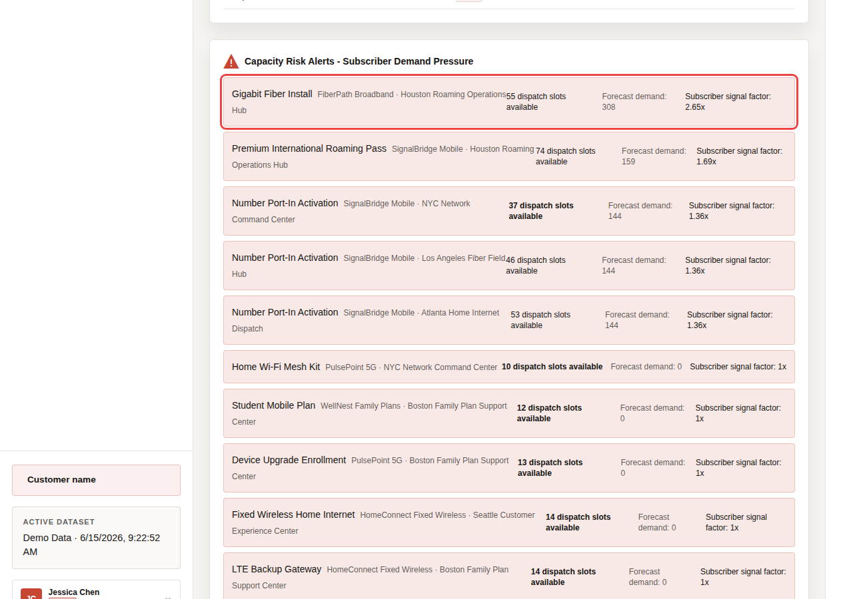
Capacity Risk Alerts with forecast demand and dispatch capacity
Review capacity risk alerts to identify where forecast demand exceeds available capacity and where field teams may need to rebalance resources, adjust dispatch, or prioritize service recovery.
- Scroll to Capacity Risk Alerts.
- Review the services, network sites, available capacity, forecast demand, and subscriber signal factor.
- Focus on a service such as Gigabit Fiber Install at Houston Roaming Operations Hub.
Spatial context becomes operational action when teams can see where forecast demand, capacity, and field dispatch options are misaligned.
In the current demo dataset, Gigabit Fiber Install at Houston Roaming Operations Hub shows 55 dispatch slots available against 308 forecast demand and is marked low capacity. Number Port-In Activation appears as a critical example in the NYC Network Command Center, with 37 available dispatch slots and 144 predicted demand.
Note: These are sample values from the current demo dataset and may change after a refresh, seed update, or custom dataset import. Treat these numbers as an example of the current operating pattern. Review the live values in the UI and connect them to the operational pattern: subscriber impact, capacity exposure, SLA risk, revenue exposure, dispatch load, or restoration status.

7.5 Task 4: Explain the spatial pattern
Explain the spatial pattern as field-aware service assurance: network sites, subscriber locations, demand forecasts, and dispatch routes stay connected to the same governed telecom data foundation.
- Network site and subscriber locations are stored with spatial coordinates.
- Demand forecasts and subscriber signals add operational pressure to geography.
- Field dispatch routes show how the business responds.
- Oracle Spatial keeps the map, proximity, route, and zone context connected to transactional service data.
You can move to the next scene.

7.6 Credits & Build Notes
- Author - Oracle LiveLabs Team
- Last Updated By/Date - Oracle LiveLabs Team, 2026-06-29

8 Scene 7 Subscriber Service Orders

8.1 Introduction
Subscriber Service Orders shows how one service order can support several telecom workflows at once. Care teams need operational detail, service operations teams need transactional accuracy, application teams need document-shaped access, and field teams need dispatch context.
Telecom teams struggle when the information needed for one service-assurance decision lives in separate OSS, BSS, care, NOC, field, and analytics tools. That separation slows action, increases reconciliation work, and makes it harder to trust the result.
Oracle AI Database helps address these challenges by keeping the service order in one governed data platform while exposing it through the shape each workflow needs. Relational tables provide ACID transactions, foreign keys, and operational SQL.
JSON Relational Duality Views expose the same service order as a nested JSON document for application and API use cases. Oracle Spatial adds dispatch and distance context for field visibility, and VPD policies can control which orders each user can see.
Access controls help ensure users see only the telecom data they are allowed to see, which matters for subscribers, service orders, network regions, enterprise accounts, and AI governance.
Estimated Time: 10 minutes
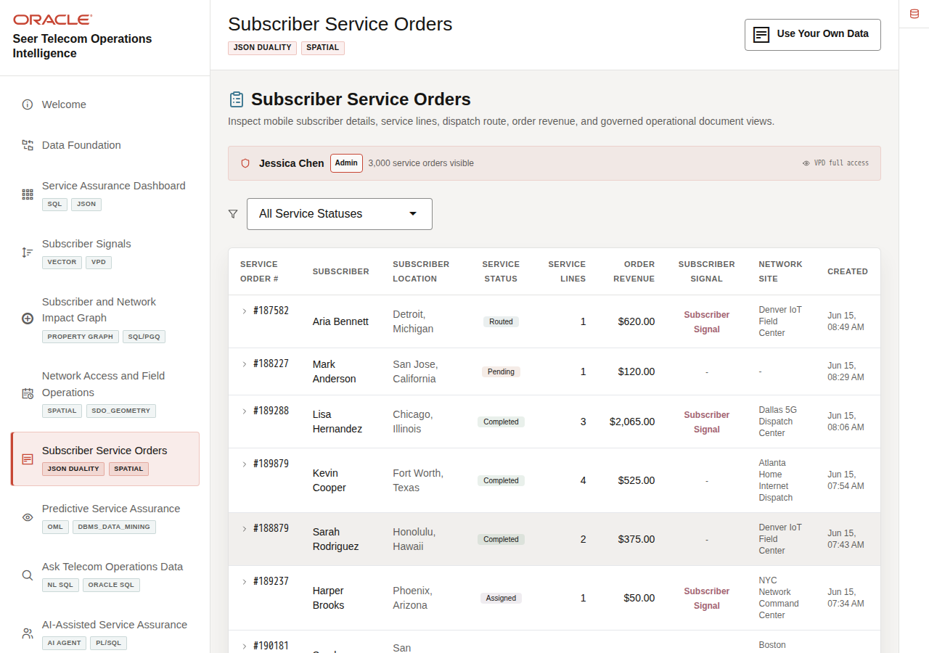
Subscriber Service Orders list with service order workspace

8.1.1 Objectives
In this scene, you will learn what telecom decision the page supports, what evidence the user should inspect, and what action the team may take next.

8.2 Task 1: Review the service-order workspace
Subscriber Service Orders workspace and filters
Review the service-order workspace to establish the operational context: who the order is for, what status it is in, what value is involved, and which dispatch center is responsible.
- Click Subscriber Service Orders in the sidebar.
- Review the VPD banner below the page subtitle. It shows the active demo user and whether the user has full access or a region-filtered order view.
- Review the status filter and the service-order table.
- Focus on service order #189288.
In the current demo dataset, service order #189288 is for Lisa Hernandez in Chicago, Illinois. It is marked Completed, contains 3 line items, totals $2,065, and is fulfilled by Dallas 5G Dispatch Center. This service order will be the data point used through the rest of the scene.
Note: These are sample values from the current demo dataset and may change after a refresh, seed update, or custom dataset import. Treat these numbers as an example of the current operating pattern. Review the live values in the UI and connect them to the operational pattern: subscriber impact, capacity exposure, SLA risk, revenue exposure, dispatch load, or restoration status.

8.3 Task 2: Inspect the relational service-order detail
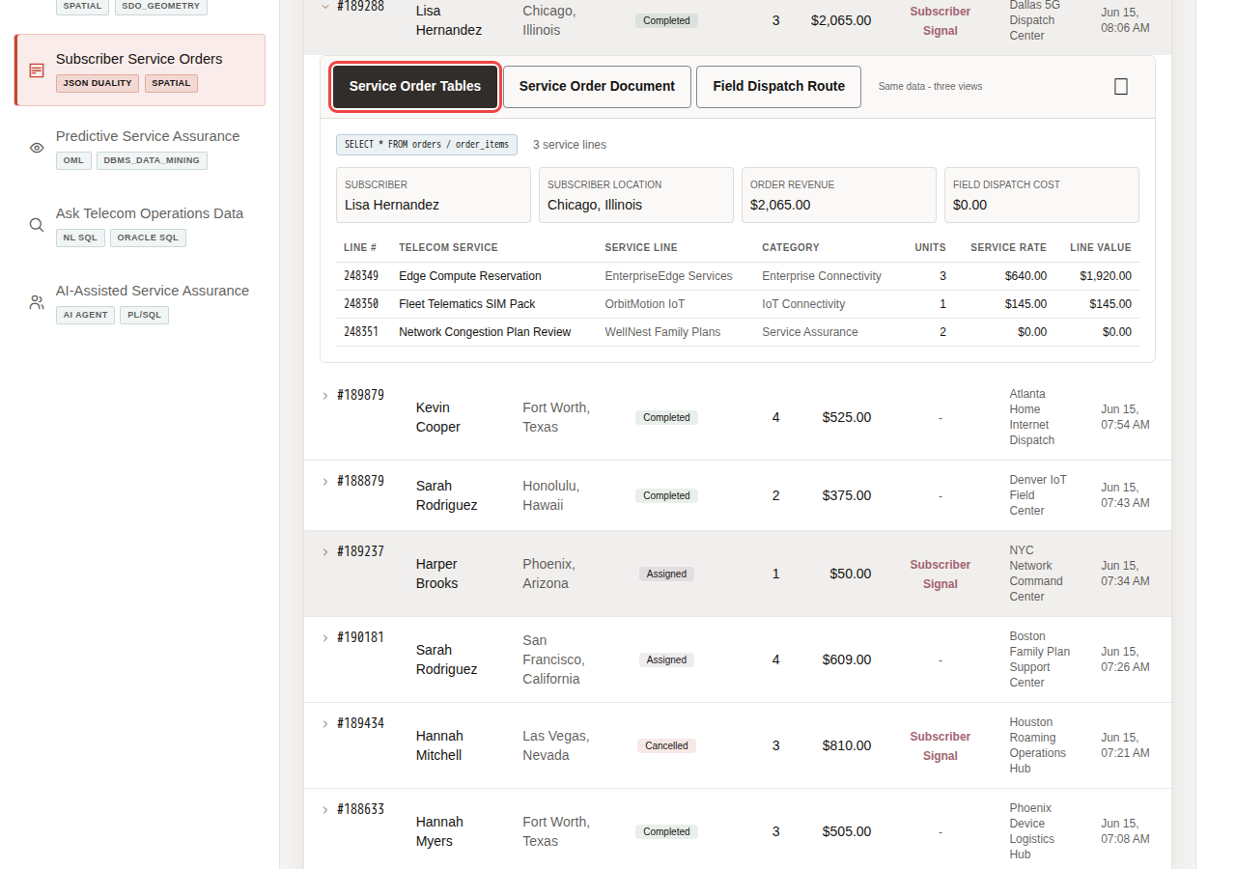
Service order detail with relational service-order tables
Inspect the relational service-order detail to validate the subscriber, location, order total, dispatch cost, line items, quantities, and pricing that care and service operations teams need for follow-up.
- Click service order #189288.
- Confirm the Service Order Tables tab is selected.
- Review the subscriber, location, total, dispatch cost, and line-item table.
- Review the services in the order, such as Edge Compute Reservation, Fleet Telematics SIM Pack, and Network Congestion Plan Review.
This view is useful for service operations and customer care because it shows normalized transactional data in a format that is easy to validate. The order header, subscriber, service, brand, category, quantity, unit price, and line total are connected through relational joins while preserving ACID consistency.
The relational order record shows an order-level shipping or dispatch cost of $0.00. The later route view calculates $22.20 of field-dispatch context; these are separate measures.

8.4 Task 3: Compare the Service Order Document
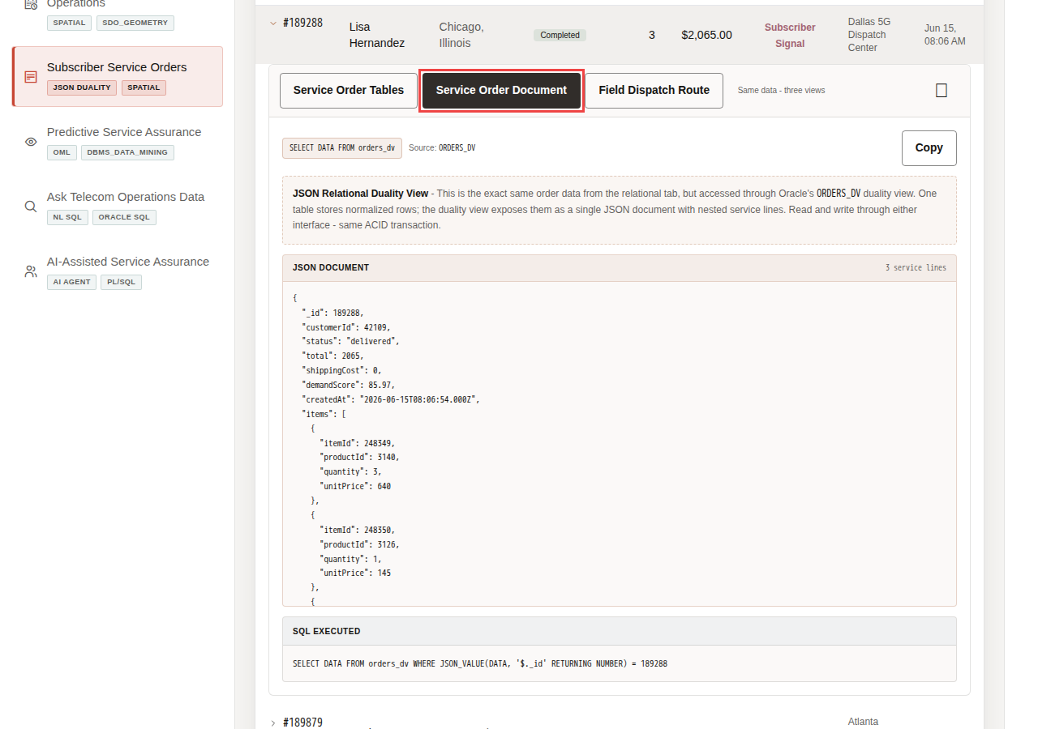
Service Order Document tab with JSON document for order 189288
Compare the Service Order Document to show that the same governed service order can support both operations users and application teams without creating separate copies of the record.
- Click Service Order Document in the expanded order panel.
- Review the source label for the JSON Duality View.
- Review the JSON document for service order 189288.
- Notice that the document contains order identity, subscriber identity, status, total, dispatch cost, demand score, created date, and nested line items.
The key point is that the service order is not copied into a separate document store. The same governed order can appear as operational detail or as a document shape for applications.

8.5 Task 4: Review field dispatch context
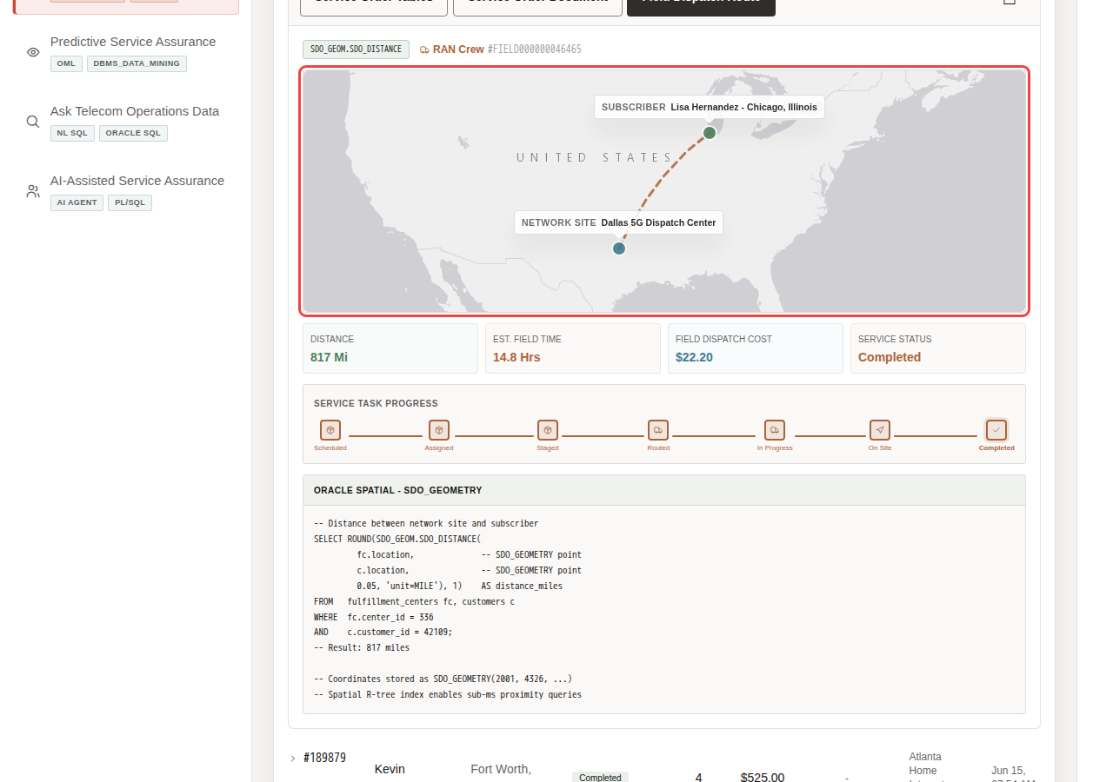
Field Dispatch Route tab with network site, subscriber location, and dispatch metrics
Review field dispatch context to connect the service order to the dispatch center, subscriber location, distance, transit time, dispatch cost, and progress timeline.
- Click Field Dispatch Route in the expanded order panel.
- Review the network site and subscriber locations on the map.
- Review the dispatch context below the map: distance, estimated transit time, dispatch cost, and status.
- Review the dispatch progress timeline.
The business value is that teams can make the decision from connected, governed data. Oracle AI Database provides the shared foundation that keeps operational data, analytics, and AI workflows aligned.
For order #189288, the page connects Dallas 5G Dispatch Center to Lisa Hernandez in Chicago. The operational detail includes a spatial distance of about 817 miles and a route-derived field-dispatch cost of $22.20. This connects the service-order record to field visibility, not just API payloads or order totals.
Note: These are sample values from the current demo dataset and may change after a refresh, seed update, or custom dataset import. Treat these numbers as an example of the current operating pattern. Review the live values in the UI and connect them to the operational pattern: subscriber impact, capacity exposure, SLA risk, revenue exposure, dispatch load, or restoration status.
You can move to the next scene.

8.6 Credits & Build Notes
- Author - Oracle LiveLabs Team
- Last Updated By/Date - Oracle LiveLabs Team, 2026-06-29

9 Scene 8 Predictive Service Assurance

9.1 Introduction
Predictive Service Assurance helps telecom teams decide which predictive signals should become action. The page brings together service-impact risk prediction, retention segments, service revenue forecasts, service behavior clusters, and network access risk so teams can plan capacity, outreach, dispatch, and care response before pressure turns into churn or SLA breach.
Telecom teams struggle when the information needed for one service-assurance decision lives in separate OSS, BSS, care, NOC, field, and analytics tools. That separation slows action, increases reconciliation work, and makes it harder to trust the result.
Oracle AI Database helps address these challenges by keeping machine learning close to governed telecom data. Oracle Machine Learning models can be trained, persisted, and scored in the database with DBMS_DATA_MINING, PREDICTION(), PREDICTION_PROBABILITY(), and CLUSTER_ID(). Service-impact risk prediction, retention segmentation, service revenue forecasting, service behavior clustering, and network access risk scoring can run from the same connected data foundation that powers the rest of the LiveStack Demo. The backend model name remains DEMAND_SURGE_MODEL for compatibility with the seed scripts, but the business interpretation in the demo is service-impact risk. The model uses governed telecom service features including subscriber signals, service-order activity, service value, and a service-pressure score.
Estimated Time: 10 minutes
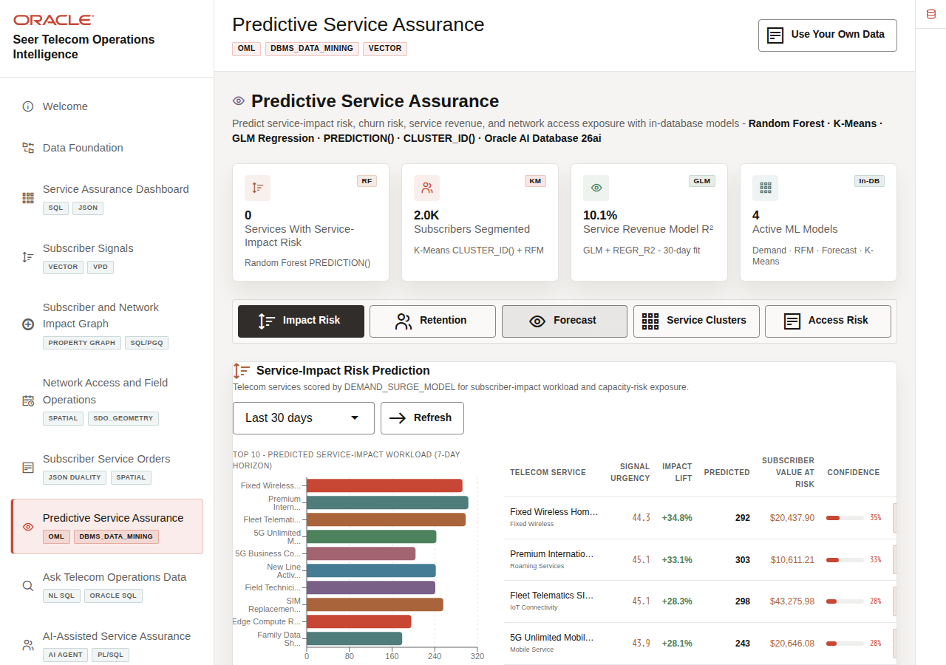
Predictive Service Assurance summary cards and mode tabs

9.1.1 Objectives
In this scene, you will learn what telecom decision the page supports, what evidence the user should inspect, and what action the team may take next.

9.2 Task 1: Review the predictive assurance workspace
Predictive Service Assurance summary cards and mode tabs
Review the predictive assurance workspace as a set of decision tools for service-impact risk, retention, revenue forecasting, service behavior grouping, and network access risk.
- Click Predictive Service Assurance in the sidebar.
- Review the four summary cards at the top of the page: services with service-impact risk, subscribers segmented, revenue model R2, and active ML models.
- Review the mode tabs: Impact Risk, Retention, Forecast, Service Clusters, and Access Risk.
This page is a business-facing analytics surface, not a separate data science notebook. The predictions are shown next to the operational context needed to act on them.

9.3 Task 2: Inspect service-impact risk prediction
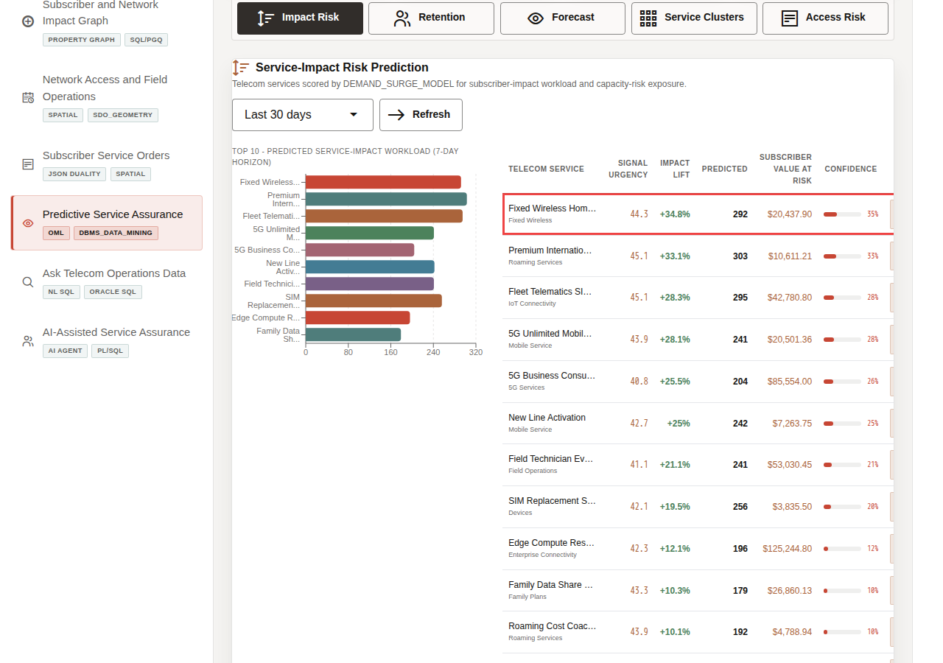
Service-impact risk prediction results
Inspect service-impact risk prediction to identify services where predicted pressure may require capacity planning, field dispatch, care outreach, SLA management, or retention action.
- Stay on the Impact Risk tab.
- Use the scoring window selector if you want to change the time window, then click Refresh.
- Review the bar chart and service table.
- Focus on a top risk row, such as Fixed Wireless Home Internet or Premium International Roaming Pass.
In the current demo dataset, Fixed Wireless Home Internet shows signal urgency 44.3, impact lift +34.8%, predicted workload 292, subscriber value at risk of $20,437.90, and 35% confidence. The same table also shows services such as Premium International Roaming Pass, Fleet Telematics SIM Pack, and 5G Unlimited Mobile Plan.
This gives the service assurance user a concrete question to answer: should the provider add capacity, adjust field dispatch, prioritize outreach, prepare care teams, or protect an SLA before service pressure turns into churn?
Note: These are sample values from the current demo dataset and may change after a refresh, seed update, or custom dataset import. Treat these numbers as an example of the current operating pattern. Review the live values in the UI and connect them to the operational pattern: subscriber impact, capacity exposure, SLA risk, revenue exposure, dispatch load, or restoration status.

9.4 Task 3: Filter retention segments
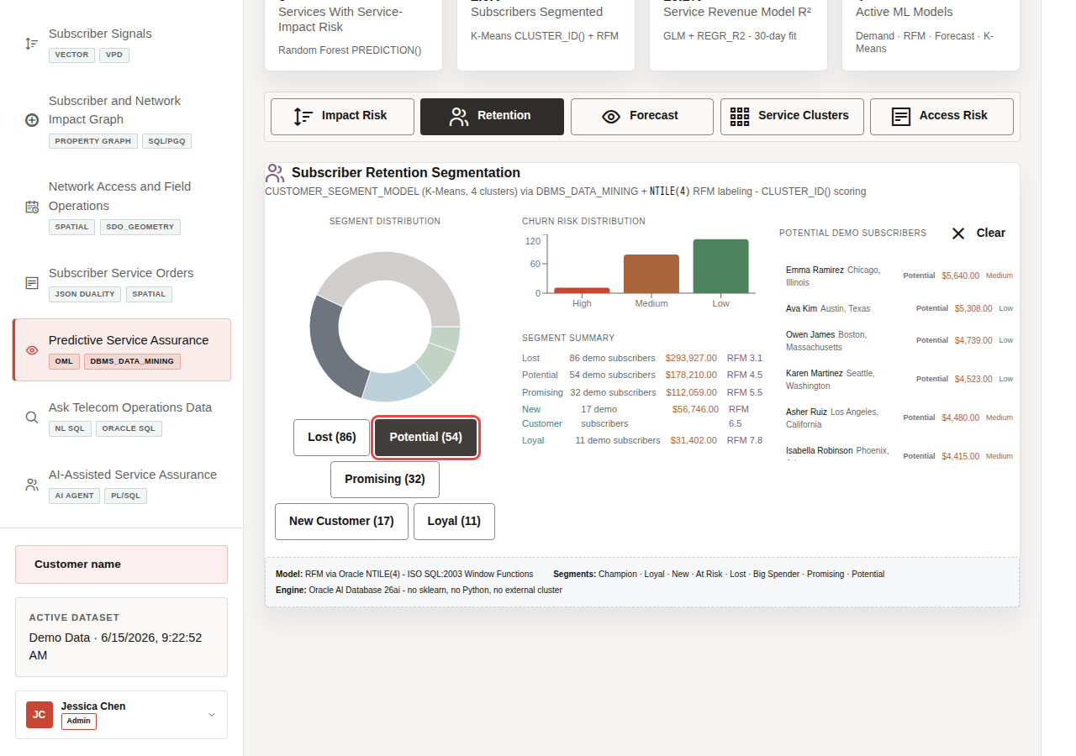
Retention segment filter and filtered subscriber list
Filter retention segments to turn model output into groups of subscribers who may need outreach, plan optimization, retention action, or service follow-up.
- Click Retention.
- Review the segment distribution and segment summary.
- Click Loyal (11), Potential (54), or another segment button.
- Review the filtered subscriber list on the right.
Segmentation becomes operational when teams can turn subscriber groups into retention campaigns, plan optimization, service follow-up, or care outreach.
In the current demo dataset, the visible segment distribution includes Lost (86), Potential (54), Promising (32), New Customer (17), and Loyal (11). Selecting a segment filters the subscriber list so the user can inspect the people behind that score, including spend, location, churn risk, and predicted lifetime value.
Note: These are sample values from the current demo dataset and may change after a refresh, seed update, or custom dataset import. Treat these numbers as an example of the current operating pattern. Review the live values in the UI and connect them to the operational pattern: subscriber impact, capacity exposure, SLA risk, revenue exposure, dispatch load, or restoration status.

9.5 Task 4: Change the service revenue forecast horizon
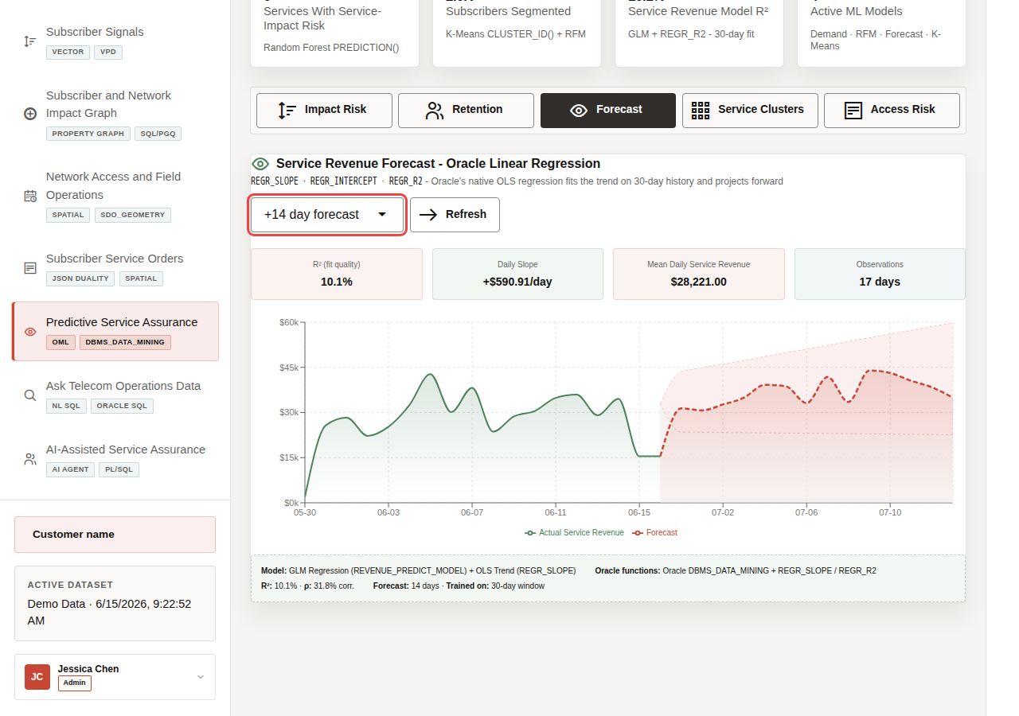
Forecast horizon selector, model quality cards, and service revenue forecast chart
Change the service revenue forecast horizon to understand both the projected revenue trend and how much confidence planners should place in it.
- Click Forecast.
- Change the forecast horizon to +14 day forecast.
- Click Refresh if the page does not update automatically.
- Review the model quality cards and the forecast chart.
A low model-quality score tells planners to treat the forecast as directional, not certain. This builds trust because the demo does not hide weak predictions.
In the current demo dataset, the 14-day forecast view shows a trend R2 of 10.1%, a daily slope of +$590.91/day, mean daily service revenue of $28,221, and 17 days of observations.
Note: These are sample values from the current demo dataset and may change after a refresh, seed update, or custom dataset import. Treat these numbers as an example of the current operating pattern. Review the live values in the UI and connect them to the operational pattern: subscriber impact, capacity exposure, SLA risk, revenue exposure, dispatch load, or restoration status.

9.6 Task 5: Review service behavior clusters
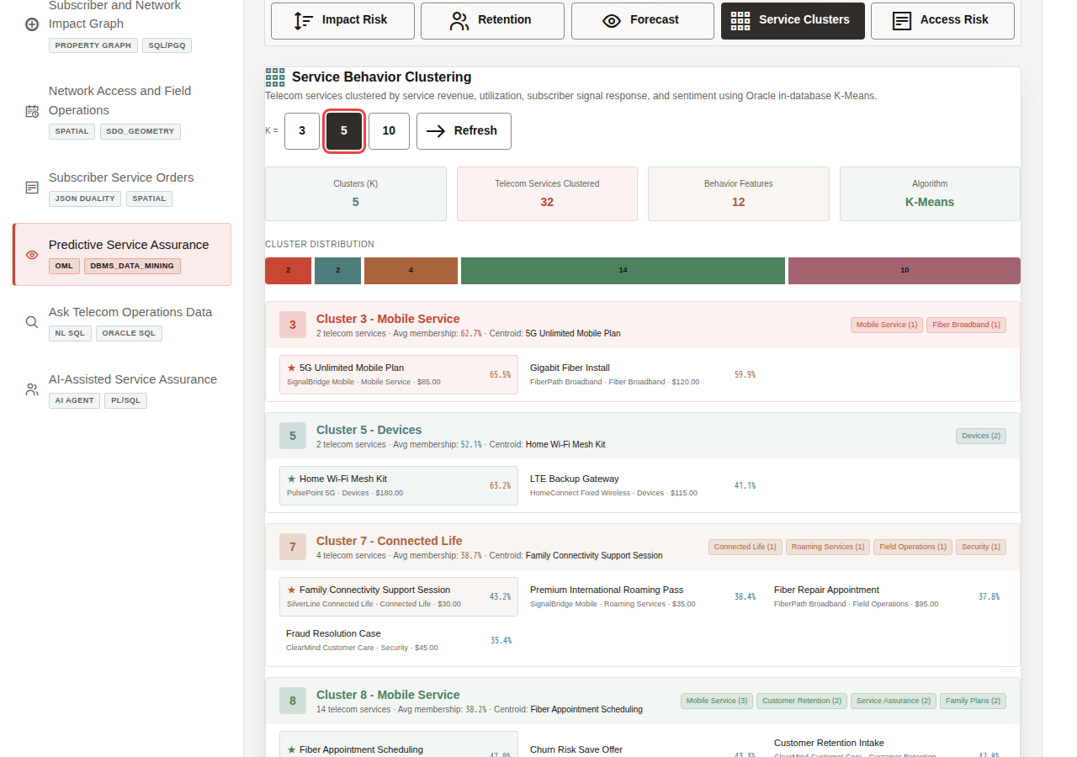
Service Behavior Clustering K control and cluster assignments
Review service behavior clusters to see how related telecom services group together by usage and demand patterns, which can support bundling, recommendation design, plan optimization, and lookalike service analysis.
- Click Service Clusters.
- Change the K = control if you want to compare cluster counts.
- Review the cluster summary cards and distribution bar.
- Review one cluster card and its service assignments.
This helps a telecom analyst understand how AI-assisted grouping can support service bundling, plan optimization, recommendation design, and lookalike service exploration.
In the current demo dataset, K = 5 clusters group 32 telecom services. The visible Cluster 3 contains 5G Unlimited Mobile Plan and Gigabit Fiber Install. Premium International Roaming Pass appears in Cluster 7.
Note: These are sample values from the current demo dataset and may change after a refresh, seed update, or custom dataset import. Treat these numbers as an example of the current operating pattern. Review the live values in the UI and connect them to the operational pattern: subscriber impact, capacity exposure, SLA risk, revenue exposure, dispatch load, or restoration status.

9.7 Task 6: Review network access risk
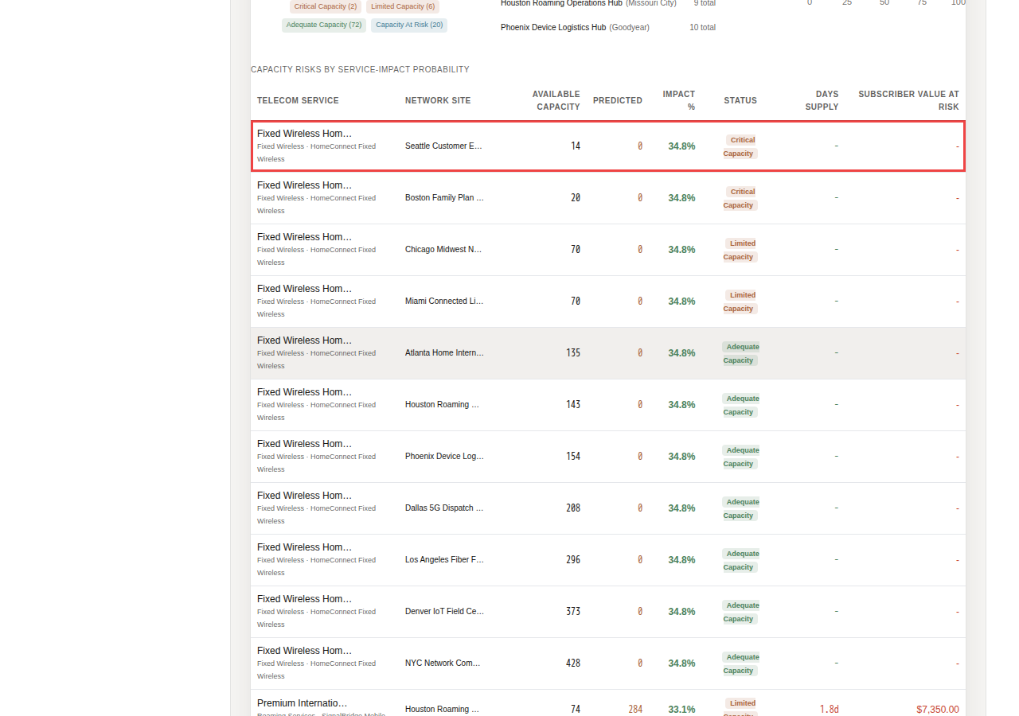
Network Access Risk summary and capacity risks by service-impact probability
Review network access risk to connect predicted demand with site capacity, available units, capacity status, and revenue or churn exposure.
- Click Access Risk.
- Review the access-risk summary cards.
- Scroll to Capacity Risks by Service-Impact Probability.
- Focus on a high-risk service and site combination.
The business value is that teams can make the decision from connected, governed data. Oracle AI Database provides the shared foundation that keeps operational data, analytics, and AI workflows aligned.
You can move to the next scene.

9.8 Credits & Build Notes
- Author - Oracle LiveLabs Team
- Last Updated By/Date - Oracle LiveLabs Team, 2026-06-29

10 Scene 9 Ask Telecom Operations Data

10.1 Introduction
Ask Telecom Operations Data helps business users ask telecom questions in plain language while keeping the answer path visible. Users can inspect generated SQL, run it against governed Oracle data, and review returned rows, making self-service analytics faster and easier to trust.
Telecom teams struggle when the information needed for one service-assurance decision lives in separate OSS, BSS, care, NOC, field, and analytics tools. That separation slows action, increases reconciliation work, and makes it harder to trust the result.
Oracle AI Database helps address these challenges by keeping query execution grounded in the live telecom schema. In this LiveStack Demo, the app sends the business question and schema context to the local Ollama runtime, validates the generated SQL path, and uses Oracle AI Database 26ai as the execution authority.
The user can inspect generated SQL before execution, run the SQL to return rows, or use narrative modes when they want a summarized answer.
Estimated Time: 10 minutes
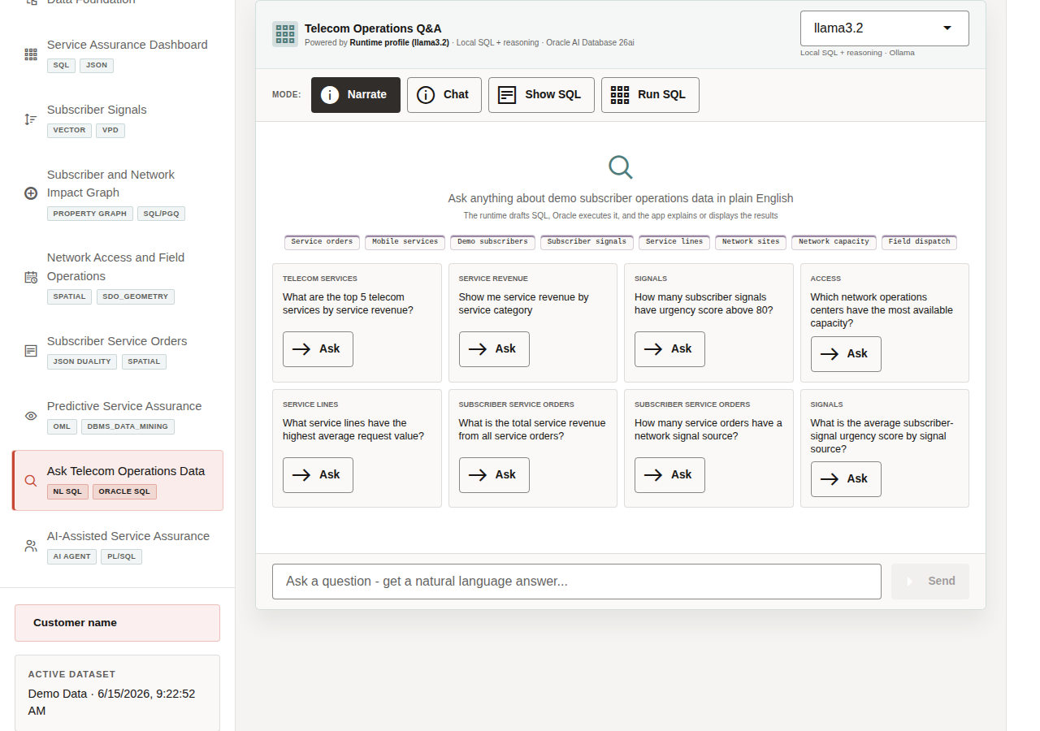
Ask Telecom Operations Data workspace with modes and example questions

10.1.1 Objectives
In this scene, you will learn what telecom decision the page supports, what evidence the user should inspect, and what action the team may take next.

10.2 Task 1: Review the Ask Telecom Operations Data workspace
Ask Data modes and example questions
Review the workspace to show how telecom users can ask questions in plain language while still keeping the query path visible and controlled.
- Click Ask Telecom Operations Data in the sidebar.
- Review the runtime profile in the top right of the chat card. The current demo uses the local llama3.2 runtime through the SC_LLAMA_PROFILE profile.
- Review the four modes: Narrate, Chat, Show SQL, and Run SQL.
- Review the example question tiles.
- Focus on a concrete question such as What are the top 5 telecom services by service revenue? or How many subscriber signals have urgency score above 80?
Use this page to show the balance between business access and technical governance: the user asks in plain English, but the system keeps SQL visible and Oracle as the trusted execution layer.

10.3 Task 2: Inspect generated SQL
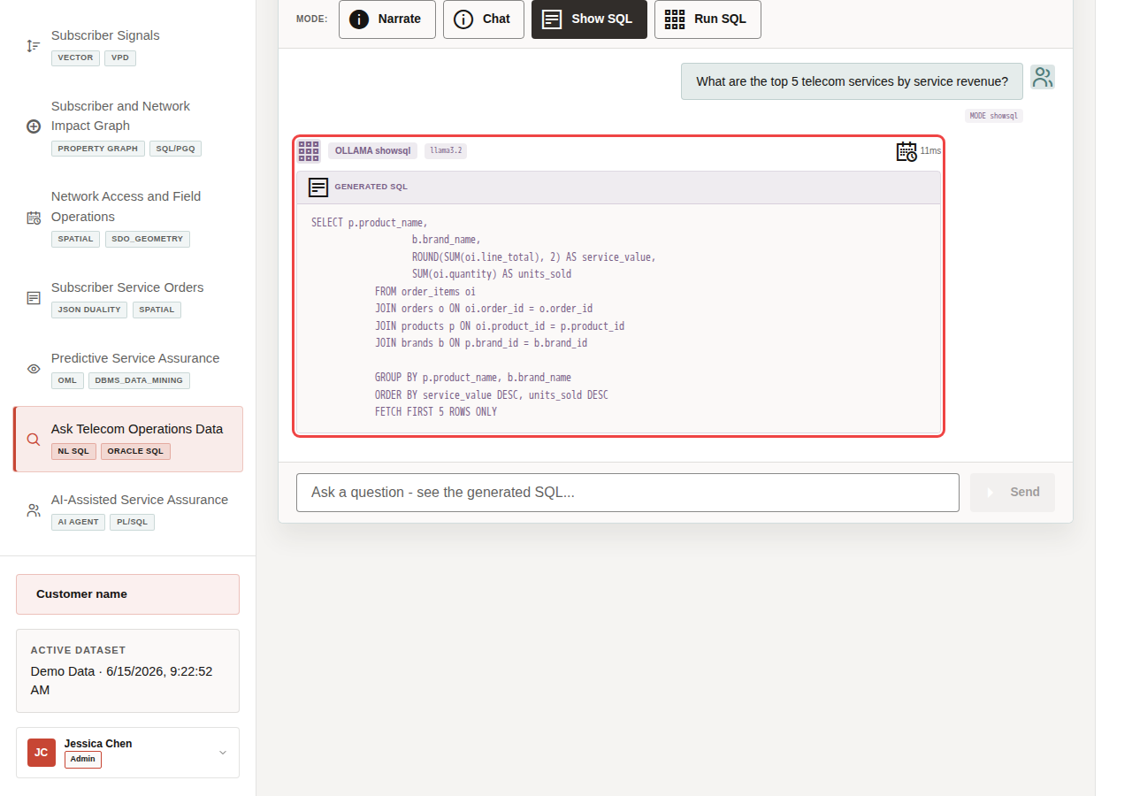
Generated SQL for the selected telecom revenue question
Inspect generated SQL to show that the answer is traceable. Even if the user does not read every line, the query can be reviewed instead of trusting a hidden AI response.
- Click Show SQL.
- Click Ask on What are the top 5 telecom services by service revenue?
- Review the generated SQL.
The generated SQL joins telecom service and service-order data to answer a business question. This is the governance moment in the scene: the business user can inspect the query path before asking the database to return rows.
The value is not only convenience. A telecom analyst can get faster answers while still seeing the SQL and returned rows behind the result.

10.4 Task 3: Run SQL and inspect returned data
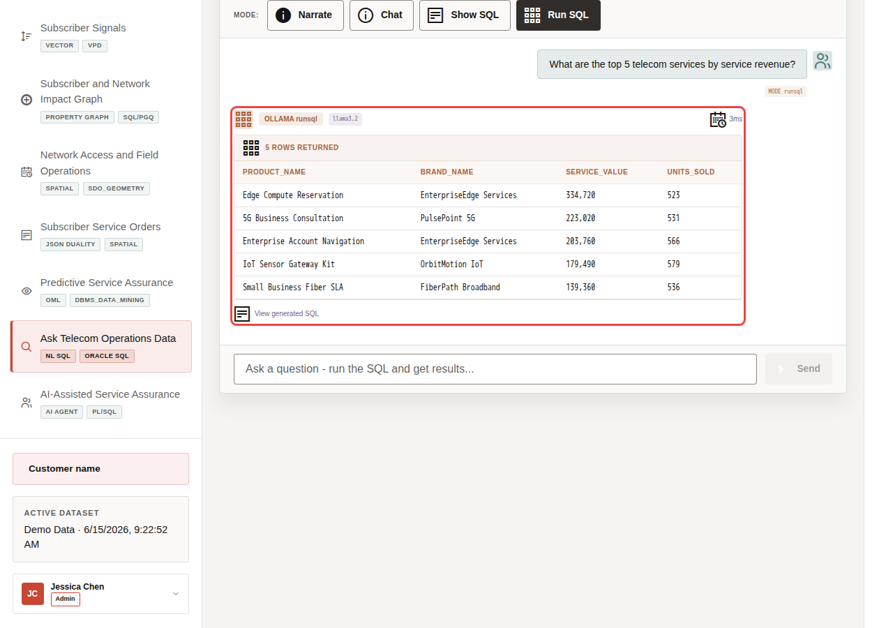
Returned service revenue rows after running the generated SQL
Run SQL and inspect the returned data to connect a plain-English telecom question to live service-order rows, revenue patterns, subscriber signals, or capacity evidence.
- Click Clear if the generated SQL result is still visible.
- Click Run SQL.
- Click Ask on the same service revenue question.
- Review the returned table.
This is the data point to emphasize during the demo. The natural-language question surfaces a concrete telecom operations answer from live service-order data. A business user can discover which services contribute most to revenue without writing SQL, while the SQL and database result remain visible for trust.

10.5 Task 4: Explain the governance pattern
Explain the governance pattern as speed with control: the user asks in plain language, the system shows or runs SQL, Oracle returns trusted data, and the answer remains reviewable.
- The user asks a telecom operations question in plain English.
- The app builds prompt and schema context for the selected runtime profile.
- Ollama drafts SQL or a response plan.
- Oracle AI Database executes the generated SQL against the live schema.
- The UI returns either visible SQL, raw rows, or a narrated answer.
This pattern matters because communications providers want faster answers, but they also need governed access. Ask Telecom Operations Data shows how natural-language analytics can be useful without hiding the query path or replacing the database as the trusted execution layer.
Note: Ollama provides the local AI runtime used for reasoning, while Oracle remains the governed source for data access and execution.
You can move to the next scene.

10.6 Credits & Build Notes
- Author - Oracle LiveLabs Team
- Last Updated By/Date - Oracle LiveLabs Team, 2026-06-29

11 Scene 10 AI-Assisted Service Assurance

11.1 Introduction
AI-Assisted Service Assurance shows how an AI assistant can support telecom operations without becoming a black box. When an agent helps with network access, subscriber operations, signal analysis, or field capacity, users need to see the routing decision, tools used, data returned, confidence, and audit record.
Telecom teams struggle when the information needed for one service-assurance decision lives in separate OSS, BSS, care, NOC, field, and analytics tools. That separation slows action, increases reconciliation work, and makes it harder to trust the result.
Oracle AI Database helps address these challenges by keeping the source data, SQL execution, PL/SQL tools, and durable action logging in the database. In this LiveStack Demo, the app orchestrates the agent workflow, Ollama provides reasoning, and Oracle AI Database 26ai executes the governed data operations. Agent actions are written back to agent_actions, while the UI shows the response, tool badges, and recent audit trail.
Estimated Time: 10 minutes
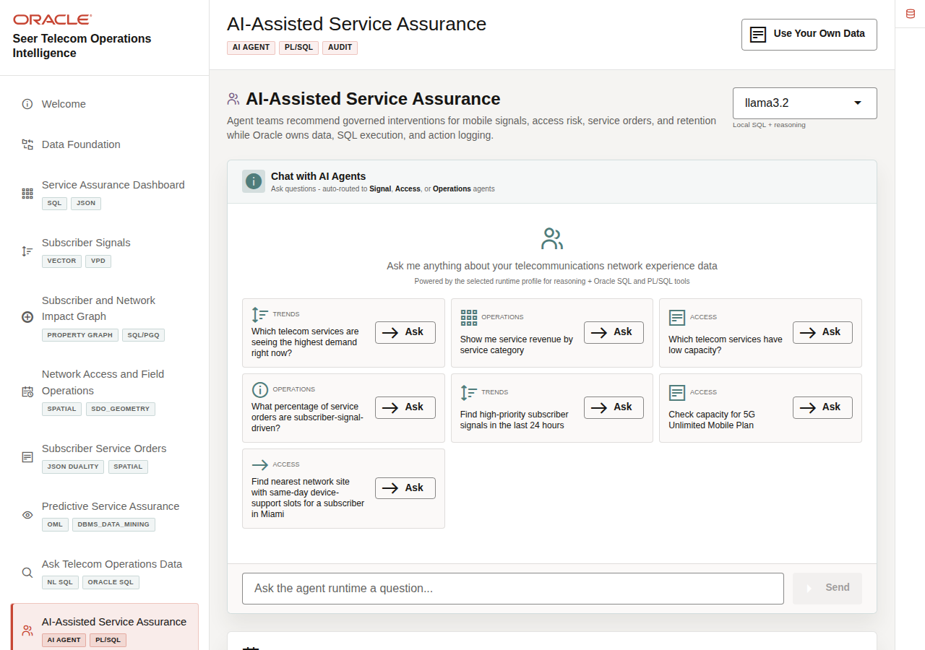
AI-Assisted Service Assurance console with runtime profile, examples, and recent actions

11.1.1 Objectives
In this scene, you will learn what telecom decision the page supports, what evidence the user should inspect, and what action the team may take next.

11.2 Task 1: Review the agent console workspace
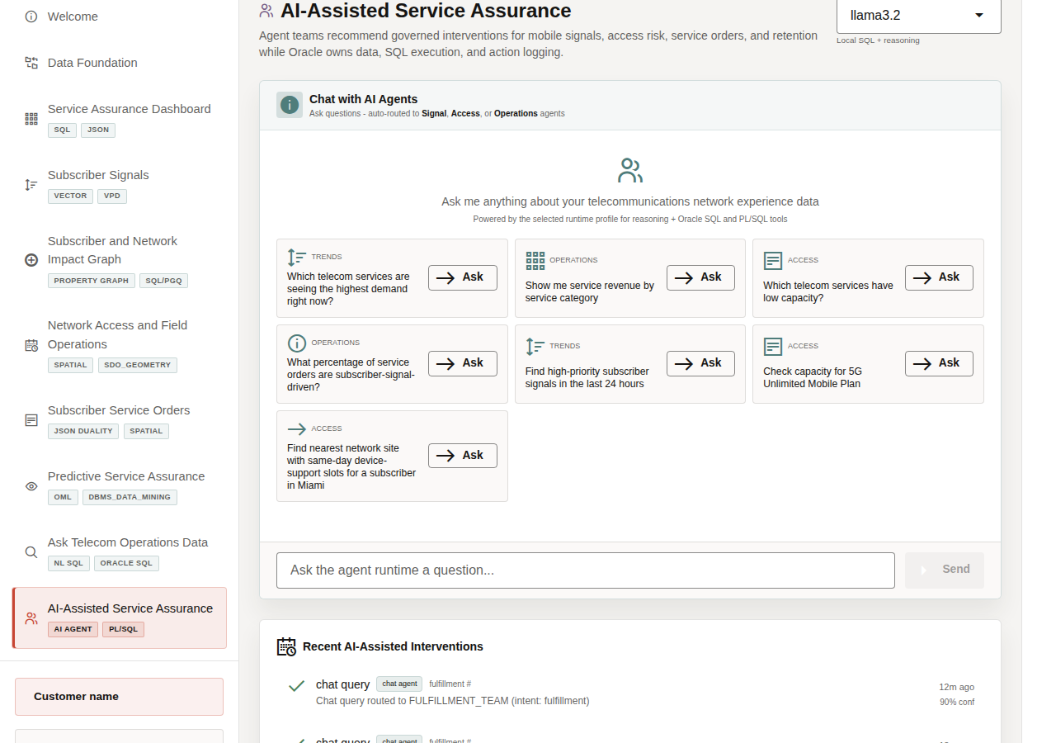
AI-Assisted Service Assurance workspace
Review the agent console as an operational workspace. Before running a task, the user can see the runtime profile, example questions, chat area, and any interventions logged by earlier demo runs. Specialist routing, tool badges, returned data, and confidence become visible after a query runs.
- Click AI-Assisted Service Assurance in the sidebar.
- Review the runtime profile selector in the top right. The current demo uses llama3.2 through an Ollama-backed runtime profile.
- Review the example questions in the chat panel.
- Review Recent AI-Assisted Interventions below the chat panel if earlier demo runs are present.
- Focus on a capacity example such as Check capacity for 5G Unlimited Mobile Plan or Which telecom services have low capacity?
Use this opening view to explain that the page is an operational agent console. The runtime profile and examples establish what can be asked; the next task shows routing, tools, returned data, confidence, and durable action history.

11.3Task 2: Run a low-capacity question
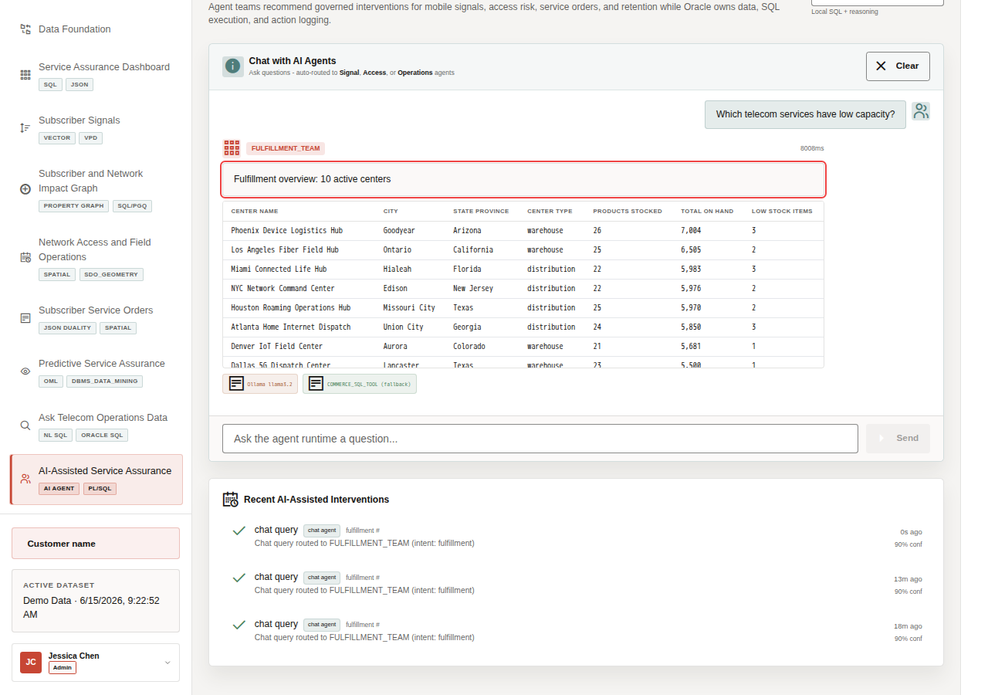
Low-capacity query result with fulfillment-center inventory and tool badges
Run the low-capacity question to show how the agent routes the request, summarizes fulfillment-center inventory pressure, and exposes the governed tool path behind the result.
- Click Ask on Which telecom services have low capacity?
- Review the agent response at the top of the chat output.
- Review the fulfillment-center inventory table returned by the agent.
- Review the tool badges below the response.
After showing the response, explain what the business can decide: investigate low-stock exposure, prioritize replenishment, or coordinate the fulfillment centers that need attention first.
In the current demo dataset, the low-capacity question routes to FULFILLMENT_TEAM and returns a fulfillment overview for 10 active centers. The table shows each center's location, center type, products stocked, total on hand, and low-stock item count. The response exposes COMMERCE_SQL_TOOL (fallback) as the governed Oracle data-access path used for the result.
Note: These are sample values from the current demo dataset and may change after a refresh, seed update, or custom dataset import. Treat these numbers as an example of the current operating pattern. Review the live values in the UI and connect them to the operational pattern: subscriber impact, capacity exposure, SLA risk, revenue exposure, dispatch load, or restoration status.

11.4 Task 3: Interpret the operational story
Interpret the result as an operational visibility story: teams can compare center-level stock breadth, total on-hand capacity, and low-stock exposure before deciding where replenishment, field support, capacity relief, or customer communication may be needed.
- The question asks for telecom services with low capacity.
- The workflow routes the request to FULFILLMENT_TEAM.
- Oracle data returns 10 active centers with products stocked, total on hand, and low-stock item counts.
- The business user can compare where capacity or replenishment pressure is concentrated.
- The audit trail records the specialist route and confidence after the query completes.
The important story is operational visibility: teams can see where inventory capacity is available, where low-stock exposure is concentrated, and which fulfillment centers may need replenishment or operational follow-up.

11.5 Task 4: Review the agent action audit trail
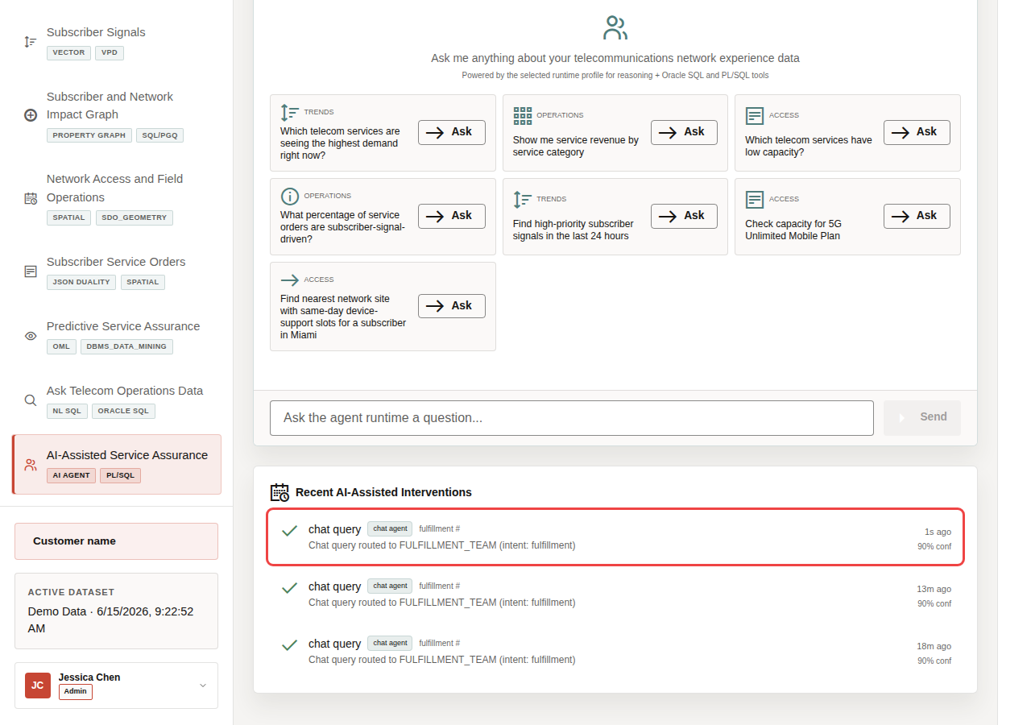
Recent AI-assisted interventions audit trail
Review the audit trail to show that AI-assisted actions do not disappear after the conversation. Operators, architects, and auditors can review what the agent did, which path it used, and how confident the system was.
- Scroll to Recent AI-Assisted Interventions.
- Review the top action row.
- Confirm that the row shows a completed chat query routed to a specialist agent path.
- Review the confidence value.
In the current demo dataset, the completed chat action is logged with 90% confidence. This is the governance point of the scene: agent decisions should be observable after the conversation. The page shows that agent interactions are not just transient chat messages. They are written into the action history so an operator, architect, or auditor can understand what happened.
Note: These are sample values from the current demo dataset and may change after a refresh, seed update, or custom dataset import. Treat these numbers as an example of the current operating pattern. Review the live values in the UI and connect them to the operational pattern: subscriber impact, capacity exposure, SLA risk, revenue exposure, dispatch load, or restoration status.
The business value is that teams can make the decision from connected, governed data. Oracle AI Database provides the shared foundation that keeps operational data, analytics, and AI workflows aligned.
Congratulations! You have completed the LiveStack demo!
The walkthrough showed how connected telecom data can support service-impact detection, subscriber signal triage, impact investigation, field capacity planning, service-order visibility, predictive assurance, governed data access, and AI-assisted action.

11.6 Credits & Build Notes
- Author - Oracle LiveLabs Team
- Last Updated By/Date - Oracle LiveLabs Team, 2026-06-29

12 Take It Home: Run LiveStack with Podman Compose

12.1 Introduction
This lab shows how to run a portable LiveStack package in your own environment using Podman Compose.
This guide is intended for technical users who can install Podman and run terminal commands. If you are new to containers, complete the Podman readiness checks before starting. If any readiness check fails, ask your workshop facilitator or system administrator for help before continuing.
Estimated time: 30 minutes for a local run, or 45 minutes when deploying to an OCI Compute VM.

12.1.1 Objectives
In this lab, you will:
- Download the portable LiveStack package.
- Confirm that Podman and Podman Compose are ready.
- Extract the package into a clean local working directory.
- Create a local runtime environment file from .env.example.
- Configure proxy settings only when your network requires them.
- Start Oracle Database, ORDS, Ollama, and the application with Podman Compose.
- Validate the application health endpoint and open the local LiveStack.
- Troubleshoot common startup, port, proxy, and first-run issues.
- Optionally deploy the same LiveStack package on an OCI Compute VM.
- Stop the stack cleanly when the demo is complete.

12.2 Before you begin
Before starting, confirm that you have:
- Podman installed.
- Podman Compose support available.
  - On macOS or Windows, Podman Desktop is recommended.
  - On Linux, confirm that either podman compose version or podman-compose version works.
- A running Podman machine on macOS or Windows.
- Terminal access:
  - Terminal on macOS or Linux.
  - PowerShell on Windows.
- Internet access to pull container images and download required application or model assets.
- Enough local resources for database and model containers.
  - Recommended minimum: 8 CPU available for containers.
  - Recommended minimum: 16 GB RAM available for containers.
  - Recommended minimum: 150 GB free disk space.
  - Use larger limits if your package includes larger Ollama models or additional data.
- The required local application port available:
  - 8505 for the LiveStack application.

12.3 New to Podman?
Podman is the local container runtime used by this LiveStack package. Podman Compose reads the compose.yml file and starts the required services together, including Oracle Database, ORDS, Ollama, and the LiveStack application.
If you are new to Podman, complete these checks before starting the lab.

12.3.1 1. Confirm Podman is installed
<copy>
podman --version
</copy>
Expected result:
- The command prints a Podman version.

12.3.2 2. Confirm compose support is available
<copy>
podman compose version
</copy>
If that command does not work, try:
<copy>
podman-compose version
</copy>
Expected result:
- One of the commands prints a compose version.

12.3.3 3. Start the Podman machine on macOS or Windows
Podman on macOS and Windows runs containers inside a lightweight Linux virtual machine. Start it before running the stack.
<copy>
podman machine start
</copy>
If the machine has not been created yet, create it first:
<copy>
podman machine init
podman machine start
</copy>
Expected result:
- The Podman machine starts successfully.

12.3.4 4. Run a quick container test
<copy>
podman run --rm hello-world
</copy>
Expected result:
- Podman pulls a small test image and prints a success message.
If this test fails, fix Podman setup before continuing with LiveStack.

12.4 Task 1: Download the portable package
- Download the LiveStack package using this link.
- Save or rename the file as livestack.zip.
Expected result:
- You have livestack.zip available on your machine.

12.5 Task 2: Prepare the working directory
Do not extract or run the stack from your Downloads folder. Create a new empty working directory first. The package extracts its files into the current folder, so a clean directory keeps the LiveStack contents organized and avoids Podman issues caused by working from Downloads.

12.5.1 For macOS or Linux
- Open a terminal.
- Create a new working directory outside of Downloads.
- <copy>
mkdir -p ~/livestack
</copy>
- Move into the new working directory.
- <copy>
cd ~/livestack
</copy>
- Move the downloaded package from Downloads into this directory.
- <copy>
mv ~/Downloads/livestack.zip .
</copy>
- Extract the package.
- <copy>
unzip livestack.zip
</copy>
- Confirm that you are in the directory that contains the compose file.
- <copy>
ls
</copy>
- Expected result:
  - You see compose.yml or compose.yaml in the current directory.
- Create or refresh the runtime environment file.
- <copy>
cp .env.example .env
</copy>

12.5.2 For Windows
- Open PowerShell.
- Create a new working directory outside of Downloads.
- <copy>
New-Item -ItemType Directory -Force -Path "$HOME\livestack" | Out-Null
</copy>
- Move into the new working directory.
- <copy>
Set-Location "$HOME\livestack"
</copy>
- Move the downloaded package from Downloads into this directory.
- <copy>
Move-Item "$HOME\Downloads\livestack.zip" .
</copy>
- Extract the package.
- <copy>
tar -xf .\livestack.zip
</copy>
- Move into the extracted LiveStack application folder.
- The folder name can vary by package, such as finance, healthcare, or another industry name. Replace <extracted-folder-name> with the folder name created when you extracted livestack.zip.
- <copy>
Set-Location .\<extracted-folder-name>
</copy>
- Example:
- <copy>
Set-Location .\telco
</copy>
- Confirm that you are in the directory that contains the compose file.
- <copy>
Get-ChildItem
</copy>
- Expected result:
  - You see compose.yml or compose.yaml in the current directory.
- Create or refresh the runtime environment file.
- <copy>
Copy-Item .env.example .env -Force
</copy>
Expected result:
- You are in a clean working directory outside Downloads.
- The extracted package contains compose.yml or compose.yaml, .env.example, application source files, database setup files, and supporting scripts.
- You created a local .env file from .env.example.

12.6 Task 3: Configure proxy settings, if your network requires them
Most home, cloud VM, and unrestricted corporate networks do not need this step. Skip this task when your network allows direct access to container registries, npm, Object Storage, and Ollama model downloads.
- If your network requires a proxy, configure the proxy in Podman or Podman Desktop before starting the stack. Image pulls happen before the compose containers exist, so Podman itself must be able to reach external registries.
- Open .env and add proxy values if your environment requires them.
- <copy>
HTTP_PROXY=http://proxy.example.com:8080
HTTPS_PROXY=http://proxy.example.com:8080
http_proxy=http://proxy.example.com:8080
https_proxy=http://proxy.example.com:8080
</copy>
- Keep local service names in NO_PROXY and no_proxy.
- <copy>
NO_PROXY=localhost,127.0.0.1,::1,db,ords,ollama,app,host.containers.internal
no_proxy=localhost,127.0.0.1,::1,db,ords,ollama,app,host.containers.internal
</copy>
Expected result:
- Podman can pull external images through the network proxy when one is required.
- Local compose services still talk to db, ords, ollama, and app directly on the internal Podman network.

12.7 Task 4: Start the LiveStack with Podman Compose
- If you are using Podman on macOS or Windows and your Podman machine is not already running, start it now.
- <copy>
podman machine start
</copy>
- Confirm that you are in the directory that contains the compose file.
- <copy>
ls compose.yml compose.yaml 2>/dev/null
</copy>
- On Windows PowerShell, use:
- <copy>
Get-ChildItem compose.yml,compose.yaml -ErrorAction SilentlyContinue
</copy>
- Start all services.
- <copy>
podman compose up -d --build
</copy>
- If your environment uses the standalone podman-compose command, use:
- <copy>
podman-compose up -d --build
</copy>
- Watch the service state.
- <copy>
podman compose ps
</copy>
- If your environment uses the standalone podman-compose command, use:
- <copy>
podman-compose ps
</copy>
Expected result:
- db, ords, ollama, and app move toward a healthy state.
- The initialization containers complete successfully.
- The application listens on the host port defined by the LiveStack package.

12.8 Task 5: Understand first-run downloads
On a clean install, the first startup can take several minutes. The stack pulls container images, installs application dependencies, downloads and warms the configured Ollama models, and loads the ONNX embedding model used by Oracle vector search when the package includes one.
To avoid downloading the ONNX model at first run, place all_MiniLM_L12_v2.onnx in db/data/onnx/ before starting the stack. The database bootstrap uses the packaged file before falling back to the configured ONNX_MODEL_URL.
Expected result:
- First-run startup time is expected to be longer than later restarts.
- Subsequent starts reuse the Podman volumes for Oracle data and Ollama models unless you remove the volumes.

12.9 Task 6: Validate health and open the application
- Check the application health endpoint.
- <copy>
curl http://localhost:8505/api/health
</copy>
- Open the LiveStack UI in a browser.
- <copy>
open http://localhost:8505
</copy>
- If you are not on macOS, open this URL manually in your browser:
- <copy>
http://localhost:8505
</copy>
Expected result:
- The health check returns a healthy JSON response after Oracle is ready.
- The browser opens the LiveStack locally.

12.10 Task 7: Stop the stack when finished
- Stop and remove running containers while preserving volumes.
- <copy>
podman compose down
</copy>
- If your environment uses the standalone podman-compose command, use:
- <copy>
podman-compose down
</copy>
- Use this command only when you intentionally want to delete the local Oracle and Ollama volumes for a complete reset.
- <copy>
podman compose down -v
</copy>
- If your environment uses the standalone podman-compose command, use:
- <copy>
podman-compose down -v
</copy>
Expected result:
- podman compose down stops the local LiveStack cleanly.
- Demo data and downloaded models remain available on the next startup unless you use the explicit volume-removal command.

12.11 Troubleshooting
Use this section when the stack does not start, a service is unhealthy, the application does not open, or first startup appears to be slow.

12.11.1 Check service status
<copy>
podman compose ps
</copy>
If your environment uses the standalone podman-compose command, use:
<copy>
podman-compose ps
</copy>

12.11.2 View service logs
Database logs:
<copy>
podman compose logs db
</copy>
ORDS logs:
<copy>
podman compose logs ords
</copy>
Ollama logs:
<copy>
podman compose logs ollama
</copy>
Application logs:
<copy>
podman compose logs app
</copy>
Follow application logs in real time:
<copy>
podman compose logs -f app
</copy>
If your environment uses podman-compose, replace podman compose with podman-compose in the commands above.

12.11.3 Port 8505 is already in use
The LiveStack application uses local port 8505. If the application does not start or the browser opens another application, check whether another process is already using that port.
For macOS or Linux:
<copy>
lsof -i :8505
</copy>
For Windows PowerShell:
<copy>
netstat -ano | Select-String ":8505"
</copy>
Stop the conflicting process or update the compose port mapping if your package supports changing it.

12.11.4 First startup takes a long time
The first run can take several minutes because Podman may need to pull images, install dependencies, download Ollama models, initialize Oracle Database, and load model files. Later starts are usually faster because container images and volumes are reused.
Check progress with:
<copy>
podman compose logs -f db
podman compose logs -f ollama
podman compose logs -f app
</copy>

12.11.5 Image pulls fail
If image pulls fail, check these items:
- Confirm that your machine has internet access.
- Confirm that Podman can pull a small public test image with podman run --rm hello-world.
- If your network requires a proxy, configure the proxy in Podman or Podman Desktop and update .env as described in Task 3.
- If you are on a corporate network or VPN, ask your network administrator whether container registry access is allowed.

12.11.6 Health check is not ready
If curl http://localhost:8505/api/health does not return a healthy response immediately, wait for the database and application startup to finish, then try again.
Check logs with:
<copy>
podman compose logs db
podman compose logs app
</copy>

12.11.7 Reset the stack
Stop containers but keep data and downloaded models:
<copy>
podman compose down
</copy>
Completely reset local data and downloaded models:
<copy>
podman compose down -v
</copy>
Use the volume-removal command only when you intentionally want a clean reset.

12.12 Task 8: Deploy the LiveStack on an OCI Compute VM with Podman (Optional)
Use this task when you want to run the LiveStack on an OCI Compute VM instead of your laptop.
Prerequisites:
- A created Virtual Cloud Network (VCN).
- Security rules configured for the VM subnet.
- Ingress to TCP port 8505 allowed from your approved client CIDR.
- An OCI Compute VM running Oracle Linux 9.
- SSH access to the VM, using the private key paired with the public key added during VM creation.
- The LiveStack package download URL for your workshop.
- SSH into the OCI VM from your local terminal.
- <copy>
ssh -i ~/.ssh/<private-key-file> opc@<vm-public-ip>
</copy>
- Update the VM and install Podman plus common download tools.
- <copy>
sudo dnf update -y
sudo dnf install -y container-tools podman-docker unzip curl dnf-plugins-core
podman --version
</copy>
- Install and enable Podman Compose support on Oracle Linux 9.
- <copy>
sudo dnf install -y oracle-epel-release-el9
sudo dnf config-manager --enable ol9_developer_EPEL
sudo dnf install -y podman-compose
podman compose version || podman-compose version
</copy>
- If the VM firewall is running, allow the LiveStack application port.
- <copy>
if sudo systemctl is-active --quiet firewalld; then
sudo firewall-cmd --permanent --add-port=8505/tcp
sudo firewall-cmd --reload
fi
</copy>
- Create a working directory on the VM.
- <copy>
mkdir -p ~/livestack
cd ~/livestack
</copy>
- Download the LiveStack package to the VM.
- <copy>
curl -L -o livestack.zip "<livestack-package-url>"
</copy>
- Extract the package and move into the directory that contains the compose file.
- <copy>
unzip livestack.zip
COMPOSE_FILE="$(find . -maxdepth 3 \( -name compose.yml -o -name compose.yaml \) | head -n 1)"
cd "$(dirname "$COMPOSE_FILE")"
</copy>
- Create the runtime environment file.
- <copy>
cp .env.example .env
</copy>
- Confirm that the compose file exposes the application on port 8505.
- <copy>
grep -n "8505" compose.yml compose.yaml 2>/dev/null
</copy>
- The application should be exposed on port 8505. To reach it from your browser, both the OCI subnet security rules and the VM firewall must allow inbound TCP traffic on port 8505 from your approved client CIDR.
- Start the LiveStack with Podman Compose.
- <copy>
podman compose up -d --build || podman-compose up -d --build
</copy>
- Watch the service state from the VM.
- <copy>
podman compose ps || podman-compose ps
</copy>
- Validate the application health endpoint from the VM.
- <copy>
curl http://localhost:8505/api/health
</copy>
- Open the public LiveStack URL from your browser.
- <copy>
http://<vm-public-ip>:8505
</copy>
Expected result:
- The OCI VM is running the LiveStack with Podman Compose.
- The application health endpoint responds locally on the VM.
- The LiveStack UI is reachable from your browser at http://<vm-public-ip>:8505.

12.13 Why this matters
A portable LiveStack runbook turns this guide into something teams can reproduce instead of just read. By shipping the application as a Podman Compose package with a clear startup flow, you reduce environment drift, make scene validation repeatable, and give teams a practical way to explore the same Oracle-backed experience on macOS, Linux, Windows, and OCI Compute.
This guide is self-service for technical users who can install Podman and run terminal commands. Users who are new to containers should complete the Podman readiness checks before starting and ask for help if those checks fail.

12.14 Credits and build notes
- Author - LiveLabs Team
- Last Updated By/Date - LiveLabs Team, 2026-06-04

