OAuth Setup for Oracle Fusion Setup and Configuration Skills Registry (FSCR) Version 26D

OAuth Client Setup for FSCR Authentication

Integrated Application in OCI IAM Fusion Applications Identity Domain
Login to the OCI IAM identity domain of your Fusion Applications instance as an Identity Administrator.
Navigate to “Identity & Security / Domains”. Click on the identity domain of your Fusion Applications instance.
Select tab “Integrated applications”.
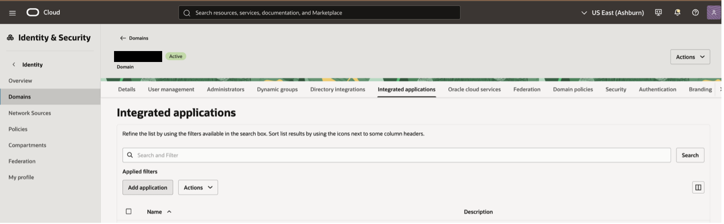
Click “Add application”.
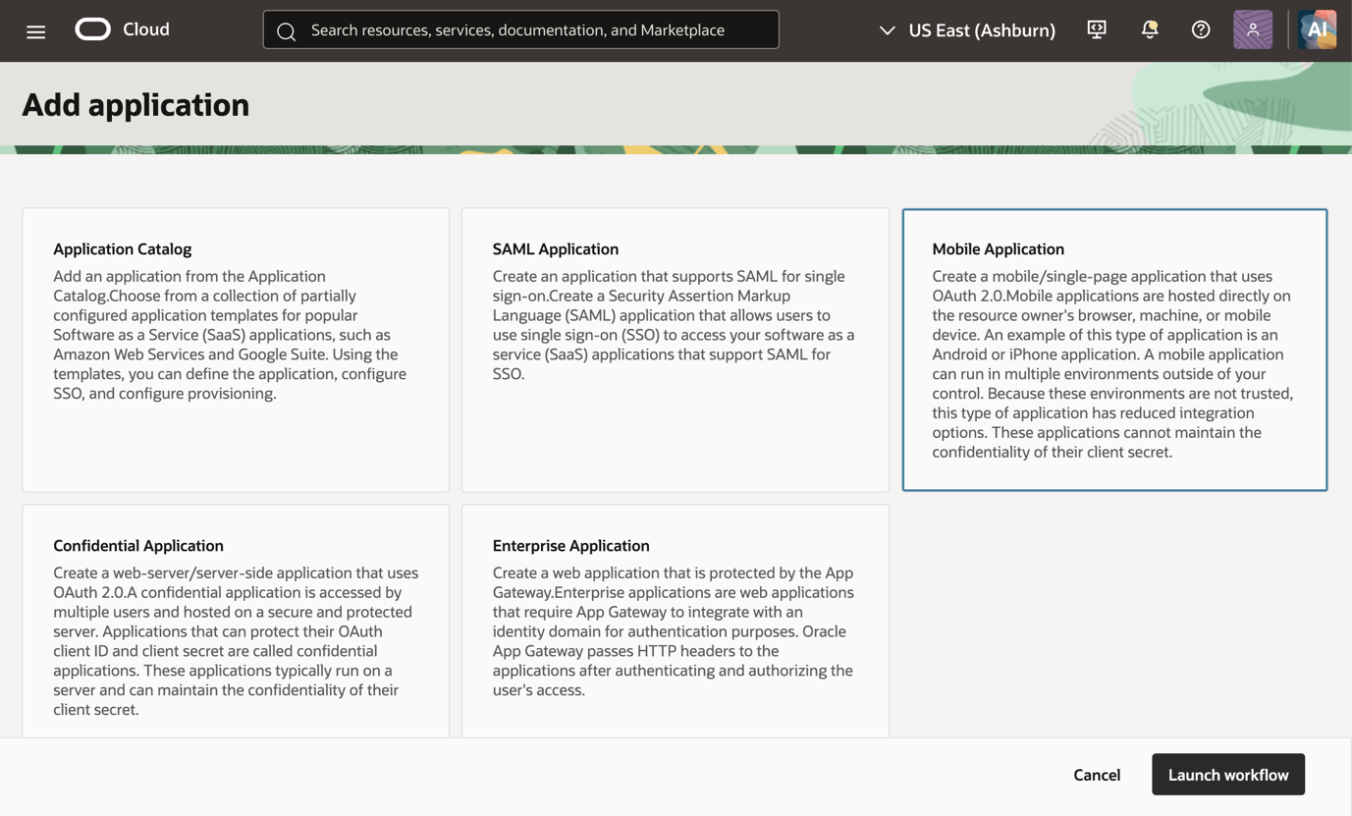
Select “Mobile Application” and click “Launch workflow”.
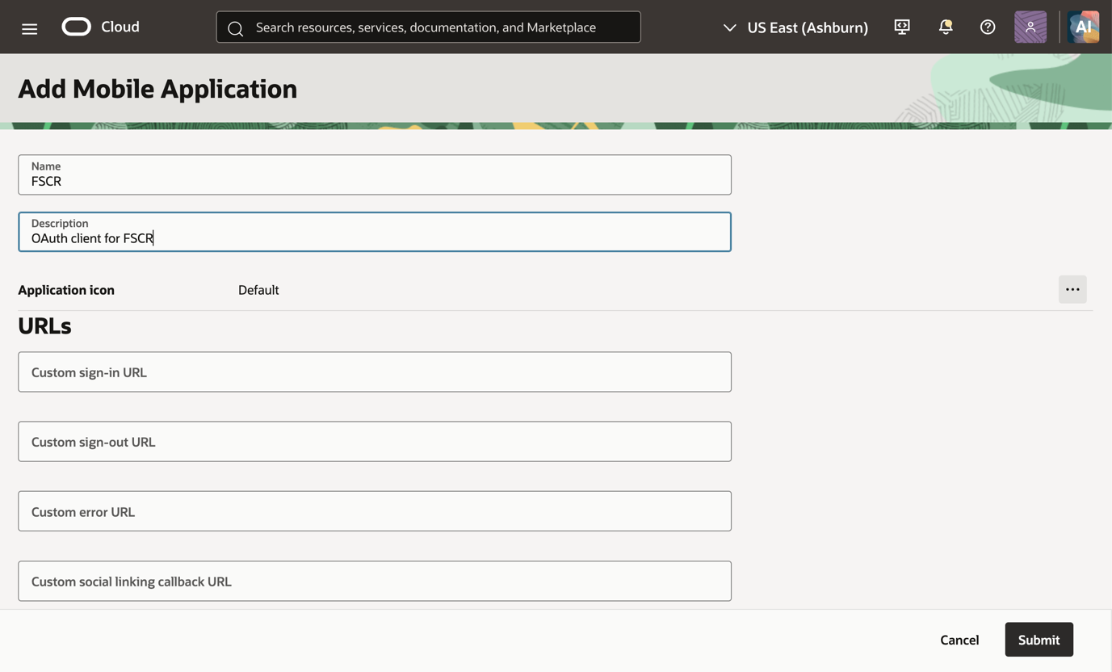
Give the application a name and a description.
(Optional): Check the flag “Enforce grants as authorization” if you want to restrict access only to specific users or groups. Those users or groups would need to be added in the “Users” or “Groups” tab of the created mobile application. If you enable this flag don’t forget to add your FSCR users to the mobile application after submitting, otherwise FSCR login won’t work.
No other entries are needed on this page.
Click “Submit”.
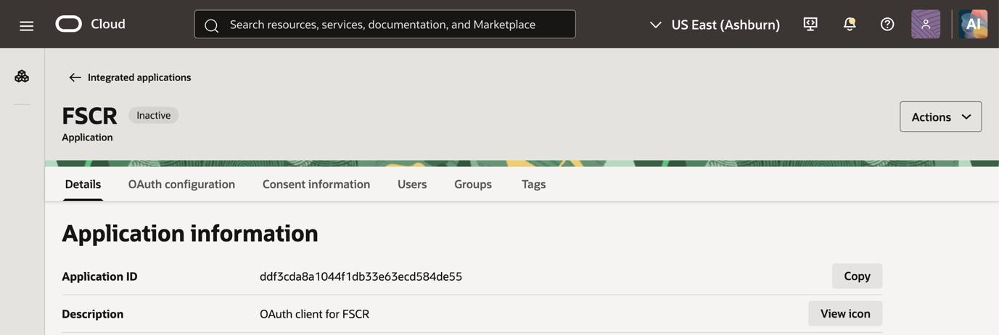
Select the “OAuth configuration” tab.
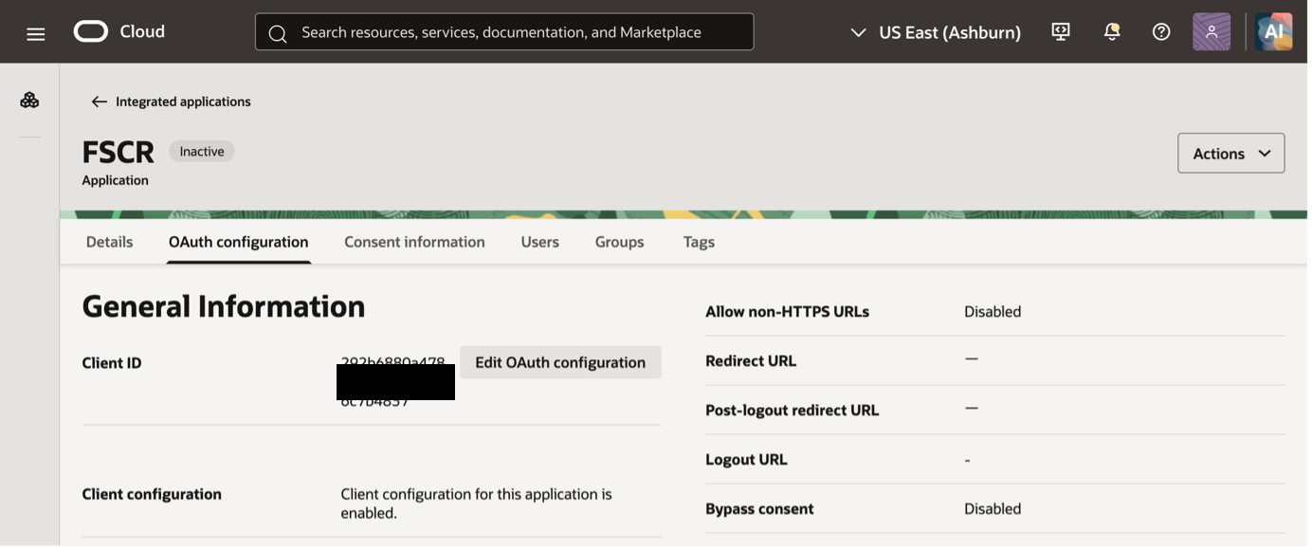
Click ”Edit OAuth configuration”.
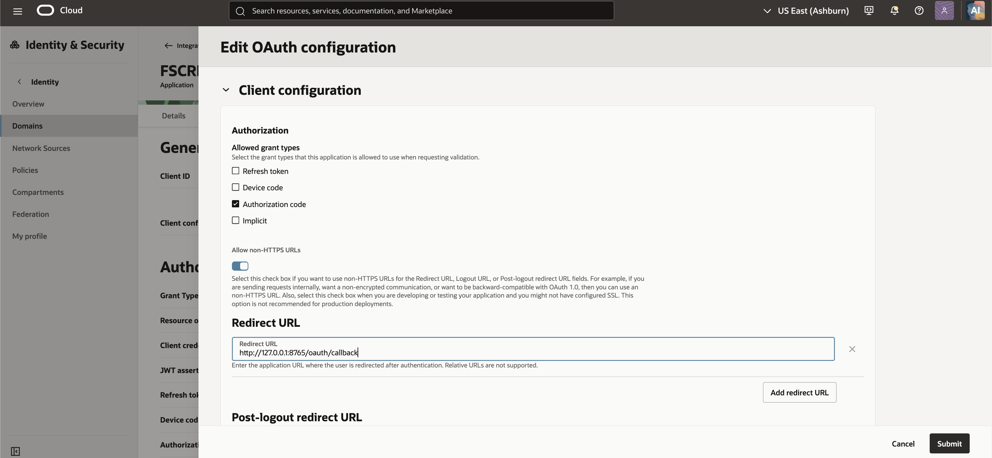
Enable grant type “Authorization code”.
Select “Allow non-HTTPS URLs” and add redirect url for Codex for codex callback listener “http://127.0.0.1:8765/oauth/callback”.

Mandatory scopes
In section “Token issuance policy” enable “Add resources” and add the below resource scopes from your Fusion Applications environment resources:
- Oracle Applications Cloud (Fusion) or Fusion Applications Cloud Service (“scope”)
- Oracle Fusion AI Cloud (Spectra) (“ai_scope”)
- Oracle Boss Cloud (Spectra) (“boss_scope”)
- spectra-fusion-common (“fusion_common_scope”)
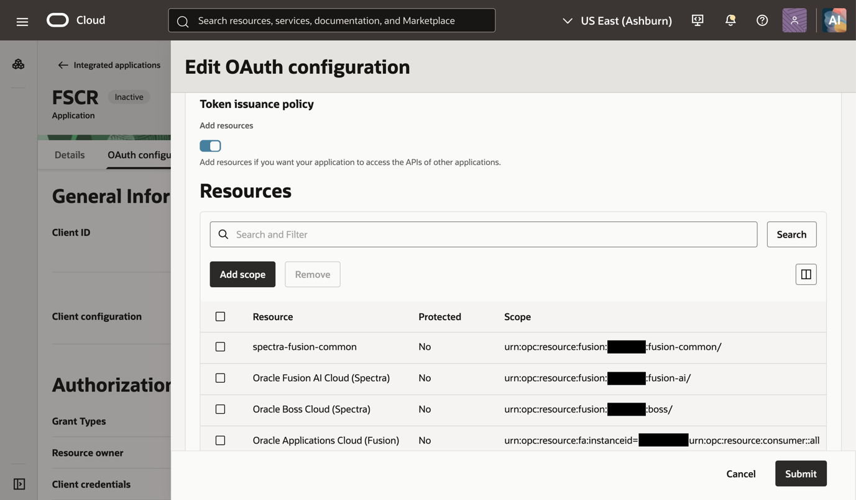
Note that the resource names are indicative only and may vary with environments. If needed, consult your Fusion domain administrator to get the correct resource names and scopes enabled.

Optional Properties and scopes
The remaining properties mentioned in fusionEnv.properties file are optional and depend upon specific Fusion products/modules being part of the implementation.

Risk Cloud and Knowledge Management
- Risk Cloud (“rmc_scope”)
- spectra-knowledge-management (“km_scope”)
The Risk Cloud and knowledge management scopes are as shown below
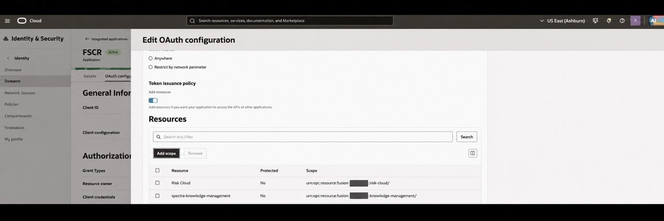

CPQ - Configure Price Quote
- Oracle CPQ Applications Cloud (Spectra) (“cpq_scope”)
If the Fusion implementation plan in FSCR includes Fusion CPQ, ensure to add the CPQ scope to the Mobile application as shown below
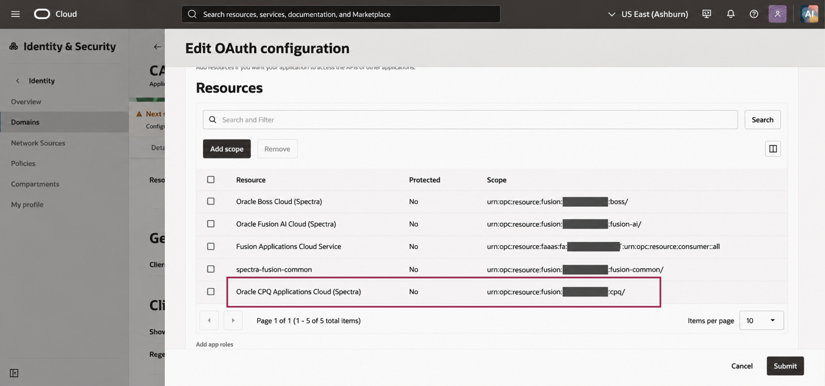
Note that the resource and scope value may vary in your environment from what is shown above.

Field Service
If Field Service product is part of the FSCR fusion implementation, you will need to add the Field Service scope to the Mobile application as shown below.
- Field Service (“fs_scope”)
- Field Service URL (“fs_restBaseUrl”)
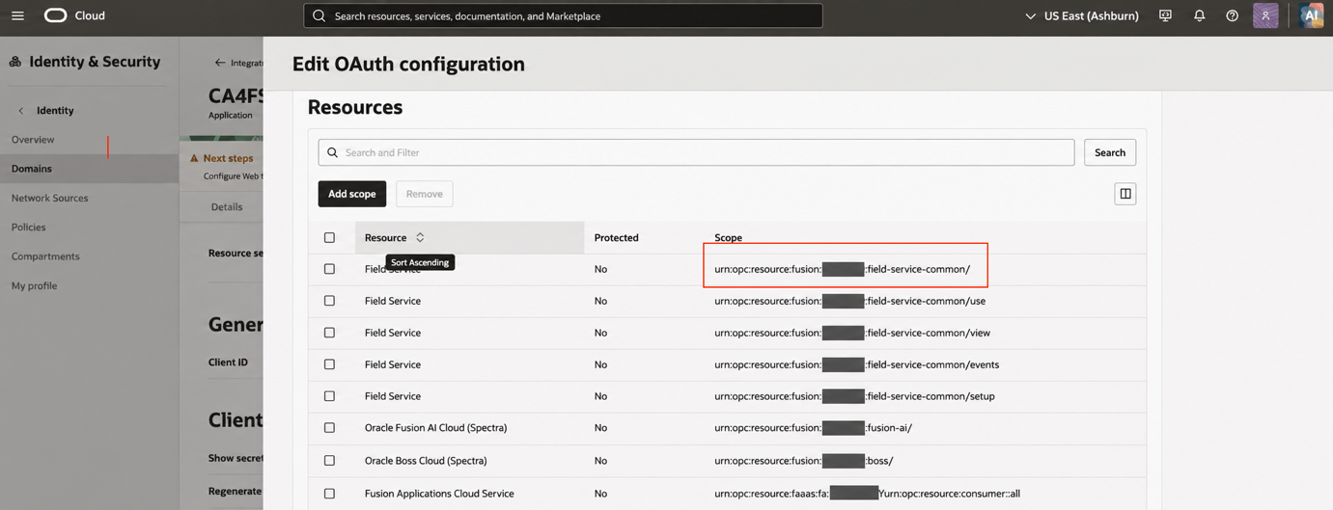
Field service provides multiple scopes, only the highlighted scope above is used by FSCR during implementation and requires to be added to the Mobile application.
Also note the value of Field Service Scope and Field Service Base URL to be populated in the fusionEnv.properties.
The Field Service URL (needed for fs_restBaseUrl) can be found in the Field Service Resource App under Oracle Cloud Services section of the Fusion Identity domain console as shown below.
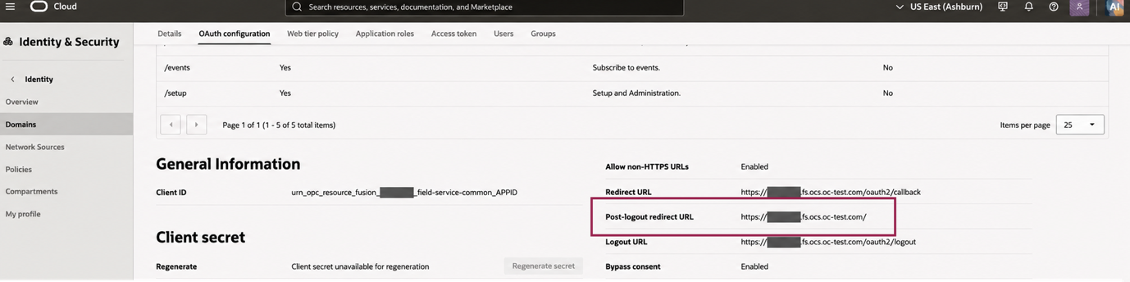

CX Unity (CDP)
If CX Unity product is part of the FSCR fusion implementation, you will need to add the appropriate scope to the Mobile application as highlighted below.
- CDP App (“cdp_scope”)
- Oracle CX Unity URL (“cdp_restBaseUrl”)
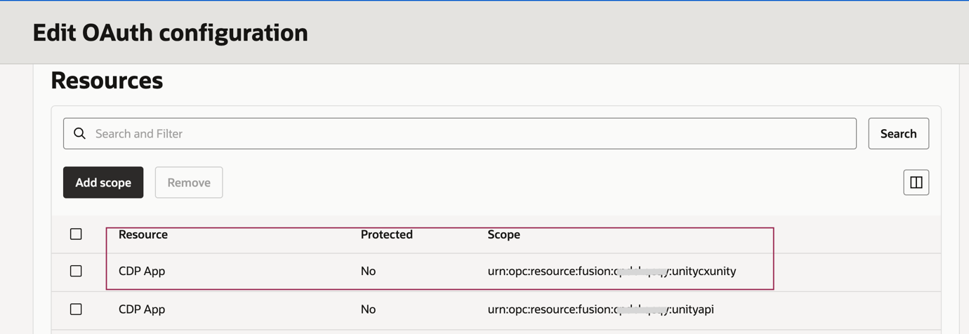
CX Unity provides multiple scopes, only the highlighted scope above is used by FSCR during implementation and requires to be added to the Mobile application.
Also note the value of CX Unity Scope and CX Unity Base URL to be populated in the fusionEnv.properties.
The CX Unity URL (needed for cdp_restBaseUrl) can be found in the CDP Resource App under Oracle Cloud Services section of the Fusion Identity domain console as shown below.
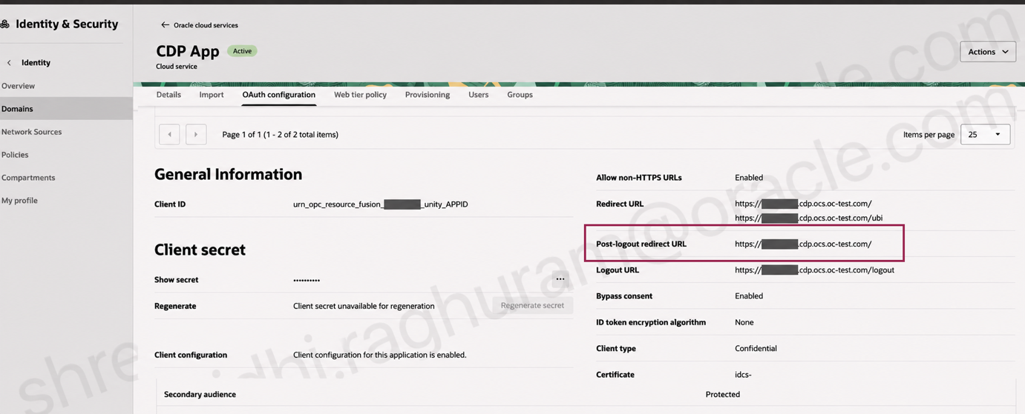

Once all the required scopes are added, Click “Submit”.
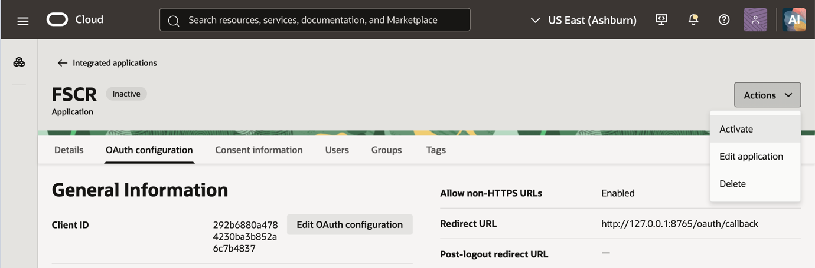
Activate the application by clicking “Activate” in the “Actions” menu.
Note down the Client ID of the created Mobile Application.

FSCR fusionEnv.properties File
In the Codex FSCR folder populate the fusionEnv.properties file.
Shown below is a sample file for reference. Note that your values will be based on values noted in previous section.
The fusionEnv.properties file is located in the sub-folder core/auth.
Replace the values for your Fusion Applications environment as appropriate and as collected in the previous section.
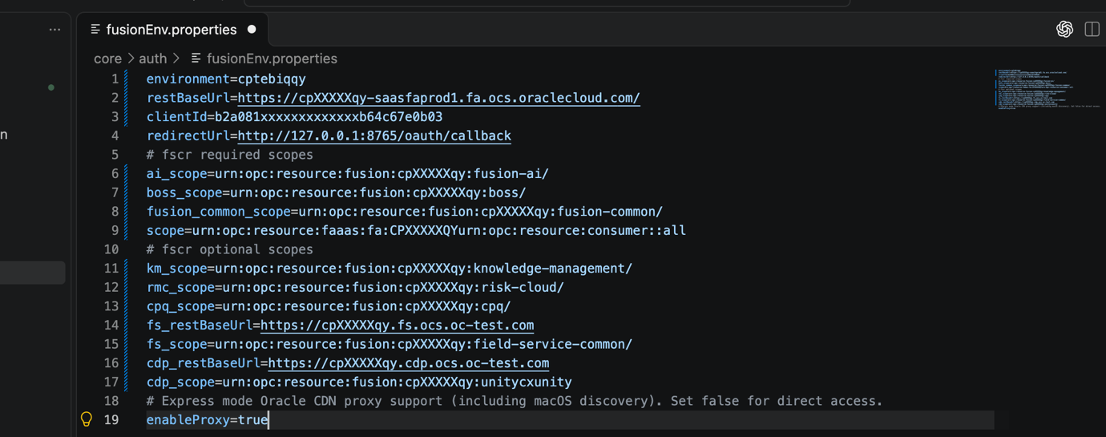
Note that the trailing / values are important. Ensure the scope values retain the trailing “/” as present in the Mobile Applications Oauth Configuration section.

Test of OAuth Setup
Login within Codex using prompt “fusion login”.
You will be prompted for permissions and asked to login using your browser window. Complete the login process and Codex should be able to get the right access token.

