# Asking Direct Questions on Data

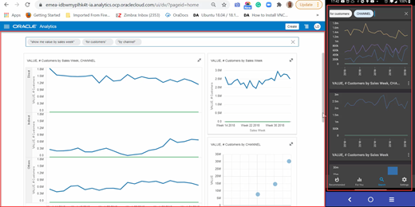

BI ASK

## Introduction

When creating a **Project** out of a **Data Set**, you’ll see a blank canvas.  
This time we are going to avoid *blank canvas syndrome* using **BI Ask**, which is the search bar on the Home page to find the data and quickly visualize it.

**BI Ask** (**N**atural **L**anguage **Q**uery **P**rocessing) promotes direct interactions between the users and the BI System to explicitly understand what every user is interested in.  
Interprets semantic layer, user private data, expression library and catalog artifacts and generates on-the-fly queries – visualizations.

Estimated Lab Time: 40 minutes

### Objectives

* **Use BI Ask to ask (or type) direct questions (Natural Language) on data - desktop/laptop**
* **Use BI Ask to ask direct questions (Natural Language) on data - mobil (Day by Day)**
* **Troubleshoot and Fine-Tune Searches**

### Prerequisites

* An Oracle Cloud Free Tier or Paid
* You have completed  
  [“Lab 1: Provisioning your Autonomous Database instance”](%22../../provision-adw/provision-adw.md%22)  
  [“Lab 2: Provisioning your Oracle Analytics Cloud instance”](%22../../provision-oac/provision-oac.md%22)  
  [“Lab 3: Connecting OAC to ADW and adjusting Data Set properties”](%22../../a-connoactoadw/a-connoactoadw.md%22)

## **STEP 1**: Certify and Index your Data Set

### Search for your Data Set

* In order to ask (English) questions on the data set, we need to **index** the Data Set to **enable searching**  
  > Note: English it’s just an example, more languages are supported
* 1.1 In the **Oracle Analytics Home** page, click the **Navigator** on top left, and then click **Data**  
  > Note: if you are still on the previous lab, you can quickly Go Back Go Back to the **Home** page without saving the project  
  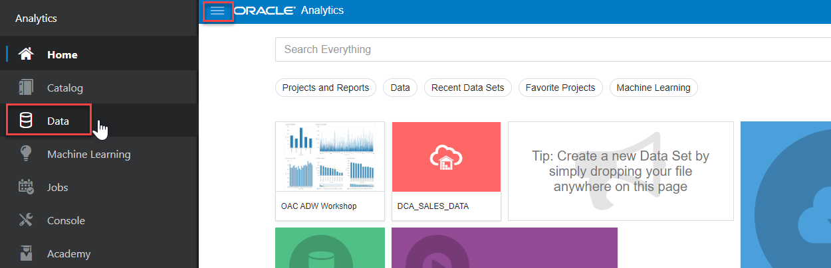
* 1.2 Select your Data Set.  
  From **Data** page, then **Data Sets** section identify **DCA_SALES_DATA** Data Set.
* 1.3 Click the **Actions menu** of the data set or right-click the Data Set, and click **Inspect**  
  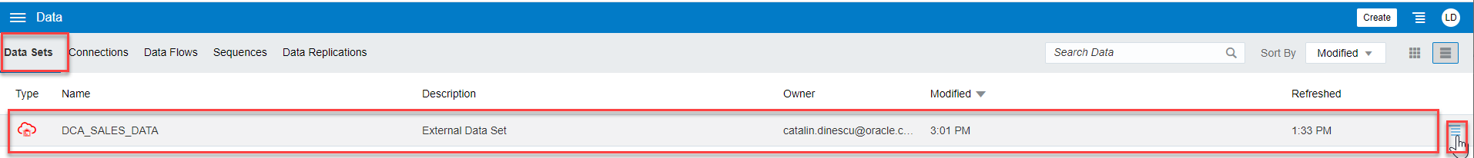 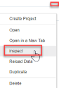
* 1.4 **Certify** the Data Set  
  From **General** tab click **Certify** button  
  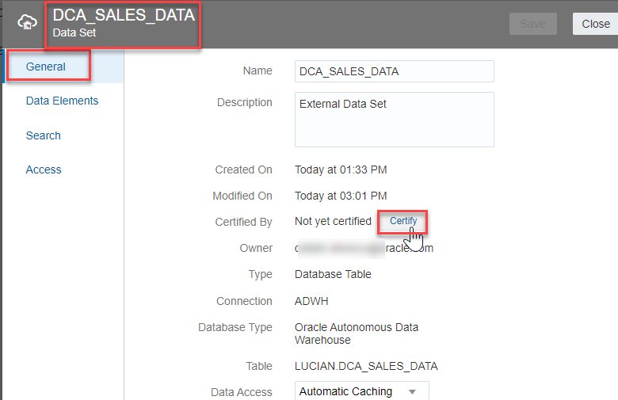
* 1.5 **Index** the Data Set  
  From **Search** tab click **Index Data Set for Searching**  
  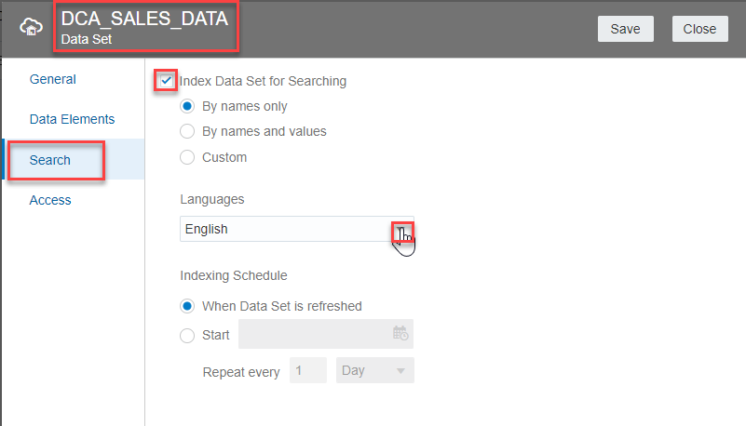
* 1.6 **Control access** (optional)  
  Access to the Data Sets can be controlled from **Access** tab  
  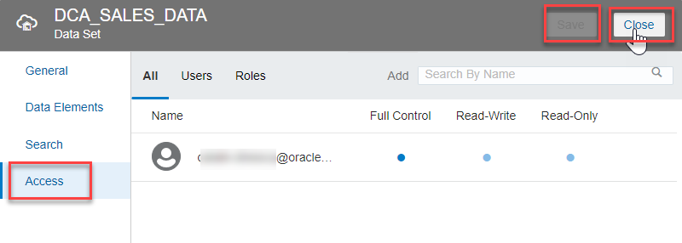  
  > Note: is best practice to enforce control using **Roles** rather than individual **Users**
* Click **Save** and then **Close** button.
* 1.7 Go to **Home** Page Click **Navigator** and then select **Home**  
  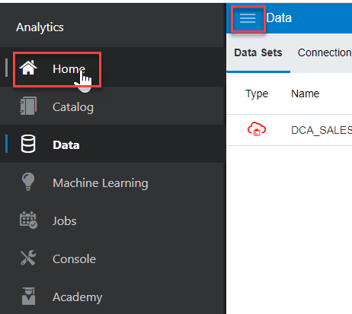

## **STEP 2**: Ask Questions about your data

### BI Ask

* In the **Home** Page of OAC, a dialog bar appearing at the top can be leveraged to **ask** plain English language questions on the data.
* 1.1 Click the **Search** bar and **Type** in the bar area “**show me value by sales week**”.  
  As you enter the information, the application returns search results in a drop-down list. The system can be searched by column names or data elements or both. Best fit results are returned immediately
* 1.2 Press **SHIFT + ENTER** to visualize data  
  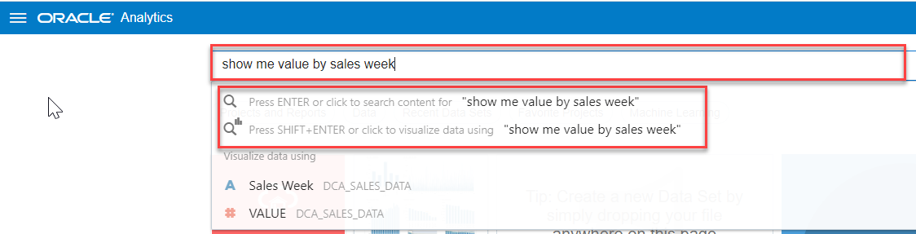
* 1.3 Check the results. Insights are rendered immediately from the best matching Data Set  
  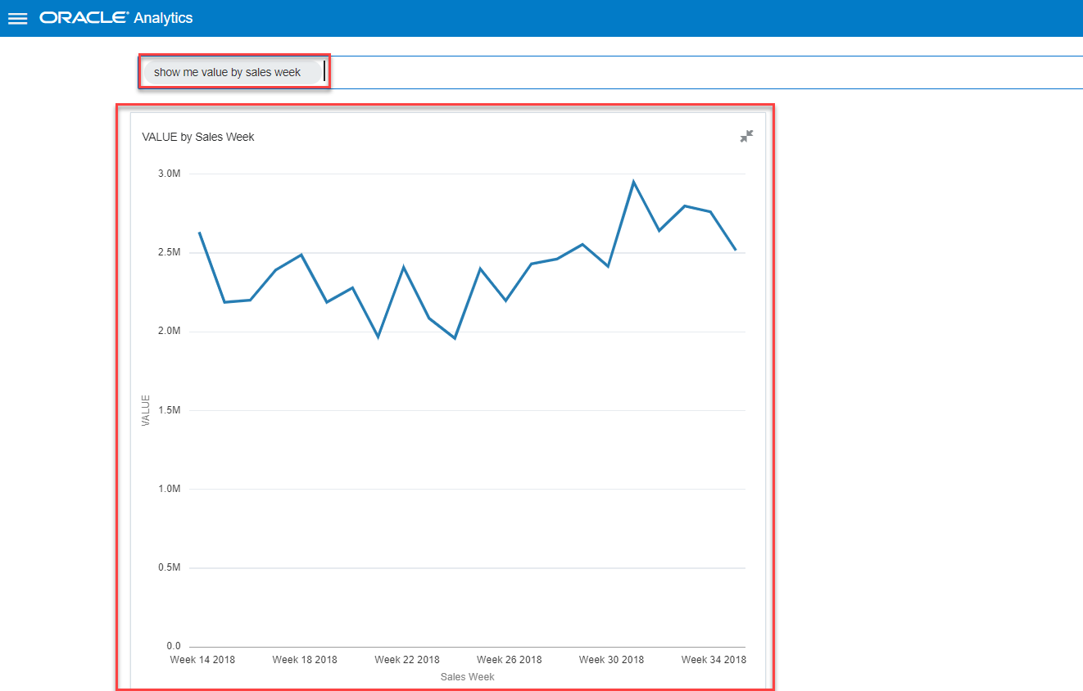
* 1.4 Continue to type in the bar area “**for customers**” and press **SHIFT + ENTER**  
  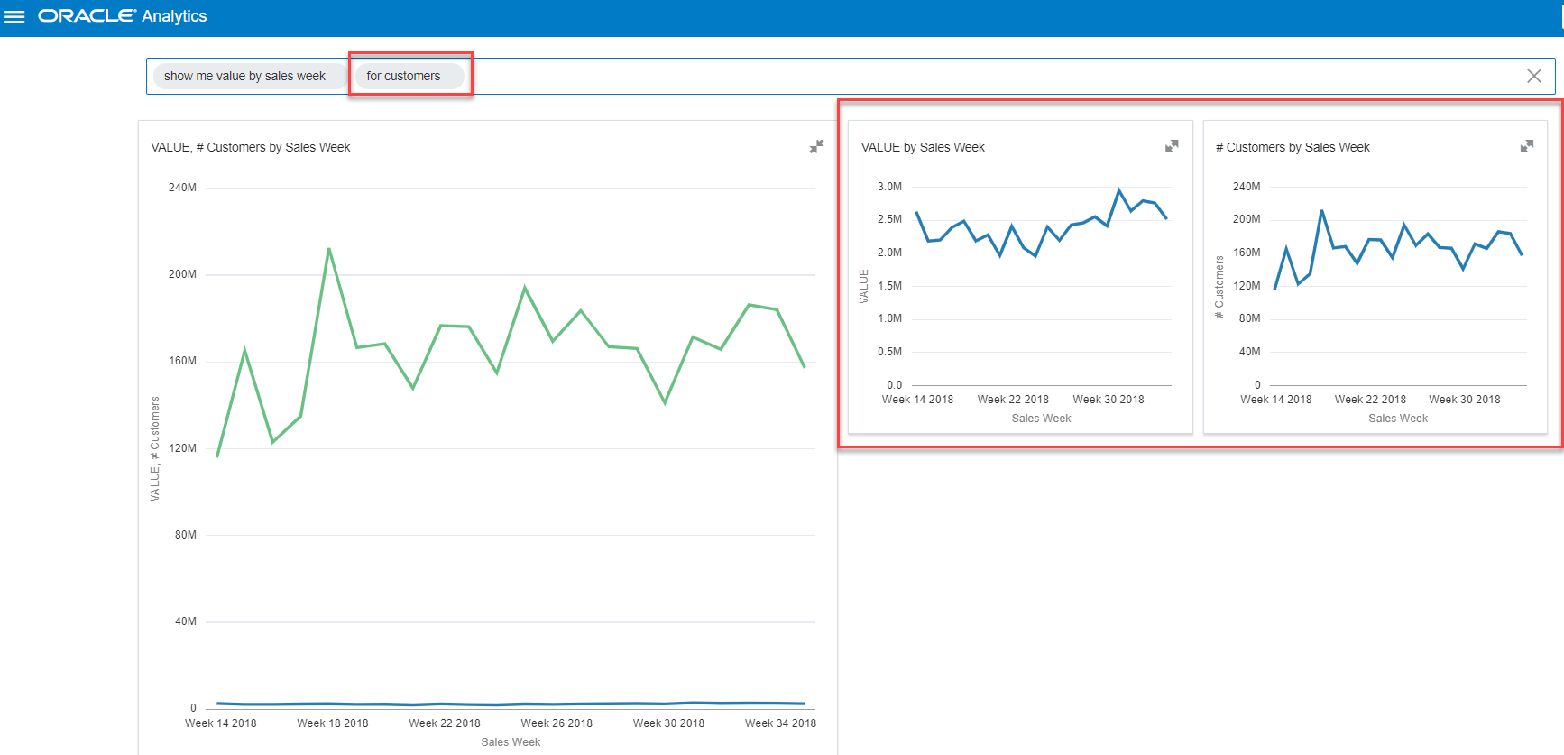 We observe that we are losing customers over time
* 1.4 Continue to type in the bar area “**for direct channel**” and press **SHIFT + ENTER**  
  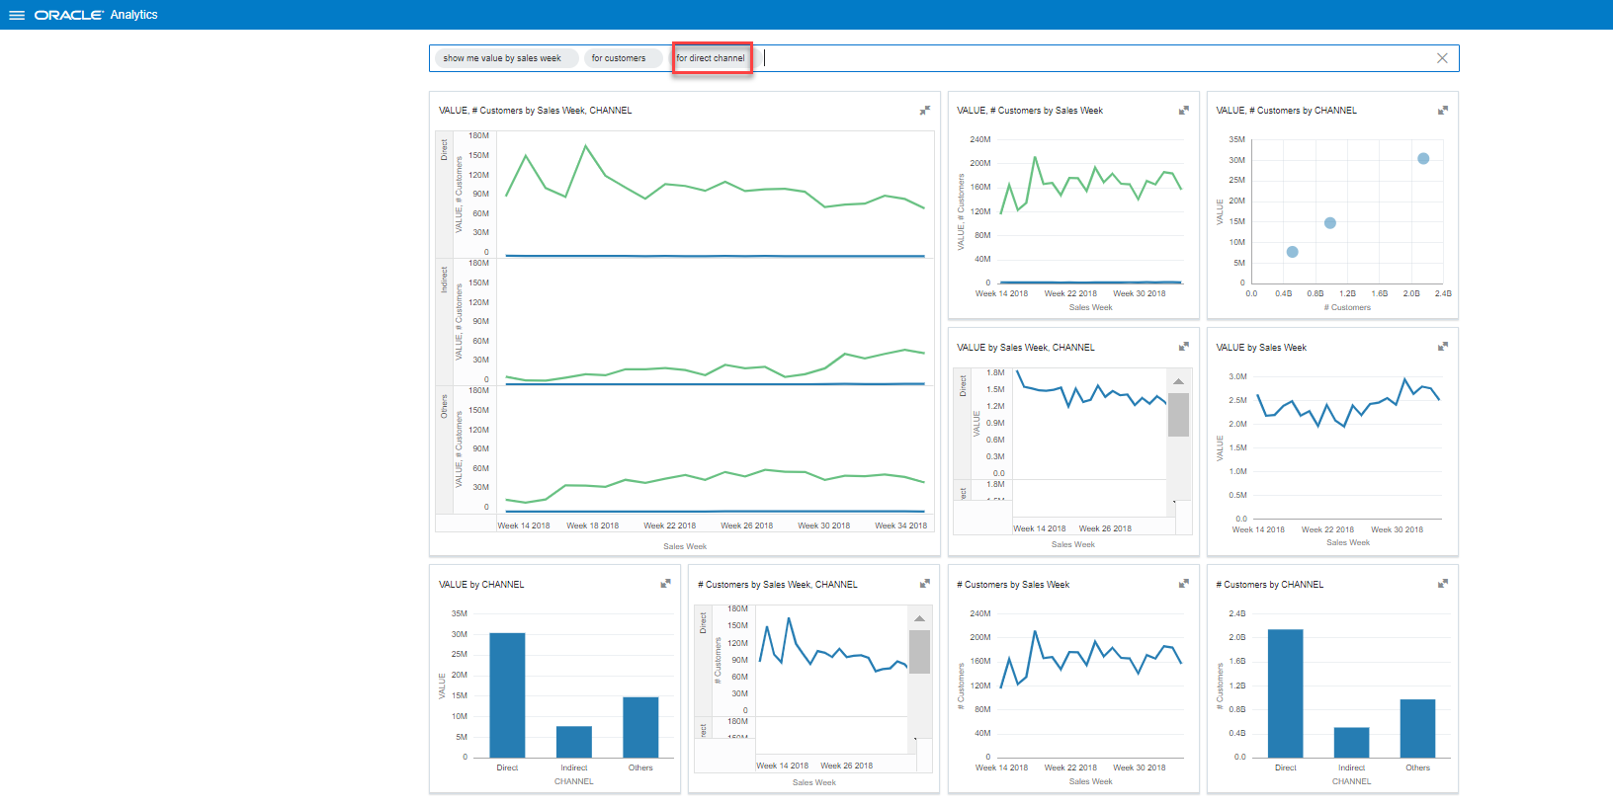
* 1.5 Remove the last query.  
  Select “**for direct channel**” and press the x (remove) sign Remove Data
* 1.6 Continue to type in the bar area “**by channel**” and press **SHIFT + ENTER**  
  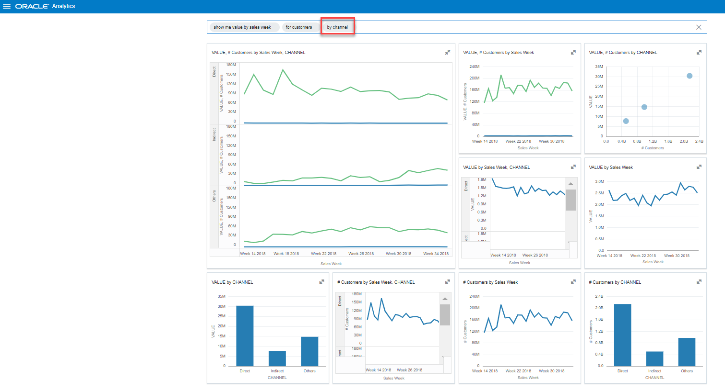
* 1.7 You have 9 visuals to start with. You can always choose one (or more) and explore it.  
  > Note: optional you can select the first visual, hover over the top left of the visual and choose **Explore as Project** Visualize Data  
  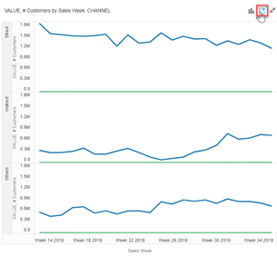

### Day by Day

* We should be able to get our questions answered at anytime and anywhere even when we are on the go. We should be able to move from desktop to mobile seemly, ask the same questions, get the same results and more.
* **Oracle Day by Day** is an mobile analytic app that learns what you are interested in, when and where you are interested in it, and who you like to share and collaborate with. Start your day with a smart list of analytics that helps you make better decisions — day by day.
* **Oracle’s Day by Day** has been named a **winner** in the [Ventana Research 13th Annual Digital Innovation Awards](https://www.ventanaresearch.com/resources/awards/innovation#winners) in the category of **Analytics** for 2020.
* It’s **supercharging BI Ask** with **context**. Understand who, what, when and where people are interested and eventually why.
* Key Features:
  + Search based interface
  + Natural Language Search
  + Proactive delivery based on Time, Place and Threshold
  + It will infuse analytics into a users daily activities, and not the other way around
  + Collaboration with people and other apps
* **2.1 Prerequisites**  
  **2.1.1 Apps prerequisites**: Install Day by Day
  + Search for “**Oracle Day by Day**” app with Google Play or App Store  
    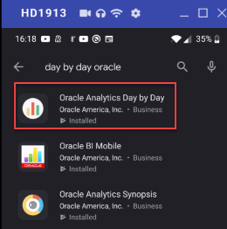
  + Install Day by Day is nothing different from installing any of your casual mobile apps.
  + Don’t deny apps permissions right from the start; you can always go to your mobile app settings and work on permissions, if necessary.
* **2.1.2 OAC prerequisites**:
  + Your **User** must have at least a **BI Content Author** and a **DV Consumer** Role. > Note: that’s enough for our lab, but in a full enterprise environment you should also [Enable Data Model and Catalog Crawl](https://docs.oracle.com/en/cloud/paas/analytics-cloud/acabi/manage-how-content-is-indexed-and-searched.html#GUID-64DDEF84-75B8-4D0D-A625-17E9538435F0) for your User
  + In the **Oracle Analytics Home** page, click the **Navigator** on top left, and then click **Console**  
    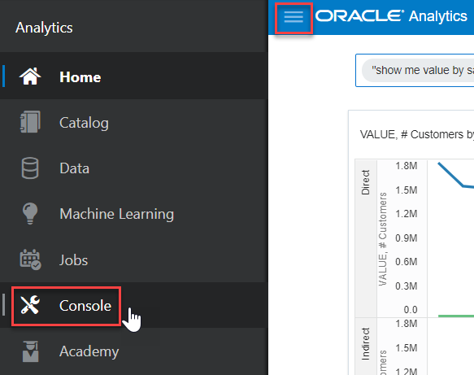
  + From **Configuration** and Administration click **Users and Roles** > Note: a new browser page is opening
* 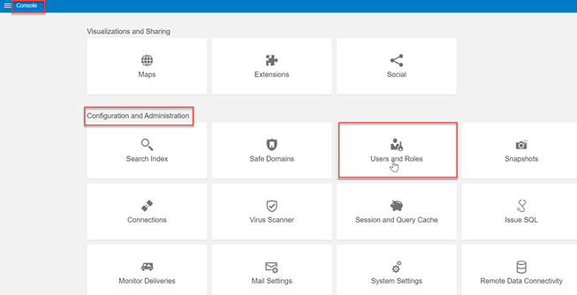
* Console
  + From **Application Role Management** search for your **User** in the search box upper right, then click on **Manage Application Role** Console  
    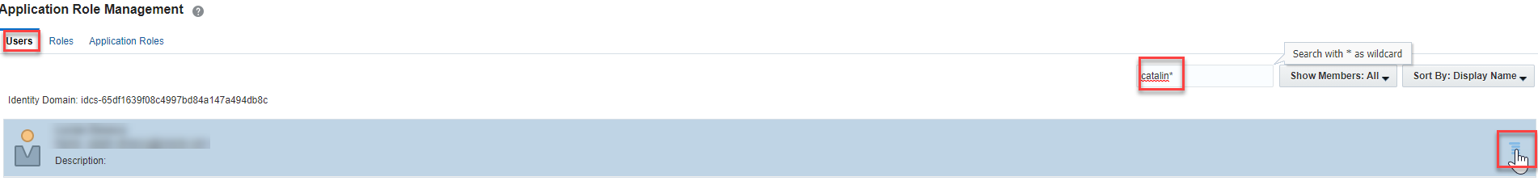
  + From **Manage Roles** click **Search** button and see **Available Applications Roles**  
    > if you already have **BIService Administrator** role you are OK  
    > you double-click on **BI Content Author** and a **DV Consumer Role** to move it from the left side to the right side if necessary  
    Click **OK** button.  
    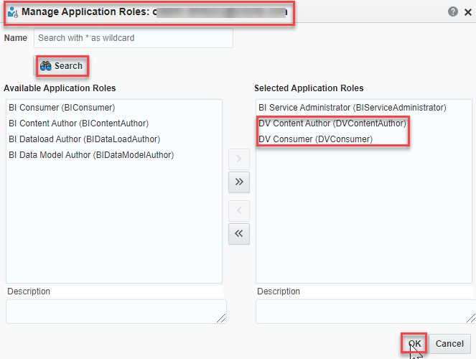
  + Close the new opened browser page, return to the **Console**, click on **Navigator** and select **Home Page**  
    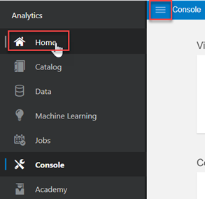
* **2.2 Connect to your OAC instance**  
  The prerequisites are met, so it’s time to connect your mobile to your OAC instance
  + Enter your **Instance details**: (https://name-tenency.analytics.ocp.oraclecloud.com)
  + Enter your ** OAC login User Name** and **Password**; if you have enabled SSO in OAC, you have to set up [OAuth](https://docs.oracle.com/en/cloud/paas/analytics-cloud/biday/basics.html#GUID-4AE4B43-56F4-4DAC-8FF1-5FC4B5DE5BB)  
    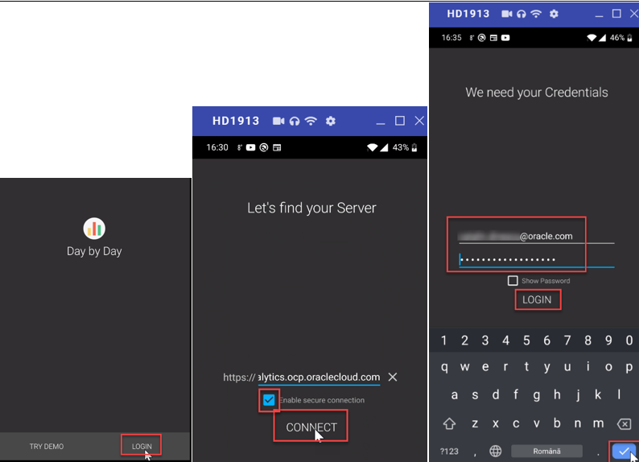
* **2.3 Ask your question**.  
  You can simply speak or type in plain English questions, which gets directed to your data set
* 2.3.1 Go to **Search** tab.  
  Click on the microphone icon and speak “**show me value by week and customers by channel**”  
  > Alternatively, you can type the same question Questions are parsed and reports are returned which best matches the question, from the best matched data set.
* Search results are listed in this order:   
  1. Data model (semantic layer)   
  2. Certified data sets   
  3. Personal data sets   
  4. Catalog items (projects, analyses, dashboards, and reports)
* 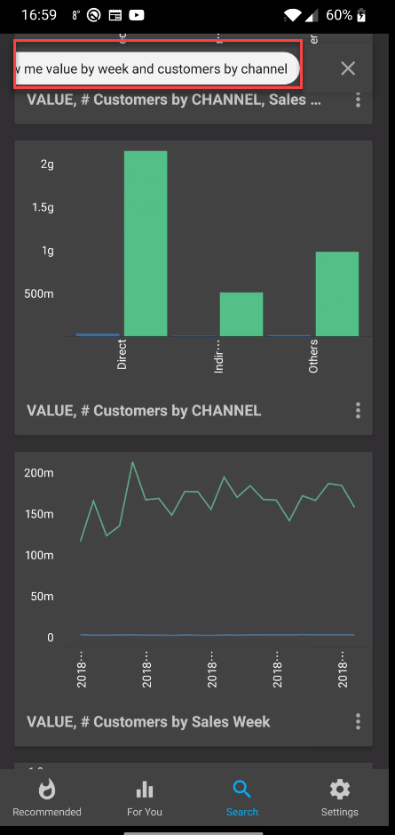
* Speak
* **2.4 Add visuals to your feeb**.  
  Interesting visuals can be added to daily feeds. The daily feeds appear on the Home screen when the user logs in every time.  
  Choose two visuals, click on the 3 dots and select **Add to Your Feed**  
  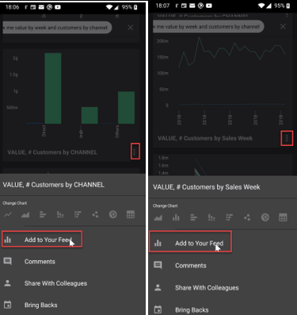
* **2.5 Comment**.  
  Choose a visual, click on the 3 dots and select **Comments**. Speak or type “**Please review ASAP**”  
  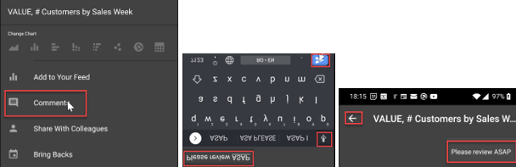 > Note: see “**1 comment**” Comment at the bottom of the feed

## **STEP 3**: Troubleshoot and Fine-Tune Searches

This topic briefly describes common problems that you might encounter, and suggestions to fine-tune your searches.

### Connectivity

If the app can’t connect to the server, then:

**1.1 Verify the URL format** of the server in the app.  
The URL format must be https://hostname:port for example, https://oacserver.com:443

**1.2 Run the Users Service End Point test**.  
Using a desktop browser, navigate to https://oacserver.com:443/bimajel. A page with a link for the Users Service End Point test must be displayed

**1.3 Test the URL** for the server in a browser on a computer. After confirming that the URL works properly in that browser, enter the same URL in a browser on the mobile device.

**1.4 Certificate issues.**  
Be aware of warnings for bad certificates in the address bar and when loading a page on the desktop or on the mobile device

### BI ASK Troubleshooting, No Suggestions

* **2.1 Check ASK on the Home Page** - Verify it Returns Suggestions  
  Type in the ASK bar on the home page and verify that suggestions are returning.
* **2.2 Verify that Indexes are Created**  
  Verify that the index has but run for at least one subject area. **Run index** again in case it is corrupt
* **2.3 Verify Security**  
  User must be at least a BI Content Author and a DV Consumer. Make sure you are searching for a term that exists

### No Results or Missing Results

* **3.1 Check ASK on the Home Page**- Verify it Returns Suggestions > Understand Matched vs Unmatched Terms.  
  Remember ASK on the desktop only supports matched terms, Day by Day supports either.  
  Unmatched terms may not always return what you expect.
* **3.2 Verify Security**  
  User must be at least a BI Content Author and a DV Consumer. Make sure you are searching for a term that exists

### App Specific Issues

* **4.1 Notification Issues**  
  4.1.1 Verify Notifications are Enabled
  + Android – Settings | Apps | Day by Day | Show Notifications
  + iOS - Settings | Day by Day | Notifications | Allow Notifications
* 4.1.2 Verify Do Not Disturb Options
  + Android – Settings | Do Not Disturb
  + iOS - Settings | Do Not Disturb
* 4.1.3 Test with a Simple Bring Back
  + Do a quick search and set any card as a bring back in 2 minutes
  + Send the app to the background lock the device and wait 2 minutes

### Location Issues

* **5.1 Verify Location Services** are Enabled
  + Android – Settings | Apps | Day by Day |Permissions
  + iOS - Settings | Day by Day | Location
* **5.2 Check for Low Power Mode** or **WIFI Disabled**
* **5.3 Test with a Simple Bring Back** by Location

### Other Issues

* **6.1 Cannot Upload Profile Image**
  + Verify Camera and Photo Access
  + Check Image Size (larger then 1 MB)

### Fine-Tune Searches

* **7.1 Avoid special characters** in your indexes, especially in terms from your subject areas
* **7.2 Don’t index any field** names whose value includes a large amount of text or confidential information
* **7.3 Try to flatten hierarchies** or avoid indexing hierarchies
* **7.4 Minimize the number of duplicate dimensions**
* **7.5 Create synonyms** to handle search queries > Please check [Configuring Synonyms for ASK Interface](http://oracledataviz.blogspot.com/2018/11/un-documented-beta-oac-1833-feature.html) blog
* **7.6 Expand acronyms** because they aren’t easily understood when searching > In a voice query, say “percent” or “percentage” rather than “p-c-t”.
* **7.7 Ensure** that your **security** settings improve and personalize what users see
* **7.8 Ensure** that the administrator has **Certified the Data Sets** that users need to find

You have just finished to learn how to ask direct questions to your data using **BI Ask** in both desktop and mobile flavour as well as basic troubleshooting and index tips.  
> Optional: you can check in the next [video](https://youtu.be/uEESc7yo6kA) how BI Ask engine works with OAC DV and Day by Day in a side by side comparison

**This concludes this lab. Please proceed to the next lab in the Content menu.**

## Want to Learn More?

* [Troubleshoot Indexing](https://docs.oracle.com/en/cloud/paas/analytics-cloud/acabi/troubleshoot-indexing.html)
* [Using Search and BI Ask](https://docs.oracle.com/en/cloud/paas/bi-cloud/bilug/using-search-and-bi-ask.html#GUID-97F546AE-6277-45AB-B5A7-C55E2328AC0E)
* [Natural Language Interview with Jacques Vigeant](https://www.youtube.com/watch?v=piE1ah51DnE&feature=youtu.be)
* [Oracle’s Day By Day: Transforming The Way People Consume Analytics](https://blogs.oracle.com/analytics/oracle%e2%80%99s-day-by-day:-transforming-the-way-people-consume-analytics?source=:em:nw:mt:RC_PDMK190606P00196:OACBLOGJUL20WK4&elq_mid=168112&sh=15062418261323181322082406290313253035&cmid=PDMK190606P00196C0058)
* [Using Oracle Analytics Day by Day](https://docs.oracle.com/en/cloud/paas/analytics-cloud/biday/basics.html#GUID-8D2A7AA1-37E0-4862-9FD9-DEE1179E5D69)

## **Acknowledgements**

* **Author** - Lucian Dinescu, Product Strategy, Analytics
* **Contributors** -
* **Last Updated By/Date** - Lucian Dinescu, January 2021

## Need Help?

Please submit feedback or ask for help using our [LiveLabs Support Forum](https://community.oracle.com/tech/developers/categories/livelabsdiscussions). Please click the **Log In** button and login using your Oracle Account. Click the **Ask A Question** button to the left to start a *New Discussion* or *Ask a Question*. Please include your workshop name and lab name. You can also include screenshots and attach files. Engage directly with the author of the workshop.  
Please contact us at analyticsenablement_us_grp@oracle.com for any suggestions or challenges you might have with **Oracle Analytics** labs.

If you do not have an Oracle Account, click [here](https://profile.oracle.com/myprofile/account/create-account.jspx) to create one.