Lab Guide

Topic Name

Date (January 1, 2019)

Lab Guide Mark Down Conversion Template Information *(remove this section before publishing)*

In general, the simpler the better.

* Label every image with a figure number starting from #1, counting to the total number of figures or ‘images’. This will help you keep track of images as they are generated in the /media subfolder.
* When using bullets, only use the standard bullet, do not use check marks or arrows, they will not translate in the final markdown.
* Images will all be left justified and displayed at their normal size.
* For code examples and any other distinctive formatting like tables, highlights, etc. you will need to format the markdown directly.
* After you are finished, *update* the Table of Contents – *right click* on the Table of Contents, and select Update Field from pop-up menu. Select “Update Entire Table” radio button and click on the OK button. It will retain navigation after the markdown conversion. You will need to remove the page numbers manually.
* Install Python if you do not have it, and refer to conversion scripts below
* <https://github.com/jjking2019/ospa-github-ideas/blob/master/docx_md_converter_scripts.md>
* Delete this section before publishing

Sample Table of Contents

Lab Guide Overview 4

Lab Purpose and Rules 4

Labs 4

Lab 1: Name of Lab 4

Lab 2: Name of Lab 5

Appendix: Name of Appendix 6

# Lab Guide Overview

## Lab Purpose and Rules

A brief overview of what you expect the student to accomplish in your lab. The purpose of this lab is to familiarize attendees with the feature functionality of the technology. It is assumed that attendees have a solid understanding of basic related concepts.

To optimize your experience there are some general guidelines that will help you get the most from these lab exercises.

* Read through an entire exercise before executing any of the steps. Merely following the screen shots or script files without understanding the flow will diminish your learning experience.
* Read all the script files before executing them. Most of them are run to echo the files before actually executing the code. Careful reading of the file before executing will enable you to better understand what the script does.
* Ask before you do. If you have any questions, please ask the instructor before you march down a path that may lead to unsatisfactory results.
* Follow the steps as shown in the Lab Guide. Do not freestyle during the labs. This is a live environment. If you want to do something that is not in the labs, ask the lab instructor first. In particular, do not create, delete, or alter any database objects without asking first.
* There is no prize for finishing first; there is no penalty for finishing last. The goal is to gain a firm understanding of Oracle Cloud Infrastructure.
* Ask questions freely. The only dumb questions are those that are not asked.

# Labs

Description of business solution….

**Prerequisite**: Before starting these labs, you should have ….

**NOTE:** Content is driven by external factors such as user data entries and login date. As a result, what you see displayed in your environment may not exactly match with the lab screenshots. Screenshots are provided solely for illustrative purposes to help guide you through the user interface.

# Lab 1: Name of Lab

Description and purpose of Lab 1….

* Key features and functionality
* Built-in best practice predefined content
* Drivers and key performance indicators (KPIs)
* Ease of use with configuration wizards
* Planning and reporting needs in one centralized repository

1. Open…

2. Click….

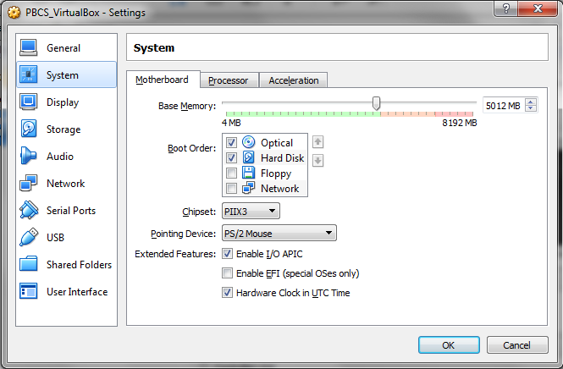Figure 1.1

**Note:** The following instructions cover general steps to back up demo content for most EPM Cloud services. Minor differences will exist with updates to the software. Steps and screenshots provided are based on EPM Version 16.09 User Interface and are provided solely for illustrative purposes.

# Lab 2: Name of Lab

Description and purpose of Lab 2….

1. Open…
2. Click….

# Appendix: Name of Appendix