JMS Service Migration lab.

Create Weblogic domain
cd $LABS_HOME/setup-packages/jms-package/
./setup-domain-appgrid.sh
This command will create domain with the following configuration:
<DESCRIBE WHAT IS INSIDE DOMAIN >
Admin server is up and running after the end of the script.

Configure Oracle DB.
2.1 Check that Oracle DB is running.
Open terminal, Log as root and check Oracle DB status
su -
service oracle-xe status
If we see message
TNS-12541: TNS:no listener
TNS-12560: TNS:protocol adapter error
TNS-00511: No listener
Linux Error: 111: Connection refused
issue the following command:
service oracle-xe start
You should see the following:
[root@testhost ~]# service oracle-xe start
Starting Oracle Net Listener.
Starting Oracle Database 11g Express Edition instance.
Check the running status once again, now you should see the following messages at the end of the output:
Service "XE" has 1 instance(s).
Instance "XE", status READY, has 1 handler(s) for this service...
Service "XEXDB" has 1 instance(s).
Instance "XE", status READY, has 1 handler(s) for this service...
The command completed successfully
  - Setup Weblogic database user and the corresponding tables
cd $LABS_HOME/setup-packages/jms-package/
./setup-db.sh

Deploy JMS listener application
  - Before deploying JMS listener application to the cluster, we must start two managed servers (appgrid-ms-1 and appgrid-ms-2). To do that, let’s open two Terminal windows, set title (Terminal->Set Title) of the first window to MS1 log, set title of the second window to MS2 log and issue the following commands:
Window 1:
cd $APPGRID_DOMAIN_HOME/bin
./startms1.sh
Window 2:
cd $APPGRID_DOMAIN_HOME/bin
./startms2.sh
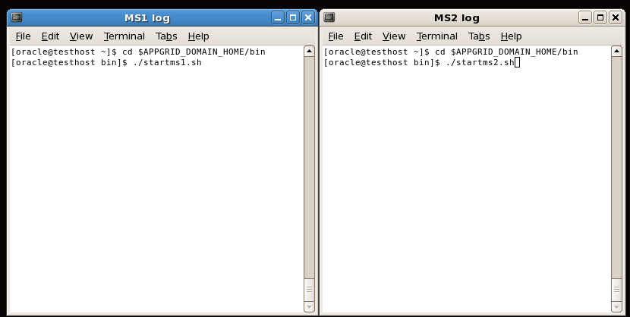
Wait until you see messages indicating that both servers has changed their state to RUNNING:
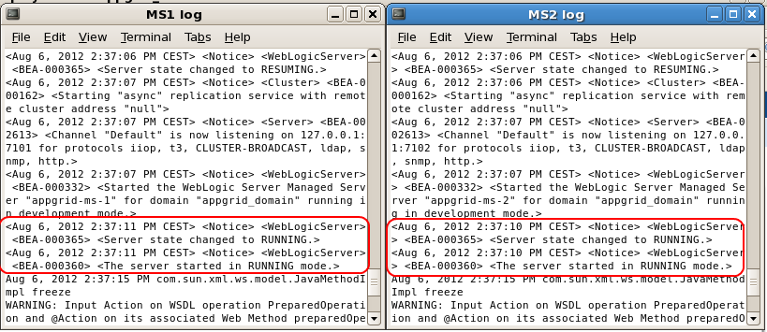
  - Now let’s deploy the JMS listener application. Open new terminal window and issue the following commands:
cd $LABS_HOME/setup-packages/jms-package/examples/migration/scripts
./deploy-migration-listener.sh
Open Weblogic Administration console by entering http://localhost:7001/console in the browser window and logic as weblogic user with password welcome1 .
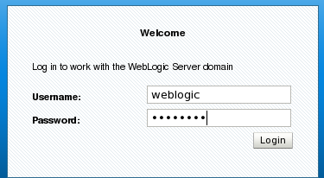

Check that migration-listener application has been successfully deployed by checking Deployments list in the WLS Console:
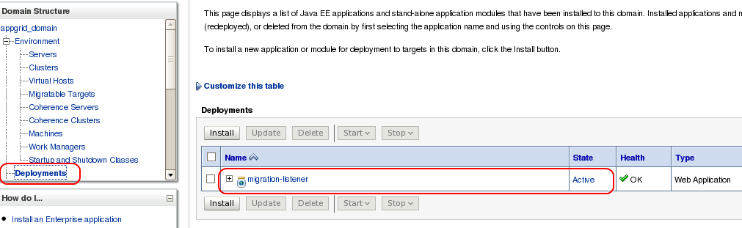

4. Configure for automatic service migration.
4.1. Select appgrid-cluster-1 cluster in the Administration console
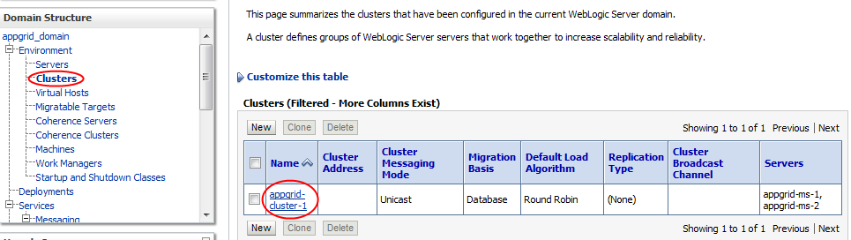
  - Go to Configuration->Migration subtab
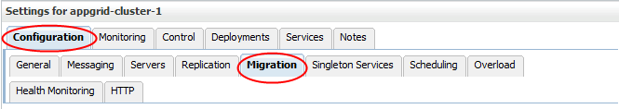
  - Shuttle my-machine-1 and my-machine2 from Available to the Chosen list of machines for the migratible servers, then pick appgrid-cluster-ds-nonXA as a datasource for storing leasing information. Also note that the table name for storing leasing information is ACTIVE, you’ve created this table earlier on step 2.2 of the lab. Save these changes.
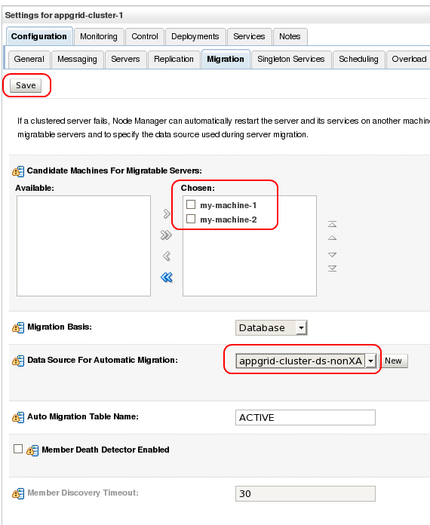
  - Select Environment -> Migratible targets in the domain structure, then click appgrid-ms1 migratible target in the table
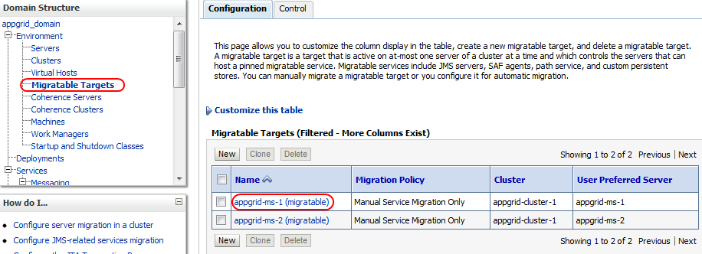
Go to Configuration -> Migration subtab, select Auto-Migrate Failure Recovery Services as a value of Service Migration Policy setting, then shuttle appgrid-ms-1 and appgrid-ms-2 to the list of chosen candidate servers for this migratible target. Save your changes.
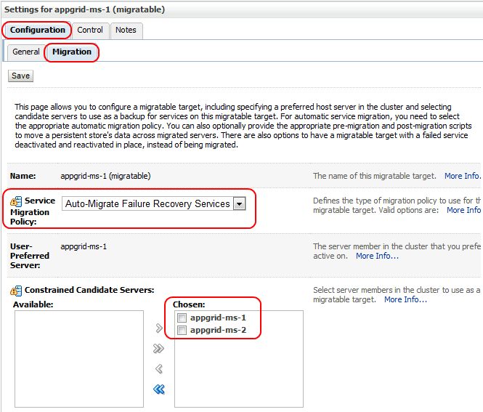
  - AdminServer and both managed servers appgrid-ms-1 and appgrid-ms-2 should be restarted for changes to take effect.
Go to Environment -> Servers, select all servers and shutdown them.
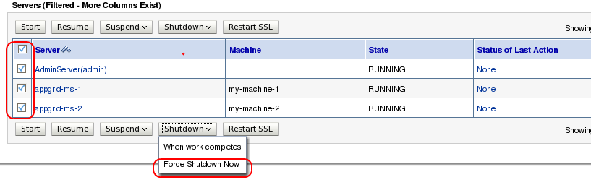
Next, start AdminServer using $APPGRID_DOMAIN_HOME/bin/startWebLogic.sh script, start both managed servers as described in steps 3.1.

Testing the automatic service migration.
  - During step 4.3 we have set up Migration Basis to Database and specified JDBC datasource (appgrid-cluster-ds-nonXA) and table name (ACTIVE) as a place to store migration information. Let’s explore what’s inside table now
    - Open SQL Developer using the icon available on the desktop 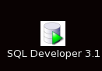
    - Create new Connection
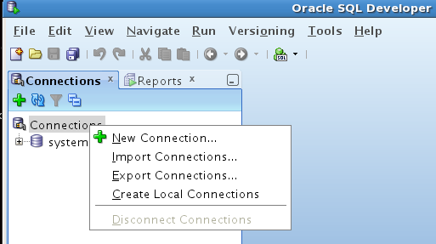
    - Enter connection properties like on the screenshot below (password is weblogic), press Test button to check if connection successful, then click Save and close this window.
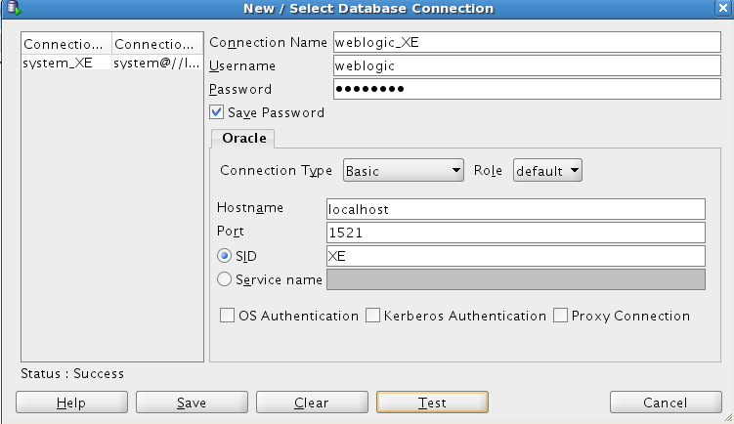
    - Pick the newly created connection and, right-click and select Connect menu item.
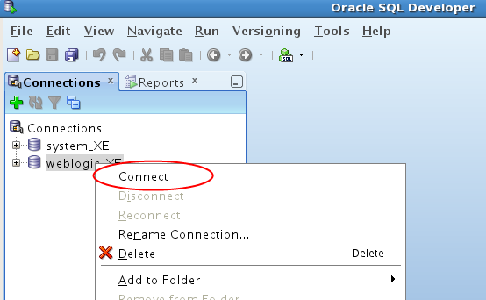
    - Issue SELECT * FROM ACTIVE SQL statement in the SQL Worksheet window. You should see that appgrid-ms-1 managed server is now hosting appgrid-ms-1 migratible target.
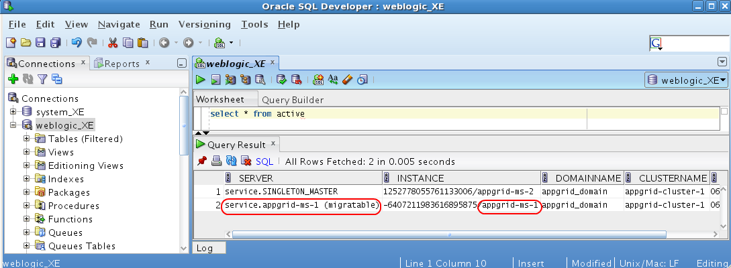
Do not close this SQL Developer windows.
  - Open Terminal Window set the title to Message Producer issue the following command:
cd $LABS_HOME/setup-packages/jms-package/examples/migration/scripts/
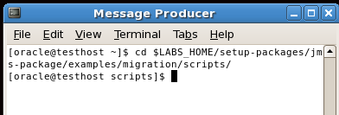
  - Rearrange the windows on the desktop to be able to see Message Producer window, both managed server log windows, WLS Console and SQL Developer Worksheet (look at the example below):
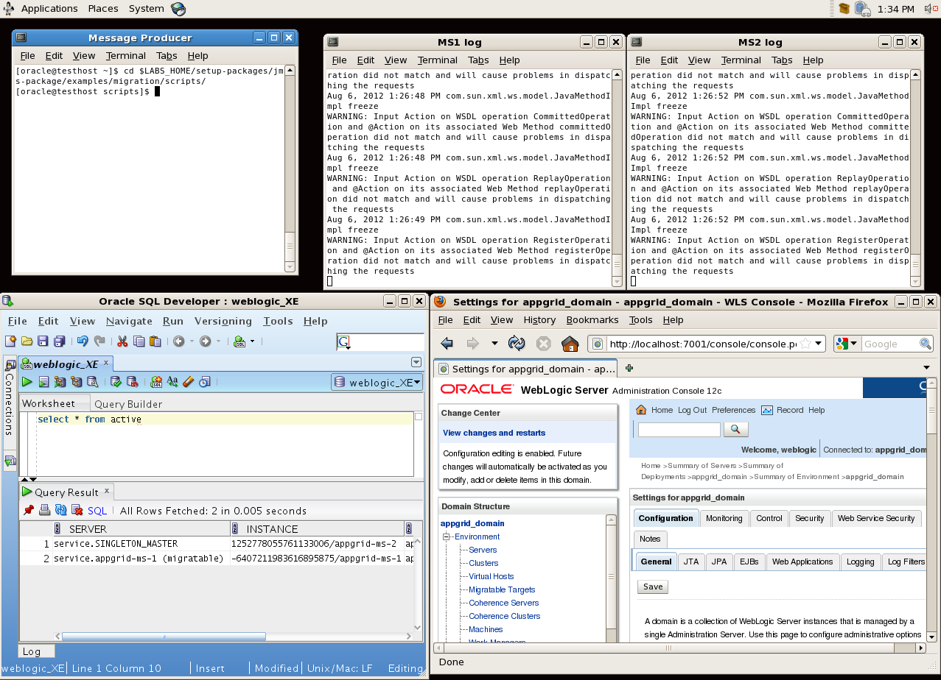
  - Execute the following command in the Message Producer window:
./start-migration-producer.sh
You will see the output confirming that messages has been sent to the queue. Because com/oracle/appgrid/example/jms/base/queue is a uniform distributed queue targeted to the appgrid-cluster-1, messages are distributed evenly across all the JMS Servers targeted to the cluster, in our case it’s appgrid-jms-server-1 and appgrid-jms-server-2 which are associated with managed servers appgrid-ms-1 and appgrid-ms-2 via corresponding migratable targets.
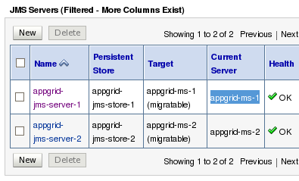
Look at the output of the appgrid-ms-1 and appgrid-ms-2, you will see that:
- messages with even numbers are delivered to JMS Server appgrid-jms-server-1 and processed by MDB running on appgrid-ms-1.
- messages with odd numbers are delivered to JMS Server appgrid-jms-server-2 and processed by MDB running on appgrid-ms-2
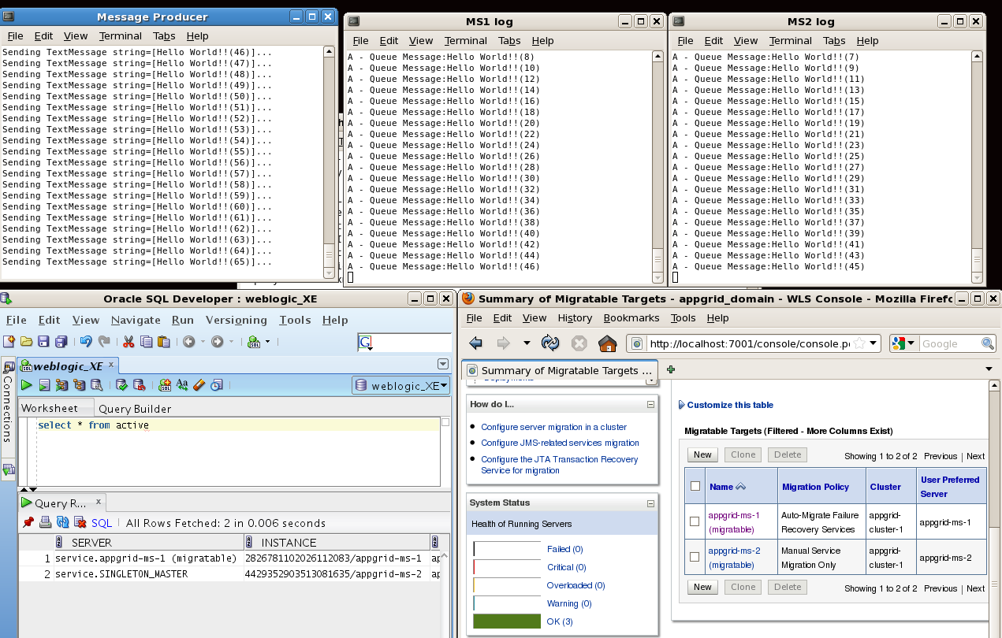
  - Now let’s kill appgrid-ms-1 managed server: open another one tab in the Terminal Window where Message Producer is running, and issue the following command
./killMS1.sh
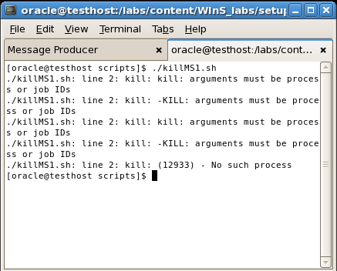
After some time you will see that messages with the odd numbers are now also processed on appgrid-ms-2. Why? Because appgrid-jms-server-1 JMS Server has been migrated to appgrid-ms-2 with the corresponding migratible target appgrid-ms-1, you can check this by re-executing select statement from the ACTIVE table:
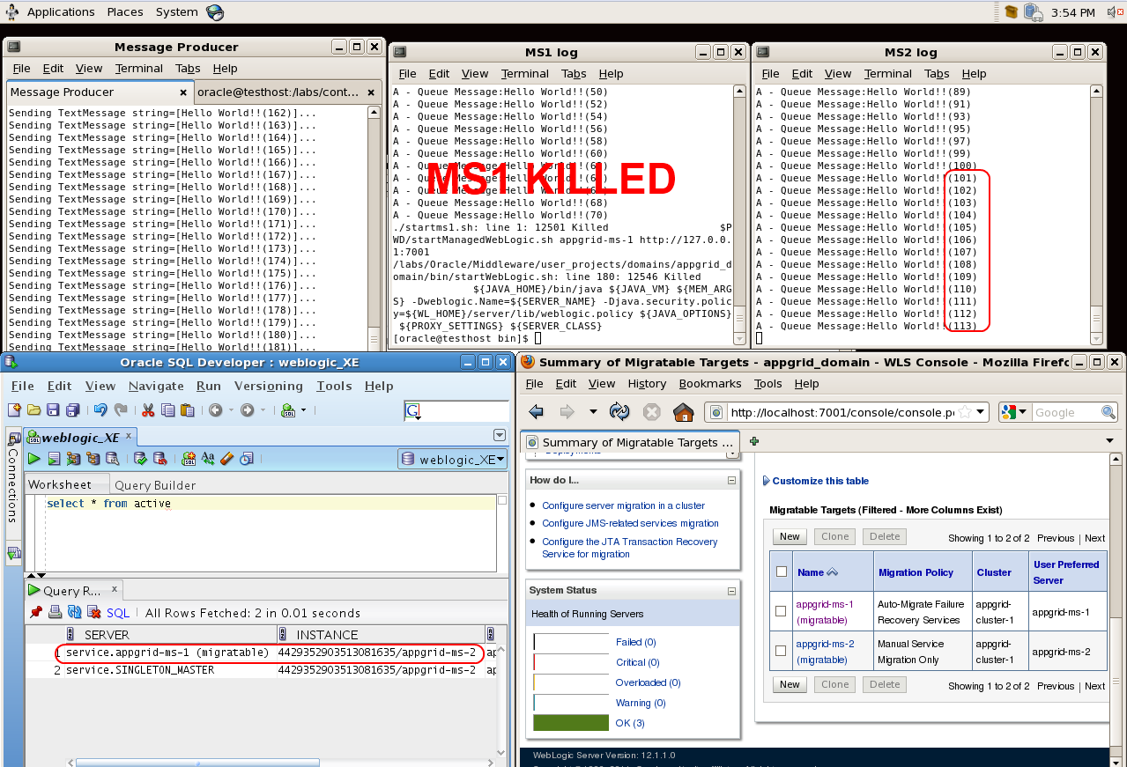
  - Let’s start previously killed appgrid-ms-1 by issuing ./startms1 command in the MS1 log console window managed server in the same window. After the server will change its state to RUNNING you will not see that it’s started to process messages, because appgrid-jms-server-1 has not migrated back to appgrid-ms-1, and there is a good reason for such behavior – you do not want to automatically migrate back to unreliable server.
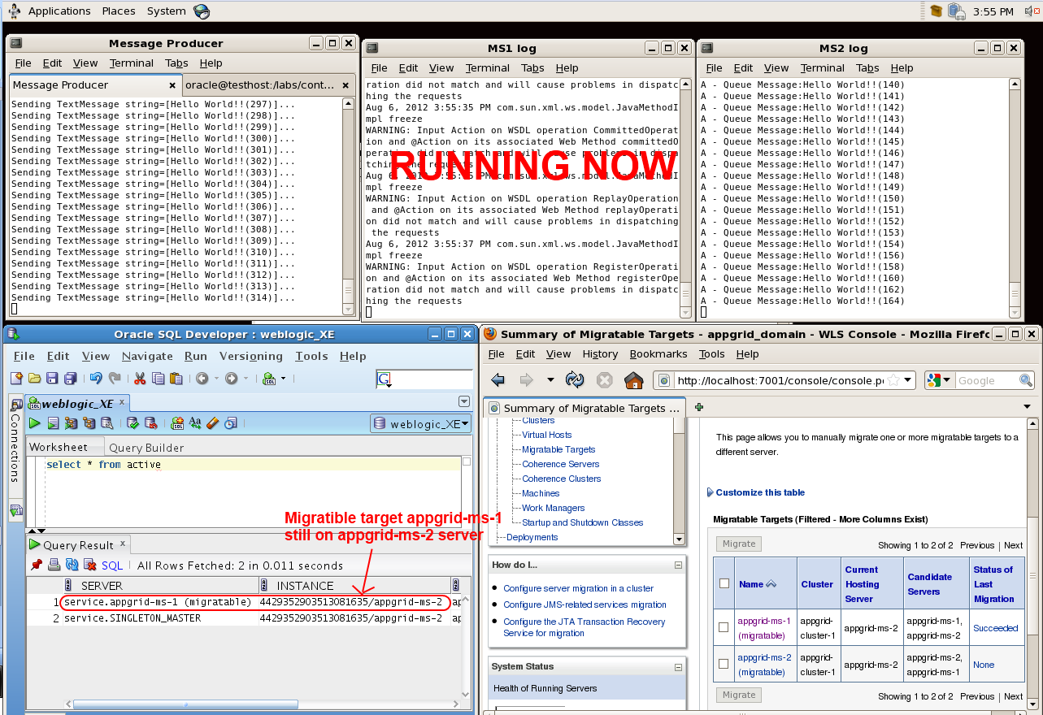
  - To return migratible target appgrid-ms-1 back to appgrid-ms-1 server, we should select this migratible target in WLS Console , click Migrate button,
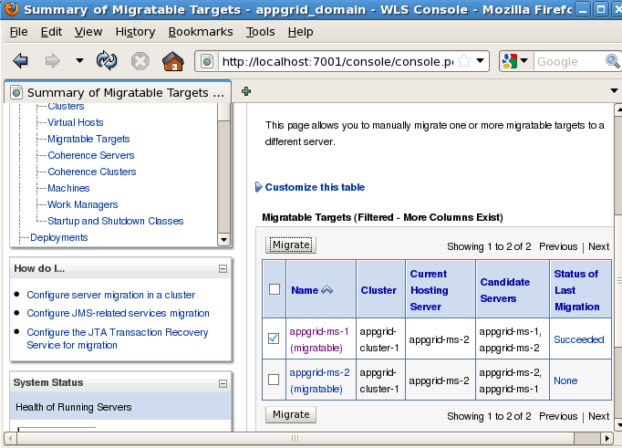
Select appgrid-ms-1 as a new hosting server and press OK.
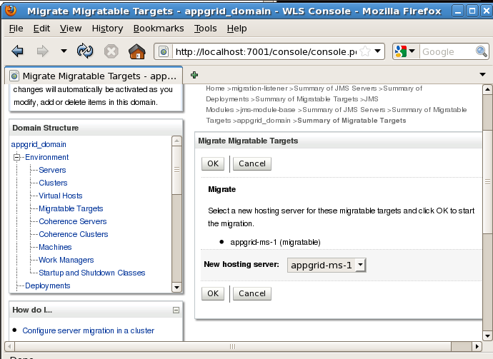
  - As a result you will see that JMS Server appgrid-jms-server-1 returned back to appgrid-ms-1 managed server and MDB processing messages appear in appgrid-ms-1 server log.
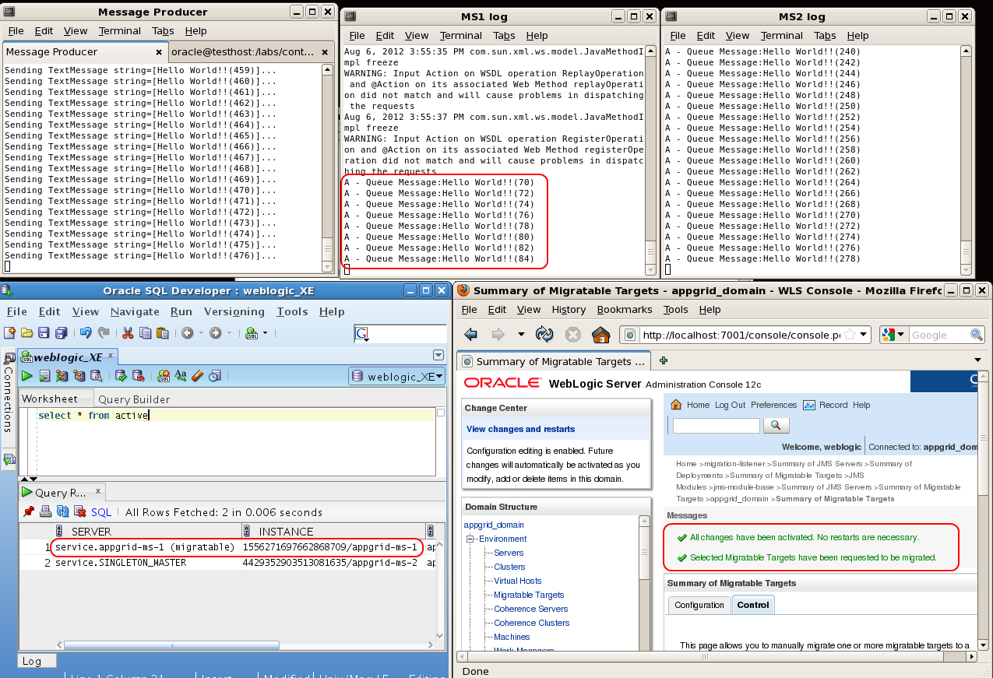
As you might see, with JMS Service Migration your messages are not stuck in the queues even if the managed server hosting the corresponding JMS Server is going down.

