**Oracle Autonomous Data Warehouse: Getting Started Workshop - Lab 1**

**Introduction**

This lab walks you through the steps to get started using the Oracle Autonomous Data Warehouse (ADW) on Oracle Infrastructure Cloud (OCI). You will provision a new ADW instance and connect to the database using Oracle SQL Developer.

**Objectives**

* Learn how to provision a new Autonomous Data Warehouse
* Learn how to connect to your new Autonomous Data Warehouse

**Required Artifacts**

* The following lab requires an Oracle Public Cloud account. You may use your own cloud account, a cloud account that you obtained through a trial, or a training account whose details were given to you by an Oracle instructor.
* Oracle SQL Developer 18.3 or later (see [Oracle Technology Network download site](http://www.oracle.com/technetwork/developer-tools/sql-developer/downloads/index.html))  
  Please use SQL Developer version 18.3 or later as this version contains enhancements for key Autonomous Data Warehouse features, including using ADW behind a VPN or Firewall.

*Note:* If you are a Windows user on 64-bit platform, download the 'Windows 64-bit with JDK 8 included' distribution as it includes both Java 8 and the Java Cryptography Extension (JCE) files necessary to run SQL Developer and connect to your Autonomous Data Warehouse.  
If you are a non-Windows user, download and install the appropriate [Java 8 JDK](http://www.oracle.com/technetwork/java/javase/downloads/jdk8-downloads-2133151.html) for your Operating System. Download and extract the [Java Cryptography Encryption Archive](http://www.oracle.com/technetwork/java/javase/downloads/jce8-download-2133166.html) to the directory as indicated in the README.txt.

**Part 1. Provisioning an ADW Instance**

In this section you will be provisioning an ADW instance using the cloud console.

**STEP 1: Sign in to Oracle Cloud**

* Go to [cloud.oracle.com](https://cloud.oracle.com/), click **Sign In** to sign in with your Oracle Cloud account.

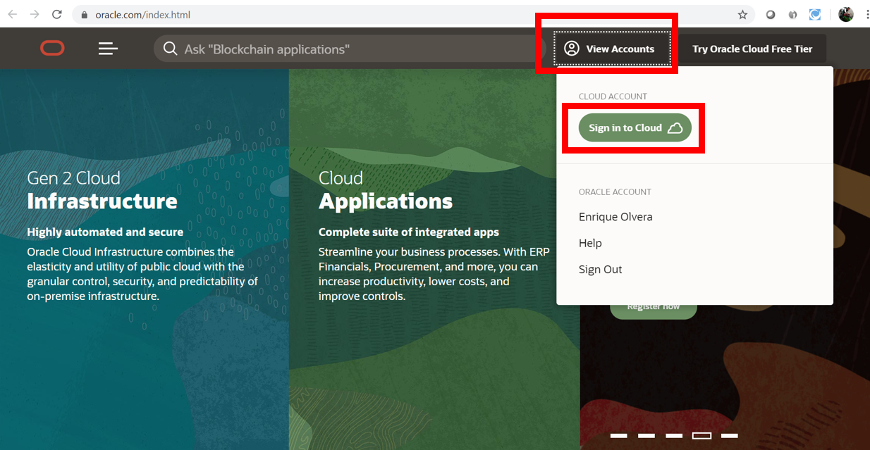

* Enter your **Cloud Account Name** and click next.

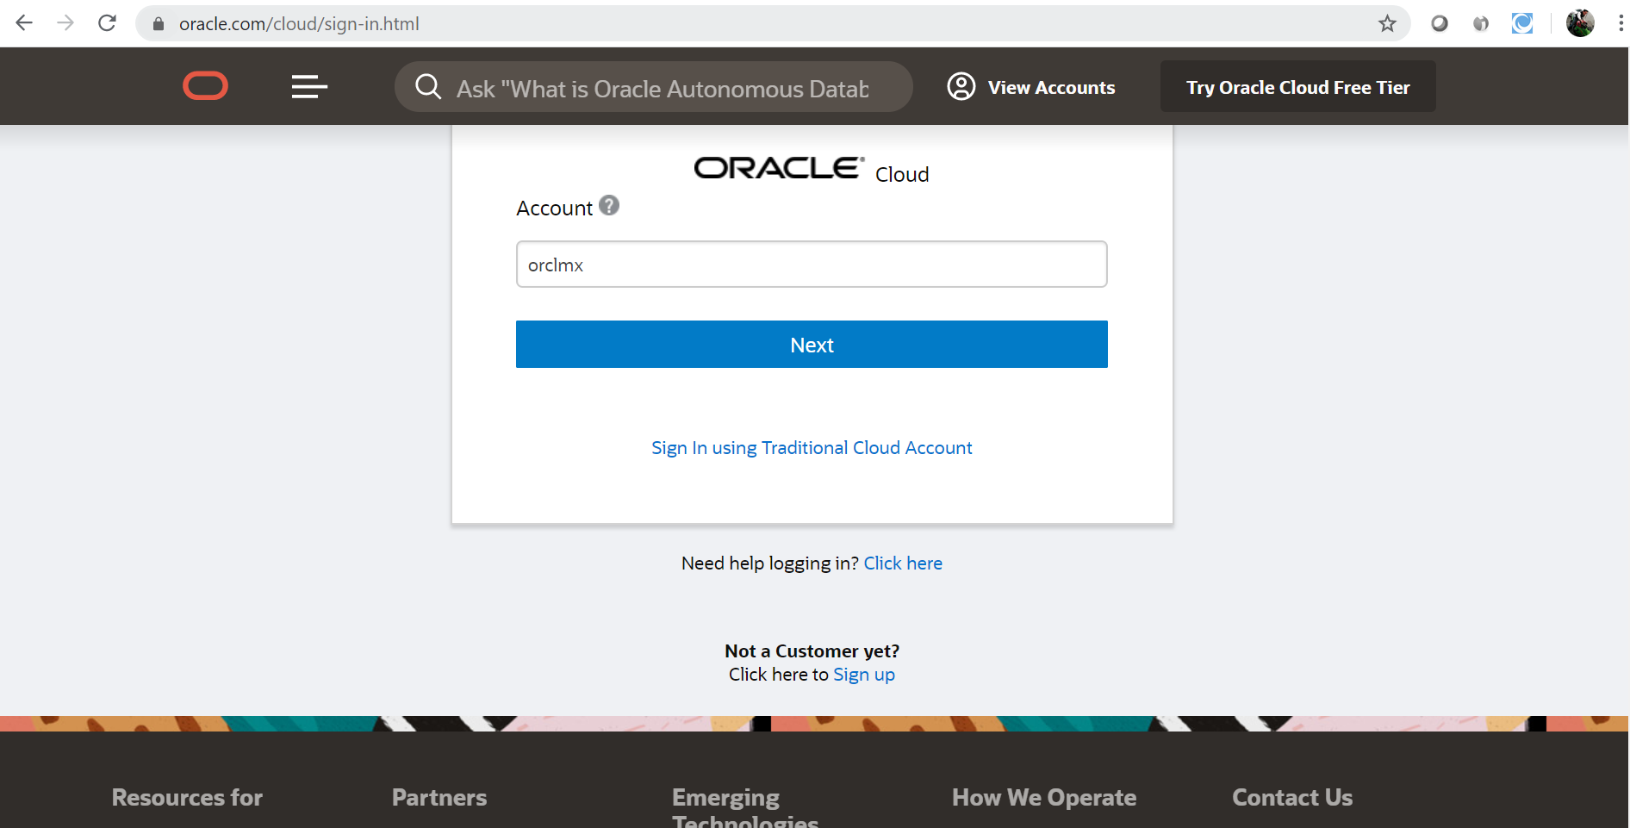

* Enter your Oracle Cloud **username** and **password**, and click **Sign In**.

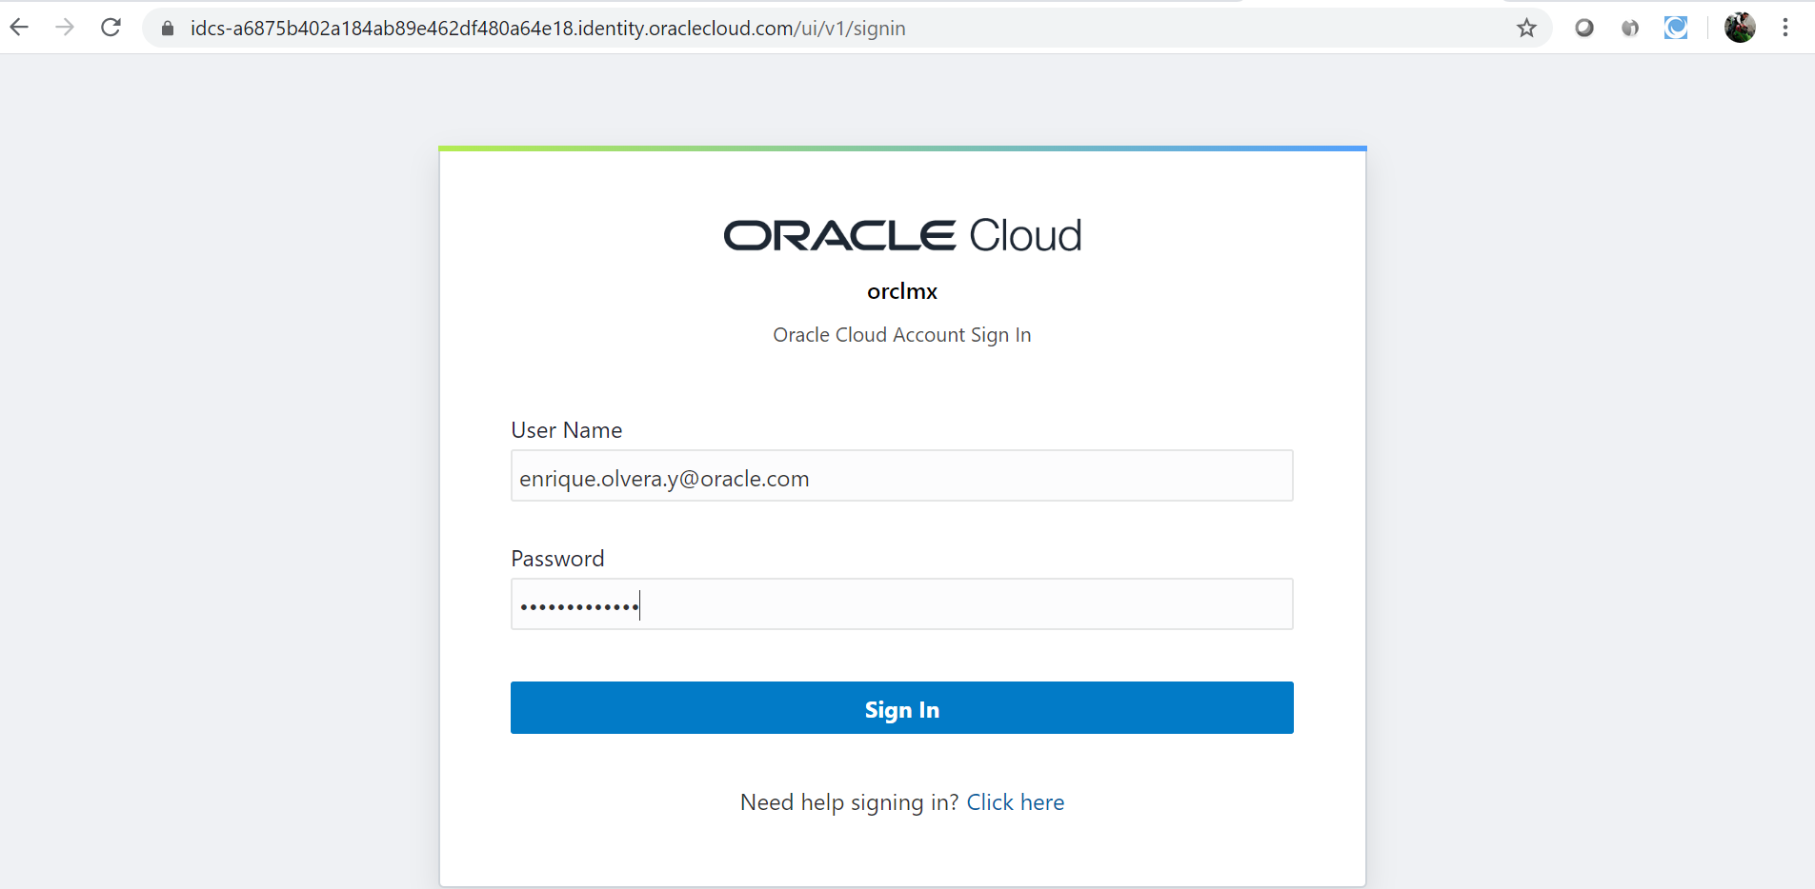

**STEP 2: Create an ADW Instance**

* Once you are logged in, you are taken to the cloud services dashboard where you can see all the services available to you. Click the **Autonomous Database** tile.

*Note:* You may also access your Autonomous Data Warehouse service via the pull out menu on the top left of the page, or by using Customize Dashboard to add the service to your dashboard.

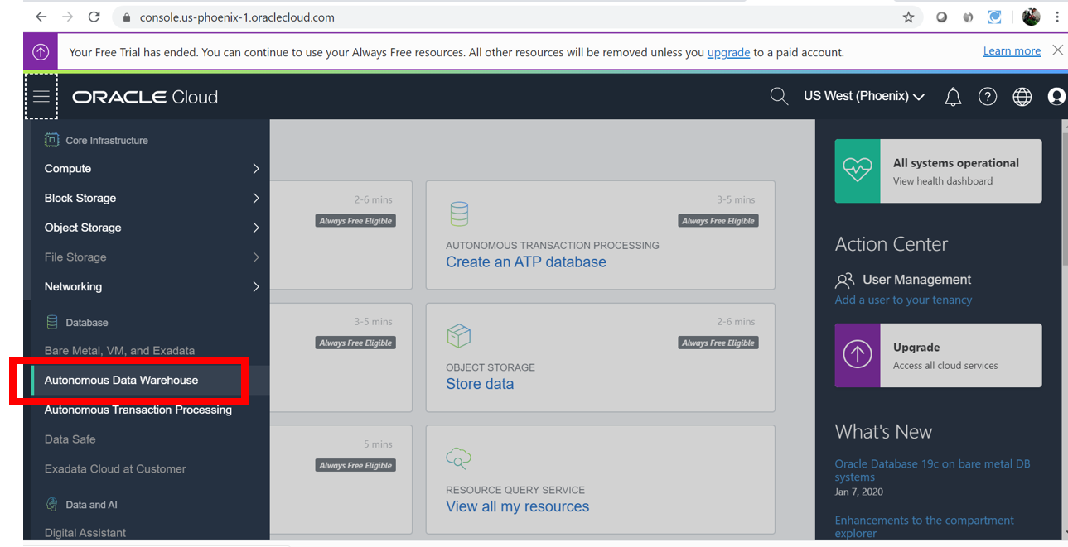

* Click on **Create Autonomous Data Warehouse Instance**.

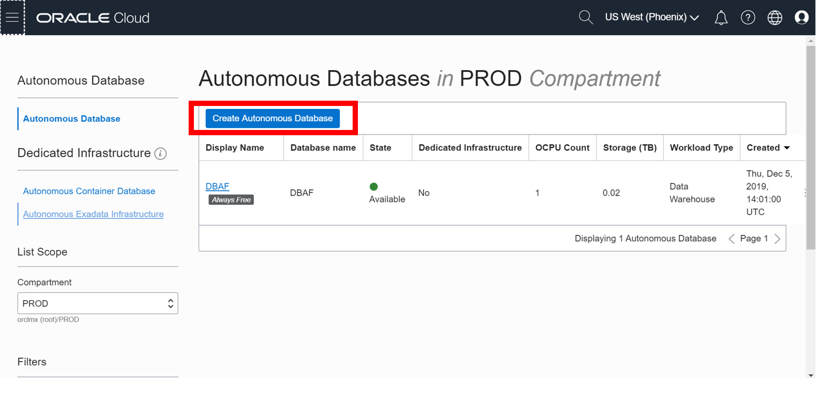

* Make sure your workload type is **ADW** or **All** to see your Autonomous Data Warehouse instances. Select your **root compartment**, or **another compartment of your choice** where you will create your new ADW instance. If you want to create a new compartment or learn more about them, click [here](https://docs.cloud.oracle.com/iaas/Content/Identity/Tasks/managingcompartments.htm#three).  
  *Note* - Avoid the use of the ManagedCompartmentforPaaS compartment as this is an Oracle default used for Oracle Platform Services.

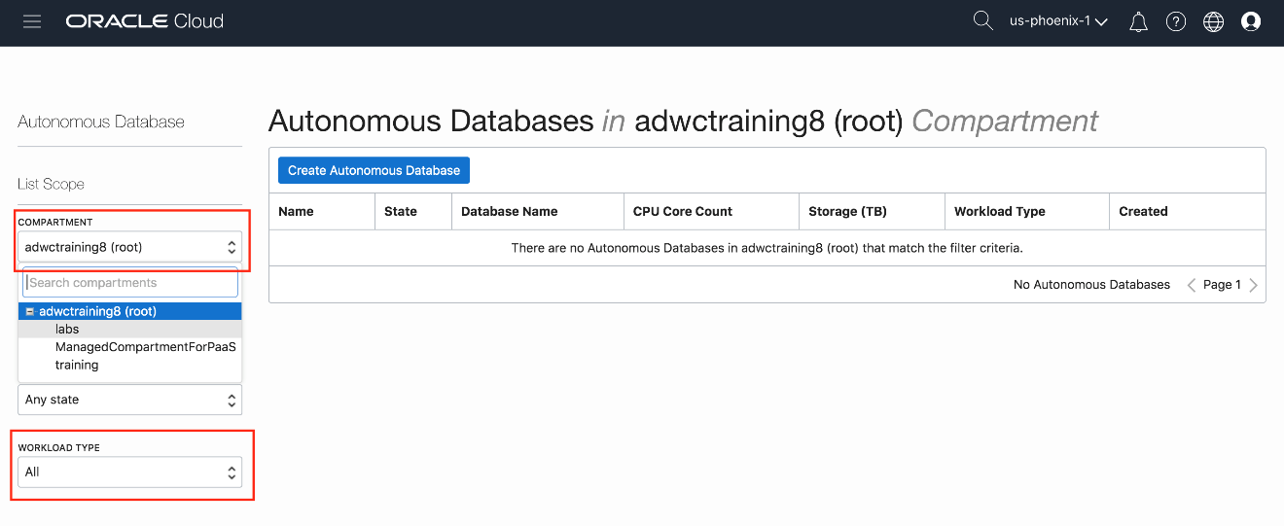

* Click the **Create Autonomous Database** button to start the instance creation process.



* This will bring up the Create Autonomous Database screen where you will specify the configurations of the instance. Select the **Autonomous Data Warehouse** option, the root compartment, or another compartment of your choice as well as Display Name and Database Name.

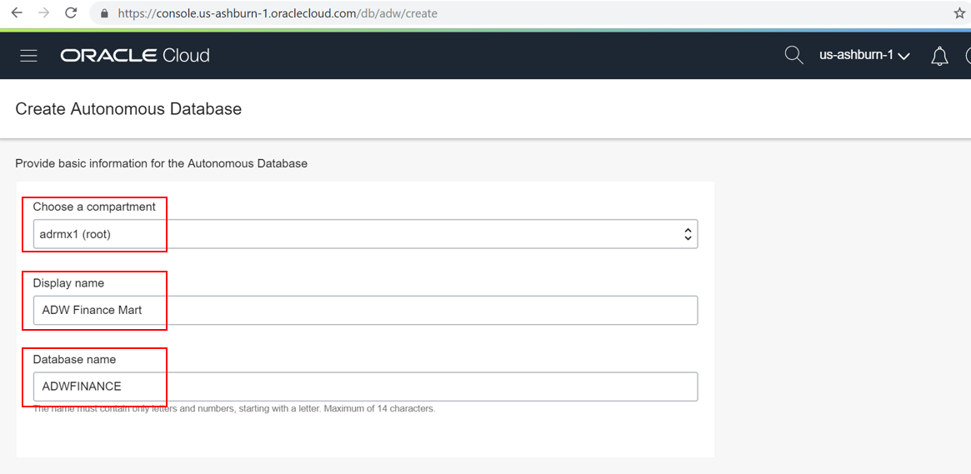

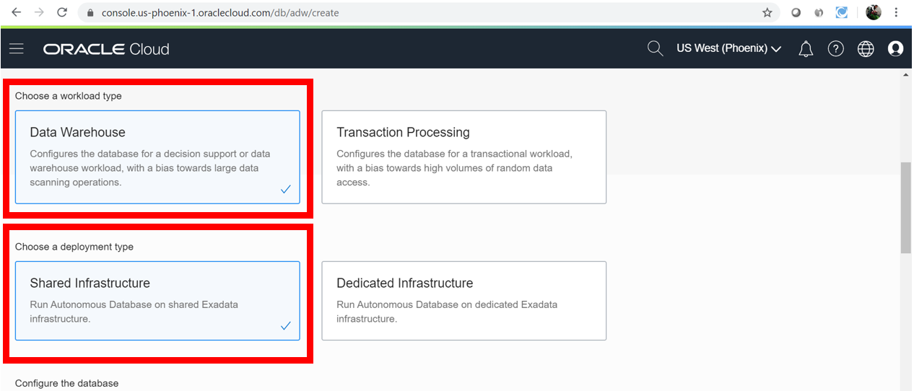

* Specify a memorable display name for the instance, **ADW Finance Mart**. Also specify your database's name, for this lab use **ADWFINANCE**. Next, Choose **Data Warehouse** workload type and **Shared Infrastructure** deployment type select the number of CPUs and storage size. Here, we use **2 CPUs** and **1 TB** of storage.

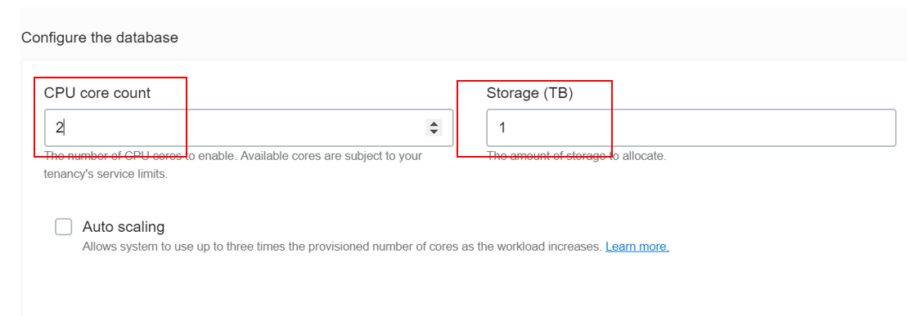

* Then, specify an ADMIN password for the instance, adhering to the requirements, and then re-enter a password confirmation of it. Make a note of this password.

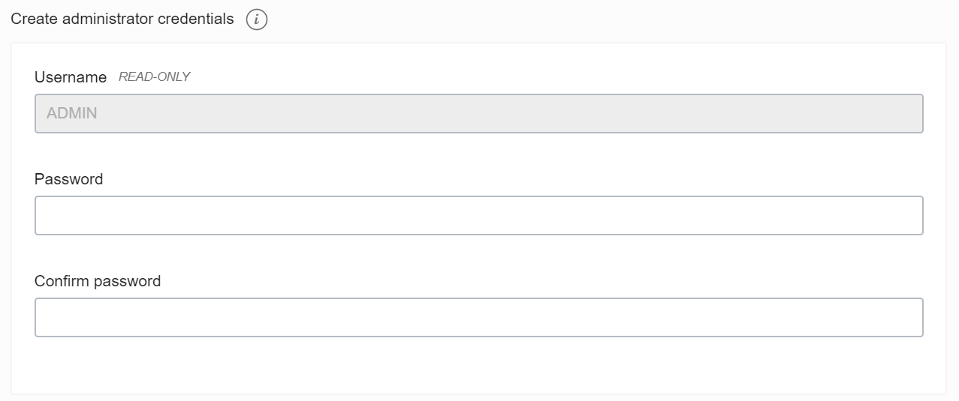

* For this lab, we will select **My Organization Already Owns Oracle Database software Licences**. If your organization owns Oracle Database licenses already, you may bring those license to your cloud service.  
  Make sure everything is filled out correctly, then proceed to click on **Create Autonomous Data Warehouse**.

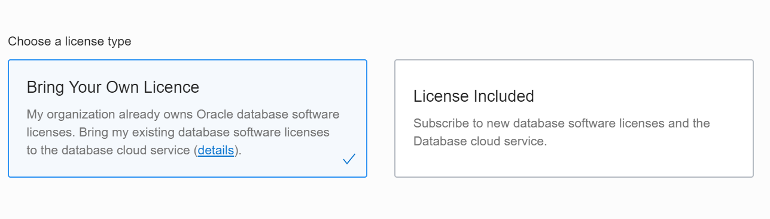

* Your instance will begin provisioning. In a few minutes the state will turn from Provisioning to Available. At this point, your database is ready to be used!

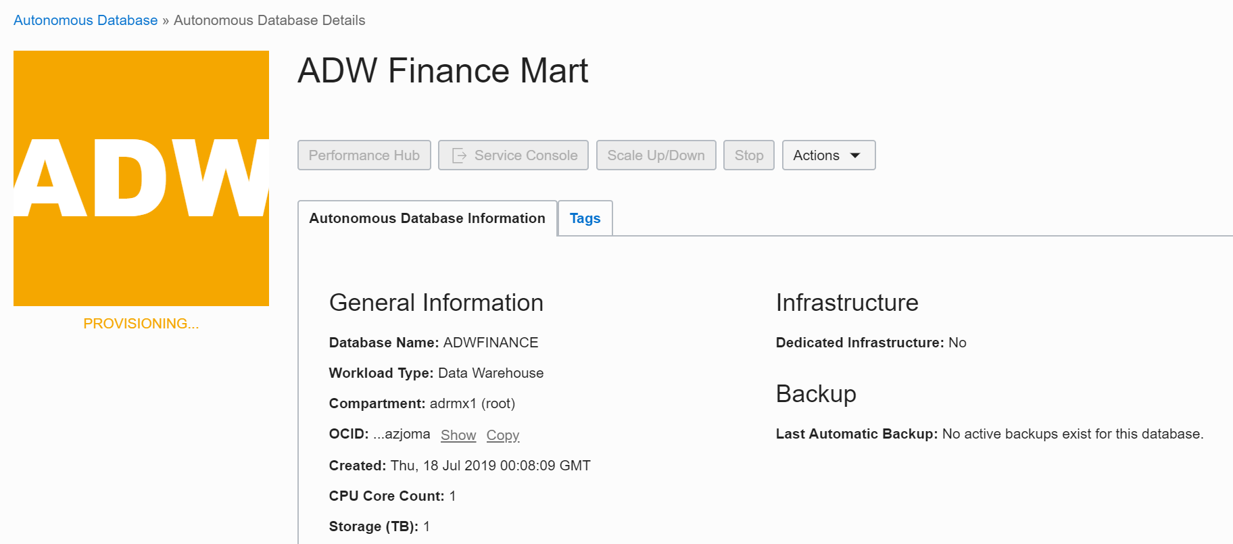

* You now have created your first Autonomous Data Warehouse instance. Have a look at your instance's details here including its name, database version, CPU count and storage size.

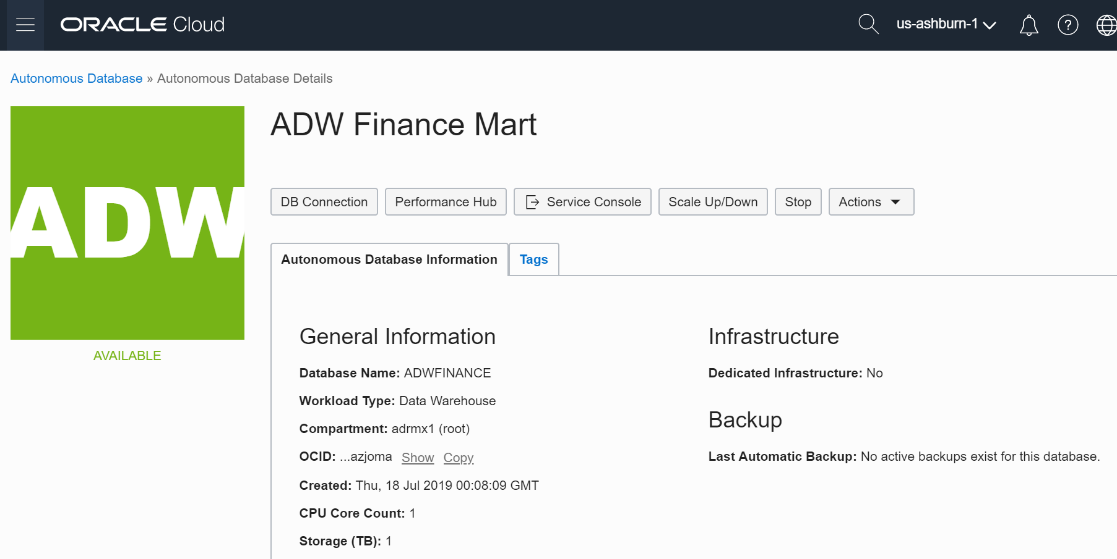

**Part 2. Connecting to ADW**

**Downloading the Connection Wallet**

As ADW only accepts secure connections to the database, you need to download a wallet file containing your credentials first. The wallet can be downloaded either from the instance's details page, or from the ADW service console.

**STEP 4: Download the Connection Wallet**

* In your database's instance details page, click **DB Connection**.

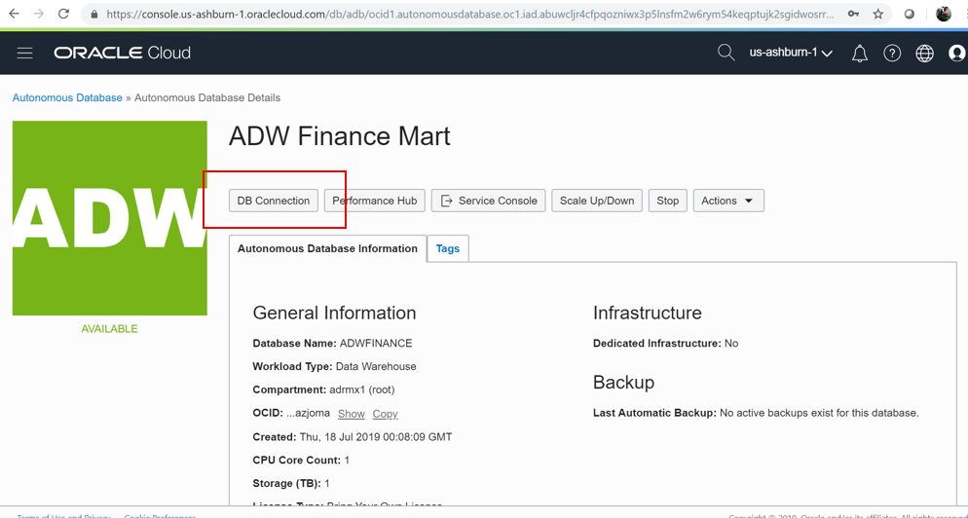

* Under Download a Connection Wallet, click **Download Wallet type Instance Wallet**.

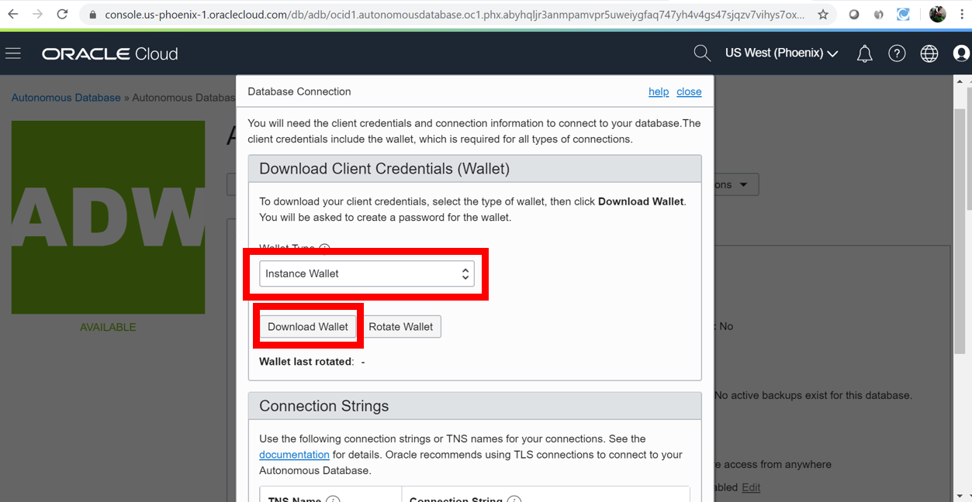

* Specify a password of your choice for the wallet. You will need this password when connecting to the database via SQL Developer later, and is also used as the JKS keystore password for JDBC applications that use JKS for security. Click **Download** to download the wallet file to your client machine.  
  *Note: If you are prevented from downloading your Connection Wallet, it may be due to your browser's pop-blocker. Please disable it or create an exception for Oracle Cloud domains.*

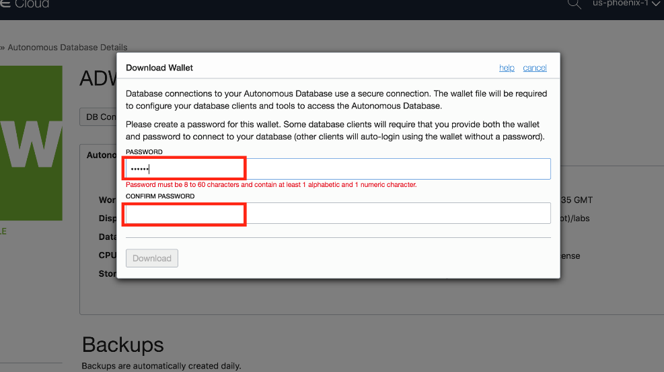

**Connecting to the database using SQL Developer**

Start SQL Developer and create a connection for your database using the default administrator account 'ADMIN' by following these steps.

**STEP 5: Connect to the database using SQL Developer**

* Click the **New Connection** icon in the Connections toolbox on the top left of the SQL Developer homepage.

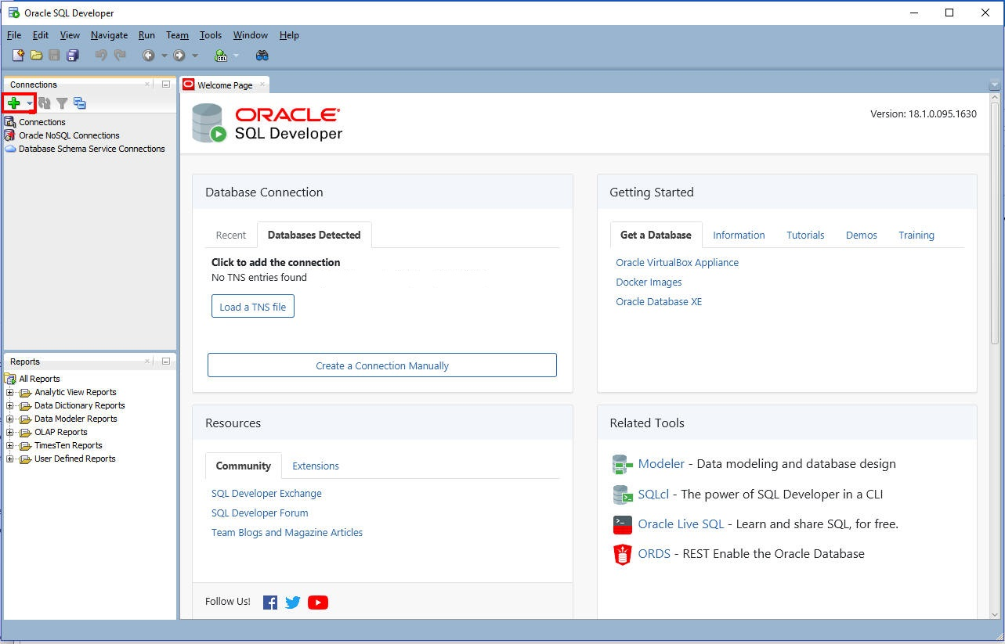

* Fill in the connection details as below:
  + **Connection Name:** admin_high
  + **Username:** admin
  + **Password:** The password you specified during provisioning your instance
  + **Connection Type:** Cloud Wallet or PDB or Cloud (depends on you software version)
  + **Configuration File:** Enter the full path for the wallet file you downloaded before, or click the **Browse button** to point to the location of the file.
  + **Service:** There are 3 pre-configured database services for each database. Pick **<databasename>_high** for this lab. For  
    example, if you the database you created was named adwfinance, select adwfinance_high as the service.

*Note* : SQL Developer versions prior to 18.3 ask for a **Keystore Password.** Here, you would enter the password you specified when downloading the wallet from ADW.

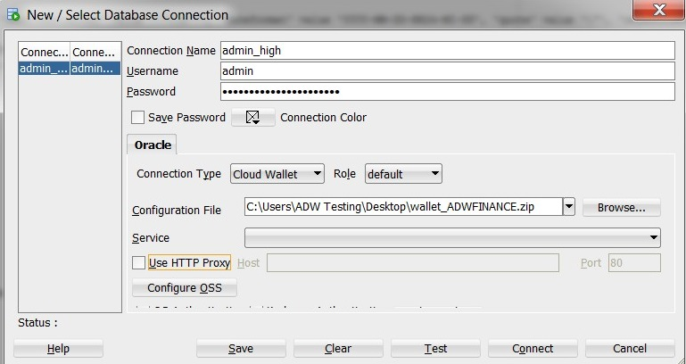

* Test your connection by clicking the **Test** button, if it succeeds save your connection information by clicking **Save**, then connect to your database by clicking the **Connect** button. An entry for the new connection appears under Connections.
* If you are behind a VPN or Firewall and this Test fails, make sure you have [SQL Developer 18.3](https://www.oracle.com/technetwork/developer-tools/sql-developer/downloads/index.html) or higher. This version and above will allow you to select the "Use HTTP Proxy Host" option for a Cloud Wallet type connection. While creating your new ADW connection here, provide your proxy's Host and Port. If you are unsure where to find this, you may look at your computer's connection settings or contact your Network Administrator.