**Oracle Autonomous Data Warehouse: Getting Started Workshop - Lab 3**

**Introduction**

In this lab, you will be uploading files to the Autonomous Database Service, creating sample tables.

You can load data into your new Autonomous Data Warehouse using Oracle Database tools, and Oracle and 3rd party data integration tools.

For more information about loading data, see the documentation [Loading Data from Files in the Cloud](https://www.oracle.com/pls/topic/lookup?ctx=en/cloud/paas/autonomous-data-warehouse-cloud&id=CSWHU-GUID-07900054-CB65-490A-AF3C-39EF45505802).

**Objectives**

* Learn how to use the SQL Developer Data Import Wizard
* Learn how to create tables in your database

**Required Artifacts**

* The following lab requires an Oracle Cloud account. You may use your own cloud account, a cloud account that you obtained through a trial, or a training account whose details were given to you by an Oracle instructor.
* Oracle SQL Developer (see Lab Guide 1 for more specifics on the version of SQL Developer and how to install and configure it).

**Download Sample Data**

**STEP 1: Download the Sample Data Files to Your Local Computer**

* For this lab, you will need a handful of data files. Use [files.zip](https://github.com/oraclehubteam/workshops/blob/master/files.zip?raw=true) as the sample source files for you to upload to the object store. Unzip it to a directory on your local computer.

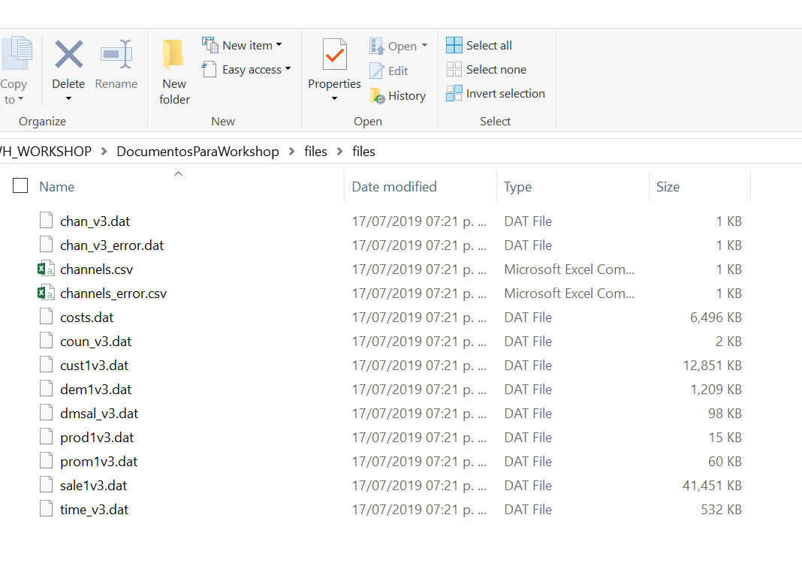

**Load data from the local file system**

**STEP 2: Loading Data Using the Data Import Wizard in SQL Developer**

* Click ‘**Tables**’ in your user schema object tree. Clicking the right mouse button opens the context-sensitive menu in SQL Developer; select ‘**Import Data**’:

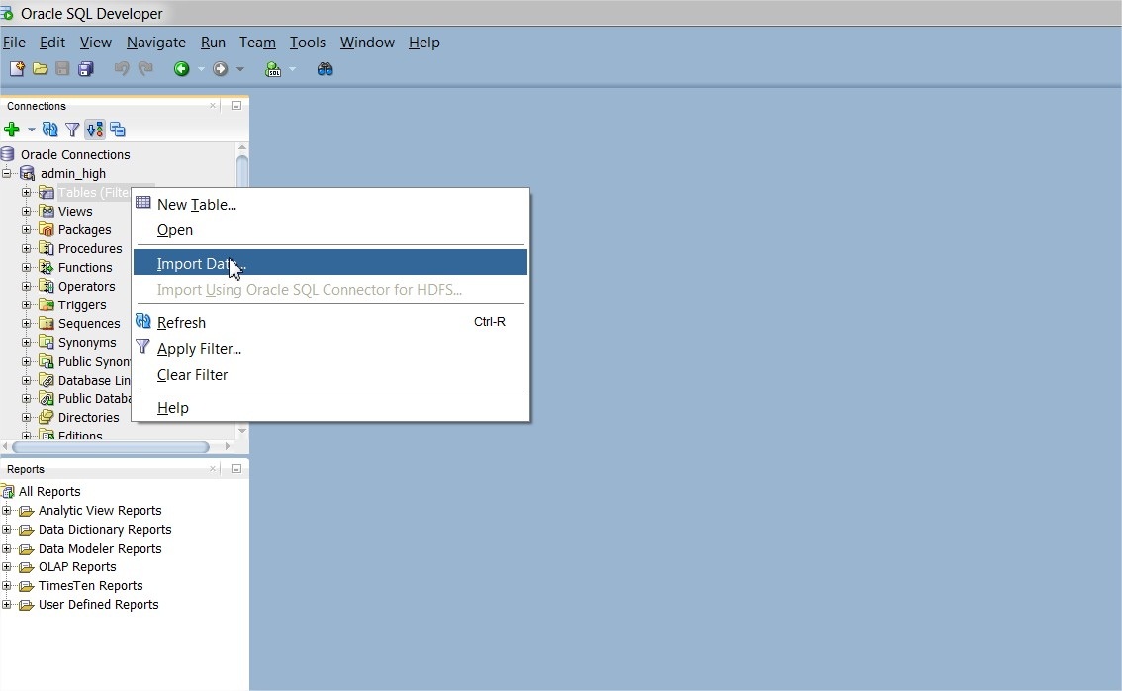

* The Data Import Wizard is started. Enter the following information:
  + Select **Local File** as source for the data load
  + Click the browse button and navigate to the channels.csv file (you extracted this file from the zip file you downloaded at the start of this lab).
  + You might see a read error since channels.csv has lines terminated by ";", as is sometimes the case with certain data. Manually enter a semi-colon in the **line terminator** box to properly parse the data.

After selecting the file, you can preview the data and select the appropriate file formats. You will see that the data preview is interactive and changes according to your selection.

When you are satisfied with the file content view, click **NEXT**.

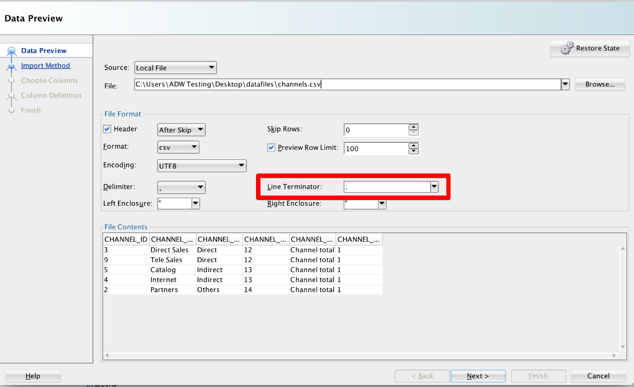

* On Step 2 of the Import Wizard, you control the import method and parameters. Leave the Import Method as Insert. Enter *CHANNELS_LOCAL* as your target table name, this table will be created by the import wizard. Click **NEXT**.

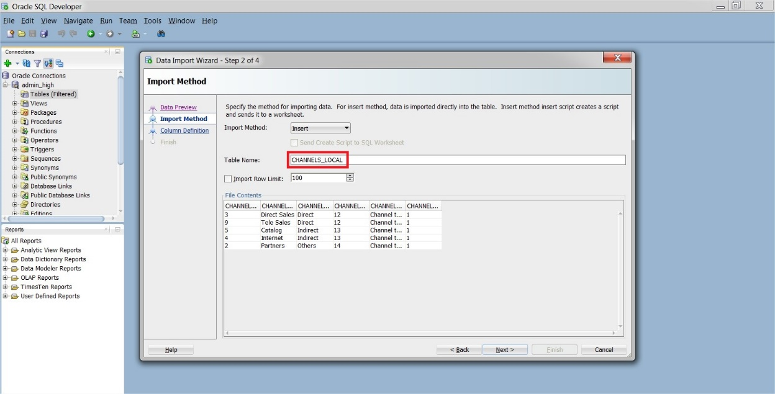

* The Choose Columns screen lets you select the columns you want to import. Leave the defaults and click **NEXT**.
* The column definition screen allows you to set the column names and data types for your new table. You can change these if you need to. For this exercise leave them as default and click **NEXT**.

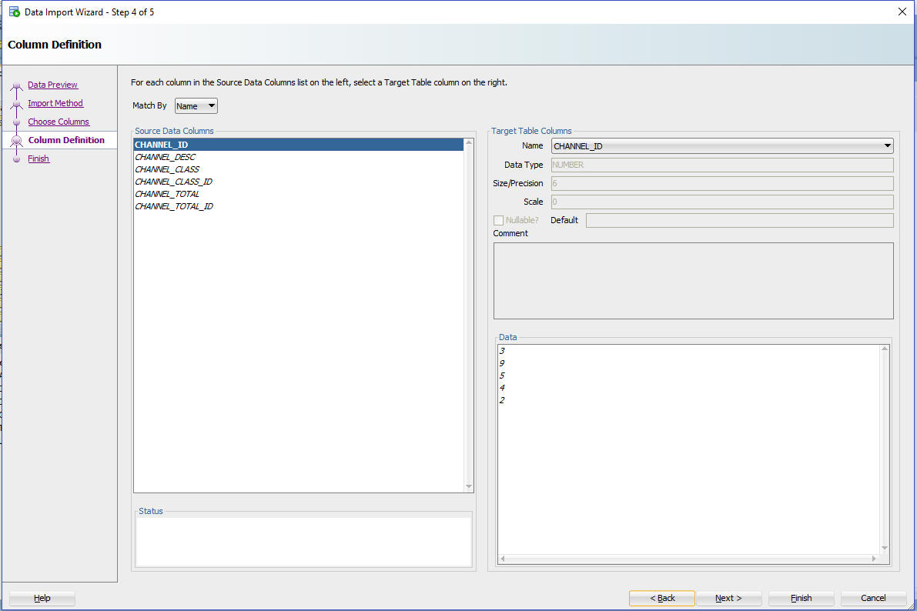

* The final screen reflects all your choices made in the Wizard. Click **FINISH** to load the data into your newly created table *CHANNELS_LOCAL*. If you don't see it in your object tree under Tables, right click on Tables and hit refresh.

