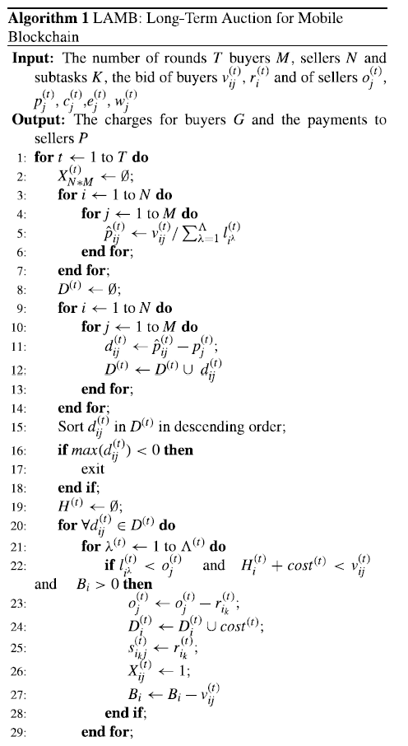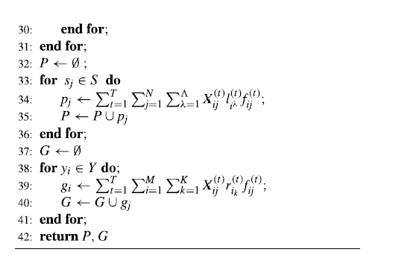

**Calculating the payment and charge**

**Sorting & allocation**

**Unit price of buyers’ resources**

**Unit price diff. between buyer and seller**

**charge**

**payment**

**allocation**