Technical Note - Final Equalizer Design - Oradio / HiVi B3S / 7 L Bass-Reflex Cabinet

Document purpose

This document describes the final parametric equalizer configuration, its acoustic rationale, and the key insights derived from listening tests, RTA measurements, and loudspeaker–enclosure modelling.

The goal of the equalizer is:
- tight, non-boomy bass
- maximum perceived low-frequency extension from a small cabinet
- natural tonal balance without coloration in the lower midrange

System overview

Loudspeaker
- AS07808AS-R (PUI link) is equal to HiVi B3S (3″ midwoofer),
- Fs ≈ 100 Hz, Qts ≈ 0.88

Enclosure
- Type: bass-reflex
- Internal volume: 7 L
- Port: Ø45 mm × 13 cm
- Tuning frequency (fb): ≈ 63–65 Hz

DSP / EQ
- ALSA LADSPA
- Plugin: EqFA4p (4-band parametric equalizer)
- Bandwidth parameter (bw) expressed in octaves, not Q

Final equal design:

Band | Center | BW (oct) | Gain | Purpose
A | 60 Hz | 0.9 | +10 dB | Low-frequency extension / bass foundation
B | 88 Hz | 0.35 | −3 dB | Narrow resonance control (boom suppression)
C | 1 kHz | 1.0 | +2 dB | Presence / clarity compensation
D | Disabled | – | – | Not required
Global | – | – | −8 dB | Headroom management

Key acoustic insights

1. Why the 60 Hz boost works
- The cabinet tuning (≈ 63 Hz) allows efficient port radiation.
- A moderately wide boost (bw = 0.9) reinforces the port contribution without over-emphasising higher bass.
- The perceived bass extension improves dramatically, while excursion remains acceptable due to port support.

2. Why a notch at 88 Hz is required
Listening tests and sine sweeps revealed:
- a narrow, audible peak around 88–90 Hz
- present even close to the speaker, confirming it is not a room mode

Root causes:
- interaction between driver Fs (~100 Hz), port resonance harmonics, and internal cabinet modes
- real-world effects not fully captured by ideal bass-reflex simulations

A narrow notch at 88 Hz:
- removes boom without thinning the bass
- is far more effective than cuts at 100 Hz or 130 Hz

3. Why the notch is only −3 dB
- Deeper cuts (−4 to −5 dB) removed too much warmth
- −3 dB is sufficient to suppress the resonance while preserving musical weight
- Psychoacoustically, small reductions at resonance frequencies have a large subjective effect

4. Why no permanent cut at 150–300 Hz
Although RTA measurements showed a broad rise in this region:
- a −3 dB cut at ~250 Hz made the sound too thin
- a −2 dB cut was acceptable but unnecessary after extended listening

Conclusion:
- the perceived tonal balance is better without a permanent upper-bass cut
- slight excess energy here contributes positively to warmth and presence in real listening conditions

EqFA4p: https://quitte.de/dsp/caps.html#CAPS_for_Electric_Guitar

Settings:

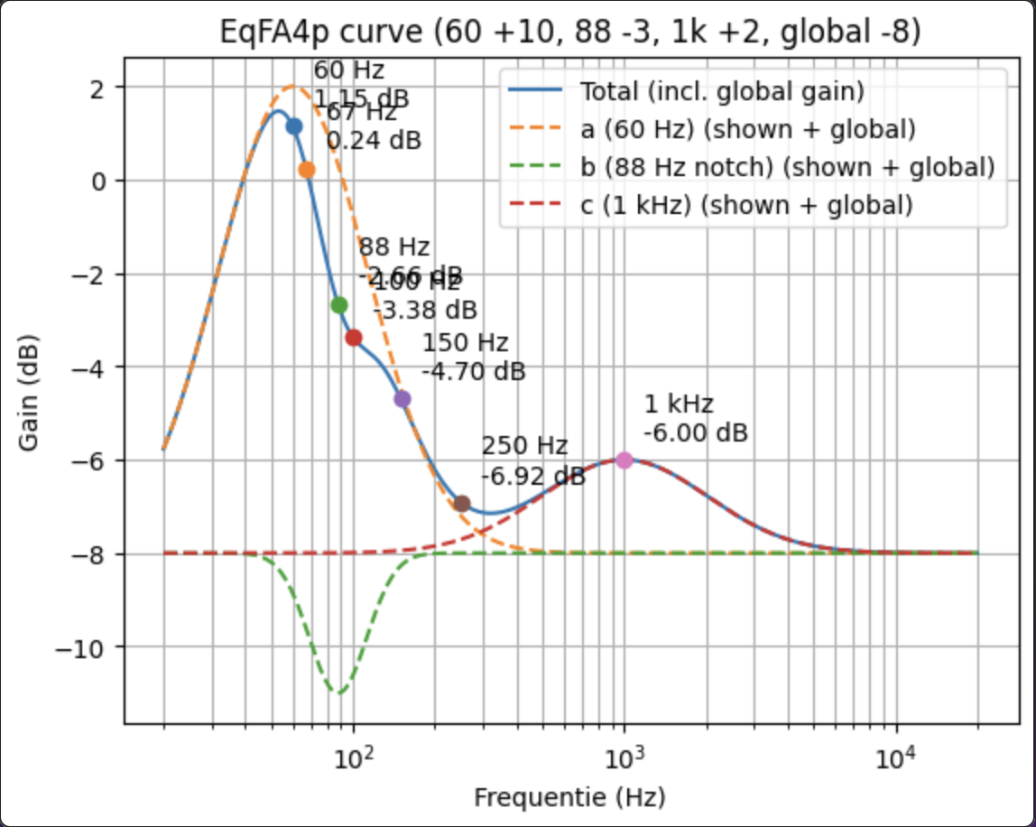

pcm.caps_eq_mpd {
type ladspa
slave.pcm "mpd_equal_out_plug"
path "/usr/lib/ladspa"
plugins [
{
label EqFA4p
input {
controls [
1 60 0.9 10.0
1 88 0.35 -3.0
1 1000 1.0 2.0
0 8000 1.0 0.0
-8.0
]
}
}
]
}

Gain structure and headroom
- Global gain of −8 dB prevents digital clipping
- Compensates for the +10 dB low-frequency boost
- Maintains safe DSP and DAC operating margins

Resulting sonic character
- Bass: tight, deep, non-boomy
- Low-mid: clean, no boxiness
- Midrange: natural, slightly forward
- Overall impression: larger and more confident sound than cabinet size suggests

For ref Speaker properties:
