Table of Contents
1 Introduction 1
2 Top-down layered static view 2
3 Detailed design of the gpio_service module. 3
3.1 LEDControl Class 3
3.1.1 Purpose 3
3.1.2 Design & Threading 3
3.1.3 API Reference 4
3.1.3.1 LEDS Constants 4
3.1.3.2 Methods: 4
3.1.4 Error handling 6
3.2 Module test 6

Introduction

The touch buttons are located at the front panel of the Oradio3
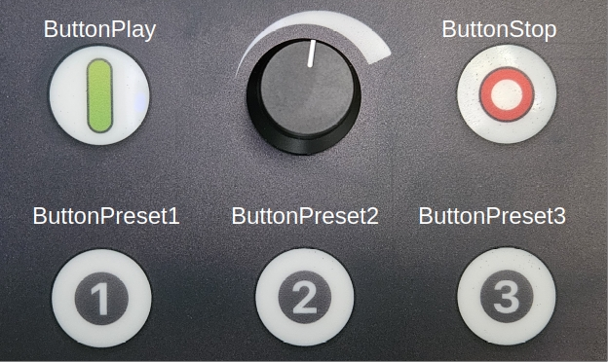
Button | Function
ButtonPlay | - Start playing the last selected music after stop  - When Spotify-App is connected, the active playlist will played
ButtonStop | - The music is stops playing music.  - The Oradio3 enters standby mode.
ButtonPreset1 | The playlist assigned to Preset1 is played
ButtonPreset2 | The playlist assigned to Preset2 is played
ButtonPreset3 | The playlist assigned to Preset3 is played

The touch button has a proximity or touch sensor. A button does not need to be touched, also when in close proximity a touch will be detected.
When a button is touched a click-sound will be heard, to indicate that touching the button was detected.
When the ButtonPlay button is touched for a longer time, it will be recognized as a button-long-press. At this moment only a button-long-press is enabled for the ButtonPlay, to start the Oradio WiFi Access Point. For other button there is no button-long-press enabled.

Top-down layered static view
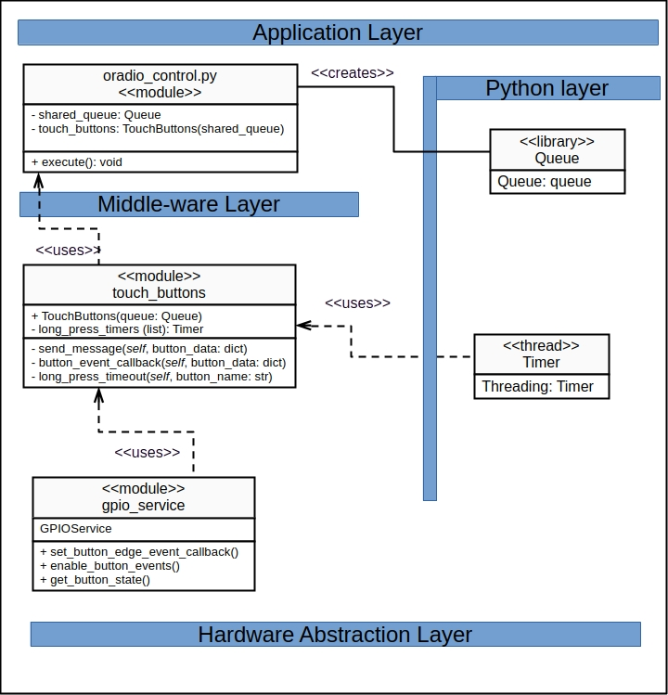

The Oradio3 software layering typically consists of three main layers:
- the hardware abstraction layer (HAL), which includes the physical components.
- the middle-ware layer, which facilitates communication and data management between the hardware and applications. The OS services is considered to be part of this layer
- the application layer, where the actual software applications run and perform specific tasks.
The Python Layer is a supporting layer to include Python modules and libraries.

The TouchButtons() class is a Oradio3 module offering services related to touching buttons. It imports the GPIOService class, which provides a wrapper to setup the events when a button is touched and to read the state of the touch buttons pins.
The class depends on a queue, which is accepted in the constructor of the class. It is a shared queue to submit messages to the creator (oradio_control.py) of the class.

Detailed design of the touch_buttons module.
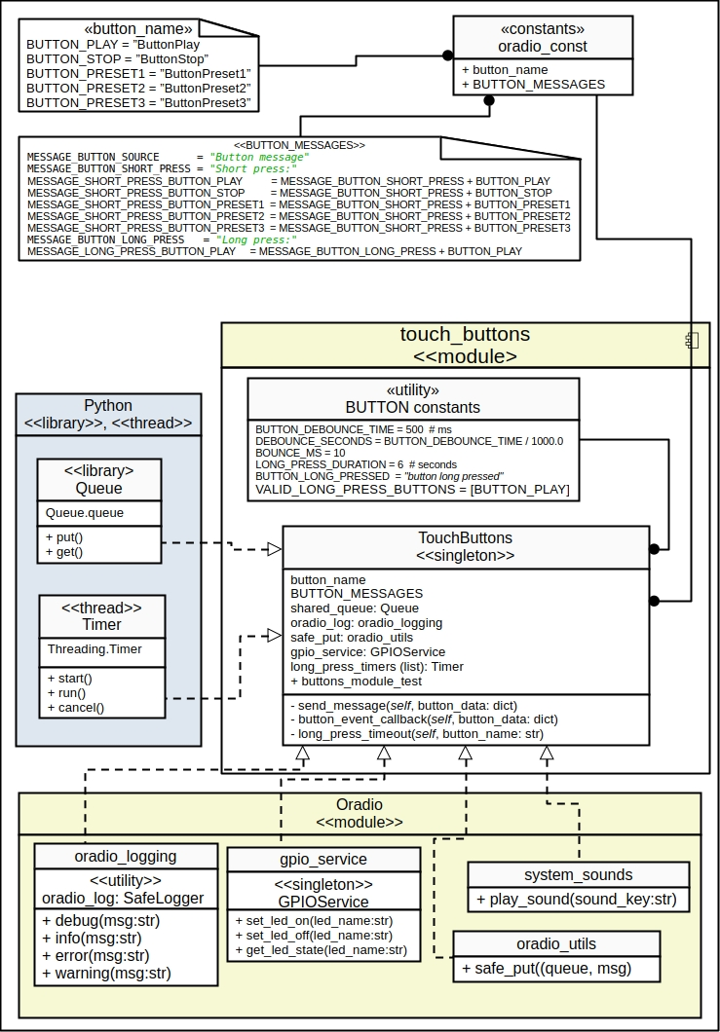

TouchButtons Class

Purpose
- Provides a method to handle the gpio_service events related to the touch buttons
- Provides a method to detect a long key press
- Provides a click sound when a button is touched
- Submits messages via the shared queue to the caller, to inform the caller on the button activities

Design & Threading
- Singleton: Restricts the class to a single instance, to offer a single point of access for the led controls.
- Timers: For the long press detection a Threading.Timer is used, which will expire after the long press timing.
- Logging: For logging purposes the oradio.SafeLogger utility is used offered by oradio_logging module.
- Queue: A queue is used between caller and this class to send a message upon button events.
- GPIOService: creates an instance of the GPIOService class to use methods to setup the event handling, and reading the state of a touch button.

API Reference

BUTTONS Constants

BUTTON_PLAY = "ButtonPlay"
BUTTON_STOP = "ButtonStop"
BUTTON_PRESET1 = "ButtonPreset1"
BUTTON_PRESET2 = "ButtonPreset2"
BUTTON_PRESET3 = "ButtonPreset3"
BUTTON_NAMES = [BUTTON_PLAY, BUTTON_STOP, BUTTON_PRESET1, BUTTON_PRESET2, BUTTON_PRESET3]
BUTTON_PRESSED = "button pressed"
BUTTON_RELEASED = "button released"

Methods:
There are no public methods, only private methods. The communication is managed via a shared queue, to prevent “polling” methods or callbacks.

Error handling
- All errors are logged using the oradio_log.error or .warning utility of oradio_logging.py

Attributes for module test
The class provides an attribute <buttons_module_test > to enable or disable module test functions within the class. This is used when class is created to add a TimingData() class (test_classes.py) for performance measurements.

Module test
There is a module test program <touch_buttons_test.py> that will provide following tests to test the methods of the class:
- All led’s ON or OFF
- All led’s blinking, with adjustable cycle-time
- A one-shot cycle for All led’s, with adjustable one-shot timing
- A single led test:
  - Turn ON or OFF a selected led,
  - One-shot for a selected led,
  - Blinking for a selected led.
  - Unknown led error handling

