Table of Contents
1 Introduction 1
1.1 Introduction into UML state diagrams 1
1.1.1 Initial state 1
1.1.2 Final State 2
1.1.3 Entry Point 2
1.1.4 Exit Point 2
1.1.5 Events 2
1.1.6 States 2
1.1.7 Transitions 3
1.1.8 Composite State 3
1.1.9 Concurrent regions 3
1.1.10 Package 4
1.2 Introduction into State transition diagrams 5
2 The Oradio state diagrams views 6
2.1 The OradioMain state diagram 6
2.2 The OradioMain composite state 7
2.2.1 State diagram 7
2.2.2 State table 8
2.3 Other state handler as packages 9
3 Top-down layered static view 10
4 Detailed design of the oradio_control module. 11
4.1 Classess 11
4.1.1 Purpose 11
4.1.2 Design & Threading 11
4.1.3 API Reference 11
4.1.3.1 BUTTONS Constants 11
4.1.3.2 Methods: 11
4.1.4 Error handling 11
4.1.5 Attributes for module test 11
4.2 Module test 11

Introduction
The oradio_control is based on a state machine.

Introduction into UML state diagrams
A state diagram models the behavior of a system or an object in response to events. A state diagram mainly consists of states, events, guards, transitions, and actions. It’s a behavioral diagram and it represents the behavior using finite state transitions.

Initial state
It shows the starting point of the system. It’s represented as a filled circle

Final State
It shows the ending point of the system. It’s represented as a circle with a dot inside

Entry Point
An input connector for control flow into an activity from outside (named) — used when connecting activities across activity partitions or when reusing activity nodes.

Exit Point
An output connector for control flow leaving an activity to outside; used to indicate exit from an activity (named).

Events
An event can be a signal,trigger or a change in the environment of the system. Events may or may not lead to a change in the system’s state.
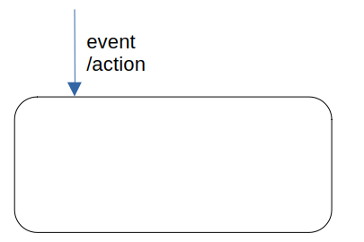
Event /action :
- event: trigger that causes the transition.
- /action: An operation executed in response to an accepted event

States
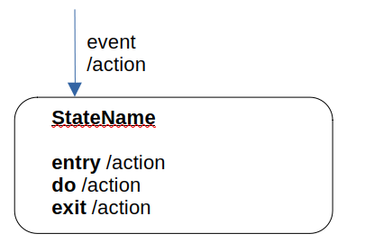
A state represents the conditions or circumstances of an object of a class at an instant of time.

- StateName: The name of the state
- Use a short, descriptive noun or noun phrase as StateName (e.g., Idle, Processing, Authenticated).
- Make it domain-centric: reflect business meaning
- Be consistent: pick a naming convention (PascalCase, snake_case) and use it everywhere.
State actions are invoked when the system is in a specific state. There are 3 types of state actions:
- Entry actions: they are executed when the system enters the state
- Do actions: they are continuously executed while the system is in the state
- Exit actions: they are executed when the system exits the state

Transitions
Transitions are shown as arrows from one state to another. They may have three indicators written on them:
- The event that triggers the transition
- The guard statement which is a condition that must be true for the transition to take place
- An action statement that will happen as a result of the transition
[isSpotifyConnected]
ButtonPlay
/playSound()
/setLed()
/startSpotifyPlayback()

Composite State
A state that has substructure and internal behavior. It can contain one or more regions, which can contain one or more states. The state diagrams are executed in parallel.
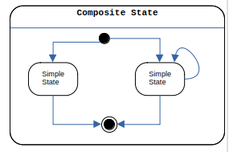

Concurrent regions
Represent separate areas of concern within a state, allowing for independent state transitions in each region, simultaneously.
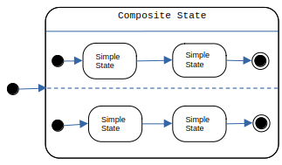

Package
The UML design symbol for a package is depicted as a tabbed folder, which represents a container for grouping related UML elements.
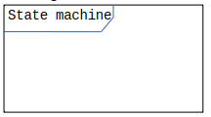

Introduction into State transition diagrams
a state-transition table is a table showing what state a finit-state machine will move to, based on the current state and other inputs. It is essentially a truth table in which the inputs include the current state along with other inputs, and the outputs include the next state along with other outputs.
Current State | Event | Condition(guards) | Next State | Action

The Oradio state diagrams views

The OradioMain state diagram
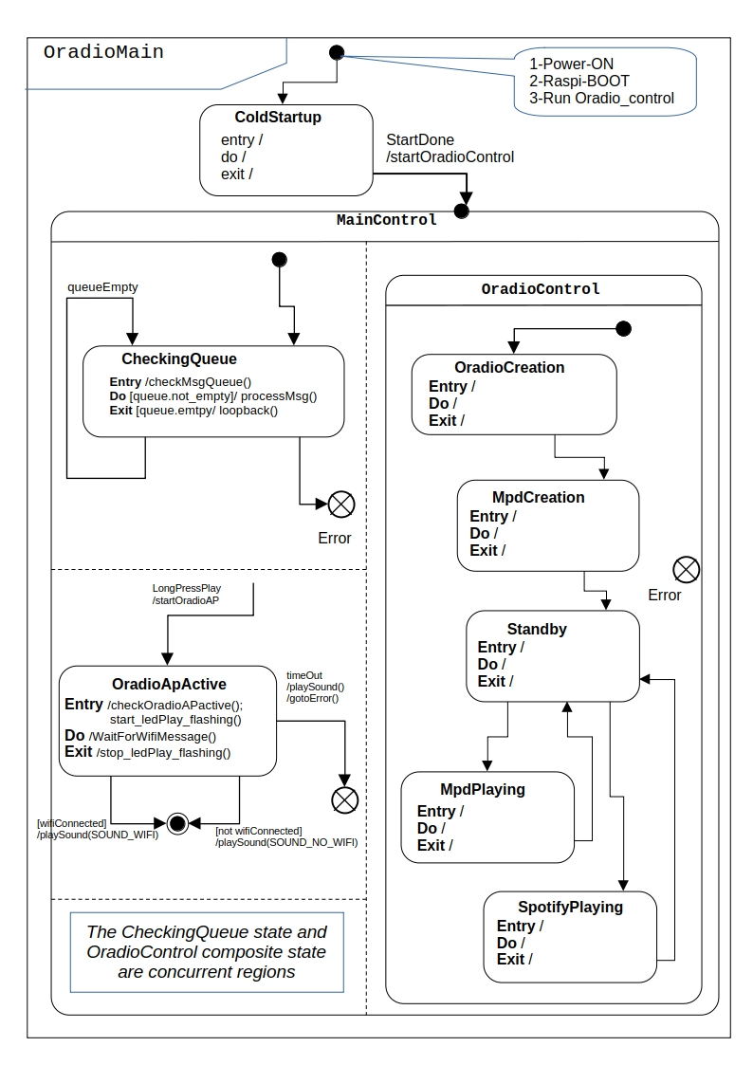

State table
TBD

The OradioMain composite state

State diagram
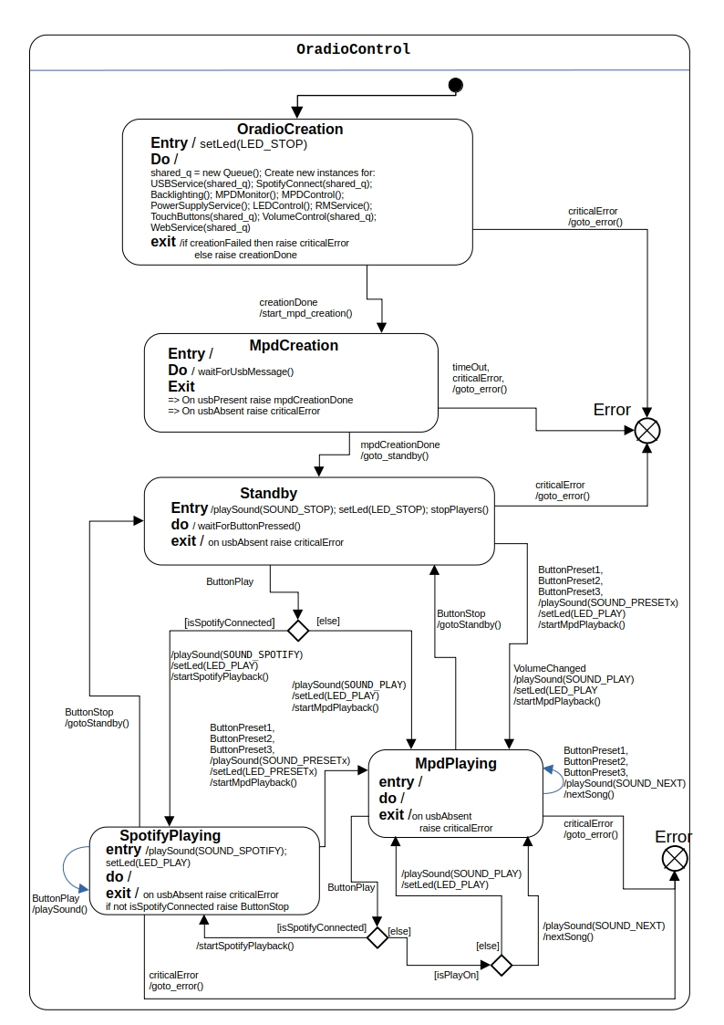

State table
Current State | Event | Condition | Next State | Action
OradioCreation | criticalError | creationFailed | ErrorHandling | goto_error()
OradioCreation | creationDone | not creationFailed | MpdCreation | start_mpd_creation()
MpdCreation | usbAbsent | None | ErrorHandling | goto_error()
MpdCreation | usbPresent | None | Standby | goto_standby()
MpdCreation | timeOut | None | ErrorHandling | goto_error()
MpdCreation | mpdCreationDone | None | Standby | goto_standby()
Standby | ButtonPreset1,  ButtonPreset2,  ButtonPreset3 | ButtonPressed | MpdPlaying | playSound(SOUND_PRESETx)  setLed(LED_PLAY)  startMpdPlayback()
Standby | VolumeChanged | None | MpdPlaying | playSound(SOUND_PLAY)  setLed(LED_PLAY)  startMpdPlayback(
Standby | ButtonPlay | ButtonPressed  not isSpotifyConnected | MpdPlaying | playSound(SOUND_PLAY)  setLed(LED_PLAY)  startMpdPlayback()
Standby | ButtonPlay | ButtonPressed  isSpotifyConnected | MpdPlaying | playSound(SOUND_SPOTIFY)  setLed(LED_PLAY)  startSpotifyPlayback()
Standby | usbAbsent | None | ErrorHandling | goto_error()
MpdPlaying | ButtonPlay | isSpotifyConnected | SpotifyPlaying
MpdPlaying | ButtonPlay | not isSpotifyConnected  isPlayOn | MpdPlaying | nextSong()
MpdPlaying | ButtonPlay | not isSpotifyConnected  not isPlayOn | MpdPlaying | playSound()  setLed()
MpdPlaying | ButtonStop | None | Standby | gotoStandby()
MpdPlaying | usbAbsent | None | ErrorHandling | goto_error()
SpotifyPlaying | ButtonStop | ButtonPressed | Standby | gotoStandby()
SpotifyPlaying | ButtonStop | not isSpotifyConnected | Standby | gotoStandby()
SpotifyPlaying | usbAbsent | None | ErrorHandling | goto_error()

m

Other state handler as packages
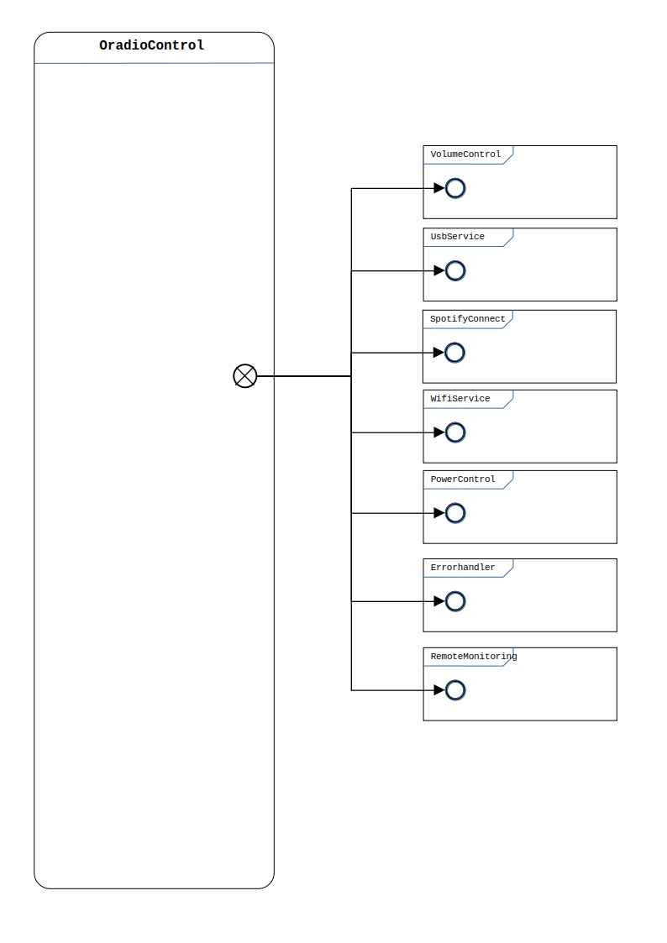

Top-down layered static view

TBD

Detailed design of the oradio_control module.

Classess

Purpose

Design & Threading

API Reference

BUTTONS Constants

Methods:

Error handling

Attributes for module test

Module test

