Oradio I²C, Volume, and Backlighting Documentation

Inhoudsopgave
Oradio I²C, Volume, and Backlighting Documentation 1
Overview 1
Key points: 2
Module: I2CService 2
Purpose 2
Design & Threading 2
API Reference 2
Error Handling 2
Stand-alone Test Program 2
Module: VolumeControl 2
Purpose 2
Design & Threading 3
ALSA Integration 3
API Reference 3
Stand-alone Test Program 3
Module: Backlighting 3
Purpose 3
Design & Threading 3
Sensor & DAC Handling 3
API Reference 3
Stand-alone Test Program 4
Architecture & Interconnections 4
Data Flow Examples: 4
Hardware & I²C Considerations 4
Dependencies 4
Notes & Best Practices 5
UML Class Diagram for Oradio I2C Modules 5

Overview
Oradio’s audio system on Linux (Raspberry Pi) uses three main modules:
- I2CService: Provides thread-safe communication with I²C devices.
- VolumeControl: Reads an analog rotary knob (MCP3021 ADC) and sets ALSA mixer volume.
- Backlighting: Reads ambient light (TSL2591) and controls the MCP4725 DAC for smooth backlight adjustment.

Key points:
- Both VolumeControl and Backlighting run background threads.
- I2CService is a singleton used by both modules to avoid concurrent bus access.
- All modules include standalone test routines.

Module: I2CService

Purpose
- Encapsulates all I²C communication.
- Provides a thread-safe API for reading/writing bytes and blocks.
- Centralizes error handling and logging for I²C operations.
- Supports retries and backoff for write operations.

Design & Threading
- Singleton: Only one instance exists to prevent multiple threads from accessing SMBus simultaneously.
- Thread Safety: All SMBus operations are guarded by a threading.Lock.
- Retry Logic: Write operations retry I2C_RETRIES times with I2C_BACKOFF seconds delay.

API Reference
Method | Description
read_byte(device, register) | Thread-safe read of a single byte. Returns int or None on failure.
write_byte(device, register, value) | Thread-safe write of a single byte with retry/backoff.
read_block(device, register, length) | Reads up to 32 bytes. Returns list[int] or None.
write_block(device, register, data) | Writes up to 32 bytes with retry/backoff.

Error Handling
- All errors are logged using oradio_log.error or .warning.
- Exceeding block size logs an error immediately.
- Failed writes after all retries are logged as errors.

Stand-alone Test Program
- Scans /dev/i2c-* to find available buses.
- Probes expected devices (MCP3021, TSL2591, MCP4725, HUSB238).
- Reports missing and unexpected devices using color-coded console output.

Module: VolumeControl

Purpose
- Reads analog volume knob via MCP3021 ADC over I²C.
- Updates ALSA mixer volume in raw units.
- Sends asynchronous notifications of significant volume changes.

Design & Threading
- Background Thread: _volume_manager polls ADC continuously.
- Adaptive Polling:
  - Fast polling (POLLING_MIN_INTERVAL) when knob changes.
  - Slow polling (POLLING_MAX_INTERVAL) when idle.
  - Step size POLLING_STEP for adaptive intervals.
- Notification Queue: Sends messages once per significant change.

ALSA Integration
- Uses AlsaVolume wrapper class.
- Avoids redundant ALSA calls by caching the last set volume.
- Ensures volume is clamped to [VOLUME_MINIMUM..VOLUME_MAXIMUM].

API Reference
Method | Description
start() | Start the volume manager thread.
stop() | Stop the volume manager thread safely.
set_notify() | Re-arm the notification queue trigger.

Stand-alone Test Program
- Interactive menu with options to start/stop the thread and set notifications.
- Queue listener process prints received volume change messages.

Module: Backlighting

Purpose
- Automatically adjusts display backlight using ambient light readings.
- Supports manual override: off or maximum brightness.
- Smooth transitions prevent sudden brightness jumps.

Design & Threading
- Background Thread: _backlight_manager continuously adjusts DAC output.
- Smooth Transition Algorithm: Gradually moves current backlight value toward target over TRANSITION_TIME with updates every ADJUST_INTERVAL.
- Thresholding: DAC writes occur only if change ≥ CHANGE_THRESHOLD.

Sensor & DAC Handling
- TSL2591 ALS sensor: Reads visible light (16-bit) over I²C.
- MCP4725 DAC: Writes 12-bit output via I²C.
  - SAVE_PERSISTENT for EEPROM storage (boot-safe).
  - SAVE_VOLATILE for fast, non-persistent updates.

API Reference
Method | Description
start() | Start auto-adjust thread.
stop() | Stop auto-adjust thread.
off() | Turn off backlight and stop auto-adjust.
maximum() | Set backlight to maximum and stop auto-adjust.
read_sensor() | Return (raw_visible_light, lux, interpolated DAC value) for monitoring.

Stand-alone Test Program
- Interactive menu to start/stop auto-adjust, set off/maximum, and monitor sensor values in real time.

Architecture & Interconnections
- I2CService is the central communication hub, shared by both VolumeControl and Backlighting.
- VolumeControl → I2CService: Reads MCP3021 ADC (0x4D).
- Backlighting → I2CService:
  - Reads TSL2591 ALS sensor (0x29).
  - Writes MCP4725 DAC (0x60).
- Thread Safety: Single Lock in I2CService ensures no collisions.
- Queues & Notifications: Volume changes are reported asynchronously to calling code.

Data Flow Examples:
- Volume change:
Knob → MCP3021 → I2CService → VolumeControl → ALSA Mixer → Notification Queue
- Backlight auto-adjust:
Ambient light → TSL2591 → I2CService → Backlighting → Interpolation → MCP4725 DAC → Backlight

Hardware & I²C Considerations
- Supports Raspberry Pi (bus 1).
- Maximum block read/write: 32 bytes (SMBus limitation).
- Expected devices:
  - MCP3021 ADC (0x4D)
  - TSL2591 ALS sensor (0x29)
  - MCP4725 DAC (0x60)
  - HUSB238 USB-C Power Controller (0x08)
- Ensure /dev/i2c-1 permissions allow access (sudo may be required).

Dependencies
- Python 3.8+
- smbus2 for I²C
- alsaaudio for ALSA integration
- oradio_logging for logging
- singleton decorator
- oradio_utils for safe queue operations

Notes & Best Practices
- Thread Lifecycle: Always start threads via start() and stop with stop() before program exit.
- Singleton Usage: Only one instance of I2CService ensures safe multi-threaded access.
- Error Handling: All I²C and ALSA errors are logged; modules attempt retries or continue gracefully.
- Adaptive Polling & Smoothing: Optimized to reduce CPU usage while maintaining responsive behavior.
- Stand-alone Testing: Each module has an interactive menu for diagnostics, ideal during development or deployment.

UML Class Diagrams
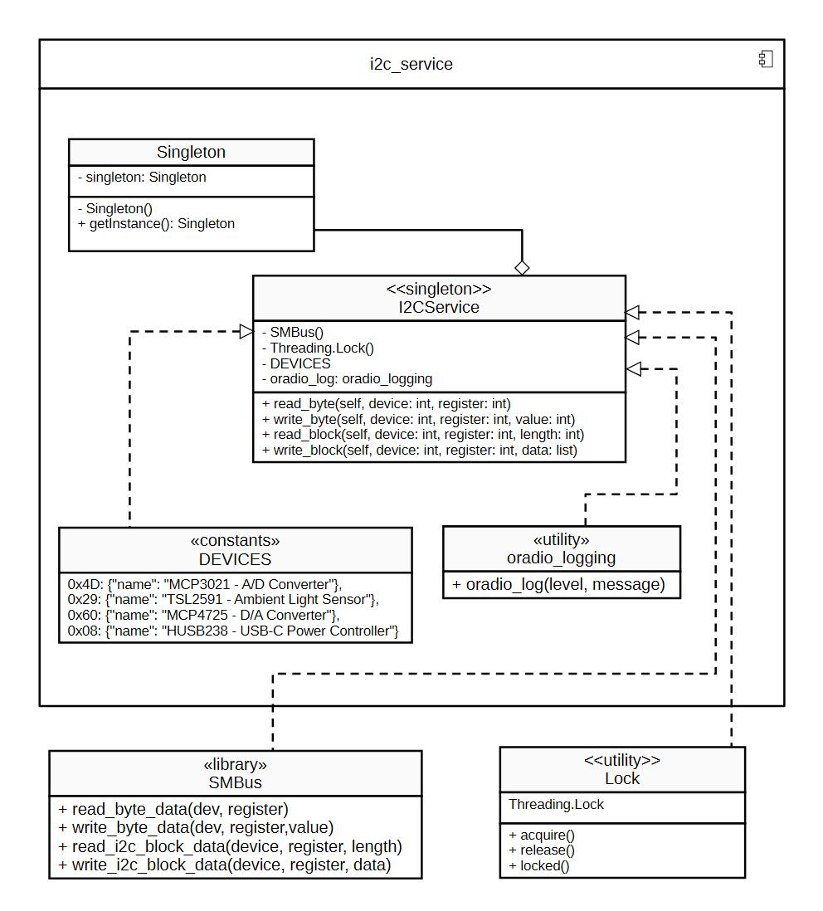
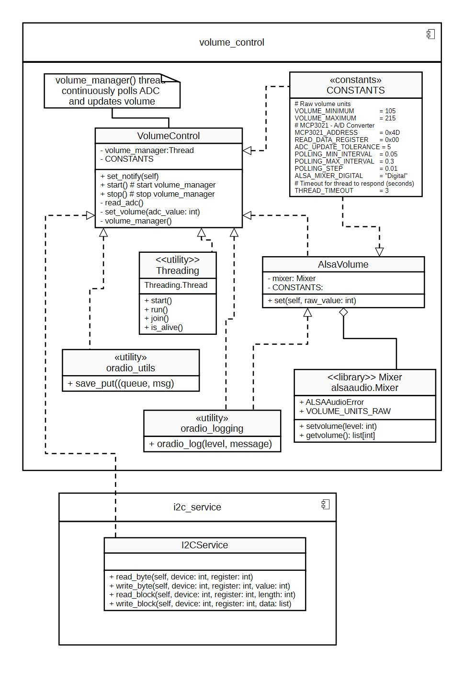
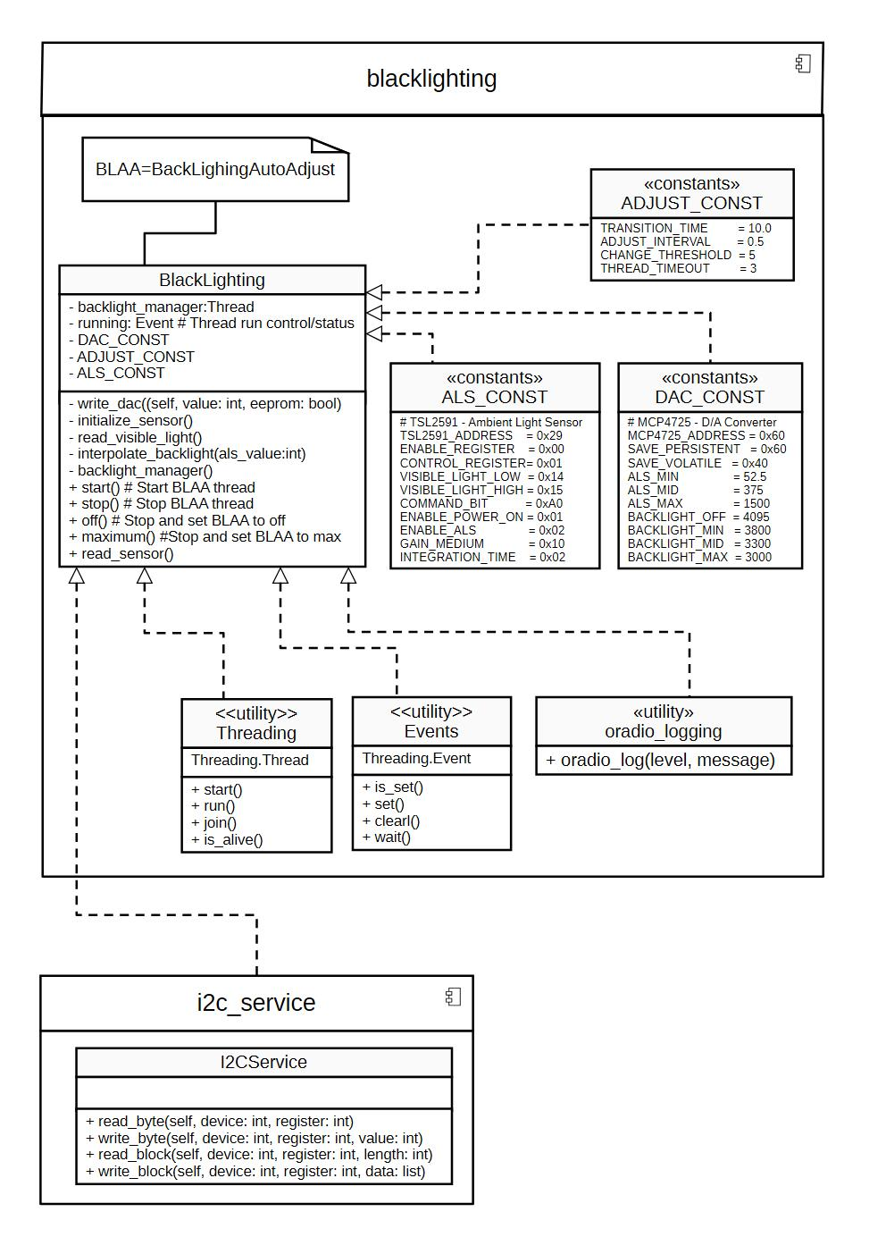
backlighting

Notes:
- Both VolumeControl and Backlighting depend on the singleton I2CService.
- VolumeControl composes an AlsaVolume object for ALSA mixer control.
- Threads in both modules allow continuous polling and auto-adjustment.

