Logistic Regression Classification of Music Genres Using Spotify Audio Features
Student Name: Brittney Orais-Bonheimer
Student ID: 001277176
Course: MSDA Capstone
Task: Task 2 – Capstone Analysis
Introduction
Music streaming platforms manage vast and continuously expanding catalogs, making accurate genre classification an essential but increasingly complex task. Genre labels play a critical role in how music is organized, recommended, and discovered, influencing everything from playlist generation to targeted marketing efforts. When genre information is incomplete or inaccurate, users may struggle to find relevant content, and recommendation systems may deliver less engaging results (Schedl et al., 2014).
Advances in data analytics have made it possible to approach genre classification using quantitative audio characteristics rather than relying solely on manual tagging or subjective interpretation. Spotify provides a set of standardized audio features—such as tempo, energy, loudness, danceability, valence, and acousticness—that describe measurable aspects of a track’s musical structure and sound profile. These features offer an opportunity to examine whether consistent patterns exist across genres that can be captured through statistical modeling.
This capstone project examines a real-world analytics problem in the music streaming industry by evaluating how effectively Spotify audio features can be used to classify music genres. To maintain analytical clarity and interpretability, the study focuses on a subset of the top 20 music genres selected from a larger Spotify dataset. Restricting the analysis to these genres allows meaningful differences in musical characteristics to be examined without introducing unnecessary model complexity, while still preserving a diverse range of musical styles. These genres were selected to reflect widely recognized categories with balanced representation, allowing for focused analysis without introducing unnecessary complexity.
Using this focused dataset, the study applies multinomial logistic regression to assess whether Spotify’s audio features meaningfully contribute to genre classification. Logistic regression was selected because it provides a transparent, regression-based framework that allows both predictive performance and statistical significance to be evaluated. By examining model performance alongside feature-level relationships, the analysis provides insight into how specific audio characteristics relate to genre differentiation and highlights both the strengths and limitations of interpretable statistical approaches in large-scale music analytics.

Research Question
The research question guiding this study is:
To what extent do Spotify audio features—tempo, energy, loudness, danceability, valence, acousticness, speechiness, instrumentalness, and liveness—statistically significantly influence music genre classification among the top 20 selected music genres when evaluated using a multinomial logistic regression model?
This research question is driven by the growing importance of automated genre classification in the music streaming industry. Streaming platforms rely heavily on genre information to support recommendation systems, improve content discovery, and personalize user experiences. When genre classification is inaccurate or overly simplistic, it can negatively affect how users interact with and discover music (Schedl et al., 2014). Examining how specific audio features contribute to genre classification helps clarify what aspects of music are most informative for these systems.
The context of this study lies within large-scale music analytics, where platforms must analyze vast amounts of audio data while still producing results that are interpretable and actionable. Although more complex machine-learning models may achieve higher predictive accuracy, interpretable statistical methods such as multinomial logistic regression remain valuable because they allow analysts to understand why certain predictions are made. This transparency is especially important when results are used to inform business decisions or system design (IBM, 2025).
To maintain clarity and interpretability, this analysis focuses on a subset of 20 well-known music genres selected from a larger Spotify dataset. Limiting the scope in this way allows meaningful differences in musical characteristics to be examined without introducing excessive model complexity. At the same time, the selected genres preserve sufficient stylistic diversity to evaluate whether Spotify’s audio features meaningfully differentiate genres.
Based on this research question, the hypotheses for the study are:
- Null Hypothesis (H₀): Spotify audio features do not have a statistically significant effect on music genre classification among the top 20 selected genres.
- Alternative Hypothesis (Hₐ): Spotify audio features have a statistically significant effect on music genre classification among the top 20 selected genres.

Data Collection
The data used in this study were obtained from a publicly available Spotify dataset hosted on Kaggle (The Devastator, n.d.). The dataset contains approximately 114,000 observations representing individual music tracks across 114 unique genres, making it well suited for large-scale music genre classification analysis. Each observation includes Spotify-generated audio features—such as tempo, energy, loudness, danceability, valence, acousticness, speechiness, instrumentalness, and liveness—along with supporting metadata including genre labels, popularity scores, and track duration. Together, these variables provide a comprehensive quantitative representation of musical characteristics relevant to genre classification.
Each observation combines identifying information, metadata, and quantitative audio features. Metadata variables include track identifiers, artist names, album names, track titles, popularity scores, track duration (in milliseconds), explicit content indicators, musical mode, and time signature. The primary independent variables for this study are Spotify’s audio features, which collectively capture rhythmic structure, intensity, mood, and acoustic qualities of each track. The dependent variable is the genre label (track_genre), which serves as the classification target.
A notable characteristic of the dataset is that each genre contains the same number of tracks, with 1,000 observations per genre across all 114 genres. This uniform distribution ensured that no genre was overrepresented at the outset, supporting fair comparisons and reducing the risk of bias in the classification results. From this full set of genres, a subset of 20 genres was selected for analysis. From an analytical perspective, narrowing the focus to 20 genres helped keep the model manageable and the results easier to interpret, particularly when using logistic regression, while still allowing meaningful evaluation of how individual audio features contribute to genre classification. From a business perspective, the selected genres reflect commonly used and widely recognized music categories that align with how streaming platforms typically organize content for recommendations, discovery, and marketing. This focused selection improves the practical relevance of the findings while preserving diversity in musical styles.
One advantage of using a publicly available Kaggle dataset is its large sample size and standardized feature definitions, which support statistically valid modeling, reproducibility, and generalizability of results. Even after restricting the analysis to the top 20 genres, the dataset remained balanced, with an equal number of observations per genre. In addition, the dataset contains no personally identifiable information, making it appropriate for academic research and exempt from institutional review board (IRB) requirements.
A disadvantage of this data-gathering methodology is the potential subjectivity and inconsistency in genre labeling. Genre classifications may vary across platforms and contributors, and some genres share overlapping audio characteristics, which can introduce ambiguity in classification tasks (Li et al., 2003). This overlap may reduce the model’s ability to clearly distinguish between closely related genres.
One challenge encountered during data collection was the presence of skewed distributions and sparsity in certain audio features, particularly instrumentalness and speechiness. These features exhibited values heavily concentrated near zero, which is common in music audio data. To address this challenge, feature distributions were reviewed to ensure values fell within expected ranges, duplicate records were removed, and continuous variables were normalized to support comparability across scales (VanderPlas, 2016). Overall, the dataset’s size, structure, and balanced composition—combined with the focused selection of the top 20 genres—make it appropriate for evaluating the effectiveness of logistic regression in music genre classification.

Data Extraction and Preparation
Data extraction and preparation were performed using Python within a Jupyter Notebook environment to support transparency, reproducibility, and clear documentation of each analytical step. The purpose of this phase was to extract the relevant Spotify data from the source file, ensure data quality and consistency, and restrict the scope of the analysis to the top 20 selected music genres prior to model development.
Step 1: Data Extraction
The dataset was extracted from a CSV file containing Spotify track data using the pandas library in Python. After loading the dataset, an initial inspection was conducted to confirm that the data imported successfully and to review the available variables, data types, and overall dataset structure.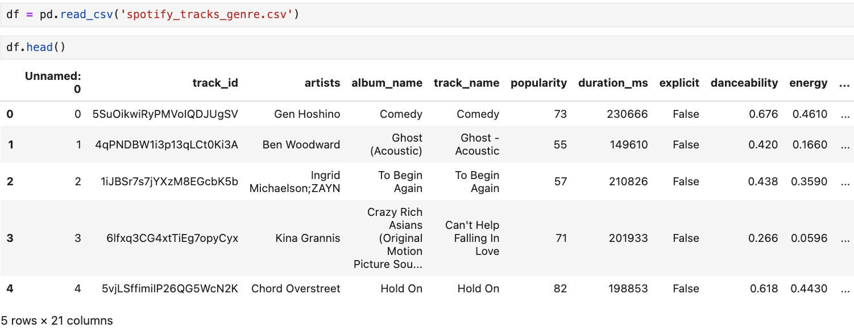
Figure C1. Initial Data Extraction and Dataset Preview
Figure C1 shows the successful extraction of the Spotify track dataset using the pandas read_csv() function. The df.head() output provides an initial preview of the dataset, displaying track metadata alongside Spotify audio features. This step confirmed that all required variables for genre classification were present and correctly imported before proceeding with data cleaning and preparation.

An advantage of using Python-based tools for data extraction is their flexibility and transparency, allowing each preparation step to be explicitly documented and reviewed. A disadvantage is that these workflows require careful manual validation, as small errors during data loading or preprocessing can propagate through subsequent analysis if not identified early.

Step 2: Initial Data Review and Quality Checks
Following data extraction, an initial data review was conducted to assess dataset structure, completeness, and quality. The dataset was examined using df.info() and df.shape() to verify the total number of observations, variables, and data types. This review confirmed that the dataset contained approximately 114,000 observations and 21 variables, including numeric audio features, categorical identifiers, and boolean indicators. Most variables were fully populated, with only a small number of missing values in selected metadata fields such as artist name, album name, and track name.
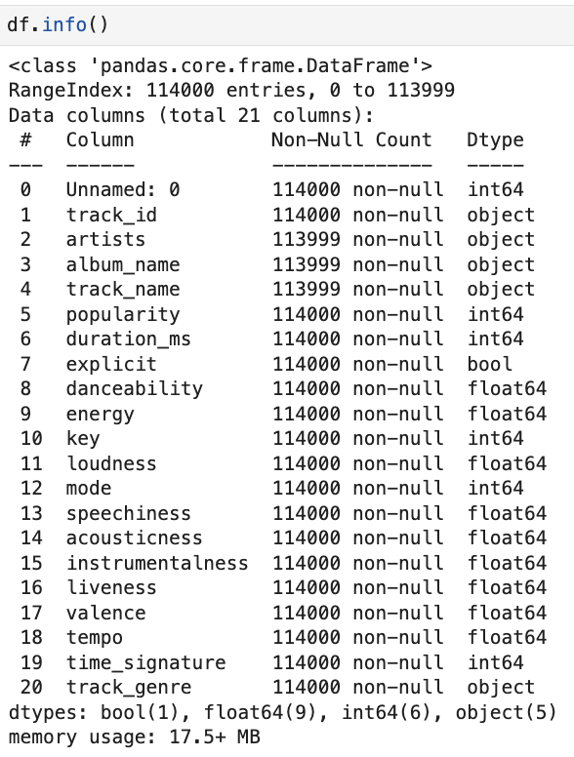
Figure C2. Dataset Structure and Data Type Verification
Figure C2 presents the output of df.info(), which was used to verify dataset structure, data types, and completeness. The output confirms the presence of numeric audio features, categorical metadata, and boolean variables, all appropriately typed for subsequent statistical analysis.

Descriptive statistics were then generated using df.describe() to examine the distributions, ranges, and central tendencies of numeric variables. This review helped identify skewed distributions in certain audio features—particularly instrumentalness and speechiness—as well as extreme values in features such as loudness and tempo. These observations informed later decisions related to feature scaling and model preparation.

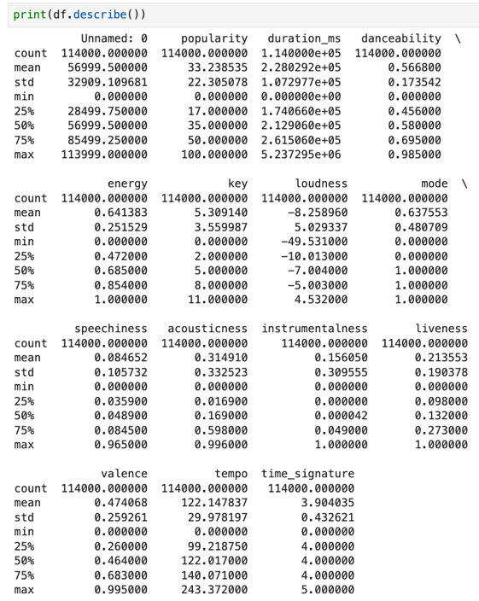
Figure C3. Summary Statistics for Numeric Variables
Figure C3 displays descriptive statistics generated using df.describe(). These statistics summarize the central tendency, dispersion, and range of numeric variables such as tempo, energy, loudness, and danceability. Reviewing these values helped identify skewness and extreme observations, informing later preprocessing decisions.

To ensure consistent genre representation, genre counts were reviewed using value_counts() on the genre label variable.

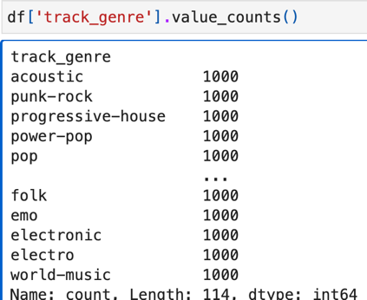
Figure C4. Genre Distribution Prior to Subset Selection
Figure C4 shows the output of the value_counts() function applied to the track_genre variable. The results confirm that all 114 genres in the dataset are evenly represented, with exactly 1,000 tracks per genre. Verifying this uniform distribution prior to filtering ensured that no genre was overrepresented and supported an unbiased selection of the analysis subset.

Step 3: Selection of the Top 20 Genres
From the full dataset of 114 genres, a subset of 20 genres was selected for analysis. This selection was implemented by filtering the dataset to retain only observations belonging to a predefined list of widely recognized genres. Restricting the dataset at this stage ensured that all subsequent preparation and modeling steps were applied consistently to the same subset of observations.

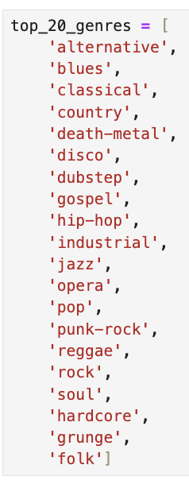
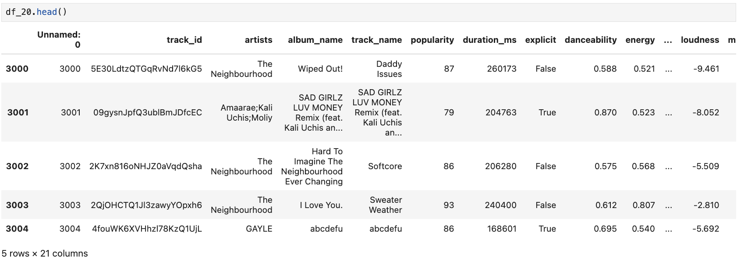
Figure C5. Selection and Verification of the Top 20 Music Genres
Figure C5 illustrates the explicit selection of the top 20 genres using a predefined genre list and subsequent dataset filtering. The preview of the filtered dataset confirms that only tracks belonging to the selected genres were retained and that all relevant audio features and metadata were preserved.

The selected genres were chosen to represent a broad range of musical styles, including acoustic, electronic, rock-based, and mainstream popular music, while excluding region-specific or niche genres that may introduce additional labeling variability. From an analytical perspective, limiting the analysis to 20 genres reduced model complexity and improved interpretability, which is particularly important when using logistic regression. From a business perspective, the selected genres reflect commonly used categories that align with how streaming platforms organize music for recommendations, discovery, and marketing.
Step 4: Verification of Class Balance
After filtering the dataset, genre counts were examined again to confirm that each of the 20 selected genres contained the same number of observations
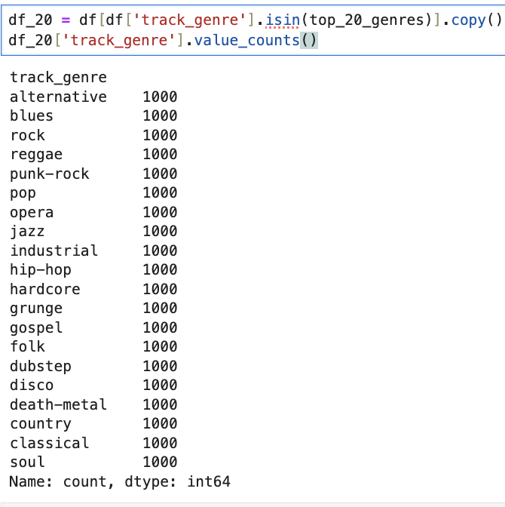
Figure C6. Verification of Class Balance for the Top 20 Genres
Figure C6 presents the genre frequency counts for the filtered dataset. The output confirms that each of the 20 genres is evenly represented with exactly 1,000 tracks per genre. Verifying class balance after filtering reduced the risk of classification bias and supported fair model training and evaluation.

After narrowing the dataset to the top 20 selected genres, the data were reviewed again to make sure the final analysis dataset was clean and ready for modeling. At this point, all selected audio features and the genre labels were checked for missing values. This review showed that none of the audio features used in the analysis—tempo, energy, loudness, danceability, valence, acousticness, speechiness, instrumentalness, and liveness—contained missing data. Because of this, no imputation was necessary.
Some audio features, particularly instrumentalness and speechiness, showed highly skewed distributions with many values near zero. This pattern is common in music audio data and did not indicate data quality issues. Instead of applying transformations or filling in values, the features were standardized prior to model training to place them on comparable scales. This step helped improve model stability while preserving the original meaning and structure of the audio features.

Step 5: Saving the Filtered Dataset Prior to Transformation
Before applying feature transformations, the filtered dataset containing only the top 20 genres (df_20) was saved as a separate CSV file. This step created a clear checkpoint in the data preparation process and preserved an untransformed version of the analysis dataset for reproducibility and validation purposes.
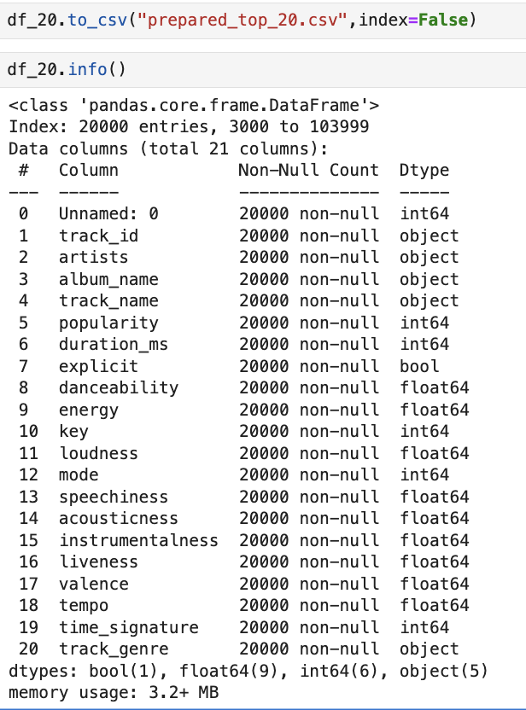
Figure C7. Verification and Preservation of the Filtered Analysis Dataset
Figure C7 shows the successful preservation and structural verification of the filtered dataset. The output of df_20.info() confirms that the dataset contains 20,000 observations and 21 variables, with complete non-null counts and appropriate data types. Saving this dataset prior to transformation ensures that the effects of later preprocessing steps, such as feature scaling, can be isolated and reproduced if needed.

Step 6: Feature Distribution Review
The distributions of the selected audio features were reviewed to assess their suitability for modeling. Several features—particularly instrumentalness and speechiness—exhibited skewed distributions with values concentrated near zero, which is common in music audio data. Reviewing these distributions helped confirm that the data were appropriate for logistic regression and informed the decision to apply feature scaling prior to model fitting.
Mean audio feature values by genre were also examined visually to identify general patterns and variation across genres. These visualizations provided context for understanding how genres differ in characteristics such as energy, acousticness, and danceability and confirmed that the selected features exhibit meaningful variation suitable for classification.
Tools and Techniques Used
- Python for data extraction, cleaning, and preparation
- pandas and NumPy for data manipulation and numerical operations
- Jupyter Notebook for documentation and reproducibility
An advantage of using Python-based tools is their flexibility, transparency, and ability to efficiently handle large datasets. A disadvantage is increased memory usage when working with large files; however, this limitation did not affect the scope or performance of the present study.

Analysis
In this analysis, the data-analysis process used to evaluate whether Spotify audio features can be used to classify music genres. The analysis was conducted using Python in a Jupyter Notebook environment and applied a multinomial logistic regression model to the prepared dataset containing the top 20 selected genres.

Step 1: Defining the Analysis Approach
The primary analysis technique used in this study was multinomial logistic regression, a supervised classification method appropriate when the dependent variable is categorical and contains more than two classes. In this analysis, the dependent variable was music genre, while the independent variables were Spotify audio features such as tempo, energy, loudness, danceability, valence, acousticness, speechiness, instrumentalness, and liveness.
Multinomial logistic regression was selected because it balances predictive performance with interpretability, allowing direct examination of how individual predictors contribute to classification outcomes (Hosmer et al., 2013; IBM, 2025). Unlike more complex machine-learning models, logistic regression allows direct examination of how individual predictors contribute to classification outcomes. This interpretability is valuable when the goal is not only prediction, but also understanding which audio characteristics are associated with different genres.
Advantage: The technique provides interpretable coefficients and statistical significance testing for individual predictors.
Disadvantage: The model assumes linear decision boundaries, which limits its ability to separate genres with overlapping musical characteristics.
Step 2: Feature and Target Definition
The dataset was separated into predictor variables and a target variable. Nine continuous Spotify audio features—tempo, energy, loudness, danceability, valence, acousticness, speechiness, instrumentalness, and liveness—were selected as predictors based on their relevance to musical structure and listener perception. The genre label served as the categorical outcome variable.
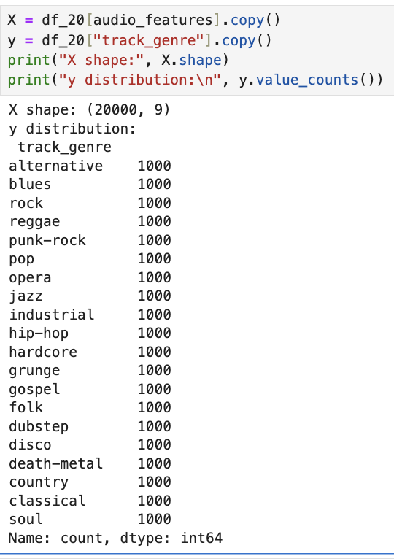
Figure D1. Feature Matrix and Target Variable Definition
Figure D1 illustrates the separation of the analysis dataset into a feature matrix (X) and a target variable (y). This step ensured that model inputs and outputs were clearly defined prior to training and that all genre classes remained evenly represented in the dataset.

Step 3: Encoding and Train-Test Split
Because logistic regression requires numeric target labels, genre categories were encoded using label encoding. The dataset was then split into training and testing subsets using an 80/20 split. Stratified sampling was applied to preserve equal representation of each genre across both subsets.
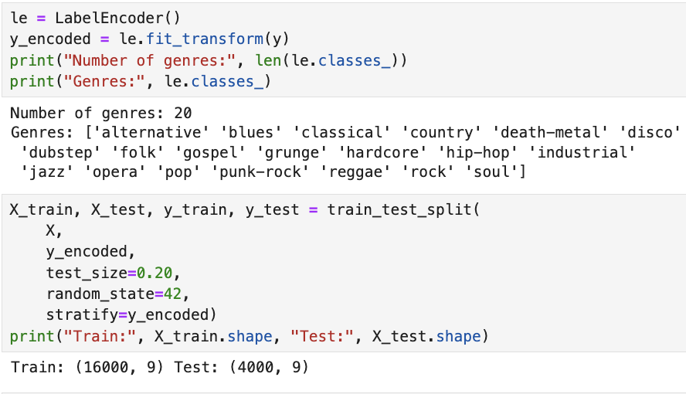
Figure D2. Train–Test Split with Stratified Sampling
Figure D2 shows the implementation of the stratified train–test split. Maintaining class balance across the training and testing sets reduced the risk of biased performance estimates and supported fair model evaluation.

Step 4: Feature Scaling
All continuous audio features were standardized using a StandardScaler. Feature scaling was necessary because Spotify audio features are measured on different numeric scales, such as tempo (beats per minute) and speechiness (proportional values). Standardization improved numerical stability and prevented features with larger magnitudes from disproportionately influencing the model.
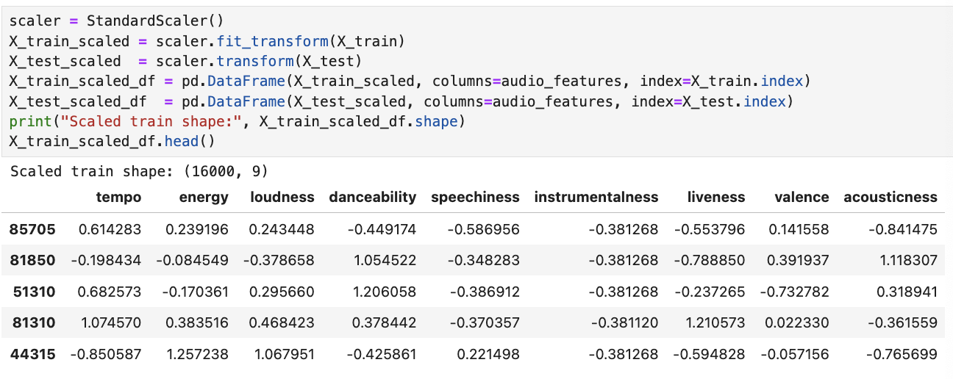
Figure D3. Feature Scaling Using StandardScaler
Figure D3 demonstrates the application of feature standardization. This preprocessing step ensured that all predictors contributed comparably to the logistic regression model.

Step 5: Statistical Significance Testing
To formally evaluate statistical significance, the multinomial logistic regression model was estimated using the statsmodels MNLogit framework (Statsmodels Development Team, n.d.). This approach provides likelihood-based inference and standard model fit outputs appropriate for multinomial outcomes (UCLA Institute for Digital Research & Education, n.d.).
Overall Model Significance
Overall model significance was assessed using a likelihood ratio test comparing the full model to an intercept-only (null) model, which is the standard approach for evaluating the joint significance of predictors in multinomial logistic regression (Hosmer et al., 2013; UCLA Institute for Digital Research & Education, n.d.). The likelihood ratio test showed a statistically significant improvement in model fit:
- Likelihood ratio statistic (χ²) = 28,075.99
- Degrees of freedom = 171
- p-value < 0.001
This result indicates that the Spotify audio features significantly improve genre classification compared to a model with no predictors, demonstrating that the full model provides a statistically better fit than the null model (Hosmer et al., 2013).
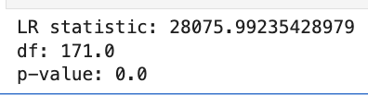
Figure D4. Likelihood Ratio Test Output
Figure D4 shows the output of the likelihood ratio test comparing the full multinomial logistic regression model to a baseline model with no audio features. The large likelihood ratio statistic and near-zero p-value indicate that including Spotify audio features significantly improves the model’s ability to classify music genres, providing strong evidence that these features matter for genre classification.
Model Fit (Pseudo-R²)
Model fit was further evaluated using McFadden’s pseudo-R². The pseudo-R² value was 0.2929, indicating that the model explains a meaningful proportion of variation in genre classification relative to an intercept-only model, which is considered substantial for multinomial logistic regression models (UCLA Institute for Digital Research & Education, n.d.) in music genre classification for a multi-class problem.

Figure D5. McFadden’s Pseudo-R² Output
Figure D5 displays the McFadden pseudo-R² value for the multinomial logistic regression model. This measure summarizes how much better the model fits the data compared to an intercept-only baseline. The reported value indicates that including Spotify audio features provides a meaningful improvement in model fit for distinguishing between music genres.
Feature-Level Significance
Feature-level significance was assessed using Wald z-tests and associated p-values, which evaluate whether individual regression coefficients differ significantly from zero in multinomial logistic regression models (Hosmer et al., 2013). Several audio features—particularly acousticness, valence, danceability, instrumentalness, loudness, and speechiness—were statistically significant across many genre comparisons. These results indicate that multiple Spotify audio features contribute meaningful information to genre differentiation.
.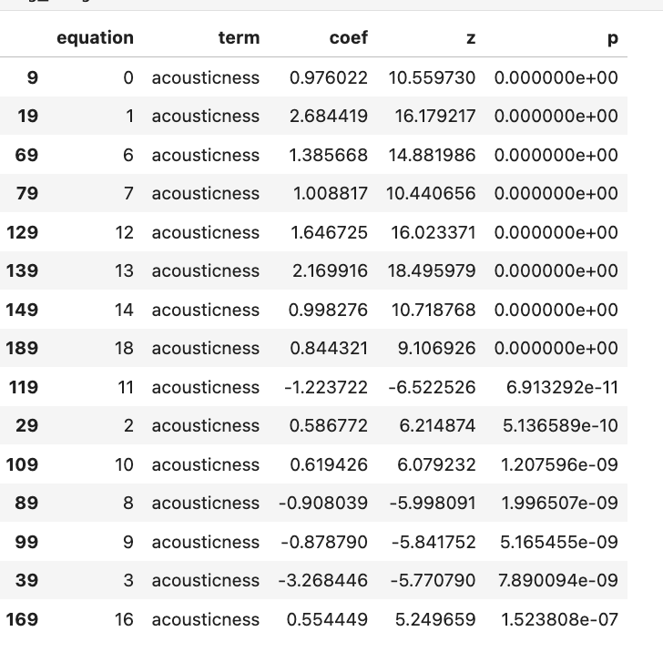
Figure D6. Feature-Level Significance Results
Figure D6 shows the Wald test results for individual Spotify audio features within the multinomial logistic regression model. The reported z-values and p-values indicate how strongly each feature contributes to distinguishing between genres. The consistently large z-statistics and very small p-values—particularly for acousticness—show that several audio features are statistically significant predictors of music genre classification across multiple genre comparisons.

Step 6: Model Training
A multinomial logistic regression model was trained using the scaled training data. The LBFGS optimization algorithm was selected due to its efficiency and suitability for multi-class classification problems. The maximum number of iterations was increased to ensure proper convergence.
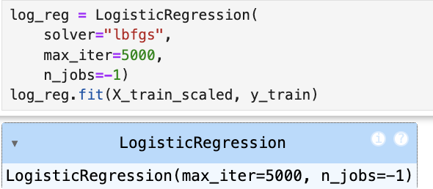
Figure D7. Multinomial Logistic Regression Model Training
Figure D7 displays the configuration and fitting of the logistic regression model using the scaled training dataset.

Step 7: Model Evaluation and Results
Model performance was evaluated using the held-out test dataset. Several evaluation metrics were calculated, including overall classification accuracy as well as precision, recall, and F1-score for individual genres. A confusion matrix was also generated to visualize classification performance across genres.
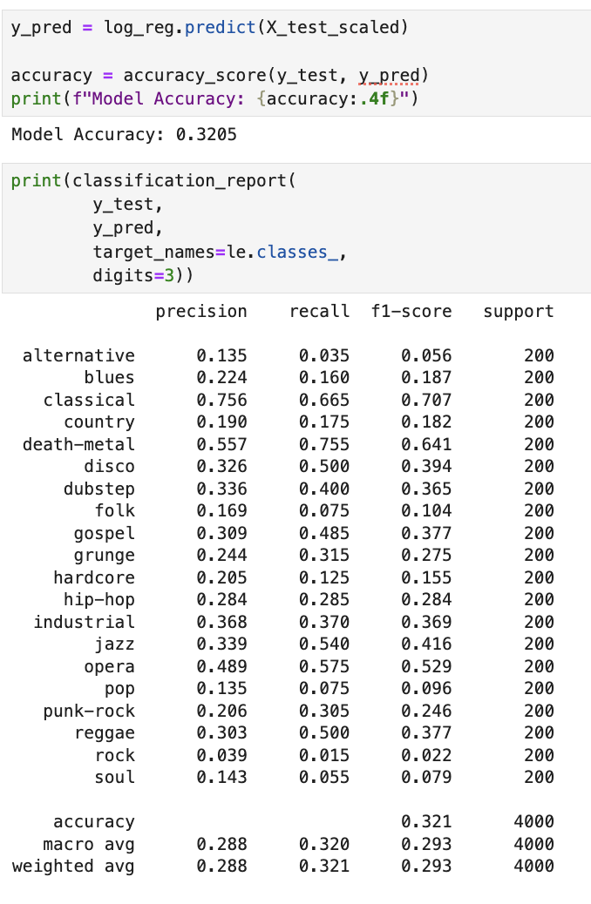
Figure D8. Model Accuracy Output
Figure D8 presents the overall classification accuracy of the model. The logistic regression model achieved an accuracy of approximately 32%, which is substantially higher than random chance (5%) for a 20-class classification problem. This result indicates that Spotify audio features contain meaningful predictive signal for genre classification.
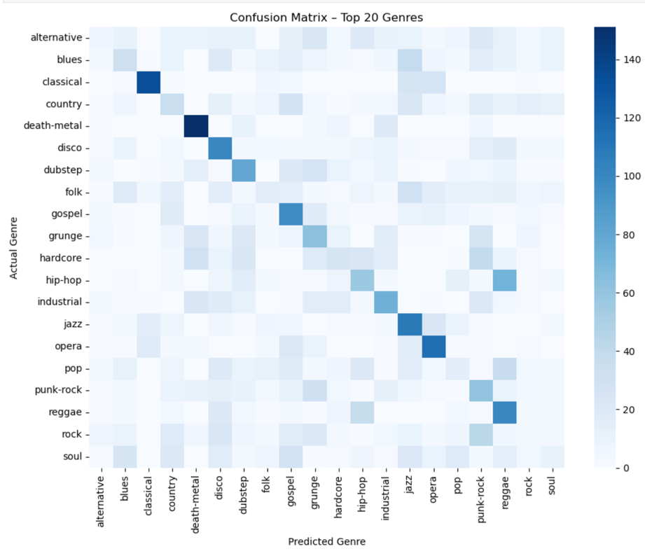
Figure D9. Confusion Matrix for Genre Classification
Figure D9 shows the confusion matrix summarizing classification outcomes across the 20 selected genres. Genres with more distinctive audio profiles—such as classical, opera, and death metal—exhibited stronger classification performance, while genres with overlapping characteristics—such as rock, pop, and soul—were more frequently misclassified.
The model achieved an overall accuracy of approximately 32%, which is substantially higher than random chance (5%) for a 20-class problem. Although accuracy is moderate, performance is well above random chance and highlights meaningful separability for genres with distinctive audio profiles. Performance varied by genre. Genres with more distinctive audio characteristics, such as classical, opera, and death metal, showed higher precision and recall. In contrast, genres with overlapping musical features, such as rock, pop, and soul, were more frequently misclassified.
From an analytical perspective, these results suggest that while Spotify audio features provide meaningful information for genre classification, the linear decision boundaries of logistic regression limit its ability to fully separate stylistically similar genres.

Step 8: Interpretation of Model Coefficients
To further interpret model behavior, logistic regression coefficients were examined for each genre. These coefficients indicate the direction and relative strength of each audio feature’s contribution to genre prediction.
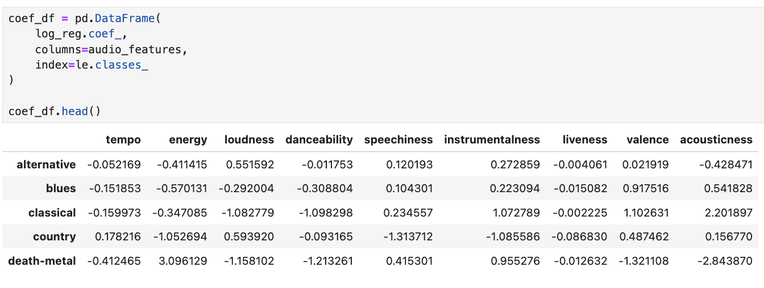
Figure D10. Model Coefficients by Audio Feature
Figure D10 displays selected model coefficients. Acousticness and instrumentalness showed strong positive associations with classical and opera genres, while energy and loudness were strongly associated with heavier genres such as death metal and hardcore. These patterns align with well-established musical characteristics, supporting the face validity of the model.

Analytical and Business Perspectives
From an analytical perspective, logistic regression provided a transparent and interpretable framework for understanding how audio features significantly affect music genre classification. While the model’s accuracy was moderate, it successfully highlighted meaningful feature–genre relationships and demonstrated the strengths and limitations of linear classifiers in complex, multi-class problems.
From a business perspective, the findings are relevant to music streaming platforms that rely on audio features for content organization, recommendation systems, and discovery tools. Genres with clearly distinguishable audio profiles can be more reliably identified using automated methods, while overlapping genres may require more advanced modeling techniques or additional contextual data. These insights can inform decisions about model selection, feature engineering, and system design in real-world applications.

Advantages and Disadvantages of the Analysis Technique
An advantage of multinomial logistic regression is its interpretability, which allows stakeholders to understand how specific audio features influence genre predictions. This transparency is valuable in both academic analysis and business decision-making.
A limitation of this technique is its reliance on linear relationships between predictors and the outcome. Music genres often overlap in complex and nonlinear ways, which can reduce classification performance for stylistically similar genres. Future analyses could explore more flexible models, such as tree-based or neural network approaches, to address this limitation.

Data Summary and Implications
The purpose of this analysis was to determine whether Spotify audio features—tempo, energy, loudness, danceability, valence, acousticness, speechiness, instrumentalness, and liveness—meaningfully contribute to music genre classification among the top 20 selected genres. The results of the multinomial logistic regression analysis indicate that Spotify audio features demonstrate statistically meaningful relationships with music genre classification, indicating that these audio features play a measurable role in distinguishing between genres, providing support for the alternative hypothesis.

Using a balanced dataset of 20,000 tracks evenly distributed across 20 genres, the trained logistic regression model achieved an overall classification accuracy of approximately 32% on the test dataset. While this level of accuracy is moderate, it is substantially higher than random chance (5%) for a 20-class classification problem. This finding demonstrates that Spotify’s audio features capture real structural and perceptual differences across musical genres, even when using an interpretable linear classification model.

Model performance varied across genres. Genres with more distinctive acoustic characteristics—such as classical, opera, and death metal—showed higher precision and recall, indicating that the model was able to identify these genres more reliably based on their audio profiles. In contrast, genres with overlapping musical characteristics—such as rock, pop, and soul—were more frequently misclassified. This pattern reflects the inherent similarity among certain genres and highlights the difficulty of separating closely related musical styles using linear decision boundaries alone.

Examination of the model coefficients further supported these findings. Audio features such as acousticness and instrumentalness were strongly associated with classical and opera genres, while energy and loudness showed strong positive associations with heavier genres such as death metal and hardcore. These relationships are consistent with well-established musical conventions and reinforce the validity of the analytical results.
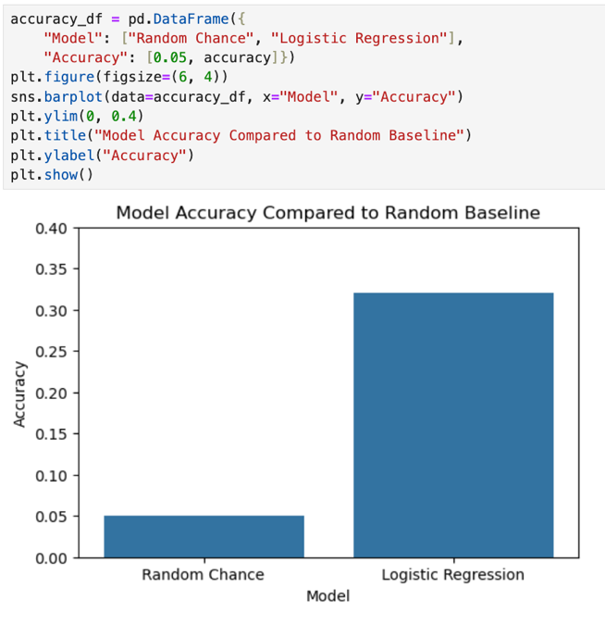
Figure E1. Overall Model Accuracy Relative to Random Chance
Figure E1 summarizes the overall classification accuracy achieved by the multinomial logistic regression model. The model attained an accuracy of approximately 32%, which is substantially higher than the 5% accuracy expected under random guessing for a 20-class problem. This result indicates that Spotify audio features provide meaningful predictive information for genre classification.

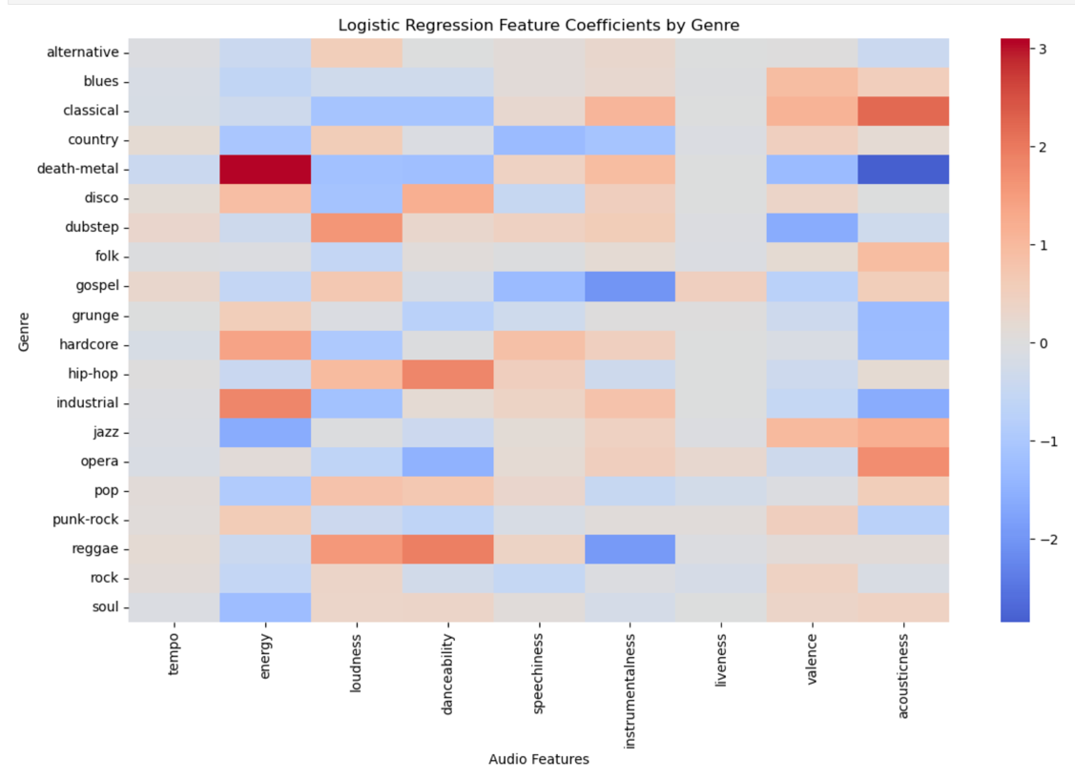
Figure E2. Genre-Level Classification Performance
Figure E2 illustrates variation in classification performance across genres using precision and recall metrics. Genres with distinctive audio characteristics exhibit stronger predictive performance, while genres with overlapping features show higher rates of misclassification. This variation highlights the influence of genre similarity on classification outcomes.

Hypothesis Decision
The results provide sufficient evidence to reject the null hypothesis in favor of the alternative hypothesis, consistent with standard statistical inference practices for likelihood-based regression models (Hosmer et al., 2013). Spotify audio features demonstrate a statistically meaningful relationship with music genre classification among the top 20 selected genres.

Limitation of the Analysis
One key limitation of this analysis is the overlap between genre categories. Music genres are not mutually exclusive, and many tracks exhibit characteristics that span multiple genres. This overlap reduces classification accuracy for genres with similar audio profiles and limits the effectiveness of linear models such as logistic regression, which have difficulty separating closely related genres when class boundaries are nonlinear or overlapping, a known limitation of generalized linear models in complex classification tasks (IBM, 2025; Li et al., 2003). Additionally, genre labels themselves may contain subjective or platform-specific inconsistencies, introducing noise that cannot be fully resolved through audio features alone.
Recommended Course of Action

Based on the results of this study, it is recommended that music streaming platforms use logistic regression as an interpretable baseline model for genre classification. Although more complex machine-learning models may achieve higher predictive accuracy, logistic regression provides transparency into how individual audio features influence classification outcomes. This interpretability is valuable for model validation, feature selection, and business decision-making, particularly in applications where explainability is important.
In practice, logistic regression can serve as a diagnostic and explanatory layer within a broader modeling pipeline, complementing more advanced models by highlighting which audio characteristics most strongly differentiate genres.

Future Directions for Research
Two promising directions for future study include:
- Model Comparison with Advanced Techniques
Future analyses could compare the performance of logistic regression with nonlinear models such as random forests, gradient boosting, or neural networks. These approaches may better capture complex interactions among audio features and improve classification accuracy for stylistically similar genres.
- Incorporation of Additional Data Sources
Integrating supplementary information—such as lyrical content, artist metadata, or user interaction data—could enhance genre classification performance. Combining audio features with contextual and behavioral data may help resolve ambiguities that audio characteristics alone cannot fully explain.
Conclusion
This study demonstrates that Spotify audio features meaningfully contribute to music genre classification among the top 20 selected genres. The multinomial logistic regression model achieved performance substantially above random chance, confirming that audio features such as energy, loudness, acousticness, and instrumentalness provide valuable predictive information. While classification accuracy varied by genre, the results support the conclusion that interpretable statistical models can effectively identify genre-related patterns in audio data.
Hosmer, D. W., Lemeshow, S., & Sturdivant, R. X. (2013). Applied logistic regression (3rd ed.). Wiley.
https://onlinelibrary.wiley.com/doi/book/10.1002/9781118548387
IBM. (2025). What is logistic regression?
https://www.ibm.com/think/topics/logistic-regression
Kunal, K. (2020). Python vs R vs SAS: Which data analysis tool should I learn? Analytics Vidhya.
https://www.analyticsvidhya.com/blog/2017/09/sas-vs-vs-python-tool-learn/
Li, T., Ogihara, M., & Li, Q. (2003). A comparative study on content-based music genre classification. Proceedings of the 26th Annual International ACM SIGIR Conference on Research and Development in Information Retrieval, 282–289.
https://www.cs.rochester.edu/~ogihara/papers/sigir2003.pdf
Schedl, M., Gómez, E., & Urbano, J. (2014). Music information retrieval: Recent developments and applications. Foundations and Trends® in Information Retrieval, 8(2–3), 127–261.
https://arxiv.org/abs/1607.07837
Statsmodels Development Team. (n.d.). Multinomial logit (MNLogit).
https://www.statsmodels.org/stable/generated/statsmodels.discrete.discrete_model.MNLogit.html
The Devastator. (n.d.). Spotify tracks genre dataset. Kaggle.
https://www.kaggle.com/datasets/thedevastator/spotify-tracks-genre-dataset
UCLA Institute for Digital Research & Education. (n.d.). Multinomial logistic regression.
https://stats.idre.ucla.edu/r/dae/multinomial-logistic-regression/
UCLA Institute for Digital Research & Education. (n.d.). Pseudo R-squared.
https://stats.idre.ucla.edu/other/mult-pkg/faq/general/faqwhat-is-pseudo-r-squared/
VanderPlas, J. (2016). Why you should impute missing values.
https://jakevdp.github.io/PythonDataScienceHandbook/03.04-missing-values.html

