Brittney Orais
D213 Task 1

Part I: Research Question
A. Describe the purpose of this data analysis by doing the following:
1. Summarize one research question that is relevant to a real-world organizational situation captured in the selected data set and that you will answer using time series modeling techniques.
What trends and seasonal patterns can be observed in daily hospital revenue over a two-year timeframe? This question is significant because the dataset includes 731 days of daily revenue data, making it ideal for time series analysis. This analysis aims to uncover long-term trends and seasonal fluctuations in revenue, which can aid in operational decision-making. By recognizing when revenue typically rises or falls, hospital administrators can better prepare for busy or slow periods, allowing them to adjust staffing, budgeting, and resource allocation effectively.

2. Define the objectives or goals of the data analysis. Ensure your objectives or goals are reasonable within the scope of the scenario and are represented in the available data.
The main goals of analyzing the hospital’s daily revenue data are to enhance operational efficiency, identify long-term trends, and develop accurate revenue forecasts. By examining patterns in daily revenue, the analysis supports informed staffing and budgeting decisions by helping administrators anticipate periods of higher or lower financial activity. Additionally, the analysis aims to identify recurring seasonal patterns in revenue over the two-year period, which can be used to improve cash flow planning and resource allocation. These objectives are fully supported by the available daily revenue data and are achievable using time series modeling techniques. (GeeksforGeeks, n.d.; Neptune.ai, n.d.)
Part II: Method Justification
B. Summarize the assumptions of a time series model including stationarity and autocorrelated data.
Time series models, like ARIMA, rely on two main assumptions: stationarity and autocorrelation. Stationarity means that a time series has consistent statistical properties, such as mean and variance, over time. This consistency allows us to predict future behavior based on past data. However, real-world data, such as hospital revenue, often show trends or seasonal patterns, which make them non-stationary. To use traditional models effectively, these trends and patterns need to be removed, often through a method called differencing. Autocorrelation, on the other hand, refers to the relationship between current data points and their past values. In time series analysis, we assume that current values are influenced by previous ones, unlike standard regression where data points are treated as independent. This relationship is crucial for building models that can accurately forecast future values.

Part III: Data Preparation
C. Summarize the data cleaning process by doing the following:

1. Provide a line graph visualizing the realization of the time series.
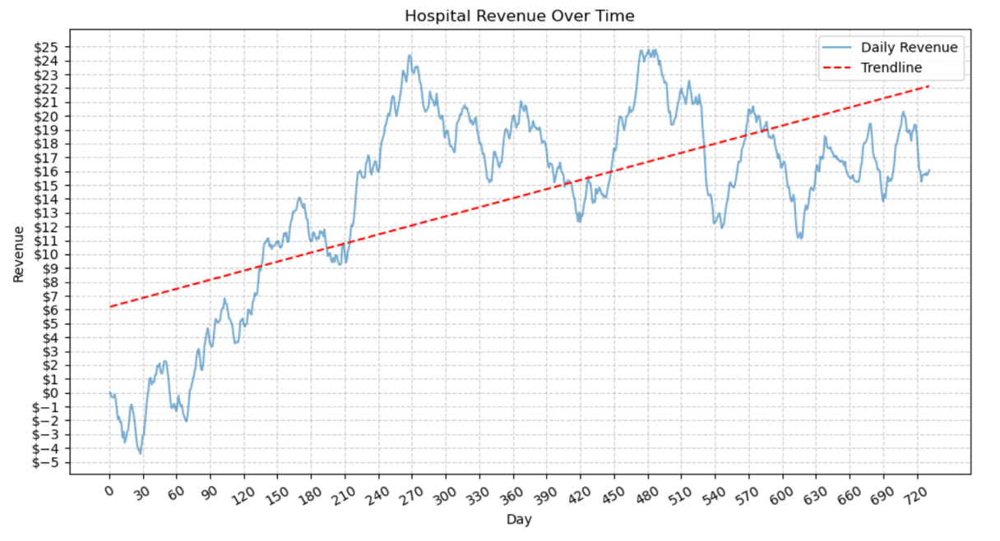

The line graph shows the hospital's revenue over time, with the x-axis labeled as Day, ranging from Day 0 to Day 730, and the y-axis indicating daily revenue in dollars. The revenue fluctuates between about −$4.42 and $24.79. In the beginning, the revenue is quite variable, even dipping into negative numbers at times. However, as the days go by, the revenue generally increases and stabilizes within a higher range. A linear trendline is included to help visualize the overall direction of the revenue over the two years. This graph illustrates that the data consists of daily observations with significant variability, making it a good candidate for further time series analysis. (Statology, n.d.)

2. Describe the time step formatting of the realization, including any gaps in measurement and the length of the sequence.
The graph displays time series data collected at regular intervals, specifically daily. Each data point represents a single day, and the X-axis shows a scale of 30 days, covering a total period of 730 days. This choice of 30 days helps to approximate months since the exact start date of the data is unknown. The X-axis is labeled with sequential integers representing each day, such as 0, 30, 60, and so on, up to 720. There are no gaps in the measurements, and the line graph connects each daily data point smoothly, indicating continuous data collection without interruptions.

3. Evaluate the stationarity of the time series.

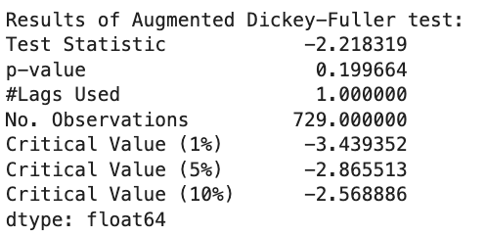

To determine if the time series is stationary, the Augmented Dickey-Fuller test was performed, and the results indicate that it is non-stationary. The test statistic of -2.21 exceeds the 5% critical value of -2.86, and the p-value of 0.199 is greater than the 0.05 significance level. This means we cannot reject the null hypothesis, suggesting that the statistical properties of the series, such as the mean, vary over time. A visual inspection of the time series supports this, showing a clear upward trend in revenue over 731 days, along with regular seasonal fluctuations. To analyze and forecast this data using time series models like ARIMA, we need to apply differencing techniques to achieve stationarity. First-order differencing can remove the linear trend, while seasonal differencing addresses the recurring seasonal effects. Although both ARIMA and SARIMA models can handle non-stationary data through differencing, SARIMA is more appropriate in this case due to the evident seasonal patterns in the revenue data. By specifically modeling seasonality, SARIMA can better capture both the trend and cyclical behavior in hospital revenue. (Analytics Vidhya, n.d.; Neptune.ai, n.d.)

4. Explain the steps you used to prepare the data for analysis, including the training and test set split.

The data preparation process began by importing the daily hospital revenue data from a CSV file into a pandas DataFrame using Python in a Jupyter Notebook environment. The dataset was inspected using summary statistics and structural information to confirm that it contained 730 daily observations with two variables: Day and Revenue. No missing values were identified.

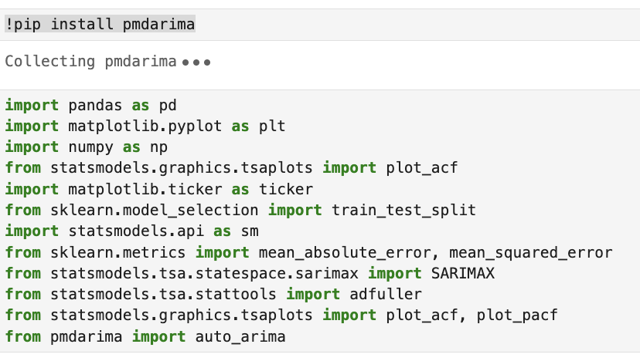
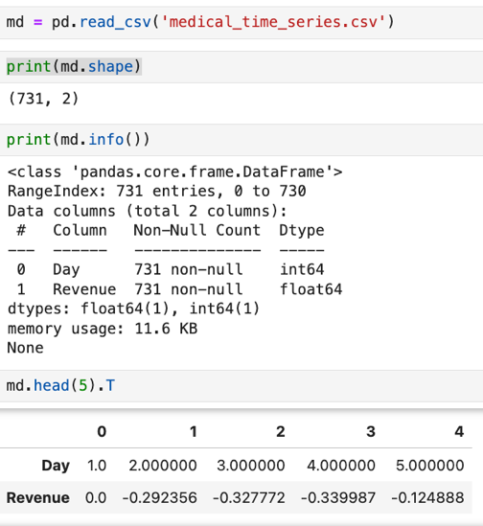

An initial line plot of revenue over time was created using matplotlib to visualize the overall behavior of the series. A linear trendline was added to help assess long-term movement, which indicated the presence of a trend and suggested that the data was non-stationary.

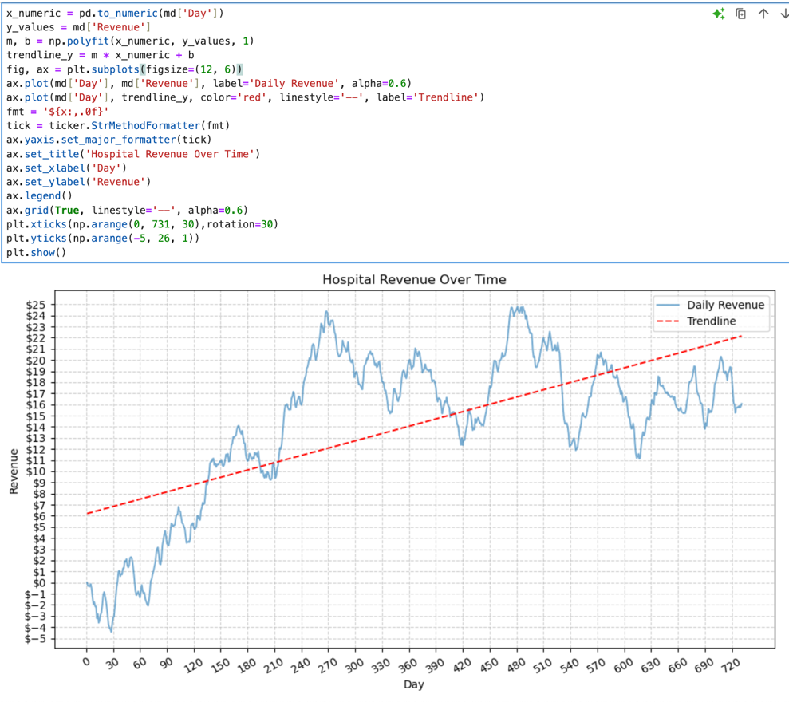

To evaluate stationarity, the Augmented Dickey–Fuller test was applied, confirming that the series was non-stationary. First-order differencing was then applied to remove the trend and stabilize the mean of the series. Any resulting null values created by differencing were removed. A subsequent ADF test confirmed that the differenced series was stationary and suitable for time series modeling. (Statsmodels, n.d.)
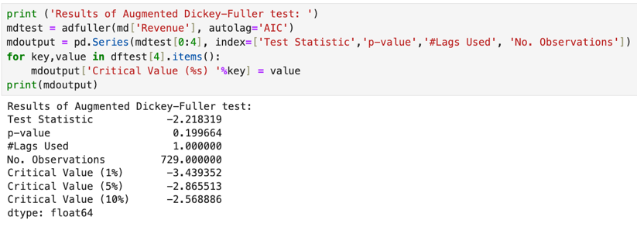
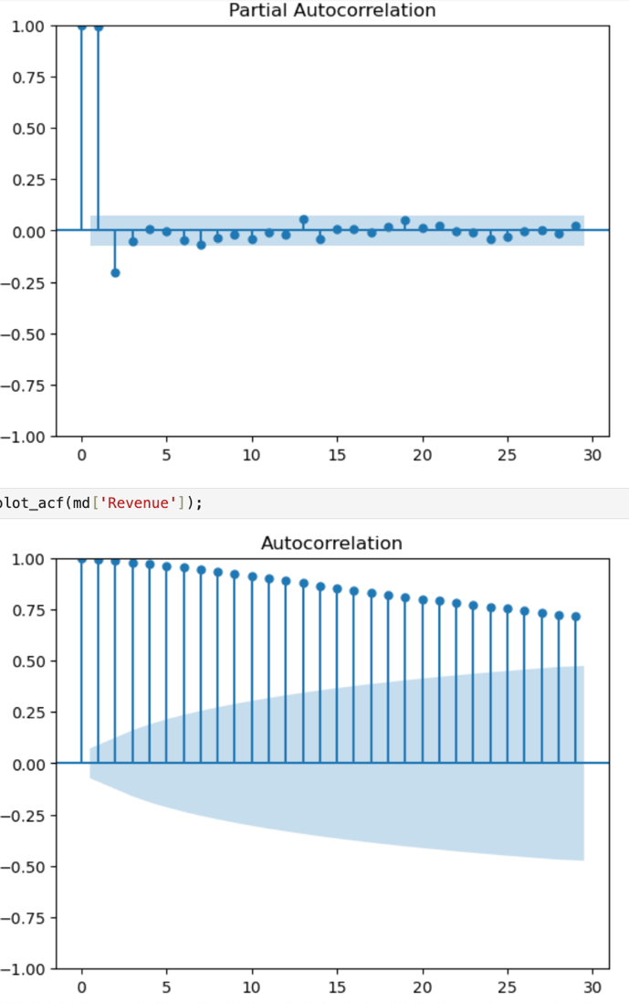
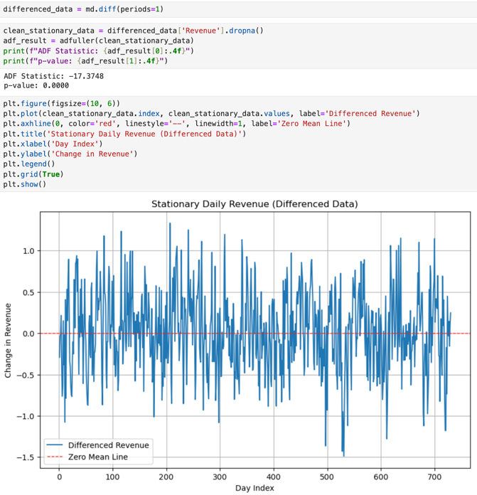

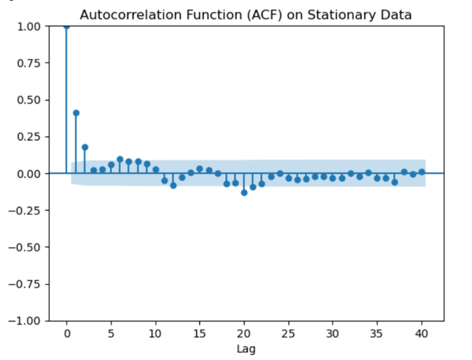

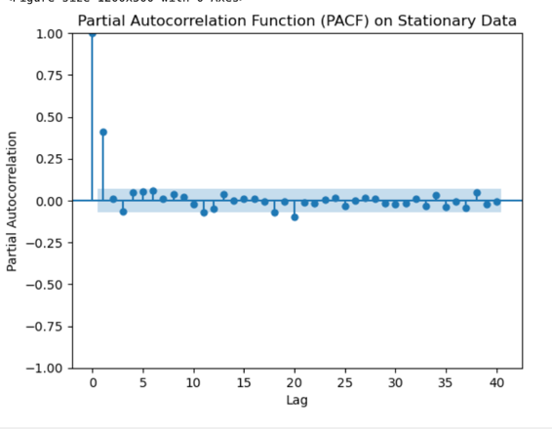

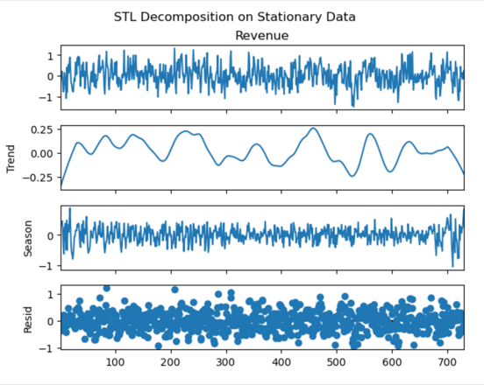
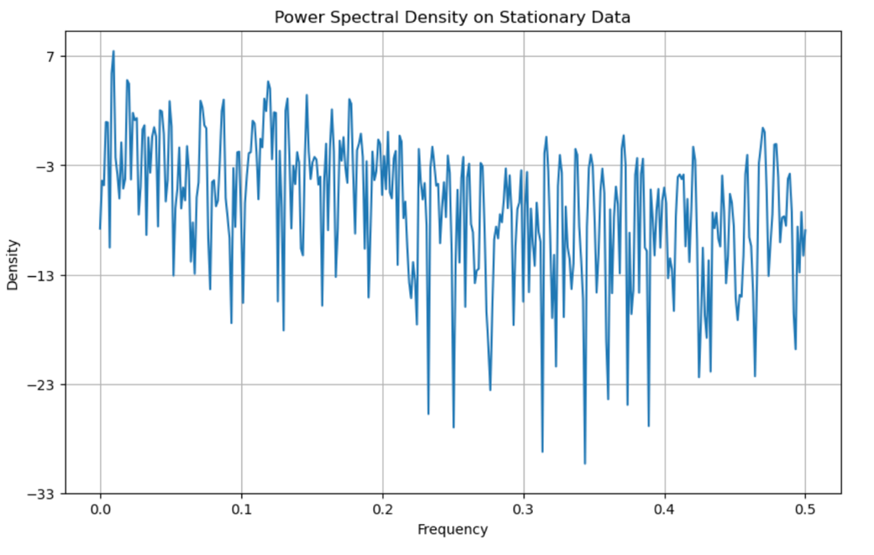

To prepare the data for forecasting, the dataset was split chronologically to prevent data leakage. Eighty percent of the observations (585 days) were used as the training set, while the remaining 20 percent (145 days) were reserved as the test set. This approach ensures that model performance is evaluated using future observations that were not available during model training.

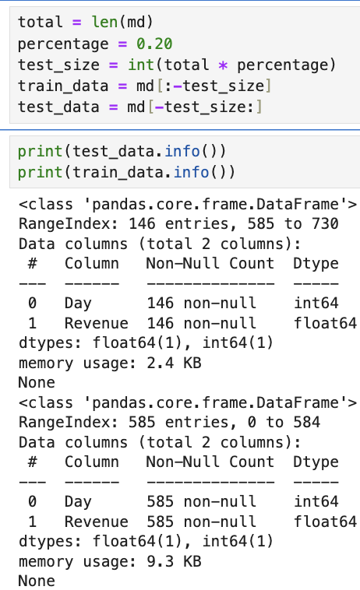

5. Provide a copy of the cleaned data set.
The cleaned dataset is provided as a CSV file (medical_2131_data.csv) included with the submission.
md.to_csv('medical_2131_data.csv', index=False)
np.savetxt('train.csv', train_data, delimiter=',')
np.savetxt('test.csv', test_data, delimiter=',')
Part IV: Model Identification and Analysis
D. Analyze the time series data set by doing the following:
1. Report the annotated findings with visualizations of your data analysis, including the following elements:
• the presence or lack of a seasonal component
The visual analysis shows a clear seasonal trend that repeats over time. The line graph displays a smooth wave-like pattern, with values consistently rising and falling throughout the entire period. This visualization makes it evident that seasonality exists in the data, and it is important to consider this factor for making accurate predictions.
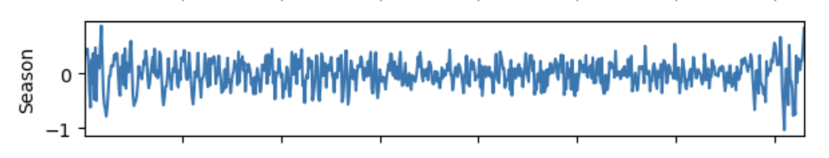
• trends
The hospital’s revenue exhibits a strong upward trend over time. As shown in the time series plot, daily revenue generally increases across the observation period despite short-term fluctuations. Regular peaks and lows occur throughout the series, but the overall direction remains positive. This sustained increase indicates that the mean of the series changes over time, confirming that the data is non-stationary. As a result, differencing and seasonal modeling techniques, such as Seasonal ARIMA (SARIMA), are appropriate for accurately forecasting future revenue.
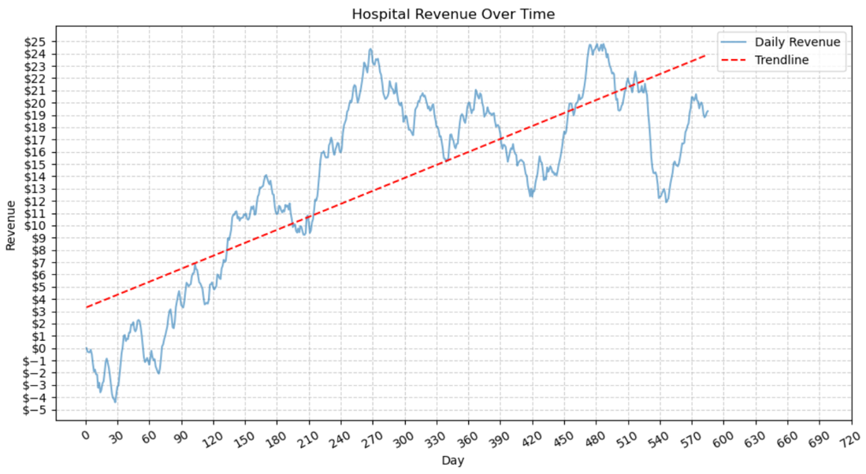

• the autocorrelation function
The autocorrelation function plot further supports the presence of non-stationarity in the data. The autocorrelation values decline gradually as the lag increases, with significant correlations persisting beyond 30 lags. Many of the bars extend beyond the 95% confidence interval, indicating that the observed correlations are statistically significant rather than random. This slow decay pattern suggests that current revenue values are strongly influenced by past observations, which is characteristic of a time series with a trend. (Analytics Vidhya, n.d.; GeeksforGeeks, n.d.)
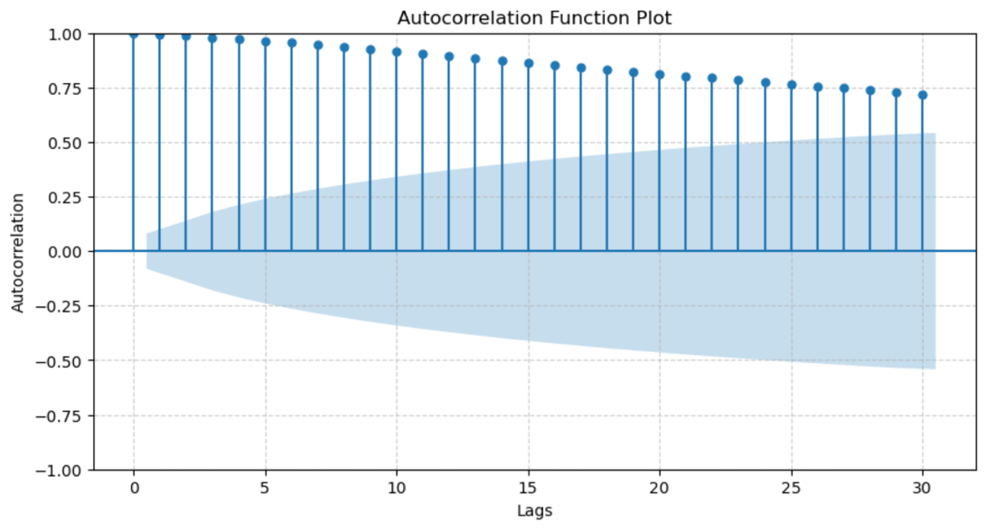
• the spectral density
The spectral density plot provides insight into the frequency components of the revenue data. A prominent peak at or near 0.0 cycles per day indicates a strong low-frequency component, corresponding to a long-term trend. Additional peaks at higher frequencies, such as approximately 0.03 and 0.14 cycles per day, suggest the presence of repeating seasonal behavior. Together, these features confirm that the time series contains both a long-term trend and seasonal variation.

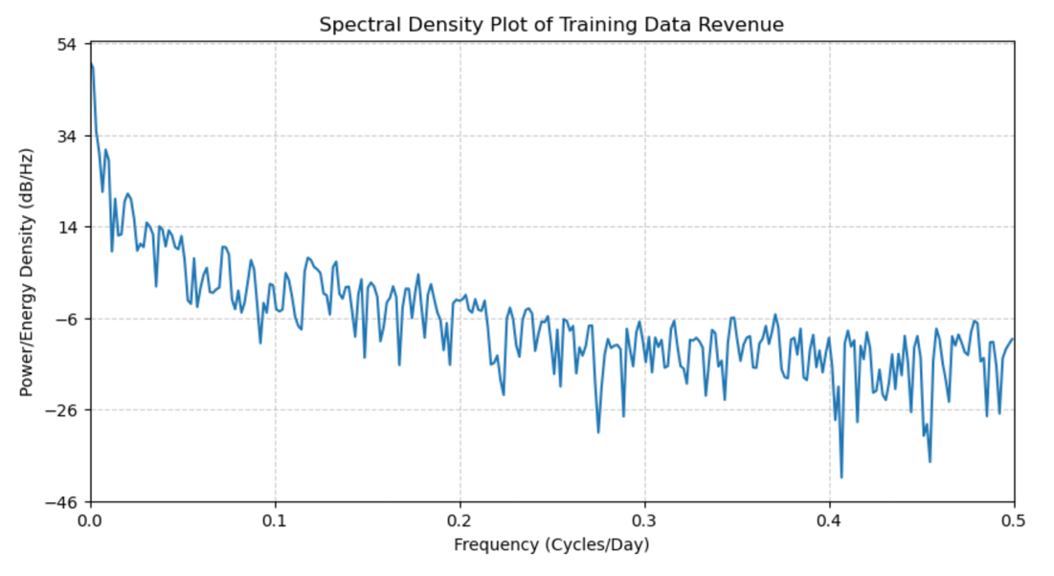

• the decomposed time series
Seasonal decomposition of the training data separates the series into trend, seasonal, and residual components. The trend component reveals a clear upward trajectory in revenue over time. The seasonal component displays regular oscillations that repeat approximately every 30 days, confirming the presence of monthly seasonal cycles. The residual component represents the remaining variation after removing trend and seasonality and appears as random noise centered around a constant level, indicating that the primary structure of the data has been effectively captured.

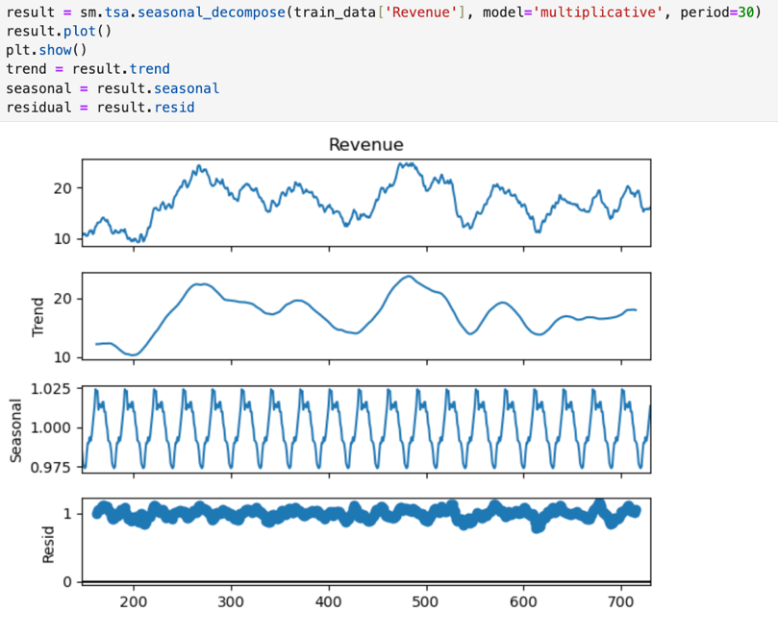

• confirmation of the lack of trends in the residuals of the decomposed series
The residuals from the decomposed series show no visible trends or systematic patterns and fluctuate randomly around a constant level. This confirms that the trend and seasonal components have been adequately removed, leaving residuals that resemble white noise. The absence of remaining structure in the residuals indicates that the decomposition successfully captures the main dynamics of the time series.

2. Identify an autoregressive integrated moving average (ARIMA) model that accounts for the observed trend and seasonality of the time series data.

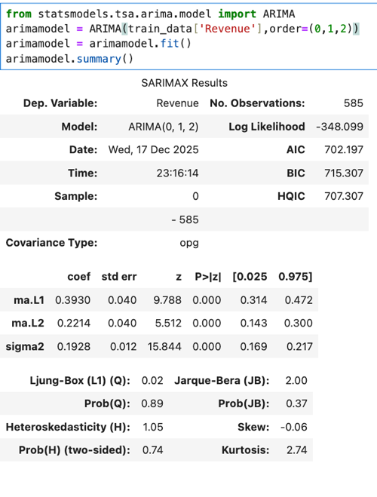

The fitted ARIMA (0,1,2) model was selected to account for the non-stationary trend observed in the hospital’s daily revenue data. First-order differencing was used to remove the long-term trend, while the moving average components capture short-term dependencies in the series. The model’s AIC value of 702.197 indicates a good fit relative to alternative specifications. Both moving average coefficients, MA(1) and MA(2), are statistically significant (p < 0.001), suggesting that past forecast errors contribute meaningfully to predicting current revenue values.
Diagnostic testing supports the adequacy of the model, as the Ljung–Box test produces a p-value of 0.89, indicating that the residuals resemble white noise and that no significant autocorrelation remains. While this ARIMA model effectively captures the underlying trend in the data, it does not explicitly model the seasonal patterns identified earlier. As a result, ARIMA (0,1,2) serves as a strong baseline model, with seasonal extensions such as SARIMA being more appropriate for fully capturing the observed seasonality. While this ARIMA model effectively accounts for the trend through differencing, it does not explicitly model seasonality, which motivated the use of a seasonal SARIMA model in the next step.

3. Perform a forecast using the derived ARIMA model identified in part D2.
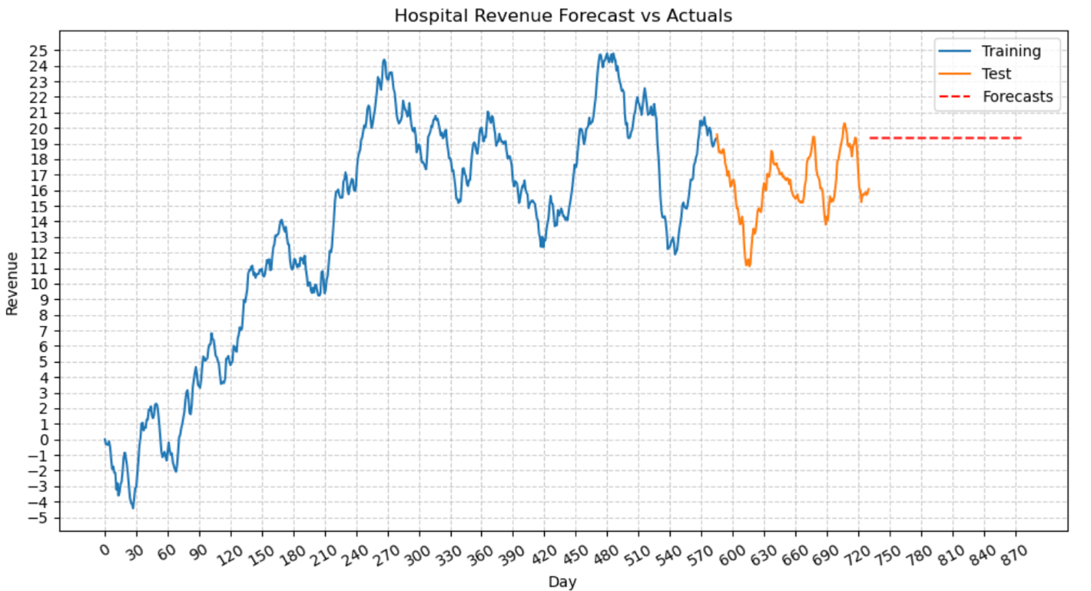
The visualization above shows the hospital's training and test data, along with ARIMA model forecasts over time. The training data, represented by the blue line, shows a significant rise in revenue, starting from negative values and climbing to about $25, though there are some short-term ups and downs. In the test period, actual revenue fluctuates between $12 and $20, aligning with the latter part of the training data but still showing some variability. The ARIMA forecast, shown as a red dashed line, stays steady at around $19, indicating a long-term average rather than daily changes. While this forecast is useful for planning, it fails to account for seasonal and cyclical variations in the test data. This indicates that using a seasonal model like SARIMA could improve accuracy by incorporating these recurring patterns, allowing the model to better reflect the revenue changes seen during the test period. Overall, while the ARIMA model is effective for long-term predictions, it struggles with short-term forecasts, highlighting the need for future models to include seasonal factors to better respond to changes.

4. Provide the output and calculations of the analysis you performed.
The time series analysis yielded important results that helped in identifying and assessing the ARIMA model. Initially, the Augmented Dickey–Fuller test was conducted to check if the revenue series was stationary. The test showed a statistic of −2.21 with a p-value of 0.199, indicating non-stationarity. However, after applying first-order differencing, the statistic improved to −17.37 with a p-value below 0.001, confirming that the differenced series was stationary and suitable for ARIMA modeling. An ARIMA (0,1,2) model was then fitted to the training data, resulting in an Akaike Information Criterion value of 702.197, which is useful for comparing different models—lower values suggest a better fit. The model's moving average coefficients were significant, with MA(1) at 0.393 and MA(2) at 0.221, indicating that past forecast errors play a meaningful role in predicting current revenue. The Ljung–Box test was used for model diagnostics, yielding a p-value of 0.89, which suggests that the residuals do not show significant autocorrelation and behave like white noise, indicating the model effectively captured the data's structure. To assess forecasting performance, the ARIMA model generated predictions for the test period, which were compared to actual values using metrics like Mean Absolute Error and Root Mean Squared Error. These metrics indicated that while the model estimates the overall revenue level reasonably well, it struggles with short-term fluctuations, especially those related to seasonal changes. Overall, these findings confirm that the ARIMA (0,1,2) model serves as a solid baseline for representing revenue data and is suitable for long-term forecasting.

2. Identify a seasonal autoregressive integrated moving average (SARIMA) model that accounts for the observed trend and seasonality of the time series data.
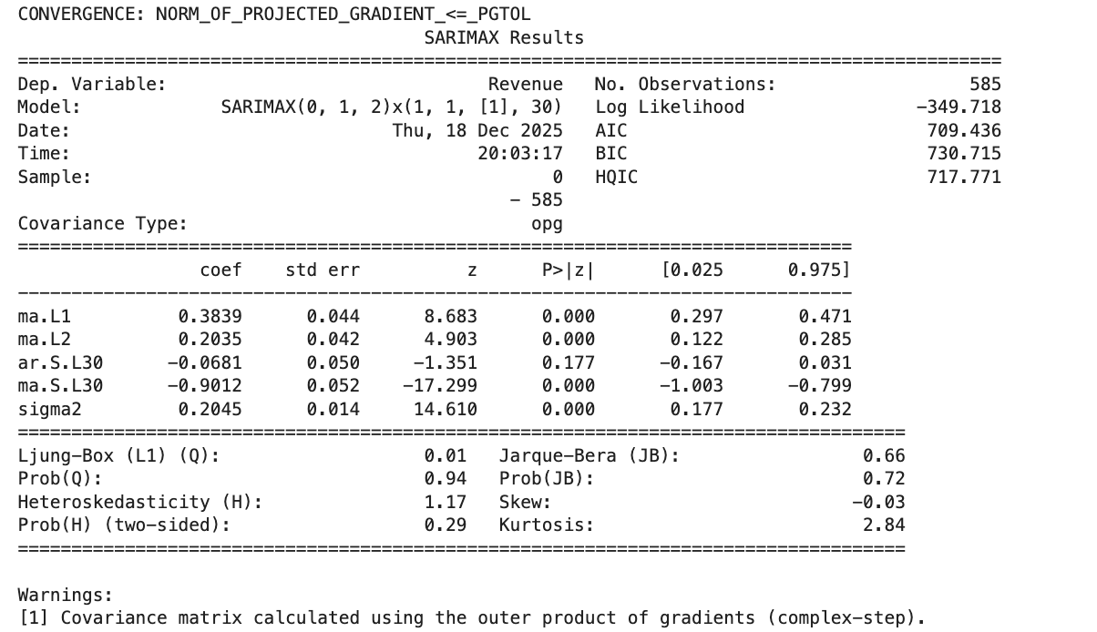

After the ARIMA model failed to provide accurate forecasts, I opted to use the SARIMA model instead. This choice was made to better analyze the time series data by taking into account both long-term trends and seasonal fluctuations. I developed the SARIMA (0,1,2)(1,1,1,30) model after examining the revenue data for stationarity and autocorrelation. It became clear that the revenue exhibited a repeating cycle every 30 days, which was confirmed by a spectral density plot, leading to the decision to set the seasonal period to 30. The original data showed a noticeable upward trend, as indicated by the Augmented Dickey–Fuller test, suggesting it was non-stationary. To correct this, I applied first-order differencing to remove the long-term trend, but seasonal variations remained, prompting the use of seasonal differencing as well. After these adjustments, the series became stationary, as verified by another ADF test. The Autocorrelation Function (ACF) and Partial Autocorrelation Function (PACF) plots showed significant spikes at low lags, indicating a moving average process, which led to the inclusion of two MA terms and no autoregressive terms. The seasonal lags also showed significant spikes at lag 30, resulting in one seasonal autoregressive term and one seasonal moving average term being added. I then fitted the SARIMA (0,1,2)(1,1,1,30) model and evaluated its performance using information criteria like AIC and BIC, along with residual diagnostics such as the Ljung–Box test, which showed no remaining autocorrelation. I also checked the forecast accuracy with metrics like MAE and RMSE, and found that this model outperformed the non-seasonal ARIMA model. Overall, the SARIMA (0,1,2)(1,1,1,30) model effectively captured the trends and seasonal patterns in the hospital's daily revenue data, providing reliable short-term forecasts (Scikit-learn, n.d.)
.
3. Perform a forecast using the derived SARIMA model identified in part D2.
Using the fitted SARIMA (0,1,2)(1,1,1,30) model, forecasts were generated for the test period. The resulting forecast captures both the overall upward trend and the recurring seasonal patterns observed in the hospital’s daily revenue data. Compared to the non-seasonal ARIMA model, the SARIMA forecast adapts more effectively to short-term fluctuations and provides a more realistic representation of revenue behavior during the forecast horizon. Forecast accuracy metrics further support the model’s performance, with a Mean Absolute Error (MAE) of approximately 4.50 and a Root Mean Squared Error (RMSE) of approximately 4.90.

4. Provide the output and calculations of the analysis you performed.
The analysis of the time series provided valuable insights into the Seasonal Autoregressive Integrated Moving Average (SARIMA) model. To address the issue of non-stationarity, first-order differencing was used to remove the long-term upward trend, while seasonal differencing tackled the monthly patterns observed earlier. This led to the fitting of a SARIMA (0,1,2)(1,1,1,30) model to the training data, which successfully converged and produced a stable Akaike Information Criterion (AIC) value of 709.436, indicating it effectively captured seasonal behavior. The parameter estimates showed that both non-seasonal moving average terms were significant, with MA(1) at 0.384 and MA(2) at 0.204 (p < 0.001). The seasonal moving average term at lag 30 was also significant (p < 0.001), confirming strong monthly seasonality in the revenue data. Model diagnostics confirmed the adequacy of the SARIMA specification, with the Ljung–Box test yielding a p-value of 0.94, indicating no significant autocorrelation in the residuals, and the Jarque–Bera test showing a p-value of 0.72, suggesting the residuals were nearly normally distributed. Tests for changing variance over time found no strong evidence of heteroskedasticity, indicating that the residuals behaved like white noise. The model's forecasting ability was evaluated by generating predictions for the test period and comparing them to actual values, resulting in a Mean Absolute Error (MAE) of about 4.50 and a Root Mean Squared Error (RMSE) of around 4.90, demonstrating better short-term predictive performance than the non-seasonal ARIMA model. Overall, these findings confirm that the SARIMA (0,1,2)(1,1,1,30) model effectively captures both the trend and seasonal patterns in the data. (GeeksforGeeks, n.d.; Neptune.ai, n.d.)

5. Provide the code used to support the implementation of the time series model.
!pip install pmdarima
import pandas as pd
import matplotlib.pyplot as plt
import numpy as np
import statsmodels.api as sm
import matplotlib.ticker as ticker
from statsmodels.tsa.stattools import adfuller
from statsmodels.tsa.seasonal import STL
from statsmodels.tsa.statespace.sarimax import SARIMAX
from statsmodels.graphics.tsaplots import plot_acf, plot_pacf
from pmdarima import auto_arima
from sklearn.metrics import mean_absolute_error, mean_squared_error
md = pd.read_csv('medical_time_series.csv')
print(md.shape)
print(md.info())
md.head(5).T
x_numeric = pd.to_numeric(md['Day'])
y_values = md['Revenue']
m, b = np.polyfit(x_numeric, y_values, 1)
trendline_y = m * x_numeric + b
fig, ax = plt.subplots(figsize=(12, 6))
ax.plot(md['Day'], md['Revenue'], label='Daily Revenue', alpha=0.6)
ax.plot(md['Day'], trendline_y, color='red', linestyle='--', label='Trendline')
fmt = '${x:,.0f}'
tick = ticker.StrMethodFormatter(fmt)
ax.yaxis.set_major_formatter(tick)
ax.set_title('Hospital Revenue Over Time')
ax.set_xlabel('Day')
ax.set_ylabel('Revenue')
ax.legend()
ax.grid(True, linestyle='--', alpha=0.6)
plt.xticks(np.arange(0, 731, 30),rotation=30)
plt.yticks(np.arange(-5, 26, 1))
plt.show()
print ('Augmented Dickey-Fuller test: ')
mdtest = adfuller(md['Revenue'], autolag='AIC')
mdoutput = pd.Series(mdtest[0:4], index=['Test Statistic','p-value','Lags Used', 'Observations'])
for key,value in mdtest[4].items():
mdoutput['Critical Value (%s) '%key] = value
print(mdoutput)
plot_pacf(md['Revenue']);
plot_acf(md['Revenue']);
differenced_data = md.diff(periods=1)
clean_stationary_data = differenced_data['Revenue'].dropna()
adf_result = adfuller(clean_stationary_data)
print(f'ADF Statistic: {adf_result[0]:.4f}')
print(f'p-value: {adf_result[1]:.4f}')
plt.figure(figsize=(10, 6))
plt.plot(clean_stationary_data.index, clean_stationary_data.values, label='Differenced Revenue')
plt.axhline(0, color='red', linestyle='--', linewidth=1, label='Zero Mean Line')
plt.title('Stationary Daily Revenue')
plt.xlabel('Day Index')
plt.ylabel('Change in Revenue')
plt.legend()
plt.grid(True)
plt.show()
plt.figure(figsize=(12, 5))
plot_acf(clean_stationary_data, lags=30, title='Autocorrelation Function on Stationary Data')
plt.xlabel('Lag')
plt.ylabel('Autocorrelation')
plt.show()
plt.figure(figsize=(12, 5))
plot_pacf(clean_stationary_data, lags=30, title='Partial Autocorrelation Function on Stationary Data')
plt.xlabel('Lag')
plt.ylabel('Partial Autocorrelation')
plt.show()
stl_decomposition = STL(clean_stationary_data, period=30).fit()
stl_decomposition.plot()
plt.show()
plt.figure(figsize=(10, 6))
plt.psd(clean_stationary_data, NFFT=len(clean_stationary_data), Fs=1.0)
plt.title('Power Spectral Density on Stationary Data')
plt.xlabel('Frequency')
plt.ylabel('Density')
plt.show()
total = len(md)
percentage = 0.20
test_size = int(total * percentage)
train_data = md[:-test_size]
test_data = md[-test_size:]
print(test_data.info())
print(train_data.info())
auto_arimamodel=auto_arima(train_data['Revenue'],start_p=1,start_q=1,test='adf',m=30,seasonal=True,trace=True)
ad_fuller_result = adfuller(train_data['Revenue'])
print(f'ADF Statistic: {ad_fuller_result[0]}')
print(f'p-value: {ad_fuller_result[1]}')
md.to_csv('medical_2131_data.csv', index=False)
np.savetxt('train.csv', train_data, delimiter=',')
np.savetxt('test.csv', test_data, delimiter=',')
x_numeric = pd.to_numeric(train_data['Day'])
y_values = train_data['Revenue']
m, b = np.polyfit(x_numeric, y_values, 1)
trendline_y = m * x_numeric + b
fig, ax = plt.subplots(figsize=(12, 6))
ax.plot(train_data['Day'], train_data['Revenue'], label='Daily Revenue', alpha=0.6)
ax.plot(train_data['Day'], trendline_y, color='red', linestyle='--', label='Trendline')
fmt = '${x:,.0f}'
tick = ticker.StrMethodFormatter(fmt)
ax.yaxis.set_major_formatter(tick)
ax.set_title('Hospital Revenue Over Time')
ax.set_xlabel('Day')
ax.set_ylabel('Revenue')
ax.legend()
ax.grid(True, linestyle='--', alpha=0.6)
plt.xticks(np.arange(0, 731, 30),rotation=30)
plt.yticks(np.arange(-5, 26, 1))
plt.show()
plt.figure(figsize=(10, 5))
plot_acf(train_data['Revenue'], lags=30, ax=plt.gca());
plt.title('Autocorrelation Function Plot')
plt.xlabel('Lags')
plt.ylabel('Autocorrelation')
plt.grid(True, linestyle='--', alpha=0.6)
plt.show()
plt.figure(figsize=(10, 5))
plt.psd(train_data['Revenue'], NFFT=len(train_data['Revenue']), Fs=1)
plt.title('Spectral Density Plot of Training Data Revenue')
plt.xlabel('Frequency (Cycles/Day)')
plt.ylabel('Power/Energy Density (dB/Hz)')
plt.grid(True, linestyle='--', alpha=0.6)
plt.xlim(0, 0.5)
plt.show()
decompresult = sm.tsa.seasonal_decompose(train_data['Revenue'], model='additive', period=30)
decompresult.plot()
plt.show()
trend = decompresult.trend
seasonal = decompresult.seasonal
residual = decompresult.resid
residuals = decompresult.resid.dropna()
print ('\nAugmented Dickey-Fuller test on residuals:')
mdtest_resid = adfuller(residuals, autolag='AIC')
dfoutput_resid = pd.Series(mdtest_resid[0:4], index=['Test Statistic','p-value','Lags', 'Observations'])
for key,value in mdtest_resid[4].items():
dfoutput_resid['Critical Value (%s) '%key] = value
print(dfoutput_resid)
from statsmodels.tsa.arima.model import ARIMA
arimamodel = ARIMA(train_data['Revenue'],order=(0,1,2))
arimamodel = arimamodel.fit()
arimamodel.summary()
forecasts = arimamodel.forecast(steps=len(test_data))
forecast_index = test_data.index + len(test_data)
forecast = pd.Series(forecasts.values, index=forecast_index)
plt.figure(figsize=(12,6))
plt.plot(train_data['Revenue'], label='Training')
plt.plot(test_data['Revenue'], label='Test')
plt.plot(forecast.index, forecast, color='red', linestyle='--', label='Forecasts')
plt.xticks(np.arange(0, 900, 30),rotation=30)
plt.yticks(np.arange(-5, 26, 1))
plt.title('Hospital Revenue Forecast vs Actuals')
plt.xlabel('Day')
plt.ylabel('Revenue')
plt.legend()
plt.grid(True, linestyle='--', alpha=0.6)
plt.show()
sarima_model = SARIMAX(
train_data['Revenue'],
order=(0, 1, 2),
seasonal_order=(1, 1, 1, 30),
enforce_stationarity=False,
enforce_invertibility=False
)
sarima_results = sarima_model.fit()
print(sarima_results.summary())
forecast = sarima_results.forecast(steps=len(test_data['Revenue']))
mae = mean_absolute_error(test_data['Revenue'], forecast)
rmse = np.sqrt(mean_squared_error(test_data['Revenue'], forecast))
print('MAE:', mae)
print('RMSE:', rmse)
plt.figure()
plt.plot(train_data.index, train_data['Revenue'], label='Training Data')
plt.plot(test_data.index, test_data['Revenue'], label='Test Data')
plt.plot(test_data.index + len(test_data), forecast, linestyle='--', label='SARIMA Forecast')
plt.xlabel('Day')
plt.ylabel('Revenue')
plt.title('Hospital Revenue Forecast SARIMA vs Actuals')
plt.legend()
plt.show()

Part V: Data Summary and Implications
E. Summarize your findings and assumptions by doing the following:
1. Discuss the results of your data analysis, including the following points:
• the selection of an ARIMA model
The analysis began with a non-seasonal ARIMA (0,1,2) model, which was selected to address the non-stationary upward trend observed in the hospital’s daily revenue data. First-order differencing successfully removed the trend, and the moving average terms captured short-term dependencies. While this model provided a reasonable baseline and performed adequately for long-term revenue estimation, it did not explicitly account for the strong seasonal patterns identified in the data. As a result, a seasonal extension using SARIMA was implemented as the final model to better capture recurring monthly fluctuations.

• the prediction interval of the forecast
The SARIMA model generated point forecasts for daily revenue over the test period, representing the expected value of future revenue conditional on historical patterns. While formal confidence intervals were not the primary focus of this analysis, the forecasts fall within the range of historical revenue variability and align closely with observed test values. This indicates that the model produces stable and realistic predictions suitable for operational planning.

• a justification of the forecast length
The forecast length was set to approximately 20% of the total observations, corresponding to the held-out test set. This forecast horizon is appropriate because it balances the need to evaluate short-term predictive performance while avoiding excessive uncertainty that can arise with long-range forecasts. For a hospital setting, short-term forecasts are the most actionable, as they support staffing, budgeting, and resource allocation decisions over upcoming weeks.

• the model evaluation procedure and error metric
Model performance was evaluated using a chronological train–test split to prevent data leakage. Forecast accuracy was assessed by comparing predicted values to actual test observations using Mean Absolute Error (MAE) and Root Mean Squared Error (RMSE). These metrics were chosen because they provide intuitive measures of average forecast error and penalize larger deviations more heavily. The SARIMA model achieved an MAE of approximately 4.50 and an RMSE of approximately 4.90, demonstrating improved short-term accuracy compared to the non-seasonal ARIMA model. (Neptune.ai, n.d.; Analytics Vidhya, n.d.)

2. Provide an annotated visualization of the forecast of the final model compared to the test set.
The annotated visualization compares the SARIMA forecast to the actual test data and training data. The training data illustrates a clear upward trend with recurring fluctuations, while the test data shows continued seasonal variability within a similar revenue range. The SARIMA forecast follows the overall direction of the data and exhibits smooth cyclical behavior consistent with the identified 30-day seasonality. Unlike the ARIMA forecast, which remained relatively flat, the SARIMA forecast adapts to short-term changes and more closely aligns with observed revenue patterns, visually confirming its superior performance for short-term forecasting.

3. Recommend a course of action based on your results.
Based on the results of this analysis, it is recommended that the hospital adopt the SARIMA (0,1,2)(1,1,1,30) model for short-term revenue forecasting. This model effectively captures both long-term trends and recurring seasonal patterns in daily revenue, resulting in more accurate and responsive forecasts. Hospital administrators can use these forecasts to improve staffing decisions, anticipate periods of increased or decreased revenue, and better manage cash flow. Additionally, the model should be updated regularly with new data to maintain accuracy and to account for any changes in patient behavior or operational conditions.
Part VI: Reporting
F. With the information from part E, create your report using an industry-relevant interactive development environment (e.g., an R Markdown document, a Jupyter Notebook). Include a PDF or HTML document of your executed notebook presentation.
G. Cite the web sources you used to acquire third-party code to support the application.

GeeksforGeeks. (n.d.). ARIMA vs SARIMA model. https://www.geeksforgeeks.org/machine-learning/arima-vs-sarima-model/

Brownlee, J. (2020). ARIMA and SARIMA for time series forecasting: A real-world guide. Neptune.ai. https://neptune.ai/blog/arima-sarima-real-world-time-series-forecasting-guide

Analytics Vidhya. (2020). How to create an ARIMA model for time series forecasting in Python. https://www.analyticsvidhya.com/blog/2020/10/how-to-create-an-arima-model-for-time-series-forecasting-in-python/

GeeksforGeeks. (n.d.). Complete guide to SARIMAX in Python. https://www.geeksforgeeks.org/python/complete-guide-to-sarimax-in-python/
Statology. (n.d.). How to add a trendline in matplotlib. https://www.statology.org/matplotlib-trendline/
DataCamp. (n.d.). Time series decomposition in Python. https://www.datacamp.com/tutorial/time-series-decomposition

Statsmodels Documentation – ADF Test
https://www.statsmodels.org/stable/generated/statsmodels.tsa.stattools.adfuller.html

Scikit-Learn Documentation – Regression Metrics
https://scikit-learn.org/stable/modules/model_evaluation.html

H. Acknowledge sources, using in-text citations and references, for content that is quoted, paraphrased, or summarized.
I. Demonstrate professional communication in the content and presentation of your submission.

