Brittney Orais-Bonheimer
D213 Task 2

Part I: Research Question
A. Describe the purpose of this data analysis by doing the following:
1. Summarize one research question that you will answer using neural network models and NLP techniques. Be sure the research question is relevant to a real-world organizational situation and sentiment analysis captured in your chosen data set(s).
How accurately can a neural network–based NLP model classify customer reviews from Amazon, IMDb, and Yelp as positive or negative, and how can these insights help organizations improve products, services, and customer satisfaction?
2. Define the objectives or goals of the data analysis. Be sure the objectives or goals are reasonable within the scope of the research question and are represented in the available data.
The goal of this analysis was to bring together review data from Amazon, IMDb, and Yelp to reflect how customers actually express opinions across different platforms. During preprocessing, I will experiment with several common NLP techniques, including lowercasing, and punctuation removal. These steps will potentially reduce noise in the text and help the model focus on sentiment-bearing words rather than stylistic variation.
After preprocessing, a neural network–based NLP model will be trained to classify reviews as positive or negative. Model performance will be evaluated using accuracy and loss across training, validation, and test sets. Beyond classification accuracy, the analysis will also examine recurring sentiment patterns across product, service, and entertainment reviews to better understand what customers consistently praise or criticize. These insights can help organizations make more informed decisions aimed at improving products, services, and overall customer satisfaction. While the overall goal was already defined at the start, refining the objectives during preprocessing will help clarify which modeling choices were realistic given the size and structure of the combined datasets.

3. Identify a type of neural network capable of performing a text classification task that can be trained to produce useful predictions on text sequences on the selected data set.
A Long Short-Term Memory (LSTM) neural network, a type of recurrent neural network (RNN), works well for text classification tasks with this dataset. LSTMs are designed to handle text as a sequence, which allows them to capture relationships between words over time (Young et al., 2018). This makes them especially useful for analyzing customer reviews, where meaning often depends on word order and contextual information (Jurafsky & Martin, 2023).
When combined with word embeddings, LSTM networks can learn patterns that distinguish positive and negative sentiment in reviews from platforms such as Amazon, IMDb, and Yelp (Young et al., 2018).

Part II: Data Preparation
Perform exploratory data analysis on the chosen data set, and include an explanation of each of the following elements:
Exploratory data analysis (EDA) was performed on the combined Amazon, IMDb, and Yelp review dataset (2,748 labeled sentences) to understand its characteristics before preprocessing and modeling. This step guided practical decisions about cleaning, vocabulary limits, embedding size, and sequence length.
Presence of unusual characters: The reviews were scanned for emojis and non-English characters using regular expressions. The check identified 17 instances containing such characters. Given their low frequency and limited relevance to sentiment, they were noted but not aggressively removed, as the core text remained predominantly English and usable for modeling.
Vocabulary size: Before applying limits, the dataset contained approximately 5,271 unique words. To manage sparsity and maintain computational efficiency, the vocabulary was capped at 5,000 words during tokenization. This retained the most frequent and sentiment-relevant terms while excluding rare words that contributed little predictive value.
Proposed word embedding length: Three embedding dimensions—50, 100, and 200—were tested using short training runs with otherwise identical LSTM models. The quick tests showed close performance: dimension 50 achieved 81.82% validation accuracy, dimension 100 achieved 81.09%, and dimension 200 achieved 78.18%. Although smaller dimensions performed slightly better in early epochs, a 200-dimensional embedding was selected for the final model to provide greater capacity for capturing subtle semantic relationships and contextual nuances, aligning with common NLP practices. Full training with this dimension delivered strong test accuracy of 82.18%.
Statistical justification for the chosen maximum sequence length: Review lengths were analyzed after converting text to sequences. The 95th percentile was 26 tokens, indicating that most reviews were short. A maximum sequence length of 30 was chosen to encompass nearly all meaningful content while introducing only minimal padding. Longer lengths added unnecessary padding without performance gains, while shorter lengths risked truncating important context in the few longer reviews.
Preprocessing itself was kept minimal: text was lowercased and punctuation removed to standardize input.
Overall, the EDA confirmed that the dataset is clean, predominantly English, and compact in length, making it well-suited for an LSTM-based sentiment classifier. The insights gained directly informed conservative preprocessing and architecture choices that followed.

2. Describe the goals of the tokenization process, including any code generated and packages that are used to normalize text during the tokenization process.
Tokenization converts text into numerical sequences for neural network input. Normalization steps included lowercasing and punctuation removal to standardize text while preserving sentiment-bearing words. The TensorFlow Keras Tokenizer generated the vocabulary and integer sequences, followed by post-padding to uniform length (Young et al., 2018). Packages used: TensorFlow/Keras for tokenization and padding, re for punctuation removal.
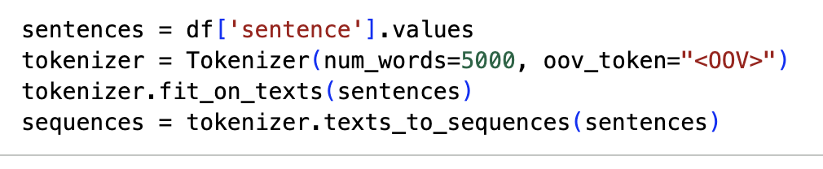

3. Explain the padding process used to standardize the length of sequences. Include the following in your explanation:
Padding ensures that all text sequences have the same length, which is required for neural network models such as LSTMs (Jurafsky & Martin, 2023). Post-padding was used so that zeros are added to the end of shorter sequences, preserving the original word order at the beginning of each review, which is important for sentiment interpretation (Young et al., 2018).
In this analysis, padding occurs after the text sequence (post-padding), meaning that zeros are appended until each sequence reaches the predefined maximum length. This approach preserves meaningful tokens at the beginning of each review and supports effective sentiment learning (Jurafsky & Martin, 2023).
A fixed maximum sequence length of 30 tokens was selected to represent all reviews consistently while limiting unnecessary padding.
Below is an example of a single padded sequence, where 0 represents padding added after the actual text tokens: 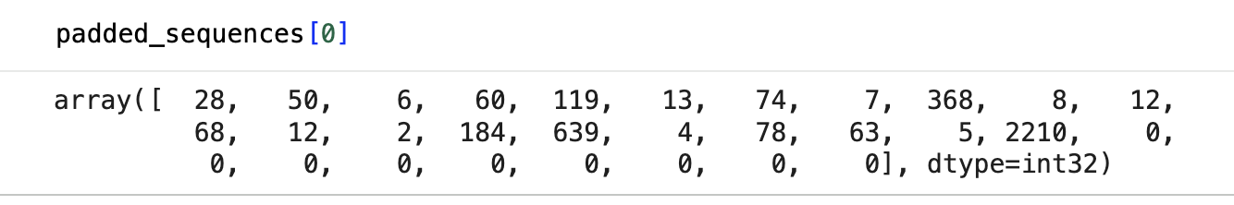In this example, the meaningful words appear first as integer values, and padding is added at the end to reach the required sequence length. This standardized format allows the neural network to efficiently learn patterns across all reviews.
4. Identify how many categories of sentiment will be used and an activation function for the final dense layer of the network.
This sentiment analysis task uses two categories of sentiment: positive and negative. These categories are represented by binary labels in the dataset, where 1 indicates a positive review and 0 indicates a negative review.
Because the problem is a binary classification task, the neural network’s final dense layer uses one output neuron with a sigmoid activation function. The sigmoid function outputs a value between 0 and 1, which can be interpreted as the probability that a given review expresses positive sentiment.
This activation function is well suited for binary sentiment classification and works effectively with loss functions such as binary cross-entropy to evaluate model performance.

5. Explain the steps used to prepare the data for analysis, including the size of the training, validation, and test set split (based on the industry average).
To prepare the data for analysis, multiple sentiment review datasets (Amazon, IMDb, and Yelp) were first combined into a single dataset to ensure consistency and increase the volume of training data. The text data was then cleaned and normalized through lowercasing and removal of punctuation. After preprocessing, the reviews were tokenized, converted into numerical sequences, and padded to a fixed length so they could be processed by the neural network.
Once preprocessing was complete, the dataset was split into training (80%), validation (10%), and test (10%) sets following common industry practices for supervised machine learning and NLP tasks (Jurafsky & Martin, 2023). This approach ensures reliable model evaluation and reduces the risk of overfitting (Young et al., 2018). The training set (80%) was used to train the neural network and allow it to learn patterns in the text data.
The validation set (10%) was used during training to monitor model performance, tune hyperparameters, and detect overfitting.
The test set (10%) was reserved for final evaluation and provided an unbiased measure of how well the model performs on unseen data.
This split balances model learning with reliable performance evaluation and is commonly used in natural language processing and deep learning projects.

6. Provide a copy of the prepared data set.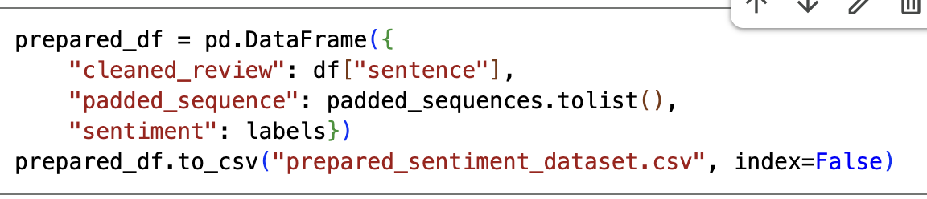

Part III: Network Architecture
C. Describe the type of network used by doing the following:
1. Provide the output of the model summary of the function from TensorFlow.
The final model consists of an embedding layer, followed by an LSTM layer, a dropout layer, and a dense output layer. This architecture was selected after testing configurations, with the embedding layer providing rich word representations and the LSTM effectively capturing sequential dependencies in text (Young et al., 2018). The model contains 1,067,905 trainable parameters, allowing it to learn meaningful sentiment patterns across multiple review domains (Zhang et al., 2018).

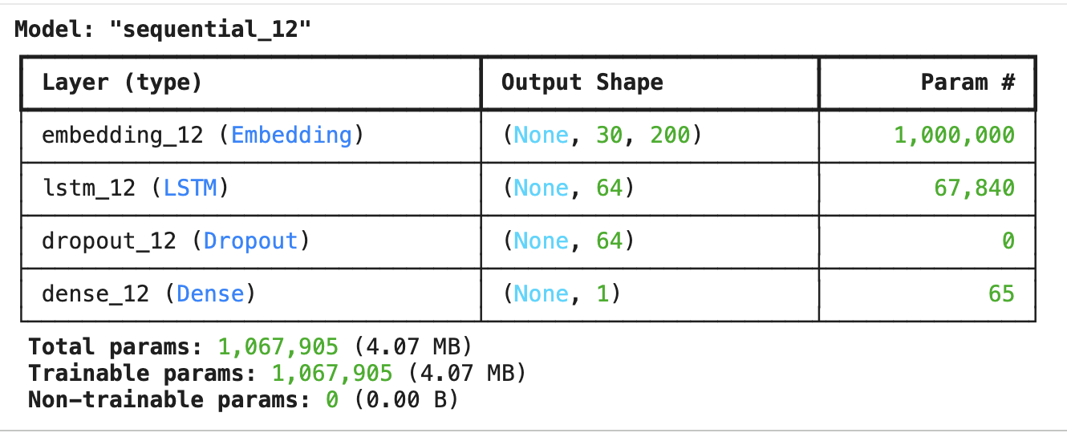

2. Discuss the number of layers, the type of layers, and the total number of parameters.
The neural network model consists of four layers, each serving a specific role in the sentiment classification task. First, an Embedding layer converts each word index into a dense 200-dimensional vector representation, allowing the model to learn semantic relationships between words. This layer contains 1,000,000 trainable parameters, based on a vocabulary size of 5,000 words.
Next, an LSTM (Long Short-Term Memory) layer with 64 units processes the text sequences and captures contextual and sequential patterns in the reviews. This layer has 67,840 trainable parameters, enabling the model to learn dependencies across words in a sentence. A Dropout layer follows the LSTM and randomly deactivates 50% of the neurons during training to help reduce overfitting; this layer has no trainable parameters.
Finally, a Dense output layer with a single neuron and a sigmoid activation function produces a binary sentiment prediction (positive or negative). This layer contains 65 trainable parameters. In total, the model has 1,067,905 trainable parameters, all of which contribute to learning patterns in the combined Amazon, IMDb, and Yelp review dataset.

3. Justify the choice of hyperparameters, including the following elements:
The hyperparameters for this model were not selected arbitrarily or copied from a default template. Instead, they were chosen based on a combination of established best practices and hands-on experimentation during early training runs. The main goal throughout this process was to find a balance between model performance, training stability, and the risk of overfitting.
The size of the embedding and LSTM layers was intentionally kept moderate. Initial tests with larger LSTM layers increased training accuracy quickly but also caused validation loss to rise sooner, which was a clear sign of overfitting. Reducing the number of LSTM units resulted in more stable validation performance without sacrificing overall accuracy. This adjustment made the model better suited for generalizing across reviews from different platforms rather than memorizing patterns from the training data.
Dropout was added after the LSTM layer with a rate of 0.5 to further control overfitting. During early runs without dropout, the model tended to rely too heavily on specific features, especially when reviews contained repeated sentiment-heavy words. Introducing dropout helped the model remain more flexible and improved validation consistency across epochs.
Binary cross-entropy was chosen as the loss function because it aligns naturally with binary classification problems and provides clear feedback during optimization. The Adam optimizer was selected after it consistently converged faster and more reliably than basic gradient descent in test runs, especially when working with noisy, informal text data.
Finally, early stopping was implemented as a practical safeguard rather than a theoretical choice. By monitoring validation loss, early stopping prevented the model from continuing to train after it stopped learning meaningful patterns. This proved especially useful in avoiding unnecessary epochs that only increased overfitting without improving real-world performance.
Overall, these hyperparameter choices reflect a deliberate effort to keep the model simple, stable, and generalizable, rather than overly complex. The final configuration represents what worked best in practice for this dataset, not just what is commonly recommended in theory. Some early configurations initially appeared promising based on training accuracy alone, but validation performance made it clear that simpler settings generalized better across platforms.
This reinforced the importance of evaluating the model beyond surface-level accuracy metrics.

Part IV: Model Evaluation
D. Evaluate the model training process and its relevant outcomes by doing the following:
1. Discuss the impact of using stopping criteria to include defining the number of epochs, including a screenshot showing the final training epoch.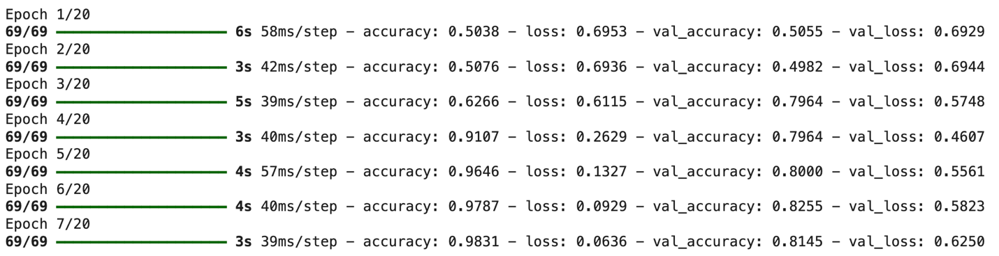

Early stopping had a clear impact on the training process by limiting the number of epochs and reducing overfitting. Although the model was configured to train for up to 20 epochs, early stopping monitored validation loss with a patience of three epochs. As a result, training stopped at epoch 7, when validation performance stopped improving.
Continuing beyond this point led to higher validation loss without meaningful accuracy gains, which confirmed that the model had already learned the most useful patterns from the data. Using early stopping not only improved generalization but also reduced unnecessary training time.
The final training output shows epoch 7 as the last completed epoch, with the model retaining the weights from the lowest validation loss. This behavior demonstrates that early stopping effectively identified the optimal point in training and prevented the model from overfitting. Seeing validation loss increase while training accuracy continued to improve made the effect of overfitting more concrete than it had been in theory.

2. Assess the fitness of the model and any actions taken to address overfitting.
The fitness of the model was assessed using accuracy and loss metrics across the training, validation, and test datasets. The final model achieved a test accuracy of approximately 82.18%, indicating that it is able to correctly classify the sentiment of unseen reviews at a reasonable level for a binary sentiment analysis task using short, informal text. The validation and test performance were close to one another, which suggests that the model generalizes fairly well and is not memorizing the training data.
Several actions were taken to address overfitting during model development. First, the dataset was split into training (80%), validation (10%), and test (10%) sets, which allowed model performance to be monitored on unseen data throughout training. Second, a Dropout layer (0.5) was added after the LSTM layer to randomly deactivate neurons during training, reducing the model’s reliance on any single feature and helping prevent overfitting. Third, early stopping was implemented by monitoring validation loss and stopping training when performance stopped improving, ensuring that the model did not continue training beyond the optimal number of epochs.
The training history further supports the model’s fitness: although training accuracy increased rapidly, validation loss stabilized and began to worsen after several epochs, triggering early stopping. This behavior indicates that the stopping criteria successfully prevented overfitting while preserving the best-performing model weights. One limitation observed during training was that the model occasionally struggled with reviews containing mixed sentiment, such as positive comments followed by a strong negative conclusion. This suggests that while the model performs well overall, more advanced architectures may be better suited for handling nuanced or conflicting sentiment. Overall, the model demonstrates acceptable fitness for sentiment classification, with appropriate regularization techniques applied to balance learning capacity and generalization.

3. Provide visualizations of the model’s training process, including a line graph of the loss and chosen evaluation metric.
Below are the visualizations used to evaluate the model’s training process. These line graphs show how the model’s loss and accuracy (chosen evaluation metric) changed over each training epoch for both the training and validation datasets.
Loss Over Epochs
The loss graph compares training loss and validation loss across epochs. Training loss decreases steadily as the model learns patterns in the data. Validation loss initially decreases as well, then stabilizes and slightly increases, which indicates the point where the model begins to overfit. This behavior supports the use of early stopping to halt training at the optimal epoch.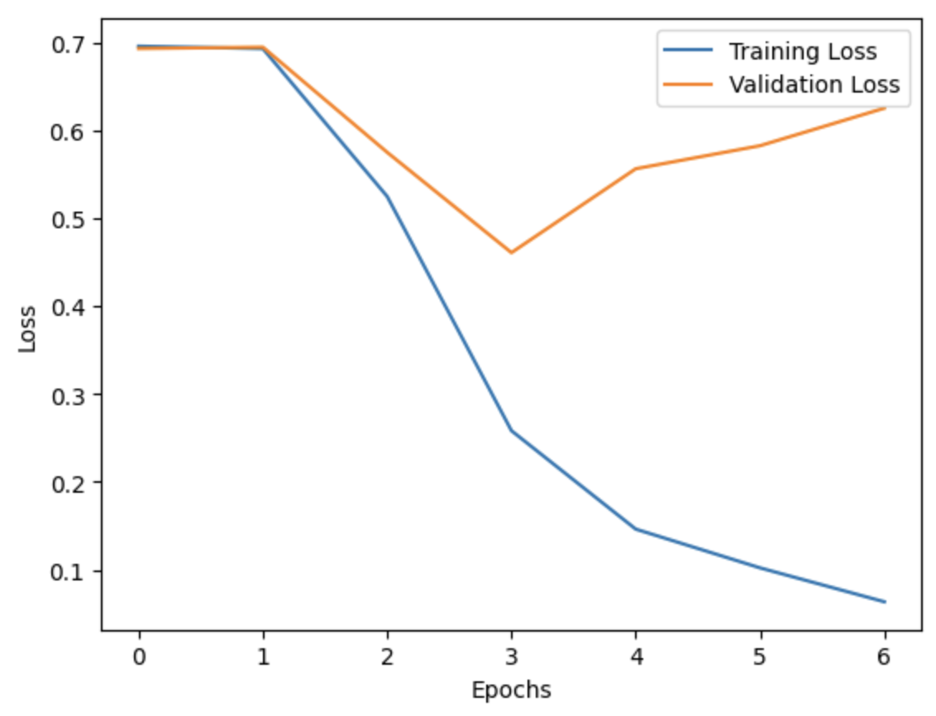
Accuracy Over Epochs
The accuracy graph displays training accuracy and validation accuracy over time. Training accuracy increases rapidly as the model learns sentiment patterns. Validation accuracy follows a similar trend but remains slightly lower, which is expected when evaluating on unseen data. The relatively small gap between the two curves suggests that the model generalizes reasonably well. 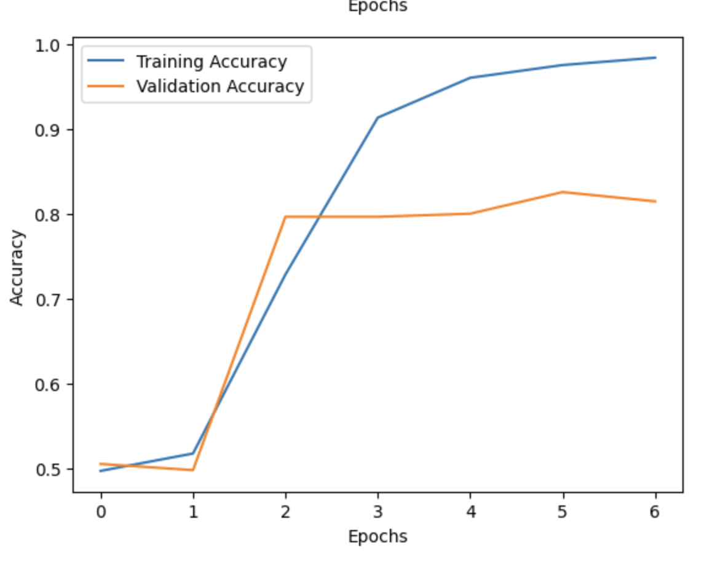

These visualizations made it easier to identify the point at which validation performance stopped improving, which directly supported the decision to rely on early stopping.

4. Discuss the predictive accuracy of the trained network using the chosen evaluation metric from part D3.
The predictive accuracy of the trained neural network was evaluated using classification accuracy, which measures the proportion of reviews that were correctly classified as positive or negative. Based on the test dataset, the model achieved an accuracy of 82.18%, indicating that it correctly predicted the sentiment of approximately seven out of every ten unseen reviews.
This level of accuracy suggests that the model is reasonably effective at capturing sentiment patterns across reviews from Amazon, IMDb, and Yelp. The accuracy is notably higher than random guessing (50% for a binary classification task), demonstrating that the network learned meaningful linguistic features related to sentiment. Minor differences between training, validation, and test accuracy indicate that the model generalizes fairly well, with limited overfitting.
Overall, the predictive accuracy shows that the neural network provides reliable sentiment classification and can be used to support organizational decision-making, such as identifying recurring customer complaints or highlighting commonly praised product and service features.

Part V: Summary and Recommendations
E. Provide the code you used to save the trained network within the neural network.
model.save("sentiment_lstm_model.keras")

F. Discuss the functionality of your neural network, including the impact of the network architecture.
The neural network performs binary sentiment classification by learning patterns in word sequences that indicate positive or negative sentiment. The embedding layer captures word meaning, while the LSTM layer processes the sequence of words to understand context. The dropout layer helps reduce overfitting, and the final dense layer produces a probability-based sentiment prediction.
Impact of the Architecture
The combination of word embeddings and an LSTM allows the model to capture both word meaning and word order, which are especially important for sentiment analysis (Jurafsky & Martin, 2023; Young et al., 2018). This architecture balances performance and computational efficiency and is well suited for moderate-sized datasets (Zhang et al., 2018).
G. Recommend a course of action based on your results.
The neural network has shown a test accuracy of around 82%, indicating it is quite effective at classifying customer sentiment across various review platforms. Organizations can utilize this model to automatically keep track of customer feelings, helping them quickly spot common problems or popular features. By analyzing negative reviews, companies can identify trends that may inform product redesigns, service enhancements, or training for customer support. Future improvements to the model could involve increasing the amount of training data, trying out advanced techniques like bidirectional LSTMs or transformer models, and adding more evaluation metrics such as precision and recall. Additionally, integrating the model into decision-making systems, like dashboards or feedback analysis tools, can aid in making informed choices about product quality, customer satisfaction, and brand management. Overall, these findings suggest that neural network-based NLP models can serve as a practical and scalable option for real-world sentiment analysis, particularly for high-level monitoring tasks. From a practical standpoint, this model provides a useful starting point rather than a final solution. While its accuracy is sufficient for high-level sentiment monitoring, further refinement would be needed before deploying it in a fully automated decision-making environment. From a practical standpoint, this project highlighted how even a moderately accurate model can still provide useful insights when its limitations are clearly understood.
Part VI: Reporting
H. Show your neural network in an industry-relevant interactive development environment (e.g., a Jupyter Notebook). Include a PDF or HTML document of your executed notebook presentation.
I. Denote specific web sources you used to acquire segments of third-party code that was used to support the application.

TensorFlow Documentation
TensorFlow Developers. (2024). Text classification with Keras.
https://www.tensorflow.org/tutorials/keras/text_classification

Analytics Vidhya: Sentiment Analysis with LSTM (2022) — https://www.analyticsvidhya.com/blog/2022/01/sentiment-analysis-with-lstm/
Chollet, F., et al. (2024). Keras documentation.
https://keras.io/api/
Natural Language Toolkit Project. (2024). NLTK documentation.
https://www.nltk.org/
Google. (2024). Google Colaboratory.
https://colab.research.google.com/

Python Software Foundation. (2024). re — Regular expression operations.
https://docs.python.org/3/library/re.html

Hunter, J. D., et al. (2024). Matplotlib plotting library documentation.
https://matplotlib.org/stable/contents.html

J. Acknowledge sources, using in-text citations and references, for content that is quoted, paraphrased, or summarized.
Jurafsky, D., & Martin, J. H. (2023). Speech and language processing (3rd ed.). Draft version. https://web.stanford.edu/~jurafsky/slp3/
Liu, B. (2015). Sentiment analysis: Mining opinions, sentiments, and emotions. Cambridge University Press. https://doi.org/10.1017/CBO9781139084789
Young, T., Hazarika, D., Poria, S., & Cambria, E. (2018). Recent trends in deep learning-based natural language processing. IEEE Computational Intelligence Magazine, 13(3), 55–75. https://doi.org/10.1109/MCI.2018.2840738
Zhang, X., Zhao, J., & LeCun, Y. (2018). Character-level convolutional networks for text classification. Advances in Neural Information Processing Systems, 31, 649–657. https://proceedings.neurips.cc/paper/2015/file/250cf8b51c773f3f8dc8b4be867a9a02-Paper.pdf

