Brittney Orais
D212 Task 3

Part I: Research Question
A. Describe the purpose of your data mining report by doing the following:
1. Propose one question relevant to a real-world organizational situation that you will answer using market basket analysis.
"When a patient is prescribed Glipizide, a medication for type 2 diabetes, what other medications are they likely to receive at the same time or in their prescription history?"

2. Define one goal of the data analysis. Ensure your goal is reasonable within the scope of the selected scenario and is represented in the available data.
The purpose of this data analysis is to apply market basket analysis techniques, such as support, confidence, and lift, to uncover common co-prescription patterns for patients taking Glipizide. This information is crucial for healthcare providers because it can reveal typical medication combinations, potential drug interactions, and adherence to treatment guidelines. For example, suppose a strong connection is found between Glipizide and a blood pressure medication. In that case, it may indicate that many diabetes patients also have hypertension, which can lead to improved care strategies. Additionally, hospitals can leverage this data to manage their inventory and develop targeted patient care programs. By identifying which drugs are frequently prescribed together, hospitals can optimize their stock and enhance patient consultations. The analysis will look for rules like Glipizide > Metformin, Lisinopril, suggesting that patients on Glipizide are likely also to take Metformin and Lisinopril. The lift metric will help determine if this relationship is statistically significant, with a lift greater than 1 indicating a strong likelihood of co-prescription among these patients. (Oracle, n.d.; DataCamp, n.d.)

Part II: Market Basket Justification
B. Explain the reasons for using market basket analysis by doing the following:
1. Explain how market basket analyzes the selected data set. Include expected outcomes.
Market basket analysis is a technique used to identify relationships among items within transactional data by examining how frequently items appear together using metrics such as support, confidence, and lift (Oracle, n.d.; ScienceDirect, n.d.). It is especially helpful when looking at patient prescriptions for Glipizide. In this context, each patient's full list of prescriptions is seen as a "basket," with the individual medications acting as "items." The goal is to identify patterns, such as Glipizide leading to Other Medications. To achieve this, three key metrics are utilized: support measures how frequently Glipizide is prescribed with other drugs, confidence indicates the probability that a patient on Glipizide is also taking those other medications, and lift shows how much more likely these drugs are to be prescribed together compared to random chance. A lift value above 1 points to a significant connection, while a value below 1 suggests a weaker link. The insights gained from this analysis could reveal that many diabetes patients on Glipizide also take medications for conditions like hypertension or need additional diabetes treatments. This information can assist healthcare providers in enhancing care strategies by recognizing common co-prescription trends. Additionally, hospitals and pharmacies can use these insights for better inventory management, ensuring they have the right stock of frequently combined medications, and creating targeted patient care programs or alerts for specific drug combinations. (DataCamp, n.d.)

2. Provide one example of transactions in the data set.
In Market Basket Analysis, a transaction is a specific set of items purchased together during a particular event. In the context of studying patient co-prescription patterns, each transaction represents a patient's complete prescription history or a snapshot of the medications they filled over two years. Think of a transaction as a "basket" filled with "items"; in retail, this might include groceries like bread and milk, while here, it consists of medications such as Glipizide, Metformin, and Lisinopril. For example, one transaction in the dataset includes the medications Glipizide, Metformin, and Lisinopril prescribed to a single patient. (ScienceDirect, n.d.; Oracle, n.d.).
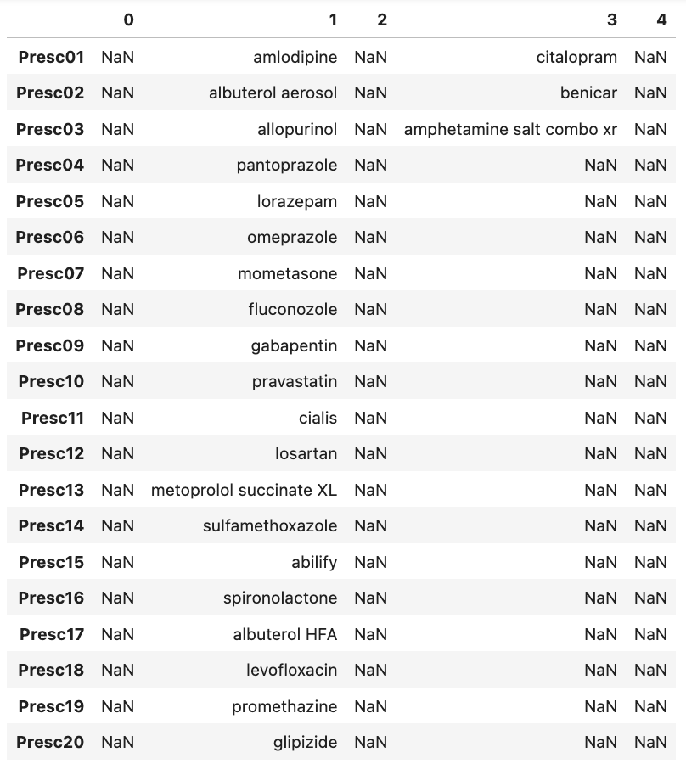

3. Summarize one assumption of market basket analysis.
Market basket analysis relies on the Apriori property, which assumes that if an itemset is frequent, all of its subsets must also be frequent, allowing infrequent combinations to be eliminated early in the analysis process (ScienceDirect, n.d.; Raschka, n.d.). This helps algorithms like Apriori to work more efficiently by not having to check every possible combination. If a smaller group of items is uncommon, the algorithm assumes that any larger group that includes it will also be rare, so it skips those combinations. Each transaction, such as a patient record, is considered separately, which means the patterns found show general trends rather than being influenced by related transactions. Each transaction is treated as independent, and items are represented in a binary present-or-absent format, meaning the analysis focuses on co-occurrence rather than causality (Oracle, n.d.). For example, when looking at medications, each drug in a patient's record is seen as independent, meaning one medication's presence doesn't affect the likelihood of another. The analysis uses measures like lift to see how often two medications are prescribed together compared to what would happen by chance. If Glipizide and Lisinopril are often prescribed together, it suggests a strong connection, even if there's no specific medical reason for it. Each patient record is treated the same when calculating support and confidence, ignoring individual patient histories. Therefore, trends observed in one hospital or clinic are believed to reflect overall patterns in Glipizide prescriptions. (ScienceDirect, n.d.)

Part III: Data Preparation and Analysis
C. Prepare and perform market basket analysis by doing the following:
1. Transform the data set to make it suitable for market basket analysis. Include a copy of the cleaned data set.
The data preparation phase began by importing the medical prescription dataset into Jupyter Notebooks using Python libraries such as Pandas, NumPy, Matplotlib, and the mlxtend package. An initial review of the dataset was conducted using the shape, info, and head functions to understand its structure, data types, and the presence of missing values. The dataset contains 15,002 rows and 20 columns, with each row representing a single patient’s prescription record and each column representing a medication position.
To make the dataset suitable for market basket analysis, each patient record was converted into a transaction by removing null values within each row while preserving the original row count. Removing null values from transactions is necessary to prevent missing data from being misinterpreted as meaningful items during association rule mining (GeeksforGeeks, 2025b). This transformation ensured that each transaction accurately reflected the complete list of medications prescribed to a single patient. Maintaining one transaction per patient is essential for valid market basket analysis, as it preserves the independence of transactions required by the Apriori algorithm.
The cleaned list of transactions was then transformed into a one-hot encoded binary matrix using the TransactionEncoder from the mlxtend library. In this encoded dataset, each column represents a unique medication, and each row indicates whether that medication was present in a patient’s prescription record. This binary format allows the Apriori algorithm to efficiently calculate support values and identify frequent itemsets. The final cleaned and encoded dataset consists of 15,002 transactions and was exported as a CSV file (medical_2123_data.csv) for use in subsequent analysis. (Raschka, n.d.; DataCamp, n.d.)
import numpy as np
import matplotlib.pyplot as plt
import pandas as pd
from mlxtend.frequent_patterns import apriori, association_rules
from mlxtend.preprocessing import TransactionEncoder

md = pd.read_csv('medical_market_basket.csv')

print(md.shape)

print(md.info())

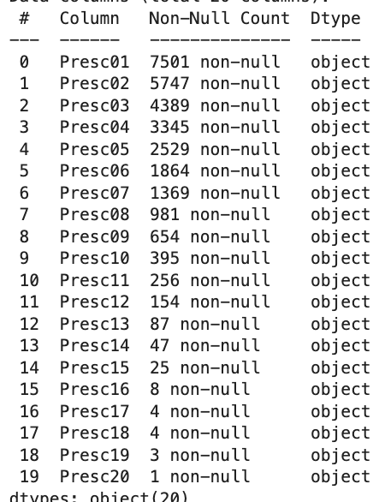

md.head(5).T
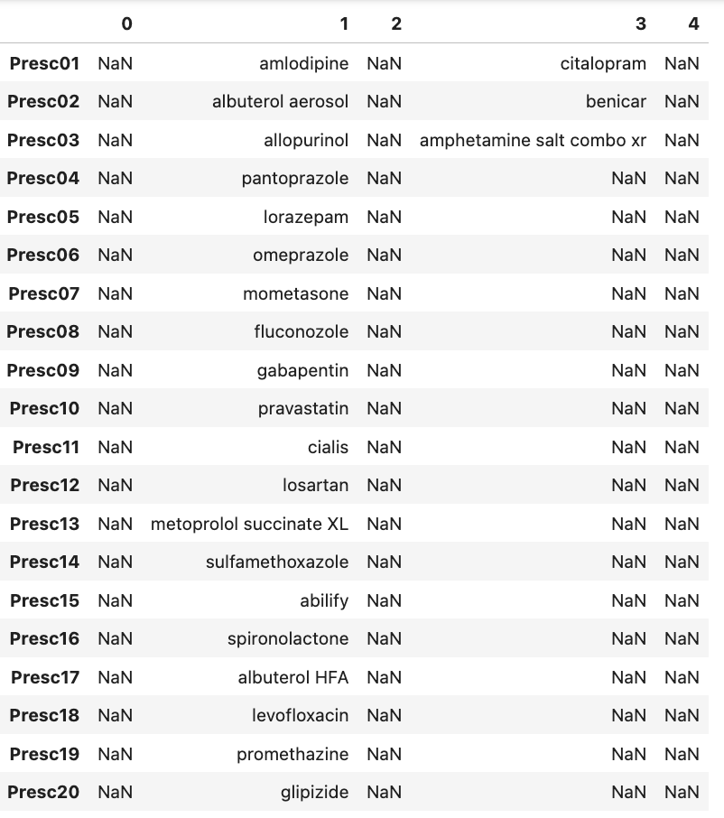
mdlist = md.apply(lambda row: row.dropna().tolist(), axis=1).tolist()
encoder = TransactionEncoder()
temp_array = encoder.fit(mdlist).transform(mdlist)
mdencode = pd.DataFrame(temp_array, columns=encoder.columns_)
mdencode

mdencode.to_csv('medical_2123_data.csv', index=False)

2. Execute the code used to generate association rules with the Apriori algorithm. Provide screenshots that demonstrate that the code is error free.

fIS = apriori(mdencode, min_support = 0.005, use_colnames = True)
fIS = fIS.sort_values(by='support', ascending=False)
fIS

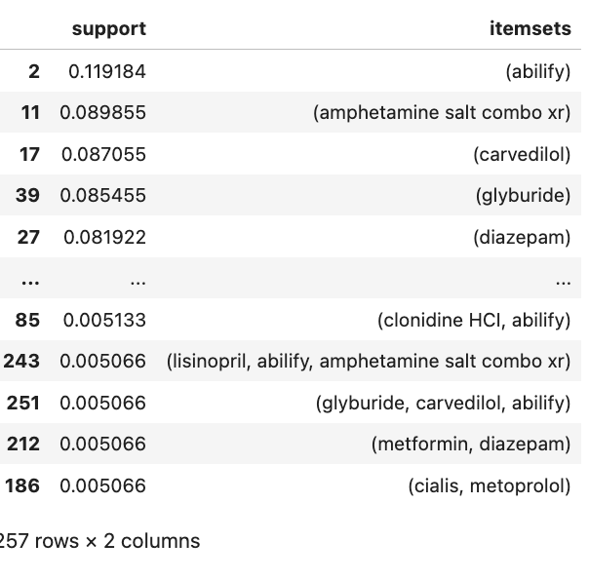

3. Provide values for the support, lift, and confidence of the association rules table.
rules = association_rules(fIS, metric = 'lift', min_threshold = 1.0)
rules

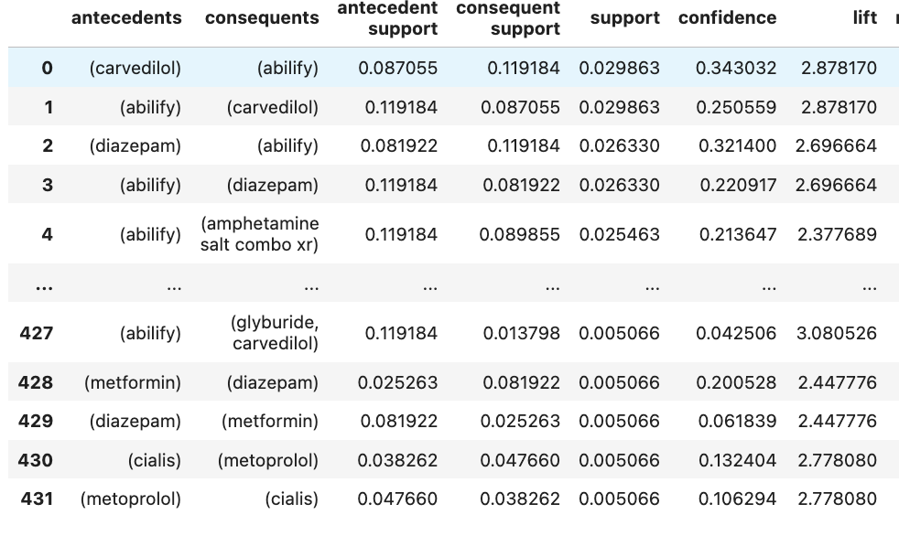

4. Explain the top three relevant rules generated by the Apriori algorithm. Include a screenshot of the top three relevant rules.

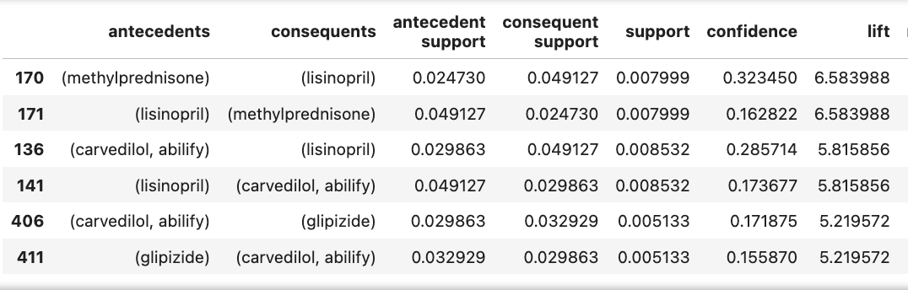
Association rules with high lift values are considered especially relevant because they highlight item relationships that occur significantly more often than expected under independence assumptions (Oracle, n.d.; ScienceDirect, n.d.).
Rule 1: (methylprednisone → lisinopril)
This rule has the highest lift value of 6.58, indicating a very strong association between methylprednisone and lisinopril. A lift greater than 1 suggests a positive relationship, and a value this high means patients prescribed methylprednisone are over six times more likely to also be prescribed lisinopril compared to the general population. The confidence of 32.35% shows that nearly one-third of patients receiving methylprednisone also receive lisinopril, making this a clinically meaningful co-prescription pattern despite its relatively low overall support.

Rule 2: (lisinopril → methylprednisone)
This rule is the reverse of Rule 1 and also has a lift of 6.58, reinforcing the strong bidirectional relationship between lisinopril and methylprednisone. The confidence value of 16.28% indicates that a notable portion of patients on lisinopril are also prescribed methylprednisone. The high lift confirms that this co-occurrence happens far more frequently than would be expected by chance, suggesting a meaningful prescribing relationship.

Rule 3: (carvedilol, abilify → lisinopril)
The third strongest rule shows that patients prescribed both carvedilol and abilify are over 5.8 times more likely to also be prescribed lisinopril compared to the average patient. This rule has a confidence of 28.57%, indicating that more than one in four patients receiving carvedilol and abilify also receive lisinopril. The elevated lift highlights a strong association among these medications, which may reflect overlapping treatment of cardiovascular and mental health conditions.

Although the research question focuses on Glipizide, the top association rules were selected based on overall lift values to highlight the strongest medication relationships in the dataset. These rules provide a broader clinical context for prescribing patterns that coexist alongside Glipizide-related treatments.

Part IV: Data Summary and Implications
D. Summarize your data analysis by doing the following:
1. Summarize the significance of support, lift, and confidence from the results of the analysis.

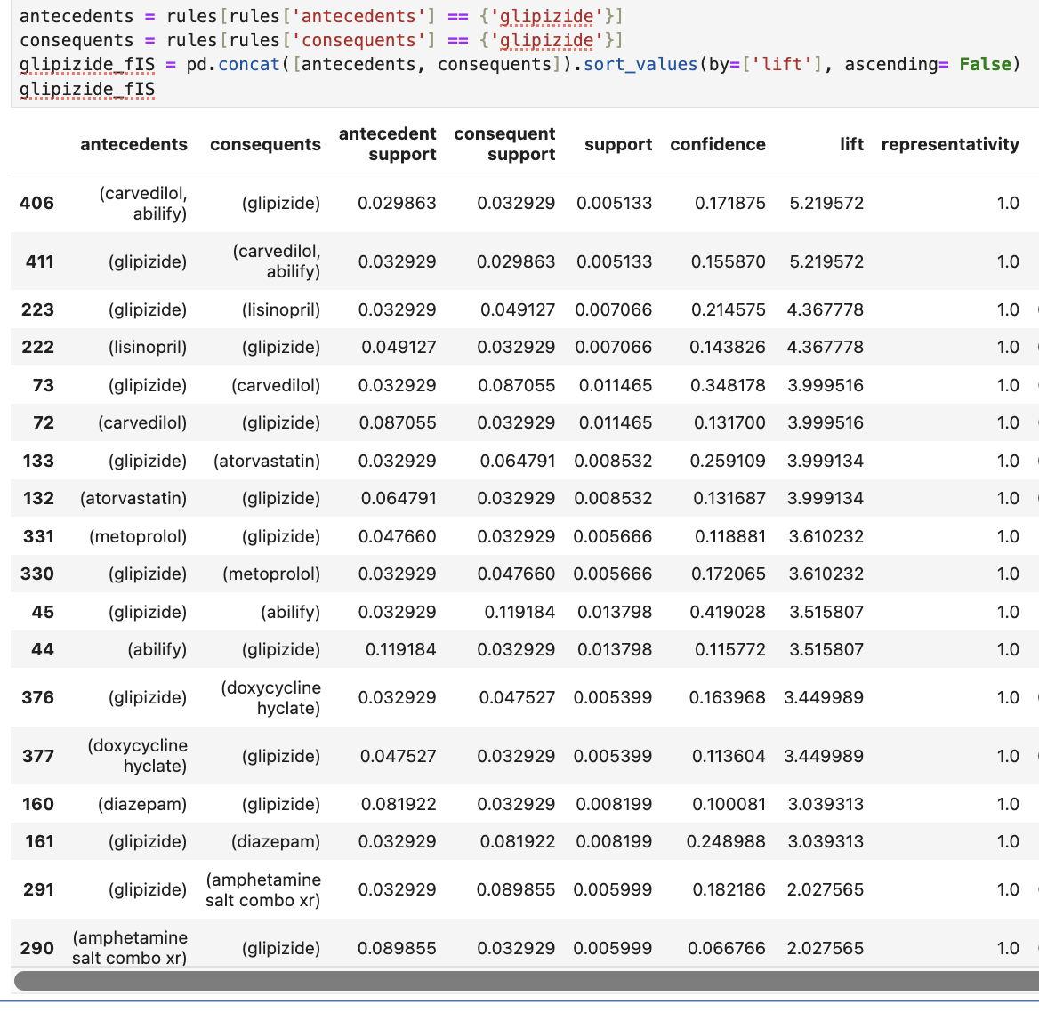

Support, confidence, and lift are key metrics used to evaluate the strength and relevance of association rules generated through market basket analysis. Support measures how frequently a combination of medications appears across all transactions, helping identify how common a particular co-prescription is within the dataset. In this analysis, support values are generally low, which is expected in medical data where prescriptions are highly individualized. Despite low support, these rules remain meaningful when paired with strong confidence and lift values.
Confidence represents the conditional probability that a patient prescribed one medication is also prescribed another. For example, when Glipizide is used as the antecedent, the rule (Glipizide → Abilify) has a confidence of approximately 41.9%, indicating that Abilify appears in nearly half of Glipizide-containing prescriptions. This suggests a notable co-prescribing pattern, even though the overall frequency of the combination is limited.
Lift measures the strength of the association by comparing the observed co-prescription rate to what would be expected if the medications were independent. Lift values greater than 1 indicate a meaningful positive relationship. Several Glipizide-related rules have lift values between 3.0 and 5.2, such as (Carvedilol, Abilify → Glipizide) with a lift of 5.22, showing these medications are prescribed together far more often than would occur by chance. Together, these metrics demonstrate that while Glipizide-related combinations are not widespread, they represent strong and statistically meaningful associations.

2. Discuss the practical significance of your findings from the analysis.
The practical significance of these findings lies in their ability to highlight common co-prescription patterns among patients with complex medical needs. Identifying medication co-prescription patterns can help healthcare organizations better understand common treatment combinations and support improved coordination of care (Drugs.com, n.d.; ScienceDirect, n.d.). Many of the strongest associations involving Glipizide include cardiovascular medications such as Carvedilol, Lisinopril, Atorvastatin, and Metoprolol, suggesting that patients treated for type 2 diabetes often also manage hypertension or other cardiovascular conditions. This aligns with real-world clinical practice, where diabetes frequently coexists with heart disease.
Additionally, strong associations between Glipizide and Abilify or Diazepam indicate that some patients are being treated simultaneously for metabolic and mental health conditions. Although these combinations have relatively low support, their high lift values suggest that when one medication is present, the likelihood of the other increases substantially. These insights can assist healthcare organizations in anticipating medication demand, identifying patient populations with multiple comorbidities, and supporting coordinated care efforts.

3. Recommend a course of action for the real-world organizational situation from part A1 based on the results from part D1.
Based on the results of the analysis, healthcare organizations should use these findings to improve clinical coordination, inventory management, and patient engagement. When Glipizide is prescribed, pharmacies and hospitals should anticipate potential co-prescriptions of cardiovascular medications such as Lisinopril, Carvedilol, Atorvastatin, and Metoprolol, ensuring adequate stock levels to prevent delays in treatment.
Clinical decision support systems can also be enhanced to flag common Glipizide-related co-prescriptions, prompting providers to review cardiovascular and mental health considerations during patient visits. This can lead to more comprehensive medication reviews and improved patient safety. Finally, healthcare organizations may develop targeted educational materials focused on managing diabetes alongside cardiovascular and mental health conditions, helping patients better understand their treatment plans and encouraging adherence to prescribed therapies. Insights gained from market basket analysis can be used to enhance inventory management, reduce medication shortages, and support informed decision-making within healthcare organizations (Oracle, n.d.; DataCamp, n.d.).

Part V: Attachments
E. Provide a Panopto video recording that includes the presenter and a vocalized demonstration showing all code used, the code being executed, and the results of all code used in the task.

F. Record all web sources you used to acquire data or segments of third-party code to support the application. Ensure the web sources are reliable.
365 Data Science. (2023, April 24). How to perform market basket analysis in Python.
https://365datascience.com/tutorials/python-tutorials/market-basket-analysis/
DataCamp. (n.d.). Apriori algorithm explained: A step-by-step guide with Python implementation.
https://www.datacamp.com/tutorial/apriori-algorithm
Drugs.com. (n.d.). Drugs & medications A–Z.
https://www.drugs.com/drug_information.html
GeeksforGeeks. (2025, July 12). Implementing Apriori algorithm in Python.
https://www.geeksforgeeks.org/machine-learning/implementing-apriori-algorithm-in-python/
GeeksforGeeks. (2025, July 23). How to create a list of lists in Python.
https://www.geeksforgeeks.org/python/python-list-of-lists/
Oracle. (n.d.). What is market basket analysis?
https://www.oracle.com/artificial-intelligence/what-is-market-basket-analysis/
Raschka, S. (n.d.). Frequent itemset mining with MLxtend.
https://rasbt.github.io/mlxtend/user_guide/frequent_patterns/apriori/
ScienceDirect. (n.d.). Market basket analysis.
https://www.sciencedirect.com/topics/computer-science/market-basket-analysis
G. Acknowledge sources, using in-text citations and references, for content that is quoted, paraphrased, or summarized.

H. Demonstrate professional communication in the content and presentation of your submission

