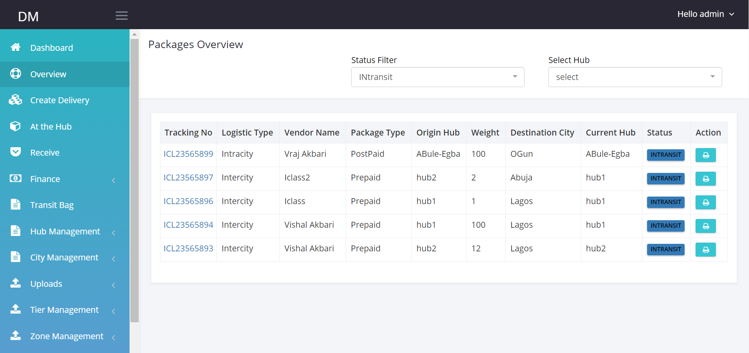

Search

Add search to the Overview page. I want to be able to search by Tracking Number, Customer Name, phone Number, Package type, Created date.

**At the Hub Tab**

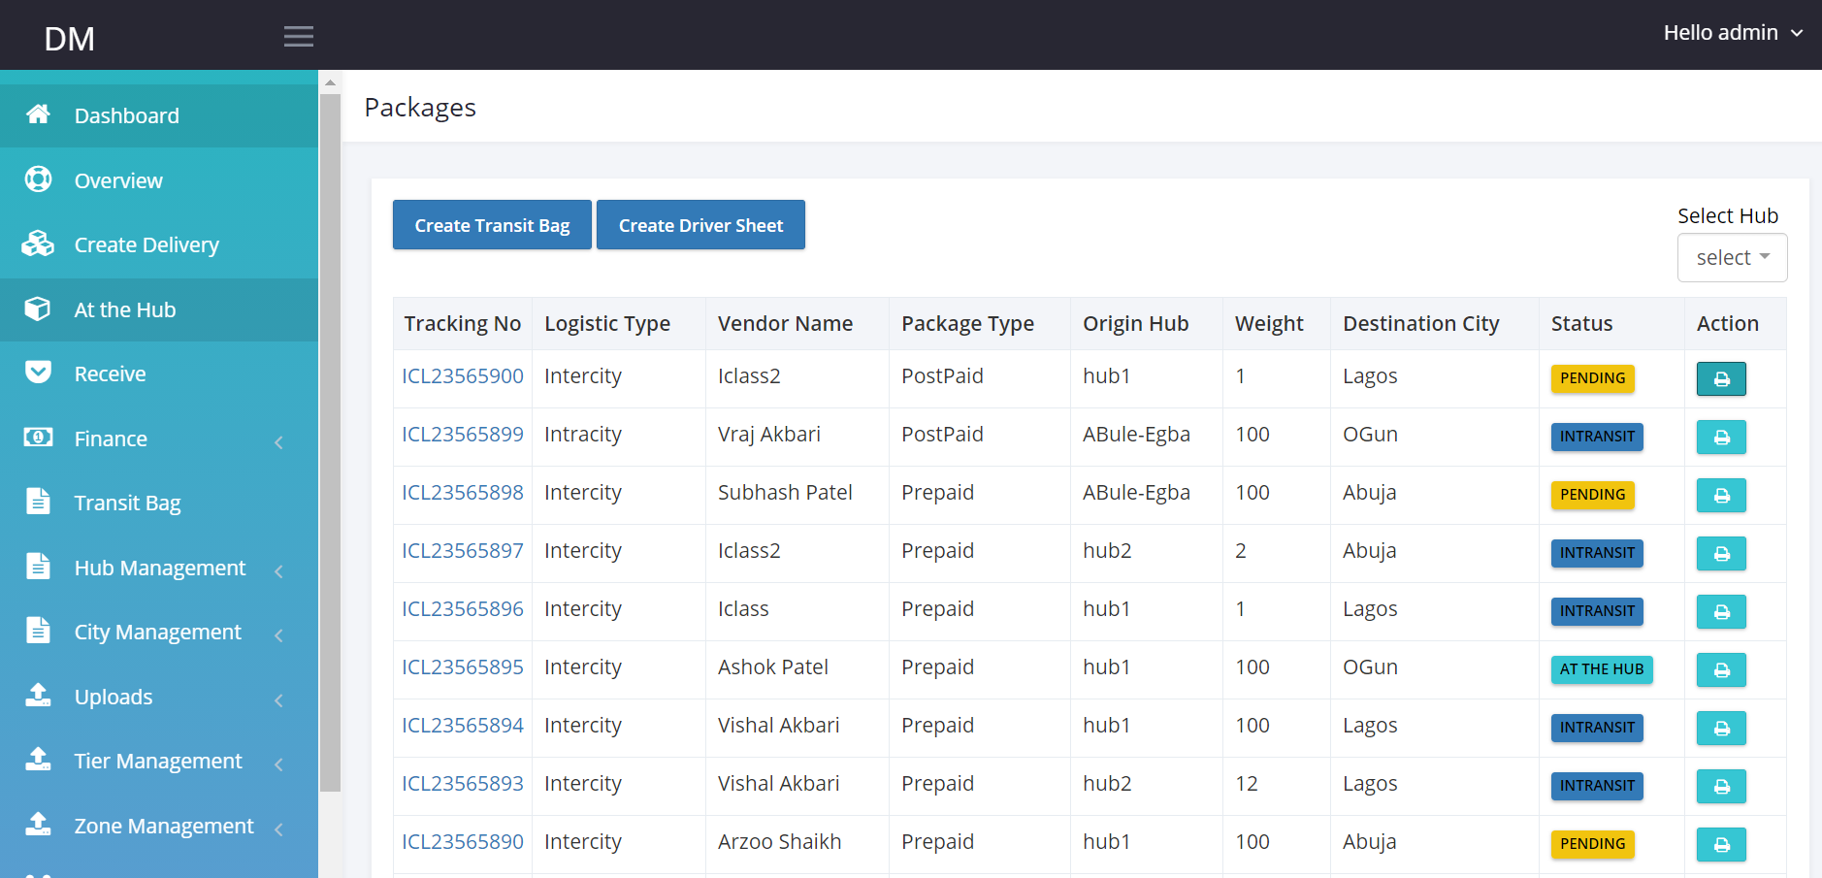

Export Csv

Search

**Add search by Tracking Number, Customer Name, Customer Phone Number, package Type.**

**Add Export Csv.**

**When creating Driver sheet, I should be able to create for packages with “pending status” and “At the Hub” status.**

**Driver login; Put a refresh button.**

**Search for customer.**