ROOM CONTROLLER
Feature Overview & Product Capabilities
What the platform does today, who it serves, and where it is headed
Prepared for investor review
Version 4.0 — Confidential
Companion to the Technical Architecture & Technology Stack document.

Product Vision
Room Controller turns any room into a remotely and self-manageable space — lights, fans, or any relay-switched device — using low-cost hardware, a managed cloud backend, and a dashboard that installs like an app on any phone, tablet, or laptop. It is built for owners and operators who need to manage one room or hundreds, across one site or many, without hiring an operations team to run it.
The next section gives a one-page view of the platform’s core capabilities; the sections after that go one level deeper on each, followed by target use cases and the near-term roadmap.

Feature Highlights — At a Glance
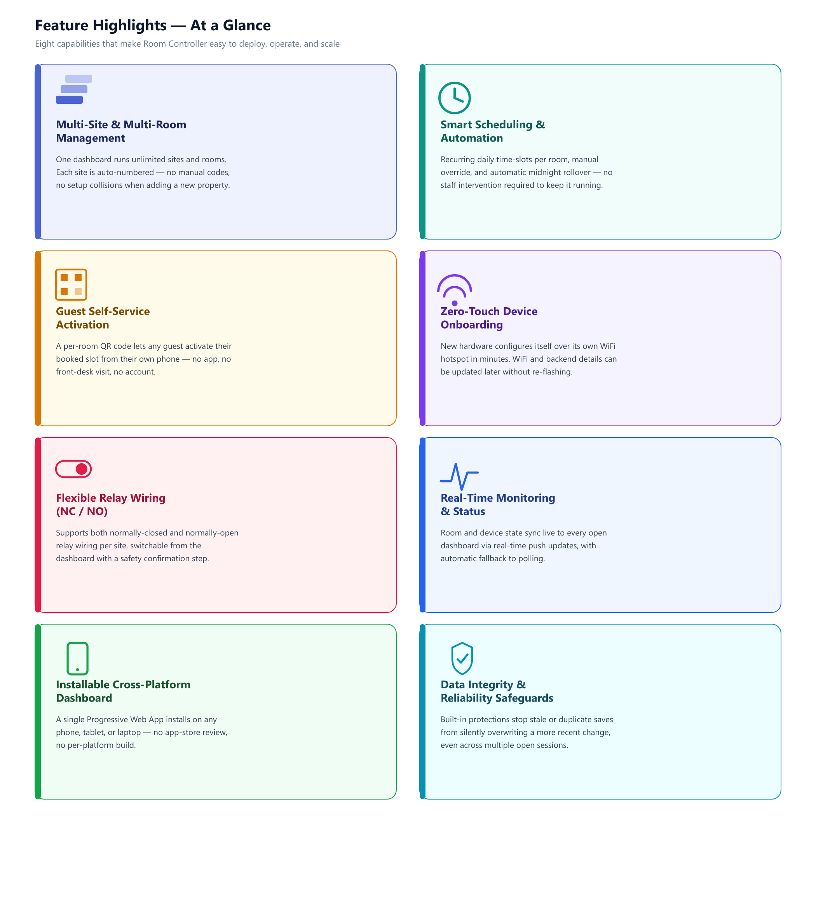

Feature Deep Dive
Multi-Site & Multi-Room Management

- Manage any number of independent sites from a single app installation, switching between them from one dropdown.
- Every site is assigned an automatic, incremental numeric key the moment it is saved — no typed codes, no naming collisions.
- Rooms, and each room’s relay/LED wiring, can be added or removed per site without touching firmware or code.

Why it matters: A single deployment scales from a single room to a multi-property portfolio without any change in how the backend is provisioned.

Smart Scheduling & Automation

- Each room supports recurring daily time-slots, so a schedule set once keeps running without daily staff input.
- A manual override always takes priority over the schedule — on, off, or back to automatic, at any time.
- Slots reset automatically at midnight, so the same recurring schedule is ready again the next day without manual re-entry.

Why it matters: Less staff time spent on manual switching translates directly into lower operating cost per site.

Guest Self-Service Activation

- Every room has its own QR code, generated from the dashboard, linking directly to a lightweight activation page.
- A guest scans it with any phone camera — no app install, no account creation.
- Entering the access code tied to their booking activates that room for the booked window only.

Why it matters: Removes front-desk-style staffing from the guest access flow, which is a direct labor-cost saving at scale.

Zero-Touch Device Onboarding

- A brand-new device creates its own temporary WiFi hotspot and setup page on first power-up — no laptop or programmer required on site.
- WiFi credentials and the backend connection can be changed later at any time, without re-flashing the device.
- Per-room hardware pins are configured from the dashboard, not hardcoded in firmware — the same firmware image works across every deployment.

Why it matters: A new site can be brought online by non-technical staff in minutes, which matters directly for install cost and rollout speed.

Flexible Relay Wiring (NC / NO)

- Supports both normally-closed and normally-open relay wiring conventions from the same firmware.
- Wiring mode is a per-site configuration choice, changeable from the dashboard rather than requiring different hardware or code.
- Changing it prompts a confirmation step, since it changes what the physical relay actually does — a deliberate safety guardrail.

Why it matters: One product SKU can be installed against whichever relay hardware a site already has, instead of stocking two variants.

Real-Time Monitoring & Status

- Room and device state — online/offline, current relay state — pushes live to every open dashboard.
- Real-time updates use a lightweight live-sync connection, with automatic fallback to periodic polling if that connection isn’t available.
- An activity log keeps a rolling history of recent actions and events per site for quick troubleshooting.

Why it matters: Operators see the true state of every room without needing to physically check it, which is the foundation for managing many sites remotely.

Installable Cross-Platform Dashboard

- Ships as a single Progressive Web App — one codebase reaches phones, tablets, and laptops alike.
- Installs to a home screen like a native app, with no app-store submission, review cycle, or per-platform build.
- Works through short connectivity gaps via offline-tolerant caching of the app shell.

Why it matters: No app-store dependency or platform-specific engineering cost, and every update reaches every user immediately on next load.

Data Integrity & Reliability Safeguards

- A save-versioning guard detects when a browser tab’s data has gone stale relative to a more recent save elsewhere, and refuses to silently overwrite it.
- Slot and schedule edits write directly to their own record, avoiding the class of bug where a wholesale update accidentally clobbers unrelated data.
- The user is warned in-app when a conflict is detected, rather than the app failing silently.

Why it matters: These are the kind of quiet correctness details that determine whether a multi-user product is trustworthy at scale, not just in a demo.

Target Use Cases
Short-Term Rentals & Vacation Homes
Owners manage lighting and devices remotely per booking; guests self-activate their stay via QR code without a smart-lock-style hardware swap.

Small Hotels & Guest Houses
Front-desk-free guest activation reduces staffing overhead for room access while owners keep full visibility and override control.

Co-Working & Meeting Rooms
Facilities teams manage many rooms across one or more locations from a single dashboard, with access tied to booking windows.

Multi-Property Portfolios
One backend deployment scales to many independently-numbered sites without new infrastructure per additional property.

Home & Small-Office Automation
Straightforward per-room scheduling and override for everyday lighting or device control, with no subscription hardware ecosystem required.

Roadmap
Illustrative near-term direction, shown to indicate where the platform is headed — not a delivery commitment.
Now — Shipped in v4.0  • Multi-site profiles with automatic numbering  • NC / NO relay wiring, confirmed from the dashboard  • Guest QR self-activation  • Save-versioning data-integrity guard | Next — Near Term  • Optional Firebase Authentication / App Check for higher-security sites  • Usage & occupancy analytics per site  • Duplicate-database-URL detection across profiles | Later — Exploratory  • Multi-network WiFi fallback for high-uptime sites  • Native push notifications for device/room alerts  • Role-based staff access permissions

Companion Document
This document is intentionally scoped to product features, use cases and roadmap. System architecture and technology choices are covered in the companion Technical Architecture & Technology Stack document, intended to be read alongside this one.

