Oran ben david

Roey gilor

Subject : Human resources management system in a software company

The HR_System is a database schema designed to manage human resources-related information within an organization. It provides a structure to store data about departments, teams, jobs, employees, paychecks, skills, personalities, interviews, candidates, and their respective relationships.

Here's a general description of the system:

Tables: The system consists of several tables to store different types of data. The main tables include:

1. department: Stores information about departments(id,name) within the organization.
2. team: Represents teams(id,name) within the organization and is linked to department and also linked to employee (1🡪M).
3. job: Contains details about different job positions in the organization and linked to skill(M🡪N),Personality(M🡪N),interview(M🡪N),Candidates(1🡪M) for example one candidate can apply to one job and one job have many candidates.
4. employee: Stores information about employees, including their job positions, teams, and employment dates. Employee linked to pay_check(1🡪M) and job(M🡪1).
5. pay_check: Contains data related to employee paychecks, including salary, month, and associated employee like we say before.
6. skill: Stores information about various skills that employees and candidates possess.skill is linked to job(M🡪N) and candidate(M🡪N).
7. personality: Contains data about different personality traits and linked to job(M🡪N),candidates(M🡪N).
8. interview: Stores information about different types of interviews during the hiring process and linked to job(M🡪N),candidates(M🡪N),status(M🡪N).
9. candidate: Contains information about candidates applying for job positions and linked to job(M🡪1),skills(M🡪N),interview(M🡪N),personality(M🡪N).
10. status: Stores various statuses related to the hiring process and linked to connection table between candidate and interview (1🡪M).

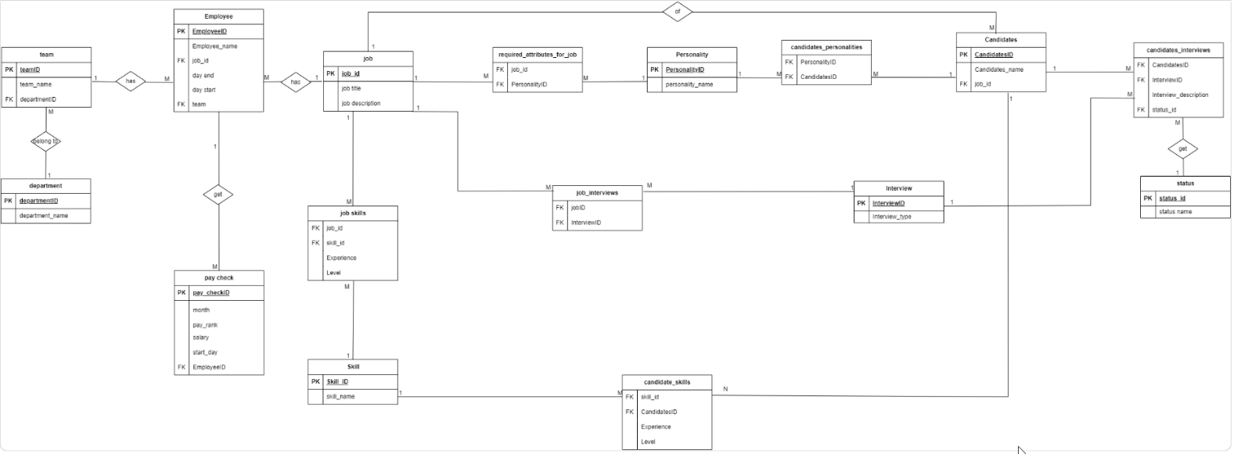Erd

**Hiring Manager**: Hiring Managers are responsible for recruiting and selecting candidates for specific job positions. They have access to job-related data and functionalities. Hiring Managers can create and manage job requirements, review candidate applications, interviews, update candidate statuses.

**HR Manager**: The HR Manager is responsible for overseeing the human resources functions within the organization. They have elevated privileges and access to HR-related data. HR Managers can perform tasks such as managing employee records, creating and modifying job positions, conducting interviews, processing paychecks, and generating HR reports. They may also have the ability to create and manage user accounts for other HR staff members.