Few notes to consider if you wish to use this app

1. Download the source code and install the required dependencies using npm install.
2. 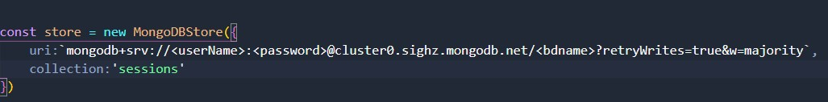In order to use this app, you must have a mongodb account (use mongo Atlas) so you can change the username, password and dbname as shown in this image to be your own (you can find this code in 🡪 app.js)
3. If you wish to allow a reset password you need to get an API key from

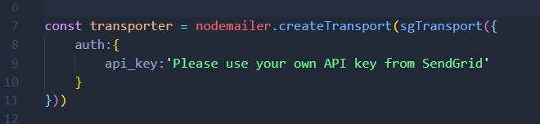SendGrid.com and insert it here

(you can find this code in 🡪 authController.js)

1. 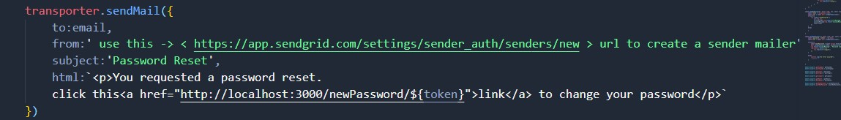With relation to the section above, you also need to create your own sender mailer. Use the URL shown in this image to create one, and insert the created email as a value to the key named “from” (you can find this code also in 🡪 authController.js)
2. With relation to section two, you will also need to repeat your steps in 🡪 database.js

Important Note:

When you first launch the application and register via the registration page the first email address, that email will be the Admin of the store.

Emails to be registered in a later point will be the clients