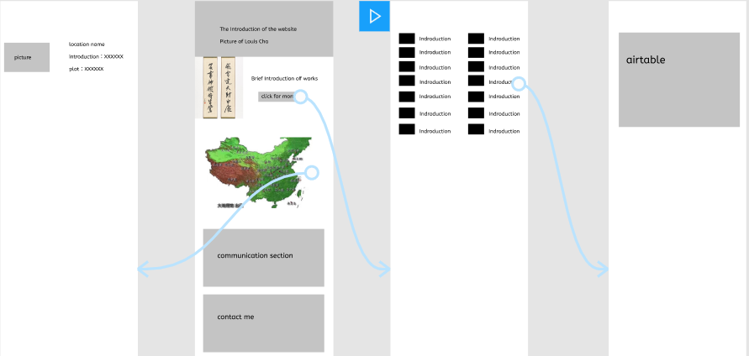

**Usability Text Analysis**

1. **Add navigation bar**

Users say that even though this prototype do not have many contents, but navigation can help them locate where they are easily. It should contain homepage, introduction of works, locations tourist evaluation and login link.

1. **Brief interesting intro of each novel**

One participant considers the overall experience is boring, this site should provide them (potential fans) more interesting and basic information, such as more pictures. An overview of each book may help them decide which one they want further to know.

1. **Comparison of each novel**

Respondents think it is useful for them to decide reading order and know about the quality of each work if the site can provide a sort about novels by ratings or by numbers of words.

1. **Divide locations into areas**

Considering the map in previous low-friendly prototype, it is hard to realize the interaction that when users click points on the map then it can show up location details. Respondents think that this site can provide other forms that people can know about both geographic locations and detailed information. Therefore, the website was redesigned the location part, dividing all locations into eight areas, which users can click for detailed information—ticket information, local cuisine, recommendation rating and introduction. Test users think these are important factors affecting them to tour.

Consistent with classification in the location section, location and corresponding plot part are also sorted by these eight areas, which is helpful for potential fans get a brief acknowledgment of the plot and then decide whether to read or not.

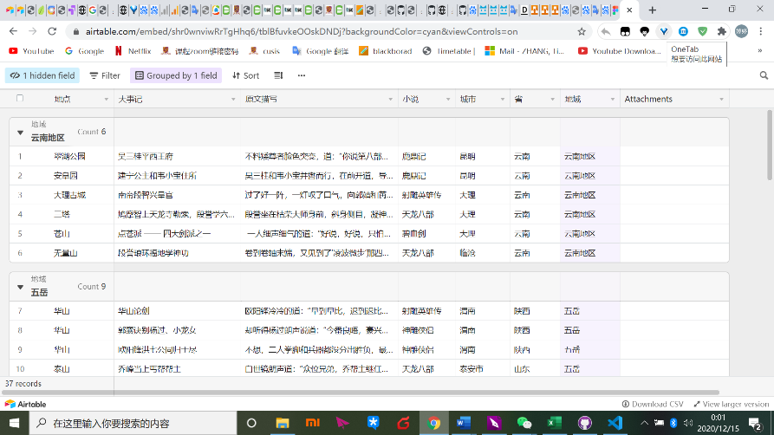

Location-plot

1. **Add tourist evaluations part**

For test users who would like to travel to these places, they want up-to-date tourist evaluations and guidelines. This site collects 2019-2020year evaluations from mafengwo.com and balances both good evaluations and bad evaluations. In the evaluation section of the table, users can unfold boxes to know more about this travelling experience like how they prepare for this tour and what tourists should pay attention to.

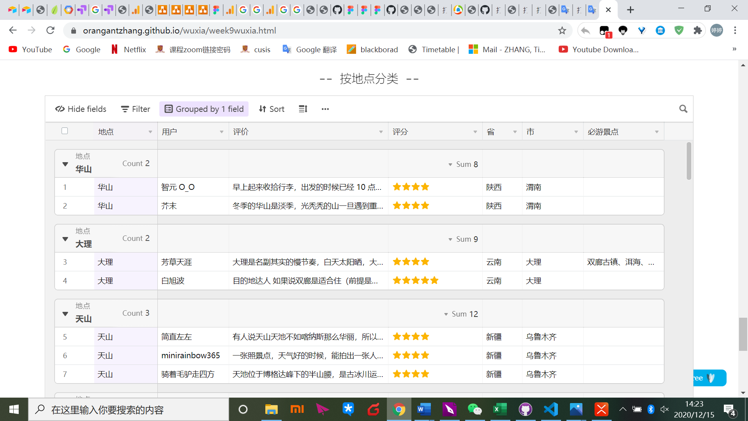

Tourist evaluations