

**The Modified Snowmelt Runoff Model**

**Graphical User Interface (GUI) User’s Manual**

**NASA Langley Research Center, DEVELOP Program, Hampton, VA 23681**

Jeffry William Ely, Old Dominion University

Joshua Kelly, University of Rhode Island

Lydia Cuker, College Of William and Mary

Joseph Novak, Old Dominion University

Laura Macaluso, Christopher Newport University

Bethany Burress, Christopher Newport University

Amberle Keith, Idaho State University

Ajoke Williams, Massachusetts Institute of Technology

**Contents**

**Topic Page**

Document Scope 3

Required Software 3

Graphical User Interface (GUI) Overview 4

Launching the Graphical User Interface 5

Prepare Inputs Panel 6

Tuning Factors Panel 12

Simulate and Validate Panel 14

Forecast Panel 17

Output File Descriptions 19

Detailed Input Parameter File Descriptions 21

Version (April 2014). Contact: [Jeff.Ely.08@gmail.com](mailto:Jeff.Ely.08@gmail.com)

**Document Scope**

This document has been provided as a resource for using the Graphical User Interface (GUI) provided with the NASA DEVELOP implementation of the Snowmelt Runoff Model script package. This package has been assembled will all the required inputs to simulate the Limarí, Copiapó, and the Huasco river basins in central northern Chile, and was created under guidance of the NASA DEVELOP National program. Simulation requires just one input file known as the “Master” file, usually of format ‘MasterYYYY.xls” where YYYY is equal to the year. Many steps must be performed to compile all data inputs into these Master files, so the processing package contains many scripts intended to be executed sequentially, with each script performing its small part of the overall process. Each script passes its information on to the next one by saving files, usually excel files. This allows advanced users to skip certain steps of the process or use their own data sources by making edits directly to input files. This document details every step of the GUI for users wishing to forecast for the three basins already characterized.

**Required Software**

Many of these scripts are written in the Matlab programming language and the Matlab software is required for use, but the GUI allows users with no Matlab experience to interface with all scripts provided at a basic level. Users who wish to learn more about Matlab should consult the Matlab educational resources available at the following location:

[ <http://www.mathworks.com/academia/student_center/tutorials/launchpad.html>]

Many of these resources are in video format with closed captioning in multiple languages including Spanish.

**Graphical User Interface Overview**

Below is a screenshot of the GUI with each object and field labeled with a number in red text. This number corresponds with a section in this document which discusses that specific field or button in greater detail.

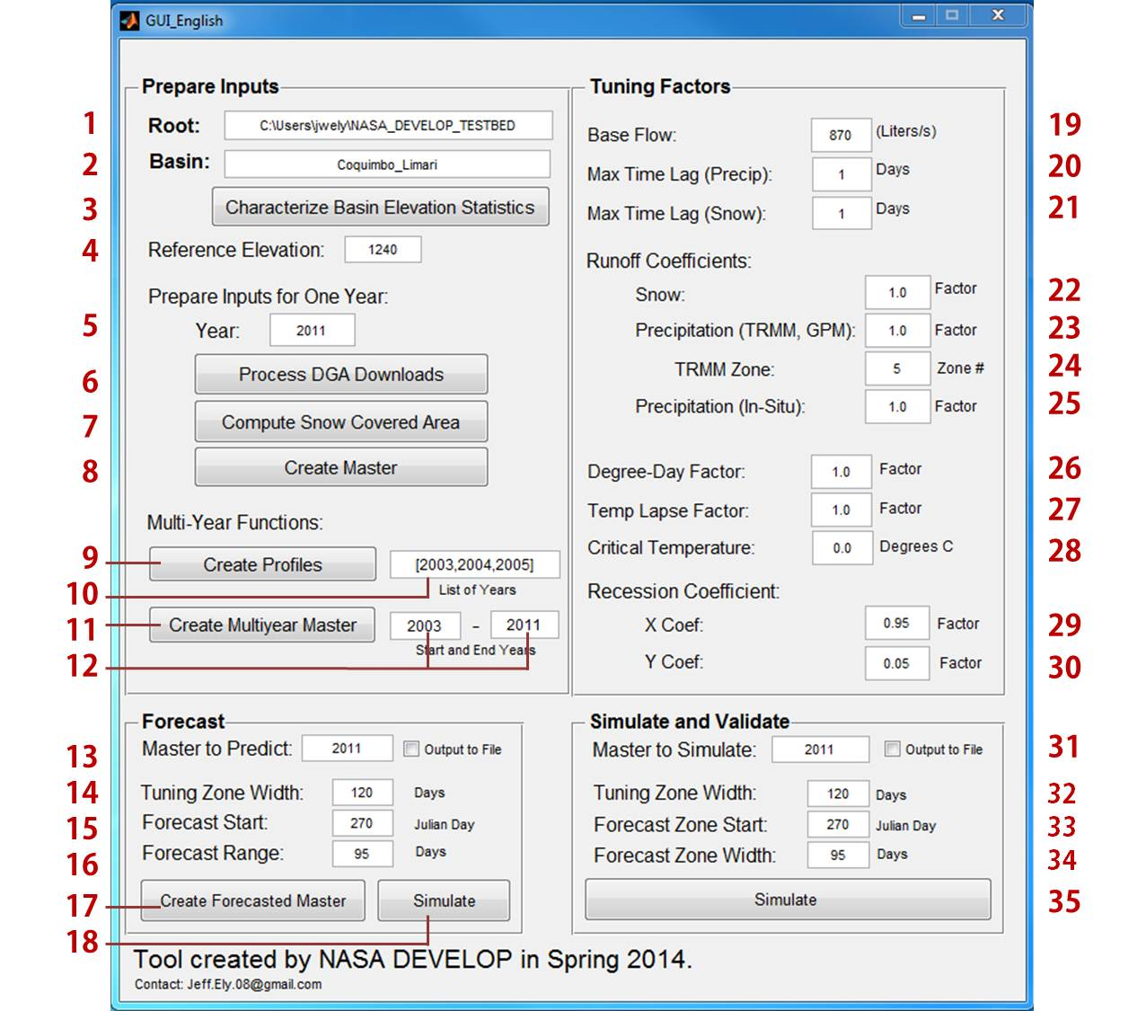

Files which are required by each script and files which are created by each script are specified in the descriptions provided. Scripts which list a required file will not work if that file does not exist, or is not in the correct format. These requirements typically list the entire file path, and for the purpose of this guide, all examples will be as though the year 2011 for the Limarí basin were being analyzed. Users performing analysis on a different basin will duplicate the exact same file structure under an appropriately named folder for the new basin like shown.

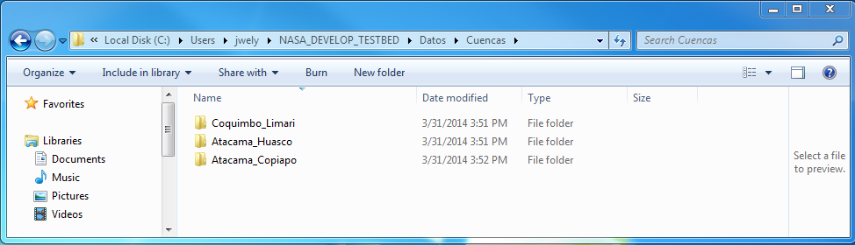

**Launching the Graphical User Interface**

There are two versions of the GUI, one in Spanish and one in English. Both versions of the GUI execute all the same scripts, but are simply labeled differently to aid Spanish and English speakers to understand the layout and functionality more quickly. To open the GUI, launch Matlab and navigate to [NASA\_DEVELOP\_SRM\Ejecutables\Matlab] in the “Current Folder” window as shown. Right click on the GUI of your language choice and click the “Run” option. This will launch the GUI.

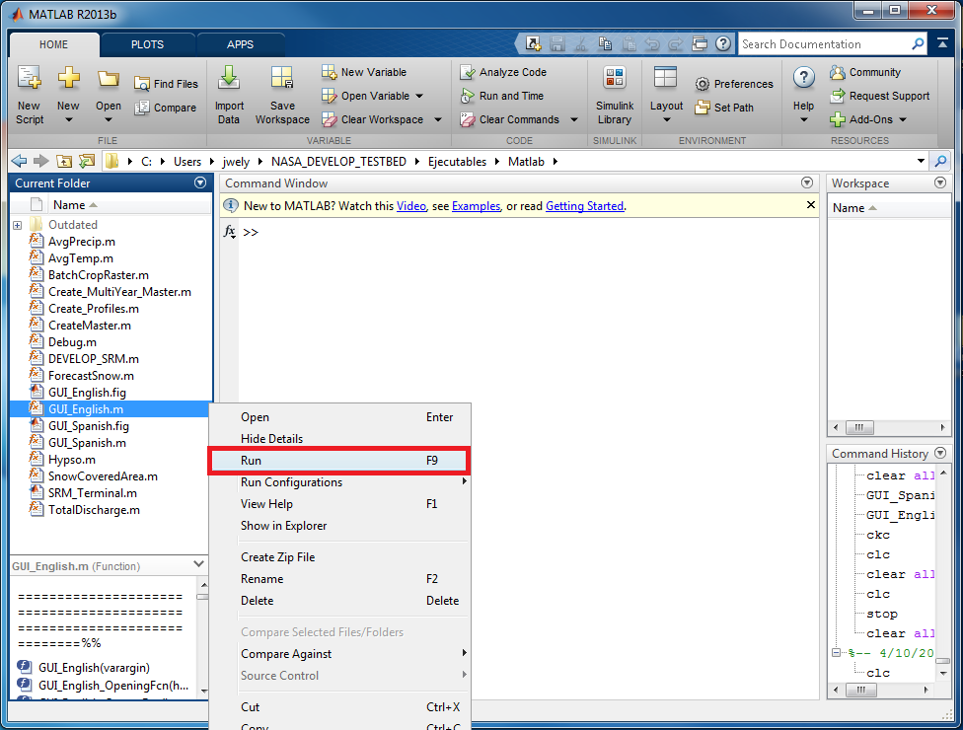

**Prepare Inputs Panel**

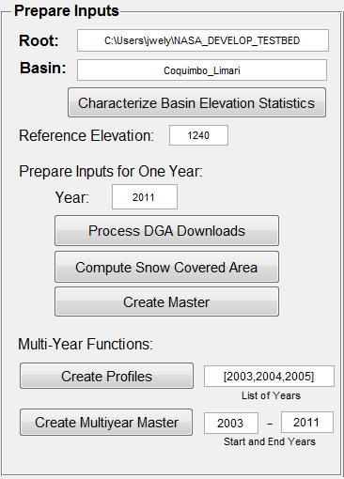This section is used to prepare data inputs for further processing. The primary function by which this script package performs Snowmelt Runoff Model simulations is by the creation of “Master” files, and this task is performed in this section.

1. **Root:** The path to the directory of the NASA\_DEVELOP\_SRM folder. All of the scripts controlled by the GUI require this input to be filled in correctly at all times. For example, on the system used

to develop these tools, the path is.  
 *[C:\Users\jwely\NASA\_DEVELOP\_TESTBED].*

1. **Basin:** The name of the basin folder containing the files and data to process. The value of this field must be exactly the same as the name of a folder located in [NASA\_DEVELOP\_SRM\Datos\Cuencas] as shown below.

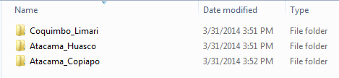

1. **Characterize Basin Elevation Statistics:**

*Requires: [\Datos\Cuencas\Coquimbo\_Limari\Parametros\Area\_Elevation.txt]   
Creates: [\Datos\Cuencas\Coquimbo\_Limari\Parametros\Hypso.xls]*

This tool creates an excel file containing required Hypsometric data about the basins elevation profile. This data includes the average elevation and total area for each elevation zone. The script requires the user to have already used ArcSWAT, and through processes covered in the ArcSWAT section of the tutorial have created the *Area\_Elevation.txt* textfile. This *Hypso.xls* file can be created manually without using ArcSWAT output, and users wishing to do so should consult the existing files for formatting. This step must only be performed once per basin, and has already been performed on the three basins provided.

1. 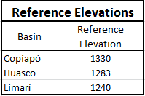**Reference Elevation:** The average elevation value of all *in situ* temperature stations used for calculating the daily temperature. For example: Daily temperature measurements for the Limarí basin were taken from two stations, Hurtado and Las Ramadas at elevations of 1100m and 1380m respectively. The average elevation of this temperature reading is 1240m, and this must be input correctly in order to simulate or forecast.
2. **Year:** The year for which the following three button functions will operate on. “Process DGA Downloads”, ”Compute Snow Covered Area”, and “Create Master”.
3. **Process DGA Downloads:**

*Requires:*

*[\Datos\Cuencas\Coquimbo\_Limari\DGA\_Descargas\Precipitaciones Diarias2011.xls]*

*[\Datos\Cuencas\Coquimbo\_Limari\DGA\_Descargas\Temperaturas Diarias Extremas2011.xls]*

*[\Datos\Cuencas\Coquimbo\_Limari\DGA\_Descargas\Caudales Medios Diarios2011.xls]  
Creates:*

*[\Datos\Cuencas\Coquimbo\_Limari\Datos\_Intermedia\AveragePrecip2011.xls]*

*[\Datos\Cuencas\Coquimbo\_Limari\Datos\_Intermedia\AverageTemp2011.xls]*

*[\Datos\Cuencas\Coquimbo\_Limari\Datos\_Intermedia\TotalDischarge2011.xls]*

An optional feature provided only for convenience. Users may obtain *in situ* data from which ever source best suits their needs and may manually format it into columnar inputs as specified in subsequent sections. This tool was built for quick and easy processing of *in situ* data in the format as provided by a data [download tool](http://snia.dga.cl/BNAConsultas/reportes) provided by the [Direcciõn General De Aguas](http://www.dga.cl). The Script executed by this button goes into the “\DGA\_Descargas” folder within the relevant basin and transforms this data from its native format to a single columnar output. In order for this button to work, all three DGA downloaded input files must be formatted exactly as shown below, titled according to the default name immediately followed by the year. Only one year of DGA data can be downloaded at a time and formatted in this way, but may have up to 10 tabs.

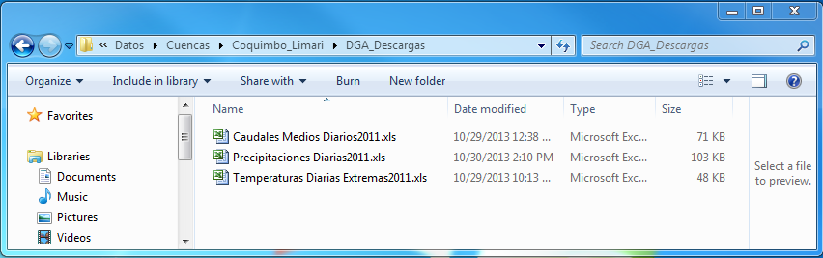

Precipitation and Temperature data available across all tabs of the DGA download xls file are averaged together to create the columnar output format. Stream Flow data available across all tabs is summed together to create the output file to accommodate adequate simulation of basins which contain dams. It is common for DGA downloaded data to have blank values and missing data. It is critical that any blank values be manually filled in with zeros “0.00” before using them to create the intermediate input files shown below. If the user does not wish to use data downloaded from this source, they may instead place the files “AveragePrecip2011.xls”, ”AverageTemp2011.xls”, and “TotalDischarge2011.xls” into this folder directly. The user should consult existing files in one of the three basins already provided for reference to ensure proper formating.

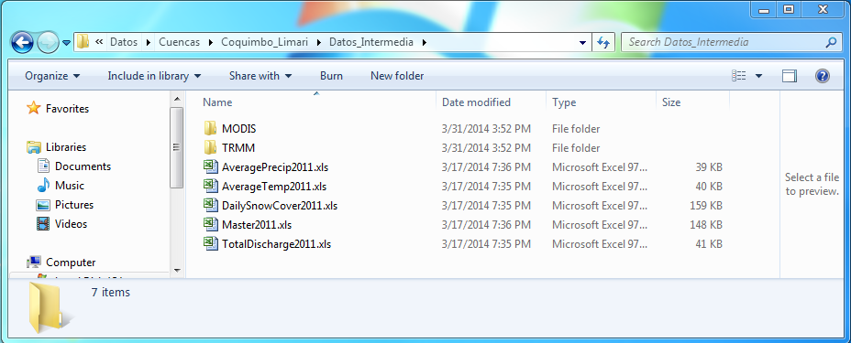

It should be noted that while DGA downloads were used while creating this script package, the DGA appears to be missing most data from 2012 forwards, so alternative *in situ* data sources should be used if these are unavailable for the time of desired simulation.

1. **Compute Snow Covered Area:**

*Requires: [\Datos\Cuencas\Coquimbo\_Limari\Datos\_Intermedia\MODIS\2011\…]*

*Creates: [\Datos\Cuencas\Coquimbo\_Limari\Datos\_Intermedia\DailySnowCover2011.xls]*

This button performs areal calculations and temporal cloud filtering on the selected year of daily MODIS data. This data must have been pre-processed with the python scripts provided, which are discussed in further detail in the general M-SRM help document. This step must be performed only once per basin per year, but will take up to 30 minutes to complete.

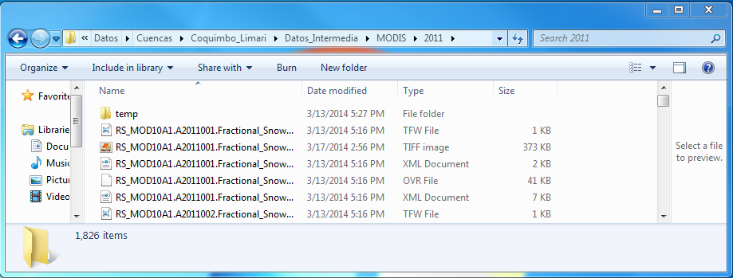

The output file “DailySnowCover.xls” does not have headers, but is formatted as follows.

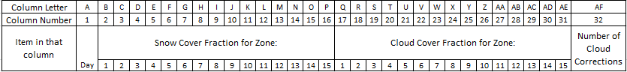

Where the first column is the Julian day, the following 15 columns are the Snowcover for elevation zones 1 through 15, the next 15 columns are cloud covered area, and the last column is the number of cloud corrections (in pixels) that were made to produce those results. Fractional snow cover and cloud cover values range from 0 to 1, with 1 being 100% snow cover in that elevation zone.

1. **Create Master:**

*Requires: [\Datos\Cuencas\Coquimbo\_Limari\Parametros\Melt\_Factor.xls]*

*[\Datos\Cuencas\Coquimbo\_Limari\Parametros\RC\_Pnasa.xls]*

*[\Datos\Cuencas\Coquimbo\_Limari\Parametros\RC\_Pstations.xls]*

*[\Datos\Cuencas\Coquimbo\_Limari\Parametros\RC\_snow.xls]*

*[\Datos\Cuencas\Coquimbo\_Limari\Parametros\RecessionCoeff.xls]*

*[\Datos\Cuencas\Coquimbo\_Limari\Parametros\Temperature\_Lapse.xls]*

*[\Datos\Cuencas\Coquimbo\_Limari\Datos\_Intermedia\AveragePrecip2011.xls]*

*[\Datos\Cuencas\Coquimbo\_Limari\Datos\_Intermedia\AverageTemp2011.xls]*

*[\Datos\Cuencas\Coquimbo\_Limari\Datos\_Intermedia\TotalDischarge2011.xls]*

*[\Datos\Cuencas\Coquimbo\_Limari\Datos\_Intermedia\DailySnowCover2011.xls]*

*[\Datos\Cuencas\Coquimbo\_Limari\Datos\_Intermedia\TRMM\TRMM\_Precip2011.dbf]*

*Creates:[\Datos\Cuencas\Coquimbo\_Limari\Datos\_Intermedia\Master2011.xls]*

The “Create Master” function is used to compile the input files which contain all the required information to perform a simulation with the Snowmelt Runoff Model, and are stored in the “Datos\_Intermedia” folder. Users with alternative data sources who wish to use custom columnar input values may create their own Master Files from scratch, though the correct format must be followed precisely. A properly formatted Master file is the only requirement for performing a simulation with the Modified Snowmelt Runoff Model.

For more information about the precise formats of these inputs, users may consult the “Detailed Input Parameter File Descriptions” section on page 21, or browse through the input files provided for the three example basins.

Master files have headers within the document, and are formatted as follows.

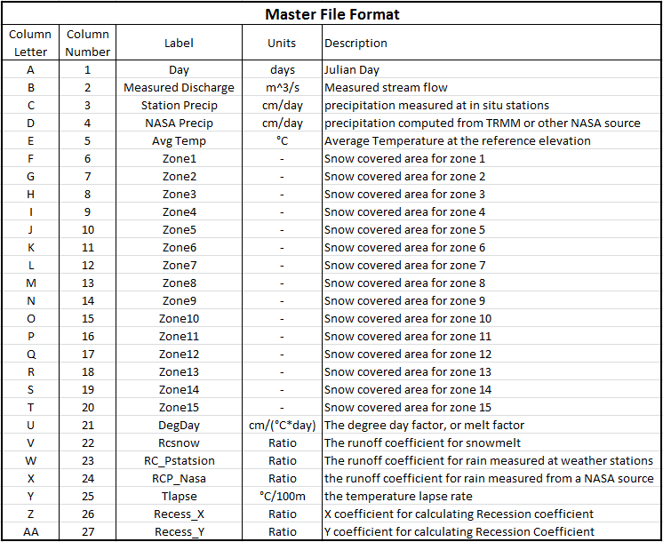

1. **Create Profiles:**

*Requires: All of the following files for at least two different years:*

*[\Datos\Cuencas\Coquimbo\_Limari\Datos\_Intermedia\AveragePrecip2011.xls]*

*[\Datos\Cuencas\Coquimbo\_Limari\Datos\_Intermedia\AverageTemp2011.xls]*

*[\Datos\Cuencas\Coquimbo\_Limari\Datos\_Intermedia\TotalDischarge2011.xls]*

*[\Datos\Cuencas\Coquimbo\_Limari\Datos\_Intermedia\DailySnowCover2011.xls]*

*Creates: [\Datos\Cuencas\Coquimbo\_Limari\Parametros\PrecipIS\_Profile.xls]*

*[\Datos\Cuencas\Coquimbo\_Limari\Parametros\PrecipNASA\_Profile.xls]*

*[\Datos\Cuencas\Coquimbo\_Limari\Parametros\SCA\_Profile.xls]*

*[\Datos\Cuencas\Coquimbo\_Limari\Parametros\Temperature\_Profile.xls]*

This “Create Profiles” function extracts data from all existing master files and averages them together to perform an average characteristic profile for precipitation, temperature, and snow covered area (SCA). In order to function, data from at least two years must have been fully prepared. Profiles should be created from as many years as possible. These profiles are required in order to forecast snow covered area. They are also used in forecasting precipitation and snow cover, but better forecasts from a reliable weather service should be used if they are available.

1. **List of Years:** The list of years for which to execute the “Create Profiles” function. This input may be a list, for example, “[2003,2004,2005,2006,2007,2008,2009,2010,2011]” which is useful for omitting anomalous years from the averaging process. This input may also be a continuous list such as “2003:2011”, which will produce the exact same results as the list mentioned previously. This field does **not** need to be the same as fields **(11)** and **(12)**, but should instead utilize all suitable years to create a good representative average profile.
2. **Create Multiyear Master:**

*Requires: The following file for at least two consecutive years:*

*[\Datos\Cuencas\Coquimbo\_Limari\Datos\_Intermedia\Master2011.xls]*

*Creates: [\Datos\Cuencas\Coquimbo\_Limari\Parametros\Master20032011.xls]*

This function simply takes master files which have already been created for several consecutive years and appends them to each other to enable longer simulation time periods. Output file names are of the format “Master[YYYY][YYYY].xls”, with no spaces or dashes. For example, a master file spanning 2003 to 2011 would be titled “Master20032011.xls”. If the user creates a multi-year master, they may simulate using this master by typing “20032011 into the appropriate GUI field (fields **13** or **31**).

1. **Start and End Years:** Intuitively, these fields designate the starting and ending years of the continuous time period spanning at least 2 years. This time period will be used by the “Create Multi-year Master” button. 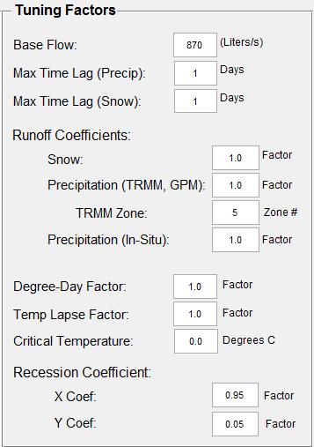**Tuning Factors Panel**

Several tuning factors for on the fly adjustments to improve the models accuracy based on the most recent data are provided in this panel. Users can run simulations many times while making changes to each parameter to study its effects on real simulation data. Users are encouraged to start of a model validation process by first setting the runoff coefficients for Snow **(22)** to zero and identify key areas where flow may be coming from liquid precipitation. Then, oppositely set the runoff coefficients for precipitation (**23** and **25**) to zero and the runoff coefficient for snow to 1.0 to study the impacts of snow cover on the flow. Better understanding of all tuning factors may be gained by reading the SRM user manual created by the developers of the original model found at the link below.

[aces.nmsu.edu/pubs/research/weather\_climate/SRMSpecRep100.pdf](http://aces.nmsu.edu/pubs/research/weather_climate/SRMSpecRep100.pdf)

1. **Base Flow:** Is the lowest level of discharge seen at any given time in units of Liters per second. This number is added uniformly to simulated flow at any given time. (L/s)
2. **Max Time Lag (Precip):** The maximum amount of time it takes for a unit of water to get from the upper reaches of the basin down to the stream gauge location for measurement. Typical time lags are low for rain (1 to 5 days) as the majority of this water flows along the steep topography very quickly.
3. **Max Time lag (Snow):**  The maximum amount of time it takes for a unit of water to get from the upper reaches of the basin down to the stream gauge location for measurement. Typical time lags for snowmelt are higher than for rain as the melting process is slower and much of this water infiltrates the soil.

**Runoff Coefficients:** Runoff coefficients are used to determine what percentage of calculated snowmelt and rain water actually makes it down to the stream gauges. The Runoff coefficients have been pre-determined to have an average value for each of the basins under study. These fields are multiplied by that predetermined average number to help tune the models accuracy. A default value of 1.0 represents an average value over all years studied, but is not likely to be precise. Runoff Coefficient fields should have a value between 0.2 and 5 for most simulations. When tuning the model, Runoff coefficients are the most likely parameters to require tuning.

1. **Runoff Coefficient for Snow:** This field is the specific runoff coefficient for water coming from snowmelt.
2. **Runoff Coefficient for Precipitation (TRMM, GPM):**  This field is the specific runoff coefficient for water coming from NASA measured rain. TRMM is currently used as of April 2014, but data from the Global Precipitation Measurement mission (GPM) is expected to replace TRMM for greater accuracy in Chile.
3. **TRMM Zone:** This field is the value of the lowest elevation zone for which there is no *in situ* precipitation data from weather monitoring stations. At this elevation zone and above, NASA remotely sensed precipitation data is assumed to apply. Below this elevation zone, *in situ* precipitation data is used for flow calculations. The default value is 5, which corresponds with the elevation zone between 2001 and 2500 meters elevation, and is used for Limarí, Huasco, and Copiapó.
4. **Runoff coefficient for Precipitation (*In Situ*):** The specific runoff coefficient for water coming from precipitation measured by weather stations *in situ*.
5. **Degree-Day Factor:** This field should typically remain unchanged from its default value of “1.0”. Recall that the degree day factor indicates the depth of snowmelt for every degree day experienced. The Degree day factors were estimated as a function of snow density for all three basins included in the package, and this factor should only be changed if snow melting rate is measured directly in the future, and found to differ significantly from the estimation.
6. **Temp Lapse Factor:**  This field should typically remain unchanged from its default value of “1.0. The temperature lapse rate specifies an approximate linear relationship between temperature and elevation. Temperature lapse factor should be changed if specific weather for the tuning period is likely to cause a greater temperature difference between the monitoring stations and the highest elevations of the basin. If the upper elevations are expected to be colder than usual, this value should be increased above 1.0.
7. **Critical Temperature:** This field should typically remain unchanged from its default value of “0.0”. The critical temperature determines if measured precipitation should be treated as rain or as snow. If the local temperature is lower than the critical temperature when a precipitation event occurs, that water will not be immediately added to stream flow, as it is expected to be accounted for in the snow melt calculations. Typical values for Critical Temperature range from -2 to 2.

**Recession Coefficient:** Recession coefficient governs the response time of the stream gauge to a precipitation or melting event. Recession coefficient is an application of an exponential equation which can be learned in greater detail by consulting the SRM manual.

1. **X Coef and Y coef:** Basins which are resistant to rapid changes in flow rate will have X coefficients just slightly smaller than 1 (typically 0.95 or more), and Y coefficients just slightly greater than 0 (typically 0.05 or less). Basins with flow that jumps up and down very quickly with large precipitation events will have X coefficients from 0.5 to 0.9 and Y coefficients from 0.1 to 0.3. These coefficients should be adjusted (with X closer to 1, and Y closer to 0) if precipitation events appear to be producing narrow peaks in the simulation which are not present in the actual stream gauge data. Oppositely, they should be adjusted (with X further from 1, and Y further from 0) if the simulation is producing narrower peaks than are observed in the stream flow data. Default values of 0.95 and 0.05 are suitable for many arid basins.
2. **See (29)**

**Simulate and Validate Panel**

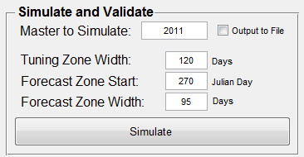This panel is the best place to learn the impacts of each tuning factor on simulated flow, and was used to validate and assess the accuracy of the model. It is intentionally configured similarly to the “Forecast” panel, and proper use of the two panels is almost identical. The model is a simulation, and for a complete set of measured inputs for some time period in the past, this panel can be used to validate and assess the models accuracy. It is intended to help the user learn how each tuning parameter in the “Tuning” panel impacts the simulation. When the “Simulate” button is pressed, all Values in the “Tuning” and “Simulate and Validate” panels must be properly specified, in addition to “Root”, “Basin”, and “Reference Elevation” in the “Prepare Inputs” panel.

1. **Master to Simulate:**  This field is simply the name of the master file the user wishes to simulate. An output file of all data used in the simulation, as well as a JPG of the produced plot may be produced and saved in the [\Salida] folder by checking the “Output to File” box before running the simulation.
2. **Tuning Zone Width:** This field designates the number of days before the “Forecast Zone Start” to begin tracking model accuracy and achieve a good result in the “Forecast Zone”. Tuning zone widths are typically between 60 and 120 days. While tuning the model, the user will attempt to match the profile of the simulated flow to the profile of the actual flow within this zone by adjusting the tuning parameters.The start of the tuning zone is marked by the first thick vertical dotted line on the output plot.
3. **Forecast Zone Start:** This field designates the Julian day on which the user is pretending to make a forecast. This allows the user to simulate the decision making process for a given time of year and forecast range. Forecast zone is default set to 270, which corresponds with a date at the end of September, the start of the growing season in much of central northern Chile. The forecast zone start is marked by the second thick vertical dotted line in the output plot.
4. **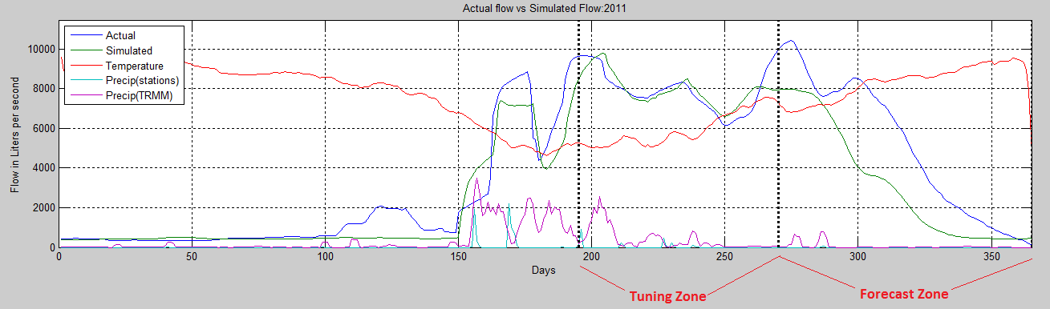Forecast Zone Width:** This field designates the length (in days) of the desired forecast period. A Forecast zone of 95 is set as the default value, as this forecast length allows the three months between the beginning of the growing season and the end of the year to be simulated. The forecast zone end is marked by the third thick vertical dotted line in the output plot.

If a forecast zone start and width are specified such that the end of the forecast zone falls outside the range of the inputs, an error will be produced. For example: If simulating just one year, and a forecast zone start of 300 is specified with a forecast zone width of 70, the simulation will attempt to run through the 370th day of the year, which does not exist.

1. **Simulate (Simulate and Validate Panel):**

*Requires:*

*A master file with the name specified in the “Master to Simulate” field (31) must exist.*

*Appropriately defined Tuning and Forecast zone dimensions (32 – 34)*

*All fields within the “Tuning” panel (19 - 30)*

*The “Root” field (1), “Basin” field (2) and “Reference Elevation” field (3).*

*Creates:*

*If the “Output to file” box is checked, the following outputs will be created.*

*[\Salida\Coquimbo\_Limari\_[Date and time]\_Validate\_2011.xls]*

*[\Salida\Coquimbo\_Limari\_[Date and time]\_Validate\_2011.jpg]*

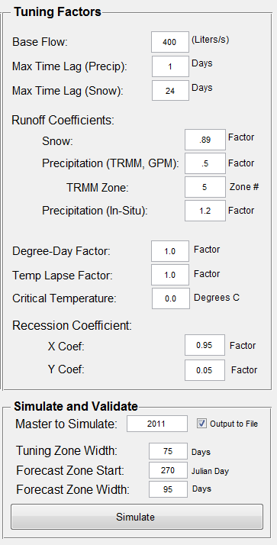The “Simulate” button runs the M-SRM for the desired year. A graph will appear which shows the simulated flow and the actual flow for comparison. In addition to actual and simulated flow, precipitation events from NASA data and from *in situ* data are plotted for reference. Snow covered area by elevation zone is also plotted immediately below the output flow chart. These resources should give the user information about which sources of water are the most influential in a particular time period. The inputs in the image to the right were used to generate the output plots shown on the next page. Once error in the “Tuning Zone” has been reduced to near 0%, and the profile shapes match up well, the user can see how accurate the model would have been if it were forecasting the output within the forecast zone.

Note that in order to enhance visibility of the tuning and forecasting zones, only the last 1000 days of the simulation will be displayed on the chart. Users who wish to view the entire input history for simulations longer than 1000 days should consult the output file.

Example outputs in both the console window and in the plot are shown below.

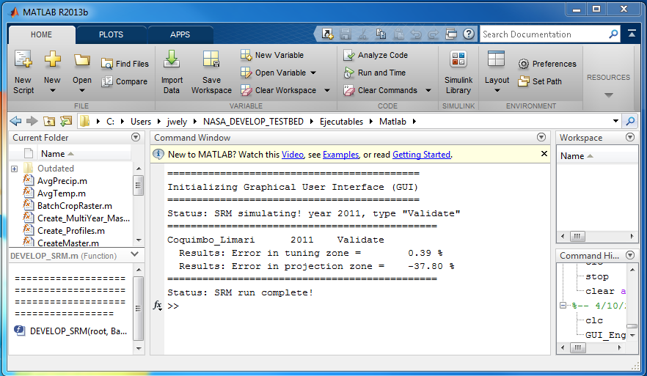

**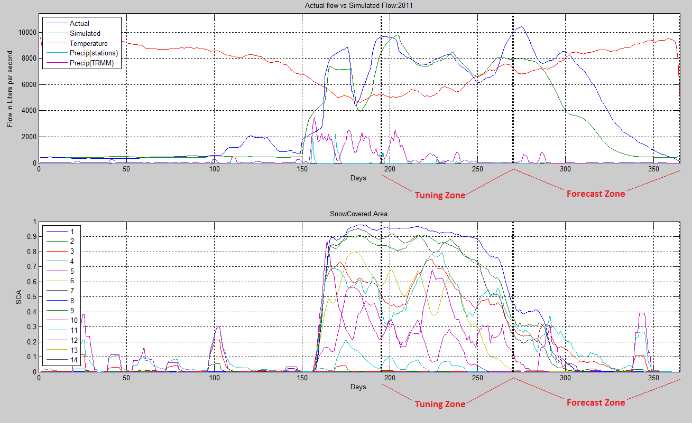**

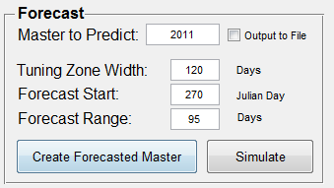**Forecast Panel**

The “Forecast” panel is intended to aid the user in making water availability forecasts and is the last of the four panels that a user should attempt to learn. Like the “Simulate and Validate” panel, it requires all values in the “Tuning” panel to be properly specified.

1. **Master to Predict:** This field is used to designate the name of the master file to be used for forecasting. It can be either a single year or a multi-year master. Since the purpose of forecasting is to project measurements into the future, the master file should be of the appropriate length to enable a good history with which to forecast, and must be no shorter than the “Tuning Zone Width”. Typically, for the forecast year, all NASA earth observation and *in situ* data up do the present date should be compiled into a master file for the appropriate year.
2. **Tuning Zone Width:** This field operates exactly the same as field **(33)**, and is used to designate the number of days before the “Forecast Start” to begin tracking model accuracy and achieve a good result in the “Forecast Zone”. Tuning zone widths are typically between 60 and 120 days. While tuning the model, the user will attempt to match the profile of the simulated flow to the profile of the actual flow within this zone by adjusting the tuning parameters.
3. **Forecast Start:** Similarly to the “Forecast Zone Start” field **(34)**, this field designates the boundary between actual input data and forecasted input data to be used in the simulation. The forecast start day specified in this field will be used to append snow cover, precipitation from *in situ* and NASA data source, and temperature profiles to enable a forecast with the range specified in the next field.
4. **Forecast Range:** This field specifies the length of the forecast to be made. Typical forecast ranges are between 90 and 120 days.
5. **Create Forecasted Master:**

*Requires:*

*[\Datos\Cuencas\Coquimbo\_Limari\Datos\_Intermedia\Master2011.xls]*

*[\Datos\Cuencas\Coquimbo\_Limari\Parametros\PrecipIS\_Profile.xls]*

*[\Datos\Cuencas\Coquimbo\_Limari\Parametros\PrecipNASA\_Profile.xls]*

*[\Datos\Cuencas\Coquimbo\_Limari\Parametros\SCA\_Profile.xls]*

*[\Datos\Cuencas\Coquimbo\_Limari\Parametros\Temperature\_Profile.xls]*

*Creates: [\Datos\Cuencas\Coquimbo\_Limari\Datos\_Intermedia\ProjectedMaster2011.xls]*

Before the simulation can be performed, a Forecasted master file must be created. This button executes the forecasting and creates a master file which will be used by the “Simulate” button **(18)**. In order to run, a Master file containing measured data up to the forecast start date must already exist for all years to be compiled into the ProjectedMaster2011.xls file. The other required inputs are theoretical profiles created by the “Create Profiles” button **(9)**.

1. **Simulate (Forecast Panel):**

*Requires:*

*A master file with the name specified in the “Master to Simulate” field* ***(13)*** *must exist.*

*Appropriately defined Tuning and Forecast zone dimensions* ***(14-16)***

*All fields within the “Tuning” panel* ***(19 - 30)***

*The “Root” field* ***(1)****, “Basin” field* ***(2)*** *and “Reference Elevation” field* ***(3).***

*Creates:*

*If the “Output to File” box is checked, the following outputs will be created.*

*[\Salida\Coquimbo\_Limari\_[Date and time]\_Forecast\_2011.xls]*

*[\Salida\Coquimbo\_Limari\_[Date and time]\_Forecast\_2011.jpg]*

This button executes the SRM using inputs from the projected master file created immediately before hand by the “Create Forecasted Master” button **(17)**.

**Output File Descriptions**

1. **Output excel file**

*Location: [\Salida\Coquimbo\_Limari\_2014-4-10\_12-31-30\_Validate\_2011.xls]*

The file name above is for the tutorial case, which was run for the Limarí basin for 2011 in Validation mode. The output file name will be named according to the basin, the time of simulation, the type of simulation, and the year being processed. Once the user has achieved sufficient knowledge of the process and decides to make forecasts of future water availability they may save an output file. The output file will appear as below.

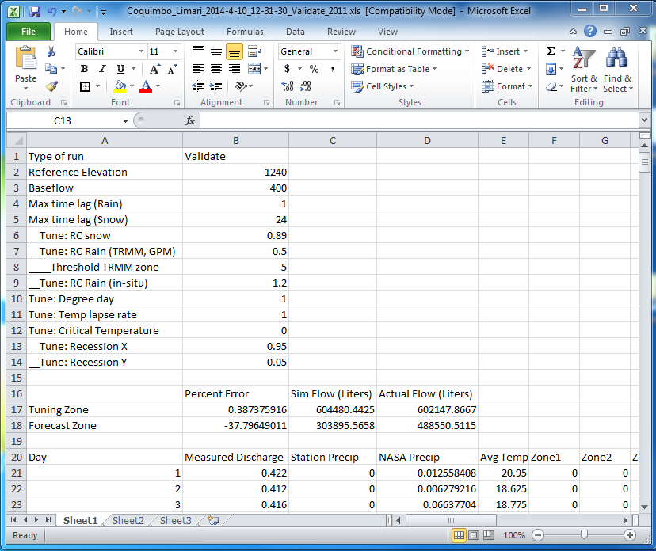The first block at the top from cells A1 to B14 contains a copy of all the tuning parameters used in the simulation so the user may duplicate the results at another time. The second block from cells A16 to D18 contains a small table to demonstrate the accuracy of the model. It is important to note that for a Validation run, errors in the forecast zone can be computed and are shown in the table, but for an actual forecast run, it is not possible to calculate these errors, so they are reported as zero.

1. **Output plot image**

*Location: [\Salida\Coquimbo\_Limari\_2014-4-10\_12-31-30\_Validate\_2011.jpg]*

In addition to the output excel file, the plot used for model tuning will be saved as an image file in the same output directory. The output file name will be named according to the basin, the time of simulation, the type of simulation, and the year being processed.

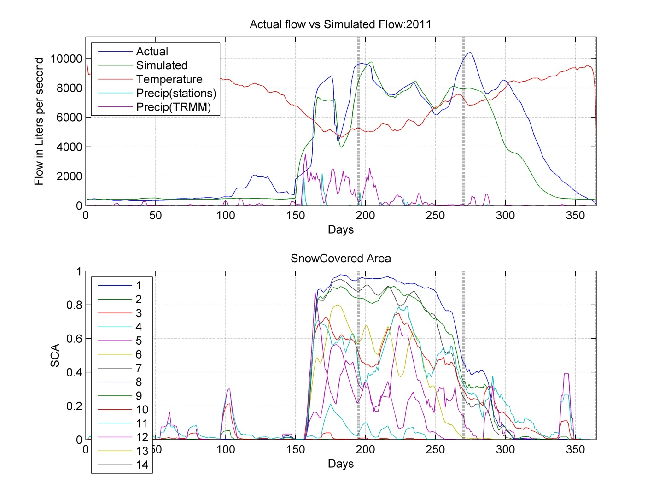

**Detailed Input Parameter File Descriptions**

This section contains descriptions of many of the input files used by scripts contained in this package. All files must be named in exactly the format as shown to ensure proper functionality. Each file listed here has already been created for the three basins included with the script package, but users who wish to characterize new basins will need to create them from scratch.

1. **Area\_Elevation.txt:**

*Location: [\Datos\Cuencas\Coquimbo\_Limari\Parametros] directory.*

Optional file that can be used by the “Characterize Basin Elevation Statistics” button **(3)**, to create the Hypso.xls file. This file is created using the ArcSWAT extension.

1. **Elev\_Zones\_Align.tif:**

*Location: [\Datos\Cuencas\Coquimbo\_Limari\Parametros] directory.*

C:\Users\jwely\NASA_DEVELOP_TESTBED\Datos\Cuencas\Coquimbo_Limari\Parametros\Elev_Zones_Align.tif

This file is required by the “Compute Snow Covered Area” button **(7)** for performing snow covered area calculations. It must be identical in resolution to the cropped MODIS data tiffs found in the [\Datos\_Intermedia\MODIS\2011] folder for the applicable basin. Once an Elevation zone tiff is created in ArcMap, the Elevation\_Zones\_Align tiff can be created by manually aligning it with a sample image from the MODIS data folder and clipping it to the correct resolution. It must be saved in the [\Parametros] directory for its basin. The image must be an 8 bit unsigned tiff, and it will likely appear entirely black in the preview image like shown for Limarí.

1. **Hypso.xls:**

*Location: [\Datos\Cuencas\Coquimbo\_Limari\Parametros] directory.*

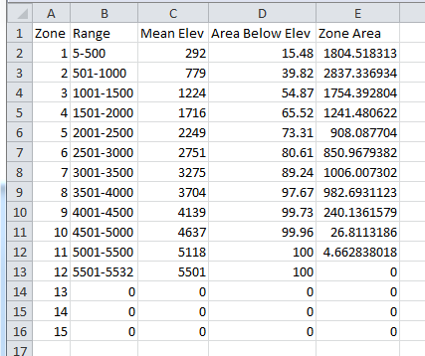

This file is required by the DEVELOP\_SRM script in order to properly simulate a given basin. The format must be exactly as shown, with space for up to 15 elevation zones. This file can be automatically generated from the Area\_Elevation.txt. The “Range” and “Mean Elev” fields are in units of meters, the units of field “Area Below Elev” is in percent, and the units of the “Zone Area” field is square kilometers.

1. **Melt\_Factor.xls:**

*Location: [\Datos\Cuencas\Coquimbo\_Limari\Parametros] directory.*

The melt factor was determined as an approximate function of snow density measurements taken in the region and seasonal variations can be seen to occur. This file is a simple list containing one column of data from cells A1 to A366. This input has units of centimeters per (degree\*day).

1. **RC\_Pnasa.xls:**

*Location: [\Datos\Cuencas\Coquimbo\_Limari\Parametros] directory.*

Runoff Coefficient for precipitation measured with NASA data from TRMM or GPM. This file is a simple list containing one column of data from cells A1 to A366. This input is dimensionless.

1. **RC\_Pstations.xls:**

*Location: [\Datos\Cuencas\Coquimbo\_Limari\Parametros] directory.*

Runoff Coefficient for precipitation measured at weather monitoring stations within the basin. This file is a simple list containing one column of data from cells A1 to A366. This input is dimensionless.

1. **RC\_snow.xls:**

*Location: [\Datos\Cuencas\Coquimbo\_Limari\Parametros] directory.*

Runoff Coefficient for water coming from snowmelt. This file is a simple list containing one column of data from cells A1 to A366. This input is dimensionless.

1. **RecessionCoeff.xls:**

*Location: [\Datos\Cuencas\Coquimbo\_Limari\Parametros] directory.*

Recession coefficient determines the sensitivity of stream flow to a rapid change in precipitation or snowmelt. Currently, this file is a simple list with two columns ranging from A1 to B366 filled with values of “1”. Due to the exponential nature of the recession coefficient, it was decided not to include average values within the file, and users must instead specify the true value for Recession Coefficient on every simulation. This input is dimensionless.

1. **Temperature\_Lapse.xls:**

*Location: [\Datos\Cuencas\Coquimbo\_Limari\Parametros] directory.*

Temperature lapse rate defines the relationship between temperature and elevation. This file is a simple list containing one column of data from cells A1 to A366. This input has units of Degrees per 100 meters.

1. **TRMM\_Precip2011.dbf:**

*Location: [\Datos\Cuencas\Coquimbo\_limari\Datos\_Intermedia\TRMM] directory.*

The file containing TRMM data as output by the python scripts provided. This is a temporary input, and the SRM scripts are already configured to accept alternative inputs from GPM when that data becomes available.

1. **GPM\_Precip2011.xls:**

Location: [\Datos\Cuencas\Coquimbo\_limari\Datos\_Intermedia] directory.

Not currently used, but if a file with the name TRMM\_Precip2011.dbf does not exist, the Snowmelt Runoff model will look for a file with this name. When GPM data becomes available, they may provide it in the following format: Column ‘A’ should contain a list of the Julian days numbered from 1 to 365 (or 366 for leap years) and Column ‘B’ should contain a list of the average precipitation values from GPM in the basin above the highest weather monitoring station.

1. **AveragePrecip2011.xls:**

*Location: [\Datos\Cuencas\Coquimbo\_limari\Datos\_Intermedia] directory.*

The file containing the average precipitation data from all *in situ* stations. Column ‘A’ contains a list of the Julian days numbered from 1 to 365 (or 366 for leap years). Column ‘B’ contains a list of the average precipitation values from *in situ* data. This file can be automatically generated by the “Process DGA Downloads” button **(6)**.

1. **AverageTemp2011.xls:**

*Location: [\Datos\Cuencas\Coquimbo\_limari\Datos\_Intermedia] directory.*

The file containing the average temperature data from all *in situ* weather stations. Column ‘A’ contains a list of the Julian days numbered from 1 to 365 (or 366 for leap years). Column ‘B’ contains a list of the average temperature values from the selected weather stations. This file can be automatically generated by the “Process DGA Downloads” button **(6)**.

1. **TotalDischarge.xls:**

*Location: [\Datos\Cuencas\Coquimbo\_limari\Datos\_Intermedia] directory.*

The file containing the total stream discharge data from appropriate stream gauges. Column ‘A’ contains a list of the Julian days numbered from 1 to 365 (or 366 for leap years). Column ‘B’ contains a list of the average temperature values from the selected weather stations. This file can be automatically generated by the “Process DGA Downloads” button

1. **Meta.txt:**

*Location: [\Datos\Cuencas\Coquimbo\_Limari\Meta.txt]*

This meta file contains just two lines of miscellaneous information (as pictured below for the Limarí basin) that isn’t adequately stored within any other files. The first piece of information are the Clipping coordinates for the purposes of MODIS snow cover and TRMM precipitation python processing, which can be found by examining the characteristics of the basin shapefile in ArcMap. The second piece of information is the basin area, which can also be found by examining the basin shapefile in ArcMap, but also by examining the Elevation zone tiff. “Basin\_Area” is in units of square meters, and is used by the M-SRM.

