

**The Modified Snowmelt Runoff Model**

**For Forecasting Water Availability in Chile**

**NASA Langley Research Center, DEVELOP Program, Hampton, VA 23681**

Jeffry William Ely, Old Dominion University

Joshua Kelly, University of Rhode Island

Lydia Cuker, College Of William and Mary

Joseph Novak, Old Dominion University

Laura Macaluso, Christopher Newport University

Bethany Burress, Christopher Newport University

Amberle Keith, Idaho State University

Ajoke Williams, Massachusetts Institute of Technology

Version (October 2014). Contact: [Jeff.Ely.08@gmail.com](mailto:Jeff.Ely.08@gmail.com)

**Contents**

**Topic Page**

Document Scope 3

Overview 3

Required Software 4

In Situ Data Used 5

Downloading NASA Data 6

TRMM - Precipitation 6

MODIS - Land Surface Temperature 8

MODIS - Snow Cover 10

ASTER - Digital Elevation Model 11

AMSR_E - Soil Moisture 12

Processing NASA Data 13

MRT functions 13

TRMM and MODIS python processing 15

MODIS Snow Cover Temporal Cloud Filtering 17

Miscellaneous Data 17

ArcSWAT Watershed Delineation 18

Merging DEM tiles 18

Projecting DEM tiles 19

ArcSWAT Project Setup 20

DEM setup 20

Stream Definition 21

Watershed Outlet Selection 22

Calculation of Sub-basin Parameters 23

Create Elevation Zone Raster and Shape files 23

Defining Basin parameters 25

Hypsometric Mean Elevations 25

Degree Day Factor 25

Runoff Coefficients 26

Time Lags 27

Temperature Lapse Rate 27

Snow Covered Area Forecasting 28

Acknowledgements 29

Version (April 2014). Contact: [Jeff.Ely.08@gmail.com](mailto:Jeff.Ely.08@gmail.com)

**Document Scope**

This implementation of the Snowmelt Runoff Model, originally developed by the United States Department of Agriculture, was created specifically for studying snowmelt in Chile. Minor modifications were made to allow precipitation inputs from multiple sources, which accommodate the unique elevation characteristics and capabilities of the *in situ* data collection network in Chile. Additional modifications were included which use individual time lag parameters for water from rainfall, and water from snowmelt to better suit the observed hydrological characteristics of the region. The Snowmelt Runoff Model (SRM) User’s Manual by J. Martinec, A. Rango, and R. Roberts remains the definitive source of information on the mathematics used for modeling runoff and including snow melt. This document aims to explain deviations from this model, and to outline the methodology used specifically by the NASA DEVELOP team with some detailed step by step instructions and some general explanations. For user reference, the Snowmelt Runoff Model (SRM) User’s Manual may be found at the link below:

[[http://aces.nmsu.edu/pubs/research/weather_climate/SRMSpecRep100.pdf]](http://aces.nmsu.edu/pubs/research/weather_climate/SRMSpecRep100.pdf)

A program known as WinSRM was written to accompany the Snowmelt Runoff Model (SRM) User’s Manual, but is not used in the present study. A custom implementation of the Snowmelt runoff Model equation, henceforth referred to as the Modified Snowmelt Runoff Model (M-SRM) was coded in Matlab to accommodate the variations on this model necessitated by Chile’s unique climate. An additional document has been provided with the NASA_DEVELOP_SRM package specifically for help using the graphical user interface (GUI) which replaces the WinSRM software for this study.

**Overview**

Files which are required by each script and files which are created by each script are specified in the descriptions provided. Scripts which list a required file will not work if that file does not exist, or is not in the correct format. These requirements typically list the entire file path, and for the purpose of this guide, all examples will be as though the year 2011 for the Limarí basin were being analyzed. Users performing analysis on a different basin will duplicate the exact same file structure under an appropriately named folder for the new basin like shown.

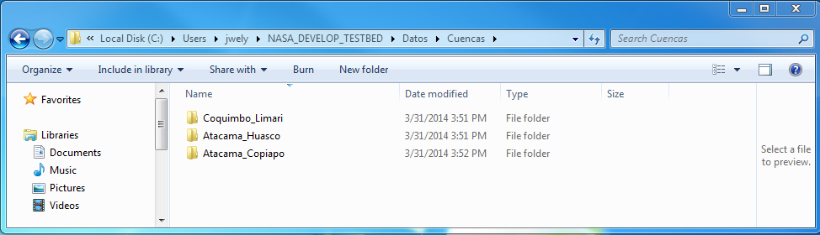

**Required Software**

While Matlab is the only software required to use the M-SRM, processing NASA data including TRMM precipitation and MODIS snow cover products requires ArcMap version 10.1 or newer, which includes Python version 2.7. In addition to these, the MODIS Reprojection Tool and the ArcSWAT extension were used.

**ArcSWAT:** This tool was used to delineate watersheds based on a Digital Elevation Model (DEM). It was used primarily for isolation of catchment areas upstream of reservoirs and corresponding stream gauges, which provided a fairly reliable record with which to validate the model. The most up to date version of ArcSWAT can be found at the following website:

[<http://swat.tamu.edu/software/arcswat/>]

**Matlab:** Matlab version 2013a was used to develop these scripts and tools, but they are confirmed to work on some other recent versions going back to 2010b. It is used to run the GUI and the M-SRM itself. It is provided at cost by Mathworks©. The user can learn more at the following website:

[<http://www.mathworks.com/products/matlab/>]

**ArcMAP:** ArcMAP version 10.1 was used throughout this study for projection management and to format remotely sensed inputs into sets of values for simulation in the M-SRM. It is provided at cost by ESRI©. The user can learn more at the following website:

[<http://www.esri.com/software/arcgis>]

***In Situ* Data Used**

All *in situ* data used can be acquired from the [Direcciõn General De Aguas](http://www.dga.cl) using a data download tool found at the following website:

[<http://snia.dga.cl/BNAConsultas/reportes>]

This data includes maximum and minimum temperatures, precipitation, stream flow, and snow density data. All four of these *in situ* data inputs were used as described in the SRM manual by J. Martinec *et al.* Manual data sanitation was required, as some records were missing. Consistently missing data caused complete omission of some monitoring stations. Some discharge (stream flow) stations have data gaps which were filled with data from stream flow stations closely upstream of the desired monitoring stations. A table of station names and elevations for the three basins provided is listed below.

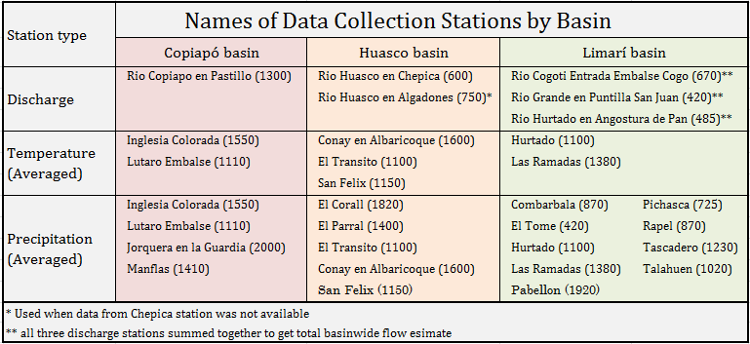

Temperature, precipitation, and discharge data were used simply as daily inputs. Snow density data was used to find “Degree Day Factor” sometimes called “Melt Factor” in this study. Snow density data was provided for a few days out of the year at stations distributed throughout region at various elevation zones. Though snow density measurements are sparse, measurement history dates back to 1970, and snow density was determined not to be a function of elevation zone. This allowed us to sort snow density measurements into bins corresponding to the month they were taken in, and averages to be calculated for each month. A cyclical condition was imposed, and a best fit sixth order polynomial equation was found to fit the data. This data was then up-sampled to provide a daily continuous time dependent value for snow density, which was converted to a degree day factor by estimation according to the equation specified in the SRM User’s Manual.

**Downloading NASA Data**

Multiple NASA data sources are used, and many data download websites exist, and some may have a better interface for bulk data downloads than others. Several options are explored within this section in fair detail for a variety of data products.

1. **TRMM Precipitation:**

Due to the lack or minimal presence of precipitation measuring stations, particularly in higher elevations, remote sensing data is used to provide a complete, spatially continuous rainfall measurement dataset. The *3b_42 V6* dataset collected by the Tropical Rainfall Measuring Mission (TRMM) satellite was used. This dataset contains the output of TRMM algorithm 3B42, which combines high quality infrared (IR) precipitation estimates with other satellite precipitation measurements (AMSU, AMSR, SSMI, etc.). The final product is measured daily rainfall rate in mm/hr at a spatial resolution of 0.25° x 0.25° between latitudes 50° S and 50° N.

The TRMM *3b_42* daily dataset can be downloaded from the NASA Mirador Earth Science Data Search Tool found at the website:

[<http://mirador.gsfc.nasa.gov/cgi-bin/mirador/presentNavigation.pl?tree=project&dataset=TRMM_3B42_daily.007&project=TRMM&dataGroup=Gridded&version=007&CGISESSID=a261e8d3bec8cea51f3b5f4e63dc7bf7>]

1. On this page, navigate to the Projects tab and click Spatial and Temporal Search. This will allow you to specify your Region of Interest (ROI) and study period.

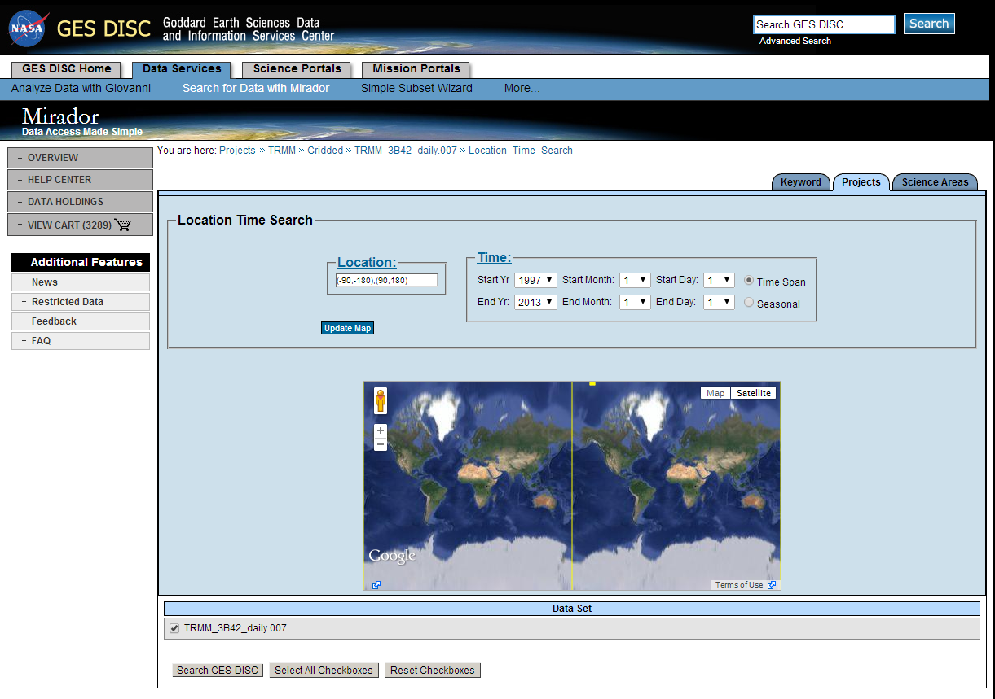

1. The Location and Time search page is displayed in the figure above. Enter the coordinates of your ROI and time period in these boxes and make sure the box next to *TRMM_3B42_daily.007* is checked. Click *Search GES-DISC* to gather data results.
2. This will open a new page containing a File Listing of all of the daily TRMM datasets available to download. Since we need every one of them, click *Add All Files in All Pages To The Cart.*
3. This will open up the Service Selection page where you should click the button next to *Convert to NetCDF.* Once the conversion is finished, click the green *Continue to Cart* button.
4. On the next *Shopping Cart* page, click the green *Checkout* button.
5. The Download Data page will open next, from here you will have a number of options for choosing how to bulk download your selected data.
6. The easiest option for downloading large quantities of data is the GES DISC Download Manager – platform independent HTTP and FTP client. To use this option, click the tab *More Download Options*. It will be the first option in the list. This is a Java file so your Java will have to be up to date to use this.
7. Click the blue *Download* button and then launch the jar file when the download is finished.
8. The *Data Download Manager* window displaying the data to download will take about one minute to appear. Be patient. The window looks like the following figure.

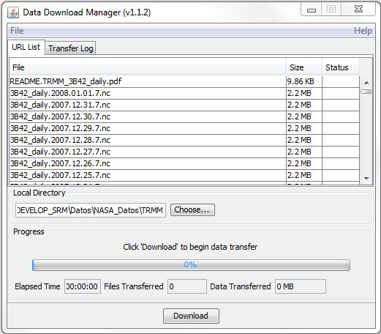

1. Set the file location in the local directory to wherever you wish to download the files. They must ultimately end up in the directory [NASA_DEVELOP_SRM\Datos\NASA_Datos\TRMM] inside individual folders for each year if the user wishes to use the TRMM analysis tools provided with the processing package.
2. Click *Download* button on the bottom of the window and allow it to run.
3. All of the TRMM data should now be in a directory on your local computer and ready for processing.

Be sure that the files are listed in chronological order (earliest to latest), which, due to the naming convention of TRMM data files can be done by organizing the files by name. Organize the data into folders for individual years, keeping them in the same earliest to latest chronological order.

1. **MODIS Land Surface Temperature:**

The SRM separates the basin into 500 m elevation zones and since we do not have an *in situ* temperature measurement for each zone, it is necessary to determine a temperature lapse rate for the basin. The MODIS Land Surface Temperature data (MOD11A1), from the Moderate-Resolution Imaging Spectroradiometer (MODIS) sensor on board the Terra satellite, was used with a spatial resolution of 1 km within 1200 km by 1200 km tiles. Details regarding the algorithm can be found by reading the MODIS Land-Surface Temperature Algorithm Theoretical Basis Documentation (LST ATBD) (Wan, 1999). A link to this document along with a user guide and accuracy report can be found at the following website:

<https://lpdaac.usgs.gov/products/modis_products_table/mod11a1>

Before downloading, one of the first steps is to determine which MODIS tiles must be downloaded for a given study area. The MODIS tiles which cover the basins under current study are “h11.v11” and “h11.v12”, but other basins may require additional tiles to be included.

1. Navigate to [<http://earthexplorer.usgs.gov/>]
2. Under the *Search Criteria* tab, specify your study region by doing one of the following:
   1. Type in an address
   2. Type a place name
   3. Enter coordinates
   4. Click the map to define your search area
3. If the red place marks on the map correctly specify your study area, click the *Data Sets* tab.
4. In the box next to *Data Set Search*, type in “MOD11A1” and make sure the dataset is checked in the window below.
5. Click the *Results* tab and you will see a number of tiles displayed. You’re going to need the tile bounding coordinates for all of the tiles that cover your study area, which may be more than one.
6. Beginning with the first tile listed, click on the browse image and it will open up a table of metadata.
7. Search for and record the *Horizontal Tile Number* and *Vertical Tile Number*, as shown in the figure below.

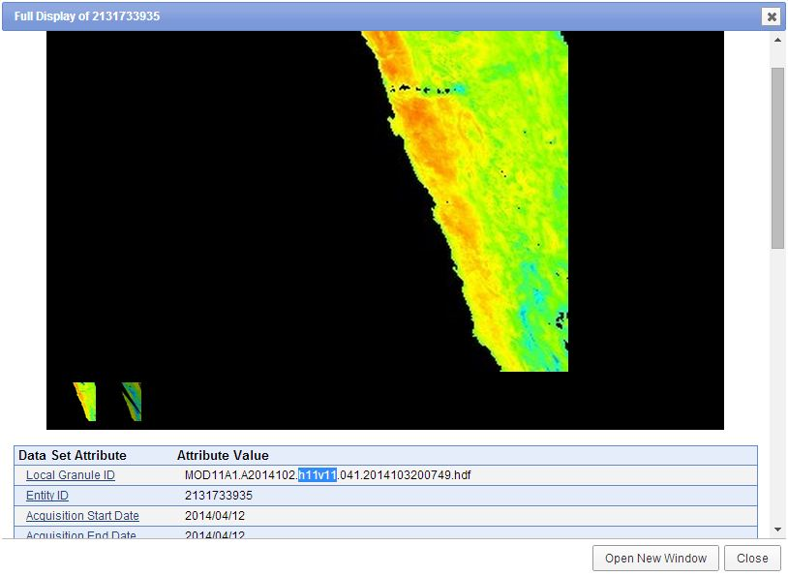

1. Collect the horizontal and vertical coordinates for all of the tiles that cover your study area. A mosaic will later be created from multiple tiles to generate a continuous image for further analysis and processing.
2. Navigate to <http://reverb.echo.nasa.gov/>
3. In order to download data from Reverb, you must create a user account. Do this by clicking *Sign In* and then *EOSDIS user account* on the next page.
4. After you have successfully registered, navigate back to the main page and within the *Spatial Search* window, click the dropdown menu and select what option you want to use to specify your study area (i.e. bounding coordinates, place name, polygon drawing). Since we know which tiles we need select *2D Coordinates* and then select *MODIS Tile SIN* under the coordinate system box and fill in the information as required. Use the *add row* option for more advanced searches.
5. In the *Search Terms* bar, type “MOD11A1”.
6. In the *Temporal Search* window, specify your study period start and end dates.
7. In the *Step 2: Select Datasets* window, make sure *MODIS/Terra Land Surface Temperature/Emissivity Daily L3 Global 1km SIN Grid V005* is selected.
8. In the *Step 3: Discover Granules* window, make sure the same dataset is selected as Step 2.
9. Hit the *Search for Granules* button.
10. On the *Select Granules* page, click the shopping cart button with the word “All” above it (seen in the figure below). This will add all of the MODIS tiles to your shopping cart automatically.

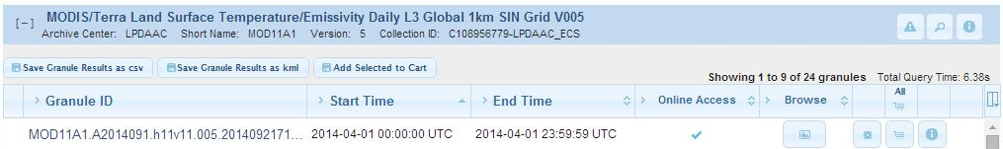

1. Click *View Items in Cart*
2. On the *Shopping Cart* , click the “Order” button.
3. To order data, the user will have to classify what the data will be used for before it can be ordered. Click the “set” button located next to “Order Options” then classify your data usage and agree to their terms in the pop up window (make sure to apply it to all applicable items). On the Review Order page, make sure all of your personal information and selected tiles are correct and click “Submit Order”.
4. In addition to the order confirmation email you will receive, be on the lookout for an email from [LPDAAC@usgs.gov](mailto:LPDAAC@usgs.gov), this is the data product access email. The order process should take about 10–15 minutes. Download the zipped files and extract the ASTER DEM data to the desired folder.
5. Alternatively, MODIS data may be downloaded with a python script provided in [NASA_DEVELOP_SRT\Ejecutables\Descargar_Reverb.py]. Users who are unfamiliar with the python may choose simply to order the data and ignore the following steps.
   1. To use this method, do not “Order” the data, instead click the *Download* button, with the *text file* option.
   2. Open up the scripts called Descargar_Reverb.py, provided in the processing package in a python editor such as IDLE. This can be done by right clicking a python script and clicking “open with IDLE”.
   3. Under the *User Inputs* section of this script, change the ftptext variable to the file path of the text file downloaded in step a.
   4. Change the variable called output to the folder where you wish the MODIS data to be saved.
   5. Hit the “F5” key to run the script.
6. **MODIS Snow Cover:**

Since SRM is designed to simulate and forecast daily streamflow in snowmelt-dominated basins, the daily Snow Cover Area is one of the most important model parameters. Snow cover can be mapped by terrestrial observations, aircraft photography, and most efficiently, by satellites. The *MOD10A1* dataset collected by the MODIS sensor on board the Terra satellite was used. The MODIS/Terra Snow Cover Daily dataset (MOD10A1) contains snow cover, snow albedo, fractional snow cover, and Quality Assessment data. The snow cover data are based on a snow mapping algorithm that employs a Normalized Difference Snow Index (NDSI) and other criteria tests (Hall et al., 2006). We used daily fractional snow cover product provided at a spatial resolution of 500 m within 1200 km by 1200 km tiles.

Like ASTER data, MODIS snow cover data may be obtained from NASA Reverb at the following website:

[<http://reverb.echo.nasa.gov/reverb>]

The steps for downloading the MOD10A1 data is the same for the MOD11A1 data as previously discussed (section 2). Both data sets use the same MODIS Tile SIN coordinate system, so the required tiles will be the same. Start at *step 9* in section 2 and continue entering the proper information for the MOD10A1 data set.

**(4) ASTER Digital Elevation Model (DEM):**

ArcSWAT utilizes three types of data: Digital Elevation Model data, a polyline rivers shapefile, and a polygon shapefile of the region of interest. We used ASTER’s Global Digital Elevation Model V002 which has 30 meter resolution. Higher resolution DEMs will yield slightly more accurate basin delineations, though will take significantly longer to process for large basins. The limiting accuracy factor for remotely sensed inputs is the MODIS Snow cover data, which is 500 meter resolution. ASTER DEM data can be acquired at NASA’s Reverb website at the URL below:

[<http://reverb.echo.nasa.gov/>]

Users are required to create an account in order to download/order data. After an account is created, the user must be logged in before proceeding.

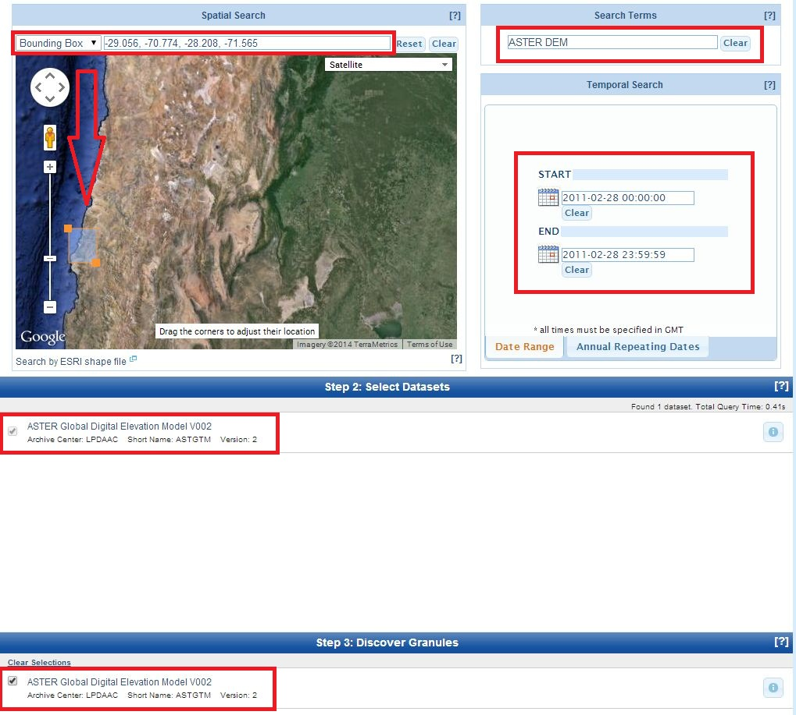

1. Simply search for the desired location by using the bounding box tool or enter the coordinates.
2. Under the *Search Terms* box enter “ASTER DEM.”
3. Under the *Temporal* Search box set the date as 2011-02-28 for the Start and End date.
4. Under *Select* Datasets check the box labeled *ASTER Global Digital Elevation Model V002*.
5. Check the same box under *Discover Granules* and click *Search for Granules*.
6. In the List View on the next page, highlight all of the granules and click “Add Selected to Cart”.
7. At the shopping cart page, you will see a list of the tiles you selected and if the data is orderable, downloadable, or both. Unfortunately, the ASTER DEM data is only orderable so click the “Order” operation.
8. On the next page, you will have to classify what the data will be used for before you can order. Click the “set” button located next to “Order Options” then classify your data usage and agree to their terms in the pop up window (make sure to apply it to all applicable items). On the Review Order page, make sure all of your personal information and selected tiles are correct and click “Submit Order”.
9. In addition to the order confirmation email you will receive, be on the lookout for an email from [LPDAAC@usgs.gov](mailto:LPDAAC@usgs.gov), this is the data product access email. The order process should take about 10–15 minutes. Download the zipped files and extract the ASTER DEM data to the desired folder.

**(5) AMSR-E Soil Moisture:**

The Advanced Microwave Scanning Radiometer – Earth Observing System (AMSR-E) is a sensor on NASA’s Aqua satellite. AMSR-E data has spatial resolution of 56 km. It is designed for use in areas of low vegetation and without any snow cover. This data set is completely optional, it was only used to get an idea of how dry the soil is so the coefficients could be set in the M-SRM. Due to complications with downloading, it is not recommended for use. However, it can be downloaded from the following website:

[<http://reverb.echo.nasa.gov/>]

Search for the AMSR-E sensor on the Aqua satellite and the dates must be between October 2002 and June 2011. The area is null since the dataset is worldwide. It is common for the file not to have any spatial referencing.

**Processing NASA Data**

Daily resolution raw data images must be processed extensively to reduce all data to columns of numerical inputs for simulation by the M-SRM. The most important of these is MODIS snow cover data and TRMM precipitation data. Python scripts were written to accomplish this task, which will work for all three basins included with the processing package, but which should also work for any other basin in Chile. These steps may need to be performed by the user each year to make forecasts, so extended detail is provided.

1. **Preparing MODIS snow cover data:**

*Requires:*

*[\Datos\NASA_Datos\MODIS\2011\MOD10A1....hdf]*

*Creates:*

*[\Datos\NASA_Datos\MODIS\2011\prm\Fractional_SnowCover...tif]*

A custom script built by DEVELOP is used to reproject and mosaic all MODIS data for the study regions of Coquimbo and Atacama Chile. The tool first reprojects MODIS data to UTM_Zone_19S with the WGS_1984 Datum, then mosaics all available tiles together. Later, this data will be clipped to the individual boundaries of each basin, and be resampled to match the resolution of the elevation zone tif generated from ASTER data. Before getting started, ensure MODIS snow cover data files are stored in the correct locations. All data must be organized into folders by year, with all data for a given year laying within a folder titled for that year. For example, 2011 MODIS data should be in the following location:

[NASA_DEVELOP_SRM\Datos\NASA_Datos\MODIS\2011]

And the contents should be similar to what is shown below. Note that the folder titled “prm” should not exist before processing, but the folder will be created by the scripts the user is about to run. All applicable tiles of MODIS data should go into the same folder, notice that the folder contains both “h11v11” and “h11v12” tiles.

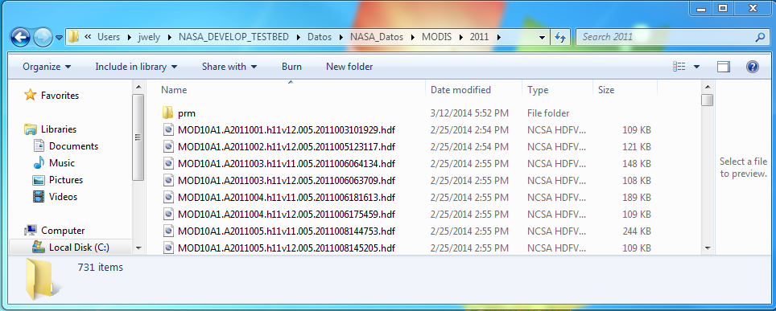

Once the user has all data available for the specified year, begin the following procedure:

1. Navigate to the “Ejecutables” folder located at [NASA_DEVELOP_SRM\Ejecutables ]
2. Right click the file named “Prepare_MODIS.py” and “edit with IDLE”
3. Similarly to the Graphical User Interface for the M-SRM, the input block of this script contains two variables which will be changed by the user. These two inputs are common between nearly all scripts included in this processing package.
   1. **Package** is the file path to the NASA_DEVELOP_SRM folder, for example under DEVELOP this was equal to 'C:/Users/jwely/NASA_DEVELOP_TESTBED'
   2. **Year** is simply the year of MODIS data to be processed, which the user should have already put in place.
4. Once the user has changed the three input variables, hit “F5” or run the module. Your script should look similar to the screenshot below.

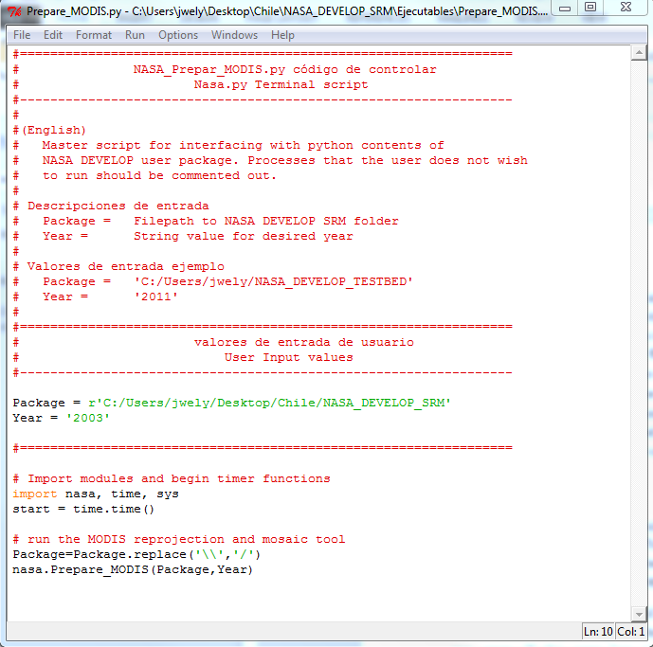

1. When the script has finished, a folder titled “prm” should appear within the folder containing all processed MODIS data.

This python script is analyzing all MODIS data for a given year, which should include tiles for ALL basins under study. If only the three basins included are under study, this script only needs to be run once. If the user has added additional basins which require additional tiles, this Prepare_MODIS.py script will need to be run again for each year.

1. **TRMM and MODIS python processing:**

*Requires:*

*[\Datos\Cuencas\Coquimbo_Limari\Meta.txt]*

*[\Datos\Cuencas\Coquimbo_Limari\Parametros\Shapefile\Shape.shp]*

*[\Datos\Cuencas\Coquimbo_Limari\Parametros\Shapefile\HighShape.shp]*

*[\Datos\Cuencas\Coquimbo_Limari\Parametros\Elev_Zones.tif]*

*Process_MRT.py, must already have been run, and all data must be properly located.*

*Creates:*

*[\Datos\Cuencas\Coquimbo_Limari\Datos_Intermedia\TRMM\TRMM_Precip2011.dbf]*

*[\Datos\Cuencas\Coquimbo_Limari\Datos_Intermedia\MODIS\2011]*

This script performs two tasks. The first task is to completely perform basin specific precipitation calculations for the given input year and basin with TRMM data. TRMM data was used in this study for calculations in elevation zones above 2000 meters, because precipitation monitoring station data is unavailable in these zones. This process includes creating temporary folders, converting the NETcdf files to rasters, executes zonal statistics functions to calculate average precipitation value per zone, then compiles this information into a single dbf file. The second task is to perform basin specific pre-processing on MODIS data to prepare these images for temporal cloud filtering, which will be done in Matlab. MODIS processes performed in this step include clipping the data output from MRT to the precise basin geometry, up sampling the image to match the resolution of the 30m digital elevation model, and saving the data in the “Datos Intermedia” folder under the appropriate basin folder.

Similarly to the MODIS data, it is important to make sure all data is in the correct location. TRMM data should be located in a folder of the appropriate year in the TRMM data directory. For example, 2011 TRMM data belongs in [NASA_DEVELOP_SRM\Datos\NASA_Datos\TRMM\2011]. Similarly, MODIS data from 2011 belongs in [NASA_DEVELOP_SRM\Datos\NASA_Datos\MODIS\2011].

Once data has been confirmed to be in the correct location, follow the steps below.

1. Navigate to the “Ejecutables” folder located at [NASA_DEVELOP_SRM\Ejecutables]
2. Right click the file named “Process_NAA_Datos.py” and “edit with IDLE”
3. The input block of this script contains four variables which will be changed by the user. The first three are common between nearly all scripts included in this package.
   1. **Package** is the file path to the NASA_DEVELOP_SRM folder, for example under development this was equal to 'C:/Users/jwely/NASA_DEVELOP_TESTBED'
   2. **Basin** is the name of a folder containing basin specific data to be processed. Scripts reference this folder and organize data within it for further processing. Valid inputs must be exactly the same as folder names in the basin directory: [NASA_DEVELOP_SRM\Datos\Cuencas]
   3. **Year** is simply the year of MODIS data to be processed, which the user should have already put in place.
   4. **Zonefield** is a specific direction used in calculating zonal statistics for TRMM data. These functions require entries in an attribute table of “HighShape.shp” to share a field with the same value. This field was named “NASA” when creating a shapefile of each basin above 2000 meters, and all values in this field were set to 0. Users wishing to characterize new basins must create this field when creating the shapefile in “HighShape.shp”.
4. Once the user has changed the four input variables, hit “F5” or run the module. The input block of your script should look similar to the screenshot below.

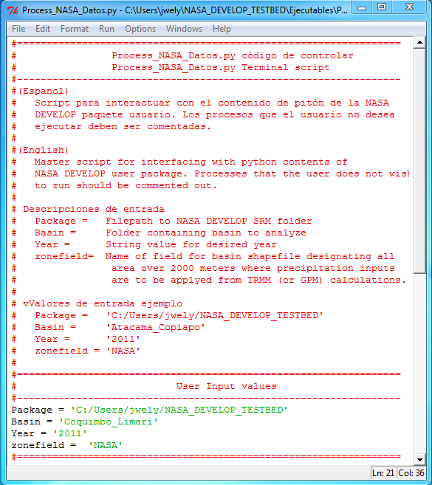

If failure errors are displayed, projection errors are likely. For this study, all projections used are in UTM_Zone_19S, with the WGS_1984 datum. Other projections may be used, but the projections must be completely consistent between all files.

1. **MODIS Snowcover and Temporal Cloud Filtering:**

To ensure a continuous time history of accurate snow cover data, a temporal cloud filtering procedure was developed and implemented using Matlab. This filtering process examines each individual pixel contained in the pre-processed MODIS images on a given day, and performs the following logical check. If today that pixel is clouds, but yesterday it was snow, then it is assumed clouds are simply covering the snow, and the pixel is corrected to snow. This filtering process is executed forward in time, and allows a complete data set to be obtained even in the event of week long periods of inclement weather which obscures snow cover. Once the cloud filtering process is complete, the Matlab script outputs a daily time history of percentage snow cover per elevation zone, ready for direct insertion into the Snowmelt Runoff Model.

The Matlab code which performs this analysis and a description of its requirements is included in the GUI help file.

**Miscellaneous Data**

**ArcSWAT Shapefiles:** To use ArcSWAT, users must download a polygon shapefile of the region of interest and a corresponding polyline shapefile of the rivers found within that region on a GIS clearinghouse website or go to the USGS hydroshed website at the following website:

[<http://hydrosheds.cr.usgs.gov/dataavail.php>]

Both river and basin shapefiles can be downloaded by clicking the links “15sec SHAPE: Drainage Basins (BETA)” and “15sec SHAPE: River Network,” and choose the appropriate continent. For the basins it is necessary to clip your area of interest and create a new shapefile for the ArcSWAT tool. Once the shapefile has been created, convert it to raster in order to use it as a mask in the ArcSWAT tool.

**ArcSwat: Delineating Watersheds**

ArcSWAT utilizes three types of data: Digital Elevation Model data, a polyline rivers shapefile, and a raster of the region of interest. ArcSWAT is used to delineate basin boundaries and characterize the elevation profile. In the current study, basin delineation was performed to isolate catchment areas upstream of reservoirs and corresponding stream gauges for direct model validation. The availability of stream monitoring stations should be considered when delineating a basin. The recommended DEM dataset is ASTER’s Global Digital Elevation Model V002. This data can be acquired at NASA’s Reverb website as directed in the section on downloading NASA data. It is assumed that a starting shapefile of the basin under study is readily available for new basin characterization.

This section will yield a DEM

1. **Merging the DEM tiles:**

The first step to performing hydrological analysis with ArcSWAT is to merge the DEM tiles together. The following steps may be followed for ASTER data.

1. Within each extracted DEM file folder, search for the file with the format

**ASTGTM2_**_dem**

1. Move all of these files into a single “Raw DEM tile” directory
2. Open ArcMap
3. Navigate to the *Mosaic to New Raster* tool within *Data Management Tools -> Raster -> Raster Dataset*
4. Input all of the DEM .tif files in the “Input Rasters” command
5. Define your desired Output Location
6. Name your output file and specify the file extension as **.tif**
7. Leave the “Spatial Reference for Raster (optional)” blank
8. Change Pixel Type to **16_Bit_Signed**
9. Keep cell size at its default value
10. Classify Number of Bands as **1**
11. Keep Mosaic Operator and Mosaic Colormap Mode at their default values and hit OK. Below is a screenshot of the Mosaic to New Raster window.

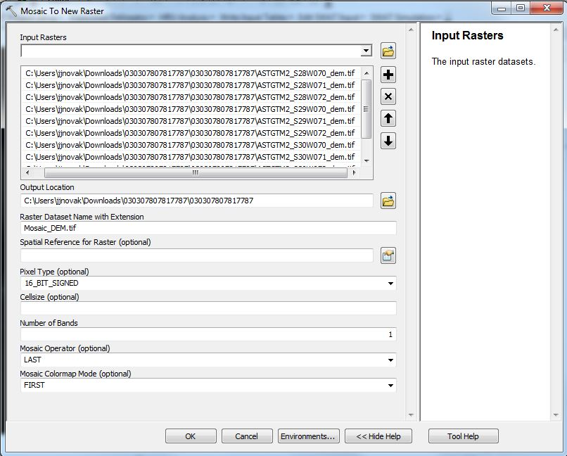

1. **Projecting the DEM:**

It is necessary to project the DEM before starting the ArcSWAT tool. Currently there is only a Geographic Coordinate System and a Projected Coordinate System is required.

1. Navigate under tools to *Data Management Tools -> Projections and Transformations -> Raster -> Project Raster.*
2. Navigate to find your DEM file.
3. Name your output data set and choose a location.
4. Choose a projected coordinate system (we used WGS 1984 UTM zone 19S for all of our shapefiles and rasters, it is up to you to decide which projection you use). The Project Raster window may look similar to the screenshot below.

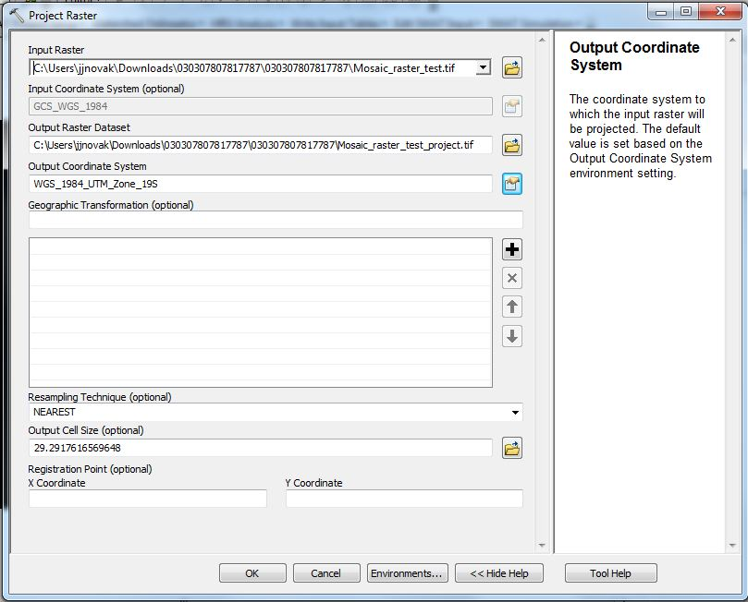

1. **Project Setup:**
2. In ArcMap, turn on the ArcSWAT Toolbar by clicking “ArcSWAT” within *Customize ­-> Toolbars*
3. In the SWAT toolbar, click the *Swat Project Setup* dropdown menu and select *New Project Setup*
4. Select the folder where your DEM file is located in the *Project Directory* window
5. Provide a name for your SWAT Project and Raster Storage databases
6. Select the folder you would like to use for the SWAT Parameter Geodatabase

NOTE: You can only create one ArcSWAT project per Project Directory. If you want to run the model for a second basin, you’ll need to use a different folder

1. **DEM setup:**
2. In the SWAT toolbar, open the *Watershed Delineator* menu and select *Automatic Watershed Delineation*
3. Click the folder icon next to the *Open DEM Raster* window, select *Load from Disk*, and select your DEM file
4. Click the green United States icon to initialize the *DEM projection setup*
5. Select **meter** for *Z Unit* and leave everything else as its default value
6. Click to enable the *Mask* option. This will mask out all portions of the DEM that are not located within the shapefile boundary, drastically reducing processing time.
7. Back in the SWAT window, click on the folder next to the *Mask* window and import your newly created raster file
8. Click to enable the *Burn In* option and load in your polyline rivers shapefile. With this enabled, SWAT superimposes the rivers onto the DEM to define the location of the stream network to improve hydrographic segmentation
9. **Stream Definition:**

This is where the capabilities of SWAT are limited by those of the Snowmelt Runoff Model. SWAT is capable of delineating the entire watershed into numerous sub-watersheds based on the minimum size as defined by the user (in unit hectares). SRM segments calculations into 500 meter elevation zones. Therefore, SWAT must be setup so that it does not define sub-watersheds.

1. Select *DEM-based* as the method for stream definition
2. Click the *Flow direction and accumulation* button to pre-process the DEM by filling sinks and calculating the flow direction and flow accumulation grids. This step may require a significant amount of time depending on the size of your study area.
3. When this process is finished, the “DigitStream” file will output to the map. This shows the location of rivers as calculated using the flow accumulation grids.
   1. Note: It is important to understand that we will be running the SWAT tool twice. The first time will be to find the actual river basin size for either the reservoir or meter station. The resulting basin will be divided up into many sub basins. Due to the formatting of the TopoRep.txt file it is very important that the basin is not divided into sub basins; rather it should be one whole continuous basin.
4. Choosing the size of the sub basins
   1. In the text box to the right of *Area*, classify the minimum sub-watershed size as the minimum possible value allowed (possible range is shown). This forces SWAT to delineate the watershed into multiple sub basins that can be selected later. It may be necessary to play around with the size and run the Create streams and outlets tool multiple times until you find that the points are best lining up with your point of interest (you may want to add the coordinates with the add point tool to show it on the map), see figure below.
   2. On your second run, choose the maximum sub-watershed size as the minimum possible value allowed. This time you want to get the entire area in one single basin. Note that you may find that the area does not match up with the original mask; this is common and can be ignored due to the relative small size of the missing area.

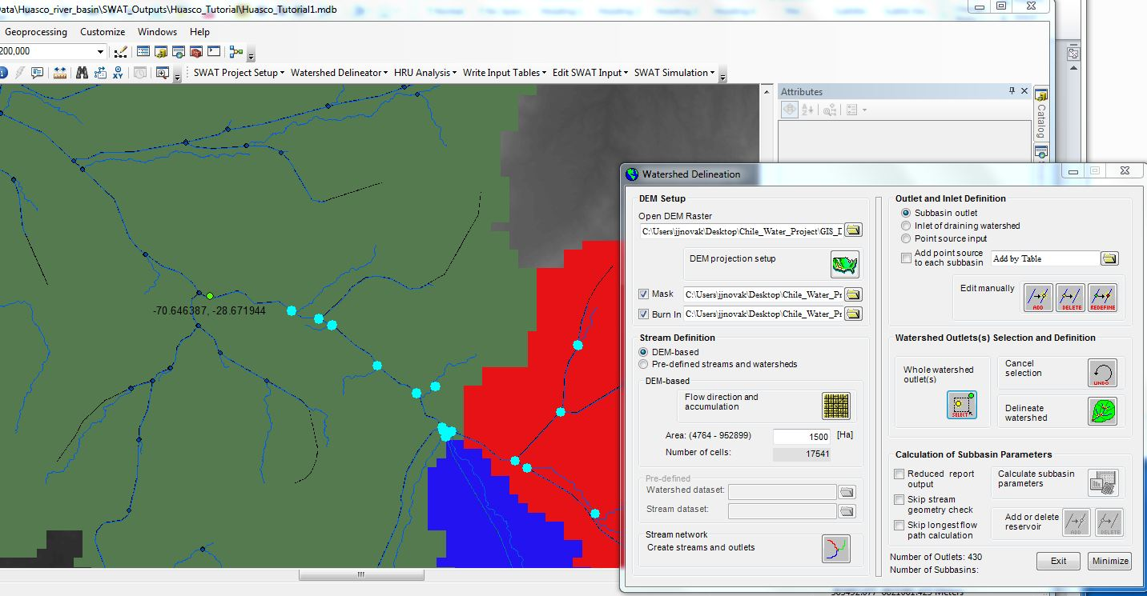

Above is a screen shot of the ArcSWAT tool after selecting the sub basins above the reservoir. In this picture the green dot is the added reservoir location. Note that although there is a closer point below the reservoir but it was not selected due to the addition of a stream inlet that is not contributing to the reservoir. Depending on the scenario, it may be better to choose the point below your reservoir or meter station.

1. Click on the button next to *Create streams and outlets*. This generates the ArcSWAT subbasin, streams, and outlets feature classes.
2. Ignore the buttons under the **Outlet and Inlet Definition** header.
3. **Watershed Outlet Selection and Definition:**
4. Click the “Select” button below *Whole watershed outlet(s)*
5. You will be told to select watershed outlets by dragging a box around the outlets (points) on the map (the Watershed Delineation dialog window will minimize).
6. To select watershed outlets, drag a box around all of the points that were created in the previous step (during the second run, there should be only one point).
7. A confirmation prompt will appear that tells you how many outlets have been selected. If you wish to reselect (if you missed some points), click the same “Select” button again.
8. To start the watershed delineation, click the green button next to *Delineate watershed*. When completed, a message indicating successful completion will appear.
9. A *Watershed* and *Basin* layer will be added to the map. The *Watershed* layer contains all of the subbasins and the *Basin* layer depicts the full watershed boundary. It’s important that both of these layers overlap each other (no subbasins should be depicted within the overall basin boundary).
10. Save either the *Watershed* or *Basin* layer as it will be needed for future analyses and for the second run through of the ArcSWAT tool. Right click the layer in the ArcMap Table of Contents and use the *Export Data* function. Remember to convert the shapefile to raster and save it in a different location. Note that your basin may not match up perfectly with the downloaded basin mask or if you are running this a second time, it may not match your previously made basin. This is normal and can be ignored assuming it is a small difference. At this point you are done if it is your first run and you can start a new project setup and follow the appropriate directions. If it is your second time, please continue to the next steps.
11. **Calculation of Sub-basin Parameters:**

This step is only necessary during the second run through.

1. **Check the box next to *Reduced report output***. This will significantly speed up the calculation of the parameters as elevation statistics and frequency distribution data will be calculated for the full watershed only (although it shouldn’t matter as the subbasin is the same extent as the full watershed). It is also necessary so there is no redundant information and the text file is in the correct format.
2. Click the button next to *Calculate subbasin parameters*. This will calculate geomorphic characteristics of the watershed, but most importantly elevations and their frequency.
3. When all parameters are calculated, a dialog box appears.
4. Navigate to the *Watershed Delineator* pull down tab on the ArcSWAT toolbar and click *Watershed Reports.*
5. Select *Topographic Report* in the next dialogue window.
6. This will open a text document in Notepad called *TopoRep.txt*. This report provides a statistical summary and distribution of surface elevations in the watershed.

These elevation data will be used to calculate mean hypsometric elevations within each elevation zone so be sure to save this file in a known location and rename it as “Area_Elevation.txt.” The SRM will look for this file under this name in the folder [\Datos\Cuencas\Coquimbo_Limari\Parametros], and use it to create the “Hypso.xls” elevation characteristic file.

1. **Creation of Elevation Zone raster and Shapefiles:**

In order to use the provided tools for further spatial processing of NASA data, several additional basin files must be saved and named appropriately.

1. A shapefile called “Shape.shp” must be saved in the shape files folder in the basin parameters folder at [\Datos\Cuencas\Coquimbo_Limari\Parametros\Shapefile]. This shapefile must be exactly the outline of the basin.
2. A raster image in TIFF format of the ASTER elevation data called “Elev_Zones.tif” must be saved in the parameters folder at [\Datos\Cuencas\Coquimbo_Limari\Parametros]. This tiff must be properly projected in UTM_Zone_19S based on the WGS_1984 Datum, and must be clipped to the shapefile created with the ArcSWAT analysis. All remotely sensed inputs will be re sampled to match the resolution of this tiff.
3. A shapefile called “HighShape.shp” must be saved in the shape files folder in the basin parameters folder at [\Datos\Cuencas\Coquimbo_Limari\Parametros\Shapefile]. This shape file must outline the area for which NASA precipitation data will be used in the SRM model, for all basins included, this elevation is 2000 meters (elevation zone 4 and below), but users characterizing new basins may use a different value when appropriate. This shapefile can be constructed by making a copy of the “Elev_Zones.tif” and reclassifying zones below 2000 meters to “NoData”, and zones above 2000 meters as “1”, then converting that raster to a shapefile.
4. In addition to the elevation zone tiff, an additional tiff specifically for temporal cloud filtering in Matlab must be created and named “Elev_Zones_Align.tif”. This image is created for proper alignment of processed MODIS data and the elevation zone information when calculating snow covered areas. Since Matlab does not natively track geospatial reference data, the method employed simply compares the two images pixel for pixel. This requires the Elev_Zones_Align image to be identical resolution to images created by the python scripts provided. Removal of white space in the image is required for this to occur, and so a Matlab script called “BatchCropDirectory.m” was used. The easiest way to accomplish this is as follows:
   1. Process 1 year of MODIS and TRMM data as described in the “TRMM and MODIS python processing” section.
   2. Create a copy of the “Elev_Zones.tif” and place it in the same directory as the 1 year of MODIS data to be processed. For example: [\Datos\Cuencas\Coquimbo_Limari\Datos_Intermedia\MODIS\2011]
   3. Manually run the script “BatchCropDirectory.m” on the directory corresponding to the 1 year of data already processed. This script will overwrite existing files with the new images with white space removed.
   4. Open up one of the MODIS data files and the freshly cropped “Elev_Zones.tif” copy with a photo editing software of choice. We used the GNU Image Manipulation Program or “Gimp” which is open source and a free download.
   5. Visually inspect the alignment of the two images by pasting the snow cover tiff over the elevation zone tiff and making adjustments to the image as desired. Because of the up sampling, perfect edge alignment cannot be achieved, but a close approximation is sufficient for basins over 500 square kilometers in size. Small protruding sections of the elevation zone tif may have to be removed to achieve an adequate alignment, and small amounts of white space may be necessary on some edges to ensure the resolution matches the MODIS snow cover images precisely.
   6. When the copy of “Elev_Zones.tif” is aligned to the users satisfaction, ensure the resolution is identical, then save this image in the Parametros folder as “Elev_Zones_Align.tif”. Make sure any temporary files created in the Datos_Intermedia folders or MODIS data folders are deleted. Be sure not to alter the bit depth of the image. It must remain a single channel 8 bit unsigned integer as before.
5. In addition to these shapefiles, a metadata file is also required for performing TRMM and MODIS calculations. This meta file contains just two lines of miscellaneous information (as pictured below for the Limarí basin) that isn’t adequately stored within any other files. The first line of information is the Clipping coordinates used to manually specify the outmost extents of the image to be processed to minimize processing time. This information can be found by examining the characteristics of the basin shapefile in ArcMap and copying the bounding box data. The second piece of information is the basin area, which can also be found by examining the basin shapefile in ArcMap, but also by examining the Elevation zone tiff. “Basin_Area” is in units of square meters, and is used by the M-SRM.

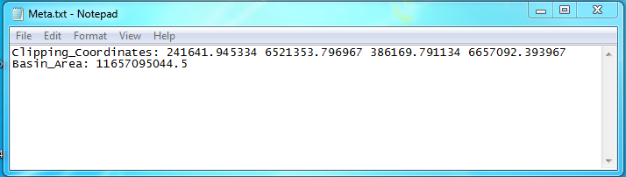

**Defining Basin Parameters**

Many basin parameters are required for a proper snowmelt runoff model simulation. Users characterizing new basins should reference The Snowmelt Runoff Model (SRM) User’s Manual by J. Martinec, A. Rango, and R. Roberts, but brief descriptions of our methodology are provided here.

1. **Hypsometric Mean Elevations:**

*Relevant Files: [\Datos\Cuencas\Coquimbo_Limari\Parametros\Area_Elevation.txt]*

*[\Datos\Cuencas\Coquimbo_Limari\Parametros\Hypso.xls]*

The Hypsometric Mean Elevations represent the average elevations for each elevation zone. These are the elevations compared against the reference elevation when temperature values are extrapolated. They are produced automatically by a script which analyzes ArcSWAT output.

1. **Degree Day Factor (Melt Factor):**

*Relevant Files: [\Datos\Cuencas\Coquimbo_Limari\Parametros\Melt_Factor.xls]*

The Snowmelt Runoff model approximates the melting rate of snow by relating two key parameters, temperature and snow covered area. The degree day factor () function is a seasonally fluctuating value which indicates the depth of snow which is melted for each degree over the critical temperature experienced on a given day each elevation zone. This factor was estimated using the SRM manual suggested formula below, and has units of cm/(ºC×day).

Snow density data was provided for a few days out of the year at stations distributed throughout the basin at various elevation zones. Though snow density measurements are sparse, measurement history dates back to 1970, and snow density was determined not to be a function of elevation zone. This allowed us to sort snow density measurements into bins corresponding to the month they were taken in, and averages to be calculated for each month. A cyclical condition was imposed, and a best fit sixth order polynomial equation was found to fit the data. This data was then up-sampled to provide a daily continuous time dependent degree-day factor function.

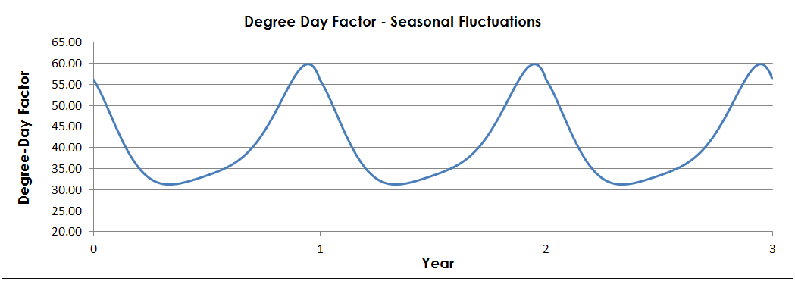

1. **Runoff Coefficients:**

*Relevant Files: [\Datos\Cuencas\Coquimbo_Limari\Parametros\RC_Snow.xls]*

*[\Datos\Cuencas\Coquimbo_Limari\Parametros\RC_Pnasa.xls]*

*[\Datos\Cuencas\Coquimbo_Limari\Parametros\RC_Pstations.xls]*

The runoff coefficients determine what percentage of rain becomes runoff () and what percentage of snow melt becomes runoff (). Evaporation and soil absorption are the primary mechanisms by which snow melt or rain are prevented from becoming runoff. Runoff coefficients simply indicate a ratio of water volume which persists until it reaches stream gauges. Utilization of common model default values produced extremely inaccurate simulations, prompting further investigation into soil moisture, an influential factor in determining the value of runoff coefficient.

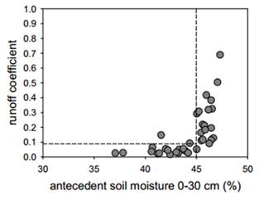Surface soil moisture content data collected by the Advanced Microwave Scanning Radiometer (AMSR) was used to determine an average annual soil moisture contents from 5% to 30%. A relationship of soil moisture to runoff coefficient was described by Penna et al. in 2011 where a soil moisture threshold of 45% was identified, at which runoff coefficient sharply decreases. Below this threshold, coefficients are typically below 0.1 and approach 0 as soil moisture approaches 30%, likely due to the sponging effect of dry soil. With this insight, and a trial and error approach, extremely low values between 0.01 and 0.06 for and between 0.010 and 0.02 for were determined to produce the most accurate simulations of total daily runoff. These findings are consistent with the expected effects of extremely low soil moisture on the values of runoff coefficient. These values indicate that 1% to 2% of total snowmelt and 1% to 6% of total rainfall contributes to runoff and is consequently available for capture in the basins reservoir systems. Runoff coefficients should be more precisely tuned for each year using tools made available in the Graphical User Interface, and described in the GUI help document

The NASA Develop team utilized separate runoff coefficients for liquid precipitation for the TRMM and *in situ* data sources respectively, as individual tuning from each source is likely to be desired. For simulations performed, TRMM has been observed to detect many additional precipitation events than the *in situ* weather stations, particularly in the second half of the year. This simply means that when the model equation is calculating total flow rate, elevation zones 1 through 4 (below 2000 meters) use a different precipitation input, and a different runoff coefficient than zones 5 and above.

1. **Time Lags:**

Time lag refers to the amount of time it takes for a unit of water to get from the upper reaches of the basin down to the stream gauge location for measurement. The standard snowmelt runoff model assumes all water sources to be subject to the same time lag, which is a good approximation for many of the basins studied with it in the past. However, the exceptionally dry nature of the basins in central and northern Chile appears to cause different hydrological behavior. Liquid rain appears to influence stream flow far more rapidly than the slow process of snowmelt, and recession coefficient alone does not appear capable of adequate accounting for this observation. Two time lag parameters which separately delay stream flow from rain and snow respectively were implemented. These two time lags are thought to loosely correspond with surface and subsurface runoff. Future modeling which considers aquifer deposits and withdrawals from streamflow and reservoirs may be implemented for improved accuracy, but further geological and hydrological study is required.

Typical time lags are low for rain (1 to 5 days) as the majority of this water flows along the steep topography very quickly. Typical time lags for snowmelt are higher than for rain as the melting process is slower and much of this water infiltrates the soil. Significant complication appears present in the driest two of the three basins, Huasco and Copiapó from subsurface runoff and groundwater fluctuations.

1. **Temperature Lapse Rate:**

*Relevant Files: [\Datos\Cuencas\Coquimbo_Limari\Parametros\Temperature_Lapse.xls]*

The temperature lapse rate () is used to extrapolate average temperatures in each elevation zone from a reference temperature at a lower elevation. For each basin, the highest elevation temperature stations were selected, and their temperatures were averaged together for daily temperature inputs. The elevations of these stations were averaged together to obtain a reference elevation, which when combined with temperature lapse rate allows extrapolation of these temperature readings from the reference elevation upwards. While the standard adiabatic temperature lapse rate for a free column of air is 0.65º C per 100 m rise in elevation, these basins are subject to variation in this lapse rate due to anticyclonic weather patterns inherent to the steep topography. A lapse rate unique to each of the three basins was calculated using the level 3 MODIS Daily Land Surface Temperature product (MOD11A1) at 1 kilometer resolution, downloaded from the NASA Reverb website.

Before using the MODIS data, the figures need to be converted. The units are in Kelvin and need to be multiplied by 0.02. For more information please see the MODIS website at:

<https://lpdaac.usgs.gov/products/modis_products_table/mod11a1>

The MODIS data was clipped with our elevation zone raster and divided into the same elevation zones. A zonal statistic tool was used to produce an average temperature for each elevation zone.

The resulting table of statistics gave us our average temperatures for each elevation zone. The temperatures were graphed as a function of the elevation zone. Once the points were plotted, a best fit line was added and the slope was the T-lapse rate. For the SRM, the T-lapse rate needs to be the change in temperature for 100 meter intervals. The found slope is in 500 meter intervals so it was necessary to divide by 5 to get the proper format for use in the SRM. While looking at random days over a year time period, it was found that the T-Lapse rate varied a lot. To get a better look at the entire year, 1 in every 5 days was calculated through the entire year. A moving average was used to smooth out the results over the entire year. The SRM requires a value for each day of the year so in order to complete our data set, the missing days were interpolated. Depending on time available, you may want to calculate for each day of the year or even look at different years to get a better value for the T-lapse rate.

1. **Snow Covered Area Forecasting:**

*Relevant Files: [\Datos\Cuencas\Coquimbo_Limari\Parametros\SCA_Profile.xls]*

*[\Datos\Cuencas\Coquimbo_Limari\Parametros\PrecipIS_Profile.xls]*

*[\Datos\Cuencas\Coquimbo_Limari\Parametros\PrecipNASA_Profile.xls]*

*[\Datos\Cuencas\Coquimbo_Limari\Parametros\Temperature_Profile.xls]*

Daily snow cover data from 2004-2013 show the yearly trends of snow coverage and melt. For most years, the snowpack appears in mid-May and continues to grow throughout the winter months until melting accelerates in September and October. Snow cover data is combined with historical temperature and precipitation data to complete the daily inputs for the Snowmelt Runoff Model. Snow covered area was temporally filtered to remove spurious zero values corresponding to widespread cloud cover events, and demonstrated a large positive impact on the accuracy of the model. A seasonal average snow cover trend for the years 2004-2011 was created then further smoothed to demonstrate the overall seasonal cycle of snow covered area. While each year’s actual snow covered area profiles vary dramatically from the smoothed average, the snow covered area consistently reduces more sharply in the lower elevation zones. This consistent relative rate of decrease in snow cover by elevation zone forms a basis for predicting snow covered area curves.

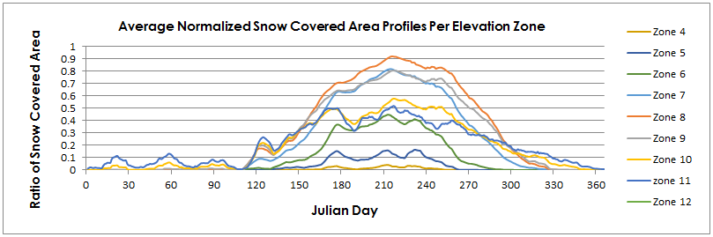

To forecast daily snow cover inputs, up to date snow cover data is input, and theoretical average snow cover profiles are scaled to apply an expected tapering of the total snow covered area contributing to snowmelt. This is intended to work particularly on the downslope of the snow covered area profiles, with forecasts being performed near the end of September, (Julian day 270). This helps convert the M-SRM from a simulating tool, to a forecasting tool. As a place holder, a similar process is performed on temperature and precipitation data, though users are recommended to provide better precipitation and temperature forecasts from a weather service when using the M-SRM to forecast. Additional information can be found in the GUI help file.

**Acknowledgements**

The Chile Water Resources Team would like to thank our partners and colleagues for their support with this project.

**Pedro Bejares and Javier Chaud:**  from the Chilean Embassy for help with communications, data transfer coordination and translation efforts.

**Dr. Ricardo Cabezas Cartes:** from CIREN for his help in data collection, providing knowledge of the area, and suggestions for the project.

**Dr. Angelica Gutierrez**: from NOAA for her input on the model and her support.

**Dr. Kenton Ross**: our formal science advisor, for his guidance and critique during the term.

**James Favors:** as the international correspondent for the DEVELOP National Program Office.

**Lauren Childs-Gleason:** from the DEVELOP National Program Office for support and feedback throughout this project.

**Lauren Makely**: for assistance with edits and deliverables.

**Tiffani Orne:** for assistance with edits and deliverables.

**Beth Brumbaugh:** for assistance with edits and deliverables.

**Steve Padgett-Vasquez:** for assisting in translation efforts.