Introduction of Computer
Homework 4 Report
Name: 徐子程
Student ID: B06602037
SQLITE DB Browser version: 3.11.99
Please use any legal SQLite commands to finish the following questions.

HW# 4-1 (10%): Find the Dept which contain job “Cook” or “Executive Chef”.

SQLite commands:
SELECT DISTINCT Dept FROM JOB
WHERE JobTitle='Cook' OR JobTitle='Executive Chef'
ORDER BY Dept
Result:
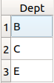

HW# 4-2 (10%): Find all the JobTitle in Dept A.

SQLite commands:
SELECT DISTINCT JobTitle FROM JOB
WHERE Dept='A'
Result:
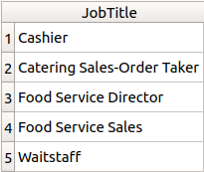

HW# 4-3 (10%): Count the assignments which started in 2011 or terminated in 2012.

SQLite commands:
SELECT COUNT(*) FROM ASSIGNMENT
WHERE strftime('%Y', StartDate) = '2011' OR strftime('%Y', TermDate) = '2012'
Result:
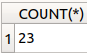

HW# 4-4 (10%): Find the names of the employees who live in Broadway and list the name in ascending order.

SQLite commands:
SELECT Name FROM EMPLOYEE
WHERE Address LIKE '%Broadway%'
ORDER BY Name
Result:
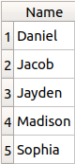

HW# 4-5 (10%): Count the assignments which JobTitles contain “Manager”.

SQLite commands:
SELECT COUNT(A.JobId) FROM ASSIGNMENT AS A
INNER JOIN JOB AS J ON J.JobId=A.JobId
WHERE J.JobTitle LIKE '%Manager%'
Result:
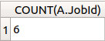

HW# 4-6 (10%): Find the employees who have exactly 4 assignments and list their (Name, EmpId)s in a relation.

SQLite commands:
SELECT E.Name, E.EmpId FROM EMPLOYEE AS E
INNER JOIN ASSIGNMENT AS A ON E.EmpId=A.EmpId
GROUP BY E.EmpId HAVING count(A.JobId) = 4
ORDER BY E.Name
Result:
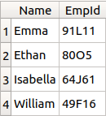

HW# 4-7 (10%): Find the employees who have assignments started in 2011 and list their (Name, EmpId)s in a relation.

SQLite commands:
SELECT DISTINCT E.Name, E.EmpId FROM EMPLOYEE AS E
INNER JOIN ASSIGNMENT AS A ON E.EmpId=A.EmpId
WHERE strftime('%Y', StartDate) = '2011'
ORDER BY E.Name
Result:
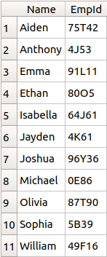

HW# 4-8 (10%): Find the employees who didn’t have assignments started in 2011 and list their (Name, EmpId)s in a relation.

SQLite commands:
SELECT E.Name, E.EmpId FROM EMPLOYEE AS E
INNER JOIN ASSIGNMENT AS A ON E.EmpId=A.EmpId
EXCEPT
SELECT E.Name, E.EmpId FROM EMPLOYEE AS E
INNER JOIN ASSIGNMENT AS A ON E.EmpId=A.EmpId
WHERE strftime('%Y', StartDate) = '2011'
ORDER BY E.Name
Result:
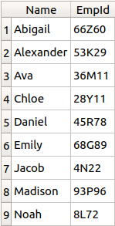

HW# 4-9 (10%): Count jobs’ popularity and list their (JobTitle, Count)s in relation.

SQLite commands:
SELECT JobTitle, count(JobTitle) FROM JOB AS J
JOIN ASSIGNMENT AS A ON J.JobId = A.JobId
GROUP BY JobTitle
ORDER BY count(JobTitle) DESC
Result:
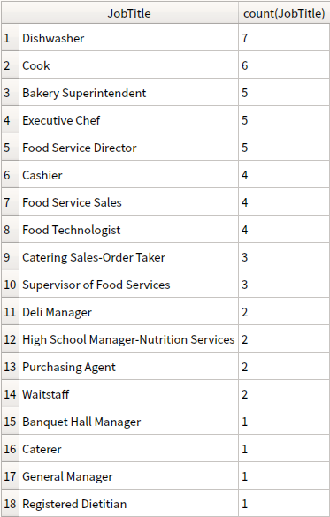

HW# 4-10 (10%): Find which jobs are the top 3 most popular. List them as (JobTitle, Count)s in relation. If the job count order is 543332221, you should list the jobs whose count are not lower than 3.

SQLite commands:
SELECT J.JobTitle, count(J.JobTitle) FROM JOB AS J
JOIN ASSIGNMENT AS A ON J.JobId = A.JobId
GROUP BY J.JobTitle

HAVING count(J.JobTitle) >= (
SELECT DISTINCT count(J.JobTitle) FROM JOB AS J
JOIN ASSIGNMENT AS A ON J.JobId = A.JobId
GROUP BY J.JobTitle
ORDER BY count(J.JobTitle) DESC
LIMIT 2,1) -- 2,1 represents 3rd largest number

ORDER BY count(J.JobTitle) DESC
Result:
