Introduction of Computer
Homework 5 Report
Name: 徐子程
Student ID: B06602037

Your tensorflow version: 1.13.1 (With GPU support , GPU : NVIDIA GTX 1060 6G)
Keras version: 2.2.4
Environment (Windows 10 / MacOS / Linux): Ubuntu 18.04.2 LTS

- Verify Installation (30%)
To verify your tensorflow installation, open the python shell and import the package “keras”. There should be a message showing that keras is using the tensorflow backend. Please paste the screenshot here.

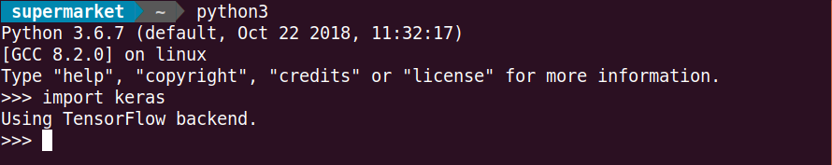

- Classification with Neural Network
- The structure of your best model. (10%)
3 flatten layers
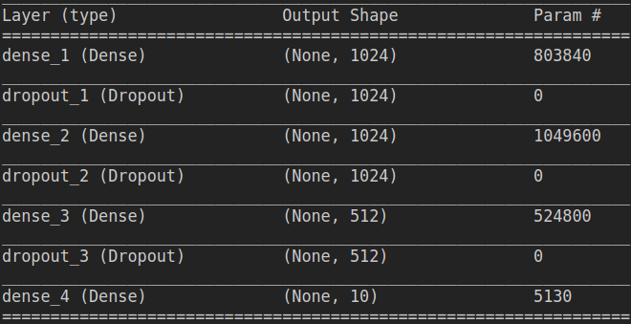

- Training accuracy. (5%)
Up to 0.94
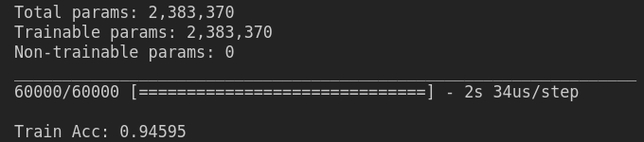

- How do you determine the termination of training ? (10%)
We set the number of training epochs.

- How do you determine which model structure is better ? (10%)

By comparing the validation data accuracy, if the accuracy is better than previous training epoch , we save the model into a file.
After all training epochs were done, we load the best model for testing data.

- Bonus : Convolutional Neural Network
Model structure:
4 convolution layers, 2 pooling layers, 2 flatten layers
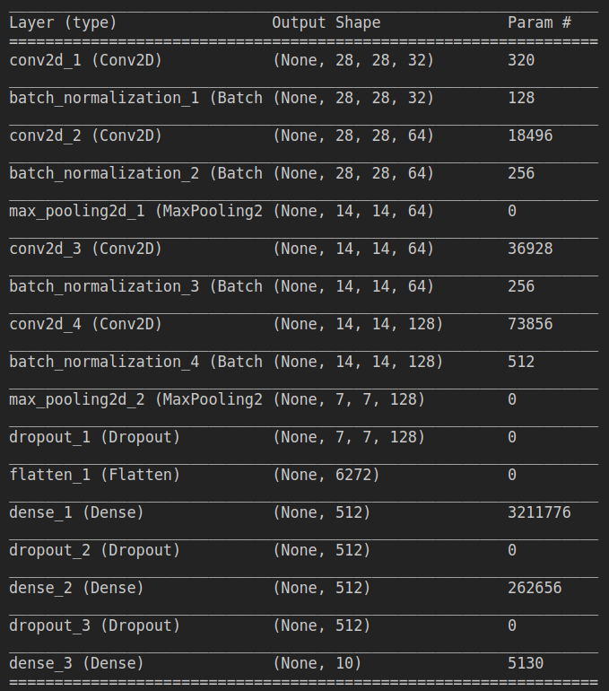

Observations:
If dropout value is not big enough, overfitting will occur. The better value is around 50%.

Best validation accuracy: Up to 0.94
